Fleet connectivity across West Coast fisheries: quantifying the effect of a management intervention on revenue diversity in an interconnected socioeconomic environment
Emma Fuller, Jameal Samhouri, James Watson, Joshua Stoll
Nov 6, 2015

Introduction
We employed a novel clustering algorithm to determine commercial fishing strategies along the US west coast. We found that the algorithm correctly identified spatial and temporal patterns of known single – and multispecies fisheries, and used the classification method to (i) determine vessel-level participation in individual fisheries and emergent diversification of their participation across fisheries, and (ii) describe networks of fisheries participation for entire communities (ports). We found that the majority of vessels examined were generalists, which participated in more than one commercial fishery in our time-period. In addition, interconnectedness of fisheries participation varied strongly across ports. Using these individual and community-level measures of fisheries diversification and connectivity of participation networks, we evaluated how the introduction of a new management structure, catch shares, influenced vessel-level participation in the affected fishery (LE trawl), along with diversity measures for vessels and ports as a function of their participation in the catch share fishery. We hypothesized that catch shares would affect fishing strategies in one of two ways: causing vessels to either drop out of the fishery or, for those that remained in the fishery, allowing them to diversify by participating more heavily in other fisheries. For port communities, we tested whether changes at the vessel level were reflected at the port-level. We found that the implementation of catch shares caused a minority (xx%) of vessels to leave commercial fishing altogether, while yy% of vessels continued to participate in the affected fishery and diversified by participating in additional fisheries. A third group consisted of vessels that exited catch shares but continued to fish commercially (zz%). These vessels showed a mixed response, with increased and decreased fishing diversity observed. We also found that these changes at the vessel-level did not affect participation among fisheries at a community level. This work helps to formalize and quantify social ecological linkages across scales.
Methods
Description of Data Sources
We used landings tickets which record all commercial landings on the US west coast between 2009-2013. While rich, this dataset lacked information on outside employment and/or any commercial fishing landings outside of the US west coast EEZ. To account for this, we restricted our analyses to vessels with an average of at least $5000 in annual revenue and remove vessels which landed commercial catch in Alaska. We also discarded landings from 2011, the year in which catch shares were established. This left 3,127 vessels which were responsible for approximately 99% of the total revenue and biomass landed during this period.
Defining Realized Fisheries
We defined realized fisheries as a gear-type which targeted a coherent species assemblage (van Putten et al. 2011). The Pacific Management Council has developed a set of sector based definitions similar to this approach for the federally managed groundfish landings, but no equivalent existed for non-groundfish fisheries (NWFSC Observer Program). In order to treat the landings dataset uniformly, we applied a metier-like analysis to this landing data (Deporte et al. 2012).
To construct these realized fisheries we defined species targets through clustering species composition of landings. We used the Hellinger Distance (Legendre & Legendre 2012) to calculate the similarity in revenue profiles between trips and built a weighted, undirected network. The Hellinger Distance D between the species composition of two fishing trips A and C is defined as
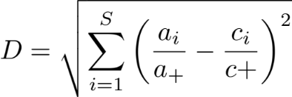 | Eq. 1
with
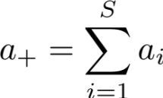 | Eq. 1
where a_{i} is the revenue derived from species i on trip A, and c_{i} is the revenue derived from species i on trip C where there are S total species.
We used the infoMap community detection algorithm (Rosevall & Bergstrom 2008) to find groups of trips with similar target assemblages. To facilitate data analysis, we used one year of landings (2010) which we split by gear. Pairwise distances among trips and community detection were used within each gear partition which results in classification of trips to a target assemblage category. Linking the clusters to gear used for the trip gives realized fisheries. Using the 2010 realized fisheries assignments we implemented a k-nearest neighbor search with Hellinger Distance as the distance metric to assign trips from 2009, 2012, and 2013 other trip to the realized fishery to which they were closest in multi-dimensional space.
A drawback of this classification method, and part of the reason for its need, is that there exists no independent classification of US west coast fisheries to which we can easily compare. To address this drawback, we rely on our ability to recover patterns already documented for US west coast fisheries. Specifically, because we did not bound our clusters spatially, temporally, or by vessel characteristics we would expect to recover known spatial and temporal structure if our classification approach was reliable. We also compared our realized fisheries to existing sector definitions of groundfish, and groundfish impacting fisheries provided by the Northwest Fisheries Science Center (NWFSC) Observer Program.
Calculating changes in vessel and community level fishing diversity
At the vessel level we measured diversity as the effective Shannon index (ESI) of revenue diversity (Jost 2006). ESI of vessel j is calculated as
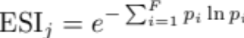 | Eq. 1
where F is the number of realized fisheries and p_{i} is the proportion of revenue derived from realized fishery i.
To represent connectivity among fisheries at the port level we built directed, weighted networks. Nodes represented a realized fishery, and the strength of the connections between nodes represented the number of vessels which land both. More formally, we built a network G_{i} for each port i in which an edge AB is the number of vessels which participate in both fisheries A and B divided by the total number of vessels that participate in fishery A. Similarly, edge BA is the number of vessels which participate in both fisheries divided by the total number of vessels that participate in fishery B.
To measure similar characteristics as our vessel measure of diversity we developed a metric which increases as both the number of fisheries and the evenness in which they are participated increases. Common network topology measures such as shortest path and centrality metrics capture the evenness of connectivity across the network but don’t reflect the difference between a port with many or few fisheries present. To address these concerns we develop an index of average fishery connectance (AFC) for port j defined as the sum of edge weights (w) present in network G_{j} divided by the number of nodes (V) in G_{j}.
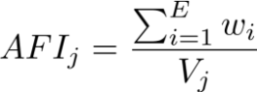 | Eq. 2
Because edge weights are constrained to be between 0-1, this value can be interpreted as the average number of fisheries to which a fishery is fully connected (i.e. all vessels participate in both fisheries) in port j.
Analysis of management change
At the vessel level, we used a simple linear regression to compare the change in ESI between vessels which did and did not participate in catch shares. At the port level, we compared the change in AFC in ports with and without catch share landings. If catch shares allowed vessels to be more flexible in their fisheries participation, we’d expect the catch share vessels/ports would, on average, demonstrate increased diversity after catch shares. To this end we fit the following regression
Eq. 3
Due to the nature of our response variable, we also included models in which pre-catch share diversity was a covariate. This is because the ability to change diversity between two periods is related to the starting period diversity. For example, if a vessel is a specialist (i.e. diversity = 0), then it is impossible for that vessel to drop in diversity and any random variation will bias diversity upwards. Similarly, if a vessel was maximally diversified, then the vessel could either remain the same or with random variation drop in diversity. Because there are many sources of variation separate from that induced by management change (i.e weather, market conditions) we expect this effect to be significant. Thus the model is
Eq. 4
We compared alternative models using the information theoretic approach which allows direct comparison of the models’ goodness of fit using model likelihoods (Burnham & Anderson 2002). The Akaike Information Criterion (AIC, Burnham & Anderson 2002) was used to find the most parsimonious model which balanced both the goodness of fit (as measured by likelihood) and model complexity (as measured by the number of parameters). Here the lower the AIC, the better the model (Burnham & Anderson 2002).
Results
Data driven definition of realized fisheries
Our clustering algorithm identified 102 realized fisheries which had 109 species (of the 207 total caught) contributing at least 1% revenue to the composition. Realized fisheries often consisted of a single species but could also comprise assemblages of species (Fig. S1a). Whether their catch consisted of a single species or multiple species, the realized fisheries were characterized by distinct patterns of temporal and spatial structure (Fig. S2a, b). These patterns suggested strong agreement between our realized fisheries and NWFSC Observer sector designations, as did comparisons of vessel sizes and catch composition (single- vs. multi-species) (Table 1).
The realized fisheries also varied by several orders of magnitude in effort (number of trips) and revenue (Fig. S1b), with a small number of fisheries accounting for the majority of effort and revenue. For example, only 10 of the 102 fisheries were responsible for 90% of ex-vessel revenue in the time period we examined (Table 1). These fisheries included XYZ, which have been well-studied but not quantitatively described prior to now (e.g., dungeness crab pots (Botsford & Wickham 1978), spiny lobster pots (Kay et al. 2012), or red urchin diving (Smith & Wilen 2003)) (Table 1).
Table 1: We summarize fleet characteristics for three realized fisheries and compare to the corresponding NWFSC Observer sector description. Parenthetical values represent the percentage of trips which fell within expected ranges. The following fisheries represent (with pink shrimp and limited entry groundfish) the top ten realized fisheries by revenue. Fleet characteristics for which no corresponding NWSFC observer sector is present are presented as 95 percentiles for length, latitude and seasonality.
Fishery  Sector name if applicable | Latitude  decimal degrees | Catch composition  % trips multispecies | Seasonality  fishing season | Vessel Length  ± 1 ft
Limited entry groundfish trawl/catch shares | 35.4-49  (97.9%) | 100%  (98.2%) | NA | 35-95  (99.5%)
Pink shrimp trawl | 35.8-49  (97.9%) | NA | Apr 1 – Oct 31  (99.8%) | 38-105  (100%)
California halibut trawl | 37.4 – 34.05  (96.5%) | NA | NA | 29-71  (99.8%)
Dungeness crab pots | 36.8-47.6 | 0.9% | Oct 26 – Aug 8 | 22-67
Market squid seine | 33.7-36.8 | 6.8% | May 24 – Feb 25 | 36-80
Albacore troll | 37.5-46.9 | 0.6% | Jul 10-Oct 22 | 23-72.5
Sablefish long-line | 33.2-48.4 | 70% | Jan 16-Dec 15 | 20-57
Shore-side Hake | 43.3-46.9 | 92% | Jun 16-Nov 15 | 65-129
Chinook salmon troll | 35.4-48.4 | 14% | Apr 11-Oct 22 | 20-50
Sardine seine | 33.7-46.9 | 42% | Jan 8-Oct 22 | 45-80
Spiny lobster pot | 32.7-34.4 | 8.3% | Oct 5-Mar 12 | 18-42
Changes in vessel and community level fishing diversity
The existence of 102 realized fisheries on the US west coast opens up a variety of opportunities for diversification of fishing practices by individual vessels. We find that between 2009-2010, 66% of commercial vessels on the west coast participated in more than one realized fishery (Fig. 2a) although the degree to which vessels diversified varied regionally. For all four of the management regions on the west coast, generalists (vessels which landed > 1 realized fishery) outnumbered specialists (vessels which landed in a single realized fishery) (Fig. 2b). The distribution of diversity varied among the generalists, from vessels that were highly specialized but had a few landings in additional fisheries to those that fished in many fisheries evenly (Fig. 2c). Notably, the majority of diversified vessels revenue was dominated by revenue from a single fishery (71%), with very small percentages coming from alternatives. However almost a quarter (24.4%) of diversified vessels were participating in at least two fisheries equally, with some vessels (4.6%) participating evenly in more than three fisheries (Fig. 2c).
The preceding analysis focused on fishing strategies employed by individual vessels, without consideration of how those strategies came together to create characteristic fisheries participation networks for specific places/communities/ports. We found differences in the number and interconnectedness of fisheries across ports (Fig. 3a). Ports had anywhere between 0-6 fisheries connected. This variation is exemplified by distinctions between participation networks in Santa Barbara, CA and Eureka, CA (Fig 3ab). Santa Barbara was characterized by a much more complex participation network, with more than double the average fishery connectance of Eureka.
Effect of management change
Between the period before (2009-2010) and after (2012-2013) catch shares, vessels showed a modest, but significant, 3% increase in fisheries diversification (p = 0.01898). However, we found that vessels subject to catch shares management demonstrated a four-fold higher (12%) increase in diversification, significantly more than vessels not subject to catch shares management (p = 0.04061). In addition, ports that had catch share quota landed at them were 8% more diverse following catch shares management implementation, but this change was not statistically significant (p = 0.5737 ) (Fig 4).
Discussion
- Generalist fishing the norm, not the exception
  - Models of fishing typically model fleets as homogenous groups of vessels. Following theoretical formulations, most empirical fleet analyses take a similar approach, focusing on a group of boats which participate in catching a set of species with a particular gear and ignoring the other fisheries in which the vessels may participate. Fishing on the US west coast however, is better described as a heterogeneous group of multi-purpose vessels fishing in many different combinations of fisheries.
- Catch shares has increased revenue diversity at the vessel level
  - Find that catch shares do allow better diversification at vessel, and so if relationship with revenue variability holds, then we expect that catch shares make revenue less variable for these vessels.
  - Is a good thing for those boats that continued to fish in groundfish trawl. But not all boats made the transition, and it seems like the smaller, more diversified trawlers were more likely to not make it into the new management regime. Examining what happens to these fisheries, and whether these patterns of connectivity can predict new entries is an important next step of this work.
- Scale of analysis matters
  - Results highlight the importance of scale, catch shares are a “success” in terms of fishing diversity at the vessel level, but policy discusses community level. And there is no effect there.
  - Realized fisheries also have a particular scale, and it is slightly different resolution than permit: i.e. there are multiple distinct target assemblages within the open-access nearshore fishery but multiple permit-types contribute to the sablefish long-line fishery. It’s not clear which, realized fishery or permitted sector, is the better measure of resilience or adaptability. Realized fisheries capture the ecological structure of the fishery, and provides information on how diversified a vessel/community is ecologically. But permits reflect anthropogenic limitations on movement among fisheries, which realized fisheries, as presently defined, lack.
Figures
Figure 1: Schematic of methods
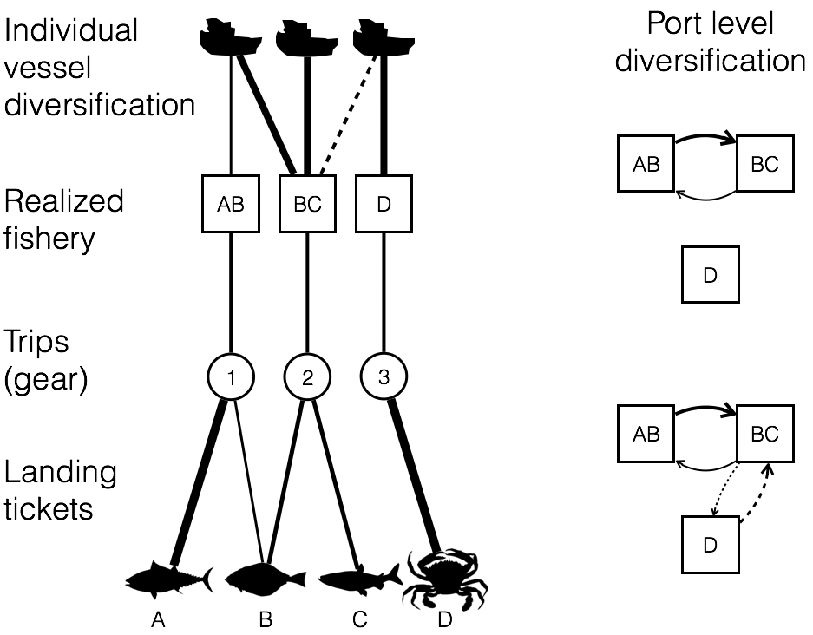
Figure 2: Distribution of fisheries diversity at the vessel level; A) coastwide, B) by management region, C) breakdown of generalism for each management sector. Generalists are vessels which land > 1 realized fishery.
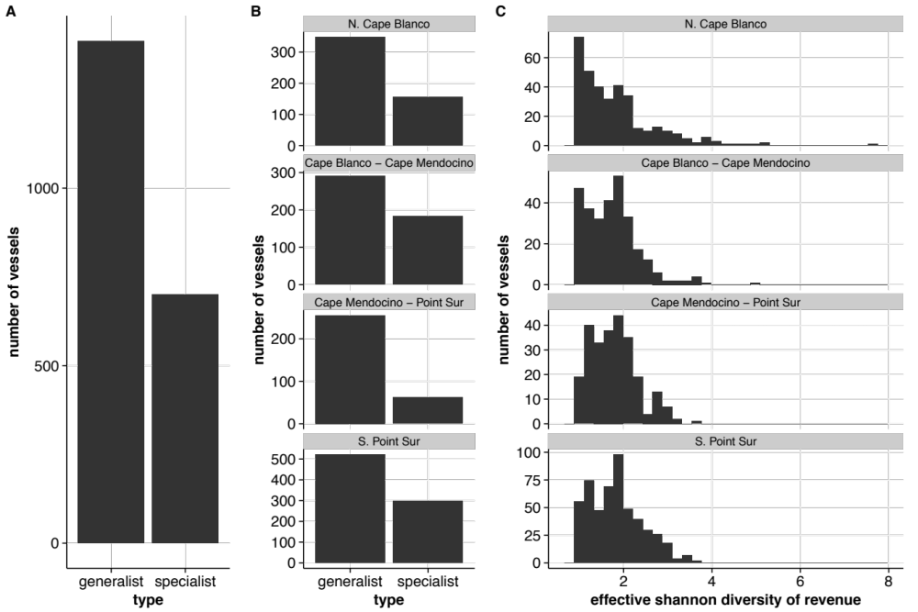

Figure 3: Diversity of fishing communities on the US west coast. A) Fisheries participation network for all landings in Santa Barbara, CA between 2009-2010, B) Fisheries participation network for all landings in Eureka, CA between 2009-2010, C) AFI values for all ports on US west coast with > 3 vessels landing between 2009-2010.
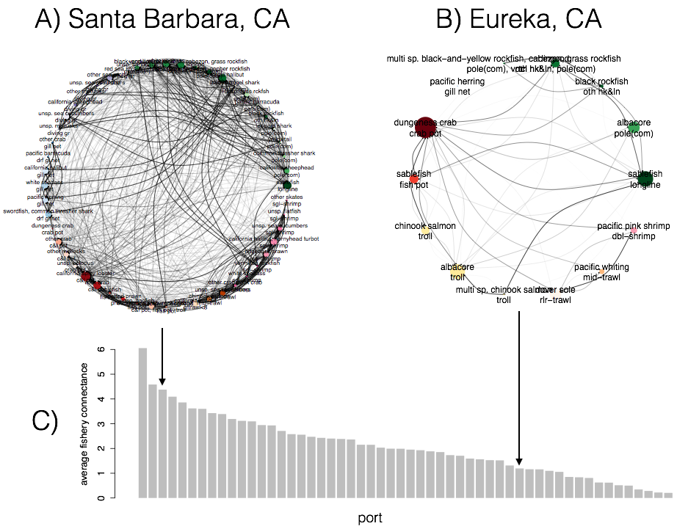
Figure 4: Effect of management change on fisheries diversity at vessel and port community level.
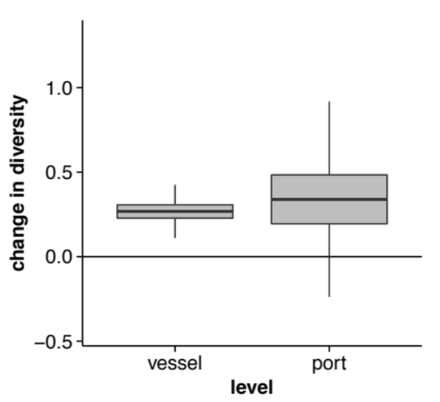

Supplement
Evaluating realized fisheries classification
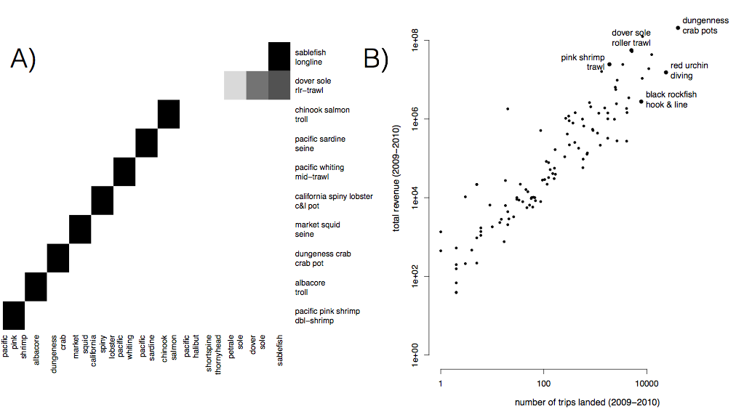
S1: A) Species composition for top ten realized fisheries (rows). Cell color represents the proportion of landings for which each species (column) is responsible. Most of the biggest realized fisheries are composed of primarily a single species, but groundfish trawl is strongly multispecies. B) Comparison of effort and revenue for all realized fisheries between 2009-2010.

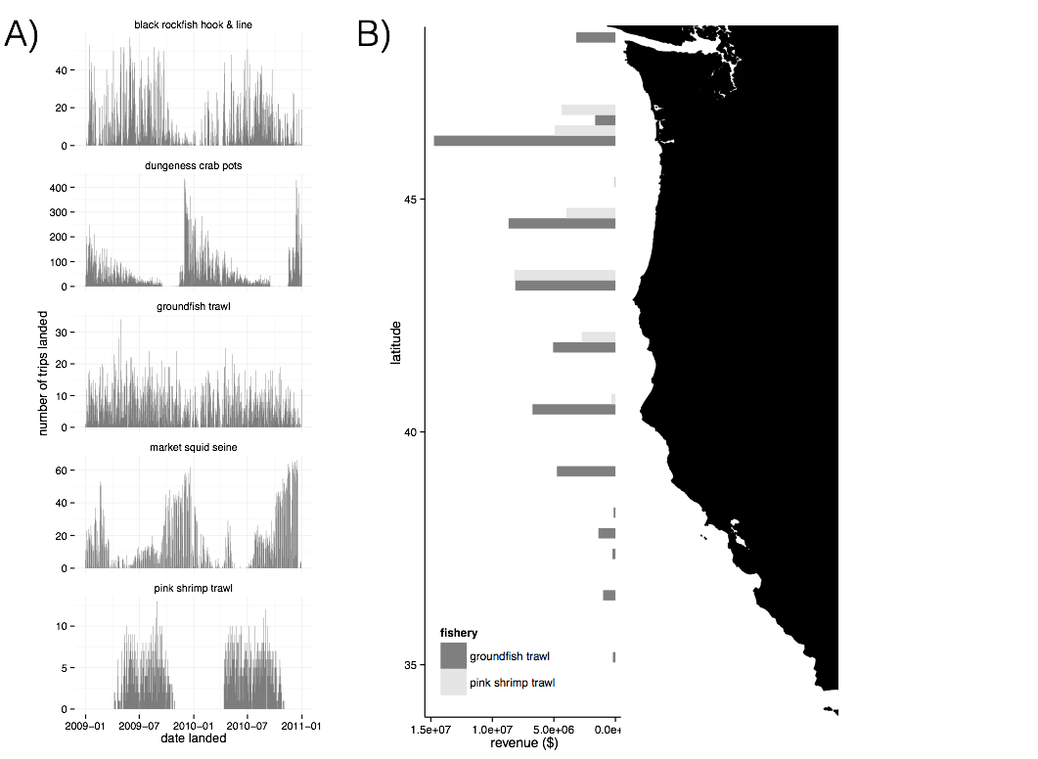
S2: A) Seasonality of five major realized fisheries between 2009-2010. Distinct seasonal patterns are observed in dungeness crab, market squid and pink shrimp fisheries. B) Spatial structure of landings for two example fisheries between 2009-2010. Landings are binned by latitude. Pink shrimp trawl is landed further north, while groundfish trawl landings are distributed more evenly across the coast.

Testing based on ITQs
ITQs went in for the limited entry trawl fishery which targets federally managed groundfish species in 2011. Therefore we’d expect to see any metiers that are trawl based to have an IFQ flag in their landings. However when we examine our landings for trips landed after 2011, we find a number of trips which both use trawl gear, but do not use quota to land.
with(subset(trips, year>2011 & grgroup=="TWL" & !(trips$drvid %in% ak_ves)), table(ifq_landing, metier.2010))

ifq_landing TWL_1 TWL_2 TWL_3 TWL_4 TWL_5 TWL_6 TWL_7
0 1146 156 0 482 944 0
N 5 0 0 0 0 0 0
Y 2215 78 225 167 0 0 30
Here TWL_1 corresponds to DTS, TWL_2 is california halibut, TWL_3 is chinook salmon caught with midwater trawl (bycatch for hake), TWL_4 is whiting, TWL_5 is bait shrimp, TWL_6 is sea cucumber, TWL_7 is yellowtail bycatch for whiting.
We wouldn’t expect bait shrimp or sea cucumbers to involve species in ITQs, so the lack of ITQ flags makes sense. Similarly TWL_4 and TWL_7 having exclusively quota landings after 2011 makes sense both hake and yellowtail are quota species. TWL_3 having both quota and non-quota makes sense since some chinook catches are mixed with hake, and sometimes chinook are caught alone. The concerning sets of catches are the 5 TWL_1 catches and the fact that TWL_2 is split. TWL_2 is california halibut. California halibut are often caught with bottom trawls, but near shore. There’s two sectors for CA halibut, open access and federally manged limited entry. Limited entry boats are allowed to fish only in federal waters, can fish year round, but require quota. Limited entry boats are allowed to trawl in state waters and have to observe a 3 month closed period (March 15-June 15) for CA halibut spawning. Thus the split in TWL_2 is not suprising. However if the sector split can explain this, we’d expect all TWL_2 landings, reported afte 2011, landed without ifq quota, would not be present between March 15 and June 15. Instead, we see that while April and May are the lowest months, there are still TWL_2 landings.
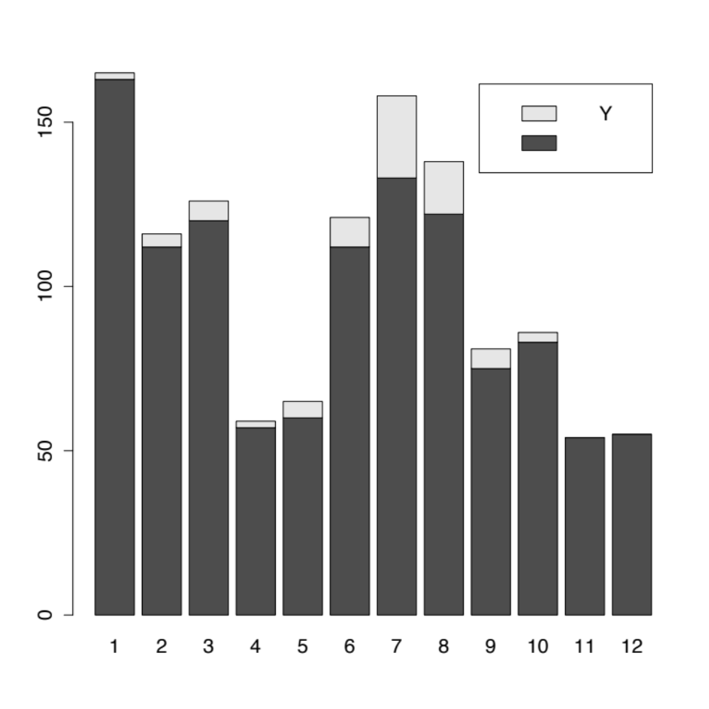
Here the numbers are months, and the color is whether or not there is quota present. “Y” is quota, the blank means no quota (although it’s coded as “Y”, “N” and “” in the fish tickets).

