People, Fishing and the Management of a Human Dominated Ecosystem

Emma Cassel Fuller

A Dissertation

Presented to the Faculty

of Princeton University

in Candidacy for the Degree

of Doctor of Philosophy

Recommended for Acceptance

by the Department of

Ecology and Evolutionary Biology

Advisor: Simon Levin

May 2016

© Emma Fuller, 2016. All rights reserved.

Abstract

Understanding how to balance human well-being and ecological integrity is one of the fundamental challenges in conservation and natural resource management. As our human-footprint on ecosystems expands and deepens, we are increasingly realizing that human well-being is crucial to understanding social-ecological systems and managing them sustainably.

In my first chapter I add to this literature by extending a theoretical model to examine the effects of two biophysical stressors on a marine species. While this model was developed to understand how harvest and climate change may interact to affect species viability, the model emphasized the sensitivity of the results to assumptions about human behavior. This result adds to a small, but growing, body of literature that demonstrates the importance of considering resource-users’ dynamics when attempting to predict outcomes for biophysical systems.

Despite conceptual advances in linking human-wellbeing to biophysical dynamics, a major challenge exists in operationalizing these conceptual framings. In my second chapter I use the US West Coast commercial fisheries system as a case study and developed a novel network approach of linking the social system (i.e. fishing communities) to the ecological system (the fish). This approach made use of data collected by management, making it immediately operational for all managed fisheries in the US. Such a conceptual framework represents a major step forward for mapping and quantifying these linkages between social and natural systems. I add to this work by analyzing these resultant networks to show that the topological structure and modularity varied non-randomly, providing additional features that may be useful for mangers seeking to balance human well-being with sustainable populations of fish.

In my third chapter I analyzed patterns of participation across the US West Coast commercial fisheries before and after a major management change in a single fishery. Using individual and fishing community level analyses, using the framework described above, I show that the policy affected how fishermen shift their effort across fisheries at the individual level, but community level attributes remain unchanged. This work demonstrates how such social-ecological system level policy analysis may be conducted.

Overall this dissertation helps move us towards a set of tools managers can use to evaluate policy efficacy in commercial fisheries in the face of rapid environmental change while balancing ecological integrity and human well-being.

TABLE OF CONTENTS

Abstract iv Table of Contents v

Acknowledgements viii

Introduction 1  
Chapter One: The persistence of populations facing climate shifts and harvest 10

Abstract 11

Introduction 11

Materials and Methods 14

Results 23

Discussion 29

Acknowledgements 37

References 38

Supporting Information 47

Chapter Two: Participation Networks: Linking fisheries to fishing communities on the US West Coast 60

Abstract 61

Introduction 61

Materials and Methods 65

Results 71

Discussion 78

Acknowledgements 81

References 82

Supporting Information 91

Chapter Three: The effects of a management action on the broader marine socio-ecological system 99

Abstract 100

Introduction 100

Materials and Methods 103

Results 106

Discussion 110

Acknowledgements 113

References 114

Supporting Information 124

Conclusions 125

Acknowledgements

I have been extremely lucky over my time in Princeton to be surrounded by a group of generous, thoughtful, and incredibly smart mentors. My thanks go to Simon, first and foremost, for welcoming me into his lab. I have also had the pleasure of a supportive committee in Steve Pacala, David Wilcove, and Rob Pringle. In addition to my formal committee, I’m extremely grateful to have had an informal committee in James Watson, Malin Pinsky and Jameal Samouri. The time and effort each gave contributed substantially to my development as a scientist. Their mentorship also speaks highly of Simon’s lab, that he attracts such talented scientists as post-docs and collaborators. Special thanks must go to Jameal Samhouri, who served as a thoughtful and insightful informal adviser, and who offered me an intellectual home as a visiting student at the Northwest Fisheries Science Center. There’s not enough I could say about Jameal’s mentorship, only that it’s unfortunate that as a government scientist he doesn’t regularly advise graduate students.

My undergraduate mentor, Greg Dwyer, I am also thankful for. Without Greg I would never have (re)discovered my love of science nor would I have applied to a PhD program, let alone at Princeton. His mentorship prepared me for graduate school more than any college class and set me on a path that has culminated with this PhD.

This dissertation also reflects the efforts of collaborators whose thoughtful advice and hard work have been indispensable for the work in this thesis. Above all Emily Klein organized and helped conduct interviews with fishermen, scientists and managers along the US west coast. The insight derived from these conversations can’t be overstated. My research at Princeton has also been made enormously enjoyable by the people in the EEB department and I am particularly grateful to Molly Schumer, Ruthie Birger, and Anieke van Leeuwen.

I have also been pleased to be a part of many side projects which brought me into contact with a group of fantastic collaborators outside of my department. Working with Talia Young, Brad Dubik, and Matthew Hayes have broadened and sharpened analytic skills, and I look forward to the future collaborations planned.

Finally I am, of course, grateful for the encouragement of my family. My husband Peter, especially, who has been a supportive partner through it all. Thank you.

Introduction

Our modern society is exerting massive pressures on our biosphere. As of the 20th century we fix more fertilizer synthetically than all terrestrial plants are able to do combined (Galloway and Cowling 2002). CO2 emissions are higher than any other time in human history (Lunt et al. 2009). We have data too from ecological systems suggesting that they likewise have undergone massive change; extinction rates for example are at a minimum 100 times higher then any time during the past 65 million years (Ceballos et al. 2015). From loosing mega fauna in the Pleistocene (Barnosky et al. 2004), to more recent disruptions due to species harvest or extirpation (Dirzo et al. 2014; McCauley et al. 2015) or disease introductions (Sinclair et al. 2007), humanity’s footprint is both broad and deep. Many geologists believe that these shifts will be apparent in the geological record, and propose that we re-label our current era as the Anthropocene, distinct from the Holocene that came before (Waters et al. 2016). With these reorganizations of natural systems, comes the need for management. Yet conservation and management of natural resources is frequently a misnomer: often it’s not the ecology of these systems we’re manage, but our use of them with which we’re concerned.

To manage for continued human use, for sustainability, managers require a detailed understanding of the ecology of the systems of interest. Such an understanding can guide the types of use to allow. Historically much of the science upon which managers have relied to guide management falls in this category. However, as the scale of human pressure on our natural systems has expanded, it’s become clear that such biophysical science is necessary but not sufficient for sustainability (Castree et al. 2014; Hicks et al. 2016). Because management is an inherently social process and requires normative decision about for what to manage (Mace 2014), and because human use of the environment is difficult to entirely constrain, sustainably managing these systems also requires an understanding of how and why people use these resources. Because of these facts, understanding how to balance the tradeoffs between human well-being and ecological integrity is one of the largest challenge in natural resources management and conservation (McShane et al. 2011; Karp et al. 2015).

This quandary is particularly obvious when human well-being is a goal of management alongside that of ecological integrity. These mandates exist in most state-governed resource management units (i.e. fisheries (16 U.S.C. §§ 1801-1884), forestry (US Forest Service 2015), public lands in the US (Department of the Interior 2016)), but also in conservation organizations mission statements (The Nature Conservancy 2016; Conservation International 2016).

But understanding human well-being is also important because how people change their behavior as the distribution and abundance of resources change can result in unexpected and counter-intuitive ecological outcomes. Indeed, in my first chapter I extend a theoretical model to examine how a population of fish would be affected by the joint pressures of two stressors: climate change driven range shifts and harvest. In this model I explore not only the possible synergy of the two stressors, but also examine the outcomes of two common forms of management. I find that, while these stressors are approximately additive, the management recommended is sensitive to the assumptions made on how effort is reallocated (Fuller, Brush, and Pinsky 2015). This theoretical model, built with the aim of determining the sensitivity of marine fish to joint biophysical stressors, instead emphasizes the importance of understanding human behavior. This result dovetails with existing theoretical work suggesting that the dynamics of harvesters, i.e. how they respond to changes in the ecological conditions, can determine the stability of a system and ability to be managed sustainably (Tavoni, Schlüter, and Levin 2012; Lade et al. 2013). Empirical work is reaching the same conclusion, in 2009 Elinor Ostrom received her Nobel prize for pointing out under what conditions, ecological and social, societies can avoid the tragedy of the commons (Ostrom 2009).

This challenge of understanding how human well-being and ecological integrity interact is a challenge that exists across systems, terrestrial to marine, but fisheries systems offer an excellent system in which to examine it empirically. Fisheries are a good case study of human-environmental interactions in that fishermen are affected by both the ecological system (the spatial and temporal distribution and abundance of fish they target) and markets (price, demand and supply for fish). Commercial fisheries harvest is also important for the livelihoods of many people. Fisheries also make a good example because harvest is also an important, and sometimes major, ecological driver of these systems. There are a number of theoretical (Wilen, Smith, and Lockwood 2002; Smith and Wilen 2003)and empirical (Smith, Zhang, and Coleman 2008)examples in agreement with the theoretical results of my first chapter: that how people allocate effort spatially determines efficacy of management measures. Accordingly there is a great deal of interest in systems-level, integrated, social ecological management (P. S. Levin et al. 2009).

Commercial fisheries in the North America and Europe in particular are promising systems because of the large amounts of data which have been collected at big temporal and spatial scales. Indeed these fisheries have already been identified as a promising system in which to test many large scale ecological theories, due to the datasets describing the fish (Jensen, Branch, and Hilborn 2011). But these fisheries typically also have rich data on the people who harvest them, the fishermen. This data has been much less explored at a systems level. In the following two chapters I focus on the US west coast commercial fishery system using a dataset capturing landings for all commercial fisheries between 2009 and 2013 to developing new, nuanced ways of understanding how people interact with their environment.

Despite the increasing focus on valuing, and therefore measuring, human well-being alongside ecological quality indicators (i.e. biodiversity, ecosystem function), we still lack clear ways to operationalize these goals(Mace 2014). Developing new, nuanced methods for understanding how people interact with their environment and ways to describe them is important for advancing sustainability science (Hicks et al. 2016). This challenge is particularly acute in US commercial fisheries, where managers are mandated to manage both for the ecological viability of targeted species and the fishing communities which depend on them (16 U.S.C. §§ 1851), but not provided with a clear mechanistic understanding of how the sub-systems are linked.

In the US, fishing communities are legally defined by how much the region (approximated to the port) relies on commercial fishing as a source of revenue (16 US Code§ 600.345). Accordingly, existing research focuses on how people combine fishing with other economic sectors (Jepson and Colburn 2013; Pollnac et al. 2015). In the US, how people spread their effort within the fishery has never been effectively mapped or examined. In my second chapter I use the landings data on the US west coast to develop an approach to quantitatively link fishing communities (the social system) to individual fisheries (the ecological system). This approach is a novel conceptual framework and advances our understanding of the system-level human connectivity amongst fisheries. This analysis reveals the existence of system level properties that may be useful heuristics for managers to use in evaluating adaptive capacity of these fishing communities. In particular, I reveal the possibility of “keystone fisheries” and that these fisheries systems display an intermediate scale of organization not previously identified.

Because the appreciation of the interconnectivity of marine systems is still relatively recent and the inclusion of people in these networks nascent, there are to my knowledge no published studies empirically examining how these system-level properties change as a function of management. Yet to effectively manage social ecological systems such studies are necessary to choose among policy options. In my third chapter I contribute to filling this gap by making use of the systems-level analysis described above to analyze how a major change in the management of a single fishery affects the human connectivity of the US west coast commercial fisheries system. Thanks to the rich data, I am able to conduct this analysis at two scales: that of the individual fishing vessel and the fishing community, contributing additional nuance to the results. I find that fishermen have changed their patterns of participation across fisheries as a function of how they were affected by the management change but the system-level properties remained unchanged. While the goal of the studied management change had nothing to do with the larger fishery system, this work demonstrates how such systems-level policy evaluations could proceed.

In this thesis I present theoretical models, a conceptual framework and empirical analyses focused on the question of how to quantitatively and comprehensively include people in food webs. This work helps move us towards a set of tools managers can use to evaluate policy efficacy in commercial fisheries social ecological systems in the face of rapid environmental change while balancing the need for ecological integrity and human well-being.

References

Barnosky, Anthony D, Paul L Koch, Robert S Feranec, Scott L Wing, and Alan B Shabel. 2004. “Assessing the Causes of Late Pleistocene Extinctions on the Continents..” *Science (New York, N.Y.)* 306 (5693): 70–75. doi:10.1126/science.1101476.

Castree, Noel, William M Adams, John Barry, Daniel Brockington, Bram Büscher, Esteve Corbera, David Demeritt, et al. 2014. “Changing the Intellectual Climate.” *Nature Climate Change* 4 (9). Nature Publishing Group: 763–68. doi:10.1038/nclimate2339.

Ceballos, G, P R Ehrlich, A D Barnosky, A Garcia, R M Pringle, and T M Palmer. 2015. “Accelerated Modern Human-Induced Species Losses: Entering the Sixth Mass Extinction.” *Science Advances* 1 (5). American Association for the Advancement of Science: e1400253–53. doi:10.1126/sciadv.1400253.

Conservation International. 2016. “Mission and Vision.” Accessed April 14. http://www.conservation.org/global/philippines/about/Pages/mission.aspx.

Department of the Interior. 2016. “The Bureau of Land Management: Who We Are, What We Do.” Accessed April 14. http://www.blm.gov/wo/st/en/info/About_BLM.print.html.

Dirzo, Rodolfo, Hillary S Young, Mauro Galetti, Gerardo Ceballos, Nick J B Isaac, and Ben Collen. 2014. “Defaunation in the Anthropocene..” *Science (New York, N.Y.)* 345 (6195). American Association for the Advancement of Science: 401–6. doi:10.1126/science.1251817.

Fuller, Emma, Eleanor Brush, and Malin L Pinsky. 2015. “The Persistence of Populations Facing Climate Shifts and Harvest.” *Ecosphere* 6 (9). Ecological Society of America: art153–16. doi:10.1890/ES14-00533.1.

Galloway, James N, and Ellis B Cowling. 2002. “Reactive Nitrogen and the World: 200 Years of Change.” *Ambio* 31 (2): 64–71. doi:10.1579/0044-7447-31.2.64.

Hicks, Christina C, Arielle Levine, Arun Agrawal, Xavier Basurto, Sara J Breslow, Courtney Carothers, Susan Charnley, et al. 2016. “Engage Key Social Concepts for Sustainability.” *Science (New York, N.Y.)* 352 (6281): 38–40. doi:10.1126/science.aad4977.

Jensen, Olaf P, Trevor A Branch, and Ray Hilborn. 2011. “Marine Fisheries as Ecological Experiments.” *Theoretical Ecology* 5 (1): 3–22. doi:10.1007/s12080-011-0146-9.

Jepson, Michael, and Lisa L Colburn. 2013. “Development of Social Indicators of Fishing Community Vulnerability and Resilience in the U.S. Southeast and Northeast Regions.” NMFS-F/SPO-129. *U.S. Department of Commerce, NOAA Technical Memorandum NMFS-F/SPO-129*. U.S. Dept. of Commerce.

Karp, Daniel S, Chase D Mendenhall, Elizabeth Callaway, Luke O Frishkoff, Peter M Kareiva, Paul R Ehrlich, and Gretchen C Daily. 2015. “Confronting and Resolving Competing Values Behind Conservation Objectives.” *Proceedings of the National Academy of Sciences* 112 (35): 11132–37. doi:10.1073/pnas.1504788112.

Lade, Steven J, Alessandro Tavoni, Simon A Levin, and Maja Schlüter. 2013. “Regime Shifts in a Social-Ecological System.” *Theoretical Ecology* 6 (3): 359–72. doi:10.1007/s12080-013-0187-3.

Levin, Phillip S, Michael J Fogarty, Steven A Murawski, and David Fluharty. 2009. “Integrated Ecosystem Assessments: Developing the Scientific Basis for Ecosystem-Based Management of the Ocean.” *PLoS Biology* 7 (1): e1000014–16. doi:10.1371/journal.pbio.1000014.

Lunt, Daniel J, Alan M Haywood, Gavin A Schmidt, Ulrich Salzmann, Paul J Valdes, and Harry J Dowsett. 2009. “Earth System Sensitivity Inferred From Pliocene Modelling and Data.” *Nature Geoscience* 3 (1). Nature Publishing Group: 60–64. doi:10.1038/ngeo706.

Mace, Georgina M. 2014. “Ecology. Whose Conservation?.” *Science (New York, N.Y.)* 345 (6204). American Association for the Advancement of Science: 1558–60. doi:10.1126/science.1254704.

McCauley, Douglas J, Malin L Pinsky, Stephen R Palumbi, James A Estes, Francis H Joyce, and Robert R Warner. 2015. “Marine Defaunation: Animal Loss in the Global Ocean..” *Science (New York, N.Y.)* 347 (6219). American Association for the Advancement of Science: 1255641–41. doi:10.1126/science.1255641.

McShane, Thomas O, Paul D Hirsch, Tran Chi Trung, Alexander N Songorwa, Ann Kinzig, Bruno Monteferri, David Mutekanga, et al. 2011. “Hard Choices: Making Trade-Offs Between Biodiversity Conservation and Human Well-Being.” *Biological Conservation* 144 (3). Elsevier Ltd: 966–72. doi:10.1016/j.biocon.2010.04.038.

Ostrom, Elinor. 2009. “A General Framework for Analyzing Sustainability of Social-Ecological Systems.” *Science (New York, N.Y.)* 325 (5939): 419–22. doi:10.1126/science.1172133.

Pollnac, Richard B, Tarsila Seara, Lisa L Colburn, and Michael Jepson. 2015. “Taxonomy of USA East Coast Fishing Communities in Terms of Social Vulnerability and Resilience.” *Environmental Impact Assessment Review* 55: 136–43.

Sinclair, A R E, SIMON A R MDUMA, J GRANT C HOPCRAFT, John M Fryxell, Ray Hilborn, and SIMON THIRGOOD. 2007. “Long-Term Ecosystem Dynamics in the Serengeti: Lessons for Conservation.” *Conservation Biology* 21 (3). Blackwell Publishing Inc: 580–90. doi:10.1111/j.1523-1739.2007.00699.x.

Smith, Martin D, and James E Wilen. 2003. “Economic Impacts of Marine Reserves: the Importance of Spatial Behavior.” *Journal of Environmental Economics and Management* 46 (2): 183–206. doi:10.1016/S0095-0696(03)00024-X.

Smith, Martin D, Junjie Zhang, and Felicia C Coleman. 2008. “Econometric Modeling of Fisheries with Complex Life Histories: Avoiding Biological Management Failures.” *Journal of Environmental Economics and Management* 55 (3): 265–80. doi:10.1016/j.jeem.2007.11.003.

Tavoni, Alessandro, Maja Schlüter, and Simon Levin. 2012. “The Survival of the Conformist: Social Pressure and Renewable Resource Management.” *Journal of Theoretical Biology* 299 (April): 152–61. doi:10.1016/j.jtbi.2011.07.003.

The Nature Conservancy. 2016. “About US: Vision and Mission.” Accessed April 14.

US Forest Service. 2015. “USDA Forest Service Strategic Plan: FY 2015-2020.” Vol. 1045.

Waters, C N, J Zalasiewicz, C Summerhayes, A D Barnosky, C Poirier, A Ga uszka, A Cearreta, et al. 2016. “The Anthropocene Is Functionally and Stratigraphically Distinct From the Holocene.” *Science (New York, N.Y.)* 351 (6269): aad2622–22. doi:10.1126/science.aad2622.

Wilen, J E, M D Smith, and D Lockwood. 2002. “Avoiding Surprises: Incorporating Fisherman Behavior Into Management Models.” *Bulletin of Marine …*.

CHAPTER ONE

The persistence of populations facing climate shifts and harvest[1]

Abstract

Many species are expected to shift their geographic distribution as climates change, and yet climate change is only one of a suite of stressors that species face. Species that might, in theory, be able to shift rapidly enough to keep up with climate velocity (the rate and direction that isotherms move across the landscape) may not in actuality be able to do so when facing the cumulative impacts of multiple stressors. Despite empirical reports of substantial interactions between climate change and other stressors, we often lack a mechanistic understanding of these interactions. Here, we develop and analyze a spatial population dynamics model to explore the cumulative impacts of climate with another dominant stressor in the ocean and on land: harvest. We find that critical rates of climate velocity and harvest depend on the growth rate and dispersal kernel of the population, as well as the magnitude of the other stressor. This allows us to identify conditions under which harvesting and climate velocity can together drive populations extinct even when neither stressor would do so in isolation. Except in these extreme cases, we also find that the interaction between the declines in biomass caused by climate velocity and harvest is approximately additive. Finally, we show that threshold harvest rules can be effective management tools to mitigate the interaction between the two stressors, while protected areas can either help or hinder, depending on how harvesters reallocate their effort.

Introduction

There are many stressors that can disturb an ecosystem. Ecologists have been working for decades to quantify the consequences of individual perturbations (Wilcove et al. 1998) and to measure the effects of multiple stressors and the interactions between them (Travis 2003, Crain et al. 2008, Darling and Côté 2008). If disturbances interact synergistically, a perturbation that has little effect when occurring alone may amplify the disturbance caused by a coincident perturbation (Crain et al. 2008, Darling and Côté 2008, Gurevitch et al. 2000, Nye et al. 2013). In the most worrying cases, interactions among multiple stressors could drive a population extinct, even though assessments of the individual impacts would not predict extinction (e.g., Pelletier et al. 2006, Travis 2003). Because disturbances rarely occur in isolation, measuring the effects of multiple disturbances provides a better understanding of likely impacts to an ecosystem (Doak and Morris 2010, Folt et al. 1999, Fordham et al. 2013).

Climate change and harvesting, two of the largest anthropogenic impacts for both marine and terrestrial species (Halpern et al. 2008, Milner-Gulland and Bennet 2003, Sekercioglu et al. 2008), provide an important example of two concurrent ecological disturbances. One effect of climate change is that isotherms—contour lines connecting places with the same temperature—move across a landscape with a rate and direction referred to as climate velocity (Burrows et al. 2011, Loarie et al. 2009). Marine and terrestrial population distributions shift in response to climate change (Chen et al. 2011, Perry et al. 2005), and there is evidence that climate velocities can successfully explain these shifts (Pinsky et al. 2013).

Many of these shifting species are also subject to harvesting or fishing (Sala 2000, Wilcove et al. 1998, Worm et al. 2009), so interactions between the two stressors are possible. For example, empirical data suggest that Atlantic croaker populations move poleward with warming temperatures, but do so less when heavily fished (Hare et al. 2010); several terrestrial species follow warming temperatures more effectively in protected areas than in unprotected areas (Thomas et al. 2012); and a number of studies concluded that harvest increases the sensitivity of populations to climate variability (Anderson et al. 2008, Botsford et al. 2011, Planque et al. 2010, Shelton et al. 2011). While not specifically addressing range shifts and harvest together, there have been experimental indications of synergistic interactions between warming temperatures and harvesting (Mora et al. 2007). Taken together, this work underscores the importance of understanding in greater mechanistic detail how climate velocity and harvesting interact. Models provide a useful tool for building our intuition about this interaction.

A common approach to modeling climate impacts has been to use bioclimatic-envelope models (also known as species distribution models). These statistical models typically correlate presence-absence or abundance data with biophysical characteristics to predict how species’ ranges will differ under climate change (Elith et al. 2006, Guisan and Zimmermann 2000, Guisan and Thuiller 2005). Despite these models’ widespread adoption, many authors have criticized bioclimatic-envelope models as oversimplified because they lack dispersal, reproduction, species interactions, and other processes important for population dynamics (Kearney and Porter 2009, Robinson et al. 2011, Zarnetske et al. 2012).

Recent work on range shifts has addressed some of these gaps by explicitly including dispersal and reproduction in models of species distributions under climate change (Berestycki et al. 2009, Zhou and Kot 2011). In these models, the region in which a population can survive (e.g., the region of suitable temperatures) is shifting in space, and a population can only survive if it disperses to and grows in newly suitable habitat at a sufficient rate. Related models have been applied to study population persistence in advective environments (Byers and Pringle 2006). However, even these more mechanistic models only address one disturbance: climate-driven range shifts.

Here, we focus on a relatively simple ecological model that captures the dominant processes (reproduction, dispersal, and population growth) underlying climate-driven range shifts and population responses to harvesting pressure. We built this model originally for marine species, but because of its mathematical generality, it could also apply to any species with distinct growth and dispersal stages (e.g., plants and many insects). We identify the harvesting rate and climate velocity that drive populations extinct, investigate how the critical rate of one stressor depends on the other, and analyze the declines in biomass caused by each stressor. We also examine two different types of management strategies—threshold harvesting rules and protected areas—to determine how these management strategies affect population persistence and biomass. We chose to model protected areas because they are often recommended for conservation of biodiversity and improved yield from harvest (Gaines et al. 2010b, Pimm et al. 2001, Watson et al. 2011), and previous work has suggested protected areas can be a key form of climate insurance that provides stepping stones to help species keep up with a changing environment (Hannah et al. 2007, Thomas et al. 2012). Finally, we demonstrate how to apply this model by using parameters describing black rockfish (*Sebastes melanops*) in California (Gaines et al. 2010a, White et al. 2010).

Methods

The Model

We model the dynamics of populations along a one-dimensional line of longitude, similar to Zhou and Kot (2011). Individuals in the population can only reproduce within a defined segment of this one-dimensional coastline (hereafter simply “patch”), which represents the range of thermally suitable conditions for the population. The patch shifts at a fixed rate towards the poles, and offspring disperse away from their parents according to a dispersal kernel. In its basic form, harvest removes a constant fraction of the local population density from each point along the coastline.

The above verbal description is represented well by integrodifference models, which have been used extensively for spatial population dynamics problems with discrete time (e.g., discrete growth and dispersal stages) and continuous space (Kot and Schaffer 1986, Lockwood et al. 2002, Van Kirk and Lewis 1997, Zhou and Kot 2011). More specifically, if is the number of individuals settling after dispersal at position and time , then the number of individuals in the next generation is given by

|  |  |
| --- | --- |
|  | (1) |

where *f(n)* is a recruitment function describing the number of juveniles that settle and survive to adulthood given that the juvenile population is of size *n*, *g(n)* is a function describing the number of adults that remain after harvesting given local density *n.* *R0* is the intrinsic growth rate of the population (i.e., number of offspring per adult), and *k(x-y)* is a dispersal kernel giving the probability of an offspring traveling from position *y* to position *x*. Reproduction only occurs within the suitable patch of length *L*, which shifts across space at a climate velocity *c* in units of distance per generation. In other words, if *t* is the number of generations that has passed, the center of the patch will be at location *ct*, and the upper and lower bounds of the patch will be found at *ct + L/2* and *ct – L/2,* respectively.

Initially, we use *g(n) = n – hn* as our function for those surviving harvesting, where *h* is the proportion of the population harvested. This assumes that harvest removes a constant fraction from each location *x*, as might be expected from an even distribution of harvesters across space. We used a Beverton-Holt stock-recruitment function to describe the settlement and survival of offspring *f(n)* while accounting for density dependent competition and mortality:

|  |  |
| --- | --- |
|  | (2) |

As before, *R0* is the intrinsic growth rate, while *K* is the carrying capacity at a given point in space, which we assume to be constant (see Table 1 for a full description of parameters and functions). Since *f(K) = K/R0*, if *n = K*, there will be *K/R0* surviving offspring, and when they reproduce at rate *R0* the population will remain at carrying capacity. As shown in Appendix A, the precise forms of *g(n)* and *f(n)* are not important to the persistence of the population. Persistence depends only on *g’(0)* and *f’(0).* The full functional forms do matter, however, for equilibrium biomass.

Analyzing this kind of model becomes easier if the dispersal kernel is separable into its dependence on sources and destinations of larvae, that is, if there are functions *ai* and *bi* such that *k(x-y) = )* (see Appendix B for further details). In the analyses presented below, we used a separable Gaussian kernel (Latore et al. 1998) given by

|  |  |
| --- | --- |
|  | (3) |

To derive analytical expressions for the critical rates of harvesting and climate velocity, we approximate the kernel to its first-order terms, as described in Appendix C. To examine the sensitivity of the model to the shape of the kernel, we also analyze a sinusoidal kernel (see Appendix D).

At demographic equilibrium, the population will move in a traveling wave, where the population density at a given point in space will change, but the density at a location relative to the shifting patch will not (Zhou and Kot 2011). The traveling wave *n\** must satisfy

|  |  |
| --- | --- |
|  | (4) |

where describes the position within the patch. For a separable kernel, the equilibrium traveling pulse *n*(x)* must satisfy

|  |  |
| --- | --- |
|  | (5) |

where the *mi* satisfy the equations

|  |  |
| --- | --- |
|  | (6) |

(Latore et al. 1998). We show the derivation of these equations in Appendix B. While there are certainly interesting transient dynamics as the population reaches its equilibrium traveling wave, We focus on equilibrium biomass to make results from different dispersal kernels, parameters, and methods of analysis directly comparable, without the confounding effects of initial conditions and rates of approach to equilibrium.

Table 1. Parameters and functions used in the text.

|  |  |
| --- | --- |
| Variable | Definition |
| *nt(x)* | density of individuals at position *x* at time *t* |
| *n\** | density of individuals at equilibrium at position relative to the patch |
| *k(x – y)* | dispersal kernel, the probability of offspring traveling from position *y* to position *x* |
| 〈*d*〉 | expected distance traveled by an offspring |
| *f(n)* | recruitment function, the number of offspring produced by a population of size *n* |
| *R0* | intrinsic growth rate of the population at low abundance |
| *K* | carrying capacity |
| *g(n)* | harvest function, the number of adults remaining after a population of size *n* has been harvested |
| *h* | proportion of adults harvested, when *g(n) = (1 – h)n* |
| *L* | patch length |
| *c* | climate velocity in units of distance per generation |

Calculating Persistence

At low harvesting rates *h a*nd low climate velocities *c*, populations will persist. However, above certain critical values, populations will be driven extinct. When the population is extinct, the system is in its trivial equilibrium: for all , which satisfies Eq. 4. If a population is to persist, it must be able to avoid extinction and grow even when small (Zhou and Kot 2011). Population persistence is therefore equivalent to the trivial traveling pulse being an unstable equilibrium, where the introduction of a small population will grow rather than return to extinction. The critical parameters *h\** and *c\** are defined as the parameters that make the trivial pulse unstable. See Appendix A for further details of this analytical calculation.

Regardless of the functional form of the recruitment function *f*, the only property that determines whether or not a population can persist is *f’(0)*, i.e. how quickly recruitment increases when the population size is near (but above) 0. For us, this number is 1, and any recruitment function with the same value will give the same results with respect to persistence. In addition to this property, the population’s ability to persist depends on properties of the population itself (the shape of the dispersal kernel, and the expected distance a larva disperses 〈*d*〉), properties of the environment (the length of the viable patch *L* and how quickly the environment shifts *c*), and the harvesting rate *h*. For a Gaussian kernel, the critical rates *c\** and *h\** are those values of *c* and *h* such that

|  |  |
| --- | --- |
|  | (7) |

We derive a similar expression for a sinusoidal kernel in the Appendix D. We realize that this formula is not straightforward to interpret. For both Gaussian and sinusoidal kernels, however, we can approximate the critical harvesting proportion by a function that looks like

|  |  |
| --- | --- |
|  | (8) |

where *p* is a decreasing function of the length of the viable patch and the intrinsic growth rate, and *q* describes how *h\** increases with patch length (*L*) and varies with expected dispersal distance and climate velocity (see Appendix E for details).

Calculating the interaction of climate velocity and harvest

We identify interactions between climate velocity and harvest in two ways. The first and simplest way is to see if there is an interaction between the critical rate of one stressor and the magnitude of the other stressor. We identify such an interaction if *h\** depends on *c*,or if *c\** depends on *h*. If this type of interaction exists, determining the critical level of one stressor requires knowing the severity of the second. Before the stressors are extreme enough to drive the population extinct, however, they will cause it to decrease in size. The second way of identifying interactions is to compare how the two stressors affect population biomass individually and jointly. In order to do measure these effects, we find the total biomass of the population when it reaches an equilibrium traveling pulse and compare this equilibrium biomass in the presence and absence of climate shift, harvesting, or both. Eqs. 5 and 6 allow us to numerically find the total biomass in the equilibrium traveling pulse under each of these conditions.

We use *B0* to denote the equilibrium biomass without either stressor, *Bh* the equilibrium biomass with harvesting but with climate velocity equal to 0, *Bc* the equilibrium biomass with climate velocity greater than 0 but no harvesting, and *Bhc* the equilibrium biomass with both stressors. For each stressor or combination of stressors, we calculate the decline in biomass caused by stressor *s* as

|  |  |
| --- | --- |
|  | (9) |

Based upon this definition, there are three kinds of interaction types that can be defined. If the interaction is additive, then the cumulative response to both stressors together would be *Ehc* = *Eh* + *Ec*. If the stressors instead interact synergistically, then *Ehc* > *Eh* + *Ec*. In contrast, if the stressors interact antagonistically, then *Ehc* < *Eh* + *Ec*. I can therefore quantify the interaction as

|  |  |
| --- | --- |
|  | (10) |

where positive *S* indicates synergy, negative *S* indicates antagonism, and *S* of zero indicates an additive interaction. This is a common way to measure the interaction among stressors, though an alternative approach would be to use the ratio of affected to unaffected biomass as a measure of effect size (multiplicative model) or to consider the effect of the single worst stressor (simple comparative effects model) (Crain et al. 2008, Folt et al. 1999). The additive model we use here is the most conservative when quantifying negative effects, meaning that it is less likely to identify synergistic interactions (Crain et al. 2008, Folt et al. 1999).

Management strategies

We use simulations to implement two management strategies (threshold harvesting rules and protected areas) that make our basic integrodifference model analytically intractable. We also take advantage of the increased flexibility of simulations over mathematical analysis to use the Laplace dispersal kernel, a commonly used model of marine larval dispersal (Botsford et al. 2001) that is not amenable to the analytical methods we use above. This allows us to show that our results are not qualitatively dependent on our choice of dispersal kernel.

Under threshold harvesting rules, harvesting pressure is no longer implemented as a proportional removal from the population. Instead, we evaluate the abundance at each point in space to determine how much harvesting should occur. If the population abundance is below the designated threshold, no harvesting occurs. If the population exceeds the threshold, then all the ‘surplus’ individuals are available to be harvested. This approach is an extreme version of the harvest control rules proposed for many existing fisheries (Froese et al. 2011).

In addition, we introduce networks of protected areas into our simulations by designating segments of space where the harvesting rate is equal to 0. Protected areas, particularly in the ocean, are typically designed to meet either harvest management or conservation goals (Agardy 1994, Gaines et al. 2010a, Holland and Brazee 1996), and their spacing and size differ according to which goal is being pursued. Harvest-oriented protected areas are often designed such that they maximize adult spillover into harvestable areas by creating many small, closely spaced reserves (Gaines et al. 2010a, Gaylord et al. 2005, Hastings and Botsford 2003). To mimic this management scheme, we implemented protected areas with a length 1/3 of the average dispersal distance and an inter-reserve spacing 2/3 of the average dispersal distance. Conservation-oriented protected areas seek to protect entire ecosystems and reduce adult spillover by creating fewer, larger protected areas (Toonen et al. 2013). To mimic this scheme, we implement protected areas with a length 4 times the average dispersal distance and an inter-reserve spacing 8 times the average dispersal distance between them (Lockwood et al. 2002). In both harvest-oriented and conservation-oriented protected area networks, 1/3 of the coastline is protected. With protected areas present, we test two ways in which harvesting pressure could respond to reserves: either total harvesting is reduced to 2/3 of what it would be without reserves (i.e., harvest effort in reserves is eliminated), or harvesting is shifted to available, unprotected habitat such that total harvesting pressure remains constant (i.e., harvest effort is displaced).

For every simulation, we seed the model with 50 individuals at a single location and iterate for 2000 generations to reach equilibrium without harvesting or climate shift (more than sufficient based on initial tests). we then add harvesting pressure, allow the population to again reach equilibrium (2000 generations), and finally add a changing climate by moving the viable patch with a certain velocity. After 6000 generations we calculate equilibrium biomass as the mean biomass of 2000 additional generations. If population abundance declines below 0.001, the population is considered extinct. Implementing protected areas makes the population abundance cycle, but averaging over 2000 generations is sufficient to erase the effects of periodicity in our results. For most systems, these long timespans are not biologically realistic. However, they ensure that the population reaches its equilibrium traveling wave and that initial conditions do not affect our results. We find qualitatively similar results with shorter simulation times.

Parameters

For our general model investigation, we used the following parameters: *R0* between 3 and 10, between 0.1 and 2, *K* = 100, *L* = 1. In this parameterization, is expressed in fractions of the habitable patch width, while *c* is expressed in fractions of the patch width per generation. In addition, we used life history parameters for black rockfish (*Sebastes melanops*) as an example of how our model can be applied (White et al. 2010). We chose black rockfish because it is of both conservation and commercial interest. The parameters for black rockfish in the California Current were as follows: *R0* = 2.86, = 73 km, *K* = 1, and *L* = 1000 km (White et al. 2010). We used marine protected areas with length and spacing representative of the reserves put in place by California’s Marine Life Protection Act (20 km wide, spaced 76 km apart) (Gaines et al. 2010a). For the black rockfish example, we tested climate velocities from 0 to 200 km/decade, which was the upper limit observed globally (Burrows et al. 2011). See Appendix F and Table S1 for additional parameter details. While our results depend quantitatively on the parameters of the model, our results are qualitatively robust and we chose a representative set of parameters to analyze.

Results

Persistence with Harvesting and Climate Velocity

We begin by examining the critical rates of harvesting and climate velocity, i.e., those rates sufficient to drive the population extinct. As one might expect, we identify an interaction between the critical rate of one stressor and the magnitude of the other. Specifically, the critical rate of each stressor is lower if a population faces higher intensities of the other stressor (note the negative slope of the lines in Figure 1). This means that a harvesting rate that is sustainable in the absence of environmental shift (*c* near zero) may no longer be sustainable if the environment begins to change rapidly (c >> zero). We also found this negative relationship when we parameterized the model for black rockfish (Appendix G, Figure S2).



Figure 1. Lines indicate the critical harvesting rate as a function of climate velocity on the x-axis. The shade of grey corresponds to the growth rate, with darker lines corresponding to higher growth rates. Line style indicates the average dispersal distance. These results are from an approximated Gaussian dispersal kernel with parameters , .

We also examine the sensitivity of critical rates to growth and dispersal. In our model, it is always the case that increasing the intrinsic growth rate (*R0*), all else being equal, will increase the critical climate velocity *c\**and the critical harvesting rate *h\**, since a population that grows more quickly can recover more effectively from losses caused by these stressors (compare lines with different shading in Figure 1). However, whether or not dispersing farther is better depends on how quickly the environment is shifting (compare solid and dashed lines in Figure 1). When the environment is shifting slowly, populations with wider dispersal kernels have a lower critical harvesting rate because dispersing farther results in too many larvae dispersing off the viable patch. When the environment is shifting quickly, on the other hand, populations with wider dispersal kernels can better withstand harvesting because larvae dispersing long distances more effectively colonize the habitat patch that will be viable in the next generation.

Interactions Between Stressors

We next consider how a population responds to moderate cumulative impacts that are insufficient to drive it extinct. Whenever climate velocity or harvesting pressure exceeds its critical rate, the biomass of the population at equilibrium will be equal to 0 (by the definition of the critical rate). Before the stressors reach those thresholds, however, the equilibrium biomass of the population decreases smoothly as either the harvesting pressure or the rate of environmental shift increases (Figure 2A). We found the same results when we parameterized the model for black rockfish (Figure S2). The similarity between the shape of the equilibrium biomass surface from our mathematical analysis of an approximation of a Gaussian dispersal kernel (Figure 2A) and from our simulations of a Laplace dispersal kernel (Figure 3A) shows that this result and the following results are robust both to changing our method of analysis and to changing the dispersal kernel.



Figure 2. (A) The equilibrium biomass of the population as a function of the climate velocity on the x-axis and the harvesting rate on the y-axis. (B) Interaction between the two stressors as a function of climate velocity and harvesting rate. The heat map indicates the interaction measure *S*, as defined in Eq. 10, i.e., the loss in biomass in the doubly stressed population in excess of the sum of the losses caused by each stressor individually. *S* of 0 indicates additive interaction of the stressors. The excess loss, on the order of , is small in comparison to the total biomass, which can be as large as . These results are from an approximated Gaussian dispersal kernel with parameters , , , and .

When we compare the cumulative impacts of the stressors to the sum of each stressor individually, we find low levels of positive synergy between the two stressors (Figure 2B). The stressors display a synergistic interaction most strongly at high harvest and climate velocity rates, close to where they would drive the population extinct. However, the degree of synergy is low and concentrated in a limited part of parameter space. Throughout much of the range of harvest rates and climate velocities, the interaction between the effects of the stressors is essentially additive. We note that results are robust to changes from a Gaussian to a sinusoidal dispersal kernel.

Alternative management strategies

With harvest thresholds in place, there is a threshold population density below which harvesting is not allowed. Therefore, the population can only be driven extinct by harvesting alone if the threshold is 0, i.e. the whole population is harvested, and otherwise a small population can always escape harvesting. In addition to making it impossible for harvesting to drive a population extinct, the harvest thresholds remove the interaction between the critical climate velocity *c\**and the harvesting rate *h* (notice the vertical line dividing positive and zero biomass in Figure 3B). In this case, the effect of the stressors follows a simple comparative model: the cumulative impacts of the two stressors are equal to the individual effect of the worst stressor.



Figure 3. The equilibrium biomass of the population as a function of the climate velocity on the x-axis and the harvesting rate on the y-axis under alternative management strategies. (A) The equilibrium biomass for simulations with constant harvest rates (compare to figure 2A). (B) Equilibrium biomass for simulations with threshold management. For threshold management, the maximum threshold below which no harvesting is allowed is set to be the largest population size observed at a given time step before harvesting. For a less severe threshold, we use a proportion of this maximum threshold, so that a lower proportion gives a lower threshold and allows for more harvesting. We show this proportion on the y-axis. (C) Equilibrium biomass for simulations with many small protected areas with harvesting pressure outside reserves unchanged. (D) Equilibrium biomass for simulations with few large protected areas with harvesting pressure outside reserves unchanged. (E) Equilibrium biomass for simulations with many small protected areas with harvesting pressure reallocated outside reserves. (F) Equilibrium biomass for simulations with few large protected areas with harvesting pressure reallocated outside reserves. These results are from a simulation with a Laplacian dispersal kernel with parameters , , , and

If the harvesting rate in unprotected areas is not increased with implementation of the protected areas (i.e., if harvest effort is eliminated instead of displaced), the population withstands combinations of higher climate velocities and higher harvesting rates than without the protected areas. This result applies to either strategy for implementing protected areas (many small versus few large) (compare Figures 3C and D to Figure 3A). Despite these similarities, there are differences between the strategies of having many small and few large protected areas. At lower climate velocities, small protected areas spaced less than one average dispersal distance apart result in smaller fluctuations of population biomass relative to large spaced protected areas further apart (Appendix G, Figure S1).

If, on the other hand, harvesting effort is reallocated rather than eliminated by the protected areas, the existence of protected areas reduces the critical climate velocity and harvesting rate. In other words, implementation of protected areas in these cases causes extinction of the population at lower climate velocities and harvesting rates than with the case of no marine protected areas (compare Figures 3E and F to 3A, C and D). We find the same qualitative results in our black rockfish parameterization: threshold harvesting changes the interaction between range shifts and harvesting pressure to a comparative model, and displacing effort outside of MPAs can result in lower population biomass than without MPAs at all (see Appendix F and Figure S4 for details).

Discussion

Climate change and harvest are two of the dominant human impacts on marine species and many terrestrial species, but our understanding of their interaction and joint effects remains limited. By analyzing a general model that incorporates dispersal and reproduction with a set of representative parameters and parameters describing black rockfish, we find an interaction between the critical rate of each stressor and the magnitude of the other, such that the critical harvesting rate decreases as climate velocity increases and vice versa. In other words, the more quickly the environment shifts, the less harvesting it takes to drive the population extinct. We then find that climate velocity and harvesting interact essentially additively in their effects on biomass for most combinations of stressor levels, with weak synergy only appearing close to population extinction.

Our results suggest that particular combinations of harvesting and climate velocity will affect certain species more than others. Species with a higher intrinsic population growth rate (i.e., growth rate at low abundance) and a longer average dispersal distance will better track rapid climate velocities, as compared to species with a low intrinsic population growth rate and short dispersal distances. This finding matches previous expectations: higher growth rates make a population more resistant to the removals from harvesting or the losses associated with tracking climate velocity. It is worth pointing out that a higher population growth rate can be generated by shorter generation times, higher fecundity, or higher survival. Empirical work also suggests that marine fish and invertebrates with faster life histories, as well as terrestrial birds and plants with greater dispersal abilities, shift their distributions more quickly in response to warming (Angert et al. 2011, Perry et al. 2005, Pinsky et al. 2013).

While higher reproductive rates improve a population’s ability to persist in our model, higher dispersal distances do not necessarily do so. In agreement with related results from Zhou and Kot (2011), I found that at low speeds, a short dispersal distance improved the maximum harvesting rate a population could sustain, while at higher speeds a longer dispersal distance improved the maximum climate velocity under which the population could persist. It appears that climate velocity could selectively favor species with dispersal distances best matched to the rate of shift.

Our finding that the interaction between harvest and climate velocity on biomass is effectively additive would appear to contrast with demonstrations of synergy between harvest and climate in the literature. For example, a number of modeling and empirical studies have found that fishing increases the sensitivity of populations to climate variability (including Anderson et al. 2008, Botsford et al. 2011, Shelton et al. 2011), and a recent review reaches the same conclusion (Planque et al. 2010). Positive feedback loops involving the loss of predators due to fishing have also been identified that amplify climate impacts on prey species (Kirby et al. 2009, Ling et al. 2009, Planque et al. 2010). Similarly, synergy between harvesting and temperature was detected in experimental populations of rotifers (Mora et al. 2007).

A partial explanation for the differences between our model results and the previous evidence for synergy may be that we analyze the ability of populations to keep pace with climate velocity, while many previous studies examined other aspects of changing climate. In the rotifer experiment, for example, populations were subjected to warming temperatures, but organisms were unable to relocate to thermal optima (Mora et al. 2007). In many other fishing and climate studies, the impacts of climate variability on stationary populations have been the focus, rather than cumulative climate change or shifting distributions (Anderson et al. 2008, Botsford et al. 2011, Planque et al. 2010, Shelton et al. 2011, Walters and Parma 1996). Work that does incorporate shifting species distributions typically examines regional or global scenarios for climate change, making it difficult to isolate the effect that different species interactions, climate and harvesting each play (Cheung et al. 2010).

Another explanation for the discrepancy may be that the only effect of harvesting in our model is a reduction in the amount of the adult biomass. In reality, populations often contain a diversity of subpopulations, ages, and genotypes that can buffer them against climate variability and climate change (Schindler et al. 2010). Harvest tends to simplify this diversity within populations, making them more sensitive to climate variability (Mora et al. 2007, Planque et al. 2010). In addition, some synergistic interactions between climate and harvesting identified in previous studies involved the loss of predators and the release of prey (Kirby et al. 2009, Ling et al. 2009), but our model did not include food web dynamics or species interactions and thus was unable to capture these dynamics. Our simple, single-species, non-age-structured model suggests that additive interactions between climate velocity and harvesting constitute a reasonable baseline or “null” expectation in the absence of more complicated mechanisms. Future work considering food web processes and genetic, spatial, and age diversity will be important to examine other possible sources of synergistic (or antagonistic) interactions between harvesting and climate velocity.

We also examine whether two frequently recommended management approaches, protected areas and harvest control rules, could help ensure species persistence in the face of multiple stressors, again both for a general set of parameters and for parameters describing black rockfish. Threshold harvesting rules in particular appear to fundamentally alter how the two stressors interact. In particular, the interaction between the critical rates is fundamentally altered: the critical climate velocity no longer depends on harvesting and as long as the climate velocity is below this critical rate, the population size is determined only by the magnitude of harvesting. In our model, thresholds appear to have this effect because they effectively prevent harvesting of the leading edge and allow colonization to occur as if these individuals were moving into un-harvested areas.

While we framed our model as one that describes a population following a shifting climate gradient, it shares many features with a population that is invading new territory. Our results match well with invasion theory, which has shown that populations move into new territory at a rate approximately equal to 2, where *l* is the mean squared displacement of individuals per unit time (Fisher 1937). With a constant harvest rate applied everywhere, the invasion rate would drop to 2, whereas the invasion rate would be unaffected if harvesting avoided the leading edge, in accordance with our finding that protecting the low-abundance leading edge from harvesting can mitigate the effect climate shift. Since this elegant early result, theoretical and empirical work in invasion biology has shown that a low growth rate at the leading edge of a moving population, which could, for instance result from an Allee effect caused by the low population density there, can slow down or prevent an invasion (Hastings et al. 2005, Kot et al. 1996, Lewis et al. 1993, Veit et al. 1996). It is interesting to note that newly colonized populations, which initially appear at low abundance, are commonly unregulated in fisheries systems (Beddington et al. 2007, Dowling et al. 2008). Whether fisheries and other harvesting activities rapidly exploit newly colonizing species depends in part on the interaction of social, economic, and regulatory factors (Pinsky and Fogarty 2012). Our work highlights the fact that a low (or zero) harvest rate on species that have recently colonized new habitats can be important for helping them keep up with rapid climate velocities.

Previous work has advanced protected areas as a way to help organisms keep pace with shifting climates, as well as to ameliorate anthropogenic disturbances like harvesting and habitat fragmentation (Botsford et al. 2001, Gaylord et al. 2005, Hannah et al. 2007, Hastings and Botsford 2003, Lawler et al. 2010, Thomas et al. 2012, Watson et al. 2011). We find that protected areas can actually make the population more vulnerable to climate change and harvesting pressures than a scenario in which no reserves are present if harvesting pressure is reallocated to unprotected areas. If, on the other hand, harvesting pressure within reserves is removed from the system, our results show that protected areas increase the critical climate velocity and harvest rate of harvested populations. Since reallocation of harvesting effort has the effect of increasing the harvest rate in unprotected areas, this result matches our earlier finding that high harvest pressures at the leading edge of a population can make it more vulnerable to climate velocity. In a theoretical model of an initially small population invading a patchy environment, decreasing the growth rate in the unfavorable patches made it harder for the population to invade (Kinezaki et al., 2003, Shigesada et al. 1986). This agrees with our finding that reallocating harvesting pressure to unprotected areas increases sensitivity to stressors.

We also find that the details of protected-area design affect our results. Few, large protected areas increase population fluctuations at low climate velocities as the population moves through protected and unprotected areas. Many smaller protected areas, on the other hand, maintain a population whose minimum biomass is higher, which could potentially provide a buffer against extinction caused by stochastic events. This occurs because harvest drives the population to lower levels while between protected areas. The larger those gaps are, the more diminished the population will be during its transit.

Whether many small or fewer large protected areas is better depends on many factors and is often species- or system-specific (Gaines et al. 2010b, McCarthy et al. 2011). Halpern (2003) found in a meta-analysis of empirical studies of MPAs that the benefits from implementing an MPA did not depend strongly on its size, though Claudet et al. (2008) found that fish density increased with reserve size. Using a theoretical model, Neubert (2003) found that the optimal MPA spacing to maximize harvesting yield depended on the length of the region in which the population could survive: as the length increased, more and smaller MPAs became preferable. Increasing the length of the viable region is equivalent to increasing the size of the habitable patch in our model, so that his results are similar to our findings. On the other hand, McLeod et al. (2008) argued that having fewer larger MPAs should increase an ecosystem’s resilience to climate change by protecting self-persistent populations. Similarly, Moffitt et al. (2011) used a theoretical model to compare MPAs that were 10 km long spaced 50 km apart to MPAs that were 20 km long spaced 100 km apart and found that the larger more widely spaced MPAs would support the persistence of a greater number of species types. However, none of these studies considered a population moving across a network of MPAs. By considering how a population will track a moving isotherm, we contribute to this body of work by showing that small gaps between protected areas may help species keep up with climate velocities in the face of harvest and that considering a shifting climate is important for making recommendations about MPA spacing.

The advantage of a simple model like ours is that it is potentially general enough to apply to a wide range of species. Our discrete-time, continuous-space model captures the processes important to species with distinct growth and dispersal stages, which includes most marine organisms, plants, and many insects. Our approach does not capture all the complexities of real populations or of harvesting dynamics, however. For example, we do not include the potential for negative per capita growth at low densities, often called Allee or depensation effects. Allee effects can make it more difficult for a population to invade a new environment (Hastings et al. 2005, Kot et al. 1996, Lewis et al. 1993, Veit et al. 1996). We would also expect that populations with Allee effects would be more sensitive to the combined effects of harvest and climate velocity than our model initially suggests. We also did not include age structure or other aspects of sub-population diversity (e.g., spatial or genetic) in our model. As described above, these forms of diversity have been important for studying the joint effects of harvesting and climate variability (Botsford et al. 2011, Planque et al. 2010), and they will likely be important for understanding climate velocity impacts as well.

Besides these species-specific extensions, our modeling framework could be extended to consider species interactions, such as between predator and prey (Gilman et al. 2010). There are some rules of thumb to predict how multiple stressors will affect multispecies systems. For example, ecosystems that contain at least some species tolerant to a wide range of stressors (positive species co-tolerance) can more effectively maintain functioning in the face of climate change (Vinebrooke et al. 2004). End-to-end simulation models, which incorporate physical environmental drivers and describe the dynamics of species at multiple trophic levels (e.g., Travers-Trolet et al. 2014), are increasingly popular as a framework for modeling multispecies systems (Fulton 2010). Because our model is not specific to a particular region or set of species, it can be used as a complement to these larger simulation studies. Hollowed et al. (2000) recommend caution in building overly detailed models because determining model sensitivity and understanding (sometimes hidden) assumptions becomes difficult.

A final important extension would be to represent harvesting dynamics more realistically. Our results show that the success of protected areas is diminished if harvest is reallocated to unprotected areas. Previous studies have also found that the details of how effort is reallocated can change the predicted effects on population dynamics (Kellner 2007). Whether or not harvesting pressure is reallocated, fishermen often focus their efforts at the boundaries between protected and unprotected areas, where the spillover from the MPAs is likely to be highest. There are circumstances under which fishing the line can lead to comparable biomass and overall catch relative to uniform harvesting pressure in unprotected areas (Kellner 2007). However, in our model, fishing the line would reduce the low-abundance leading edge as it moves into an unprotected area and we therefore expect that it would make it more difficult for a population to persist. To the extent that harvester behavior has been considered in fisheries, there is considerable uncertainty in how vessels allocate effort over space and respond to changes in environmental and regulatory conditions (Fulton et al. 2011, Pinsky and Fogarty 2012, van Putten et al. 2011, Wilen et al. 2002). Harvest behaviors are rarely integrated into modeling efforts, and an important next step will be integrated assessments of social-ecological systems.

Using a simple, mechanistic model like the one we present here helps to build intuition about the conditions under which species can survive the cumulative impacts of climate and harvesting. This work highlights the importance of considering stressors in combination, as outcomes deviate from what we would predict in isolation. It also shows the importance of management choices, as the location of harvest greatly affects the interaction between harvesting and climate. While fisheries management strategies only change harvesting practices and do not directly address climate change, understanding how regulations can affect interactions between harvesting and range shifts can help to improve harvesting rules and the development of protected areas. Our results offer encouraging evidence that management practices can help protect marine populations from the cumulative impacts of harvesting and climate change, particularly if the location of harvesting can be controlled.

Acknowledgements

Collaborators and co-authors on this manuscript include Eleanor Brush and Malin Pinsky. We would like to thank Catherine Offord and Will Scott for discussions on this project, and James Watson, Emily Klein and Simon Levin for comments on an earlier draft. EF was supported by the National Science Foundation (GRFP, GEO-1211972) and GreenMar (Consortium Agreement GreeMar-AGMT dtd 05-05-2014, Prime Nordforsk Project Number: 61582).

Literature Cited

Agardy, M. T. 1994. Advances in marine conservation: the role of marine protected areas. Trends in Ecology & Evolution 9: 267–270.

Anderson, C.N.K., C. H. Hsieh, S. A. Sandin, R. Hewitt, A. Hollowed, J. Beddington, R. M. May, and G. Sugihara. 2008. Why fishing magnifies fluctuations in fish abundance. Nature 452: 835–9.

Angert, A.L., L. G. Crozier, L. J. Rissler, S. E. Gilman, J. J. Tewksbury, and A. J. Chunco. 2011. Do species’ traits predict recent shifts at expanding range edges? Ecology Letters 14: 677–89.

Beddington, J.R., D. J. Agnew, and C. W. Clark. 2007. Current problems in the management of marine fisheries. Science 316: 1713–6.

Berestycki, H., O. Diekmann, C. J. Nagelkerke, and P. A. Zegeling. 2009. Can a species keep pace with a shifting climate? Bulletin of Mathematical Biology 71: 399–429.

Botsford, L. W., A. Hastings, and S. D. Gaines. 2001. Dependence of sustainability on the configuration of marine reserves and larval dispersal distance. Ecology Letters 4: 144–150.

Botsford, L. W., M. D. Holland, J. F. Samhouri, J. W. White, and A. Hastings. 2011. Importance of age structure in models of the response of upper trophic levels to fishing and climate change. ICES Journal of Marine Science: Journal du Conseil 68: 1270–1283.

Burrows, M. T. et al. 2011. The pace of shifting climate in marine and terrestrial ecosystems. Science334: 652-5.

Byers, J. E., and J. M. Pringle. 2006. Going against the flow: retention, range limits and invasions in advective environments. Marine Ecology Progress Series 313: 27-41.

Chen, I. C., J. K. Hill, R. Ohlemüller, D. B. Roy, and C. D. Thomas. 2011. Rapid range shifts of species associated with high levels of climate warming. Science 333: 1024-6.

Cheung, W. W. L., V. W. Y. Lam, J. L. Sarmiento, K. Kearney, R. E. G. Watson, D. Zeller, and D. Pauly. 2010. Large-scale redistribution of maximum fisheries catch potential in the global ocean under climate change. Global Change Biology 16: 24–35.

Claudet, J., Osenberg et al. 2008. Marine reserves: size and age do matter. Ecology Letters 11: 481–489.

Crain, C. M., K. Kroeker, and B. S. Halpern. 2008. Interactive and cumulative effects of multiple human stressors in marine systems. Ecology Letters 11: 1304–15.

Darling, E. S., and I. M. Côté. 2008. Quantifying the evidence for ecological synergies. Ecology Letters 11: 1278–86.

Doak, D, F., and W. F. Morris. 2010. Demographic compensation and tipping points in climate-induced range shifts. Nature 467: 959–62.

Dowling, N. A., D. C. Smith, I. Knuckey, A. D. M. Smith, P. Domaschenze, H. M. Patterson, and W. Whitelaw. 2008. Developing harvest strategies for low-value and data-poor fisheries: Case studies from three Australian fisheries. Fisheries Research94: 380–390.

Elith, J. et al. 2006. Novel methods improve prediction of species’ distributions from occurrence data. Ecography 29: 129–151.

Fisher, R.A. 1937. The wave of advance of advantageous genes. Annals of Eugenics 7: 355-369.

Folt, C. L., C. Y. Chen, M. V. Moore, and J. Burnaford. 1999. Synergism and antagonism among multiple stressors. Limnology and Oceanography 44: 864–877.

Fordham, D. A. A. et al. 2013. Population dynamics can be more important than physiological limits for determining range shifts under climate change. Global Change Biology 19: 3224-3237.

Froese, R., T. A. Branch, A. Proelß, M. Quaas, K. Sainsbury, and C. Zimmermann. 2011. Generic harvest control rules for European fisheries. Fish and Fisheries 12: 340–351.

Froese, R. 2014. FishBase. <http://www.fishbase.org/summary/Sebastes-melanops.html>

Fulton, E. A. 2010. Approaches to end-to-end ecosystem models. Journal of Marine Systems 8*:171-183.*

Fulton, E. A., A. D. M. Smith, D. C. Smith, and I. E. van Putten. 2011. Human behaviour: The key source of uncertainty in fisheries management. Fish and Fisheries 12: 2-17.

Gaines, S. D., C. White, M. H. Carr, and S. R. Palumbi. 2010a. Designing marine reserve networks for both conservation and fisheries management. Proceedings of the National Academy of Sciences 107: 18286–93.

Gaines, S. D., S. E. Lester, K. Grorud-Colvert, C. Costello, and R. Pollnac. 2010b. Evolving science of marine reserves: new developments and emerging research frontiers. Proceedings of the National Academy of Sciences107: 18251–5.

Gaylord, B., S. D. Gaines, D. A. Siegel, and M. H. Carr. 2005. Marine reserves exploit population structure and life history in potentially improving fisheries yields. Ecological Applications 15: 2180–2191.

Gilman, S.E., M. C. Urban, J. J. Tewksbury, G. W. Gilchrist, and R. D. Holt. 2010. A framework for community interactions under climate change. Trends in Ecology & Evolution 25: 325–331.

Guisan, A., and W. Thuiller. 2005. Predicting species distribution: offering more than simple habitat models. Ecology Letters 8: 993–1009.

Guisan, A., and N. E. Zimmermann. 2000. Predictive habitat distribution models in ecology. Ecological modelling 135: 147–186.

Gurevitch, J., J. A. Morrison, and L. V. Hedges. 2000. The Interaction between Competition and Predation: A Meta-analysis of Field Experiments. The American Naturalist 155: 435–453.

Halpern, B. S. 2003. The impact of marine reserves: do reserves work and does reserve size matter? Ecological Applications 13:117-137.

Halpern, B. S. et al. 2008. A global map of human impact on marine ecosystems. Science 319: 948–52.

Hannah, L., G. Midgley, S. Andelman, M. Araújo, G. Hughes, E. Martinez-Meyer, R. Pearson, and P. Williams. 2007. Protected area needs in a changing climate. Frontiers in Ecology and the Environment 5: 131–138.

Hare, J.A., M. A. Alexander, M. J. Fogarty, E. H. Williams, and J. D. Scott. 2010. Forecasting the dynamics of a coastal fishery species using a coupled climate-population model. Ecological Applications 20: 452–64.

Hastings, A. et al. 2005. The spatial spread of invasions: new developments in theory and evidence. Ecology Letters 8: 91–101.

Hastings, A., and L. W. Botsford. 2003. Comparing designs of marine reserves for fisheries and for biodiversity. Ecological Applications 13: 65–70.

Holland, D. S., and R. J. Brazee. 1996. Marine reserves for fisheries management. Marine Resource Economics 11: 157–172.

Hollowed, A. B, N. Bax, R. Beamish, J. Collie, M. Fogarty, P. Livingston, J. Pope, and J. C. Rice. 2000. Are multispecies models an improvement on single-species models for measuring fishing impacts on marine ecosystems? ICES Journal of Marine Science: Journal du Conseil57: 707-719.

Kearney, M., and W. Porter. 2009. Mechanistic niche modelling: combining physiological and spatial data to predict species’ ranges. Ecology Letters 12: 334–50.

Kellner, J. B., I. Tetreault, S. D. Gaines, and R. M. Nisbet. 2007. Fishing the line near marine reserves in single and multispecies fisheries. Ecological Applications 17:1039-1054.

Kinezaki, N. et al. 2003. Modeling biological invasions into periodically fragmented environments. Theoretical Population Biology64: 291-302.

Kirby, R. R., G. Beaugrand, and J. A. Lindley. 2009. Synergistic Effects of Climate and Fishing in a Marine Ecosystem. Ecosystems 12: 548–556.

Kot, M., and W. M. Schaffer. 1986. Discrete-time growth-dispersal models. Mathematical Biosciences80: 109–136.

Kot, M., M. A. Lewis, and P. Van Den Driessche. 1996. Dispersal data and the spread of invading organisms. Ecology 77: 2027-2042.

Latore, J., P. Gould, and A. M. Mortimer. 1998. Spatial dynamics and critical patch size of annual plant populations. Journal of Theoretical Biology 190: 277–285.

Lawler, J. J. et al. 2010. Resource management in a changing and uncertain climate. Frontiers in Ecology and the Environment 8: 35–43.

Lewis, M. A., and P. Kareiva. 1993. Allee dynamics and the spread of invading organisms. Theoretical Population Biology43: 141-158.

Ling, S. D., C. R. Johnson, S. D. Frusher, and K. R. Ridgway. 2009. Overfishing reduces resilience of kelp beds to climate-driven catastrophic phase shift. Proceedings of the National Academy of Sciences 106: 22341–22345.

Loarie, S. R. P. B. Duffy, H. Hamilton, G. P. Asner, C. B. Field, and D. D. Ackerly. 2009. The velocity of climate change. Nature 462: 1052-5.

Lockwood, D. R., A. Hastings, and L. W. Botsford. 2002. The effects of dispersal patterns on marine reserves: does the tail wag the dog? Theoretical Population Biology 61: 297–309.

Love, M. 2011. Certainly More Than You Want to Know About The Fishes of The Pacific Coast. Really Big Press. Santa Barbara, CA 93160.

McCarthy, M.A., C. J. Thompson, A. L. Moore, and H. P. Possingham. 2011. Designing nature reserves in the face of uncertainty. Ecology Letters 14: 470–5.

McLeod, E., R. Salm, A. Green, and J. Almany. 2008. Designing marine protected area networks to address the impacts of climate change. Frontiers in Ecology and the Environment7: 362-370.

Milner-Gulland, J., and E. L. Bennett. 2003. Wild meat: The bigger picture. Trends in Ecology & Evolution 18: 351-357.

Moffitt, E. A., J. Wilson White, and L. W. Botsford. 2011. The utility and limitations of size and spacing guidelines for designing marine protected area (MPA) networks. Biological Conservation 144: 306:318.

Mora, C., R. Metzger, A. Rollo, and R. A. Myers. 2007. Experimental simulations about the effects of overexploitation and habitat fragmentation on populations facing environmental warming. Proceedings of the Royal Society B: Biological Sciences274: 1023–1028.

Neubert, M. G. 2003. Marine reserves and optimal harvesting. Ecology Letters 6: 843-849.

Nye, J. A., R. J. Gamble, and J. S. Link. 2013. The relative impact of warming and removing top predators on the Northeast US large marine biotic community. Ecological Modelling 264: 157–168.

Pelletier, E., P. Sargian, J. Payet, and S. Demers. 2006. Ecotoxicological effects of combined UVB and organic contaminants in coastal waters: a review. Photochemistry and photobiology 82: 981–993.

Perry, A. L., P. J. Low, J. R. Ellis, and J. D. Reynolds. 2005. Climate Change and Distribution Shifts in Marine Fishes. Science 308: 1912–1915.

Pimm, S. et al. 2001. Can we defy nature's end? Science 293*:* 2207-2208.

Pinsky, M. L., and M. Fogarty. 2012. Lagged social-ecological responses to climate and range shifts in fisheries. Climatic Change 115: 883-891.

Pinsky, M. L., B. Worm, M. J. Fogarty, J. L. Sarmiento, and S. A. Levin. 2013. Marine taxa track local climate velocities. Science341: 1239-42.

Planque, B., J. Fromentin, P. Cury, K. F. Drinkwater, S. Jennings, R. I. Perry, and S. Kifani. 2010. How does fishing alter marine populations and ecosystems sensitivity to climate? Journal of Marine Systems 79: 403–417.

Robinson, L. M. M., J. Elith, A. J. J. Hobday, R. G. G. Pearson, B. E. E. Kendall, H. P. P. Possingham, and A. J. J. Richardson. 2011. Pushing the limits in marine species distribution modelling: lessons from the land present challenges and opportunities. Global Ecology and Biogeography 20: 789–802.

Sala, O. E. E. et al. 2000. Global biodiversity scenarios for the year 2100. Science 287: 1770–1774.

Schindler, D.E., R. Hilborn, B. Chasco, C. P. Boatright, T. P. Quinn, L. A. Rogers, M. S. Webster. 2010. Population diversity and the portfolio effect in an exploited species. Nature 465: 609–12.

Sekercioglu, C. H., S. H. Schneider, J. P. Fay, and S. R. Loarie. 2008. Climate Change, Elevational Range Shifts, and Bird Extinctions. Conservation Biology 22: 140-150.

Shelton, A.O., and M. Mangel. 2011. Fluctuations of fish populations and the magnifying effects of fishing. Proceedings National Academy Sciences 108: 7075–7080.

Shigesada, N., K. Kawasaki, and E. Teramoto. 1986. Traveling periodic waves in heterogeneous environments. Theoretical Population Biology 30:143-160.

Thomas, C. D. et al. 2012. Protected areas facilitate species’ range expansions. Proceedings of the National Academy of Sciences 109: 14063–8.

Toonen, R.J. et al. 2013. One size does not fit all: the emerging frontier in large-scale marine conservation. Marine Pollution Bulletin 77: 7–10.

Travers-Trolet, M., Y. J. Shin, and J. G. Field. 2014. An end-to-end coupled model ROMS-N2P2Z2D2-OSMOSE of the southern Benguela foodweb: parameterisation, calibration and pattern-oriented validation. African Journal of Marine Science 36:11-29.

Travis, J. M. J. 2003. Climate change and habitat destruction: a deadly anthropogenic cocktail. Proceedings of the Royal Society B: Biological Sciences 270: 467-73.

Van Kirk, R. W., and M. A. Lewis. 1997. Integrodifference models for persistence in fragmented habitats. Bulletin of Mathematical Biology 59: 107–137.

van Putten, I. E., S. Kulmala, O. Thébaud, N. Dowling, K. G. Hamon, T. Hutton, and S. Pascoe. 2011. Theories and behavioural drivers underlying fleet dynamics models. Fish and Fisheries 13: 216-235.

Veit, R. R., and M. A. Lewis. 1996. Dispersal, population growth, and the Allee effect: dynamics of the house finch invasion of eastern North America. American Naturalist 148: 255-274.

Vinebrooke, D., Rolf et al. 2004 Impacts of multiple stressors on biodiversity and ecosystem functioning: The role of species co‐tolerance. Oikos 104: 451-457.

Walters, C., and A. M. Parma. 1996. Fixed exploitation rate strategies for coping with effects of climate change. Canadian Journal of Fisheries and Aquatic Sciences 53: 148–158.

Watson, J. R., D. A. Siegel, B. E. Kendall, S. Mitarai, A. Rassweiller, and S. D. Gaines. 2011. Identifying critical regions in small-world marine metapopulations. Proceedings of the National Academy of Sciences 108: e907-e913.

White, J.W., Botsford, L.W., Moffitt, E.A., and Fischer, D.T. 2010. Decision analysis for designing marine protected areas for multiple species with uncertain fishery status. Ecolological Applications 20: 1523–41.

Wilcove, D. S., D. R., J. Dubow, A. Phillips, and E. Losos. 1998. Quantifying threats to imperiled species in the United States. BioScience 48: 607–615.

Wilen, J. E., Smith, M. D., Lockwood, D., and Botsford, L. W. 2002. Avoiding surprises: Incorporating fisherman behavior into management models. Bulletin of Marine Science 70: 553-575.

Worm, B. et al. 2009. Rebuilding global fisheries. Science 325: 578-585.

Zarnetske, P. L., D. K. Skelly, and M. C. Urban. 2012. Biotic multipliers of climate change. Science 336: 1516–8.

Zhou, Y., and M. Kot. 2011. Discrete-time growth-dispersal models with shifting species ranges. Theoretical Ecology 4: 13–25.

Supplementary Information

In section A, details are provided for assessing the persistence of a population with an integrodifference model and the effects of the harvesting function on population persistence is discussed. In section B, details for assessing population persistence with separable dispersal kernels is provided. In section C and D, expressions for the critical harvesting rate and rate of environmental shift for Gaussian and sinuosoidal dispersal kernels are derived. In section E, approximate expressions for these critical rates are derived. In section F I provide details on differences between small and large MPA simulations. In section G, I parameterize our model for black rockfish (*Sebastes melanops*) in the California Current and demonstrate that results for parameters are qualitatively similar to results presented in the main text.

## 

## A: Determining stability

Let be the number of adults at position at time , let be a dispersal kernel describingt the probability of a larva traveling a distance , let be the recruitment function describing the number of offspring that settle and survive in juvenile population of size , let be the intrinsic growth rate of the population, and let be the harvesting function describing the number of adults harvested from a population of size . In the absence of harvesting, the integrodifference model describing the population over time is given by

|  |  |
| --- | --- |
|  | (S.1) |

as described in (Zhou and Kot 2011). With the addition of harvesting, the model becomes

|  |  |
| --- | --- |
|  | (S.2) |

In evaluating persistence, the methods of Zhou and Kot (2011) are applied to the new model, Equation 2. A traveling pulse is a solution such that population size relative to location within the patch (rather than absolute position) is constant over time, i.e.

where gives position relative to the patch.

The integrodifference equation (2) gives us an expression for :

|  |  |
| --- | --- |
|  | (S.3) |

As long as , there is a trivial solution to this problem where for all , i.e., there is a trivial traveling pulse with no adults in it. If the trivial traveling pulse is unstable, even very small populations will persist or grow and avoid crashing back to the trivial pulse. To evaluate the stability of a traveling pulse, a small perturbation is introduced to the traveling pulse to see if this perturbation grows or shrinks over time:

using (3)

by linearizing around the traveling pulse

|  |  |
| --- | --- |
|  | (S.4) |

if *n*()=0* and *f(0) = 0*.

If we assume for some and , then the perturbation grows in time if and only if . Using Equation 4, we can rewrite ,

Define the integral operator

Then the perturbation to the traveling pulse will satisfy

|  |  |
| --- | --- |
|  | (S.5) |

and are thus an eigenvalue and eigenfunction of the functional operator . The trivial traveling pulse is unstable when the dominant eigenvalue of is greater than .

The biomass in the equilibrium traveling wave depends on the specific functional forms of the harvesting function and the recruitment function . However, the persistence of the population only depends on , and . In this paper, only a proportional harvesting function is considered, i.e. the amount of adults harvested obeyed . For this function, . For the recruitment function we considered, .

## 

## B: Separable dispersal kernels

  It is not immediately obvious that the operator will have any eigenfunctions. However, Jentzsch’s theorem guarantees that there is an eigenfunction , provided that the kernel satisfies some properties (Zhou and Kot 2011). Finding the eigenfunctions and eigenvalues is in general a hard problem to solve. It becomes easier if the kernel is separable, i.e., there are functions such that . In that case, Equation 5 becomes

for any *k*

|  |  |
| --- | --- |
|  | (S.6) |

where

Finding the eigenvalues of Equation 5 then reduces to finding the eigenvalues of the matrix comprised of entires .

To find the equilibrium biomass, we rewrite Equation 3 using the separable kernel as in (Latore et al.1998):

If then

and

|  |  |
| --- | --- |
|  | (S.7) |

Equation 7 allows us to find the numerically and then we can find the total equilibrium biomass by integrating over space.

## C: Gaussian dispersal kernel

The Gaussian dispersal kernel is given by

where is one half the variance of the kernel. This is a separable kernel with (Latore et al. 1998).

As a first approximation to all but the terms for and are ignored so that Equation ([problem]) becomes

where is the error function. The critical rate of environmental shift and the critical harvesting rate are those values of and , respectively, that make .

## D: Sinusoidal dispersal kernel

The sinusoidal dispersal kernel is given by

where is the length of the patch and I assume .

In this case, so that and can be found for and (6)reduces to

If we solve for , we find

Zhou and Kot (2011) solve for the critical speed, , at which the population will be driven extinct:

In our model, the critical harvesting rate, can also be solved for, at which the population will be driven extinct:

## 

## E: Approximate critical harvesting proportions

## The following Taylor series is used to make approximations of the critical harvesting proportions under the two dispersal kernels:

For the Gaussian kernel we found

|  |  |
| --- | --- |
|  | (S.8) |

Using the Taylor series and the fact that where is the variance of the exponential kernel,

For the sinusoidal kernel we found

|  |  |
| --- | --- |
|  | (S.9) |

Using the Taylor series and the fact that where is the variance of the sinusoidal kernel,

In the case of both kernels, the critical harvesting proportion can be approximated by a function that looks like

|  |  |
| --- | --- |
|  | (S.10) |

where is a decreasing function of the length of the viable patch .

## 

## F: Protected Area fluctuations

After the simulations come to equilibrium, the fluctuations in total biomass per generation fluctuate more in reserves that are larger and spaced farther apart than simulations in which the reserves that are smaller and more closely spaced (Figure S1).



Figure S1. Results of two models with differing size and spacing of MPAs. Few large MPAs correspond to simulations with MPAs a length 4 times the average dispersal distance and an inter-reserve spacing 8 times the average dispersal distance between them. Many small MPs correspond to MPAs with a length 1/3 of the average dispersal distance and an inter-reserve spacing 2/3 of the average dispersal distance. The fluctuations in total biomass per generation fluctuate more in reserves that are larger and spaced farther apart than simulations in which the reserves that are smaller and more closely spaced regardless of how effort is reallocated.

The large reserves have a slightly larger average population, however large reserves here can induce fluctuations of biomass even in deterministic simulations. Thus I expect if reproduction was stochastic, large reserves spaced far apart would be more likely to result in extinction of the population than more closely spaced, smaller reserves. I find the same effect regardless of whether or not effort remains constant or is removed from the system.

## G: California Current Black Rockfish Parameterization

We parameterize our model for black rockfish (*Sebastes melanops*) in the California Current, with MPAs of spacing and width qualitatively similar to those in the Marine Life Projection Act (MLPA), and with a maximum climate velocity equal to that observed empirically. The parameters and references are provided in Table S1.

Table S1. Rockfish parameters.

|  |  |  |
| --- | --- | --- |
| Parameter | Value | Source |
| 〈*d*〉 | 73 km | White et al. (2010) |
| *R0* | 2.86 | White et al. (2010), equivalent to 1/(CRT) |
| *h* | 0-100% |  |
| *L* | 1000 km | Froese (2014) |
| *c* | 0-200 km/decade | Burrows et al. (2011) |
| generation time | 7 years | Love (2011) |
| MPA width | 20 km | Gaines et al. (2010b) |
| Space between MPAs | 76 km | Gaines et al. (2010b) |

Our results with this parameterization are qualitatively similar to the results presented in the main text. In particular, I find the same negative relationship between critical harvesting rate and the climate velocity (Figure S2) and an essentially additive interaction between the effects of the two stressors on biomass (Figure S3). Additionally, our black rockfish parameterization has the same counterintuitive result that MPAs from which effort is displaced (rather than eliminated) can be worse than no MPA at all (compare Figure S4A and S4D).



Figure S2. Results of model parameterization for black rockfish (*Sebastes melanops*). The line indicates the critical harvesting rate as a function of climate velocity on the x-axis.



Figure S3. Results for the model parameterized for black rockfish (*Sebastes melanops*) (A) The equilibrium biomass of the population as a function of the climate velocity on the x-axis and the harvesting rate on the y-axis. (B) Interaction between the two stressors as a function of climate velocity and harvesting rate. The heat map indicates the interaction measure *S*, as defined in Eq. 10, i.e., the loss in biomass in the doubly stressed population in excess of the sum of the losses caused by each stressor individually. *S* of 0 indicates additive interaction of the stressors.



Figure S4. The equilibrium biomass of the population as a function of the climate velocity on the x-axis and the harvesting rate on the y-axis under alternative management strategies for simulation models parameterized for black rockfish (*Sebastes melanops*). (A) The equilibrium biomass for simulations with constant harvest rates (compare to figure S2A). (B) Equilibrium biomass for simulations with threshold management. For threshold management, the maximum threshold below which no harvesting is allowed is set to be the largest population size observed at a given time step before harvesting. For a less severe threshold, we use a proportion of this maximum threshold, so that a lower proportion gives a lower threshold and allows for more harvesting. We show this proportion on the y-axis. (C) Equilibrium biomass for simulations with few large protected areas with harvesting pressure outside reserves unchanged. (D) Equilibrium biomass for simulations with few large protected areas with harvesting pressure reallocated outside reserves.

CHAPTER TWO

Participation Networks: Linking fisheries to fishing communities on the US West Coast[2]

Abstract

Defining and shifting management to multi-species, and now ecosystem-level approaches has necessitated a great deal of research on how species interact and depend on one another. We lack an analogous concept for the social side of these systems, despite the wide recognition that the human consumers of these species, the fishermen, often substitute effort between fisheries in response to ecological and management changes. Here I use US west coast fisheries as a case study to develop a novel classification to describe: (i) participation of fishing vessels in fisheries with distinct ecological compositions and (ii) networks of fisheries participation for entire communities, here defined by port. The results from this work suggest the existence of a “keystone fishery,” in this case Dungeness crab, and that there are a number of common modules, or characteristic combinations of fisheries, that appear regardless of scale of analysis that may be appropriate management units. Overall I find a wide range in the size and complexity of these networks, suggesting that some ports may be more resilient than others to perturbations.

Introduction

The study of social ecological systems has become an important way to understand linked problems of sustainable use of natural resources and human well-being (Ostrom 2009). The social dynamics of these linked systems can be crucial to better understanding the effects of perturbations, be it from ecological, economic or management changes (Tavoni, Schlüter, and Levin 2012; Lade et al. 2013). This recognition comes at the same time that conservation is shifting to incorporate and value human well-being alongside ecological integrity (i.e. biodiversity, intact habitat protection) (Kareiva and Marvier 2012). However empirical data capturing fine scale social dynamics and their interactions with ecological systems is still largely absent. Indeed one of the critiques of this new framing of “nature and people” is that there exist few empirical measures of social dynamics, of which human well-being is derived (Mace (2014), but see Hicks et al. (2016) for a recent review).

Commercial fisheries are one of the most easily recognized examples of a social ecological system and thus a useful place to start empirically examining links between social and ecological dynamics. Fishermen directly depend on the fish they harvest, and can be just as vulnerable to changes from the social sphere (economics, management) as they are from ecological perturbations (stock collapses, range shifts). Further, commercial fishing is a major driver of ecological dynamics in these systems (Jackson et al. 2001; Worm et al. 2009; McCauley et al. 2015), and so quantifying the dynamics of harvest is important for understanding how to manage these food webs. In the US the challenge of linking human well-being to fisheries management has direct relevance for management, as human well-being is enshrined in the Magnuson-Stevens Fishery Conservation and Management Act in that “*Conservation and management measures shall…take into account the importance of fishery resources to fishing communities in order to (a) provide for the sustained participation of such communities, and (b) to the extent practicable, minimize adverse economic impacts on such communities”*(16 US Code §1851).

In the US, federal commercial fisheries are managed by a series of fisheries management plans (FMPs). These FMPs detail the conditions under which someone may participate in the fishery in question, i.e. owning a license, using a specific gear, and/or catch limits. These FMPs therefore essentially define what’s commonly thought of as a “fishery”, which is a group of vessels harvesting a common pool of species with a common gear (i.e. the sablefish long-line fishery or the non-whiting groundfish trawl fishery). This definition of a fishery is a useful ecological unit, as this is the group of vessels exerting effort/causing harvest mortality for a relatively homogenous group of species under management. Yet despite managers being required to manage species (i.e. to prevent the depletion of the stock), managers manage people, not fish. And it’s not at all clear that a fishery as currently conceptualized is the best construct for organizing how management manages the people doing the fishing, nor how management may understand and manage for harvesters’ well-being.

Fishing communities, on the other hand, are legally defined by how dependent people are on commercial fishing for economic livelihoods (16 US Code§ 600.345). Correspondinglymost of the work focused on quantitatively understanding fishing communities in the US has focused on the interdependence between fisheries and other occupational sectors (Jepson and Colburn 2013; Pollnac et al. 2015). While useful for understanding the degree of reliance on marine resources a community has as a whole, these analyses lack a way to map how vulnerability of marine species to climate change, for example, may cascade up to affect the fishing communities dependent on them. While these species-to-community linkages have been recognized and described qualitatively (Norman et al. 2007), these analyses lack a way to quantitatively link the fishery to that of the fishing community often required by management. Addressing this gap is particularly timely given the recent interest by US fisheries councils to expand FMPs to Fishery Ecosystem Plans (FEPs). The goal of these FEPs is to take into account the ecosystem effects of management including identifying research needs with respect to the cumulative effects of management on fishing communities (Pacific Fishery Management Council 2014).

To address this mismatch between fishing communities and fisheries, I developed and applied a novel approach to build and describe “participation networks.” I extend this work by asking whether any general patterns exist in the topological structure of these networks and whether the relationships between fisheries and fishing communities are consistent across fishing communities at the port and state scale. Network approaches have long been a valuable tool to understand interactions among communities of species (i.e. foodwebs). To analyze these participation networks I have used two measures that have direct analogies to food-webs. The first is node centrality, which has been used to identify keystone species in food-webs(Jordan 2009), those that if removed from the food-web would lead to a disproportionately large impact on the whole system. Applied to the participation networks, measures of centrality identify “keystone fisheries”, those that most vessels in a fishing community would participate in (and possibly gain most of their revenue from) at some point of the year. These fisheries are likely ones that, regardless of ecological function or vulnerability, may from a human perspective of high management importance. The second measure is that of modularity, which describes the presence of groups of well-connected fisheries. Network modularity is an important property of any complex system (S. Levin 1999), providing resilience to perturbation by isolating effects to subcomponents. Here, modules in the participation networks identify groups of similar vessels, based on what they do on the water, that can be used to identify discrete management units. Beyond providing a method for linking fisheries to fishing communities, these first order properties of the participation networks may be key to quantifying how any perturbation – a management or environmental change – will affect the whole marine social-ecological system.

Methods

Description of Data Sources

I collected vessel landings tickets for all commercial landings on the US west-coast between 2009-2013 from the Pacific Fisheries Information Network (PacFIN) database (www.psmfc.org). These commercial landings accounted for 1.6 million tons of 196 species, resulting in 1.8 billion dollars in revenue (adjusted to 2009 levels) by a total of 4,316 vessels.

Defining Realized Fisheries

Fisheries are defined as harvest assemblages caught with a specific gear (van Putten et al. 2012; Boonstra and Hentati Sundberg 2014). The Pacific Fisheries Management Council (PFMC) has developed a set of sector-based definitions similar to this approach for the federally managed groundfish landings (www.pcouncil.org), but no equivalent exists for non-groundfish fisheries {NorthwestFisheriesScienceCenter:vj}. In order to treat the landings dataset uniformly, I applied a métier analysis to this landing data (Deporte et al. 2012) to build a set of realized fisheries. Metiers are defined as unique combinations of gear used and species assemblages caught. Gear types were taken from PacFin’s existing gear groups (Table 1). To find species assemblages I clustered species (revenue) composition of landings within a gear. This methodology requires choices in the way similarity among trips are measured, a clustering algorithm for grouping similar trips together, and a constraint that the methods can scale across hundreds of thousands of landings.

Table 1. Gear groups as defined by PacFin. For each gear type the table lists the number of vessels, amount of trips, total revenue (adjusted to 2009 dollars) and total pounds that were landed between 2009-2013.

|  |  |  |  |  |
| --- | --- | --- | --- | --- |
| Gear | Number of vessels | Number of trips | Total revenue | Total pounds |
| Hook and Line | 1,983 | 83,075 | 113,016,121 | 39,075,631 |
| Miscellaneous | 432 | 67,034 | 47,326,032 | 63,259,189 |
| Nets | 391 | 44,744 | 398,791,961 | 2,011,994,778 |
| Groundfish Trawls | 223 | 19,212 | 149,749,434 | 390,531,931 |
| Shrimp Trawls | 157 | 10,548 | 119,668,995 | 275,983,394 |
| Trolls | 2,166 | 53,790 | 232,650,297 | 140,245,797 |
| Pots and Traps | 1,710 | 166,861 | 781,037,018 | 312,394,742 |

For my distance metric I used the Hellinger distance *D* (P. Legendre and Legendre 2012) to calculate the similarity in revenue profiles between trips and generated a pairwise distance matrix. This distance metric has the benefit that it is asymmetric, where the presence of a species in both trips is considered more informative than the absence of a species. The Hellinger distance between the revenue composition of two fishing trips *A* and *B* is defined as

|  |  |
| --- | --- |
|  | (1) |

where *ai* is the fraction of revenue derived from species *i* on trip *A*, *bi* is the fraction of revenue derived from species *i* on trip *B*, and *S* indicates the total number of species collected in both trips. With this metric, trips *A* and *B* become increasingly similar (and the Hellinger distance declines) as the proportion of revenue attributable to each of the *S* species becomes increasingly matched.

I identified realized fisheries as groups of trips with similar target assemblages using the infoMap community detection algorithm (Rosvall and Bergstrom 2008). This algorithm examines networks for subgraphs more interconnected to one another than the network in which it is embedded. To generate the required network I transformed the distance matrix into a similarity matrix by subtracting the distance metric’s upper limit (i.e. ) from each pairwise distance. The result is a weighted, undirected network where trips are connected by edges proportional to their similarity. However, because my dataset contained 445,264 unique trips, I was not able to perform clustering using a single matrix containing all pairwise similarities. To obtain manageable matrix sizes I used one year of landings (2010) which I split by gear. Pairwise distances among trips and community detection were calculated within each gear partition, which grouped trips into target assemblage categories. To classify the 2009, 2012 and 2013 trips to fisheries, I assigned each unclassified trip to the same realized fishery as the 2010 trip to which it was closest in multidimensional space using a k-nearest neighbors algorithm.

A challenge in testing the effectiveness of this classification method, and part of the reason for its need, is that there is not an independent classification of US west coast fisheries that I could use to compare the results. To address this issue, I tested the reliability of our classification approach by evaluating the extent to which it identified known spatial and temporal structure of well-described US west coast fisheries and fishery sectors. Specifically, because I did not bound our clusters spatially, temporally, or by vessel characteristics, I was able to compare my emergent realized fisheries to existing sector definitions of groundfish, and groundfish impacting fisheries provided by the Northwest Fisheries Science Center Observer Program {NorthwestFisheriesScienceCenter:vj}.

Defining Participation networks

To represent connectivity among realized fisheries I built undirected, weighted networks where nodes each represented a realized fishery (Figure 1). If the graph is written as an adjacency matrix G*,* then the element *gvu* is the number of vessels that landed catch in both vertex *v* and vertex *u* over a given period. Thus nodes were connected (*gvu > 0)* when vessels participated in both and 0 otherwise (Figure 1)*.* Vertex size was proportional to the number of vessels that participated in the fishery between 2009 and 2013. Landing data was aggregated at the port, state and coast wide levels to build participation networks. In this analysis I focused on the major ports on the US west coast, defined as those which account for the top 90% of revenue coast wide (Table 2). Further to focus on major fisheries and to protect confidentiality of individual fishermen I filtered networks and dropped nodes in which fewer than three vessels participated and retained only fisheries responsible for the top 95% of revenue at a given scale. In the following I refer to fishing communities as ports to avoid confusion.

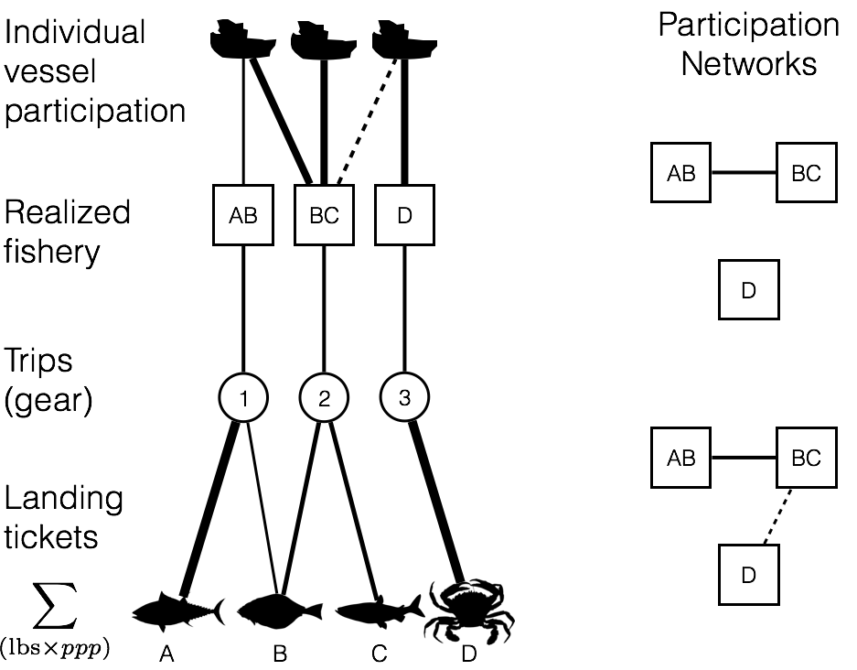

Figure 1. Using landing tickets, I used price per pound (ppp) and landed weight to calculate revenue per species per trip. I aggregated these landings to trips and grouped trips by gear. In each gear partition I identified realized fisheries by measuring pairwise similarity of each trip’s revenue composition of catch using the Hellinger distance, and clustered using infoMap. Using these fishery designations I mapped participation at the vessel level, quantified revenue diversity and fisheries connectivity at the port level.

Analyzing Participation Networks: Connectivity and Size

To measure fisheries connectivity in these participation networks I calculated the link density (*LD,* number of edges divided by nodes) which scales both with network size and interconnectedness. Because the network is undirected, this value can be interpreted as the average number of fisheries to which a fishery is connected (i.e. all vessels participate in both fisheries) at port *k*.

Analyzing Participation Networks: Centrality

While many measures of network centrality exist, here I chose simple measures which have clear interpretations. Centrality of each node in a network was measured in two ways, by node strength and betweenness centrality. Node strength is a generalization of degree for weighted networks. Degree, or the number of connections to a given node, is an intuitive measure where the more connected a node is, the more central we assume to be in the network. To make use of the information contained in edge weight I calculated node strength (Barrat et al. 2004) where node strength of node *v* is

|  |  |
| --- | --- |
|  | (2) |

in a graph with *N* total nodes (Barrat et al. 2004). Because networks varied orders of magnitude in the total number of vessels moving among nodes, I normalized this value by the sum of all edge weights in a graph, thus providing a measure ranging between 0 and 1 where 1 indicates that all connections in the network were to node *v*, and 0 means that no connections involved node *v*, and it grows such that larger edges drive up the score. Fisheries with node strength close to one are fisheries that were consistently connected to the majority of other fisheries in the network and/or were involved the strongest connections present. Thus these fisheries that scored highly in node strength across all port networks can be thought of as fisheries that are consistently central (i.e. strongly connected to most of the nodes in the network) in all the networks in which they appear.

This measure of node strength, while intuitive, only takes into account the local structure around each node. To incorporate both node strength and network structure I calculated betweenness centrality. Betweenness centrality was developed to better incorporate the topological structure of the network and specifically to capture whether nodes connected two relatively distant parts of a network (Freeman, Roeder, and Mulholland 1979). This metric is particularly useful in cases where we wish to know something about traffic or how information flows across a network, both of which are relevant when we think about fisheries participation. This metric is calculated as the number of shortest paths which travel through a given node *b(v)*.

|  |  |
| --- | --- |
|  | (3) |

where is the number of shortest paths between node *s* and node *t* and is the number of shortest paths that pass through vertex *v*. Because betweenness will scale with network size, and participation networks vary in size, I normalized this value by dividing by the number of pairs of nodes *((N-1)(N-2)/2*) that do not include *v*, so that *b* is in the interval *[0, 1]*. To incorporate weights of edges I summed the edge strength such that shortest paths that involve edges with larger weights contribute more to betweenness scores.

Analyzing Participation Networks: Modularity

Modularity was determined by looking for distinct modules in port participation networks in the top ten ports by revenue (Table 3). Modules have long been of interest for biological and social networks, however they are difficult to define formally. Most recent approaches consider that a partition of the nodes of a graph represent true structure if the proportion of edges inside the module is large when compared to the number links between them and the rest of the graph. I use this definition here and defined modules as groups of fisheries more tightly connected to one another than the rest of the network. These were identified using the walktrap algorithm(Pons and Latapy 2005). The algorithm’s name comes from the observation that random walks on networks often get “stuck” in densely connected subgraphs. The algorithm proceeds by building an agglomerative dendrogram by computing pairwise distances among all nodes and merging adjacent (i.e. sharing at least one edge) nodes/communities to form larger groupings. The weight of the edge *vu* is converted to distance by averaging all edge weights and dividing by edge weight *vu*. At each step, a pair of edges is merged based on the move that results in the greatest reduction in the variation in the mean squared pairwise distance within the candidate community. This process is repeated until all communities are fused to a single large entity. To choose the optimal partition, the modularity *Q* of each partition *P* is calculated as

|  |  |
| --- | --- |
|  | (4) |

where *ec* represents the edges inside community *C* and *ac* is the number of edges between the community and the rest of the network (Pons and Latapy 2005). For each step in the dendrogram, the modularity was computed, and the partition with the largest modularity was chosen.

Results

Realized Fisheries of the US West-coast

Applied to the landing ticket data, my clustering algorithm identified 109 realized fisheries (Supplementary Information, Table S1). Realized fisheries often consisted of a single species, but could also comprise assemblages of species (Figure S1a). Whether catch consisted of a single species or multiple species, the realized fisheries were characterized by distinct temporal and spatial structure (Fig. S2a, b). This structure showed strong agreement with the NWFSC Observer sector designations, as did comparisons of vessel sizes and catch composition (single- vs. multi-species, Table 2).

The realized fisheries also varied by several orders of magnitude in effort (number of trips) and revenue (Fig. S1b), with a small number of fisheries accounting for the majority of effort and revenue. For example, only 10 of the 109 fisheries were responsible for 90% of ex-vessel revenue and landings (pounds) in the time period I examined (Table 2). These fisheries include well-studied, but not quantitatively described sectors such as the Dungeness crab pot (Botsford and Wickham 1978), spiny lobster pot (Kay et al. 2012), and red urchin diving (Smith and Wilen 2003). In the following I refer to fisheries by their major species and gear, i.e. the Dungeness crab pot fishery is a fishery in which catches are dominated by Dungeness crab (*Metacarcinus magister*) and caught with crab pots.

Analyzing Participation Networks: Connectivity and Size

I found differences in the number and interconnectedness of fisheries across ports (Figure 2). At the port level participation networks had between 1 and 11 fisheries (nodes) and between 0 and 47 edges with a median of 6 and 7, respectively. Fisheries in these networks were connected to anywhere between 0 and 10 other fisheries with a median of 3 connections. Linkage density for these networks varied between 0 and 4.27. This variation is exemplified by participation networks in Santa Barbara, CA, Port Orford, OR, and Crescent City, CA (Figs. 3a-c). Santa Barbara was characterized by a complex participation network, with more than double the average link density of Port Orford (see Supplementary Information for all port participation networks).

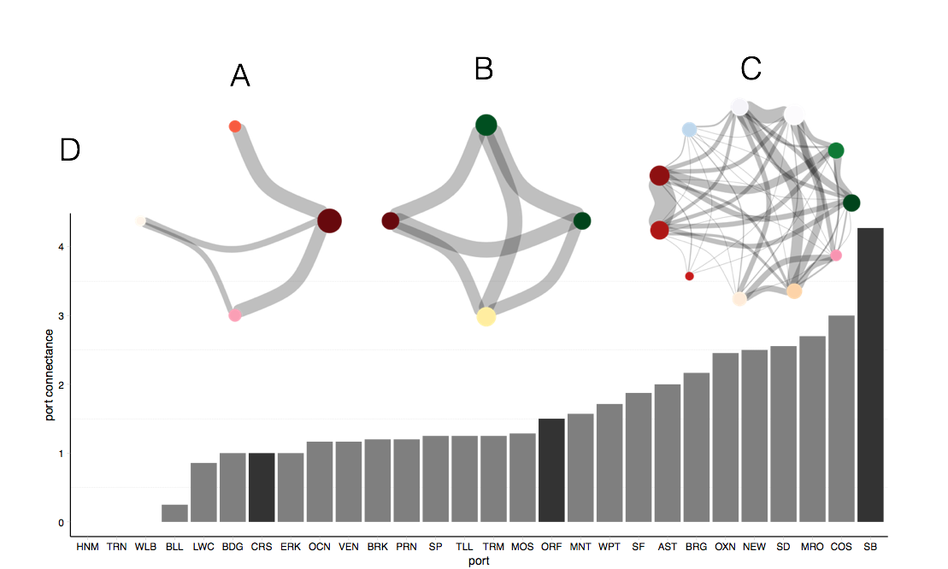

Figure 2. Spectrum of fisheries connectivity present in participation networks on the US west coast as illustrated by participation networks for A) Crescent City, CA; B) Port Orford, OR; and C) Santa Barbara, CA. Here nodes represent realized fisheries where edge width is proportional to the number of vessels that participate in the connected fisheries. Vertex size is proportional to the number of vessels which participate in each realized fishery. Color of nodes represents gear type and is consistent across networks: reds indicate pots, greens are hook and line, blues are nets, pinks are shrimp trawls, oranges are groundfish trawl, purples are miscellaneous and yellows are troll fisheries. D) Fisheries connectivity, measured as link-density for all ports on US west coast with more than three vessels landing between 2009-2013. Dark bars correspond to the network above them.

Participation networks at the state level had between 8 and 17 nodes and between 19 and 103 edges in total. The median degree of fisheries in these networks was 7, although they ranged between 2 and 16 connections. Similar to port level networks, I also found differences in the number and interconnectedness of fisheries amongst states (Figure 3). California had the highest linkage density, followed by Oregon and Washington. The differences in these networks, with California’s participation network having more than double the nodes (fisheries) than either Oregon or Washington, is striking. The California participation network had a median degree of 14 compared to 6 and 4.5 of Oregon and Washington, respectively. This difference in number and interconnectivity is likely due to the presence of more purse-seine, pelagic fisheries and invertebrate pot fisheries (i.e. market squid seine, herring, sardine and spiny lobster, red urchin and rock crab respectively) that are not as dominant in Oregon or Washington.

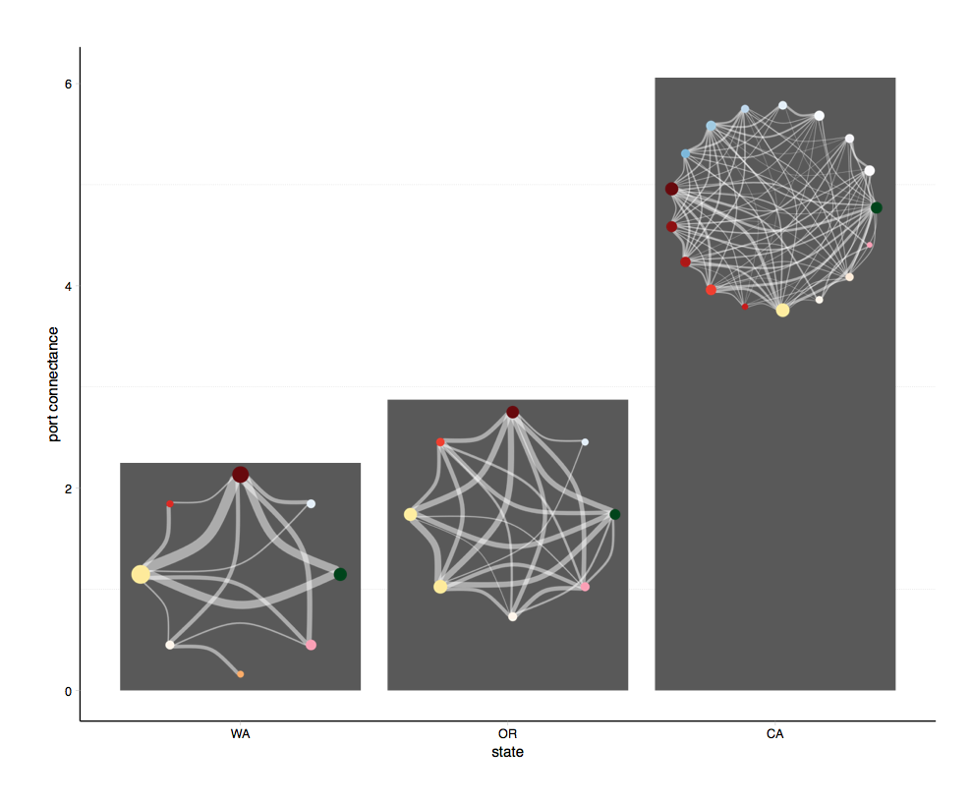Figure 3. Spectrum of fisheries for state-level participation networks on the US west. Here nodes represent realized fisheries where edge width is proportional to the number of vessels that participate in the connected fisheries. Vertex size is proportional to the number of vessels which participate in each realized fishery. Color of nodes is consistent across networks, reds represents pots, greens are hook and line, blues are nets, pinks are shrimp trawls, oranges are groundfish trawl, purples are miscellaneous and yellows are troll fisheries. The bar plot displays fisheries connectivity, measured as link-density for each state on US west coast with more than three vessels landing between 2009-2010. The participation network for each state is pictures to illustrate the intuitive differences among states.

Analyzing Participation Networks: Centrality

In contrast to typical portrayals of fleets as independent units of fishing effort, virtually all fisheries were connected to at least one other fishery by vessel participation. These connections varied, but some clear patterns emerged. Across all ports, the Dungeness crab pot fishery was consistently central in both node strength and betweenness centrality: it had the highest centrality score in 9 and the highest betweenness score in 14 of 20 ports in which this fishery was present (Figure 4). This pattern was also consistent in the state and coast-wide participation networks (Figures S3, S4). Large node strength suggests that the Dungeness crab pot fishery is much more connected than the rest of the nodes in a given network, which implies that many different fishing strategies likely include Dungeness crab pots as a component. High scores of betweenness suggest that the different strategies employed by those participating in Dungeness crab pot fishery are diverse, such that the population involved in Dungeness crab pot fishing is highly heterogeneous. Interestingly, aside from the Dungeness crab pot fishery, the betweenness centrality identifies a largely non-overlapping set of fisheries as consistently central in networks, with many more fisheries identified as peripherally connected than node strength would suggest. Herring seine (NET_5) for example has relatively high median betweenness centrality but middling node strength. This suggests that while the fishery may be less commonly participated in than crab, it connects a diverse group of fisheries.

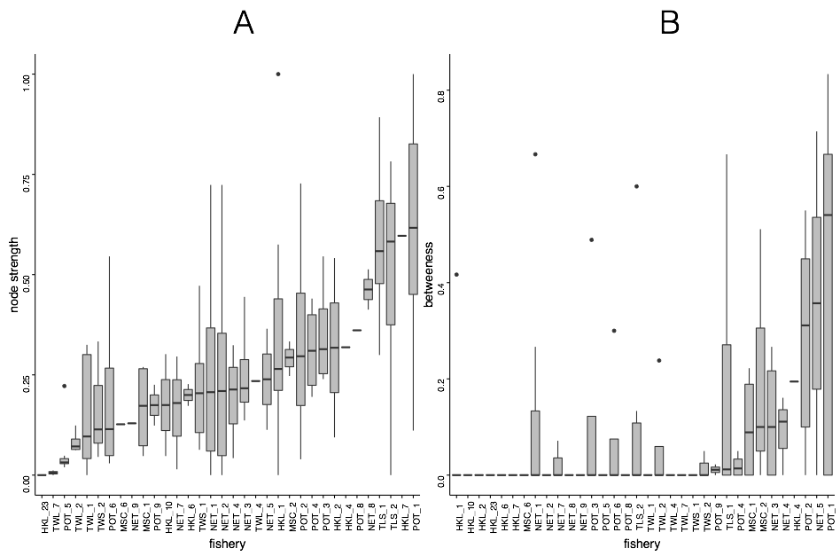Figure 4. Ordered from least to most are measures of A) node strength and B) betweenness for port-level participation networks. Fisheries are ordered from left to right from smallest to greatest median node strength and betweenness (respectively). Dungeness crab pots (POT_1) has the greatest node strength and betweenness, but other fisheries shift their ordering depending on the metric used (for state and coast-wide scales see Supplemenatry Information).

Analyzing Participation Networks: Modularity

At the port scale, I find anywhere from 2 to 7 communities in the port participation networks (Figure 5). The makeup of these communities, while varying in size, often have common memberships. The most common membership is a Dungeness crab pot and Albacore troll fishery (4/10 networks) followed by DTS trawl and pink shrimp (3/10 networks). Pelagic fisheries, i.e. purse seine fisheries for market squid, sardine, herring and mackerel, often were interconnected (i.e. Trinidad, CA: Fig 5) and there seems to be a possible replacement of Dungeness crab with spiny lobster pots as a central fishery in southern California ports. Another common combination was albacore and salmon troll fishing, a not unexpected combination given the similar ecology of target species (highly mobile, pelagic) and gear used for these fisheries (troll).

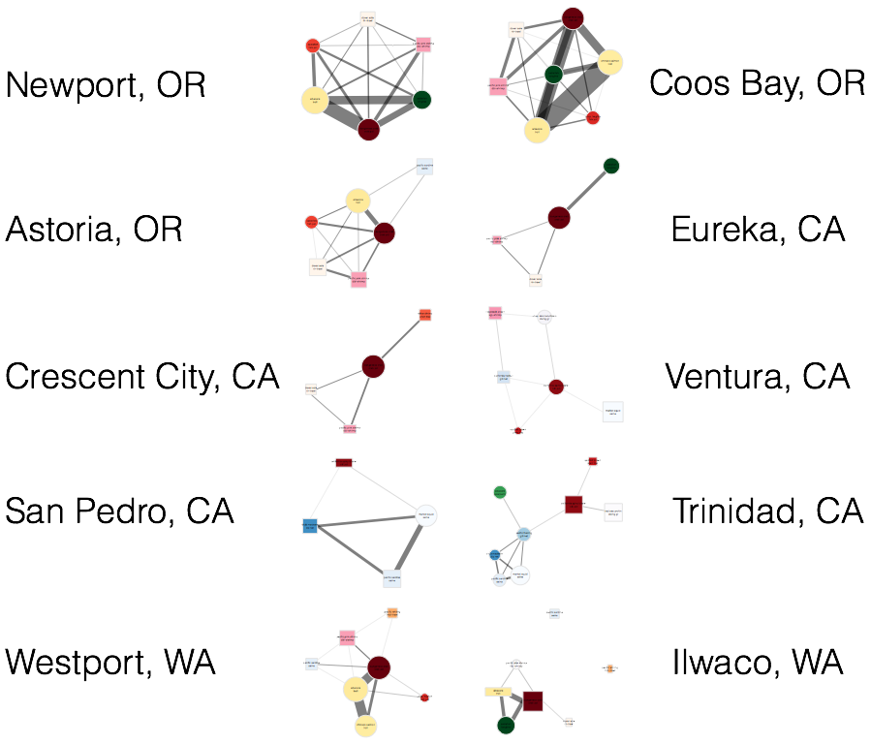Figure 5. Participation networks for the 10 ports which are responsible for 65% of total revenue derived from commercial fisheries between 2009-2013. Base colors of nodes represent fisheries using the same types of gear (i.e. pots are red, trawls are beige-orange, purse seines are blue and trolls are yellow). The shape of the node represents its community membership. The width of the edges is proportional to the log number of vessels which participate in both and the size of each node is proportional to the log number of vessels which participated in that fishery between 2009-2013. Edge widths and node sizes were adjusted for visibility so are directly comparable within graphs, but not necessarily between them.

In general communities seemed partially determined on geography and vessel size. Composition of participation networks, and these characteristic communities of fisheries, varied between southern California and further north along the coast. Southern California ports participation networks had communities dominated by market squid, no Dungeness crab fisheries, and sometimes contained sea cucumbers, California halibut and red sea urchin diving. Northern participation networks, by contrast, were dominated by Dungeness crab pot fisheries groundfish trawl and pink shrimp trawls, and contained sablefish pots and long-line fisheries not present in southern networks.

Discussion

In this chapter I have developed a novel framework for linking fisheries to ports and a way to visualize and analyze these interactions. This is the first time to my knowledge that the the connections among fisheries has been systematically examined, and the connectivity, centrality and modularity of fisheries participation and been calculated across fishing communities. I find commercial fisheries on the US west coast to be composed of many fishery highly connected (Figures 2, 3, 5). This suggests that most vessels on the US west coast are generalists, which contrasts with common approximations of commercial fleets as groups of specialists. This disconnect underscores the need for ways to map fisheries to how people participate in them, and how, in turn, to relate participation to the scale of fishing communities.

This work has also highlighted that there appears to be strong regional variation in participation structure and network, with California differing dramatically from Oregon and Washington (Figure 3). This is the first time, to my knowledge, that such regional examination in fisheries participation and connectivity has been demonstrated. Aside from management likely differing between states, it may also be due to ecology and geography. Ecologically California is a meeting of ecosystems and is extremely species rich (Dailey and Reish 1993). Geographically the shelf is narrows in along California’s coastline, and so many more deep water species are available for harvest at shorter distances.

This work also identifies Dungeness crab as a fishery of “management importance” (Figure 4). The Dungeness crab fishery is well known as an important fishery due to the proportion of revenue derived from those landings (35% of all revenue between 2009-2013, Table 2). However this work highlights that it is also a fishery that is central in many fishing communities measured either by node strength or betweenness centrality, suggesting that many people depend on it as a part of their livelihood strategy. This position in these participation networks may be due to a combination of factors. While vessels on the US west coast are diverse (Kasperski and Holland 2013), participation in commercial fisheries are likely, at least in part, constrained by vessel size. Dungeness crab is a unique fishery that draws both large and small vessels. However the regional variability in the fisheries participation networks is worth considering, since few southern port participation networks contain Dungeness crab, instead being replaced by spiny lobster pot fishing.

Using these participation networks I was also able to identify characteristic combinations of fisheries, which helps to move towards operationalizing the goal of making management match the scale of the system in which it’s embedded (Figure 5). These linkages emphasize the importance of taking a systems perspective in these complex and highly interconnected systems. There are common combinations of fisheries that appear among these participation networks: pelagic purse seining dominated by market squid purse seine, combining pink shrimp and dover, thornyhead, sablefish trawl, albacore and chinook trolling. In the northern part of the coast, Dungeness crab appeared to be a general partner, to pairing well with all fisheries, in the south, spiny lobster had a similar role.

These participation motifs contribute novel observations that are unavailable from a solely ecological perspective. Many of the fisheries that are tightly connected by participation target species that are distantly related in food webs. The linkage between albacore tuna and Dungeness crab, for example, are two single species fisheries that are ecologically disparate (pelagic and benthic) and managed under two different systems (Dungeness crab is managed by states while Albacore is managed federally as a highly migratory species), yet are frequently found together in these participation networks (Figure 5). Understanding how management may cascade from one fishery to another, especially after the Dungeness crab pot fishery closure in 2015 is a natural next step of this work.

Other extensions include examination of second order properties of the participation networks. In particular, not only are the links between realized fisheries heterogeneous, they are changing over time as fishermen re-tool and learn new skills. Thus another key property may be the transitivity of the participation networks. Transitivity describes multi-step connections, and these are particularly important when considering how information may flow through these networks. Betweenness centrality is not unrelated to transitivity, but additional work on how information flow may be related to these network properties might provide management with a useful heuristic for determining a fishing community’s adaptive capacity.

This is the first time to my knowledge that the diversity and evenness of fisheries participation and interconnectivity has been examined across ports or states. This work has highlighted, in particular, that fisheries are not comprised of specialist fleets, and there appears to be strong regional variation in participation structure and network, with California differing dramatically from Oregon and Washington. This analysis has also highlighted the centrality of the Dungeness crab pot fishery across scales and along the coast and is the first to formally describe common participation strategies in the US west coast commercial fisheries.

Acknowledgements

I thank PacFin for access to the data, the observers and fishermen on the US west coast for insightful discussions, and Emily Klein for discussions on this project. I acknowledge support from the National Science Foundation (GRFP, GEO-1211972) and GreenMar (Consortium Agreement GreeMar-AGMT dtd 05-05-2014, Prime Nordforsk Project Number: 61582).

Literature Cited

Anderson, James L, Christopher M Anderson, Jingjie Chu, Jennifer Meredith, Frank Asche, Gil Sylvia, Martin D Smith, et al. 2015. “The Fishery Performance Indicators: a Management Tool for Triple Bottom Line Outcomes.” Edited by George Tserpes. *PloS One* 10 (5): e0122809–20. doi:10.1371/journal.pone.0122809.

Barnosky, Anthony D, Paul L Koch, Robert S Feranec, Scott L Wing, and Alan B Shabel. 2004. “Assessing the Causes of Late Pleistocene Extinctions on the Continents..” *Science (New York, N.Y.)* 306 (5693): 70–75. doi:10.1126/science.1101476.

Barrat, A, M Barthelemy, R Pastor-Satorras, and A Vespignani. 2004. “The Architecture of Complex Weighted Networks.” *Proceedings of the National Academy of Sciences* 101 (11). National Acad Sciences: 3747–52. doi:10.1073/pnas.0400087101.

Baskerville, Edward B, Andy P Dobson, Trevor Bedford, Stefano Allesina, T Michael Anderson, and Mercedes Pascual. 2011. “Spatial Guilds in the Serengeti Food Web Revealed by a Bayesian Group Model.” Edited by Lauren Ancel Meyers. *PLoS Computational Biology* 7 (12). Public Library of Science: e1002321. doi:10.1371/journal.pcbi.1002321.

Boonstra, Wiebren J, and Jonas Hentati Sundberg. 2014. “Classifying Fishers' Behaviour. an Invitation to Fishing Styles,” August, n–a–n–a. doi:10.1111/faf.12092.

Brashares, Justin S, Peter Arcese, Moses K Sam, Peter B Coppolillo, A R E Sinclair, and Andrew Balmford. 2004. “Bushmeat Hunting, Wildlife Declines, and Fish Supply in West Africa.” *Science (New York, N.Y.)* 306 (5699). American Association for the Advancement of Science: 1180–83. doi:10.1126/science.1102425.

Burnham, Kenneth P, and David R Anderson. 2002. *Model Selection and Multimodel Inference: a Practical Information-Theoretic Approach*. Edited by Springer Science & Business Media.

Castree, Noel, William M Adams, John Barry, Daniel Brockington, Bram Büscher, Esteve Corbera, David Demeritt, et al. 2014. “Changing the Intellectual Climate.” *Nature Climate Change* 4 (9). Nature Publishing Group: 763–68. doi:10.1038/nclimate2339.

Ceballos, G, P R Ehrlich, A D Barnosky, A Garcia, R M Pringle, and T M Palmer. 2015. “Accelerated Modern Human-Induced Species Losses: Entering the Sixth Mass Extinction.” *Science Advances* 1 (5). American Association for the Advancement of Science: e1400253–53. doi:10.1126/sciadv.1400253.

Coleman, Felicia C, Will F Figueira, Jeffrey S Ueland, and Larry B Crowder. 2004. “The Impact of United States Recreational Fisheries on Marine Fish Populations..” *Science (New York, N.Y.)* 305 (5692): 1958–60. doi:10.1126/science.1100397.

Conservation International. 2016. “Mission and Vision.” Accessed April 14. http://www.conservation.org/global/philippines/about/Pages/mission.aspx.

Costello, Christopher, Steven D Gaines, and John Lynham. 2008. “Can Catch Shares Prevent Fisheries Collapse?.” *Science (New York, N.Y.)* 321 (5896): 1678–81. doi:10.1126/science.1159478.

Dailey, Murray D, and Donald J Reish. 1993. *Ecology of the Southern California Bight*. Univ of California Press.

Department of the Interior. 2016. “The Bureau of Land Management: Who We Are, What We Do.” Accessed April 14. http://www.blm.gov/wo/st/en/info/About_BLM.print.html.

Deporte, N, C Ulrich, S Mahevas, S Demaneche, and F Bastardie. 2012. “Regional Metier Definition: a Comparative Investigation of Statistical Methods Using a Workflow Applied to International Otter Trawl Fisheries in the North Sea.” *ICES Journal of Marine Science* 69 (2): 331–42. doi:10.1093/icesjms/fsr197.

Dirzo, Rodolfo, Hillary S Young, Mauro Galetti, Gerardo Ceballos, Nick J B Isaac, and Ben Collen. 2014. “Defaunation in the Anthropocene..” *Science (New York, N.Y.)* 345 (6195). American Association for the Advancement of Science: 401–6. doi:10.1126/science.1251817.

Essington, T E. 2010. “Ecological Indicators Display Reduced Variation in North American Catch Share Fisheries.” *Proceedings of the National Academy of Sciences* 107 (2): 754–59. doi:10.1073/pnas.0907252107.

Field, John C. 2004. “Application of Ecosystem-Based Fishery Management Approaches in the Northern California Current .” Edited by Robert C Francis.

Freeman, Linton C, Douglas Roeder, and Robert R Mulholland. 1979. “Centrality in Social Networks: II. Experimental Results.” *Social Networks* 2: 119–41.

Fuller, Emma, Eleanor Brush, and Malin L Pinsky. 2015. “The Persistence of Populations Facing Climate Shifts and Harvest.” *Ecosphere* 6 (9). Ecological Society of America: art153–16. doi:10.1890/ES14-00533.1.

Fulton, Elizabeth A, Anthony D M Smith, David C Smith, and Ingrid E van Putten. 2010. “Human Behaviour: the Key Source of Uncertainty in Fisheries Management.” *Fish and Fisheries* 12 (1): 2–17. doi:10.1111/j.1467-2979.2010.00371.x.

Galloway, James N, and Ellis B Cowling. 2002. “Reactive Nitrogen and the World: 200 Years of Change.” *Ambio* 31 (2): 64–71. doi:10.1579/0044-7447-31.2.64.

Hentati-Sundberg, J, J Hjelm, W J Boonstra, and H Österblom. 2014. “Management Forcing Increased Specialization in a Fishery System.” *Ecosystems* 18 (1). Springer US: 45–61. doi:10.1007/s10021-014-9811-3.

Hicks, Christina C, Arielle Levine, Arun Agrawal, Xavier Basurto, Sara J Breslow, Courtney Carothers, Susan Charnley, et al. 2016. “Engage Key Social Concepts for Sustainability.” *Science (New York, N.Y.)* 352 (6281): 38–40. doi:10.1126/science.aad4977.

Hilborn, Ray, Jean-Jacques Maguire, Ana M Parma, and Andrew A Rosenberg. 2001. “The Precautionary Approach and Risk Management: Can They Increase the Probability of Successes in Fishery Management?.” *Canadian Journal of Fisheries and Aquatic Sciences* 58 (1): 99–107. doi:10.1139/cjfas-58-1-99.

Jackson, J B, M X Kirby, W H Berger, K A Bjorndal, L W Botsford, B J Bourque, R H Bradbury, et al. 2001. “Historical Overfishing and the Recent Collapse of Coastal Ecosystems..” *Science (New York, N.Y.)* 293 (5530): 629–37. doi:10.1126/science.1059199.

Jensen, Olaf P, Trevor A Branch, and Ray Hilborn. 2011. “Marine Fisheries as Ecological Experiments.” *Theoretical Ecology* 5 (1): 3–22. doi:10.1007/s12080-011-0146-9.

Jepson, Michael, and Lisa L Colburn. 2013. “Development of Social Indicators of Fishing Community Vulnerability and Resilience in the U.S. Southeast and Northeast Regions.” NMFS-F/SPO-129. *U.S. Department of Commerce, NOAA Technical Memorandum., NOAA Technical Memorandum NMFS-NWFSC-85*. U.S. Dept. of Commerce.

Jordan, Ferenc. 2009. “Keystone Species and Food Webs..” *Philosophical Transactions of the Royal Society of London. Series B, Biological Sciences* 364 (1524). The Royal Society: 1733–41. doi:10.1098/rstb.2008.0335.

Jost, Lou. 2006. “Entropy and Diversity.” *Oikos* 113 (2): 363–75.

Kareiva, Peter, and Michelle Marvier. 2012. “What Is Conservation Science?.” *Bioscience* 62 (11): 962–69. doi:10.1525/bio.2012.62.11.5.

Karp, Daniel S, Chase D Mendenhall, Elizabeth Callaway, Luke O Frishkoff, Peter M Kareiva, Paul R Ehrlich, and Gretchen C Daily. 2015. “Confronting and Resolving Competing Values Behind Conservation Objectives.” *Proceedings of the National Academy of Sciences* 112 (35): 11132–37. doi:10.1073/pnas.1504788112.

Kasperski, S, and D S Holland. 2013. “Income Diversification and Risk for Fishermen.” *Proceedings of the National Academy of Sciences*. doi:10.1073/pnas.1212278110/-/DCSupplemental.

Lade, Steven J, Alessandro Tavoni, Simon A Levin, and Maja Schlüter. 2013. “Regime Shifts in a Social-Ecological System.” *Theoretical Ecology* 6 (3): 359–72. doi:10.1007/s12080-013-0187-3.

Lade, Steven J, Susa Niiranen, Jonas Hentati Sundberg, Thorsten Blenckner, Wiebren J Boonstra, Kirill Orach, Martin F Quaas, Henrik Österblom, and Maja Schlüter. 2015. “An Empirical Model of the Baltic Sea Reveals the Importance of Social Dynamics for Ecological Regime Shifts..” *Proceedings of the National Academy of Sciences of the United States of America* 112 (35): 11120–25. doi:10.1073/pnas.1504954112.

Legendre, P, and L Legendre. 2012. *Numerical Ecology*. Elsevier.

Levin, Phillip S, Michael J Fogarty, Steven A Murawski, and David Fluharty. 2009. “Integrated Ecosystem Assessments: Developing the Scientific Basis for Ecosystem-Based Management of the Ocean.” *PLoS Biology* 7 (1): e1000014–16. doi:10.1371/journal.pbio.1000014.

Levin, Simon. 1999. *Fragile Dominion*. Basic Books.

Lunt, Daniel J, Alan M Haywood, Gavin A Schmidt, Ulrich Salzmann, Paul J Valdes, and Harry J Dowsett. 2009. “Earth System Sensitivity Inferred From Pliocene Modelling and Data.” *Nature Geoscience* 3 (1). Nature Publishing Group: 60–64. doi:10.1038/ngeo706.

Mace, Georgina M. 2014. “Ecology. Whose Conservation?.” *Science (New York, N.Y.)* 345 (6204). American Association for the Advancement of Science: 1558–60. doi:10.1126/science.1254704.

McCauley, Douglas J, Malin L Pinsky, Stephen R Palumbi, James A Estes, Francis H Joyce, and Robert R Warner. 2015. “Marine Defaunation: Animal Loss in the Global Ocean..” *Science (New York, N.Y.)* 347 (6219). American Association for the Advancement of Science: 1255641–41. doi:10.1126/science.1255641.

McShane, Thomas O, Paul D Hirsch, Tran Chi Trung, Alexander N Songorwa, Ann Kinzig, Bruno Monteferri, David Mutekanga, et al. 2011. “Hard Choices: Making Trade-Offs Between Biodiversity Conservation and Human Well-Being.” *Biological Conservation* 144 (3). Elsevier Ltd: 966–72. doi:10.1016/j.biocon.2010.04.038.

Millennium Ecosystem Assessment. 2005. “*Ecosystems and Human Well-Being: Synthesis*.” *Island Press*. Washington, DC.

Norman, Karma, Jennifer Sepez, Heather Lazarus, Nicole Milne, Christina Package, Suzanne Russell, Kevin Grant, et al. 2007. “Community Profiles for West Coast and North Pacific Fisheries, Washington, Oregon, California, and Other U.S. States.” *U.S. Department of Commerce, NOAA Technical Memorandum., NOAA Technical Memorandum NMFS-NWFSC-85*, December, 602p.

Opaluch, J J, and N E Bockstael. 1984. “Behavioral Modeling and Fisheries Management.” *Marine Resource Economics*. doi:10.2307/42628847.

Ostrom, Elinor. 2009. “A General Framework for Analyzing Sustainability of Social-Ecological Systems.” *Science (New York, N.Y.)* 325 (5939): 419–22. doi:10.1126/science.1172133.

Pacific Fishery Management Council. 2014. “*Pacific Coast Fishery Ecosystem Plan for the U.S. Portion of the California Current Large Marine Ecosystem*.” 7700 NE Ambassador Place, Suite 101, Portland, Oregon 97220-1384: Pacific Fishery Management Council.

Pfeiffer, Lisa, and Trevor Gratz. 2016. “The Effect of Rights-Based Fisheries Management on Risk Taking and Fishing Safety.” *Proceedings of the National Academy of Sciences* 113 (10): 2615–20. doi:10.1073/pnas.1509456113.

Pollnac, Richard B, Tarsila Seara, Lisa L Colburn, and Michael Jepson. 2015. “Taxonomy of USA East Coast Fishing Communities in Terms of Social Vulnerability and Resilience.” *Environmental Impact Assessment Review* 55: 136–43.

Pons, Pascal, and Matthieu Latapy. 2005. “Computing Communities in Large Networks Using Random Walks.” *ArXiv Physics E-Prints*. http://arxiv.org/abs/physics/0512106#.

Rosvall, Martin, and Carl T Bergstrom. 2008. “Maps of Random Walks on Complex Networks Reveal Community Structure.” *Proceedings of the National Academy of Sciences* 105 (4). National Acad Sciences: 1118–23. doi:10.1073/pnas.0706851105.

Sethi, S A, M Reimer, and G Knapp. 2014. “Alaskan Fishing Community Revenues and the Stabilizing Role of Fishing Portfolios.” *Marine Policy*. doi:10.1016/j.marpol.2014.03.027.

Sinclair, A R E, SIMON A R MDUMA, J GRANT C HOPCRAFT, John M Fryxell, Ray Hilborn, and SIMON THIRGOOD. 2007. “Long-Term Ecosystem Dynamics in the Serengeti: Lessons for Conservation.” *Conservation Biology* 21 (3). Blackwell Publishing Inc: 580–90. doi:10.1111/j.1523-1739.2007.00699.x.

Smith, Martin D, and James E Wilen. 2003. “Economic Impacts of Marine Reserves: the Importance of Spatial Behavior.” *Journal of Environmental Economics and Management* 46 (2): 183–206. doi:10.1016/S0095-0696(03)00024-X.

Smith, Martin D, Junjie Zhang, and Felicia C Coleman. 2008. “Econometric Modeling of Fisheries with Complex Life Histories: Avoiding Biological Management Failures.” *Journal of Environmental Economics and Management* 55 (3): 265–80. doi:10.1016/j.jeem.2007.11.003.

Steneck, R S, T P Hughes, J E CINNER, W N ADGER, S N ARNOLD, F BERKES, S A BOUDREAU, et al. 2011. “Creation of a Gilded Trap by the High Economic Value of the Maine Lobster Fishery.” *Conservation Biology* 25 (5): 904–12. doi:10.1111/j.1523-1739.2011.01717.x.

Tavoni, Alessandro, Maja Schlüter, and Simon Levin. 2012. “The Survival of the Conformist: Social Pressure and Renewable Resource Management.” *Journal of Theoretical Biology* 299 (April): 152–61. doi:10.1016/j.jtbi.2011.07.003.

The Nature Conservancy. 2016. “About US: Vision and Mission.” Accessed April 14.

US Forest Service. 2015. “USDA Forest Service Strategic Plan: FY 2015-2020.” Vol. 1045.

van Putten, Ingrid E, Soile Kulmala, Olivier Thébaud, Natalie Dowling, Katell G Hamon, Trevor Hutton, and Sean Pascoe. 2012. “Theories and Behavioural Drivers Underlying Fleet Dynamics Models.” *Fish and Fisheries* 13 (2): 216–35. doi:10.1111/j.1467-2979.2011.00430.x.

Waters, C N, J Zalasiewicz, C Summerhayes, A D Barnosky, C Poirier, A Ga uszka, A Cearreta, et al. 2016. “The Anthropocene Is Functionally and Stratigraphically Distinct From the Holocene.” *Science (New York, N.Y.)* 351 (6269): aad2622–22. doi:10.1126/science.aad2622.

Wilen, J E, M D Smith, and D Lockwood. 2002. “Avoiding Surprises: Incorporating Fisherman Behavior Into Management Models.” *Bulletin of Marine …*.

Worm, Boris, Ray Hilborn, Julia K Baum, Trevor A Branch, Jeremy S Collie, Christopher Costello, Michael J Fogarty, et al. 2009. “Rebuilding Global Fisheries..” *Science (New York, N.Y.)* 325 (5940). American Association for the Advancement of Science: 578–85. doi:10.1126/science.1173146.

Supplementary Information

Realized Fisheries

|  |  |  |  |  |  |  |  |  |  |
| --- | --- | --- | --- | --- | --- | --- | --- | --- | --- |
| 1) | pot_1 | Dungeness crab | crab pot | 45 | 23 | 32 | 105532 | no | 1194 |
| 2) | msc_1 | red sea urchin | diving gear | 80 | 20 | NA | 58224 | no | 211 |
| 3) | tls_1 | chinook salmon | troll | 50 | 25 | 25 | 39383 | no | 1481 |
| 4) | pot_2 | California spiny lobster | crab & lobster pot | 100 | NA | NA | 28588 | no | 253 |
| 5) | hkl_1 | sablefish | longline | 66 | 15 | 19 | 25026 | no | 595 |
| 6) | net_1 | market squid | seine | 100 | NA | NA | 20325 | no | 154 |
| 7) | hkl_2 | black rockfish | other hook & line | 67 | 33 | NA | 18358 | no | 342 |
| 8) | tls_2 | albacore | troll | 42 | 26 | 32 | 13851 | no | 1260 |
| 9) | pot_3 | rock crab | crab & lobster pot | 100 | NA | NA | 11806 | no | 203 |
| 10) | hkl_4 | brown rockfish, gopher rockfish | pole (commercial) | 90 | 10 | NA | 10200 | yes | 209 |
| 11) | hkl_3 | California halibut | pole (commercial) | 100 | NA | NA | 9350 | no | 630 |
| 12) | twl_1 | dover sole | roller-trawl | 59 | 23 | 18 | 8305 | no | 125 |
| 13) | net_2 | pacific sardine | seine | 74 | 16 | 11 | 7169 | no | 116 |
| 14) | tws_1 | pacific pink shrimp | double-shrimp trawl | 20 | 50 | 30 | 6208 | no | 105 |
| 15) | pot_5 | spotted prawn | prawn trap | 81 | NA | 19 | 5823 | no | 37 |
| 16) | pot_6 | unsp. Hagfish | fish pot | 50 | 18 | 32 | 5630 | no | 137 |
| 17) | hkl_5 | lingcod | other hook & line, pole (commercial) | 63 | 25 | 12 | 5502 | no | 612 |
| 18) | pot_4 | sablefish | fish pot | 62 | 25 | 12 | 5393 | no | 283 |
| 19) | net_3 | California halibut | gillnet | 100 | NA | NA | 4946 | no | 63 |
| 20) | twl_2 | California halibut | groundfish trawl<8 | 100 | NA | NA | 4703 | no | 55 |
| 21) | hkl_6 | black-and-yellow rockfish, Cabazon, grass rockfish | pole (commercial), vertical hook & line | 74 | 26 | NA | 4634 | yes | 201 |
| 22) | msc_2 | unsp. Sea cucumbers | diving gear | 95 | 5 | NA | 4384 | no | 92 |
| 23) | hkl_7 | white seabass | pole (commercial) | 100 | NA | NA | 3372 | no | 387 |
| 24) | net_4 | white seabass | gillnet | 100 | NA | NA | 3292 | no | 55 |
| 25) | net_5 | pacific herring | gillnet | 89 | NA | 11 | 3270 | no | 157 |
| 26) | twl_3 | unsp. Bait shrimp | beam trawl | 100 | NA | NA | 2384 | no | 10 |
| 27) | tws_2 | ridgeback prawn | single-shrimp trawl | 85 | NA | 15 | 2203 | no | 24 |
| 28) | twl_4 | unsp. Sea cucumbers | groundfish trawl | 100 | NA | NA | 2106 | no | 48 |
| 29) | hkl_8 | vermilion rockfish | pole (commercial) | 79 | 21 | NA | 1878 | no | 263 |
| 30) | net_7 | swordfish, common thresher shark | drift gillnet | 100 | NA | NA | 1510 | yes | 82 |
| 31) | net_6 | unsp. Shad | dip net | 100 | NA | NA | 1362 | no | 10 |
| 32) | net_8 | chub mackerel | dip net | 90 | 10 | NA | 1283 | no | 51 |
| 33) | tws_3 | California halibut | single-shrimp trawl | 69 | 23 | 8 | 1239 | no | 43 |
| 34) | pot_8 | other shrimp | prawn trap | 67 | 33 | NA | 1177 | no | 33 |
| 35) | net_9 | northern anchovy | seine | 81 | 6 | 12 | 1170 | no | 45 |
| 36) | hkl_9 | unsp. Sanddabs | pole (commercial) | 100 | NA | NA | 1159 | no | 97 |
| 37) | msc_4 | Dungeness crab | other-known | 17 | 83 | NA | 1102 | no | 92 |
| 38) | pot_11 | Cabazon, gopher rockfish | fish pot | 80 | 20 | NA | 1087 | yes | 70 |
| 39) | msc_5 | basket cockle | other-known | 73 | 27 | NA | 985 | no | 44 |
| 40) | msc_3 | unsp. Bait shrimp | other-known | 25 | NA | 75 | 922 | no | 11 |
| 41) | hkl_10 | albacore | pole (commercial) | 91 | 3 | 6 | 780 | no | 285 |
| 42) | pot_9 | California sheephead | fish pot | 100 | NA | NA | 722 | no | 40 |
| 43) | twl_5 | chinook salmon | selective flat fish trawl, groundfish trawl<8, mid-water trawl | 70 | 20 | 10 | 615 | yes | 83 |
| 44) | twl_7 | pacific whiting | mid-water trawl | 29 | 43 | 29 | 599 | no | 29 |
| 45) | msc_6 | swordfish | other-known | 100 | NA | NA | 515 | no | 35 |
| 46) | tws_8 | unsp. Bait shrimp | single-shrimp trawl | 100 | NA | NA | 402 | no | 3 |
| 47) | pot_10 | other crab | crab & lobster pot | 89 | 11 | NA | 378 | no | 84 |
| 48) | hkl_11 | California sheephead | pole (commercial) | 94 | 6 | NA | 375 | no | 50 |
| 49) | msc_8 | gaper clam | other-known | NA | 100 | NA | 342 | no | 10 |
| 50) | hkl_13 | California scorpionfish | pole (commercial) | 100 | NA | NA | 329 | no | 14 |
| 51) | tws_4 | unsp. Sea cucumbers | single-shrimp trawl | 100 | NA | NA | 324 | no | 20 |
| 52) | pot_7 | Dungeness crab, rock crab | crab & lobster pot | 69 | 19 | 11 | 318 | yes | 156 |
| 53) | hkl_15 | pacific halibut | longline | 6 | 69 | 25 | 297 | no | 115 |
| 54) | hkl_18 | surfperch spp. | Pole (commercial) | 100 | NA | NA | 262 | no | 32 |
| 55) | hkl_17 | yellowtail | pole (commercial) | 100 | NA | NA | 232 | no | 68 |
| 56) | tls_5 | California halibut | troll | 100 | NA | NA | 228 | no | 53 |
| 57) | pot_12 | other mollusks | crab & lobster pot | 100 | NA | NA | 226 | no | 56 |
| 58) | hkl_14 | common thresher shark | pole (commercial) | 100 | NA | NA | 213 | no | 47 |
| 59) | net_12 | pacific barracuda | drift gillnet | 100 | NA | NA | 209 | no | 16 |
| 60) | hkl_12 | Bluefin tuna, pacific sanddab | pole (commercial) | 78 | 22 | NA | 207 | yes | 117 |
| 61) | net_11 | other crab | gillnet | 100 | NA | NA | 194 | no | 16 |
| 62) | hkl_16 | unsp. Smelt | pole (commercial) | 100 | NA | NA | 173 | no | 13 |
| 63) | twl_11 | other crab, other shrimp | groundfish trawl | 100 | NA | NA | 163 | yes | 14 |
| 64) | msc_11 | unsp. Mollusks | diving gear | 100 | NA | NA | 149 | no | 8 |
| 65) | hkl_19 | shortfin mako shark | pole (commercial) | 100 | NA | NA | 145 | no | 34 |
| 66) | pot_13 | unsp. Octopus | crab pot | 67 | 33 | NA | 145 | no | 70 |
| 67) | msc_9 | other sea urchins | diving gear | 100 | NA | NA | 136 | no | 44 |
| 68) | hkl_26 | chinook salmon | pole (commercial) | 100 | NA | NA | 114 | no | 53 |
| 69) | tls_4 | unsp. Sanddabs | troll | 71 | 21 | 8 | 108 | yes | 77 |
| 70) | tls_8 | lingcod | troll | 44 | 44 | 12 | 103 | no | 60 |
| 71) | hkl_24 | unsp. Reds rockfish | pole (commercial) | 100 | NA | NA | 98 | no | 28 |
| 72) | msc_10 | butter clam | other-known | NA | 100 | NA | 86 | no | 6 |
| 73) | twl_12 | yellowtail rockfish | selective flat fish trawl, mid-water trawl, roller-trawl | NA | 40 | 60 | 86 | no | 26 |
| 74) | twl_8 | lingcod | selective flat fish trawl, mid-water trawl, roller-trawl | 25 | 38 | 38 | 84 | no | 27 |
| 75) | tws_6 | unsp. Flatfish | single-shrimp trawl | 100 | NA | NA | 83 | no | 7 |
| 76) | hkl_20 | unsp. Shelf rockfish | pole (commercial) | 100 | NA | NA | 82 | no | 6 |
| 77) | hkl_22 | pacific barracuda | pole (commercial) | 100 | NA | NA | 76 | no | 45 |
| 78) | hkl_21 | leopard shark | pole (commercial) | 100 | NA | NA | 65 | no | 29 |
| 79) | msc_12 | other mollusks | diving gear | 78 | 22 | NA | 65 | no | 29 |
| 80) | hkl_23 | swordfish | longline | 100 | NA | NA | 57 | no | 16 |
| 81) | tls_7 | yellowtail rockfish | troll | 38 | 38 | 25 | 48 | no | 29 |
| 82) | twl_9 | nor. Unsp. Slope rockfish | roller-trawl | NA | 75 | 25 | 44 | no | 28 |
| 83) | hkl_25 | unsp. Squid | longline, other hook & line, pole (commercial) | 70 | 30 | NA | 41 | no | 12 |
| 84) | hkl_27 | unsp. Rockfish | pole (commercial) | 92 | NA | 8 | 37 | no | 21 |
| 85) | tws_9 | other crab, rock crab | single-shrimp trawl | 100 | NA | NA | 37 | yes | 10 |
| 86) | pot_14 | unsp. Eels | fish pot | 100 | NA | NA | 36 | no | 13 |
| 87) | twl_10 | pop | roller-trawl | NA | 100 | NA | 36 | no | 17 |
| 88) | twl_13 | canary rockfish, spiny dogfish | mid-water trawl | NA | 75 | 25 | 34 | yes | 19 |
| 89) | twl_14 | spiny dogfish | selective flat fish trawl, groundfish trawl<8, mid-water trawl | 50 | 25 | 25 | 33 | no | 7 |
| 90) | msc_14 | California sheephead | diving gear | 100 | NA | NA | 27 | no | 6 |
| 91) | tls_9 | sablefish | troll | 64 | NA | 36 | 27 | no | 22 |
| 92) | tws_7 | other shrimp | single-shrimp trawl | 100 | NA | NA | 23 | no | 3 |
| 93) | msc_13 | black-and-yellow rockfish | diving gear | 100 | NA | NA | 22 | no | 6 |
| 94) | msc_16 | unsp. Echinoderm | diving gear | 100 | NA | NA | 21 | no | 5 |
| 95) | tls_3 | albacore | troll | 47 | 20 | 33 | 21 | no | 21 |
| 96) | twl_6 | petrale sole | groundfish trawl<8 | 100 | NA | NA | 20 | yes | 6 |
| 97) | tws_10 | other skates | single-shrimp trawl | 100 | NA | NA | 19 | no | 5 |
| 98) | msc_7 | unsp. Sea cucumbers | diving gear | 100 | NA | NA | 18 | no | 7 |
| 99) | tls_6 | white seabass | troll | 100 | NA | NA | 18 | no | 7 |
| 100) | msc_18 | unsp. Flatfish | diving gear | 100 | NA | NA | 17 | no | 6 |
| 101) | net_10 | pacific sardine | seine | 100 | NA | NA | 14 | no | 10 |
| 102) | msc_15 | unsp. Shad | unknown gear | 100 | NA | NA | 10 | no | 2 |
| 103) | msc_17 | shortfin mako shark | other-known | 100 | NA | NA | 9 | no | 6 |
| 104) | hkl_28 | unsp. Octopus | longline, other hook & line, pole (commercial) | 25 | 75 | NA | 8 | no | 6 |
| 105) | hkl_29 | nor. Unsp. Shelf rockfish | other hook & line | NA | 100 | NA | 5 | no | 4 |
| 106) | tws_5 | hornyhead turbot, ridgeback prawn, unsp. Hagfish | single-shrimp trawl | 100 | NA | NA | 4 | yes | 3 |
| 107) | tls_10 | yellowtail | troll | NA | 100 | NA | 3 | no | 3 |
| 108) | tws_11 | white seabass | single-shrimp trawl | 100 | NA | NA | 3 | no | 2 |
| 109) | tws_12 | vermilion rockfish | single-shrimp trawl | 100 | NA | NA | 3 | no | 2 |

Evaluating realized fisheries classification

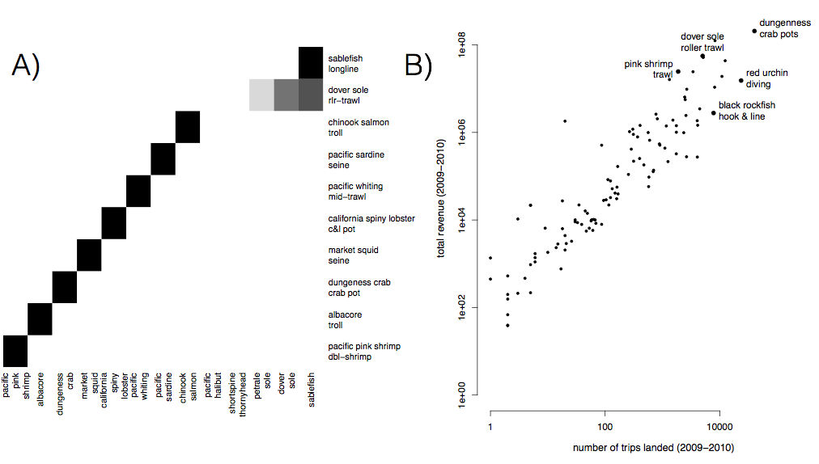

Figure S1. A) Species composition for top ten realized fisheries (rows). Cell color represents the proportion of landings for which each species (column) is responsible. Most of the biggest realized fisheries are composed of primarily a single species, but groundfish trawl is multispecies. B) Comparison of effort and revenue for all realized fisheries between 2009-2010.

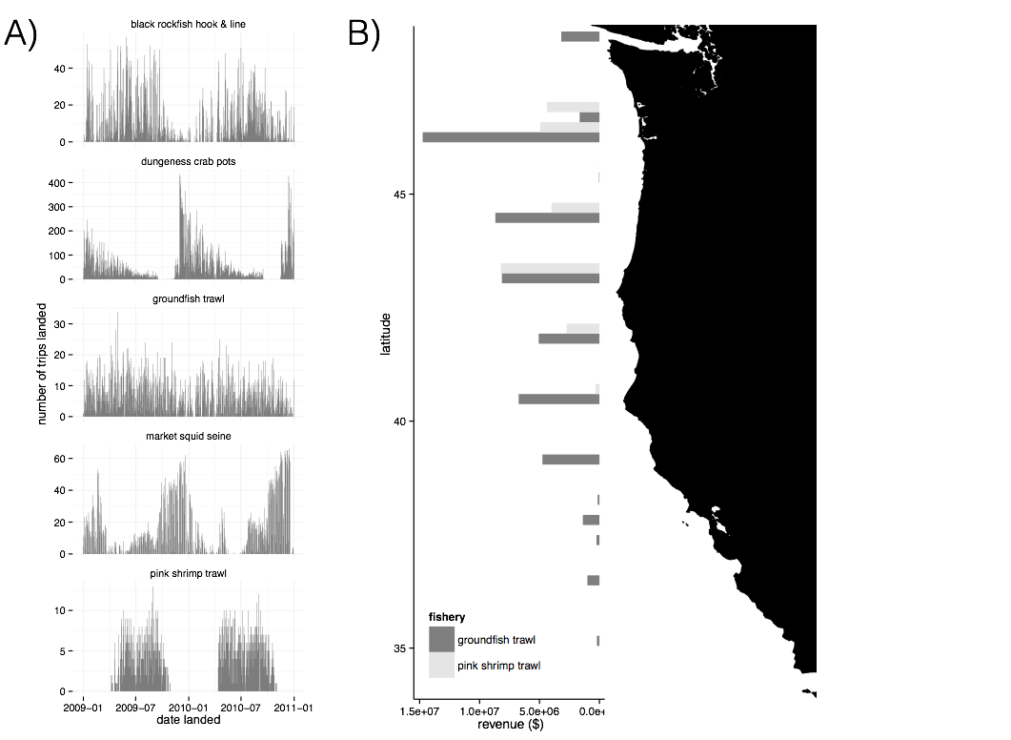

Figure S2. A) Seasonality of five major realized fisheries between 2009-2010. Distinct seasonal patterns are observed in ungeness crab, market squid and pink shrimp fisheries. B) Spatial structure of landings for two example fisheries between 2009-2010. Landings are binned by latitude. Pink shrimp trawl is landed further north, while groundfish trawl landings are distributed more evenly across the coast.

Participation Networks

[to be added]

State and Coast wide Node Strength and Betweenness Centrality

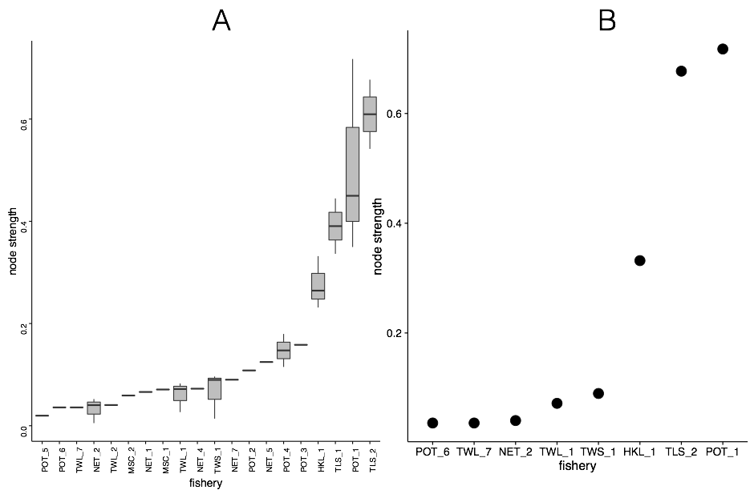

Figure S3. Node strength measured for A) state and b) coastwide participation networks.

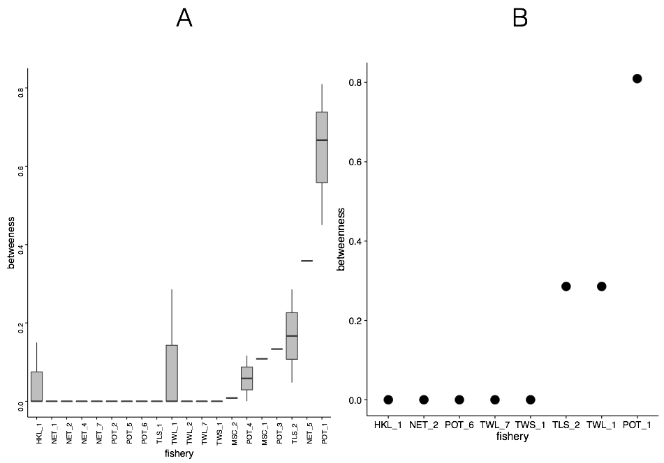

Figure S4. Betweenness centrality measured for A) state and B) coastwide participation networks.

CHAPTER THREE

The effects of a management action on the broader marine socio-ecological system[3]

Abstract

There is widespread recognition that ecosystem-based management requires an understanding of the connectivity within and between the human and ecological subcomponents of marine systems. Mapping these social-ecological connections have resulted in considerable insight, often by identifying drivers unobservable from social or ecological studies alone. This connectivity is particularly important in fisheries, where socioeconomic or ecological changes in one fishery often have cascading effects that ultimately influence another. Yet despite this recognition, social dynamics are often missing and fishing fleets are usually represented as homogenous, specialist, and static. My results highlight that on the contrary commercial fishing fleets on the US west coast are highly heterogeneous with the majority of vessels being generalists, and that a change in management is associated with a shift in patterns of participation across fisheries.

Introduction

Ecosystem based fisheries management (EBFM) focuses on interactions between species and on the ecological effects of the biophysical environment. Due to a focus on these interactions, EBFM is often described as managing an ecosystem as a whole, rather than individual species. This approach recognizes that the food-web, abiotic conditions, and human harvest are all drivers of system dynamics and seeks to manage them holistically. As such, much work on EBFM has focused on building models of food-web dynamics, and to account for how abiotic conditions may drive species interactions. Interest in EBFM also comes at a time when the importance of human behavior is being recognized, natural-resource management and conservation efforts are increasingly framing approaches in terms of ecosystem services and characterizing ecosystems more broadly as social-ecological systems (Millennium Ecosystem Assessment 2005). EBFM dovetails with these trends and advises managers that human impacts should be included both to better represent the ecological impacts fisheries have and to capture livelihoods and human well-being derived from harvest (P. S. Levin et al. 2009).

These efforts to model both social and ecological dynamics of commercial fishery systems represent progress. However, in general there has been a bias towards studying ecological dynamics, with less focus on social or economic interactions. This is especially true of fishing fleets, which are largely modeled as independent populations of specialist vessels with no exchange among fisheries. Yet just as generalist predators can couple disparate food chains through broad diet preferences (Baskerville et al. 2011), there is evidence that vessels are often generalists: strategically entering and exiting fisheries depending on short term fluctuations in market, regulatory and ecological conditions (Hentati-Sundberg et al. 2014; Kasperski and Holland 2013; Sethi, Reimer, and Knapp 2014); and that multiple fleets target the same species (Coleman et al. 2004). Ignoring these details is problematic because (1) how vessels respond to changes in management is a major source of uncertainty in fisheries science (Fulton et al. 2010) and (2) because an often stated management goal is precisely to map the flows of ecosystem services and to incorporate “human dimensions” (Mace 2014; P. S. Levin et al. 2009). Therefore, quantifying and understanding “fisheries connectivity” is important if we are to transform ecosystem-based fisheries management from a concept that is biased towards understanding food-web connectivity only, into a more holistic systems-based fisheries management, where the interactions within and between both social and ecological subcomponents are understood and quantified.

The introduction of the Pacific Trawl Rationalization (catch share) program in the federal groundfish fishery in 2011 (80 FR 19034) is just the kind of decision that is likely to create a cascade of social and ecological effects (Essington 2010; Costello, Gaines, and Lynham 2008). Previous work examining the participation of vessels across fisheries has shown that in the absence of catch shares, management can act as a driver of fishing specialization (Hentati-Sundberg et al. 2014; Kasperski and Holland 2013) and lead to inefficiencies. A catch shares system guarantees each fisher an individual and tradable quota, in theory ending the race to fish (Costello, Gaines, and Lynham 2008; Pfeiffer and Gratz 2016). It has also been shown that catch shares make fisheries more “efficient”, that is poor performing fishermen in overcapitalized fisheries generally sell their quota to more successful fishermen (Hilborn et al. 2001). In the long run though, there is evidence to suggest that catch shares can lead to diminished participation in a fishery. It is thus unclear how quota guarantees and changes in efficiency together influence entries and exits from fisheries, overall participation, and consequent diversification and connectivity among fisheries.

Here I use US west coast fisheries as a case study to develop a novel classification to characterize the diversity of revenue streams and and participation across fisheries for individual vessels and entire fishing communities (ports). My detailed study of fishery connectivity highlights the heterogeneous and dynamic nature of the social component of marine systems. In so doing, it underscores the gains to be had by incorporating such detail into existing conceptual and mathematical frameworks for EBFM.

Methods

Description of Data Sources

I collected vessel landings tickets for all commercial landings on the US west-coast between 2009-2013 from the Pacific Fisheries Information Network (PacFIN) database ([www.psmfc.org](http://www.psmfc.org/)). These data were filtered for vessels with an average of at least $5,000 in annual revenue and I further removed vessels that landed commercial catch in Alaska. I did not analyze landings from 2011, a management transition year in which catch shares were established. In doing so I restricted my analysis to fisheries landings before and after the implementation of catch shares. This left 2,413 vessels that were responsible for approximately 93% of the total revenue and biomass commercially landed on the US west-coast during this period.

Calculating Changes in Vessel and Community Level Fishing Diversity

Using a métier analysis (described in detail in Chapter 2) I classified each trip in the landings data to a realized fishery on the basis of gear and species assemblage. Using these classifications I calculated vessel revenue diversity using the effective Shannon index *H* (Jost 2006). This metric quantifies variability in the proportion of revenue *pf* derived from each realized fishery *f* (identified from the clustering approach described above), such that revenue diversity *H* for vessel *j* is calculated as

|  |  |
| --- | --- |
|  | (1) |

where *F* is the number of realized fisheries. I define specialist vessels as those that land in a single realized fishery (*H* = 1) and generalist vessels are vessels that land in more than realized fishery (*H* > 1).

To represent connectivity among realized fisheries at the port level I built participation networks (see Chapter 2), which are weighted networks where nodes represented a realized fishery, and the strength of the connections between nodes represented the number of vessels that landed catch in both over a given period. More formally, for each port *k* I built a network *Gk,XY* in which an edge weight between two nodes *X* and *Y* was the number of vessels participating in fishery *X* and *Y*. To measure port-level fisheries connectivity I calculated the link density (*LD,* number of edges divided by nodes) which scales both with network size and interconnectedness. Because the network is undirected, this value can be interpreted as two times the average number of fisheries to which a fishery is connected (i.e. all vessels participate in both fisheries) at port *k*.

In order to test whether realized fishery participation at the vessel or port level changes as a function of the implementation of catch shares, I assigned vessels and ports to one of three categories: *M1*, *M2* or*M3*. *M1*: vessels (ports) unaffected by catch shares were termed the *general participants*, which included only those vessels (ports) for which I observed no commercial landings in the catch-shares affected fishery in 2009-2010 or 2012-2013 (*nvessels* = 1,878, *nports* = 52). *M1*: *catch share participants* were those vessels (ports) had landings in the limited entry trawl fishery prior to 2011 and continued to have catch share quota landings after 2011 (*nvessels* = 71, *nports* = 16). *M3*:, *limited entry exits* were those vessels (ports) that landed in the limited entry trawl fishery prior to 2011, but had no landings using catch shares quota after 2011 (*M3, nvessels =* 35, *nports* = 10, Fig. 2). By comparing the general participants to vessels (ports) affected by catch shares (*catch share participants* and *limit entry exits*) I were able to control for exogenous inter-annual variation in revenue diversity present in both groups of vessels.

Effects of Catch Shares on Revenue Diversity and Fisheries Connectivity

I used linear regressions to determine whether a change from limited-entry to catch-shares management in the limited entry groundfish trawl sector was associated with a change in revenue diversity at the vessel level and/or a change in fisheries connectivity at the port level. For each vessel and port (henceforth I drop the indices for vessel and port for brevity)Icalculated the change in revenue diversity as the difference in revenue diversity before (*Hpre*) and after (*Hpost*) the implementation of catch shares as *ΔH = Hpost – Hpre*. I defined a change in fisheries connectivity for each port as the difference in link density before (*Cpre*) and after (*Cpost*) the implementation of catch shares as *ΔC = Cpost – Cpre*. Thus a value of zero for Δ*H* or Δ*C* indicated there was no change in revenue diversity or fisheries connectivity for a given port, respectively, between the two periods, and a positive value indicated the vessel or port increased the evenness and/or the number of fisheries from which it received revenue.

At the vessel level, if catch shares allowed more flexibility in fisheries participation, I would expect that catch share participants would, on average, demonstrate increased revenue diversity after the implementation of catch shares. To this end, I conducted a linear regression to determine the relationship between Δ*H* and the three vessel categories *M1* (general participants), *M2* (catch share participants) and *M3* (limited entry exits). However, the ability to change diversity between two periods is related to the starting period diversity. For example, if a vessel is a specialist (i.e. *H* = 1), then it is impossible for that vessel to have a drop in diversity and any random variation will bias *ΔH* upwards. Similarly, if a vessel was maximally diversified, then the vessel could either remain the same or with a random drop in diversity. Thus, I also evaluated a model in which the pre-catch share revenue diversity *Hpre* of each vessel was a covariate.

At the port level, I used similar regressions to those employed at the vessel level, to determine whether a change to catch shares management in the limited entry groundfish trawl sector was associated with a change in fishery connectivity. Thus I also regressed Δ*C* against catch shares participation with and without *Cpre* to catch shares as a covariate.

In both the vessel and port level analyses, the Akaike Information Criterion (AIC) was used to find the most parsimonious model which balanced both the goodness of fit, as measured by likelihood, and model complexity, as measured by the number of parameters (Burnham and Anderson 2002). I calculated 95% confidence intervals by randomly selected data with replacement, from both the vessel and port datasets, and repeated this procedure 10,000 times.

Results

Vessel and Community Level Fishing Diversity

I found that between the start of 2009 and the end of 2010, 66% of commercial vessels on the west coast participated in more than one realized fishery (Figure 1a) although the degree to which vessels diversified varied. Breaking these patterns down regionally using PFMC management regions, generalists outnumbered specialists (Figure 1b). The distribution of diversity varied among the generalists, from vessels that were highly specialized, but had a few landings in additional fisheries to those that fished in many fisheries evenly (Figure 1c). Notably, the majority of diversified vessels revenue was dominated by revenue from a single fishery (71%), with very small percentages coming from alternatives. However almost a quarter (24%) of diversified vessels were participating in at least two fisheries equally, with some vessels (4%) participating evenly in more than three fisheries (Figure 1c).

../../Desktop/CNH/Analysis/Metiers/writing/draft/fig2.pdf

Figure 1. Distribution of revenue diversity at the vessel level measured as the effective shannon index of revenue plotted in three different ways: A) coast wide, B) by management region, and C) breakdown of generalism for each management sector. I defined generalists as vessels that landed in more than one realized fishery. I found that generalists outnumbered specialists (A, B), although the degree of generalism varied (C).

I also found differences in the number and interconnectedness of fisheries across ports (Figure 2). Ports had between 0 and 7 fisheries that were connected. Most ports had a spectrum of vessels landing at them and I found that there was a positive, albeit weak, relationship between vessel and port level diversity (Spearman’s correlation 0.185, p < 2.2e-16, Fig S3).

Effects of catch shares management on individual vessel diversification and community-level participation networks

Two-thirds (66%) of vessels that operated in the catch shares affected fishery continued to participate in it following the implementation of catch shares, while only a minority (6%) of vessels left commercial fishing altogether. Of vessels which continued fishing in the catch-shares fishery, 87% of vessels adjusted their fishing participation, entering or exiting new fisheries. A third group consisted of vessels that exited catch shares but continued to fish commercially (28%) (Figure 2). These vessels showed a mixed response, with increased and decreased fishing diversity observed.

../../Desktop/CNH/Analysis/Metiers/writing/draft/fig4.pdf

Figure 2. I map the ways that a vessel can respond to the implementation of catch shares. Vessels that were directly affected by catch share implementation are those that fished in the limited entry (LE) groundfish fleet between 2009-2010. After 2011, vessels either continue to participate in the groundfish trawl fishery by landing with quota, or leave the catch share fishery and either leave commercial fishing entirely or continue to fish in other commercial fisheries. The width of the bar in the decision tree is proportional to the absolute number of vessels which follow a given path given by the number. Percentages are relative to each decision point. I find that very few vessels which stopped fishing in the groundfish fishery actually left commercial fishing altogether, and vessels which participated in catch shares changing their participation across fisheries.

Over our study time period, vessels that continued to fish became more diversified on average (Figure 3). Vessels that participated in catch shares, post 2011, saw an increase in their revenue diversity that was twice that for vessels which exited the catch share fishery. Notably, the change in revenue diversity was strongly explained by the revenue diversity the vessels had prior to the implementation of catch shares (in 2009-2010). Vessels with higher (lower) participation diversity prior to catch shares were more likely to show a reduction (increase) in diversity following catch shares (Table S2).

../../Desktop/CNH/Analysis/Metiers/writing/draft/fig5.pdf

Figure 3. Estimated effects of catch shares on revenue diversity for vessels, bars represent 95% confidence intervals. Vessels that participate in catch share increase in revenue diversity more than either the general participants or those that exited catch shares. At the port level the best supported model does not include a term for participation in catch shares.

At the port level I found that ports that there was a non-significant increase in fisheries connectivity by approximately 5% on average (two sided t-test p-value = 0.3287), and this was predicted by previous fisheries connectivity (*Cpre*) (Table S1, S2). However, the model which best explained the change in fisheries connectivity did not include terms for a port’s relationship to catch shares (*Mn*).

Discussion

There is widespread recognition that ecosystem-based fishery management requires an understanding of the connectivity within and between the human and ecological subcomponents of marine systems (J. L. Anderson et al. 2015). Mapping these social-ecological connections has resulted in considerable insight, often by identifying drivers unobservable from social or ecological studies alone (Brashares et al. 2004; Lade et al. 2015). This connectivity is particularly important in fisheries, where socioeconomic or ecological changes in one fishery can have cascading effects that ultimately influence others (Steneck et al. 2011; Lade et al. 2015). Yet despite this recognition, social dynamics are often missing and fishing fleets are usually represented as homogenous and non-interacting (Field 2004). Our results highlight that on the contrary fishing fleets are highly heterogeneous and continually changing in size, effort level, and composition, as numerous exogenous and endogenous forces influence them (Opaluch and Bockstael 1984). More generally, this study highlights a perhaps underappreciated aspect of social-ecological systems: as in food webs and social networks, the consequences of environmental and management changes are determined large part by the connectivity between nodes.

We found that the majority of vessels on the US west coast engage in multiple fisheries and that the implementation of the Pacific Trawl Rationalization program appears to have changed patterns of participation across fisheries. Greater than 60% of commercial fishing vessels were generalists, participating in more than one realized fishery. The revenue of each of these generalists was thus tied to multiple fisheries, effectively connecting them and setting up the potential for linked social-ecological dynamics that were previously invisible. The social implications of generalist fishing practices with corresponding diversified revenue portfolios have been most directly related to reduced exposure to income risk (Kasperski and Holland 2013; Sethi, Reimer, and Knapp 2014), with previous work identifying that vessels with more diverse revenue streams have less variable revenues (Kasperski and Holland 2013). In contrast to US west coast fisheries, Steneck et al. (2011) has documented how Maine fishermen have increasingly become dependent on a single species due to interactions among markets and ecological conditions. In addition, Hentati-Sundberg et al. (2014) and Stoll et al. (2016) have shown how commercial fishermen in Sweden and the Gulf of Maine respectively have grown increasingly specialized as management became more restrictive. Thus, while many forms of management can be constraining, reducing the portfolio of fisheries prosecuted by individual fishermen, catch shares management may expand portfolios. Further study is needed to determine whether the ubiquity of generalists on the US west-coast is indicative of systemic risk-adverse behavior, and whether revenue diversity confers a general resilience in fishermen’s revenues to perturbation, such as diminished catch due to exogenous environmental factors or a change in management or markets of particular fisheries.

Previous research on fishery diversity and revenue variability (Kasperski and Holland 2013)has focused primarily on the impacts of catch shares on the vessels that have continued to operate within the fishery of interest, assuming that vessels that exit also exit commercial fishing entirely. Our analysis shows that for the US west-coast, the majority of vessels that participated in the groundfish fishery prior to the implementation of catch shares, continued to operate after the management change albeit in other realized fisheries (Figure 2). This highlights the need to quantify how a management change, or any other perturbation, is felt throughout the marine social-ecological system as vessels/individuals reorganize their participation across realized fisheries.

The redistribution of fishing effort across a fisheries participation network is directly analogous to (changes in) predation pressure in a food-web. Specifically, if we think of vessels as predators, then the realized fisheries that they participate in are their prey. As I have shown, there are many specialist vessel/predators, but the majority of fishermen/vessels are generalist predators with a broad diet preference. In natural systems, a predator’s diet preference is largely determined by the physiological adaptations of the predator. Here, the analogy extends to the gear and skill that each vessel has. This is relevant when considering the redistribution of fishing effort across participation networks. Vessels geared and skilled at harvesting certain sets of species, will not immediately start harvesting other target species that require completely different gear and skills. This is reflected in the different realized fisheries that any one vessel participates in over a given year, and in general it is related to the topology of the participation networks.

For example, if there is a pair of species that are unconnected ecologically (i.e. there is no link between them in the food-web), but there are vessels that harvest both (i.e. there is a link in the participation network between these species’ realized fisheries), then there is a transitive link. As a consequence, a management change that affects vessel participation in one fishery, will affect that status of the (ecologically unconnected) stock of the other species. Dungeness crab and albacore tuna fisheries on the US west coast provide an appealing (but currently untested) example. Here, I find these two realized fisheries to be commonly connected by vessels at the port level, yet these species do not interact directly in the ocean. Examining changes in revenue diversity and vessel participation in the albacore tuna fishery after the recent closure of the Dungeness crab fishery in Washington and Oregon would be an excellent test of how connectivity influences fisheries participation. In general, environmental or management perturbations will ripple through these participation networks, and that their topology as well as the adaptability of fishermen, will largely determine their economic impacts.

In conclusion, our results highlight the need to consider fisheries as connected and dynamic entities. Not only does EBFM need to acknowledge the links between species in food-webs, but there needs to be an equal emphasis on the connectivity between fisheries, based on the participation of vessels, and on the economic consequences of the topology of the participation networks. I have shown that fishery participation is heterogeneous, varying greatly from place to place, and dynamic, responding to the implementation of catch shares in the groundfish fishery. If we can broaden the conceptual and mathematical models of marine systems to include such properties, then we will be truly on our way to developing systems-based fisheries management, which is likely to lead to better performing governance institutions in the future.

Acknowledgements

We thank PacFin for access to the data, the observers and fishermen on the US west coast for insightful discussions, and Emily Klein for discussions on this project. I acknowledge support from the National Science Foundation (GRFP, GEO-1211972) and GreenMar (Consortium Agreement GreeMar-AGMT dtd 05-05-2014, Prime Nordforsk Project Number: 61582).

Literature Cited

Anderson, James L, Christopher M Anderson, Jingjie Chu, Jennifer Meredith, Frank Asche, Gil Sylvia, Martin D Smith, et al. 2015. “The Fishery Performance Indicators: a Management Tool for Triple Bottom Line Outcomes.” Edited by George Tserpes. *PloS One* 10 (5): e0122809–20. doi:10.1371/journal.pone.0122809.

Barnosky, Anthony D, Paul L Koch, Robert S Feranec, Scott L Wing, and Alan B Shabel. 2004. “Assessing the Causes of Late Pleistocene Extinctions on the Continents..” *Science (New York, N.Y.)* 306 (5693): 70–75. doi:10.1126/science.1101476.

Barrat, A, M Barthelemy, R Pastor-Satorras, and A Vespignani. 2004. “The Architecture of Complex Weighted Networks.” *Proceedings of the National Academy of Sciences* 101 (11). National Acad Sciences: 3747–52. doi:10.1073/pnas.0400087101.

Baskerville, Edward B, Andy P Dobson, Trevor Bedford, Stefano Allesina, T Michael Anderson, and Mercedes Pascual. 2011. “Spatial Guilds in the Serengeti Food Web Revealed by a Bayesian Group Model.” Edited by Lauren Ancel Meyers. *PLoS Computational Biology* 7 (12). Public Library of Science: e1002321. doi:10.1371/journal.pcbi.1002321.

Boonstra, Wiebren J, and Jonas Hentati Sundberg. 2014. “Classifying Fishers' Behaviour. an Invitation to Fishing Styles,” August, n–a–n–a. doi:10.1111/faf.12092.

Brashares, Justin S, Peter Arcese, Moses K Sam, Peter B Coppolillo, A R E Sinclair, and Andrew Balmford. 2004. “Bushmeat Hunting, Wildlife Declines, and Fish Supply in West Africa.” *Science (New York, N.Y.)* 306 (5699). American Association for the Advancement of Science: 1180–83. doi:10.1126/science.1102425.

Burnham, Kenneth P, and David R Anderson. 2002. *Model Selection and Multimodel Inference: a Practical Information-Theoretic Approach*. Edited by Springer Science & Business Media.

Castree, Noel, William M Adams, John Barry, Daniel Brockington, Bram Büscher, Esteve Corbera, David Demeritt, et al. 2014. “Changing the Intellectual Climate.” *Nature Climate Change* 4 (9). Nature Publishing Group: 763–68. doi:10.1038/nclimate2339.

Ceballos, G, P R Ehrlich, A D Barnosky, A Garcia, R M Pringle, and T M Palmer. 2015. “Accelerated Modern Human-Induced Species Losses: Entering the Sixth Mass Extinction.” *Science Advances* 1 (5). American Association for the Advancement of Science: e1400253–53. doi:10.1126/sciadv.1400253.

Coleman, Felicia C, Will F Figueira, Jeffrey S Ueland, and Larry B Crowder. 2004. “The Impact of United States Recreational Fisheries on Marine Fish Populations..” *Science (New York, N.Y.)* 305 (5692): 1958–60. doi:10.1126/science.1100397.

Conservation International. 2016. “Mission and Vision.” Accessed April 14. http://www.conservation.org/global/philippines/about/Pages/mission.aspx.

Costello, Christopher, Steven D Gaines, and John Lynham. 2008. “Can Catch Shares Prevent Fisheries Collapse?.” *Science (New York, N.Y.)* 321 (5896): 1678–81. doi:10.1126/science.1159478.

Dailey, Murray D, and Donald J Reish. 1993. *Ecology of the Southern California Bight*. Univ of California Press.

Department of the Interior. 2016. “The Bureau of Land Management: Who We Are, What We Do.” Accessed April 14. http://www.blm.gov/wo/st/en/info/About_BLM.print.html.

Deporte, N, C Ulrich, S Mahevas, S Demaneche, and F Bastardie. 2012. “Regional Metier Definition: a Comparative Investigation of Statistical Methods Using a Workflow Applied to International Otter Trawl Fisheries in the North Sea.” *ICES Journal of Marine Science* 69 (2): 331–42. doi:10.1093/icesjms/fsr197.

Dirzo, Rodolfo, Hillary S Young, Mauro Galetti, Gerardo Ceballos, Nick J B Isaac, and Ben Collen. 2014. “Defaunation in the Anthropocene..” *Science (New York, N.Y.)* 345 (6195). American Association for the Advancement of Science: 401–6. doi:10.1126/science.1251817.

Essington, T E. 2010. “Ecological Indicators Display Reduced Variation in North American Catch Share Fisheries.” *Proceedings of the National Academy of Sciences* 107 (2): 754–59. doi:10.1073/pnas.0907252107.

Field, John C. 2004. “Application of Ecosystem-Based Fishery Management Approaches in the Northern California Current .” Edited by Robert C Francis.

Freeman, Linton C, Douglas Roeder, and Robert R Mulholland. 1979. “Centrality in Social Networks: II. Experimental Results.” *Social Networks* 2: 119–41.

Fuller, Emma, Eleanor Brush, and Malin L Pinsky. 2015. “The Persistence of Populations Facing Climate Shifts and Harvest.” *Ecosphere* 6 (9). Ecological Society of America: art153–16. doi:10.1890/ES14-00533.1.

Fulton, Elizabeth A, Anthony D M Smith, David C Smith, and Ingrid E van Putten. 2010. “Human Behaviour: the Key Source of Uncertainty in Fisheries Management.” *Fish and Fisheries* 12 (1): 2–17. doi:10.1111/j.1467-2979.2010.00371.x.

Galloway, James N, and Ellis B Cowling. 2002. “Reactive Nitrogen and the World: 200 Years of Change.” *Ambio* 31 (2): 64–71. doi:10.1579/0044-7447-31.2.64.

Hentati-Sundberg, J, J Hjelm, W J Boonstra, and H Österblom. 2014. “Management Forcing Increased Specialization in a Fishery System.” *Ecosystems* 18 (1). Springer US: 45–61. doi:10.1007/s10021-014-9811-3.

Hicks, Christina C, Arielle Levine, Arun Agrawal, Xavier Basurto, Sara J Breslow, Courtney Carothers, Susan Charnley, et al. 2016. “Engage Key Social Concepts for Sustainability.” *Science (New York, N.Y.)* 352 (6281): 38–40. doi:10.1126/science.aad4977.

Hilborn, Ray, Jean-Jacques Maguire, Ana M Parma, and Andrew A Rosenberg. 2001. “The Precautionary Approach and Risk Management: Can They Increase the Probability of Successes in Fishery Management?.” *Canadian Journal of Fisheries and Aquatic Sciences* 58 (1): 99–107. doi:10.1139/cjfas-58-1-99.

Jackson, J B, M X Kirby, W H Berger, K A Bjorndal, L W Botsford, B J Bourque, R H Bradbury, et al. 2001. “Historical Overfishing and the Recent Collapse of Coastal Ecosystems..” *Science (New York, N.Y.)* 293 (5530): 629–37. doi:10.1126/science.1059199.

Jensen, Olaf P, Trevor A Branch, and Ray Hilborn. 2011. “Marine Fisheries as Ecological Experiments.” *Theoretical Ecology* 5 (1): 3–22. doi:10.1007/s12080-011-0146-9.

Jepson, Michael, and Lisa L Colburn. 2013. “Development of Social Indicators of Fishing Community Vulnerability and Resilience in the U.S. Southeast and Northeast Regions.” NMFS-F/SPO-129. *U.S. Department of Commerce, NOAA Technical Memorandum., NOAA Technical Memorandum NMFS-NWFSC-85*. U.S. Dept. of Commerce.

Jordan, Ferenc. 2009. “Keystone Species and Food Webs..” *Philosophical Transactions of the Royal Society of London. Series B, Biological Sciences* 364 (1524). The Royal Society: 1733–41. doi:10.1098/rstb.2008.0335.

Jost, Lou. 2006. “Entropy and Diversity.” *Oikos* 113 (2): 363–75.

Kareiva, Peter, and Michelle Marvier. 2012. “What Is Conservation Science?.” *Bioscience* 62 (11): 962–69. doi:10.1525/bio.2012.62.11.5.

Karp, Daniel S, Chase D Mendenhall, Elizabeth Callaway, Luke O Frishkoff, Peter M Kareiva, Paul R Ehrlich, and Gretchen C Daily. 2015. “Confronting and Resolving Competing Values Behind Conservation Objectives.” *Proceedings of the National Academy of Sciences* 112 (35): 11132–37. doi:10.1073/pnas.1504788112.

Kasperski, S, and D S Holland. 2013. “Income Diversification and Risk for Fishermen.” *Proceedings of the National Academy of Sciences*. doi:10.1073/pnas.1212278110/-/DCSupplemental.

Lade, Steven J, Alessandro Tavoni, Simon A Levin, and Maja Schlüter. 2013. “Regime Shifts in a Social-Ecological System.” *Theoretical Ecology* 6 (3): 359–72. doi:10.1007/s12080-013-0187-3.

Lade, Steven J, Susa Niiranen, Jonas Hentati Sundberg, Thorsten Blenckner, Wiebren J Boonstra, Kirill Orach, Martin F Quaas, Henrik Österblom, and Maja Schlüter. 2015. “An Empirical Model of the Baltic Sea Reveals the Importance of Social Dynamics for Ecological Regime Shifts..” *Proceedings of the National Academy of Sciences of the United States of America* 112 (35): 11120–25. doi:10.1073/pnas.1504954112.

Legendre, P, and L Legendre. 2012. *Numerical Ecology*. Elsevier.

Levin, Phillip S, Michael J Fogarty, Steven A Murawski, and David Fluharty. 2009. “Integrated Ecosystem Assessments: Developing the Scientific Basis for Ecosystem-Based Management of the Ocean.” *PLoS Biology* 7 (1): e1000014–16. doi:10.1371/journal.pbio.1000014.

Levin, Simon. 1999. *Fragile Dominion*. Basic Books.

Lunt, Daniel J, Alan M Haywood, Gavin A Schmidt, Ulrich Salzmann, Paul J Valdes, and Harry J Dowsett. 2009. “Earth System Sensitivity Inferred From Pliocene Modelling and Data.” *Nature Geoscience* 3 (1). Nature Publishing Group: 60–64. doi:10.1038/ngeo706.

Mace, Georgina M. 2014. “Ecology. Whose Conservation?.” *Science (New York, N.Y.)* 345 (6204). American Association for the Advancement of Science: 1558–60. doi:10.1126/science.1254704.

McCauley, Douglas J, Malin L Pinsky, Stephen R Palumbi, James A Estes, Francis H Joyce, and Robert R Warner. 2015. “Marine Defaunation: Animal Loss in the Global Ocean..” *Science (New York, N.Y.)* 347 (6219). American Association for the Advancement of Science: 1255641–41. doi:10.1126/science.1255641.

McShane, Thomas O, Paul D Hirsch, Tran Chi Trung, Alexander N Songorwa, Ann Kinzig, Bruno Monteferri, David Mutekanga, et al. 2011. “Hard Choices: Making Trade-Offs Between Biodiversity Conservation and Human Well-Being.” *Biological Conservation* 144 (3). Elsevier Ltd: 966–72. doi:10.1016/j.biocon.2010.04.038.

Millennium Ecosystem Assessment. 2005. “*Ecosystems and Human Well-Being: Synthesis*.” *Island Press*. Washington, DC.

Norman, Karma, Jennifer Sepez, Heather Lazarus, Nicole Milne, Christina Package, Suzanne Russell, Kevin Grant, et al. 2007. “Community Profiles for West Coast and North Pacific Fisheries, Washington, Oregon, California, and Other U.S. States.” *U.S. Department of Commerce, NOAA Technical Memorandum., NOAA Technical Memorandum NMFS-NWFSC-85*, December, 602p.

Opaluch, J J, and N E Bockstael. 1984. “Behavioral Modeling and Fisheries Management.” *Marine Resource Economics*. doi:10.2307/42628847.

Ostrom, Elinor. 2009. “A General Framework for Analyzing Sustainability of Social-Ecological Systems.” *Science (New York, N.Y.)* 325 (5939): 419–22. doi:10.1126/science.1172133.

Pacific Fishery Management Council. 2014. “*Pacific Coast Fishery Ecosystem Plan for the U.S. Portion of the California Current Large Marine Ecosystem*.” 7700 NE Ambassador Place, Suite 101, Portland, Oregon 97220-1384: Pacific Fishery Management Council.

Pfeiffer, Lisa, and Trevor Gratz. 2016. “The Effect of Rights-Based Fisheries Management on Risk Taking and Fishing Safety.” *Proceedings of the National Academy of Sciences* 113 (10): 2615–20. doi:10.1073/pnas.1509456113.

Pollnac, Richard B, Tarsila Seara, Lisa L Colburn, and Michael Jepson. 2015. “Taxonomy of USA East Coast Fishing Communities in Terms of Social Vulnerability and Resilience.” *Environmental Impact Assessment Review* 55: 136–43.

Pons, Pascal, and Matthieu Latapy. 2005. “Computing Communities in Large Networks Using Random Walks.” *ArXiv Physics E-Prints*. http://arxiv.org/abs/physics/0512106#.

Rosvall, Martin, and Carl T Bergstrom. 2008. “Maps of Random Walks on Complex Networks Reveal Community Structure.” *Proceedings of the National Academy of Sciences* 105 (4). National Acad Sciences: 1118–23. doi:10.1073/pnas.0706851105.

Sethi, S A, M Reimer, and G Knapp. 2014. “Alaskan Fishing Community Revenues and the Stabilizing Role of Fishing Portfolios.” *Marine Policy*. doi:10.1016/j.marpol.2014.03.027.

Sinclair, A R E, SIMON A R MDUMA, J GRANT C HOPCRAFT, John M Fryxell, Ray Hilborn, and SIMON THIRGOOD. 2007. “Long-Term Ecosystem Dynamics in the Serengeti: Lessons for Conservation.” *Conservation Biology* 21 (3). Blackwell Publishing Inc: 580–90. doi:10.1111/j.1523-1739.2007.00699.x.

Smith, Martin D, and James E Wilen. 2003. “Economic Impacts of Marine Reserves: the Importance of Spatial Behavior.” *Journal of Environmental Economics and Management* 46 (2): 183–206. doi:10.1016/S0095-0696(03)00024-X.

Smith, Martin D, Junjie Zhang, and Felicia C Coleman. 2008. “Econometric Modeling of Fisheries with Complex Life Histories: Avoiding Biological Management Failures.” *Journal of Environmental Economics and Management* 55 (3): 265–80. doi:10.1016/j.jeem.2007.11.003.

Steneck, R S, T P Hughes, J E CINNER, W N ADGER, S N ARNOLD, F BERKES, S A BOUDREAU, et al. 2011. “Creation of a Gilded Trap by the High Economic Value of the Maine Lobster Fishery.” *Conservation Biology* 25 (5): 904–12. doi:10.1111/j.1523-1739.2011.01717.x.

Tavoni, Alessandro, Maja Schlüter, and Simon Levin. 2012. “The Survival of the Conformist: Social Pressure and Renewable Resource Management.” *Journal of Theoretical Biology* 299 (April): 152–61. doi:10.1016/j.jtbi.2011.07.003.

The Nature Conservancy. 2016. “About US: Vision and Mission.” Accessed April 14.

US Forest Service. 2015. “USDA Forest Service Strategic Plan: FY 2015-2020.” Vol. 1045.

van Putten, Ingrid E, Soile Kulmala, Olivier Thébaud, Natalie Dowling, Katell G Hamon, Trevor Hutton, and Sean Pascoe. 2012. “Theories and Behavioural Drivers Underlying Fleet Dynamics Models.” *Fish and Fisheries* 13 (2): 216–35. doi:10.1111/j.1467-2979.2011.00430.x.

Waters, C N, J Zalasiewicz, C Summerhayes, A D Barnosky, C Poirier, A Ga uszka, A Cearreta, et al. 2016. “The Anthropocene Is Functionally and Stratigraphically Distinct From the Holocene.” *Science (New York, N.Y.)* 351 (6269): aad2622–22. doi:10.1126/science.aad2622.

Wilen, J E, M D Smith, and D Lockwood. 2002. “Avoiding Surprises: Incorporating Fisherman Behavior Into Management Models.” *Bulletin of Marine …*.

Worm, Boris, Ray Hilborn, Julia K Baum, Trevor A Branch, Jeremy S Collie, Christopher Costello, Michael J Fogarty, et al. 2009. “Rebuilding Global Fisheries..” *Science (New York, N.Y.)* 325 (5940). American Association for the Advancement of Science: 578–85. doi:10.1126/science.1173146.

Supplemental information

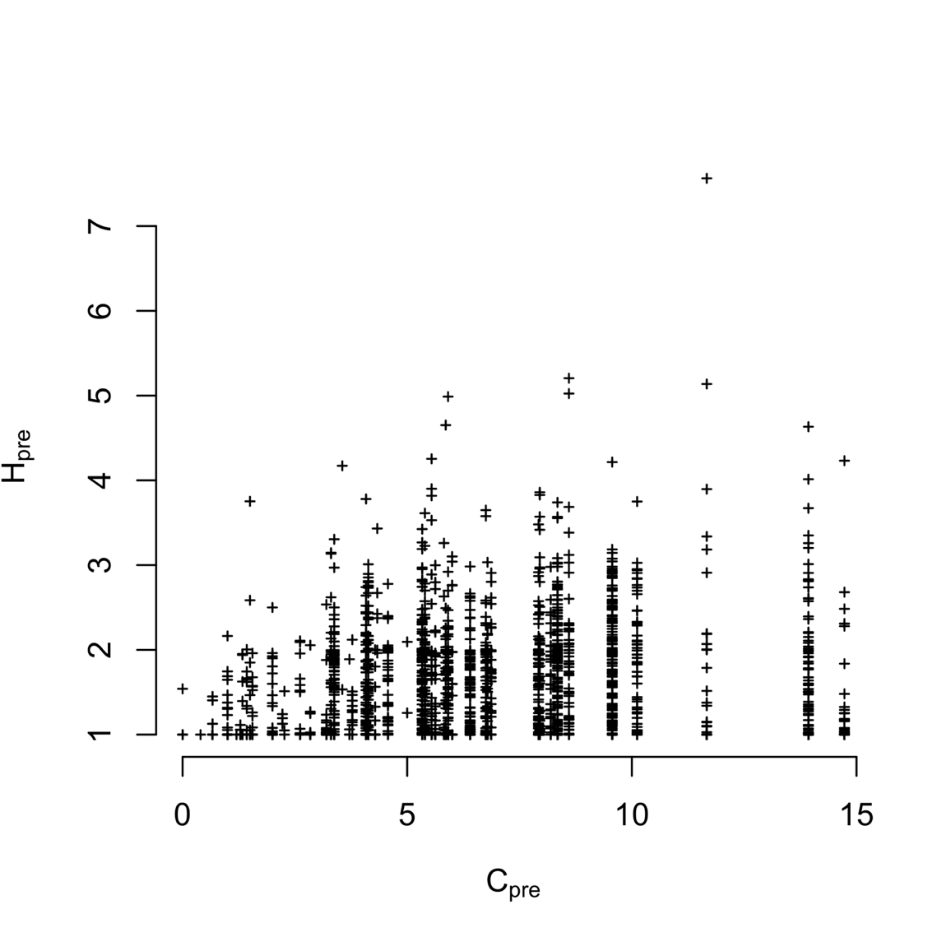

Figure S1. Plotting vessel participation diversity (H, 2009-2010) against port connectivity (C, 2009-2010). I find vessel and port level diversity weakly correlated (Spearman’s correlation 0.1849745, p < 2.2e-16). But the most diverse vessels tend to be found in the most diverse ports.

Table S1. Akaike Information Criterion (AIC) values for the models with and without terms for catch shares. Values for the best model at each level are in boldface.

|  |  |  |  |  |  |  |
| --- | --- | --- | --- | --- | --- | --- |
| *Level* | *Hpre* | *Catch shares* | *No. Parameters (K)* | *AIC* | *ΔAIC* | *Adjusted R2* |
| *Vessel* | *Yes* | *No* | *1* | *3140.767* | *30.916* | *0.2392* |
|  | *Yes* | *Yes* | *2* | *3109.851* | *0* | *0.2471* |
|  | *No* | *Yes* | *1* | *3643.718* | *533.867* | *0.01007* |
| *Port* | *Yes* | *No* | *1* | *184.1367* | *0* | *0.8866* |
|  | *Yes* | *Yes* | *2* | *186.5804* | *2.4437* | *0.8858* |
|  | *No* | *Yes* | *1* | *325.8152* | *141.6785* | *0.2404* |

Table S2. Coefficient values for two best fit models for each scale of analysis

|  |  |  |  |
| --- | --- | --- | --- |
| *Level* | *Variable* | *Best model* | *Second best* |
| *Vessel* | *Hpre* | *-0.46 (0.02)* | *-0.46 (0.10)* |
|  | *General fleet* | *0.74 (0.03)* | *0.74 (0.03)* |
|  | *Catch share participant* | *0.27 (0.07)* | *-* |
|  | *Limited entry exit* | *-0.24 (0.10)* | *-* |
| *Port* | *Cpre* | *-0.67 (0.03)* | *-0.66 (0.03)* |
|  | *General fleet* | *-* | *0.29 (0.27)* |
|  | *Catch share participant* | *-* | *0.19 (0.28)* |
|  | *Limited entry exit* | *-* | *0.33 (0.33)* |
|  |  |  |  |

Conclusions

Understanding how to balance human well-being and ecological integrity is one of the fundamental challenges in conservation and natural resource management(Mace 2014; Castree et al. 2014). As our human-footprint on ecosystems expands and deepens, we are increasingly realizing that human well-being is crucial to understanding social-ecological systems and managing them sustainably.

In my first chapter I add to the small, but growing literature that demonstrates the importance of considering resource-users’ dynamics when attempting to predict outcomes for biophysical systems. I show that the interactions between harvest and range shifts are approximately additive, but that the results are sensitive to the assumptions about harvesting reallocation of effort.

Despite conceptual advances in linking human-wellbeing to biophysical dynamics, a major challenge exists in operationalizing these conceptual framings. In my second chapter I take advantage of a unique dataset collected by fisheries manages on the US West Coast. Using these data I developed a novel network approach of linking the social system (i.e. fishing communities) to the ecological system (the fish). Because this approach made use of data collected by management, making it immediately operational for all managed fisheries in the US. Such a conceptual framework represents a major step forward for mapping and quantifying these linkages between social and natural systems. I add to this work by analyzing these resultant networks to show that the topological structure and modularity varied non-randomly, providing additional features that may be useful for mangers seeking to balance human well-being with sustainable populations of fish. Specifically, I find that Dungeness crab may represent a “keystone fishery” and linkages among that are counter-intuitive from a solely ecological perspective.

In my third chapter I analyzed patterns of participation across the US West Coast commercial fisheries before and after a major management change in a single fishery. Using individual and fishing community level analyses, using the framework described above, I show that the policy affected how fishermen shift their effort across fisheries at the individual level, but community level attributes remain unchanged. This work demonstrates how such social-ecological system level policy analysis may be conducted.

In this thesis I present theoretical models, a conceptual framework and empirical analyses focused on the question of how to quantitatively and comprehensively include people in food webs. This work helps move us towards a set of tools managers can use to evaluate policy efficacy in commercial fisheries social ecological systems in the face of rapid environmental change while balancing the need for ecological integrity and human well-being.

1. Published as Fuller, Brush, Pinsky (2015) Ecosphere
2. In preparation for submission at Fish & Fisheries
3. In preparation for submission at Canadian Journal of Aquatic and Fishery Sciences