CHAPTER THREE

The Effects of a Management Action on the Broader Marine Socio-Ecological System[[1]](#footnote-1)

Abstract

There is widespread recognition that ecosystem-based management requires an understanding of the connectivity within and between the human and ecological subcomponents of marine systems. Mapping these social-ecological connections have resulted in considerable insight, often by identifying drivers unobservable from social or ecological studies alone. This connectivity is particularly important in fisheries, where socioeconomic or ecological changes in one fishery often have cascading effects that ultimately influence another. Yet despite this recognition, social dynamics are often missing and fishing fleets are usually represented as homogenous, specialist, and static. My results highlight that on the contrary commercial fishing fleets on the US west coast are highly heterogeneous with the majority of vessels being generalists, and that a change in management is associated with a shift in patterns of participation across fisheries.

Introduction

Ecosystem based fisheries management (EBFM) focuses on interactions between species and on the ecological effects of the biophysical environment. Due to a focus on these interactions, EBFM is often described as managing an ecosystem as a whole, rather than individual species. This approach recognizes that the food-web, abiotic conditions, and human harvest are all drivers of system dynamics and seeks to manage them holistically. As such, much work on EBFM has focused on building models of food-web dynamics, and to account for how abiotic conditions may drive species interactions. Interest in EBFM also comes at a time when the importance of human behavior is being recognized, natural-resource management and conservation efforts are increasingly framing approaches in terms of ecosystem services and characterizing ecosystems more broadly as social-ecological systems (Millennium Ecosystem Assessment 2005). EBFM dovetails with these trends and advises managers that human impacts should be included both to better represent the ecological impacts fisheries have and to capture livelihoods and human well-being derived from harvest (Levin et al. 2009).

These efforts to model both social and ecological dynamics of commercial fishery systems represent progress. However, in general there has been a bias towards studying ecological dynamics, with less focus on social or economic interactions. This is especially true of fishing fleets, which are largely modeled as independent populations of specialist vessels with no exchange among fisheries. Yet just as generalist predators can couple disparate food chains through broad diet preferences (Baskerville et al. 2011), there is evidence that vessels are often generalists: strategically entering and exiting fisheries depending on short term fluctuations in market, regulatory and ecological conditions (Hentati-Sundberg et al. 2014; Kasperski and Holland 2013; Sethi, Reimer, and Knapp 2014); and that multiple fleets target the same species (Coleman et al. 2004). Ignoring these details is problematic because (1) how vessels respond to changes in management is a major source of uncertainty in fisheries science (Fulton et al. 2010) and (2) because an often stated management goal is precisely to map the flows of ecosystem services and to incorporate “human dimensions” (Mace 2014; Levin et al. 2009). Therefore, quantifying and understanding “fisheries connectivity” is important if we are to transform ecosystem-based fisheries management from a concept that is biased towards understanding food-web connectivity only, into a more holistic systems-based fisheries management, where the interactions within and between both social and ecological subcomponents are understood and quantified.

The introduction of the Pacific Trawl Rationalization (catch share) program in the federal groundfish fishery in 2011 (80 FR 19034) is just the kind of decision that is likely to create a cascade of social and ecological effects (Essington 2010; Costello, Gaines, and Lynham 2008). Previous work examining the participation of vessels across fisheries has shown that in the absence of catch shares, management can act as a driver of fishing specialization (Hentati-Sundberg et al. 2014; Kasperski and Holland 2013) and lead to inefficiencies. A catch shares system guarantees each fisher an individual and tradable quota, in theory ending the race to fish (Costello, Gaines, and Lynham 2008; Pfeiffer and Gratz 2016). It has also been shown that catch shares make fisheries more “efficient”, that is poor performing fishermen in overcapitalized fisheries generally sell their quota to more successful fishermen (Hilborn et al. 2001). In the long run though, there is evidence to suggest that catch shares can lead to diminished participation in a fishery. It is thus unclear how quota guarantees and changes in efficiency together influence entries and exits from fisheries, overall participation, and consequent diversification and connectivity among fisheries.

Here I use US West Coast fisheries as a case study to develop a novel classification to characterize the diversity of revenue streams and participation across fisheries for individual vessels and entire fishing communities (ports). My detailed study of fishery connectivity highlights the heterogeneous and dynamic nature of the social component of marine systems. In so doing, it underscores the gains to be had by incorporating such detail into existing conceptual and mathematical frameworks for EBFM.

Methods

Description of Data Sources

I collected vessel landings tickets for all commercial landings on the US West Coast between 2009-2013 from the Pacific Fisheries Information Network (PacFIN) database ([www.psmfc.org](http://www.psmfc.org/)). These data record the landing of 1.5 million metric tons of 221 different species, landed over the course of over 600,000 trips from Washington to California, by over 5,000 different vessels for a combined value of approximately $2.2 billion (adjusted for 2009 inflation). These data were filtered for vessels with an average of at least $5,000 in annual revenue and I further removed vessels that landed commercial catch in Alaska. I did not analyze landings from 2011, a management transition year in which catch shares were established. In doing so I restricted my analysis to fisheries landings before and after the implementation of catch shares. I also drop landings for which no individually identifying information is provided, which primarily affects bivalve fisheries (geoducks and oysters) landed in Washington state. This left 3,824 vessels that were responsible for approximately 99% of the total revenue and biomass commercially landed on the US west-coast during this period.

Defining Realized Fisheries

To capture fisheries participation, I define realized fisheries as harvest assemblages caught with a specific gear (van Putten et al. 2012; Boonstra and Hentati Sundberg 2014). To calculate the similarity between pairs of trips I compare trips’ revenue profiles, or the amounts of money each species returns in a given landing. To compute the similarity between the trips’ revenue profiles I calculate the Hellinger distance *D* (P. Legendre and Legendre 2012). This distance metric has the benefit that it is asymmetric, where the presence of a species in both trips is considered more informative than the absence of a species. The Hellinger distance between the species composition of two fishing trips *A* and *B* is defined as

|  |  |
| --- | --- |
| $$D_{AB}= \sqrt{\sum_{i=1}^{S}{{\left(a_{i}-b_{i}\right)}^{2},}}$$ | (1) |

where *ai* is the fraction of revenue derived from species *i* on trip *A*, *bi* is the fraction of revenue derived from species *i* on trip *B*, and *S* indicates the total number of species collected in both trips. With this metric, trips *A* and *B* become increasingly similar (and the Hellinger distance declines) as the proportion of revenue attributable to each of the *S* species becomes increasingly matched. Using these pairwise distances we build a distance matrix.

I identify realized fisheries as groups of trips with similar target assemblages using the infoMap community detection algorithm (Rosvall and Bergstrom 2008). This algorithm examines networks for subgraphs more interconnected to one another than the network in which it is embedded. To generate the required network I transform the distance matrix into a similarity matrix by subtracting the distance metric’s upper limit (i.e. $\sqrt{2}$) from each pairwise distance. The result is a weighted, undirected network where trips are connected by edges proportional to their similarity. However, because my dataset contained over one million unique trips, it was computationally intractable for me to perform clustering using a single matrix containing all pairwise similarities. To obtain manageable matrix sizes I use one year of landings (2010) which I split by gear. Pairwise distances among trips and community detection are calculated within each gear partition, which group trips into target assemblage categories. To classify the 2009-2010, 2012-2013 trips to fisheries, I assign each unclassified trip to the same realized fishery as the 2010 trip to which it was closest in multi-dimensional space using a k-nearest neighbors algorithm.

A challenge in testing the effectiveness of this classification method, and part of the reason for its need, is that there is not an independent classification of US West Coast fisheries that I could use to compare the results. To address this issue, I test the reliability of my classification approach by evaluating the extent to which it identified known spatial and temporal structure of well-described US West Coast fishery sectors. Specifically, because I do not bound the clusters spatially, temporally, or by vessel characteristics, I am able to compare the emergent realized fisheries to existing sector definitions of groundfish, and groundfish impacting fisheries provided by the Northwest Fisheries Science Center Observer Program (Northwest Fisheries Science Center 2015).

Calculating Changes in Fishing Diversity and Connectivity

Using these classifications described above, I calculate vessel revenue diversity using the effective Shannon index *H* (Jost 2006). This metric quantifies variability in the proportion of revenue *pf* derived from each realized fishery *f* (identified from the clustering approach described above), such that revenue diversity *H* for vessel *j* is calculated as

|  |  |
| --- | --- |
| $$H_{j}=e^{\sum_{f=1}^{F}{p_{f}\ln{p_{f}}}},$$ | (1) |

where *F* is the number of realized fisheries. I define specialist vessels as those that land in a single realized fishery (*H* = 1) and generalist vessels are vessels that land in more than realized fishery (*H* > 1).

To represent connectivity among realized fisheries at the port level I build participation networks for port groups, which are weighted networks where nodes represented a realized fishery, and the strength of the connections between nodes represented the number of vessels that landed catch in both over a given period (see Chapter 2 for methodological details). Port groups are assemblages of ports close in geographic distance to one another. Using port groups helps to remove artificial distinctions within communities (i.e. the LA metropolis has > 3 different named ports to which vessels land, see Chapter 2 supplement for composition of port groups). In the following I will refer to ports and port groups interchangeably to mean these groups of nearby ports. To measure port-level fisheries connectivity I calculate the link density (*LD,* number of edges divided by nodes) which scales both with network size and interconnectedness. Because the network is undirected, this value can be interpreted as the average number of fisheries to which a fishery is connected at port *k*.

In order to test whether realized fishery participation at the vessel or port level changes as a function of the implementation of catch shares, I assign vessels and ports to one of three categories: *M1*, *M2* or*M3*. *M1*: vessels (ports) unaffected by catch shares were termed the *general participants*, which included only those vessels (ports) for which I observe no commercial landings in the catch-shares affected fishery in 2009-2010 or 2012-2013 (*nvessels* = 2,412, *nports* = 1). *M1*: *catch share participants* were those vessels (ports) had landings in the limited entry trawl fishery prior to 2011 and continued to have catch share quota landings after 2011 (*nvessels* = 79, *nports* = 17). *M3*: *limited entry exits* were those vessels (ports) that landed in the limited entry trawl fishery prior to 2011, but had no landings using catch shares quota after 2011 (*M3, nvessels =* 48, *nports* = 0, Fig. 2). By comparing the general participants to vessels (ports) affected by catch shares (catch share participants and limit entry exits) I were able to control for exogenous inter-annual variation in revenue diversity present in both groups of vessels.

Effects of Catch Shares on Revenue Diversity and Fisheries Connectivity

I use linear regressions to determine whether a change to catch shares management in the limited entry groundfish trawl sector was associated with a change in revenue diversity at the vessel level and/or a change in fisheries connectivity at the port level. For each vessel and port (henceforth I drop the indices for vessel and port for brevity)I calculate the change in revenue diversity as the difference in revenue diversity before (*Hpre*) and after (*Hpost*) the implementation of catch shares as *ΔH = Hpost – Hpre*. I define a change in fisheries connectivity for each port as the difference in link density before (*Cpre*) and after (*Cpost*) the implementation of catch shares as *ΔC = Cpost – Cpre*. Thus a value of zero for Δ*H* or Δ*C* indicated there was no change in revenue diversity or fisheries connectivity for a given port, respectively, between the two periods, and a positive value indicated the vessel or port increased the evenness and/or the number of fisheries from which it received revenue.

At the vessel level, if catch shares allowed more flexibility in fisheries participation, I expect that catch share participants would, on average, demonstrate increased revenue diversity after the implementation of catch shares. To this end, I conduct a linear regression to determine the relationship between Δ*H* and the three vessel categories *M1* (general participants), *M2* (catch share participants) and *M3* (limited entry exits). However, the ability to change diversity between two periods is related to the starting period diversity. For example, if a vessel is a specialist (i.e. *H* = 1), then it is impossible for that vessel to have a drop in diversity and any random variation will bias *ΔH* upwards. Similarly, if a vessel was maximally diversified, then the vessel could either remain the same or with a random drop in diversity. Thus, I also evaluat a model in which the pre-catch share revenue diversity *Hpre* of each vessel was a covariate.

At the port level, I use similar regressions to those employed at the vessel level, to determine whether a change to catch shares management in the limited entry groundfish trawl sector was associated with a change in fishery connectivity. Thus I also regress Δ*C* against catch shares participation with and without *Cpre* to catch shares as a covariate.

In both the vessel and port level analyses, the Akaike Information Criterion (AIC) was used to find the most parsimonious model which balanced both the goodness of fit, as measured by likelihood, and model complexity, as measured by the number of parameters (Burnham and Anderson 2002). I calculate 95% confidence intervals by randomly selected data with replacement, from both the vessel and port datasets, and repeated this procedure 10,000 times



Figure 1. Using landing tickets I use price per pound (ppp) and landed weight to calculate revenue per species per trip. I aggregate landings to trips and group trips by gear. In each gear partition I identify realized fisheries by measuring pairwise similarity of each trip’s revenue composition of catch using the Hellinger distance, and clustered using infoMap. Using these fishery designations, I map participation at the vessel level, quantify revenue diversity and fisheries connectivity at the port level.

Results

Realized Fisheries

Applied to the landing ticket data, my clustering algorithm identified 118 realized fisheries (Table S3). Realized fisheries often consisted of a single species, but could also comprise assemblages of species (Fig. 2b). Whether their catch consisted of a single species or multiple species, the realized fisheries were characterized by distinct temporal and spatial structure (Fig. 3). This structure showed strong agreement with the NWFSC Observer sector designations, as did comparisons of vessel sizes and catch composition (single- vs. multi-species, Table 1).

Table 1. I summarize fleet characteristics for three realized fisheries and compare to the corresponding NWFSC Observer sector description. Parenthetical values represent the percentage of trips which fell within expected ranges. The following fisheries represent (with pink shrimp and limited entry groundfish) the top fifteen realized fisheries by revenue. Fleet characteristics for which no corresponding NWSFC observer sector is present are presented as 95 percentiles for length, latitude and seasonality.

|  |  |  |  |  |
| --- | --- | --- | --- | --- |
| Fishery  Sector name if applicable | Latitude  decimal degrees | Catch composition  % trips multispecies | Seasonality  fishing season | Vessel Length  ± 1 ft |
| Limited entry groundfish trawl/catch shares | 35.4-49  (100%) | 100%  (87.1%) | year-round | 35-95  (98.9%) |
| Pink shrimp trawl | 35.8-49  (100%) | NA | Apr – Oct  (99.9%) | 38-105  (99.5%) |
| California halibut trawl | 34.05--37.4  (65%) | CA halibut dominated | year-round | 29-71  (99.8%) |
| Dungeness crab pots | 36.8-49.0 | 0% | Oct – Jul | 22-65 |
| Market squid seine | 33.7-37.5 | 1% | May – Feb | 37-80 |
| Albacore troll | 38.2-46.9 | 0% | Jul -- Oct | 24-72.75 |
| Geoduck dredge | 47.0-49.0 | 0% | Year-round | NA |
| Sablefish long-line | 33.2-48.4 | 26.8% | Year-round | 20-56.5 |
| Chinook salmon troll | 35.4-48.1 | 5.6% | Apr -- Oct | 20-50 |
| Sardine seine | 33.7-46.9 | 10.6% | Year-round | 46-80 |
| Spiny lobster pot | 32.7-34.4 | 3.5% | Year-round | 18-42 |
| Red urchin diving | 36.8-49.0 | 0.2% | Year-round | 22-65 |
| Sablefish pot | 34.3-46.3 | 2.2% | Year-round | 25-66 |
| Chinook gillnet | 46.3-48.7 | 3.15% | March -- Oct | 18-32 |
| Spotted prawn trap | 33.2-48.7 | 4.3% | Year-round | 25-73 |
| Pacific halibut longline | 42.7-48.7 | 1.5% | Jun -- Oct | 26-76 |

The realized fisheries vary by several orders of magnitude in effort (number of trips) and revenue (Fig. 2a), with a small number of fisheries accounting for the majority of effort and revenue. For example, only 15 of the 118 fisheries were responsible for 90% of ex-vessel revenue and landings (pounds) in the time period I examine (Table 1). These key realized fisheries include sectors which have been well-studied, but not quantitatively described prior to now, for example the Dungeness crab pot (Botsford and Wickham 1978), spiny lobster pot (Kay et al. 2012), and red urchin diving (Smith and Wilen 2003) (Table 1) realized fisheries.

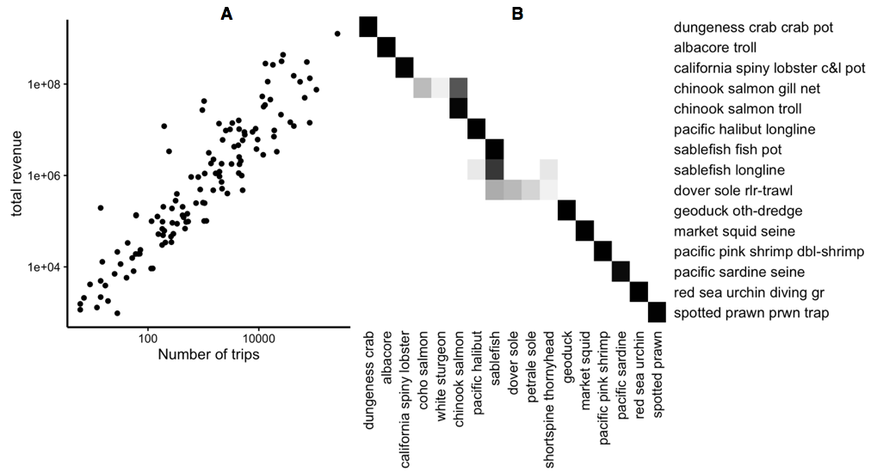

Figure 2: A) Comparison of effort and revenue for all realized fisheries between 2006-2014.

B) Species composition for fifteen ten realized fisheries (rows), accounting for 90% of the total revenue derived from commercial fisheries landings. Cell color represents the proportion of landings for which each species (columns) is responsible. Most of the biggest realized fisheries are composed of primarily a single species, but dover sole roller-trawl, for example, is multispecies.

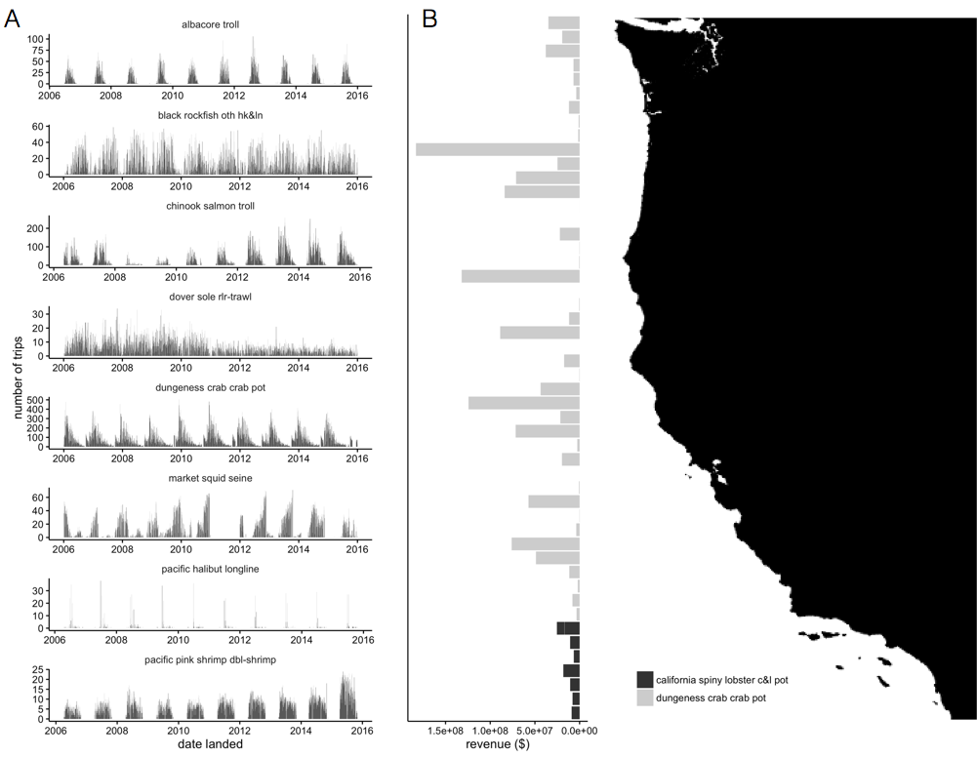

Figure 3: A) Seasonality of five major realized fisheries. Distinct seasonal patterns are observed in Dungeness crab, market squid and pink shrimp fisheries. B) Spatial structure of landings for two example fisheries. Revenue from landings are binned by latitude. Dungeness crab is landed further north, while California spiny lobster pot landings are restricted to the area around the Channel Islands.

Vessel and Community Level Fishing Diversity

I find that between the start of 2009 and the end of 2010, 71% of commercial vessels on the west coast participated in more than one realized fishery (Figure 4a) although the degree to which vessels diversified varied. Breaking these patterns down regionally using PFMC management regions, generalists outnumber specialists (Figure 4b). The distribution of diversity varies among the generalists, from vessels that are highly specialized, but have a few landings in additional fisheries to those that fish in many fisheries evenly (Figure 4c). Notably, the majority of diversified vessels revenue is dominated by revenue from a single fishery (75%), with very small percentages coming from alternatives. However a fifth (20%) of diversified vessels are participating in at least two fisheries equally, with some vessels (5%) participating evenly in more than three fisheries (Figure 4c).

../Analysis/new_analysis/catch_shares/Analysis/fig_2.pdf

Figure 4. Distribution of revenue diversity at the vessel level measured as the effective Shannon index of revenue plotted in three different ways: A) coast-wide, B) by management region, and C) breakdown of generalism for each management region. I define generalists as vessels that landed in more than one realized fishery. I find that generalists outnumbered specialists (A, B), although the degree of generalism varies (C).

I also find differences in the number and interconnectedness of fisheries across ports (Figure 5). Ports have between 0 and 3 fisheries that were connected. Most ports have a spectrum of vessels landing at them and I find no relationship between vessel and port level diversity (Fig S1).

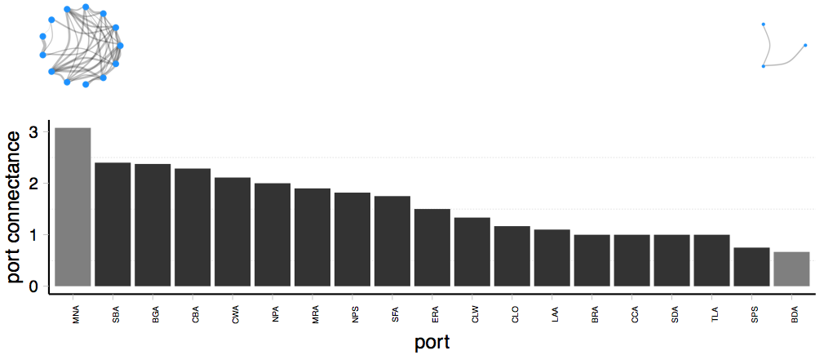

Figure 5. Spectrum of fisheries connectivity present in participation networks on the US west coast as illustrated by participation networks for Monterey area ports (left) and Bodega bay area ports (right). Here nodes represent realized fisheries where edge width is proportional to the number of vessels that participate in the connected fisheries. Bar plot shows fisheries connectivity, measured as link-density for all ports on US west coast with more than three vessels landing between 2009-2013. Light bars correspond to the network above them.

Effects of catch shares management on individual vessel diversification and community-level participation networks

Two-thirds (66%) of vessels that operated in the catch shares affected fishery prior to 2011 continue to participate in it following the implementation of catch shares, while only a minority (6%) of vessels left commercial fishing altogether. Of vessels which continued fishing in the catch-shares fishery after 2011, 87% of vessels adjust their fishing participation, entering or exiting new fisheries. A third group consisted of vessels that exited catch shares but continued to fish commercially (28%) (Figure 6). These vessels show a mixed response, with increased and decreased fishing diversity observed.

../../Desktop/CNH/Analysis/Metiers/writing/draft/fig4.pdf

Figure 6. I map the ways that a vessel can respond to the implementation of catch shares. Vessels that were directly affected by catch share implementation are those that fished in the limited entry (LE) groundfish fleet between 2009-2010. After 2011, vessels either continue to participate in the groundfish trawl fishery by landing with quota, or leave the catch share fishery and either leave commercial fishing entirely or continue to fish in other commercial fisheries. The width of the bar in the decision tree is proportional to the absolute number of vessels which follow a given path given by the number. Percentages are relative to each decision point. I find that very few vessels which stopped fishing in the groundfish fishery actually left commercial fishing altogether, and vessels which participated in catch shares changing their participation across fisheries.

Over my study time period, vessels that continued to fish became more diversified on average (Figure 7). Vessels that participate in catch shares post 2011, saw an increase in their revenue diversity that was twice that for vessels which exited the catch share fishery. Notably, the change in revenue diversity is strongly explained by the revenue diversity the vessels had prior to the implementation of catch shares (in 2009-2010). Vessels with higher (lower) participation diversity prior to catch shares are more likely to show a reduction (increase) in diversity following catch shares (Table S2).

../../Desktop/CNH/Analysis/Metiers/writing/draft/fig5.pdf

Figure 7. Estimated effects of catch shares on revenue diversity for vessels, bars represent 95% confidence intervals. Vessels that participate in catch share increase in revenue diversity more than either the general participants or those that exited catch shares. At the port level the best supported model does not include a term for participation in catch shares.

At the port level I find that at the port-level there is a non-significant increase in fisheries connectivity by approximately 5% on average (two sided t-test p-value = 0.3287), and this was predicted by previous fisheries connectivity (*Cpre*) (Table S1, S2). However, the model which best explained the change in fisheries connectivity did not include terms for a port’s relationship to catch shares (*Mn*).

Discussion

There is widespread recognition that ecosystem-based fishery management requires an understanding of the connectivity within and between the human and ecological subcomponents of marine systems (Anderson et al. 2015). Previous work which maps these social-ecological connections has resulted in considerable insight, often by identifying drivers unobservable from social or ecological studies alone (Brashares et al. 2004; Lade et al. 2015). This connectivity is particularly important in fisheries, where socioeconomic or ecological changes in one fishery can have cascading effects that ultimately influence others (Steneck et al. 2011; Lade et al. 2015). Yet despite this recognition, social dynamics are often missing and fishing fleets are usually represented as homogenous and non-interacting (Field 2004). My results highlight that on the contrary fishing fleets are highly heterogeneous and continually changing in size, effort level, and composition, as numerous exogenous and endogenous forces influence them (Opaluch and Bockstael 1984). More generally, this study highlights a perhaps underappreciated aspect of social-ecological systems: as in food webs and social networks, the consequences of environmental and management changes are determined large part by the connectivity between nodes.

I find that the majority of vessels on the US west coast engage in multiple fisheries and that the implementation of the Pacific Trawl Rationalization program appears to have changed patterns of participation across fisheries. Greater than 60% of commercial fishing vessels were generalists, participating in more than one realized fishery. The revenue of each of these generalists was thus tied to multiple fisheries, effectively connecting them and setting up the potential for linked social-ecological dynamics that were previously invisible. The social implications of generalist fishing practices with corresponding diversified revenue portfolios have been most directly related to reduced exposure to income risk (Kasperski and Holland 2013; Sethi, Reimer, and Knapp 2014), with previous work identifying that vessels with more diverse revenue streams have less variable revenues (Kasperski and Holland 2013). In contrast to US west coast fisheries, Steneck et al. (2011) has documented how Maine fishermen have increasingly become dependent on a single species due to interactions among markets and ecological conditions. In addition, Hentati-Sundberg et al. (2014) and Stoll et al. (2016) have shown how commercial fishermen in Sweden and the Gulf of Maine respectively have grown increasingly specialized as management became more restrictive. Thus, while many forms of management can be constraining, reducing the portfolio of fisheries prosecuted by individual fishermen, catch shares management may expand portfolios. Further study is needed to determine whether the ubiquity of generalists on the US west-coast is indicative of systemic risk-adverse behavior, and whether revenue diversity confers a general resilience in fishermen’s revenues to perturbation, such as diminished catch due to exogenous environmental factors or a change in management or markets of particular fisheries.

Previous research on fishery diversity and revenue variability (Kasperski and Holland 2013) has focused primarily on the impacts of catch shares on the vessels that have continued to operate within the fishery of interest, assuming that vessels that exit also exit commercial fishing entirely. My analysis shows that for the US west-coast, the majority of vessels that participated in the groundfish fishery prior to the implementation of catch shares, continue to operate after the management change, albeit in other realized fisheries (Figure 2). This highlights the need to quantify how a management change, or any other perturbation, is felt throughout the marine social-ecological system as vessels/individuals reorganize their participation across realized fisheries. This likely to be particularly important if there is a pair of species that are unconnected ecologically (i.e. there is no link between them in the food-web), but there are vessels that harvest both (i.e. there is a link in the participation network between these species’ realized fisheries), then there is a transitive link. As a consequence, a management change that affects vessel participation in one fishery, will affect that status of the (ecologically unconnected) stock of the other species. Dungeness crab and albacore tuna fisheries on the US west coast provide an appealing (but currently untested) example. Here, I find these two realized fisheries to be commonly connected by vessels at the port level, yet these species do not interact directly in the ocean. Examining changes in revenue diversity and vessel participation in the albacore tuna fishery after the recent closure of the Dungeness crab fishery in Washington and Oregon would be an excellent test of how connectivity influences fisheries participation. In general, environmental or management perturbations will ripple through these participation networks, and that their topology as well as the adaptability of fishermen, will largely determine their economic impacts.

In conclusion, my results highlight the need to consider fisheries as connected and dynamic entities. Not only should EBFM acknowledge the links between species in food-webs, there needs to be an equal emphasis on the connectivity between fisheries, based on the participation of vessels, and on the economic consequences of the topology of the participation networks. I have shown that fishery participation is heterogeneous, varying greatly from place to place, and dynamic, responding to the implementation of catch shares in the groundfish fishery. If we can broaden the conceptual and mathematical models of marine systems to include such properties, then we will be truly on our way to developing systems-based fisheries management, which is likely to lead to better performing governance institutions in the future.

Acknowledgements

I thank PacFin for access to the data, the observers and fishermen on the US west coast for insightful discussions, and Jameal Samhouri, James Watson, and Emily Klein for discussions on this project. I acknowledge support from the National Science Foundation (GRFP, GEO-1211972) and GreenMar (Consortium Agreement GreeMar-AGMT dtd 05-05-2014, Prime Nordforsk Project Number: 61582).

Literature Cited

Anderson, James L, Christopher M Anderson, Jingjie Chu, Jennifer Meredith, Frank Asche, Gil Sylvia, Martin D Smith, et al. 2015. “The Fishery Performance Indicators: a Management Tool for Triple Bottom Line Outcomes.” Edited by George Tserpes. *PloS One* 10 (5): e0122809–20. doi:10.1371/journal.pone.0122809.

Baskerville, Edward B, Andy P Dobson, Trevor Bedford, Stefano Allesina, T Michael Anderson, and Mercedes Pascual. 2011. “Spatial Guilds in the Serengeti Food Web Revealed by a Bayesian Group Model.” Edited by Lauren Ancel Meyers. *PLoS Computational Biology* 7 (12). Public Library of Science: e1002321. doi:10.1371/journal.pcbi.1002321.

Boonstra, Wiebren J, and Jonas Hentati Sundberg. 2014. “Classifying Fishers' Behaviour. an Invitation to Fishing Styles.” *Fish and Fisheries* 17 (1): 78–100. doi:10.1111/faf.12092.

Botsford, Louis W, and Daniel E Wickham. 1978. “Behavior of Age-Specific, Density-Dependent Models and the Northern California Dungeness Crab ( Cancer Magister) Fishery.” *Journal of the Fisheries Research Board of Canada* 35 (6): 833–43. doi:10.1139/f78-134.

Brashares, Justin S, Peter Arcese, Moses K Sam, Peter B Coppolillo, A R E Sinclair, and Andrew Balmford. 2004. “Bushmeat Hunting, Wildlife Declines, and Fish Supply in West Africa.” *Science (New York, N.Y.)* 306 (5699). American Association for the Advancement of Science: 1180–83. doi:10.1126/science.1102425.

Burnham, Kenneth P, and David R Anderson. 2002. *Model Selection and Multimodel Inference: a Practical Information-Theoretic Approach*. Edited by Springer Science & Business Media.

Coleman, Felicia C, Will F Figueira, Jeffrey S Ueland, and Larry B Crowder. 2004. “The Impact of United States Recreational Fisheries on Marine Fish Populations..” *Science (New York, N.Y.)* 305 (5692): 1958–60. doi:10.1126/science.1100397.

Costello, Christopher, Steven D Gaines, and John Lynham. 2008. “Can Catch Shares Prevent Fisheries Collapse?.” *Science (New York, N.Y.)* 321 (5896): 1678–81. doi:10.1126/science.1159478.

Essington, T E. 2010. “Ecological Indicators Display Reduced Variation in North American Catch Share Fisheries.” *Proceedings of the National Academy of Sciences* 107 (2): 754–59. doi:10.1073/pnas.0907252107.

Field, John C. 2004. “Application of Ecosystem-Based Fishery Management Approaches in the Northern California Current .” Edited by Robert C Francis.

Fulton, Elizabeth A, Anthony D M Smith, David C Smith, and Ingrid E van Putten. 2010. “Human Behaviour: the Key Source of Uncertainty in Fisheries Management.” *Fish and Fisheries* 12 (1): 2–17. doi:10.1111/j.1467-2979.2010.00371.x.

Hentati-Sundberg, J, J Hjelm, W J Boonstra, and H Österblom. 2014. “Management Forcing Increased Specialization in a Fishery System.” *Ecosystems* 18 (1). Springer US: 45–61. doi:10.1007/s10021-014-9811-3.

Hilborn, Ray, Jean-Jacques Maguire, Ana M Parma, and Andrew A Rosenberg. 2001. “The Precautionary Approach and Risk Management: Can They Increase the Probability of Successes in Fishery Management?.” *Canadian Journal of Fisheries and Aquatic Sciences* 58 (1): 99–107. doi:10.1139/cjfas-58-1-99.

Jost, Lou. 2006. “Entropy and Diversity.” *Oikos* 113 (2): 363–75.

Kasperski, S, and D S Holland. 2013. “Income Diversification and Risk for Fishermen.” *Proceedings of the National Academy of Sciences*. doi:10.1073/pnas.1212278110/-/DCSupplemental.

Kay, Matthew C, Hunter S Lenihan, Carla M Guenther, Jono R Wilson, Christopher J Miller, and Samuel W Shrout. 2012. “Collaborative Assessment of California Spiny Lobster Population and Fishery Responses to a Marine Reserve Network..” *Ecological Applications : a Publication of the Ecological Society of America* 22 (1): 322–35.

Lade, Steven J, Susa Niiranen, Jonas Hentati Sundberg, Thorsten Blenckner, Wiebren J Boonstra, Kirill Orach, Martin F Quaas, Henrik Österblom, and Maja Schlüter. 2015. “An Empirical Model of the Baltic Sea Reveals the Importance of Social Dynamics for Ecological Regime Shifts..” *Proceedings of the National Academy of Sciences of the United States of America* 112 (35): 11120–25. doi:10.1073/pnas.1504954112.

Legendre, P, and L Legendre. 2012. *Numerical Ecology*. Elsevier.

Levin, Phillip S, Michael J Fogarty, Steven A Murawski, and David Fluharty. 2009. “Integrated Ecosystem Assessments: Developing the Scientific Basis for Ecosystem-Based Management of the Ocean.” *PLoS Biology* 7 (1): e1000014–16. doi:10.1371/journal.pbio.1000014.

Mace, Georgina M. 2014. “Ecology. Whose Conservation?.” *Science (New York, N.Y.)* 345 (6204). American Association for the Advancement of Science: 1558–60. doi:10.1126/science.1254704.

Millennium Ecosystem Assessment. 2005. “*Ecosystems and Human Well-Being: Synthesis*.” *Island Press*. Washington, DC.

Northwest Fisheries Science Center. 2015. “Data Analysis and Products.” *Fisheries Observation Science*. Seattle, WA. Accessed December 8. http://www.nwfsc.noaa.gov/research/divisions/fram/observation/data\_products/bottom\_trawl.cfm#description.

Opaluch, J J, and N E Bockstael. 1984. “Behavioral Modeling and Fisheries Management.” *Marine Resource Economics*. doi:10.2307/42628847.

Pfeiffer, Lisa, and Trevor Gratz. 2016. “The Effect of Rights-Based Fisheries Management on Risk Taking and Fishing Safety.” *Proceedings of the National Academy of Sciences* 113 (10): 2615–20. doi:10.1073/pnas.1509456113.

Rosvall, Martin, and Carl T Bergstrom. 2008. “Maps of Random Walks on Complex Networks Reveal Community Structure.” *Proceedings of the National Academy of Sciences* 105 (4). National Acad Sciences: 1118–23. doi:10.1073/pnas.0706851105.

Sethi, S A, M Reimer, and G Knapp. 2014. “Alaskan Fishing Community Revenues and the Stabilizing Role of Fishing Portfolios.” *Marine Policy*. doi:10.1016/j.marpol.2014.03.027.

Smith, Martin D, and James E Wilen. 2003. “Economic Impacts of Marine Reserves: the Importance of Spatial Behavior.” *Journal of Environmental Economics and Management* 46 (2): 183–206. doi:10.1016/S0095-0696(03)00024-X.

Steneck, R S, T P Hughes, J E CINNER, W N ADGER, S N ARNOLD, F BERKES, S A BOUDREAU, et al. 2011. “Creation of a Gilded Trap by the High Economic Value of the Maine Lobster Fishery.” *Conservation Biology* 25 (5): 904–12. doi:10.1111/j.1523-1739.2011.01717.x.

van Putten, Ingrid E, Soile Kulmala, Olivier Thébaud, Natalie Dowling, Katell G Hamon, Trevor Hutton, and Sean Pascoe. 2012. “Theories and Behavioural Drivers Underlying Fleet Dynamics Models.” *Fish and Fisheries* 13 (2): 216–35. doi:10.1111/j.1467-2979.2011.00430.x.

Supplemental information

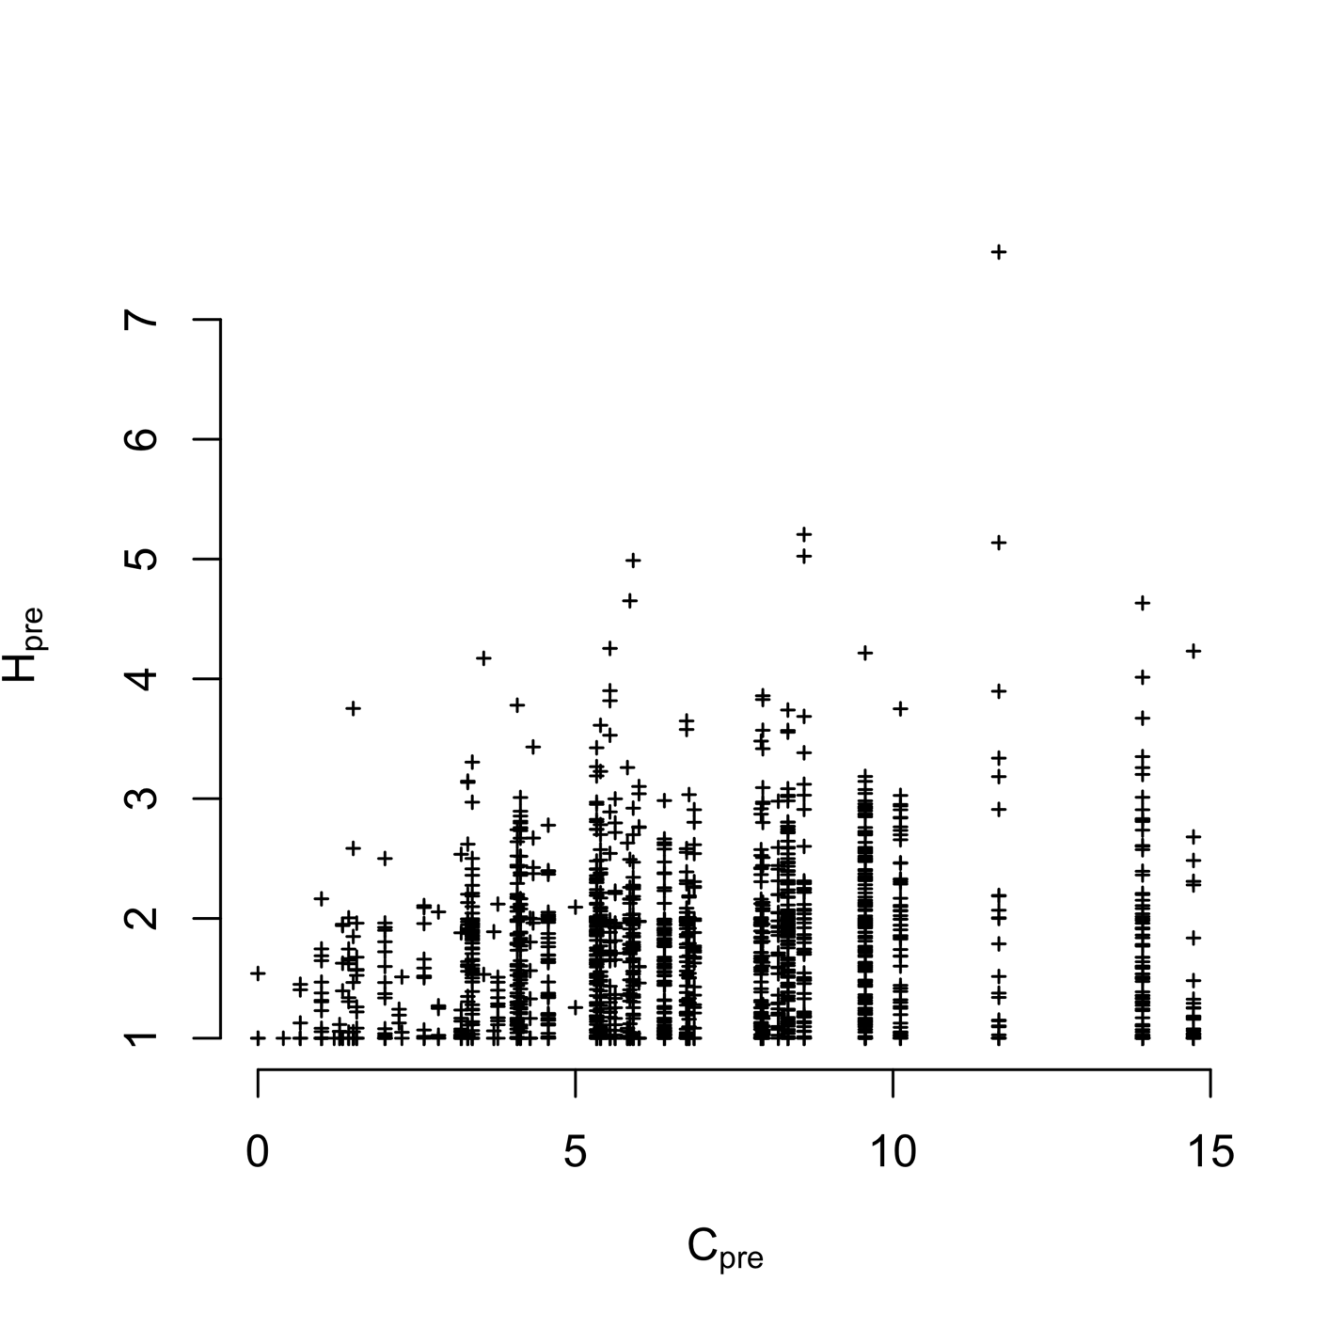

Figure S1. Plotting vessel participation diversity (H, 2009-2010) against port connectivity (C, 2009-2010). We find vessel and port level diversity weakly correlated (Spearman’s correlation 0.1849745, p < 2.2e-16). But the most diverse vessels tend to be found in the most diverse ports.

Table S1. Akaike Information Criterion (AIC) values for the models with and without terms for catch shares. Values for the best model at each level are in boldface.

|  |  |  |  |  |  |  |
| --- | --- | --- | --- | --- | --- | --- |
| *Level* | *Hpre* | *Catch shares* | *No. Parameters (K)* | *AIC* | *ΔAIC* | *Adjusted R2* |
| Vessel | Yes | No | 1 | 3140.767 | 30.916 | 0.2392 |
| Yes | Yes | 2 | 3109.851 | 0 | 0.2471 |
| No | Yes | 1 | 3643.718 | 533.867 | 0.01007 |
| Port | Yes | No | 1 | 184.1367 | 0 | 0.8866 |
| Yes | Yes | 2 | 186.5804 | 2.4437 | 0.8858 |
| No | Yes | 1 | 325.8152 | 141.6785 | 0.2404 |

Table S2. Coefficient values for two best fit models for each scale of analysis

|  |  |  |  |
| --- | --- | --- | --- |
| *Level* | *Variable* | *Best model* | *Second best* |
| Vessel | Hpre | -0.46 (0.02) | -0.46 (0.10) |
| General fleet | 0.74 (0.03) | 0.74 (0.03) |
| Catch share participant | 0.27 (0.07) | - |
| Limited entry exit | -0.24 (0.10) | - |
| Port | Cpre | -0.67 (0.03) | -0.66 (0.03) |
| General fleet | - | 0.29 (0.27) |
| Catch share participant | - | 0.19 (0.28) |
| Limited entry exit | - | 0.33 (0.33) |

Table S3. Realized fisheries for the US West Coast. Fisheries are listed from most trips taken to least. Métier provides a shorthand code for each fishery. For each fishery the species that dominates the majority of trips is listed as the Major species. Major gear is the gear type (within the larger gear group) that is most frequently used to land the catch. CA/OR/WA lists the percentages of trips landed in each state, and gives an idea of how regional the fishery is. Dungeness crab (POT\_1), for example, is landed across the coast, while red sea urchin (MSC\_1) is landed primarily in California. The number of trips are the number of trips landed in this fishery acros the entire dataset. Multispecies indicates whether more than on species constitutes, on average, 30% of any given landing. The number of vessels lists the number of unique vessel IDs that have landed this fishery over the course of the dataset. NAs are listed for vessel counts in fisheries for which individual vessel identity is not reliably provided (i.e. MSC\_2, DRG\_1, MSC\_3). These are primarily bivalve fisheries in which no vessel is necessarily required.

|  |  |  |  |  |  |  |  |  |
| --- | --- | --- | --- | --- | --- | --- | --- | --- |
| Métier | Major species | Major gear | CA | OR | WA | Number trips | Multi-species | Number vessels |
| POT\_1 | Dungeness crab | crab pot | 47 | 21 | 33 | 262751 | no | 1780 |
| MSC\_1 | red sea urchin | diving gear | 84 | 16 | NA | 109382 | no | 265 |
| TLS\_1 | chinook salmon | troll | 48 | 22 | 30 | 83525 | no | 1963 |
| MSC\_2 | manila clam | other known | 26 | NA | 74 | 82916 | no | NA |
| NET\_1 | chinook salmon | gill net | 11 | 7 | 82 | 76551 | no | 754 |
| DRG\_1 | geoduck | other dredge | 9 | NA | 91 | 73649 | no | NA |
| POT\_2 | California spiny lobster | crab and lobster pot | 100 | NA | NA | 55572 | no | 334 |
| MSC\_3 | pacific oyster | other known | NA | NA | 100 | 42926 | no | NA |
| HKL\_1 | sablefish | longline | 59 | 15 | 26 | 42908 | no | 873 |
| HKL\_2 | black rockfish | other hook and line | 67 | 30 | 2 | 37045 | no | 536 |
| NET\_2 | market squid | seine | 96 | 4 | NA | 32051 | no | 194 |
| TLS\_2 | albacore | troll | 42 | 25 | 33 | 25945 | no | 1648 |
| POT\_3 | rock crab | crab and lobster pot | 97 | 3 | NA | 25112 | no | 307 |
| MSC\_4 | razor clam | other known | NA | 10 | 90 | 21121 | no | NA |
| HKL\_4 | brown rockfish, gopher rockfish | commercial pole | 88 | 10 | 2 | 19032 | yes | 330 |
| HKL\_3 | California halibut | commercial pole | 100 | NA | NA | 18747 | no | 978 |
| TWL\_1 | dover sole | roller trawl | 61 | 16 | 23 | 18140 | no | 151 |
| POT\_4 | spotted prawn | prawn trap | 65 | NA | 35 | 16159 | no | 90 |
| NET\_3 | pacific sardine | seine | 74 | 17 | 9 | 15443 | no | 140 |
| NET\_4 | chum salmon | gill net | NA | 5 | 95 | 14502 | no | 555 |
| TWS\_1 | pacific pink shrimp | double rigged shrimp trawl | 28 | 39 | 33 | 13154 | no | 147 |
| POT\_6 | unspecified hagfish | fish pot | 58 | 14 | 28 | 12246 | no | 280 |
| HKL\_5 | lingcod | other hook and line, commercial pole | 68 | 23 | 9 | 12017 | no | 1182 |
| POT\_5 | sablefish | fish pot | 66 | 23 | 11 | 11757 | no | 531 |
| NET\_6 | California halibut | gill net | 100 | NA | NA | 10268 | no | 96 |
| HKL\_6 | black-and-yellow rockfish, cabezon, grass rockfish | commercial pole, vertical hook and line | 79 | 21 | NA | 9526 | yes | 314 |
| TWL\_2 | California halibut | ground fish trawl, < 8ft foot rope | 100 | NA | NA | 8765 | no | 73 |
| MSC\_5 | unspecified sea cucumbers | diving gear | 100 | NA | NA | 7711 | no | 123 |
| NET\_8 | white seabass | gill net | 100 | NA | NA | 6253 | no | 79 |
| NET\_14 | pacific herring | gill net | 36 | 9 | 55 | 5766 | no | 83 |
| TWS\_2 | ridgeback prawn | single rig shrimp trawl | 92 | NA | 8 | 5584 | no | 30 |
| NET\_5 | unspecified bait shrimp, pink salmon | gill net, seine | 55 | 6 | 39 | 5223 | yes | 405 |
| NET\_10 | unspecified smelt | dip net | 69 | NA | 31 | 5149 | no | 29 |
| HKL\_9 | surfperch spp. | commercial pole | 100 | NA | NA | 5108 | no | 49 |
| NET\_9 | unspecified sea cucumbers | dip net | 11 | NA | 89 | 5054 | no | 61 |
| MSC\_6 | unspecified bait shrimp | other known | 25 | NA | 75 | 4911 | no | 19 |
| TWL\_3 | unspecified bait shrimp | beam trawl | 100 | NA | NA | 4480 | no | 16 |
| HKL\_7 | white seabass | commercial pole | 100 | NA | NA | 4417 | no | 550 |
| HKL\_8 | vermilion rockfish | commercial pole | 73 | 24 | 2 | 4344 | no | 492 |
| POT\_7 | other shrimp | other pots | 46 | 29 | 25 | 4262 | no | 63 |
| NET\_12 | swordfish, common thresher shark | drift gill net | 89 | NA | 11 | 3590 | yes | 121 |
| TWL\_4 | unspecified sea cucumbers | groundfish trawl | 100 | NA | NA | 3585 | no | 57 |
| NET\_16 | northern anchovy | seine | 70 | 9 | 22 | 3362 | no | 69 |
| TWS\_3 | California halibut | single rig shrimp trawl | 77 | 19 | 4 | 3219 | no | 67 |
| NET\_11 | unspecified shad | dip net | 33 | 33 | 33 | 2995 | no | 30 |
| NET\_7 | sockeye salmon | gill net | NA | 6 | 94 | 2812 | no | 327 |
| NET\_13 | chub mackerel | dip net | 93 | 7 | NA | 2552 | no | 81 |
| HKL\_10 | chub mackerel, pacific sanddab, white croaker | longline | 96 | 4 | NA | 2174 | yes | 153 |
| POT\_11 | cabezon, gopher rockfish, lingcod | fish pot | 80 | 20 | NA | 2131 | yes | 141 |
| MSC\_9 | basket cockle | other known | 58 | 19 | 23 | 2128 | no | 75 |
| MSC\_8 | Dungeness crab | other known | 24 | 76 | NA | 1953 | no | 160 |
| TWL\_6 | pacific pink shrimp | beam trawl | 50 | NA | 50 | 1950 | no | 19 |
| HKL\_11 | albacore | commercial pole | 92 | 3 | 5 | 1915 | no | 479 |
| TWL\_5 | chinook salmon, lingcod, ridgeback prawn | groundfish trawl | 62 | 16 | 22 | 1622 | yes | 136 |
| POT\_9 | California sheephead | fish pot | 100 | NA | NA | 1519 | no | 68 |
| HKL\_15 | pacific bonito, unspecified sanddabs | commercial pole | 72 | 21 | 7 | 1505 | yes | 372 |
| NET\_15 | other sea urchins | dip net | NA | NA | 100 | 1473 | no | 32 |
| MSC\_10 | swordfish | other known | 100 | NA | NA | 1252 | no | 54 |
| TWS\_8 | unspecified bait shrimp | single rig shrimp trawl | 100 | NA | NA | 1132 | no | 5 |
| NET\_17 | red sea urchin | dip net | 15 | NA | 85 | 1122 | no | 30 |
| HKL\_18 | yellowtail | commercial pole | 100 | NA | NA | 1052 | no | 202 |
| MSC\_11 | ghost shrimp | other known | 67 | 33 | NA | 1032 | no | 2 |
| HKL\_12 | pacific halibut | longline | 9 | 50 | 41 | 1031 | no | 247 |
| POT\_10 | other crab | crab and lobster pot | 86 | 14 | NA | 984 | no | 124 |
| TWL\_8 | pacific whiting | midwater trawl | 38 | 38 | 25 | 959 | no | 39 |
| HKL\_13 | California sheephead | commercial pole | 86 | 14 | NA | 877 | no | 112 |
| POT\_8 | Dungeness crab, rock crab, surfperch spp. | crab and lobster pot, fish pot | 65 | 17 | 19 | 809 | yes | 291 |
| POT\_12 | other mollusks | crab and lobster pot | 100 | NA | NA | 737 | no | 91 |
| TWS\_4 | unspecified sea cucumbers | single rig shrimp trawl | 100 | NA | NA | 602 | no | 25 |
| HKL\_17 | unspecified smelt | commercial pole | 100 | NA | NA | 531 | no | 26 |
| HKL\_14 | California scorpionfish | commercial pole | 100 | NA | NA | 514 | no | 24 |
| TLS\_5 | California halibut | troll | 100 | NA | NA | 489 | no | 105 |
| MSC\_12 | butter clam | other known | NA | 60 | 40 | 467 | no | 16 |
| TLS\_8 | lingcod | troll | 54 | 38 | 8 | 440 | no | 189 |
| NET\_18 | eulachon | gill net | NA | 20 | 80 | 422 | no | 46 |
| HKL\_16 | common thresher shark | commercial pole | 100 | NA | NA | 421 | no | 100 |
| NET\_19 | other crab | gill net | 100 | NA | NA | 377 | no | 23 |
| TLS\_4 | sablefish, unspecified sanddabs | troll | 59 | 18 | 23 | 334 | yes | 192 |
| HKL\_27 | chinook salmon | commercial pole | 95 | NA | 5 | 315 | no | 142 |
| NET\_20 | pacific barracuda | drift gill net | 100 | NA | NA | 303 | no | 21 |
| HKL\_19 | shortfin mako shark | commercial pole | 100 | NA | NA | 287 | no | 65 |
| MSC\_13 | unspecified mollusks | diving gear | 100 | NA | NA | 275 | no | 11 |
| POT\_13 | unspecified octopus | crab pot | 71 | 29 | NA | 265 | no | 113 |
| HKL\_21 | leopard shark | commercial pole | 100 | NA | NA | 260 | no | 58 |
| TWL\_11 | yellowtail rockfish | midwater trawl | 12 | 38 | 50 | 241 | no | 45 |
| TWS\_5 | unspecified flatfish | single rig shrimp trawl | 100 | NA | NA | 206 | no | 18 |
| HKL\_26 | unspecified reds rockfish | commercial pole | 100 | NA | NA | 198 | no | 58 |
| HKL\_23 | swordfish | longline | 100 | NA | NA | 196 | no | 31 |
| TWL\_9 | lingcod | select flatfish trawl, roller trawl | 42 | 25 | 33 | 192 | no | 54 |
| MSC\_15 | other mollusks | diving gear | 82 | 18 | NA | 187 | no | 52 |
| MSC\_7 | manila clam | other known | NA | NA | 100 | 183 | no | NA |
| MSC\_14 | other sea urchins | diving gear | 100 | NA | NA | 181 | no | 51 |
| HKL\_22 | pacific barracuda | commercial pole | 100 | NA | NA | 180 | no | 75 |
| HKL\_20 | unspecified shelf rockfish | commercial pole | 100 | NA | NA | 154 | no | 8 |
| TWL\_13 | spiny dogfish | groundfish trawl, midwater trawl | 50 | 12 | 38 | 149 | no | 13 |
| TLS\_7 | yellowtail rockfish | troll | 44 | 33 | 22 | 122 | no | 65 |
| HKL\_25 | unspecified squid | commercial pole | 72 | 22 | 6 | 116 | no | 38 |
| MSC\_19 | unspecified echinoderm | diving gear | 100 | NA | NA | 114 | no | 9 |
| MSC\_17 | California sheephead | diving gear | 100 | NA | NA | 73 | no | 7 |
| HKL\_28 | unspecified rockfish | commercial pole | 94 | NA | 6 | 71 | no | 39 |
| TWS\_9 | other skates | single rig shrimp trawl | 100 | NA | NA | 67 | no | 14 |
| TLS\_3 | albacore | troll | 48 | 19 | 33 | 61 | no | 48 |
| POT\_14 | unspecified eels | fish pot | 100 | NA | NA | 61 | no | 21 |
| MSC\_16 | black-and-yellow rockfish | diving gear | 100 | NA | NA | 60 | no | 11 |
| TWL\_7 | petrale sole | ground fish trawl, < 8ft foot rope | 100 | NA | NA | 59 | no | 11 |
| TWL\_10 | pacific ocean perch | roller trawl | NA | 60 | 40 | 55 | no | 26 |
| TWS\_10 | other crab, rock crab | single rig shrimp trawl | 100 | NA | NA | 52 | yes | 16 |
| TWL\_12 | canary rockfish | midwater trawl | 17 | 50 | 33 | 43 | no | 24 |
| TWS\_7 | other shrimp | single rig shrimp trawl | 100 | NA | NA | 41 | no | 6 |
| TLS\_6 | white seabass | troll | 100 | NA | NA | 32 | no | 21 |
| HKL\_24 | thornyheads (mixed) | longline | 100 | NA | NA | 28 | no | 13 |
| MSC\_21 | unspecified octopus | other known | 80 | 20 | NA | 28 | no | 5 |
| MSC\_23 | California halibut, unspecified flatfish | diving gear | 100 | NA | NA | 25 | yes | 12 |
| MSC\_20 | unspecified smelt | other known | 100 | NA | NA | 19 | no | 1 |
| MSC\_22 | shortfin mako shark | other known | 100 | NA | NA | 17 | no | 10 |
| DRG\_2 | horse clams | other dredge | NA | NA | 100 | 15 | no | 1 |
| HKL\_30 | unspecified slope rockfish | longline | 100 | NA | NA | 14 | no | 8 |
| MSC\_18 | unspecified shad | unknown gear | 100 | NA | NA | 14 | no | 2 |
| HKL\_29 | unspecified octopus | longline, other hook and line, commercial pole | 40 | 60 | NA | 12 | no | 8 |
| TLS\_9 | yellowtail | troll | 25 | 75 | NA | 9 | no | 9 |
| TWS\_11 | white seabass | single rig shrimp trawl | 100 | NA | NA | 7 | no | 4 |
| TWS\_12 | copper rockfish, unspecified reds rockfish, vermilion rockfish, widow rockfish | single rig shrimp trawl | 100 | NA | NA | 6 | yes | 4 |
| TWS\_6 | hornyhead turbot, ridgeback prawn, unspecified hagfish, unspecified skate | single rig shrimp trawl | 100 | NA | NA | 6 | yes | 3 |

1. In preparation for submission at Canadian Journal of Aquatic and Fishery Sciences [↑](#footnote-ref-1)