**CHAPTER ONE**

**Participation Networks: Linking fisheries to fishing communities on the US West Coast**

*Abstract*

Defining and shifting management to multi-species, and now ecosystem-level approaches has necessitated a great deal of research on how species interact and depend on one another. We lack an analogous concept for the social side of these systems, despite the wide recognition that fishermen often substitute effort between fisheries in response to ecological and management changes. Here I use US west coast fisheries as a case study to develop a novel classification to: (i) describe participation of fishing vessels in fisheries with distinct ecological compositions and (ii) describe networks of fisheries participation for entire communities (ports). The results from this work suggest the existence of a “keystone fishery,” in this case Dungeness crab, and that there are a number of common modules that appear regardless of scale of analysis that may be appropriate management units. Overall I find a wide range in the size and complexity of these networks, suggesting that some ports may be more resilient than others to perturbations.

*Introduction*

The study of social ecological systems has become an important way to understand linked problems of sustainable use of natural resources and human well-being (Ostrom 2009). This contrasts with the narrower historic focus of management on the study of biological systems. Along with the shift to describing natural resource management in terms of linked social-ecological systems, there has been a corresponding recognition that the social dynamics of these linked systems can be crucial to better understanding the effects of perturbations, be it from ecological, economic or management changes (Tavoni, Schlüter, and Levin 2012; Lade et al. 2013). This appreciation of the importance of social dynamics for driving ecological change comes at the same time that conservation is shifting to incorporate and value human well-being alongside ecological integrity (i.e. biodiversity, intact habitat protection) (Kareiva and Marvier 2012). However empirical data capturing fine scale social dynamics and their interactions with ecological systems is still largely absent. Indeed one of the critiques of this new framing of “nature and people” is that there exist few empirical measures of social dynamics, of which human well-being is derived (Mace (2014), but see Hicks et al. (2016) for a recent review).

Commercial fisheries is one of the most easily recognized examples of a social ecological system and thus a useful place to start empirically examining links between social and ecological dynamics. Fishermen directly depend on the fish they harvest, and are just as vulnerable to changes from the social sphere (economics, management) as they are from ecological perturbations (stock collapses, range shifts). Further, commercial fishing is a major driver of ecological dynamics in these systems (Jackson et al. 2001; Worm et al. 2009), and so quantifying the dynamics of harvest is equally important for understanding how to manage these food webs. In the US the challenge of linking human well-being to fisheries management has direct relevance for management, as human well-being is enshrined in the Magnuson-Stevens Fishery Conservation and Management Act in that “*Conservation and management measures shall…take into account the importance of fishery resources to fishing communities in order to (a) provide for the sustained participation of such communities, and (b) to the extent practicable, minimize adverse economic impacts on such communities”*(16 US Code §1851).

In the US, federal commercial fisheries are managed by a series of fisheries management plans (FMPs). These FMPs detail the conditions under which someone may participate in the fishery in question, i.e. owning a license, using a specific gear, and/or catch limits. These FMPs therefore essentially define what’s commonly thought of as a “fishery”, which is a group of vessels harvesting a common pool of species with a common gear (i.e. the sablefish long-line fishery or the non-whiting groundfish trawl fishery). This definition of a fishery is a useful ecological unit, as this is the group of vessels exerting effort/causing harvest mortality for a relatively homogenous group of species under management. Vessels participating in a fishery could be crudely thought of as predators in a predator-prey system. Yet despite managers being required to manage species (i.e. to prevent the depletion of the stock), managers manage people, not fish. And it’s not at all clear that a fishery as currently conceptualized is the best construct for organizing how management manages the people doing the fishing, nor how it understands their well-being. Fishing communities, on the other hand, are legally defined by how dependent people are on commercial fishing for economic livelihoods (16 US Code§ 600.345), and correspondinglymost of the work focused on understanding fishing communities in the US has focused on the interdependence between fisheries and other occupational sectors (Jepson and Colburn 2013). While useful, these approaches lack a way to directly link to the scale of the fishery, to that of the fishing community.

To address this mismatch between fishing communities and fisheries, I developed and applied a novel network modeling approach to build “participation networks” and analyzed the patterns of fisheries participation and their interrelationships at different levels of aggregation (i.e. port, state and coastwide). Network approaches have long been a valuable tool to understand interactions among communities of species (i.e. foodwebs). To analyze these participation networks I have used two measures that have direct analogies to food-webs. The first is node centrality, which has been used to identify keystone species in food-webs, those that if removed from the food-web would lead to a disproportionately large impact on the whole system. Applied to the participation networks, measures of centrality identify “keystone fisheries”, those that most vessels would participate in (and possibly gain most of their revenue from) at some point of the year. These fisheries are likely ones that, regardless of ecological function or vulnerability, may from a human perspective, have high management importance. The second measure is that of modularity, which describes the presence of groups of well-connected fisheries. Network modularity is an important property of any complex system (Levin 1999), providing resilience to perturbation by isolating effects to subcomponents. Here, modules in the participation networks identify groups of similar vessels, based on what they do on the water, that can be used to identify discrete management units. Beyond providing a method for linking fisheries to fishing communities, these first order properties of the participation networks may be key to quantifying how any perturbation – a management or environmental change – will affect the whole marine social-ecological system.

*Methods*

**Description of Data Sources**

I collected vessel landings tickets for all commercial landings on the US west-coast between 2009-2013 from the Pacific Fisheries Information Network (PacFIN) database (www.psmfc.org). These commercial landings accounted for 1.6 million tons of 196 species, resulting in 1.8 billion dollars in revenue (adjusted to 2009 levels) by a total of 4,316 vessels.

**Defining Realized Fisheries**

Fisheries are defined as harvest assemblages caught with a specific gear (van Putten et al. 2012; Boonstra and Hentati Sundberg 2014). The Pacific Fisheries Management Council (PFMC) has developed a set of sector-based definitions similar to this approach for the federally managed groundfish landings (www.pcouncil.org), but no equivalent exists for non-groundfish fisheries {NorthwestFisheriesScienceCenter:vj}. In order to treat the landings dataset uniformly, I applied a métier analysis to this landing data (Deporte et al. 2012) to build a set of realized fisheries. A métier analysis identifies realized fisheries by clustering the species composition of landings. This methodology requires choices in the way similarity among trips are measured, a clustering algorithm for grouping similar trips together, and a constraint that the methods can scale across hundreds of thousands of landings.

For my distance metric I used the Hellinger distance *D* (P. Legendre and Legendre 2012) to calculate the similarity in revenue profiles between trips and generated a pairwise distance matrix. This distance metric has the benefit that it is asymmetric, where the presence of a species in both trips is considered more informative than the absence of a species. The Hellinger distance between the species composition of two fishing trips *A* and *B* is defined as

|  |  |
| --- | --- |
| $$D_{AB}= \sqrt{\sum_{i=1}^{S}{{(a_{i}-b_{i})}^{2}},}$$ | (1) |

where *ai* is the fraction of revenue derived from species *i* on trip *A*, *bi* is the fraction of revenue derived from species *i* on trip *B*, and *S* indicates the total number of species collected in both trips. With this metric, trips *A* and *B* become increasingly similar (and the Hellinger distance declines) as the proportion of revenue attributable to each of the *S* species becomes increasingly matched.

I identified realized fisheries as groups of trips with similar target assemblages using the infoMap community detection algorithm (Rosvall and Bergstrom 2008). This algorithm examines networks for subgraphs more interconnected to one another than the network in which it is embedded. To generate the required network I transformed the distance matrix into a similarity matrix by subtracting the distance metric’s upper limit (i.e. $\sqrt{2}$) from each pairwise distance. The result is a weighted, undirected network where trips are connected by edges proportional to their similarity. However, because my dataset contained 445,264 unique trips, I was not able to perform clustering using a single matrix containing all pairwise similarities. To obtain manageable matrix sizes I used one year of landings (2010) which I split by gear. Pairwise distances among trips and community detection were calculated within each gear partition, which grouped trips into target assemblage categories. To classify the 2009, 2012 and 2013 trips to fisheries, I assigned each unclassified trip to the same realized fishery as the 2010 trip to which it was closest in multidimensional space using a k-nearest neighbors algorithm.

A challenge in testing the effectiveness of this classification method, and part of the reason for its need, is that there is not an independent classification of US west coast fisheries that I could use to compare the results. To address this issue, I tested the reliability of our classification approach by evaluating the extent to which it identified known spatial and temporal structure of well-described US west coast fisheries and fishery sectors. Specifically, because I did not bound our clusters spatially, temporally, or by vessel characteristics, I was able to compare my emergent realized fisheries to existing sector definitions of groundfish, and groundfish impacting fisheries provided by the Northwest Fisheries Science Center Observer Program {NorthwestFisheriesScienceCenter:vj}.

**Participation networks**

To represent connectivity among realized fisheries at the port level I built undirected, weighted networks where nodes each represented a realized fishery. If the graph is written as an adjacency matrix **G***,* then the element *gij* is the number of vessels that landed catch in both vertex *i* and vertex *j* over a given period. Thus nodes were connected (*gij > 0)* when vessels participated in both and 0 otherwise (Fig. 1)*.* Vertex size was proportional to the number of vessels that participated in the fishery between 2009 and 2013. Landing data was aggregated at the port, state and coast wide levels to build participation networks. In this analysis I focused on the major ports on the US west coast, defined as those which account for the top 90% of revenue coast wide. Further to focus on major fisheries and to protect confidentiality I filtered networks and dropped nodes in which fewer than three vessels participated and retained only fisheries responsible for the top 95% of revenue at a given scale.

**Centrality**

While many measures of network centrality exist, here I chose simple measures which have clear interpretations. Centrality of each node in a network was measured in two ways, by node strength and betweenness centrality. Node strength is a generalization of degree for weighted networks. Degree, or the number of connections to a given node, is an intuitive measure where the more connected a node is, the more central we assume to be in the network. To make use of the information contained in edge weight I calculated node strength (Barrat et al. 2004) where node strength of node *i* is

|  |  |
| --- | --- |
| $$s_{i}= \sum_{j=1}^{N}{g_{ij}},$$ | (2) |

in a graph with *N* total nodes (Barrat et al. 2004). Because networks varied orders of magnitude in the total number of vessels moving among nodes, I normalized this value by the sum of all edge weights in a graph, thus providing a measure ranging between 0 and 1 where 1 indicates that all connections in the network were to node *i*, and 0 means that no connections involved node *i*, and it grows such that larger edges drive up the score. Fisheries with node strength close to one are fisheries were ones that were consistently connected to the majority of other fisheries in the network and/or were involved the strongest connections present. Thus these fisheries that scored highly in node strength across all port networks can be thought of as fisheries that are consistently central (i.e. strongly connected to most of the nodes in the network) in all the networks in which they appear.

This measure of node strength, while intuitive, only takes into account the local structure around each node. To incorporate both node strength and network structure I calculated betweenness centrality. Betweenness centrality was developed to better incorporate the topological structure of the network and specifically to capture whether nodes connected two relatively distant parts of a network (Freeman, Roeder, and Mulholland 1979). This metric is particularly useful in cases where we wish to know something about traffic or how information flows across a network, both of which are relevant when we think about fisheries participation. This metric is calculated as the number of shortest paths which travel through a given node *b(v)*.

|  |  |
| --- | --- |
| $$b\left(v\right)= \sum_{s}{\frac{σ_{st}(v)}{σ_{st}},}$$ | (3) |

where $σ_{st}$ is the number of shortest paths between node *s* and node *t* and $σ_{st}(v)$ is the number of shortest paths that pass through vertex *v*. Because betweenness will scale with network size, and participation networks vary in size, I normalized this value by dividing by the number of pairs of nodes *((N-1)(N-2)/2*) that do not include *v*, so that *b* is in the interval *[0, 1]*. To incorporate weights of edges I summed the edge strength such that shortest paths that involve edges with larger weights contribute more to betweenness scores.

**Modularity**

Modularity was determined by looking for distinct communities in port participation networks in the top ten ports by revenue. Communities have long been of interest for biological and social networks, however they are difficult to define formally. Most recent approaches consider that a partition of the nodes of a graph represent true structure if the proportion of edges inside the community is large when compared to the number links between them and the rest of the graph. I use this definition here and defined communities as groups of fisheries more tightly connected to one another than the rest of the network. These were identified using the walktrap algorithm(Pons and Latapy 2005). The algorithm’s name comes the observation that random walks on networks often get “stuck” in densely connected subgraphs. The algorithm proceeds by building an agglomerative dendrogram by computing pairwise distances among all nodes and merging adjacent (i.e. sharing at least one edge) nodes/communities to form larger groupings. The weight of the edge *ij* is converted to distance by averaging all edge weights and dividing by edge weight *ij*. At each step, a pair of edges is merged based on the move that results in the greatest reduction the variation in the mean squared pairwise distance within the candidate community. This process is repeated until all communities are fused to a single large entity. To choose the optimal partition, the modularity *Q* of each partition *P* is calculated as

|  |  |
| --- | --- |
| $$Q\left(P\right)= \sum_{C∈P}{e_{C}-a_{C}^{2}},$$ | (4) |

where *ec* represents the edges inside community *C* and *ac* is the number of edges between the community and the rest of the network (Pons and Latapy 2005). For each step in the dendrogram, the modularity was computed, and the partition with the largest modularity is chosen.

*Results*

**Realized Fisheries of the US West-coast**

Applied to the landing ticket data, my clustering algorithm identified 109 realized fisheries (Appendix, Table 1). Realized fisheries often consisted of a single species, but could also comprise assemblages of species (Fig. S1a). Whether catch consisted of a single species or multiple species, the realized fisheries were characterized by distinct temporal and spatial structure (Fig. S2a, b). This structure showed strong agreement with the NWFSC Observer sector designations, as did comparisons of vessel sizes and catch composition (single- vs. multi-species, Table 1).

The realized fisheries also varied by several orders of magnitude in effort (number of trips) and revenue (Fig. S1b), with a small number of fisheries accounting for the majority of effort and revenue. For example, only 10 of the 109 fisheries were responsible for 90% of ex-vessel revenue and landings (pounds) in the time period I examined (Table 1). These fisheries include well-studied, but not quantitatively described sectors such as the Dungeness crab pot (Botsford and Wickham 1978), spiny lobster pot (Kay et al. 2012), and red urchin diving (Smith and Wilen 2003). In the following I refer to fisheries by their major species and gear, i.e. the Dungeness crab pot fishery is a fishery in which catches are dominated by Dungeness crab (*Metacarcinus magister*) and caught with crab pots.

**Participation Networks**

I found differences in the number and interconnectedness of fisheries across ports (Fig. 3). At the port level participation networks had between 1 and 11 fisheries (nodes) and between 0 and 47 edges with a median of 6 and 7, respectively. Fisheries in these networks were connected to anywhere between 0 and 10 other fisheries with a median of 3 connections. Linkage density for these networks varied between 0 and 4.27. This variation is exemplified by participation networks in Santa Barbara, CA, Port Orford, OR, and Crescent City, CA (Figs. 3a-c). Santa Barbara was characterized by a complex participation network, with more than double the average link density of Port Orford (see Appendix for all port participation networks).

Participation networks at the state level had between 8 and 17 nodes and between 19 and 103 edges in total. The median degree of fisheries in these networks was 7, although they ranged between 2 and 16 connections. Similar to port level networks, I also found differences in the number and interconnectedness of fisheries amongst states. California had the highest linkage density, followed by Oregon and Washington. The differences in these networks, with California’s participation network having more than double the nodes (fisheries) than either Oregon or Washington, is striking. The California participation network has a median degree of 14 compared to 6 and 4.5 of Oregon and Washington, respectively. This difference in number and interconnectivity is likely due to the presence of more purse-seine, pelagic fisheries and invertebrate pot fisheries (i.e. market squid seine, herring, sardine and spiny lobster, red urchin and rock crab respectively) that are not as dominant fisheries in Oregon or Washington.

**Centrality**

In contrast to typical portrayals of fleets as independent units of fishing effort, virtually all fisheries were connected to at least one other fishery by vessel participation. These connections varied, but some clear patterns emerged. The Dungeness crab pot fishery was consistently central in both node strength and betweenness centrality. Large node strength suggests that the Dungeness crab pot fishery is much more connected than the rest of the nodes in a given network, which implies that many different fishing strategies likely include Dungeness crab pots as a component. High scores of betweenness suggest that the different strategies employed by those participating in Dungeness crab pot fishery are diverse, such that the population involved in Dungeness crab pot fishing is highly heterogeneous. Interestingly, aside from the Dungeness crab pot fishery, the betweenness centrality identifies a largely non-overlapping set of fisheries as consistently central in networks, with many more fisheries identified as peripheral. Herring seine (NET_5) for example has relatively high median betweenness centrality but middling node strength. This suggests that while the fishery may be less commonly participated in than crab, it connects a diverse group of fisheries.

**Modularity**

At the port scale, I find anywhere from 2 to 7 communities in the port participation networks. The makeup of these communities, while varying in size, often have common memberships. The most common membership is a Dungeness crab pot and Albacore tuna Troll fishery (4/10 networks) followed by DTS trawl and pink shrimp (3/10 networks). Pelagic fisheries, i.e. purse seine fisheries for market squid, sardine, herring and mackeral often were interconnected (i.e. Trinidad, CA: Fig 5) and there seems to be a possible replacement of Dungeness crab with spiny lobster pots as a central fishery in southern California ports. Another common combination was albacore and salmon troll fishing, a not unexpected combination given the similar ecology of target species (highly mobile, pelagic) and gear used for these fisheries (troll).

In general communities seemed partially determined on geography and vessel size. Composition of participation networks, and these characteristic communities of fisheries, varied between southern California and further north along the coast. Southern California ports participation networks had communities dominated by market squid, no Dungeness crab fisheries, and sometimes contained sea cucumbers, California halibut and red sea urchin diving. Northern participation networks, by contrast, were dominated by Dungeness crab pot fisheries groundfish trawl and pink shrimp trawls, and contained sablefish pots and longline fisheries not present in southern networks.

*Discussion*

In this chapter I have developed a novel framework for linking fisheries to fishing communities and a way to visualize and analyze this interactions. This is the first time to my knowledge that the the connections among fisheries has been systematically examined, and the diversity and evenness of fisheries participation and been calculated across fishing communities. I find commercial fisheries on the US west coast to be highly connected (Figure 2). These interconnected fisheries contrast with common depictions of commercial fleets as groups of specialists. This disconnect underscores the need for ways to map fisheries to how people participate in them, and how, in turn, to relate participation to the scale of fishing communities.

This work has also highlighted that there appears to be strong regional variation in participation structure and network, with California differing dramatically from Oregon and Washington (Figure 3). This is the first time, to my knowledge, that such regional examination in fisheries participation and connectivity has been demonstrated. Aside from management likely differing between states, it may also be in part due to ecology and geography. Ecologically the California Bight is a meeting of ecosystems and is extremely species rich. Geographically the shelf gets narrow in CA, and so many more typically deep water species are available for harvest much closer.

This work also identifies Dungeness crab as a fishery of “management importance” (Figure 4). The Dungeness crab fishery is well know as an important fishery due to the proportion of revenue derived from those landings (35% of all revenue between 2009-2013). However this work highlights that it is also a fishery that is central in many fishing communities measured either by node strength or betweenness centrality. This position in these participation networks may be due to a combination of factors. While vessels on the US west coast are diverse (Kasperski and Holland 2013), participation in commercial fisheries are likely, at least in part, constrained by vessel size. Small boats (<30 feet in length) are unable to pull large bottom trawls thus effectively excluding them from fisheries that target groundfish, pink shrimp and pacific whiting (for example). Large boats, while technically able to participate in all fisheries, are unlikely to fish in low-volume fisheries. This is likely because fuel costs make these small volume fisheries unprofitable. As a result, there are distinct combinations of “big-boat” and “small-boat” fisheries. Dungeness crab however, is a unique fishery that draws both size classes of vessels. Large boats, while having higher fuel costs, have more deck space, which is a limiting factor for the number of pots able to be deposited or picked up per trip. Because the largest catches occur at the opening of the season, large boats have an advantage by being able to place and pick up larger number of pots earlier in the season. However smaller boats, despite smaller deck space, have lower fuel costs per trip, and may be able to persist longer in the fishery when catches drop in volume. This especially true when the price begins to rise late in the season as supply declines, making it more profitable for small boats to continue fishing into the summer. Thus this fishery hosts two distinct strategies depending on vessel size. The Dungeness crab pot fishery’s central position in these participation networks suggests that many people depend on it as a part of their livelihood strategy. However the regional variability in the fisheries participation networks is worth considering, since few southern port participation networks contain Dungeness crab, instead being replaced by spiny lobster pot fishing.

Using these participation networks I was also able to identify characteristic combinations of fisheries, which helps to move towards operationalizing the goal of making management match the scale of the system in which it’s embedded (Figure 5). There are common combinations of fisheries that appear among these participation networks: pelagic purse seining dominated by market squid purse seine, combining pink shrimp and DTS trawl, albacore and chinook trolling. In the northern part of the coast, Dungeness crab and everything, in the south, spiny lobster and everything. These linkages emphasize the importance of taking a systems perspective in these complex and highly interconnected systems. Further these participation networks contribute novel observations that are unavailable from a solely ecological perspective. Many of the fisheries that are tightly connected by participation target species that are distantly interacting in food webs. The linkage between albacore tuna and Dungeness crab, for example, are two single species fisheries that are ecologically disparate (pelagic and benthic) and managed under two different systems (Dungeness crab is managed by states while Albacore is managed federally as a highly migratory species), yet are frequently found together in these participation networks (Figure 5). Understanding how management may cascade from one fishery to another, especially after the Dungeness crab pot fishery closure in 2015 is a natural next step of this work.

Other extensions include examination of second order properties of the participation networks. In particular, not only are the links between realized fisheries heterogeneous, they are changing over time as fishers/vessels re-tool and learn new skills. Thus another key property may be the transitivity of the participation networks. Transitivity describes multi-step connections, and these are particularly important when considering how information may flow through these networks. Betweenness centrality is not unrelated to transitivity, but additional work on how information flow may be related to these network properties might provide management with a useful heuristic for determining a fishing community’s adaptive capacity.

This is the first time to my knowledge that the diversity and evenness of fisheries participation and interconnectivity has been examined across ports or states. This work has highlighted, in particular, that fisheries are not comprised of specialist fleets, and there appears to be strong regional variation in participation structure and network, with California differing dramatically from Oregon and Washington. This analysis has also highlighted the centrality of the Dungeness crab pot fishery across scales and along the coast and is the first to formally describe common participation strategies in the US west coast commercial fisheries.

*Tables*

**Table 1.** I summarize fleet characteristics for three realized fisheries and compare to the corresponding NWFSC Observer sector description. Parenthetical values represent the percentage of trips which fell within expected ranges. The following fisheries represent (with pink shrimp and limited entry groundfish) the top ten realized fisheries by revenue. Fleet characteristics for which no corresponding NWSFC observer sector is present are presented as 95 percentiles for length, latitude and seasonality.

|  |  |  |  |  |
| --- | --- | --- | --- | --- |
| Fishery  Sector name if applicable | Latitude  decimal degrees | Catch composition  % trips multispecies | Seasonality  fishing season | Vessel Length  ± 1 ft |
| Limited entry groundfish trawl/catch shares | 35.4-49  (97.9%) | 100%  (98.2%) | year-round | 35-95  (99.5%) |
| Pink shrimp trawl | 35.8-49  (97.9%) | NA | Apr 1 – Oct 31  (99.8%) | 38-105  (100%) |
| California halibut trawl | 37.4 – 34.05  (96.5%) | CA halibut dominated | year-round | 29-71  (99.8%) |
| Dungeness crab pots | 36.8-47.6 | 0.9% | Oct 26 – Aug 8 | 22-67 |
| Market squid seine | 33.7-36.8 | 6.8% | May 24 – Feb 25 | 36-80 |
| Albacore troll | 37.5-46.9 | 0.6% | Jul 10-Oct 22 | 23-72.5 |
| Sablefish long-line | 33.2-48.4 | 70% | Jan 16-Dec 15 | 20-57 |
| Shore-side Hake | 43.3-46.9 | 92% | Jun 16-Nov 15 | 65-129 |
| Chinook salmon troll | 35.4-48.4 | 14% | Apr 11-Oct 22 | 20-50 |
| Sardine seine | 33.7-46.9 | 42% | Jan 8-Oct 22 | 45-80 |
| Spiny lobster pot | 32.7-34.4 | 8.3% | Oct 5-Mar 12 | 18-42 |

*Figures*

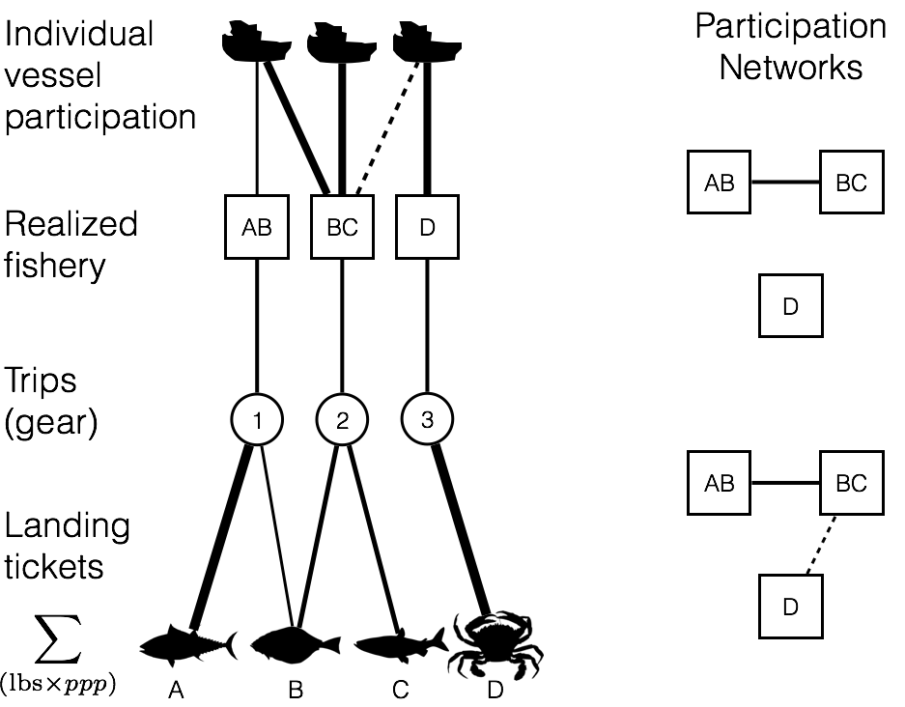

**Figure 1.** Using landing tickets, I used price per pound (ppp) and landed weight to calculate revenue per species per trip. I aggregated these landings to trips and grouped trips by gear. In each gear partition I identified realized fisheries by measuring pairwise similarity of each trip’s revenue composition of catch using the Hellinger distance, and clustered using infoMap. Using these fishery designations I mapped participation at the vessel level, quantified revenue diversity and fisheries connectivity at the port level.

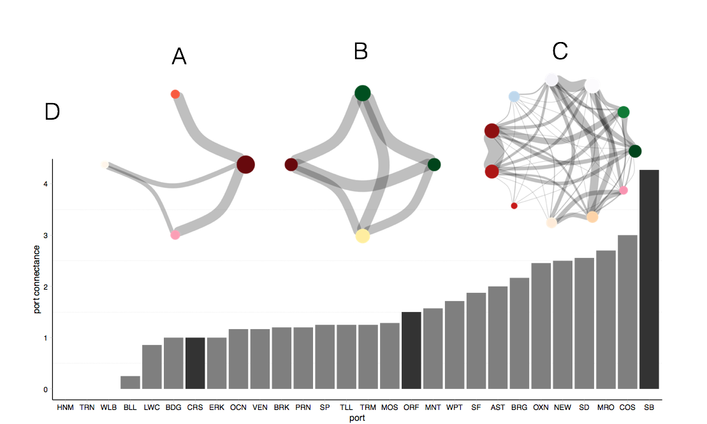

**Figure 2.** Spectrum of fisheries connectivity present in participation networks on the US west coast as illustrated by participation networks for A) Crescent City, CA; B) Port Orford, OR; and C) Santa Barbara, CA. Here nodes represent realized fisheries where edge width is proportional to the number of vessels that participate in the connected fisheries. Vertex size is proportional to the number of vessels which participate in each realized fishery. Color of nodes represents gear type and is consistent across networks: reds indicate pots, greens are hook and line, blues are nets, pinks are shrimp trawls, oranges are groundfish trawl, purples are miscellaneous and yellows are troll fisheries. D) Fisheries connectivity, measured as link-density for all ports on US west coast with more than three vessels landing between 2009-2013. Dark bars correspond to the network above them.

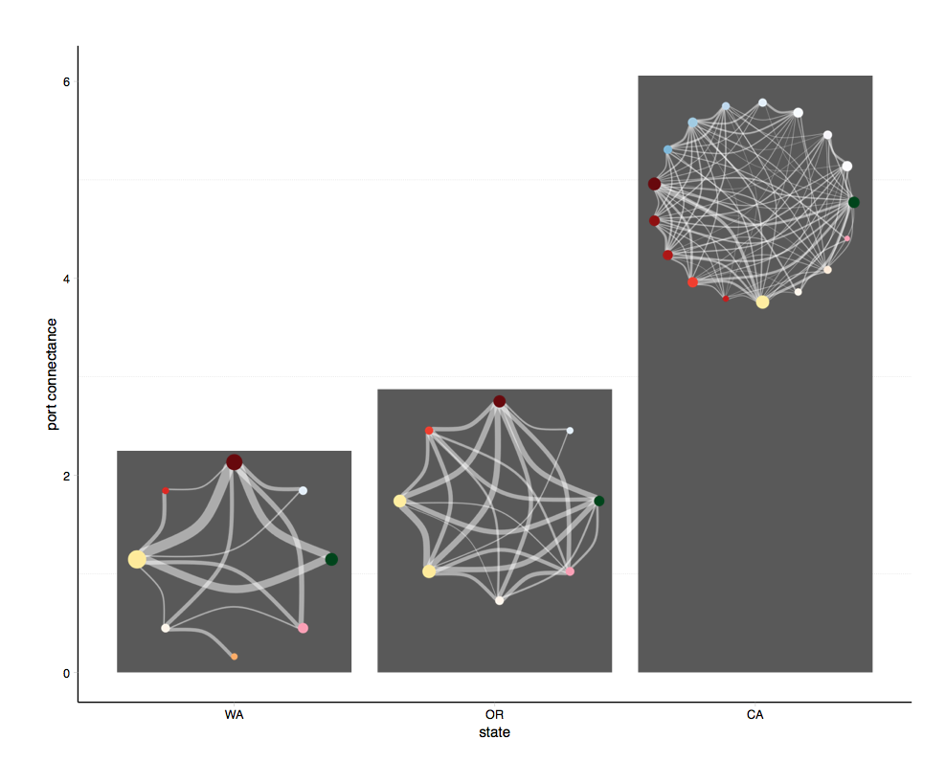**Figure 3.** Spectrum of fisheries for state-level participation networks on the US west. Here nodes represent realized fisheries where edge width is proportional to the number of vessels that participate in the connected fisheries. Vertex size is proportional to the number of vessels which participate in each realized fishery. Color of nodes is consistent across networks, reds represents pots, greens are hook and line, blues are nets, pinks are shrimp trawls, oranges are groundfish trawl, purples are miscellaneous and yellows are troll fisheries. The bar plot displays fisheries connectivity, measured as link-density for each state on US west coast with more than three vessels landing between 2009-2010. The participation network for each state is pictures to illustrate the intuitive differences among states.

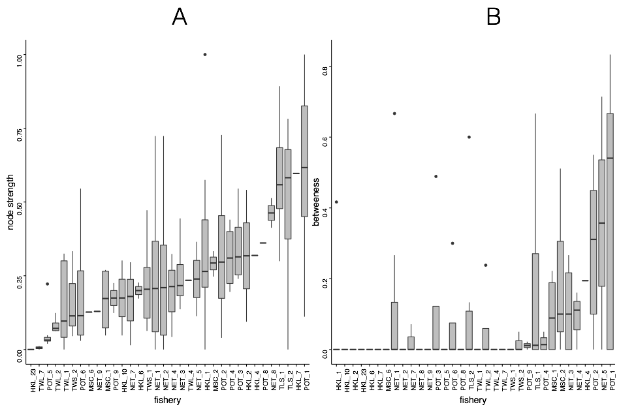**Figure 4.** Ordered from least to most are measures of A) node strength and B) betweenness for port-level participation networks. Fisheries are ordered from left to right from smallest to greatest median node strength and betweenness (respectively). POT_1 has the greatest node strength and betweenness, but other fisheries shift their ordering depending on the metric used (for state and coast-wide scales see Appendix).

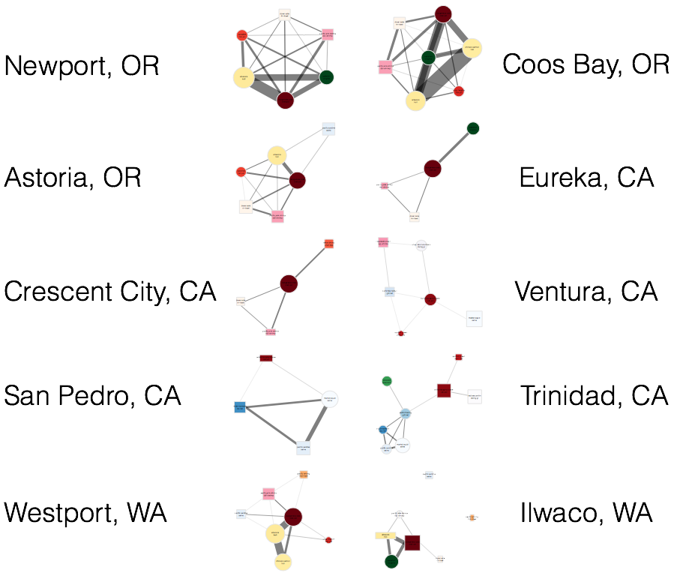**Figure 5.** Participation networks for the 10 ports which are responsible for 65% of total revenue derived from commercial fisheries between 2009-2013. Base colors of nodes represent fisheries using the same types of gear (i.e. pots are red, trawls are beige-orange, purse seines are blue and trolls are yellow). The shape of the node represents its community membership. The width of the edges is proportional to the log number of vessels which participate in both and the size of each node is proportional to the log number of vessels which participated in that fishery between 2009-2013. Edge widths and node sizes were adjusted for visibility so are directly comparable within graphs, but not necessarily between them.

*Appendix*

**Realized Fisheries**

|  |  |  |  |  |  |  |  |  |  |
| --- | --- | --- | --- | --- | --- | --- | --- | --- | --- |
| 1) | pot_1 | Dungeness crab | crab pot | 45 | 23 | 32 | 105532 | no | 1194 |
| 2) | msc_1 | red sea urchin | diving gear | 80 | 20 | NA | 58224 | no | 211 |
| 3) | tls_1 | chinook salmon | troll | 50 | 25 | 25 | 39383 | no | 1481 |
| 4) | pot_2 | California spiny lobster | crab & lobster pot | 100 | NA | NA | 28588 | no | 253 |
| 5) | hkl_1 | sablefish | longline | 66 | 15 | 19 | 25026 | no | 595 |
| 6) | net_1 | market squid | seine | 100 | NA | NA | 20325 | no | 154 |
| 7) | hkl_2 | black rockfish | other hook & line | 67 | 33 | NA | 18358 | no | 342 |
| 8) | tls_2 | albacore | troll | 42 | 26 | 32 | 13851 | no | 1260 |
| 9) | pot_3 | rock crab | crab & lobster pot | 100 | NA | NA | 11806 | no | 203 |
| 10) | hkl_4 | brown rockfish, gopher rockfish | pole (commercial) | 90 | 10 | NA | 10200 | yes | 209 |
| 11) | hkl_3 | California halibut | pole (commercial) | 100 | NA | NA | 9350 | no | 630 |
| 12) | twl_1 | dover sole | roller-trawl | 59 | 23 | 18 | 8305 | no | 125 |
| 13) | net_2 | pacific sardine | seine | 74 | 16 | 11 | 7169 | no | 116 |
| 14) | tws_1 | pacific pink shrimp | double-shrimp trawl | 20 | 50 | 30 | 6208 | no | 105 |
| 15) | pot_5 | spotted prawn | prawn trap | 81 | NA | 19 | 5823 | no | 37 |
| 16) | pot_6 | unsp. hagfish | fish pot | 50 | 18 | 32 | 5630 | no | 137 |
| 17) | hkl_5 | lingcod | other hook & line, pole (commercial) | 63 | 25 | 12 | 5502 | no | 612 |
| 18) | pot_4 | sablefish | fish pot | 62 | 25 | 12 | 5393 | no | 283 |
| 19) | net_3 | California halibut | gillnet | 100 | NA | NA | 4946 | no | 63 |
| 20) | twl_2 | California halibut | groundfish trawl<8 | 100 | NA | NA | 4703 | no | 55 |
| 21) | hkl_6 | black-and-yellow rockfish, Cabazon, grass rockfish | pole (commercial), vertical hook & line | 74 | 26 | NA | 4634 | yes | 201 |
| 22) | msc_2 | unsp. sea cucumbers | diving gear | 95 | 5 | NA | 4384 | no | 92 |
| 23) | hkl_7 | white seabass | pole (commercial) | 100 | NA | NA | 3372 | no | 387 |
| 24) | net_4 | white seabass | gillnet | 100 | NA | NA | 3292 | no | 55 |
| 25) | net_5 | pacific herring | gillnet | 89 | NA | 11 | 3270 | no | 157 |
| 26) | twl_3 | unsp. bait shrimp | beam trawl | 100 | NA | NA | 2384 | no | 10 |
| 27) | tws_2 | ridgeback prawn | single-shrimp trawl | 85 | NA | 15 | 2203 | no | 24 |
| 28) | twl_4 | unsp. sea cucumbers | groundfish trawl | 100 | NA | NA | 2106 | no | 48 |
| 29) | hkl_8 | vermilion rockfish | pole (commercial) | 79 | 21 | NA | 1878 | no | 263 |
| 30) | net_7 | swordfish, common thresher shark | drift gillnet | 100 | NA | NA | 1510 | yes | 82 |
| 31) | net_6 | unsp. shad | dip net | 100 | NA | NA | 1362 | no | 10 |
| 32) | net_8 | chub mackerel | dip net | 90 | 10 | NA | 1283 | no | 51 |
| 33) | tws_3 | California halibut | single-shrimp trawl | 69 | 23 | 8 | 1239 | no | 43 |
| 34) | pot_8 | other shrimp | prawn trap | 67 | 33 | NA | 1177 | no | 33 |
| 35) | net_9 | northern anchovy | seine | 81 | 6 | 12 | 1170 | no | 45 |
| 36) | hkl_9 | unsp. sanddabs | pole (commercial) | 100 | NA | NA | 1159 | no | 97 |
| 37) | msc_4 | Dungeness crab | other-known | 17 | 83 | NA | 1102 | no | 92 |
| 38) | pot_11 | Cabazon, gopher rockfish | fish pot | 80 | 20 | NA | 1087 | yes | 70 |
| 39) | msc_5 | basket cockle | other-known | 73 | 27 | NA | 985 | no | 44 |
| 40) | msc_3 | unsp. bait shrimp | other-known | 25 | NA | 75 | 922 | no | 11 |
| 41) | hkl_10 | albacore | pole (commercial) | 91 | 3 | 6 | 780 | no | 285 |
| 42) | pot_9 | California sheephead | fish pot | 100 | NA | NA | 722 | no | 40 |
| 43) | twl_5 | chinook salmon | selective flat fish trawl, groundfish trawl<8, mid-water trawl | 70 | 20 | 10 | 615 | yes | 83 |
| 44) | twl_7 | pacific whiting | mid-water trawl | 29 | 43 | 29 | 599 | no | 29 |
| 45) | msc_6 | swordfish | other-known | 100 | NA | NA | 515 | no | 35 |
| 46) | tws_8 | unsp. bait shrimp | single-shrimp trawl | 100 | NA | NA | 402 | no | 3 |
| 47) | pot_10 | other crab | crab & lobster pot | 89 | 11 | NA | 378 | no | 84 |
| 48) | hkl_11 | California sheephead | pole (commercial) | 94 | 6 | NA | 375 | no | 50 |
| 49) | msc_8 | gaper clam | other-known | NA | 100 | NA | 342 | no | 10 |
| 50) | hkl_13 | California scorpionfish | pole (commercial) | 100 | NA | NA | 329 | no | 14 |
| 51) | tws_4 | unsp. sea cucumbers | single-shrimp trawl | 100 | NA | NA | 324 | no | 20 |
| 52) | pot_7 | Dungeness crab, rock crab | crab & lobster pot | 69 | 19 | 11 | 318 | yes | 156 |
| 53) | hkl_15 | pacific halibut | longline | 6 | 69 | 25 | 297 | no | 115 |
| 54) | hkl_18 | surfperch spp. | pole (commercial) | 100 | NA | NA | 262 | no | 32 |
| 55) | hkl_17 | yellowtail | pole (commercial) | 100 | NA | NA | 232 | no | 68 |
| 56) | tls_5 | California halibut | troll | 100 | NA | NA | 228 | no | 53 |
| 57) | pot_12 | other mollusks | crab & lobster pot | 100 | NA | NA | 226 | no | 56 |
| 58) | hkl_14 | common thresher shark | pole (commercial) | 100 | NA | NA | 213 | no | 47 |
| 59) | net_12 | pacific barracuda | drift gillnet | 100 | NA | NA | 209 | no | 16 |
| 60) | hkl_12 | Bluefin tuna, pacific sanddab | pole (commercial) | 78 | 22 | NA | 207 | yes | 117 |
| 61) | net_11 | other crab | gillnet | 100 | NA | NA | 194 | no | 16 |
| 62) | hkl_16 | unsp. smelt | pole (commercial) | 100 | NA | NA | 173 | no | 13 |
| 63) | twl_11 | other crab, other shrimp | groundfish trawl | 100 | NA | NA | 163 | yes | 14 |
| 64) | msc_11 | unsp. mollusks | diving gear | 100 | NA | NA | 149 | no | 8 |
| 65) | hkl_19 | shortfin mako shark | pole (commercial) | 100 | NA | NA | 145 | no | 34 |
| 66) | pot_13 | unsp. octopus | crab pot | 67 | 33 | NA | 145 | no | 70 |
| 67) | msc_9 | other sea urchins | diving gear | 100 | NA | NA | 136 | no | 44 |
| 68) | hkl_26 | chinook salmon | pole (commercial) | 100 | NA | NA | 114 | no | 53 |
| 69) | tls_4 | unsp. sanddabs | troll | 71 | 21 | 8 | 108 | yes | 77 |
| 70) | tls_8 | lingcod | troll | 44 | 44 | 12 | 103 | no | 60 |
| 71) | hkl_24 | unsp. reds rockfish | pole (commercial) | 100 | NA | NA | 98 | no | 28 |
| 72) | msc_10 | butter clam | other-known | NA | 100 | NA | 86 | no | 6 |
| 73) | twl_12 | yellowtail rockfish | selective flat fish trawl, mid-water trawl, roller-trawl | NA | 40 | 60 | 86 | no | 26 |
| 74) | twl_8 | lingcod | selective flat fish trawl, mid-water trawl, roller-trawl | 25 | 38 | 38 | 84 | no | 27 |
| 75) | tws_6 | unsp. flatfish | single-shrimp trawl | 100 | NA | NA | 83 | no | 7 |
| 76) | hkl_20 | unsp. shelf rockfish | pole (commercial) | 100 | NA | NA | 82 | no | 6 |
| 77) | hkl_22 | pacific barracuda | pole (commercial) | 100 | NA | NA | 76 | no | 45 |
| 78) | hkl_21 | leopard shark | pole (commercial) | 100 | NA | NA | 65 | no | 29 |
| 79) | msc_12 | other mollusks | diving gear | 78 | 22 | NA | 65 | no | 29 |
| 80) | hkl_23 | swordfish | longline | 100 | NA | NA | 57 | no | 16 |
| 81) | tls_7 | yellowtail rockfish | troll | 38 | 38 | 25 | 48 | no | 29 |
| 82) | twl_9 | nor. unsp. slope rockfish | roller-trawl | NA | 75 | 25 | 44 | no | 28 |
| 83) | hkl_25 | unsp. squid | longline, other hook & line, pole (commercial) | 70 | 30 | NA | 41 | no | 12 |
| 84) | hkl_27 | unsp. rockfish | pole (commercial) | 92 | NA | 8 | 37 | no | 21 |
| 85) | tws_9 | other crab, rock crab | single-shrimp trawl | 100 | NA | NA | 37 | yes | 10 |
| 86) | pot_14 | unsp. eels | fish pot | 100 | NA | NA | 36 | no | 13 |
| 87) | twl_10 | pop | roller-trawl | NA | 100 | NA | 36 | no | 17 |
| 88) | twl_13 | canary rockfish, spiny dogfish | mid-water trawl | NA | 75 | 25 | 34 | yes | 19 |
| 89) | twl_14 | spiny dogfish | selective flat fish trawl, groundfish trawl<8, mid-water trawl | 50 | 25 | 25 | 33 | no | 7 |
| 90) | msc_14 | California sheephead | diving gear | 100 | NA | NA | 27 | no | 6 |
| 91) | tls_9 | sablefish | troll | 64 | NA | 36 | 27 | no | 22 |
| 92) | tws_7 | other shrimp | single-shrimp trawl | 100 | NA | NA | 23 | no | 3 |
| 93) | msc_13 | black-and-yellow rockfish | diving gear | 100 | NA | NA | 22 | no | 6 |
| 94) | msc_16 | unsp. echinoderm | diving gear | 100 | NA | NA | 21 | no | 5 |
| 95) | tls_3 | albacore | troll | 47 | 20 | 33 | 21 | no | 21 |
| 96) | twl_6 | petrale sole | groundfish trawl<8 | 100 | NA | NA | 20 | yes | 6 |
| 97) | tws_10 | other skates | single-shrimp trawl | 100 | NA | NA | 19 | no | 5 |
| 98) | msc_7 | unsp. sea cucumbers | diving gear | 100 | NA | NA | 18 | no | 7 |
| 99) | tls_6 | white seabass | troll | 100 | NA | NA | 18 | no | 7 |
| 100) | msc_18 | unsp. flatfish | diving gear | 100 | NA | NA | 17 | no | 6 |
| 101) | net_10 | pacific sardine | seine | 100 | NA | NA | 14 | no | 10 |
| 102) | msc_15 | unsp. shad | unknown gear | 100 | NA | NA | 10 | no | 2 |
| 103) | msc_17 | shortfin mako shark | other-known | 100 | NA | NA | 9 | no | 6 |
| 104) | hkl_28 | unsp. octopus | longline, other hook & line, pole (commercial) | 25 | 75 | NA | 8 | no | 6 |
| 105) | hkl_29 | nor. unsp. shelf rockfish | other hook & line | NA | 100 | NA | 5 | no | 4 |
| 106) | tws_5 | hornyhead turbot, ridgeback prawn, unsp. hagfish | single-shrimp trawl | 100 | NA | NA | 4 | yes | 3 |
| 107) | tls_10 | yellowtail | troll | NA | 100 | NA | 3 | no | 3 |
| 108) | tws_11 | white seabass | single-shrimp trawl | 100 | NA | NA | 3 | no | 2 |
| 109) | tws_12 | vermilion rockfish | single-shrimp trawl | 100 | NA | NA | 3 | no | 2 |

**Evaluating realized fisheries classification**

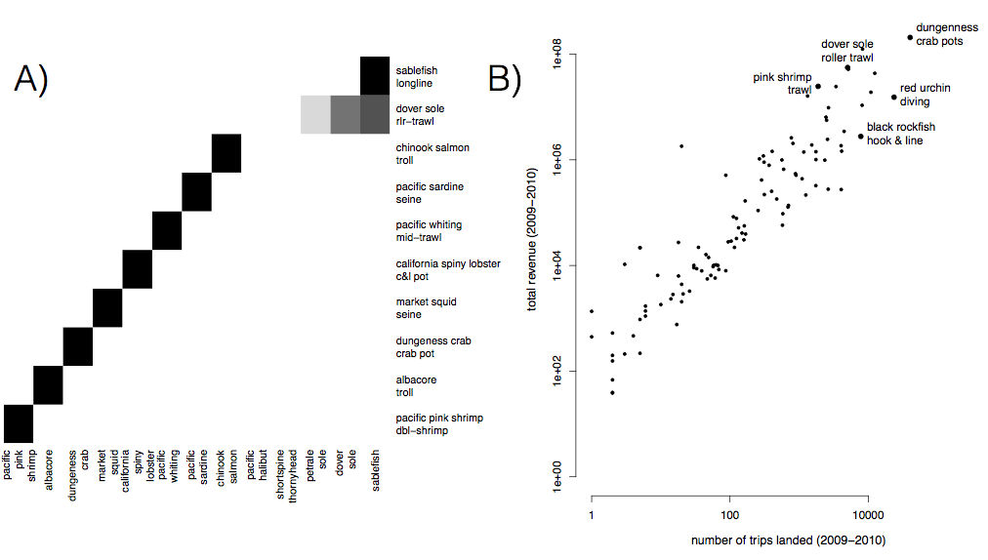

**Figure S1.** A) Species composition for top ten realized fisheries (rows). Cell color represents the proportion of landings for which each species (column) is responsible. Most of the biggest realized fisheries are composed of primarily a single species, but groundfish trawl is multispecies. B) Comparison of effort and revenue for all realized fisheries between 2009-2010.

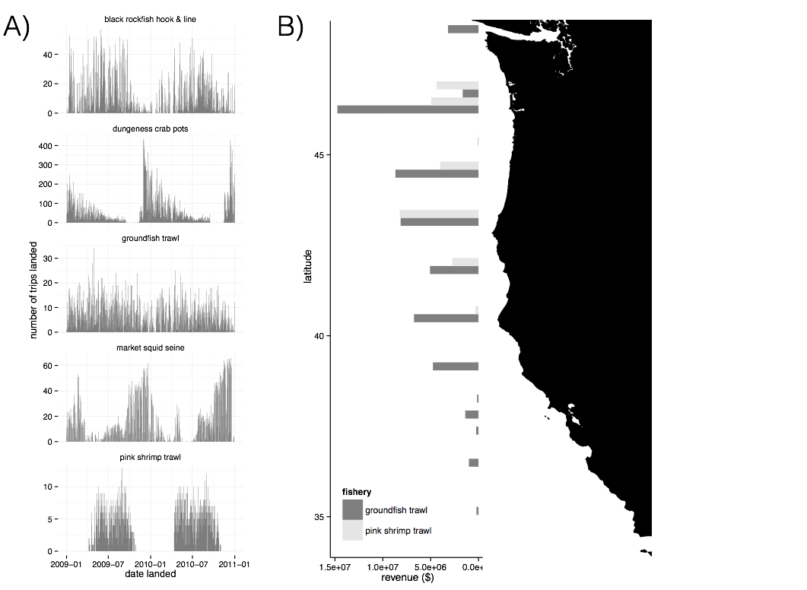

**Figure S2.** A) Seasonality of five major realized fisheries between 2009-2010. Distinct seasonal patterns are observed in dungeness crab, market squid and pink shrimp fisheries. B) Spatial structure of landings for two example fisheries between 2009-2010. Landings are binned by latitude. Pink shrimp trawl is landed further north, while groundfish trawl landings are distributed more evenly across the coast.

**Participation Networks**

**State and Coast wide Node Strength and Betweenness Centrality**

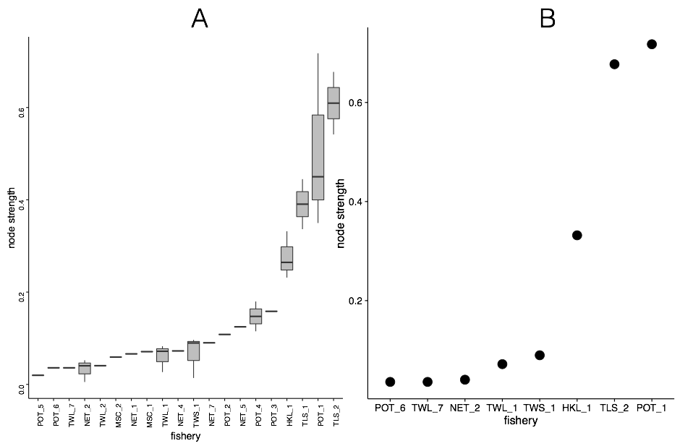

**Figure SX.** Node strength measured for A) state and b) coastwide participation networks.

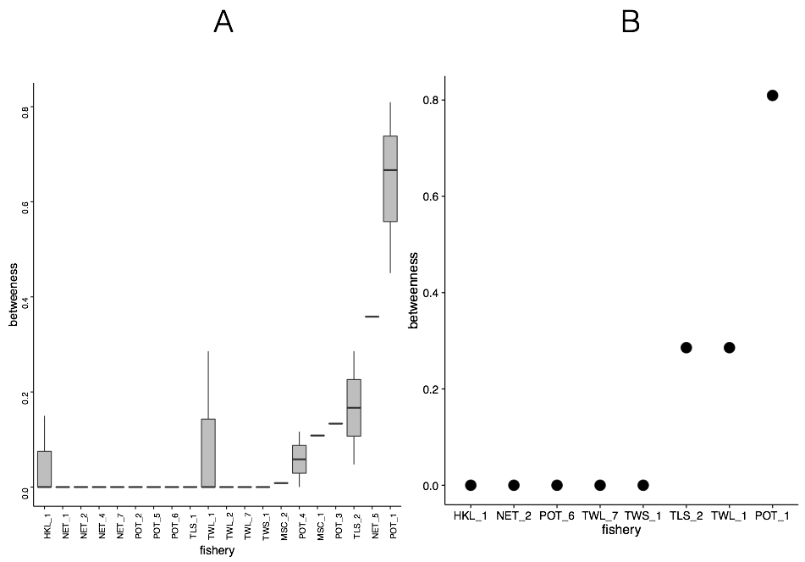

**Figure SX.** Betweenness centrality measured for A) state and B) coastwide participation networks.

*Literature Cited*

Barrat, A, M Barthelemy, R Pastor-Satorras, and A Vespignani. 2004. “The Architecture of Complex Weighted Networks.” *Proceedings of the National Academy of Sciences* 101 (11). National Acad Sciences: 3747–52. doi:10.1073/pnas.0400087101.

Boonstra, Wiebren J, and Jonas Hentati Sundberg. 2014. “Classifying Fishers' Behaviour. an Invitation to Fishing Styles,” August, n–a–n–a. doi:10.1111/faf.12092.

Deporte, N, C Ulrich, S Mahevas, S Demaneche, and F Bastardie. 2012. “Regional Metier Definition: a Comparative Investigation of Statistical Methods Using a Workflow Applied to International Otter Trawl Fisheries in the North Sea.” *ICES Journal of Marine Science* 69 (2): 331–42. doi:10.1093/icesjms/fsr197.

Freeman, Linton C, Douglas Roeder, and Robert R Mulholland. 1979. “Centrality in Social Networks: II. Experimental Results.” *Social Networks* 2: 119–41.

Hicks, Christina C, Arielle Levine, Arun Agrawal, Xavier Basurto, Sara J Breslow, Courtney Carothers, Susan Charnley, et al. 2016. “Engage Key Social Concepts for Sustainability.” *Science (New York, N.Y.)* 352 (6281): 38–40. doi:10.1126/science.aad4977.

Jackson, J B, M X Kirby, W H Berger, K A Bjorndal, L W Botsford, B J Bourque, R H Bradbury, et al. 2001. “Historical Overfishing and the Recent Collapse of Coastal Ecosystems..” *Science (New York, N.Y.)* 293 (5530): 629–37. doi:10.1126/science.1059199.

Jepson, Michael, and Lisa L Colburn. 2013. “Development of Social Indicators of Fishing Community Vulnerability and Resilience in the U.S. Southeast and Northeast Regions.” NMFS-F/SPO-129. *U.S. Department of Commerce, NOAA Technical Memorandum NMFS-F/SPO-129*. U.S. Dept. of Commerce.

Kareiva, Peter, and Michelle Marvier. 2012. “What Is Conservation Science?.” *Bioscience* 62 (11): 962–69. doi:10.1525/bio.2012.62.11.5.

Kasperski, S, and D S Holland. 2013. “Income Diversification and Risk for Fishermen.” *Proceedings of the National Academy of Sciences*. doi:10.1073/pnas.1212278110/-/DCSupplemental.

Lade, Steven J, Alessandro Tavoni, Simon A Levin, and Maja Schlüter. 2013. “Regime Shifts in a Social-Ecological System.” *Theoretical Ecology* 6 (3): 359–72. doi:10.1007/s12080-013-0187-3.

Legendre, P, and L Legendre. 2012. *Numerical Ecology*. Elsevier.

Levin, Simon. 1999. *Fragile Dominion*. Basic Books.

Mace, Georgina M. 2014. “Ecology. Whose Conservation?.” *Science (New York, N.Y.)* 345 (6204). American Association for the Advancement of Science: 1558–60. doi:10.1126/science.1254704.

Ostrom, Elinor. 2009. “A General Framework for Analyzing Sustainability of Social-Ecological Systems.” *Science (New York, N.Y.)* 325 (5939): 419–22. doi:10.1126/science.1172133.

Pons, Pascal, and Matthieu Latapy. 2005. “Computing Communities in Large Networks Using Random Walks.” *ArXiv Physics E-Prints*. http://arxiv.org/abs/physics/0512106#.

Rosvall, Martin, and Carl T Bergstrom. 2008. “Maps of Random Walks on Complex Networks Reveal Community Structure.” *Proceedings of the National Academy of Sciences* 105 (4). National Acad Sciences: 1118–23. doi:10.1073/pnas.0706851105.

Tavoni, Alessandro, Maja Schlüter, and Simon Levin. 2012. “The Survival of the Conformist: Social Pressure and Renewable Resource Management.” *Journal of Theoretical Biology* 299 (April): 152–61. doi:10.1016/j.jtbi.2011.07.003.

van Putten, Ingrid E, Soile Kulmala, Olivier Thébaud, Natalie Dowling, Katell G Hamon, Trevor Hutton, and Sean Pascoe. 2012. “Theories and Behavioural Drivers Underlying Fleet Dynamics Models.” *Fish and Fisheries* 13 (2): 216–35. doi:10.1111/j.1467-2979.2011.00430.x.

Worm, Boris, Ray Hilborn, Julia K Baum, Trevor A Branch, Jeremy S Collie, Christopher Costello, Michael J Fogarty, et al. 2009. “Rebuilding Global Fisheries..” *Science (New York, N.Y.)* 325 (5940). American Association for the Advancement of Science: 578–85. doi:10.1126/science.1173146.