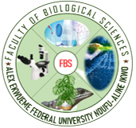

**Volume 1, Issue 1**

**Volume 1 ISSUE 1**

THE FACULTY OF BIOLOGICAL SCIENCE MAIDEN CONFERENCE

JUNE 2023

**Date: 7TH - 9TH June, 2023**

**BOOK OF ABSTRACT**

Theme

**Bioscience Research: A frontier for Nigerian economic diversification and sustainable development.**