Class 2

**Directory structure for UNIX**

**Directory Structure** – this is a convention for filesystem layout. Example:

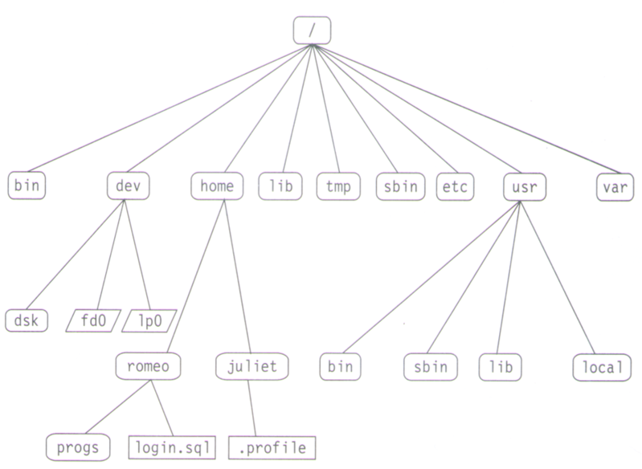

Good list from Wikipedia: <http://en.wikipedia.org/wiki/Unix_directory_structure>

Although they are all important, here are some that I hand-picked:

**/** - the root of the filesystem tree (top of everything)

**/bin** – stands for “binaries” and contains fundamental utilities such as ls and cp which are generally needed by all users

**/boot** – contains important files required for successful booting.

**/etc** – contains system-wide configuration files and system databases. It’s a good idea to backup this directory regularly. It will definitely save you a lot of re-configuration later if you re-install or lose your current installation. For example the /etc/shadow file is where the user passwords are stored.

**/home** – contains the home directories for the users

**/lib** – contains system libraries, and some critical files such as kernel modules or device drivers. These libraries can be used by installed software.

**/tmp** – a place for temporary files. On most systems, this directory is cleared out at boot or at shutdown by the local system.

**/var** – a place for files that may change often such as log files and e-mails sent to users on the system. For example /var/log is a great place for various log files.

**/sbin** - Stands for "system (or superuser) binaries" and contains fundamental utilities, such as init, usually needed to start, maintain and recover the system. They are mostly administrative tools, that should be made available only to the root (i.e., administrative) user.

**VIM**

VIM (command is VI, so this is normally referred to as just “VI”) – is a screen-oriented text editor. You can use it to create a document or edit an existing text document. VI is what the “advanced” guys use. It can be frustrating at first but hang in there and practice. Why is VI still important to learn? At times, VI may be the only text editor you can use, especially if a given operating system doesn’t have Internet access to download another editor. Another popular one is called Nano – most people starting out with Linux prefer using Nano and it’s easy to pick-up. You’ll get exposed to Nano eventually (I put a side note at the end of the document). For now, let’s VI!

To create a file, you would use this command as an example to create a file named test:

vi test

Push the **I** key to get into **INSERT** MODE. Insert mode allows you to enter text. (You will see the mode at the bottom of your screen… if you can’t see it, make the window bigger).

Pushing the **ENTER** or RETURN key in INSERT MODE will go to the next line.

To get out of INSERT MODE, push the **ESCAPE** key.

In NORMAL MODE or INSERT MODE, you can use the UP/DOWN/LEFT/RIGHT **ARROW KEYS** to navigate around.

In NORMAL MODE, pushing **dd** (the D key twice) will delete an entire line

IN NORMAL MODE, pushing the **x** key will delete the character that is highlighted

IN INSERT MODE, pushing the **backspace** key will delete the character that is highlighted

HOLD-SHIFT and push the **COLON key ‘:’** type **‘set nu’** to get line numbers. Push ‘:’ again followed with the number of the line to jump to that line (example :5 will get you to line #5).

HOLD-SHIFT and push the **COLON key** ‘**:**’ type ‘**q!**’ to quit without saving and type ‘**wq**’ to save (write) & quit.

In NORMAL MODE, pushing ‘o’ will add a new line immediately below the current line and get you in INSERT mode.

To copy paste text in VI use the “**Y**” or “**yy**” (yank) command. To copy one line use **Y**, to copy 2 lines use **2Y**, to copy 10 lines use **10Y**, to copy all lines to the end of the file use **yG**. To paste use **P** to paste right where your cursor is and **p** to paste right below the current cursor position.

To **UNDO** something such as writing text, push the ‘**U**’ key.

To **REDO** something you can push **CTRL-R** or HOLD-SHIFT and push the COLON Key “:” and type redo

It’s also possible to yank text from within a line. The following commands yank text from the current cursor position to the end of the word ‘**yw**’ and the end of the line respectively ‘**y$**’

|  |  |
| --- | --- |
| 1G | Move to the first line of the file |
| G | Move to the last line of the file |
| r | Replace one character |
| R | Replace many characters |
| D | Delete to the end of the line |
| mc | Set marker c on this line |
| `c | Go to beginning of marker c line. |
| 'c | Go to first non-blank character of marker c line. |
| J | Join lines |

There are a lot more things you can do in VI. Here are some additional resources:

<http://www.lagmonster.org/docs/vi.html>

<http://www.computerhope.com/unix/uvi.htm>

**VI TIPS:**

Always look at the bottom of your screen (make the window bigger if needed) to see which mode you are in (INSERT, or “NORMAL MODE” meaning nothing is showing there). You can leave a mode by pushing ESC

CTRL-C, CTRL-X, and EXIT can help you get out of “sticky” or “stuck” situations.

Some good text editors for Windows:

<http://www.vim.org/download.php>

<http://notepad-plus-plus.org/>

<http://www.textpad.com/>

Using a FTP-style client to copy files back & forth with your VM. You could install WinSCP <http://winscp.net/eng/index.php> and then you connect to your Linux machine using the SCP protocol (you have to pick it, aka change it from FTP) and use the IP and port 22. The user is root. After you connect you have access to the folders on your machine (just like an FTP client) and you can drag and drop files from your Desktop to your Linux machine and vice-versa. This makes it easier if you want to copy a text document from Linux and use a text editor in Windows to work on the doc and then save and copy back to the Linux machine.

A note on the **NANO** text editor

Although these notes cover VI, most beginners and many Linux users prefer the “**nano**” text editor. You can try it by using:

**nano** name_of_text

then you can write text

to save do CTRL-O, push Enter

to exit do CTRL-X