Planning What You Cannot Count: An Open-Data Framework for Bus Route Rationalisation and Fleet Sizing under Demand-Data Scarcity
Manuscript, clean reading copy · Target journal: Transport Policy (Elsevier) · revision a16a5c5

Abstract
Most Indian cities that need bus-network reform lack the origin–destination and ridership data that route-optimisation methods assume. We present an open-data, demand-free framework for bus route rationalisation and fleet sizing and apply it to Kashmir Division, India (6,584,762 residents), using a gridded population surface, OpenStreetMap, a routing engine and the digitised permit register. Its 614 route records (445 private permits and 169 timetabled services) describe only 157 corridors, so the plan's apparent 71 % "route reduction" is 99.4 % corridor retention plus a change of unit. Measuring catchments on the pedestrian network rather than as straight-line buffers lowers population served by a median of 37.4 % per route and division coverage from 35.5 % to 24.2 %; only 10.4 % of residents live near a 15-minute service. Against 2,526 driver-GPS service runs, modelled run times are too fast and a per-kilometre cap, not demand, sets cycle time on 169 of 186 routes. Joint uncertainty analysis therefore reports the fleet as a range: 989–1,058 buses as specified, but 1,130–1,266 at observed pace, against a published 1,011; the service hierarchy is robust (97.8 % tier agreement). Thirty per cent of the fleet, bought in order of new residents reached per bus, delivers 92 % of the plan's coverage. The plan is decision-robust in its hierarchy, not demand-validated.
Keywords: bus route rationalisation; demand-data scarcity; open data; network walk catchments; fleet sizing; uncertainty analysis; Kashmir

1. Introduction

1.1 Urban bus transport under stress in Indian cities
India is facing a structural and widening shortage for urban public buses. In estimation from 2026 to 2047, the country's urban population is to grow from 490 million to about 763 million; this adds more than 270 million residents who will have dependencies for public transport (CSE & CITIES Forum 2026). In contrast to this demographic situation and demand, the municipal bus fleets continue to shrink relatively. The current national bus availability ranges roughly from 0.13 to 0.14 buses per 1000 people, this makes national provision nearly 70% below the benchmark of 0.44 set by Ministry of Housing and Urban Affairs (MoHUA) as per CSE & CITIES Forum, 2026; MoHUA, 2014; Pucher et al., 2007. This shortage issue hits secondary cities most. Over 400 Class-I cities with population count ranging from 100,000 to 1 Million have no organised municipal bus network at all (CSE-CITIES Forum, 2026) while at the same time base digital transit data is almost non existing; less than 15 indian transit agencies publish open General Transit Feed Specification (GTFS) feeds. On ground, this gap is covered with private minibuses and other vehicles. Operating through this ad-hoc, permit by permit allocation without route integration or systematic timetable leaves the urban cities with fragmented and unreliable service to public.

1.2 Route rationalisation as a low-cost, high-leverage intervention
Urban transport policies often emphasize for capital-intensive, mass transit infrastructure to address the growing demand. Though the urban rail metro systems provide substantial capacity along high density corridors in primary metropolitan areas, they require significant capital for enabling route to over US$ 40 Million per km, compared to US$ 2.5 Million per km when its Bus Rapid Transit (BRT) (Badami & Haider, 2007). In secondary and Tier-II urban regions, taking mutli-year timeline projects and heavy infrastructure costs creates need for careful fiscal planning along with catering needs for immediate transit needs. Instead, comprehensive bus route rationalisation along with network redesign can make an exceptional cost effective and efficient solution that costs under US$0.05 Million per km (Badami & Haider, 2007). Rather than relying on heavy civil construction, this restructuring optimizes for existing ground infrastructure and operational vehicle assets. By merging overlapping services on busy central spines and deploying the spare assets to cover underserved peripheral corridors, route rationalisation delivers rapid improvements for better public access. This is even positively practical and cost efficient for municipal and transport departments that seek solution for delivery of time effective results on ground for people.

1.3 The demand-data precondition and why it binds
The academic literature in Transit Network Desgin and Frequency Setting (TNDFS) provides extensive mathematical frameworks to optimize bus routes and their operating schedules (Ceder, 2007; Guihaire & Hao, 2008; Ibarra-Rojas et al., 2015). However, these methodologies have the fundamental precondition: the availability of comprehensive, empirical passenger demand data, such like household origin-destination (OD) surveys, automated fare collection (AFC) transactions or automatic passenger counts (APC). In real practise, this demand creates bottleneck across four core stages of public transit planning:
- Objective function formation: Classical network optimization models minimize generalized passenger travel disutility like in-vehicle time, waiting time and transfer penalties while balancing against operator cost.
- Frequency and Headway setting: Standard operational methods calculate route frequency (f<sub>k</sub>) as a function of peak passenger volume on the heaviest loaded link (Q<sub>k,max</sub>):
<!-- FORMULA PLACEHOLDER — see EDITORIAL FLAG 1.3-a -->
Where C<sub>veh</sub> is rated vehicle capacity and LF<sub>target</sub> is the target load factor. If peak passenger volume is unobserved, frequency cannot be derived.
- Route Pruning: Standard algorithms identify and eliminate redundant routes based on passenger-kilometre revenue or observed boarding numbers. Without electronic ticketing data, authorities have no reliable way to separate essential trunk routes from redundant parallel ones.
- Model Validation: Conventional planning pipeline validate their results by back-casting simulated passenger flows against historical counts.
For mid-sized and secondary cities, this creates an operational deadlock. Local authorities cannot run standard network optimization without passenger demand data and also lack the infrastructure or survey budget to collect the needful data. This seeks rethinking of planning model. As shown in Figure 1, instead of waiting for unavailable demand data, cities can adopt a supply-side approach which builds an implementable network using open spatial data and clear, policy-driven service standards.
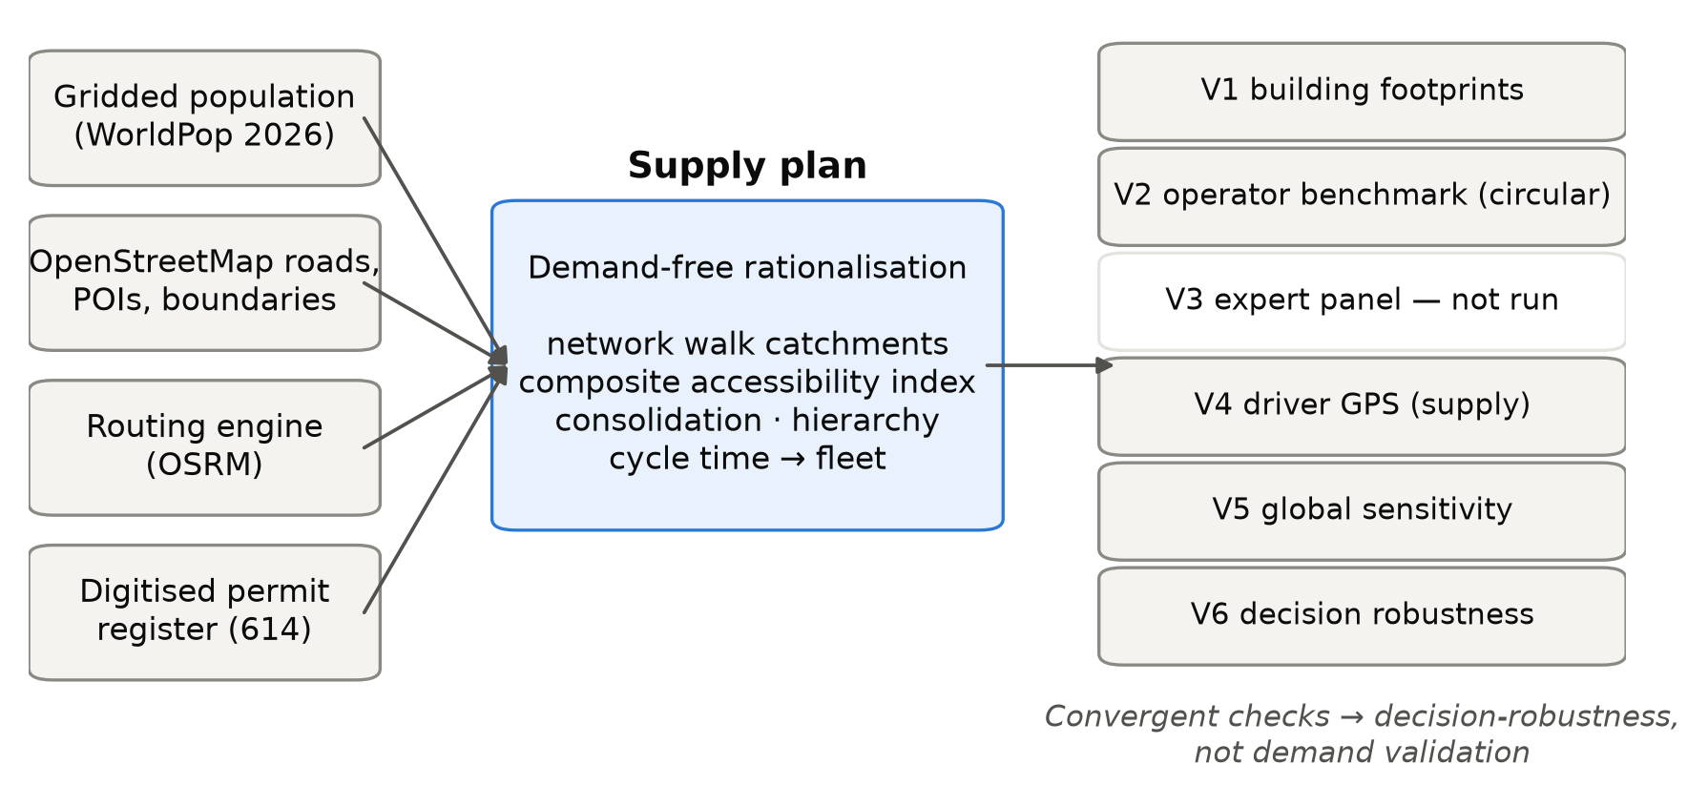
Figure 1. Conceptual framework: four open inputs produce a supply plan that is checked through six convergent channels. V3 (expert panel) was not run.

1.4 Data scarcity in Tier-II, permit-based networks
In secondary Indian cities, route-level permits stand as base for evolving the public transit network through history, issued by Regional Transport Offices (RTOs) and State Transport Authorities (STAs) in response to localized mobility demands. Over time, this point to point allocation has naturally concentrated them highly along primary commercial and healthcare arterials, while peripherals and developing peri-urban links suffer in frequency and service. In addition, the public transit delivery involves multiple stakeholders including RTOs managing private stage carriages, municipal Special Purpose Vehicles (eg: Smart City Ltd) introducing modern electric buses, and State Road Transport Corporations (SRTCs) — each operating under distinct mandates without an integrated digital scheduling platform or system.
The Kashmir Valley illustrates this operational reality at a regional scale. It comprises of 10-district urban-rural basin of 15,948 sq.km with 6.58 million residents. The valley in itself has unique physical constraints for mobility network, including nine critical Jhelum River Bridge crossing in Srinagar, major lakes barriers (Dal, Nigeen and Anchar), and sub-zero winter freezes during Chillai Kalan. The existing network comprises of 640+ legacy permit routes, with heavy overlap along primary civic arterials — such as 38 to 42 active permits serving the Soura and Lal Ded hospital corridors. The network must also consider and support the significant gender-specific transit dependency (64.5% female ridership recorded via CHALO electronic ticketing) and an annual influx of 2.5 million tourists, all of this with lack of a unified open GTFS feed.

1.5 Research gap, objectives and contributions
Despite the advancements in transit network design, present optimization frameworks offer no validated methodology to restructure fragmented, permit based bus systems in complete absence of empirical demand data, which is the case across most secondary and Tier-II Indian cities. To address this gap, this study develops a supply-side, open-data planning framework that translates road topology, gridded population distributions, and community anchors into a rationalised transit network.
Main objectives:
- O1 (Spatial Baseline): Construct an open spatial transit foundation integrating OpenStreetMap road networks, WorldPop demographics, and geo-located Points of Interest (POI) across a regional basin.
- O2 (Topological Consolidation): Develop an undirected graph consolidation algorithm to prune overlapping legacy permits into a coherent multi-tier corridor hierarchy.
- O3 (Supply-Side Scheduling): Derive policy-anchored headway bands from a Composite Demand Index (CDI) independent of unobserved passenger link flows.
- O4 (Fleet Dimensioning): Calculate realistic round-trip cycle times, fleet allocations, and vehicle size classes (light, medium, and heavy passenger vehicles: LPV, MPV, HPV) accounting for physical bridge bottlenecks and dwell penalties.
- O5 (Validation & Portability): Benchmark the operational outputs against empirical operational data and demonstrate policy transferability.
Correspondingly, this paper sets five major contributions: (1) mathematical rigorous, supply-side methodology of network design for data scarce regions; (2) a graph-based algorithm to merge overlapping route permits into unified corridors; (3) a novel demographic based and seasonal considerate demand-proxy formulations; (4) a regional-scale deployment across 10 districts in the Kashmir Valley, restructuring 644 legacy permits into 186 coordinated corridors; and (5) an open, reproducible spatial workflow designed for adoption across data-constrained secondary urban regions.

1.6 Organisation of the paper
The remainder of this paper content is as follows. Section 2 reviews the literature on transit network design under data constraints and details the physical and institutional setting of the Kashmir Valley. Section 3 formulates the supply-side methodology, detailing spatial baseline integration, topological permit consolidation, demand proxying, and fleet dimensioning. Section 4 presents the empirical results and sensitivity analyses. Section 5 discusses policy trade-offs, governance challenges, and framework transferability, before Section 6 that concludes with directions for future work.

Co-author block — "Policy Failure"
Public transport services operating in Jammu and Kashmir do not fall entirely under a single permitting authority. Bus services operating within cities/districts are permitted by the Regional Transport Authority (RTA), buses originating from other districts and operating within the Srinagar Municipal Area may fall under the permitting jurisdiction of the State Transport Authority (STA), Srinagar and Jammu municipal areas operate electric buses run by the respective Smart City Limited Companies, and finally, the JK Road Transport Corporation (JKRTC) operates intra-state and inter state services. The transport network in J&K therefore includes bus services that are governed by different permitting arrangements and agencies. For the purpose of this study, bus service data for Srinagar (the area falling within the limits of the Srinagar Municipal Corporation (SMC)) was studied. The RTA, issues permits broadly divided into Eastern and Western areas for this purpose. For city bus services permitted by the RTA, an applicant generally applies for a vehicle and indicates the area of operation, rather than proposing a specific route based on an assessment of passenger demand or the requirements of the wider network. The RTA considers such applications in accordance with the applicable legal and regulatory requirements. The Smart City electric-bus system is a separate planned intervention. There is also no systematic route-rationalisation exercise before permits are allotted. The RTC caters largely to destinations outside the municipal area and its routes were designated decades ago, without having been modified to align with changing demographic and demand patterns. At present, there is an absence of a comprehensive city-wide route plan for public transport and an absence of a single agency that regulates and manages public transport operations.
In Jammu and Kashmir, the procedure for grant of a stage carriage permit is primarily governed by the Motor Vehicles Act, 1988 and the rules made thereunder. Where the proposed Stage carriage service is to be operated within the jurisdiction of a particular Regional Transport Authority (RTA), the application is made before the concerned RTA. Accordingly, in the case of services operating within Srinagar District and falling within the jurisdiction of the RTA Srinagar, the RTA is the competent authority to consider and grant the permit. However, where the proposed service extends beyond the jurisdiction of a single RTA, the matter falls within the competence of the State Transport Authority (STA), particularly where the service originates in one district and terminates in another. The applicant is required to furnish details such as the proposed route in the classified areas (Eastern/Western), vehicle particulars, seating capacity, number of trips, timetable and other prescribed particulars. The competent authority examines the application and considers the proposed service in the context of existing transport arrangements, route feasibility and the requirements of the travelling public. The permit may be granted as applied for, granted with modifications, or refused in accordance with the applicable provisions. Once granted, the permit specifies the area (Eastern/Western) and is subject to conditions relating to the passenger capacity and other operational requirements.
Thus, the permit system in J&K operates through a two-level institutional structure, with the RTA dealing primarily with services confined to its jurisdiction and the STA dealing with services that extend across the jurisdiction of more than one RTA. These permits are permanent in nature, implying they do not have an end validity. Over time, the existing route structure has consequently developed through a combination of existing practices and the demands and representations of the Eastern and Western bus associations. While this allows individual applications to be considered within the existing regulatory framework, it does not provide an opportunity to assess how individual permits respond to travel demand and affect the transport network as a whole. In particular, permit allocation is not systematically preceded by an assessment of route duplication, passenger demand, service gaps, connectivity, fleet requirements or the frequency of services required on different corridors.
This is reflected in the present pattern of public transport services. Some corridors have overlapping services, while other areas have comparatively limited connectivity. Examples of overlapping service patterns include Lal Chowk–Lalbazar and Bagh-i-Shuer–Lal Chowk; Chanapora–Soura and Lal Chowk–Soura; and Malbagh–LD and Soura–LD. In contrast, Lal Chowk–Rangreth and Lal Chowk–PanthaChowk have been identified through official and field-level observations as areas with comparatively inadequate connectivity. These observations suggest that the issue is not simply the number of buses available, but also where those buses operate and how the routes are distributed across the city.
The underlying policy issue is that presently permitting is done as a response to individual permit applications rather than for planning the public transport network as a whole, not accounting for where services are required, where routes overlap, which areas are underserved, or what level of fleet and service frequency is appropriate for individual corridors. Moreover, the permit is valid in perpetuity, hence, it is challenging for the regulator to control, alter and plan public transport routes in the face of dynamic scenarios.
The study examines whether a city-wide bus network can be planned and fleet requirements estimated even where detailed passenger-demand data are not available. It explores the use of readily available spatial and network information as a starting point for route rationalisation and fleet planning. The intention is not to treat such information as a substitute for actual passenger-demand data, but to provide a practical basis for improving upon the present application driven approach and for developing better data systems over time.

Figure and table calls for §1
- Figure 1 — Conceptual framework (two panels). (Top) the conventional demand-driven transit planning pipeline, with data dependencies (OD matrices, AFC feeds, APC counts) drawn as locks that prevent optimisation in data-scarce settings. (Bottom) the proposed supply-side open-data pipeline, showing OpenStreetMap street topology, WorldPop gridded demographics and open Points of Interest feeding directly into topological consolidation, policy-anchored headway bands and cycle-time fleet dimensioning. Status: not yet generated (analysis/fig_generate_all.py is a stub). Caption above is the co-authors' own, transcribed verbatim.
- Statistics the attachment requires for §1, each needing a verified citation. (1) buses per 1,000 population, India against comparators; (2) number of Indian cities publishing GTFS; (3) share of Class-I cities with an organised bus service; (4) capital cost per km, metro vs BRT vs network redesign; (5) study area population, vehicle registrations, tourist arrivals. Items 1–4 appear in §1.1–§1.2 above and are covered by FLAG 1.1-a and FLAG 1.2-b. Item 5 is not yet written: population is established (6,584,762), but vehicle registrations and tourist arrivals have no source in the repository and no module produces them. Either a co-author supplies citable figures (J&K Economic Survey; JKTDC arrivals series) or item 5 is reduced to population alone.

2. Literature review and research gap

2.1 Review protocol
We searched Scopus (title, abstract, keywords) and OpenAlex (title, abstract) for English-language articles, conference papers and reviews from 2000 to 2026. Thirteen query blocks combined planning terms (network design, rationalisation, frequency setting, fleet size), data terms (origin–destination, smart card, data scarcity, open data, accessibility, equity) and context terms (India, Global South, paratransit, permits); six further Scopus queries targeted work resembling our own pipeline. The searches returned 5,488 unique records. A keyword pre-filter left 2,518 for title-and-abstract screening against written criteria (a first pass assisted by a large language model, then checked by the authors), and 873 were eligible. We coded a purposive, theme-stratified sample of 57 of these, plus three seminal earlier papers found by citation chaining, on data intensity, demand input, equity treatment, validation and planning output (Table 1; Supplementary Material S1). Forty-six were coded from full text.

2.2 Network design and route rationalisation
The transit network design and frequency-setting problem has been reviewed repeatedly (Guihaire & Hao, 2008; Kepaptsoglou & Karlaftis, 2009; Ibarra-Rojas et al., 2015; Durán-Micco & Vansteenwegen, 2022), and its operational fundamentals are textbook material (Vuchic, 2005; Ceder, 2016). The object optimised is a route set with frequencies and the objective is defined over passenger flows, so an origin–destination (OD) matrix is an input. Ten of our 60 coded studies are demonstrated only on benchmark or synthetic networks with a given OD matrix, most often the Mandl network (Mandl, 1980; Arbex & da Cunha, 2015; Yoo et al., 2023). Real-city route-and-frequency plans exist, for Rome (Cipriani et al., 2012), Tin Shui Wai (Szeto & Wu, 2011; Szeto & Jiang, 2014), Miami-Dade (Zhao & Zeng, 2008) and Bangalore (Verma et al., 2017), but each starts from a demand matrix.
Restructuring an inherited network is studied less often. Overlapping Istanbul routes have been altered inside an assignment model with a 452-zone OD matrix (Ergun & Kesten, 2011), and 14 overlapping Bangkok routes merged using on-board counts (Hoonsiri et al., 2020). Duplication can be measured from schedule data alone, but that work stops at diagnosis (Barzegari et al., 2026).

2.3 Demand estimation and its data requirements
Where demand is not surveyed it is inferred, and the inference consumes passive data: smart-card and vehicle-location records (Barry et al., 2009; Wang et al., 2011; Alsger et al., 2015), fare cards with GPS (Farzin, 2008), mobile-phone traces (Pinelli et al., 2016; Mittal & Ukkusuri, 2025) or taxi GPS (Chen et al., 2014). Even an attempt to predict passenger flows from network properties alone was trained on fare-collection data (Luo et al., 2020). These sources presuppose electronic ticketing or operator instrumentation, which permit-based minibus systems do not have.

2.4 Demand-independent and accessibility-based approaches
A second tradition plans against potential rather than realised travel: need indices built from census variables (Yao, 2007), accessibility surfaces (Tribby & Zandbergen, 2012; Karner, 2018), and transit-desert detection that uses no demand data (Carmody et al., 2025). One recent study states the premise plainly, assuming demand proportional to population (Liu & Rosenberg, 2026).
Two results from this tradition bear directly on our method, and we claim neither. First, straight-line buffers overstate catchment population relative to network distance (Gutierrez & Garcia-Palomares, 2008; Biba et al., 2010; El-Geneidy et al., 2014), a bias also shown for Indian cities (Yenisetty & Bahadure, 2020); §4 applies this correction and reports its size for our network. Second, headways can be set without ridership: frequencies on existing lines in Palma were adjusted from a socio-demographic need index (Ruiz et al., 2017). These studies evaluate networks or set a single service attribute. None carries the logic through to a fleet.

2.5 Open data and planning under scarcity
Open inputs are now adequate for such work, with caveats. Gridded population is modelled, not observed (Tatem, 2017), and OpenStreetMap road completeness, although above 80 % globally, is uneven (Barrington-Leigh & Millard-Ball, 2017). Schedule feeds support comparable accessibility measurement (Bok & Kwon, 2016; Wessel & Farber, 2019), and field mapping has produced network data for informal systems in Nairobi, Maputo and Bogotá (Williams et al., 2015; Klopp & Cavoli, 2019; Vergel-Tovar et al., 2023), enabling cross-city comparison (Falchetta et al., 2021). This literature largely stops at representation and assessment. The exception designs a network for Maputo with WorldPop and OpenStreetMap inputs but relies on proprietary phone data for demand (Mittal & Ukkusuri, 2025).

2.6 Network indicators and equity
Distributional assessment of transit supply is established (Delbosc & Currie, 2011), and equity has entered design as an objective or constraint (Ferguson et al., 2012; Camporeale et al., 2017; Kim et al., 2019). Of the 60 coded studies, 42 report no equity treatment.

2.7 Indian and Global South evidence
Indian work is strong on diagnosis (Pucher et al., 2005; Badami & Haider, 2007) and on accessibility mapping (Adhvaryu et al., 2019); an early feeder-route design drew on commuter counts at railway stations (Shrivastav & Dhingra, 2001). In Kumasi, paratransit route inefficiency was shown from field GPS and gridded population, without a plan being proposed (Dumedah et al., 2023).
The closest study to ours restructures Mexicali's concession network by grouping overlapping routes and setting headways from a service floor and inherited frequencies, with a travel survey used only for evaluation (Sánchez-Atondo et al., 2026). It does not size a fleet and does not start from a permit register.

2.8 Synthesis: the gap, quantified
Figure 2 cross-tabulates data intensity (1 = open data only; 5 = stop-level passive ridership) against planning output for the 56 studies that could be coded on both axes. Six produce a full plan, with routes and frequencies or fleet for a real city, and all six sit at intensity 4: each needs a demand matrix. None of the 30 studies at intensity 2–3 produces a full plan, although eight deliver part of one. The five studies at intensity 5 estimate demand and plan nothing, and no coded study operates at intensity 1. The literature can plan with a demand matrix or describe without one. It rarely plans without one.
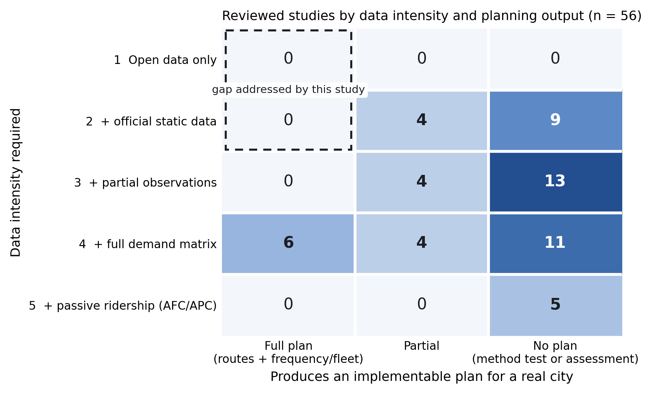
Figure 2. Reviewed studies by data intensity required and planning output (n = 56). All six full plans need a demand matrix; none at intensity 1–3 produces one.
The wedge is that most of the planning chain never needed demand. Cycle time depends on distance, speed and dwell; fleet is cycle time over headway (Vuchic, 2005; Ceder, 2016); coverage depends on geometry and population. Demand enters at one point, the frequency rule. Replace that rule with policy headway bands assigned by an ordinal open-data index, and everything downstream is computable without ridership. This is a decision logic, not a new model. To our knowledge, no study has taken a statutory stage-carriage permit register through to a tiered, fleet-sized network on this basis, with no origin–destination, ticketing, passenger-count or mobile-phone data at any stage, and tested whether the resulting decisions are robust to the index's uncertainty.

Figure and table calls for §2
- Figure 2 — Data intensity against planning output (paper/figures/fig02_gap_heatmap), n = 56, gap region outlined. Generated by paper/literature_review/finalise_table1.py.
- Table 1 — Synthesis matrix of the 60 coded studies (paper/tables/table01_synthesis_matrix). Too long for the main text under D26; proposed for Supplementary Material S1, with Figure 2 carrying the finding.

3. Study area and data

3.1 Kashmir Division as a critical case
Case selection here is deliberate rather than convenient. A critical case for a demand-free planning method is one that maximises both terms of the problem: data scarcity and planning need. Kashmir Division maximises both. On scarcity, the conventional bus network has no fare-card system, no automatic passenger counting, no published GTFS feed, no household origin–destination survey, and operates under permits that record an area of operation rather than a route; field data collection is further constrained by seasonal closure and periodic security disruption. On need, the network is a 644-row permit register with heavy duplication on hospital and civic arterials, transit deserts on the periphery, hard physical barriers (the Jhelum crossings, and the Dal, Nigeen and Anchar lake systems), extreme seasonality, and a partially deployed electric-bus system operating under a different authority from the incumbent minibuses. A method that produces an implementable plan here is not thereby proven universal, but it has been tested against a harder combination of constraints than most secondary cities present.
The study area is the ten districts of Kashmir Division — Srinagar, Budgam, Ganderbal, Baramulla, Bandipora, Kupwara, Pulwama, Shopian, Anantnag and Kulgam — covering 15,948 km² with a modelled population of 6,584,762. Administrative geography is taken from OpenStreetMap boundary relations at admin_level 5 (10 districts) and 6 (39 tehsils), and all population denominators in this paper are computed by point-in-polygon against the ten-district union, not against a bounding box.

3.2 Urban structure, population and opportunity distribution
The division is a single urban–rural basin with one dominant centre. Population is modelled from WorldPop 2026 at 100 m resolution; opportunity is represented by 2,431 OpenStreetMap points of interest across 63 categories, grouped into three tiers by the weighting scheme set out in §4.4.
The concentration of opportunity is itself a finding, and it constrains what the composite index can do. 65.3% of all points of interest in the division (1,588 of 2,431) fall inside Srinagar district. Any index with an opportunity term will therefore score Srinagar corridors highly almost by construction, which is precisely why §4.5 reports the correlation between the population and opportunity components and §5.4 tests whether the composite adds information over population alone. It is also why the paper reports results under three independent weighting schemes rather than one.
Opportunity concentration is a property of the data as much as of the city, and a planning index that ignores it will recommend reinforcing the centre it was supposed to diagnose.

3.3 Existing supply and institutional structure
The operative fact about supply in this setting is that no single agency holds the network. Permits for services confined to one Regional Transport Authority's jurisdiction are issued by that RTA; services crossing RTA boundaries fall to the State Transport Authority; the electric-bus system is operated by a municipal Smart City special-purpose vehicle; and the state road transport corporation runs longer-distance services designated decades ago. Permits are granted in perpetuity and specify an area of operation rather than a route, and are not preceded by any assessment of duplication, service gaps, fleet requirement or frequency.
The paper's primary supply dataset is 614 route records: 445 private stage-carriage permits from the Srinagar Regional Transport Office register and 169 scheduled services of the Jammu and Kashmir Road Transport Corporation, transcribed from its Kashmir Division timetable. With 30 electric-bus routes they give 644 rows. Its most important property is diagnosed in §3.5.

3.4 Data inventory
Table 2 carries the full inventory — source, resolution, processing, validation and limitations — for each dataset. The principal entries are: the permit register and corporation timetable (614 records); the OpenStreetMap road and pedestrian network, from which a walkable graph of 961,927 nodes, 973,569 edges and 23,323 km was constructed; OSRM road travel times; the WorldPop 2026 gridded population surface; the 2011 Census district totals used as an external check; 2,431 OSM points of interest; the electric-bus route set and its published ridership aggregates; OSM administrative boundaries at district and tehsil level; and a driver-application GPS corpus of 2,526 service runs (2,426 after map-matching) recorded by 157 driver app accounts between 6 February and 29 June 2026.
Complete provenance, licence terms and SHA-256 hashes for all staged inputs are recorded in data/MANIFEST.md in the companion repository.

3.5 Data quality diagnostics
This subsection is what separates a paper from a consultancy report, and the diagnostics reported here are deliberately unflattering.
The permit register is not a route register. The 614 records resolve to 157 distinct undirected origin–destination corridors, a mean of 3.91 permits per corridor and a maximum of 42 on the Hazratbal–Lal Ded corridor. This matters for how the headline result must be stated: the reduction from 644 rows to 186 active routes decomposes into 71.0 percentage points of change-of-unit and 0.2 percentage points of genuine consolidation, with 156 of 157 corridors retained (99.4%). Reporting a "71% route reduction" without that decomposition would be reporting the cleaning of a register as a planning achievement.
Modelled population runs below census. WorldPop 2026 gives 6,584,763 against a 2011 Census total of 6,888,475 across the same ten districts — a ratio of 0.956, implying a −0.30% annual rate that is implausible for this region. The deficit is carried openly: it means coverage percentages in §5 are computed against a denominator that is, if anything, conservative.
OSM completeness licenses the walk graph. The correlation between district population density and OSM road density is ρ = 0.915, indicating that mapping effort tracks settlement rather than leaving peripheral districts systematically blank. This is the empirical warrant for using an open street network as the catchment substrate, and it is reported because Barrington-Leigh and Millard-Ball (2017) give good reason to expect the opposite in some regions.
Geometry is faithful for most routes, and diagnosably unfaithful for the rest. Of 186 active routes, 142 show close agreement between stated and routed distance (median error 0.245%, r = 0.995); 44 carry substituted road distances, each individually identified rather than averaged away.
Modelled runtime understates observed runtime. Against the driver-GPS corpus, mean absolute percentage error between routing-engine time and observed in-motion time is 65.1%, and between planned and observed one-way time 47.6%, with a median planned-to-observed ratio of 0.51. This is the most consequential diagnostic in the paper and it is pursued in §6.
Observed activity is a lower bound, not a dormancy measure. GPS shows recurring service on 66 of 186 routes, while 183 of 186 route geometries lie on roads that buses demonstrably use. The gap between those two figures is app adoption, not service absence, and the smaller number must never be reported as a dormancy rate.
A register that has never been audited will always yield a spectacular reduction; the diagnostic obligation is to say how much of it is arithmetic.

3.6 Ethics, reproducibility and data availability
All analysis code, staged inputs and derived outputs are released in a public companion repository under GPL-3.0, with a fixed random seed (20260823), a pinned environment, and a claim ledger mapping every number in this paper to the module that produced it. Heavy binary inputs (the population raster and the cached walk graph) are excluded from version control and are documented with retrieval instructions and SHA-256 hashes in data/MANIFEST.md. Population, street-network, point-of-interest and administrative-boundary inputs are open data under their respective licences (WorldPop: CC BY 4.0; OpenStreetMap: ODbL).

Figure and table calls for §3
- Figure 3 — Four-panel study area: (a) boundary and administrative units; (b) population density; (c) road hierarchy; (d) opportunity density. Status: not generated.
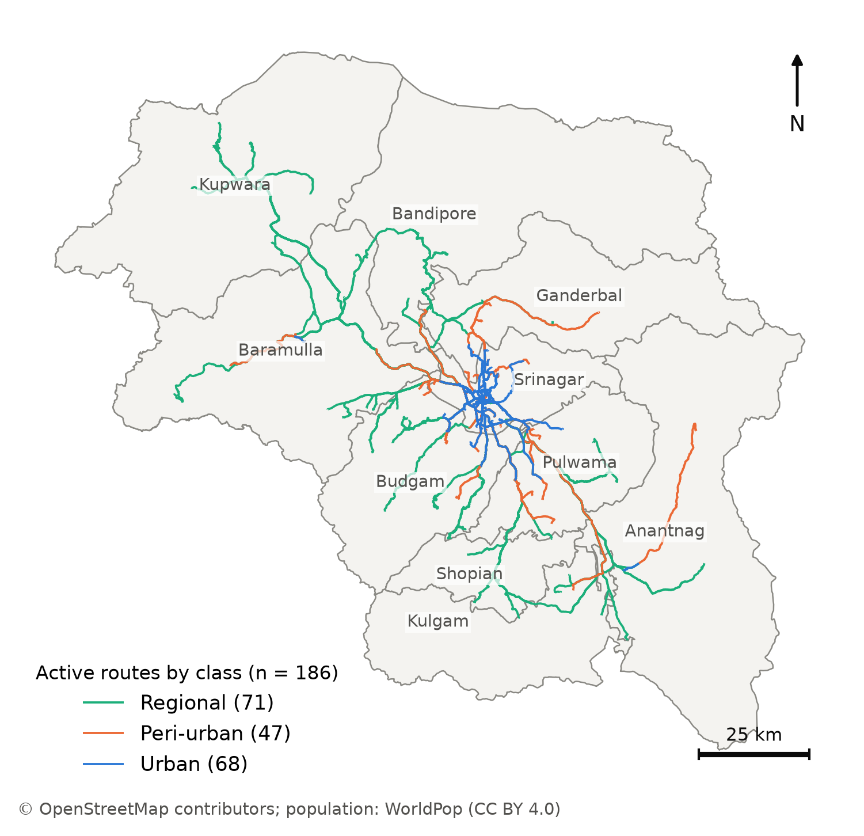
Figure 3. Study area: the ten districts of Kashmir Division and the 186 active routes of the rationalised plan by service class.
- Table 2 — Data inventory. Source · resolution · processing · validation · limitations, per dataset. Status: buildable today from data/MANIFEST.md for the staged datasets; see FLAG 3-C for the rows that reference data the study does not hold.
- Diagnostic detail behind §3.5 is already tabulated: table02a_permit_duplication, table02b_permit_activity, table02c_osm_completeness, table02d_worldpop_vs_census, table02e_poi_inventory, table02f_traveltime_error.

4. Methodology

4.1 Overview
Route planning usually starts from observed travel, but Kashmir Division has no origin-destination survey, fare-card records or passenger counts for its private and state-run buses; its only electronic ticketing is on the Srinagar Smart City e-bus service. The method therefore starts from the services already licensed and timetabled and returns a network in which every route has a service tier, a headway and a fleet.
It has four stages (Fig. 4): records to corridors (Sections 4.2 and 4.3), what each route reaches (4.4 and 4.5), merging and ranking (4.5 to 4.7), and headways and fleets (4.7 and 4.8). Sections 4.9 to 4.11 describe where the e-bus operator's figures enter, the changes made before publication, and how the plan's decisions were tested.
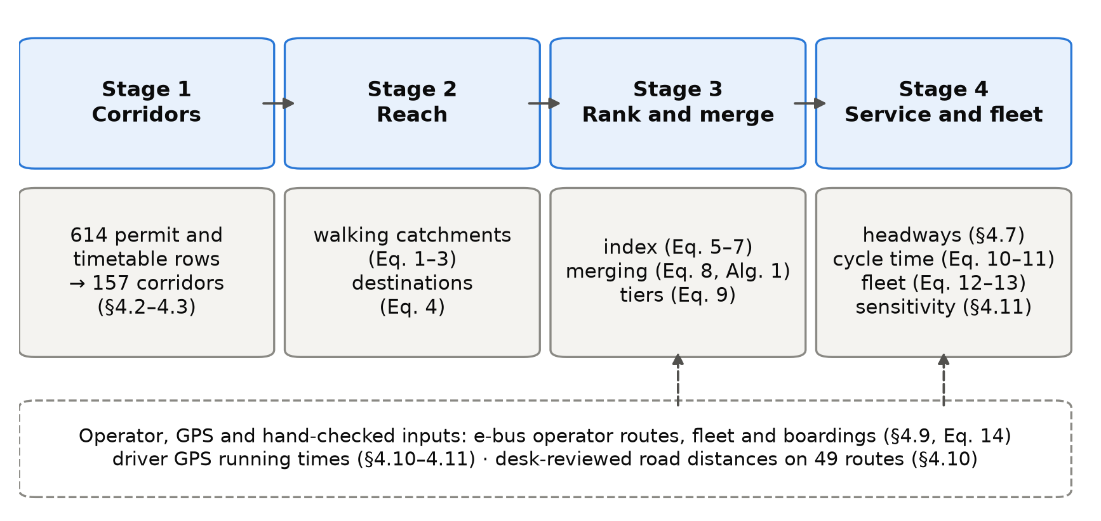
Figure 4. The four stages of the method with the equations that implement them. The dashed box lists the inputs that come from the e-bus operator, from driver GPS or from a desk review rather than from open data.

4.2 Data
Table 3 lists the inputs; the existing services enter as 614 rows. The 445 private permits come from the Srinagar Regional Transport Office, whose register is far more complete than those of the other nine Kashmir offices (453 of its 1,259 rows name both ends of a route, against 133 of 1,742 elsewhere). Of its 548 heavy-bus permits, 544 record no route, so the private input is almost all minibuses. The other 169 rows are scheduled services of the Jammu and Kashmir Road Transport Corporation, typed in from a scanned timetable. Permits were used whether or not still in force; in June 2026 only 96 of the 453 route-bearing Srinagar permits were valid.
Table 3. Inputs to the method (detail in Table 2).
Input | Source and date | Use
Private stage-carriage permits, 445 rows | Srinagar Regional Transport Office register; not open | Existing route set
Scheduled services, 169 rows | Jammu and Kashmir Road Transport Corporation, Kashmir Division timetable, transcribed by hand; not open | Existing route set
E-bus routes, fleet and boardings: 30 routes, 98 buses, 11,632,326 boardings | Srinagar Smart City operator, May 2025 to April 2026; not open | Section 4.9
Residents per 100 m cell | WorldPop constrained estimate, release R2025A (alpha) | Catchments, coverage
Walking network, 2,431 points of interest, district boundaries | OpenStreetMap extract of 6 January 2026 | Catchments, destinations, study region
Road distance and free-flow time | OSRM routing engine on the same extract | Cycle time
Bus positions: 2,526 service runs by 157 driver accounts | Driver smartphone application, 6 February to 29 June 2026; not open | Sections 4.10 and 4.11

Running times come from a driver smartphone application recording positions about every 5 seconds; sessions were split into service runs, map-matched with OSRM and grouped into corridors. The runs lie mostly in and around Srinagar and carry no passenger information, so they are used only for running time.
The population surface, an alpha release used as published, totals 95.6% of the 2011 Census count, but districts differ from the Census by up to 29%. Of the 2,431 points of interest, 65% lie in Srinagar district, partly reflecting how thoroughly each area has been mapped.
The study region Ω is the union of the ten districts. Raster cell c, centred at x_{c}, holds ρ_{c} residents; the region holds 6,584,762, the denominator of every coverage share. G = (V, E) is the walking network and route r a line of length ℓ(r). The open sources are WorldPop (Stevens et al., 2015; Tatem, 2017), OpenStreetMap (OpenStreetMap contributors, 2024) and OSRM (Luxen & Vetter, 2011), built on the same map extract as the walking network.

4.3 From permit rows to corridors
Place names were geocoded with Nominatim within the district named in each record; the rest came from a gazetteer of 103 entries, in which 37 villages that no source could locate sit at their district's centre, so routes ending there have approximate distances and catchments.
A permit licenses a vehicle, so several rows often describe one route. Rows whose end points match within 11 m, in either direction, form one corridor; the 614 rows describe 157 corridors. The busiest, Hazratbal to Lal Ded, has 42 rows, so any reduction in route numbers depends on the unit counted, which Section 5 states each time.

4.4 Walking catchments
Straight-line buffers (Murray, 2001) count people across rivers, lakes and walls as served, an error measured in several cities (Gutierrez & Garcia-Palomares, 2008; Biba et al., 2010; El-Geneidy et al., 2014). Srinagar is divided by the Jhelum and its lakes, so catchments were measured on the walking network.
Notional stops were placed every 250 m along each route and attached to the nearest node (median offset 11 m). A shortest-path search from all stops gives each node v its walking distance d(v). With budget W = 400 m and an off-network allowance τ = 100 m, one raster cell, the catchment is
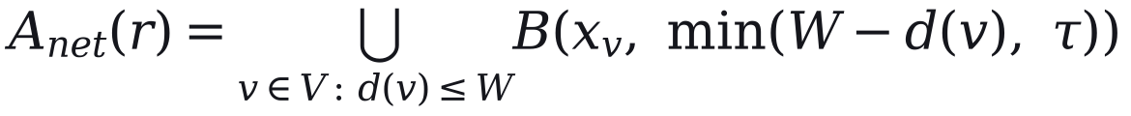 | (1)

where B(x, δ) is the disc of radius δ centred on x. Its residents are
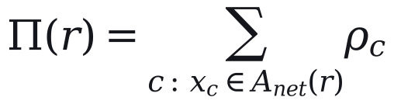 | (2)

Neighbouring routes share residents, so for network totals each cell is split equally among the n_{c} routes reaching it:
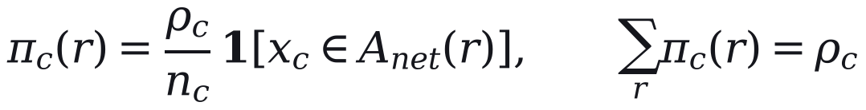 | (3)

W is varied from 300 to 800 m (Section 4.11). The quality of the walking environment, which also affects willingness to walk (Bivina et al., 2019), is not modelled.

4.5 Destinations and the composite index
Destinations were counted as cumulative opportunities (Geurs & van Wee, 2004): point q counts towards route r when its walking distance to the nearest stop, d_{q}(r), is at most 250 m, weighted by its tier t(q):
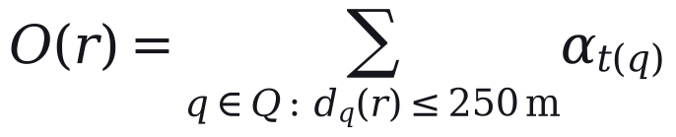 | (4)

Tiers come from OpenStreetMap tags and 67 name rules, with α = 1.00 for major destinations (1,030 points), 0.40 for others (1,080) and 0.60 for seasonal sites (321). They are coarse: every place of worship is in the top tier (547 points). The weights and tiers are our assumptions; the plan itself measured the 250 m in a straight line.
Because a residential surface misses visitors, the plan raised the resident count of the eight tourist routes, the set T:
(5)

This changes their index but not network coverage. Both measures were divided by route length, density was capped at its 95th percentile, and each was rescaled,
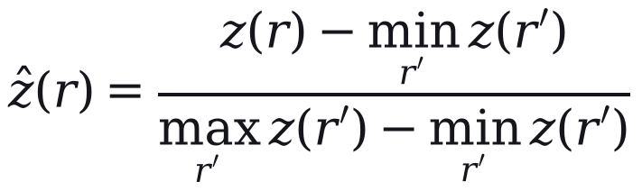 | (6)

and combined with weight β on residents (OECD & European Commission, Joint Research Centre, 2008):
(7)

where  and  rescale 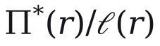 and O(r)/font face="DejaSans-Italic">ℓ/font>(r). The components correlate strongly (Pearson's r = 0.89), so the index is close to a density ranking with a destination adjustment. Section 5 compares equal weights, to which principal-component weights (Jolliffe, 2002) reduce here, with entropy weights (Shannon, 1948; Zou et al., 2006) and β from 0.2 to 0.8. The index indicates where demand is likely; it does not measure it.

4.6 Merging overlapping routes
Overlap is measured on 80 m buffers S(r):
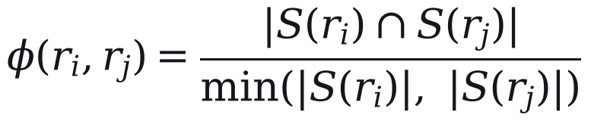 | (8)

A trunk is the highest-ranked route of its overlap group; a member joins it only when φ ≥ θ = 0.65 and their start points lie within 2.5 km. Members never merge with each other, and e-bus routes are never absorbed (Algorithm 1). These values are our assumptions.
Algorithm 1. Merging overlapping routes
Input: 644 candidate routes (614 permit and timetable rows and 30 e-bus routes); threshold θ.
1. Group routes whose 80 m buffers overlap by at least θ.
2. In each group, take the route with the highest index as trunk if it is at least 5 km long and above the 30th percentile of the index.
3. Absorb a member into the trunk if φ ≥ θ and the two start points are within 2.5 km; otherwise keep the member as a feeder.
4. Never absorb an e-bus route, and never merge two members with each other.
5. Collapse routes on the same corridor, in either direction, into one service.
Output: 186 active routes (32 trunks and 154 feeders); 458 routes absorbed.

The rule is conservative: the 186 active routes keep 156 of the 157 corridors. It is not sampled in the uncertainty analysis; scenario S4 (Section 5) is its only test.

4.7 Service tiers and headways
Routes are typed by length as urban (under 15 km), peri-urban (15 to 40 km) or regional (over 40 km), unless their permit category says otherwise. Tiers were set by Jenks natural breaks on the index (Fisher, 1958; Jenks, 1967), judged by the goodness of variance fit:
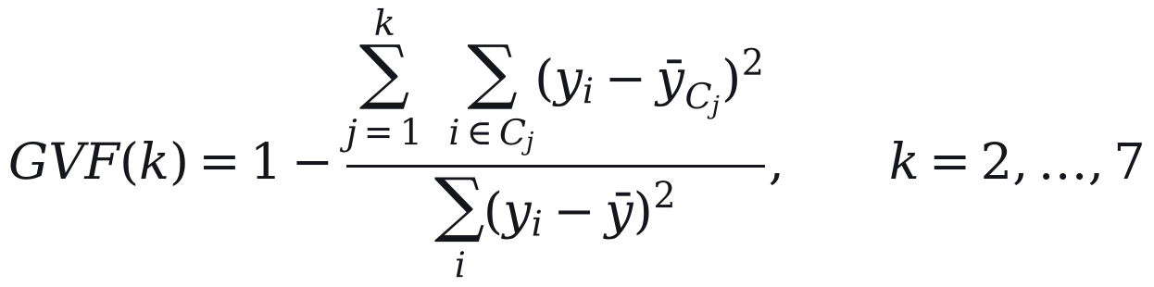 | (9)

Three tiers give 0.90 against 0.79 for two; the 0.80 threshold separating them is our choice. Published tiers carry three overrides: e-bus routes are always in the top tier, routes within 250 m of 11 listed social destinations (four migrant townships and seven hospitals) rise from the lowest tier to the middle, and routes within 5% of the gap between breaks can move one tier by road role.
Headways are service standards, set independently of the index: 15 minutes on e-bus routes, 20 on other top-tier routes and 35 on other urban and peri-urban routes. Regional routes outside the e-bus network start at 35 minutes and, when estimated load (Section 4.9) is below 55%, are lengthened in proportion and rounded to 40, 45 or 50; in practice 62 of these 67 routes run at 50 and 5 at 35. Such standards pursue a coverage goal (Walker, 2008). Each route has one headway all day.

4.8 Cycle time and fleet
One-way running time is congested free-flow time plus stop time (Vuchic, 2005; Ceder, 2007):
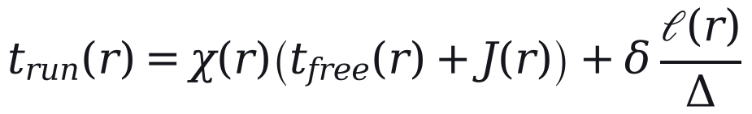 | (10)

where χ is 2.2 in the city core, a zone bounded by one line of latitude that contains 170 of 186 routes, and 1.4 elsewhere; J adds 8 minutes for a Jhelum crossing; and stops cost δ = 0.5 minutes every Δ = 500 m. These values are assumptions. Cycle time is capped per kilometre:
(11)

with λ = 1.10 for layover and ω = 4.0, 2.5 and 1.5 min/km for urban, peri-urban and regional routes. The cap binds on 169 of 186 routes, where Eq. (10) has no effect, and the urban cap is faster than the median pace observed in driver GPS, 4.62 min/km; Section 4.11 therefore also sizes the fleet from observed pace. With headway h(r),
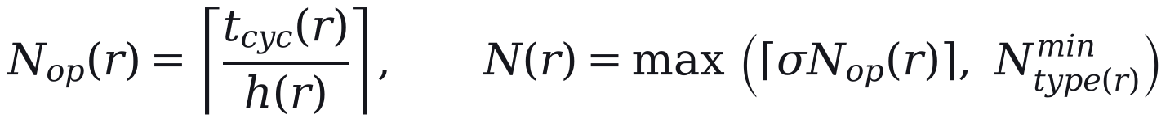 | (12)

where σ = 1.15 is an assumed spare allowance and N^{min} is two buses (one on regional routes). The operator's deployed fleet N^{emp} is a floor on the e-bus routes E:
(13)

Of these, 187 are heavy (about 12 m), 754 medium (about 9 m) and 70 light: routes under 12 km get no heavy buses, and heavy buses are at most half the fleet of longer routes. An independent re-implementation of Eqs. (10) to (12) reproduces the published fleet on all 186 routes.

4.9 Where the e-bus operator's figures enter
The method needs no observed demand for the routes it plans, but it uses the e-bus operator's figures at five points: the 30 e-bus routes are never absorbed; they are in the top tier at 15-minute headways; their fleet is at least the deployed fleet; the urban bus share and the scale of the ridership estimate come from their boardings; and that estimate can lengthen regional headways. It does not affect the route set or the tiers. For route r,
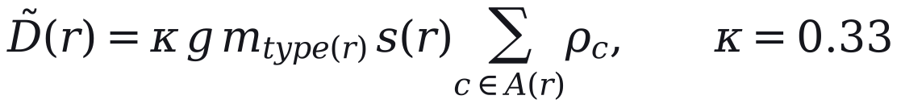 | (14)

where g = 1.6 trips per person per day is assumed, m is the bus share for the route type, A(r) the catchment and s(r) the route's share of its corridor's residents. The urban share, 0.090, was backed out of e-bus boardings for an assumed served population of about 222,000; the peri-urban and regional shares are 0.8 and 0.6 of it by assumption. κ was fitted to the operator's 11.63 million boardings (May 2025 to April 2026). Only the product κ*gm* is identified, and comparison with the operator's data (Section 6) is circular. The demand-sized fleet in Section 5 holds demand fixed, although demand responds to service (Holmgren, 2007).

4.10 Changes made before publication
Three changes were made to the model's output before publication. First, all 186 routes were reviewed at a desk with an AI research assistant, which compared modelled road distances with distances published online and recorded the websites consulted. It passed 93, flagged 88 and failed 5. Where distances differed by more than 15% and place names were confirmed, the midpoint of the published range replaced the modelled distance and the fleet was recomputed; 49 routes changed, needing 207 buses instead of 247. No replacement distance was measured on the ground.
Second, five routes matched to GPS corridors with 40 to 211 runs each were re-timed from measured moving speed, raising the fleet from 1,004 to 1,011; they are excluded from the out-of-sample test in Section 6. Third, the headway standards were revised over about fifteen versions of the plan during review, with fleets ranging from 855 to 1,144 buses.

4.11 Sensitivity and uncertainty
A one-at-a-time sweep varies each parameter with the others fixed. A Monte Carlo analysis draws twelve inputs together 5,000 times, and Sobol' indices (Sobol', Ilya M., 2001; Saltelli et al., 2008; Saltelli et al., 2010) from a Saltelli design of 1,024 base samples (14,336 model runs) apportion the variance of each output. Catchment settings are evaluated on a grid of walking budgets (300 to 800 m) and stop spacings (150 to 400 m).
Because the cap hides the running-time parameters, the fleet is computed in two regimes: A, the plan as specified; and B, in which urban and peri-urban routes outside the e-bus network take cycle times from the pace observed on 16 GPS corridors around Srinagar (5 routes from their own corridors, 84 from their type's median), computed from overall pace and from moving pace plus modelled stop time. E-bus and regional routes keep their modelled cycles, as no usable pace was observed for them.
We report medians and 5th to 95th percentile ranges. They depend on our chosen input distributions, are not confidence intervals, and exclude uncertainty in the route set. The analysis tests whether decisions survive plausible changes in parameters and speeds, not the plan against demand. Analyses run from frozen inputs in Python 3.14 (seed 20260823) with SALib 1.5.2 and jenkspy 0.4.1.

5. Results

5.1 The inherited network is a permit register, not a route register
The starting network is 614 route records (445 private permits and 169 timetabled services) that resolve, by undirected endpoint hashing at 11 m, to 157 distinct origin–destination corridors — 155 at 100 m, so the count is structural, not a rounding artefact. Duplication is severe and skewed: a mean of 3.91 permits per corridor against a median of one, with 42 separate permits on the single Hazratbal–Lal Ded axis. This governs how consolidation may be reported. Of the apparent 71.1 % row reduction (644 engine rows → 186 active), 71.0 percentage points are a change of the unit of analysis (collapsing duplicate permits on an identical corridor) and only 0.16 pp is genuine spatial consolidation — a single corridor, Parimpora–Pantha Chowk. Measured on physical corridors, the plan retains 156 of 157 (99.4 %) and adds 30 e-bus routes: it does not shrink route coverage. The cost of corridor-level collapse is counted rather than assumed away — 32 alternative via-routings across 20 corridors are suppressed, and 38/34 corridors lose vehicle-class/service-type differentiation.
Policy: the reform to defend is frequency and fleet discipline on retained corridors, not a cut in the number of places served — and it should be communicated that way to operators and the public.

5.2 Straight-line catchments overstate who is served by a third
Recomputing each catchment on the walkable pedestrian graph instead of as a circular buffer lowers measured population served by a median of 37.4 % per route (IQR 30.5–41.7 %, max 56.8 %; 184 of 186 routes overstated by >25 %). On the deduplicated network union — the only figure that may be reported as a network total — Euclidean buffering overstates served population by 31.9 % (2,339,394 → 1,592,847 residents), revising headline division coverage from 35.5 % to 24.2 %. The result is robust to the one free parameter: off-network tolerance τ = 50/100/150 m gives 52.8 % / 37.4 % / 29.2 %, and because the network catchment is a formal upper bound on the true walkshed, 37.4 % is a lower bound on the true bias. The comparison is clean because the Euclidean baseline is the plan's own number: on the 142 self-consistent routes the reimplementation reproduces published population served to a median error of 0.245 % (r = 0.995), so the F8 gap is attributable to the pedestrian network alone. Two integrity issues surface in passing: 44 routes carry externally substituted road distances patched in without redrawing geometry, and a tourist multiplier had silently injected 285,914 synthetic persons into the coverage numerator on 8 routes.
Policy: coverage claims used to justify subsidy or route awards must be quoted on the network walkshed against residents — the Euclidean figure overstates the public benefit by roughly a third.

5.3 Modelled time understates reality, and a sanity cap silently governs it
Against 2,526 driver-GPS service runs, modelled run time is far too fast: MAPE(OSRM free-flow vs observed in-motion) = 65.1 %, MAPE(plan one-way vs observed) = 47.6 %, median plan/observed ratio 0.51. The mechanism is a per-kilometre cycle-time cap intended as a guardrail that instead binds on 169 of 186 routes (90.9 %) — 100 % of Regional, 97.9 % of Peri-Urban, 76.5 % of Urban — while sitting below real pace: observed median 4.62 min/km against the 4.0 min/km Urban cap, exceeded on 83–100 % of observed corridors by class. Decomposing the run-time model shows where it holds and fails: the City-Core congestion divisor (÷2.20) reproduces observed moving speed to +1.4 %, but the assumed constant 1.0 min/km dwell is unsupported — observed dwell is 1.76 min/km, and an OLS fit (R² = 0.03, non-significant distance slope) shows dwell is fixed terminal layover, not distance-proportional.
Policy: because the binding constraint on nine-tenths of the network is a modelling ceiling set below real driving pace, the fleet it produces is a floor, and procurement should plan against the upper end of the interval in §5.7, not the point estimate.

5.4 The rationalised hierarchy and fleet
The plan designates 186 active routes — 32 trunk and 154 feeder — spanning 68 Urban, 47 Peri-Urban, and 71 Regional-District services, under policy headways of 15 min on the e-bus backbone, 20 min on other high-priority routes and 35 min on medium- and low-priority routes, with demand-responsive rural headways capped at a 50-minute maximum wait (§4.7). The required fleet is 1,011 vehicles (187 HPV / 754 MPV / 70 LPV), a +68.5 % expansion over the ~600-vehicle operating baseline. The engine reported this as 43 buses per 100,000 residents served, inside the MoHUA 40–60 benchmark; on the network-walkshed population of §5.2 it is 63.5 per 100,000, above the band. The sizing arithmetic is auditable: an independent reimplementation reproduces the published cycle time and fleet on all 186 routes — including the 30 backbone routes, whose fleet is the larger of the formula and CHALO's deployment (283 vehicles). Physical-alignment GPS corroborates 183 of 186 route geometries (median 94 % of length on bus-carrying road), while recurring service is observed on 66 of 186 — a floor on activity, not a dormancy rate (§6.3).
Policy: the fleet gap is an expansion problem, not a redistribution one — roughly 400 additional vehicles concentrated on the busiest retained corridors, not vehicles moved off pruned routes.

5.5 Network length: one kilometre of road, 3.65 kilometres of route
The 186 active routes total 5,567.7 route-km on only 1,524.5 km of distinct road — a route-km : network-km ratio of 3.65. Duplication is concentrated rather than uniform: 46.6 % of the network is served by a single route, while a 0.09 km link at Lal Chowk carries 53 routes (28 % of the network). The same measure cannot be computed for the inherited permit network, because the 458 consolidated rows carry no drawn geometry; it is bounded between 1,524.5 and 13,756.4 km and reported as not computable rather than estimated. Consolidation therefore changed how many vehicles run on each corridor, not how much of the road network is served — consistent with the 99.4 % corridor retention of §5.1.
Policy: the overlap that survives rationalisation is in the Srinagar core, and it is the place to test through-routing or stop consolidation next — not the rural periphery, where most road is single-route.

5.6 Frequent-network coverage and where the gaps are
Any-service coverage (24.2 %) flatters the network. Restricting to routes that run at least every 15 minutes (Walker, 2011) — the e-bus backbone — covers 10.4 % of residents; at 20 minutes 12.2 %, at 35 minutes 19.2 %. The three-quarters of residents outside every walkshed are not scattered: Moran's I on the uncovered-population surface (Moran, 1950) is 0.664 on a 2 km lattice and 0.729 at 5 km (both p = 0.001), so the gaps form contiguous blocks — whole valley-floor settlement belts between the radial corridors (Figure 8) — rather than isolated households.
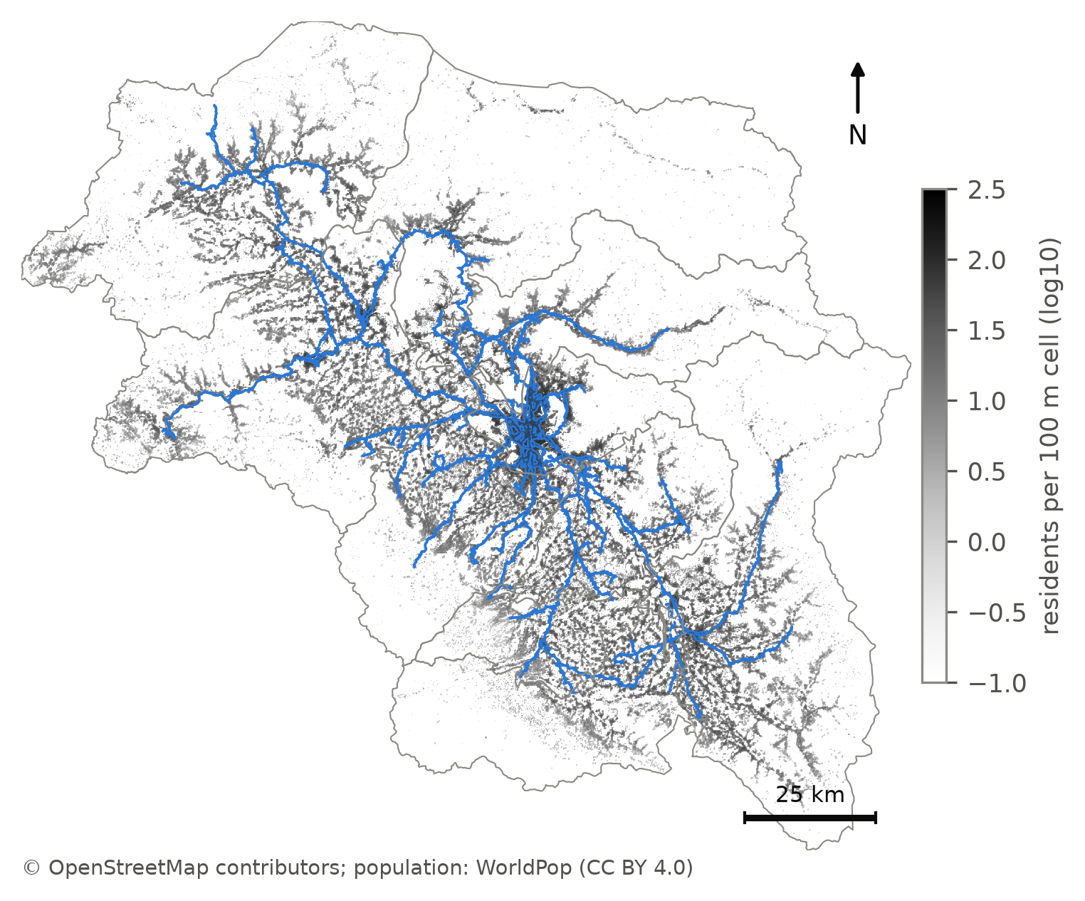
Figure 8. The deduplicated network walkshed (blue) over the WorldPop 2026 population surface: 24.2 % of the division's residents live within a 400 m walk of a route.
Policy: clustered gaps are addressable by a small number of new feeder corridors; they should be identified from the uncovered surface, not from the permit register, which by construction only describes where operators already run.

5.7 Fleet as an interval, and against peer cities
Sampling the eleven declared parameters jointly (5,000 draws) leaves the plan's own fleet almost where it was: 1,013 buses (90 % interval 989–1,058). That narrowness is not robustness. With the per-km cap in place, congestion, dwell and stop spacing each move the fleet by at most 17 buses, while removing the cap lets the same parameters move it by up to 956; the cap has absorbed the uncertainty, and the spare ratio alone explains 94 % of what variance remains. When urban and peri-urban run times are instead set from the observed pace of 16 Srinagar-belt GPS corridors (regime B, §4.10), the fleet becomes 1,182 (1,130–1,266) — 372 urban, 428 peri-urban and 384 regional buses, the regional figure unchanged because rural pace is unobserved. The published 1,011 lies below the whole observation-anchored interval. Variance under regime B splits between the spare ratio (total-order index 0.55) and the two observed paces (0.32 peri-urban, 0.13 urban), so more GPS on peri-urban corridors is the single most valuable data investment for the fleet (§7.5). The hierarchy, by contrast, is stable: tier agreement with the baseline partition is 97.8 % (94.6–100 %), 179 of 186 routes keep their tier in more than 80 % of draws, and the population weight of the index accounts for 93 % of the variance in agreement.
Policy: procure against the observation-anchored range (about 1,130–1,270 buses), treating 1,011 as the floor the model's own guardrail produces; the service hierarchy can be adopted as it stands.
Against 36 Indian peer cities (ASRTU 2024 city fleets) (Association of State Road Transport Undertakings, 2024), the plan's 0.154 buses per 1,000 residents of the division sits at the 61st percentile and inside the preferred log-model prediction interval; per resident actually within the network walkshed it is 0.635 per 1,000 — the 97th percentile, still inside the log-model interval but above the levels-model interval. The peers are public-sector fleets while 1,011 is an all-operator plan, so this places the plan within national practice; it does not validate it.

5.8 The three-tier hierarchy is recoverable from the data — but not the published one
Jenks partitions of the network-catchment index (Jenks, 1967; Fisher, 1958) select k = 3 under both pre-registered elbow rules (GVF 0.902; tiers of 37, 41 and 108 routes), Figure 7. The partition is a property of the index, not of Jenks: 1-D k-means reproduces it exactly, equal intervals agree at κ = 0.748, and only equal-count quantiles — which ignore gaps by construction — disagree (κ = 0.427). The uncomfortable result is that the plan's published bands agree with this objective partition on only 68.3 % of routes (κ = 0.503), and 20 of the 55 routes the plan designates high-priority fall in the objective bottom tier. The discrepancy has two identifiable sources: the engine ran Jenks on Euclidean catchments across all 644 permit rows, including those later consolidated, and its post-Jenks overrides (backbone lock, social and district-headquarters floors) promote routes irrespective of index value.
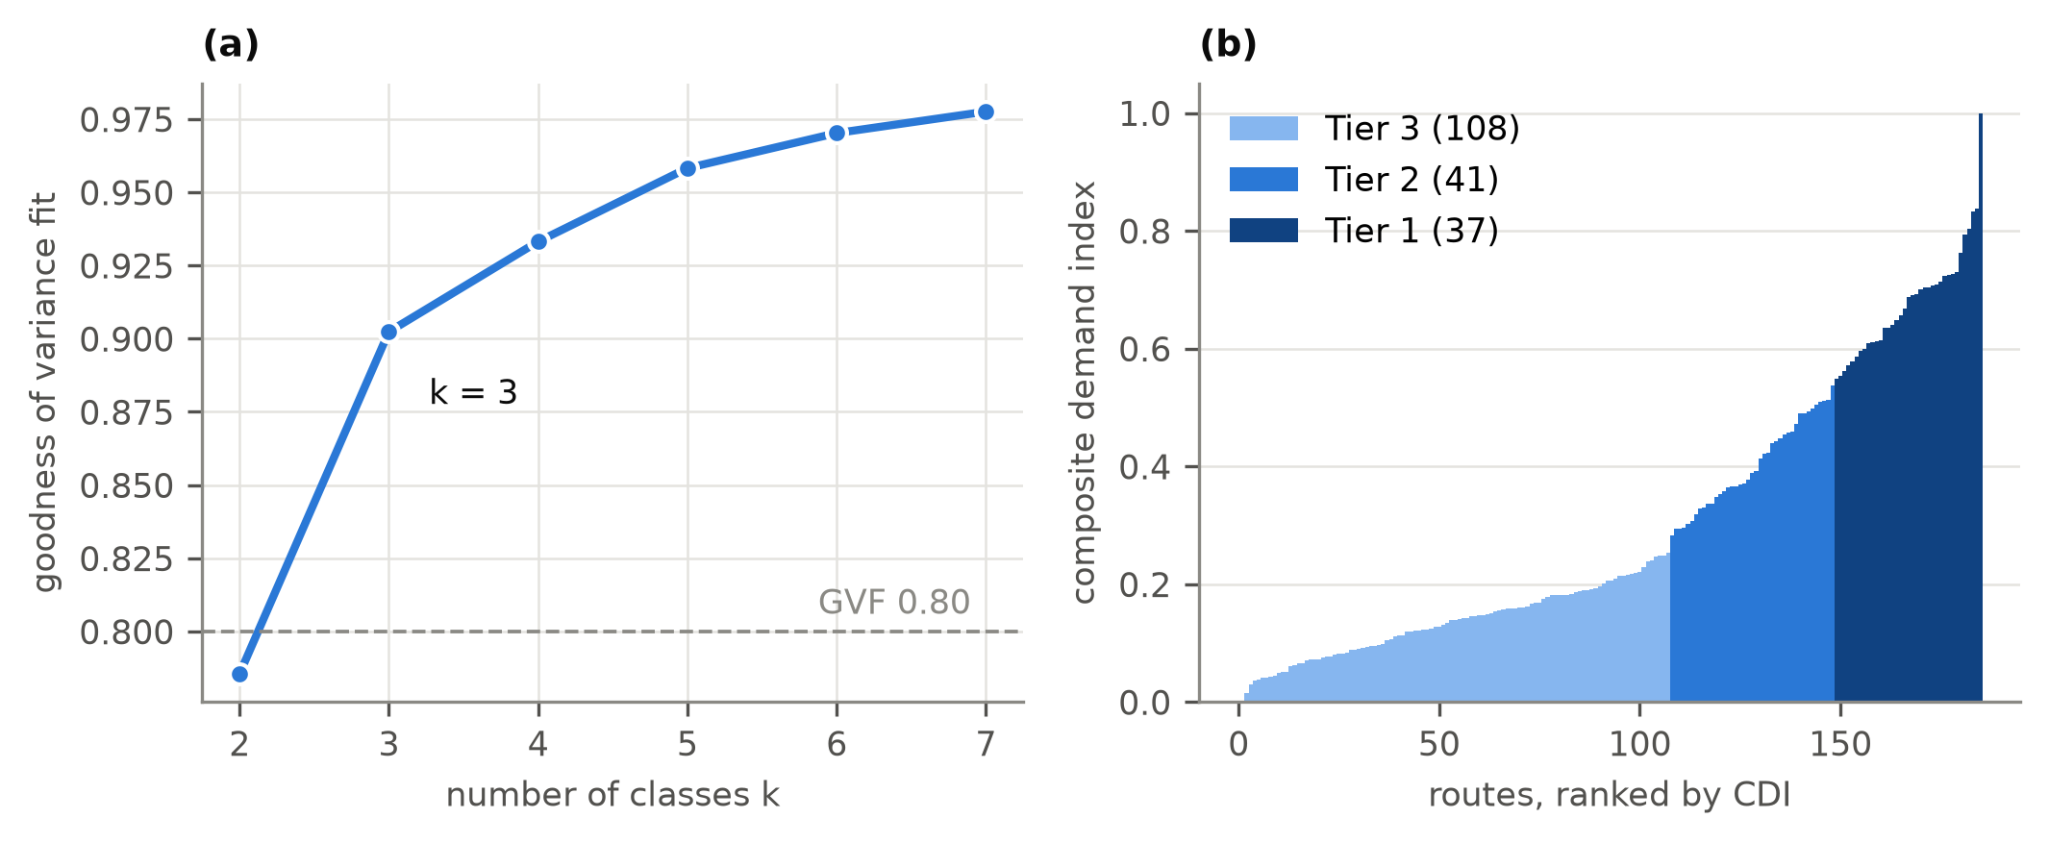
Figure 7. Class count and tiers. Left: goodness of variance fit for k = 2–7; both elbow rules select k = 3. Right: routes ranked by the network composite index, coloured by tier.
Policy: the hierarchy should be re-derived on network catchments before headways are fixed; the 20 promoted routes need an explicit, stated justification (social obligation, backbone status) or a demotion.

5.9 Equity: who is served, and who loses
Accessibility — departures per hour reachable within a 400 m network walk, per resident — is extremely unequal: population-weighted Gini 0.903 (Delbosc & Currie, 2011), driven by the 75.8 % of residents with no reachable service; among served residents it is 0.599. A before/after comparison is not reported because the consolidated permits have no geometry from which to rebuild the inherited network; the module returns this as not computable rather than manufacturing a counterfactual. The losers of consolidation are named instead (Table 5g): 32 alternative via-routings on 20 corridors are suppressed; 114,879 residents live within 400 m of a dropped intermediate place, and 13,087 of them lose bus access outright because no surviving route passes within walking distance. The largest single losses are Zoonimar on the Jehangir Chowk–Soura corridor (3,515 residents) and Rainawari on Hazratbal–Lal Ded (3,046).
Policy: the 13,087 residents who lose access are few and locatable; restoring a via-stop or a short feeder for them is cheap relative to defending their loss.

5.10 Transfers and waiting
On the rationalised network, 12.5 % of stop-to-stop pairs are one-seat rides, 72.3 % need one interchange and 13.8 % two or more (1.4 % unconnected on drawn geometry); these are shares of stop pairs, not of trips, because no origin–destination matrix exists. For the 68 origin–destination pairs whose permits were consolidated, 66 keep a one-seat ride and two fall to one interchange. Because the inherited permits ran only part of the day — the observed median vehicle is in service for 217 minutes, a duty factor of 0.242 — the plan's scheduled headways cut the median expected wait (Welding, 1957; Osuna & Newell, 1972) from 86.7 to 17.5 minutes, yet 5 of 68 pairs (7.4 %) wait longer, and the median transfer penalty at which consolidation stops paying is 31.4 minutes.

5.11 Operations: time of day, deadhead, and load
Time of day. The e-bus backbone's hourly boardings (1,221,848 in April 2026) peak at 09:00 with a peak-hour factor of 10.67 % and a peak-to-base ratio of 1.37. Reading the published headways as peak design and relaxing them off-peak saves 9.4 % of bus-hours at the same 1,011 vehicles; reading them as all-day means would instead require 215–496 more buses at the peak.
Deadhead. No depot register exists, so deadhead is bounded rather than measured: zero if buses lay over at a terminus, 1.7 % of bus-kilometres if every bus returns to its district-headquarters stand on the plan's 16-hour day, and 5.5 % on the operating day buses are actually observed to run. The gap exposes a larger assumption: the plan implies 320 service-km per bus per day, against 99 at the observed duty.
Load. On the backbone, where boardings are observed, a CHALO bus-trip today carries 18.6–37.3 boardings (the operator's trip count is ambiguous between one-way and round trips). Running the same routes at 15 minutes, with ridership held at today's level, gives 8.3 boardings per trip on day one; ridership must grow 2.2–4.5-fold to restore today's loads. Across the network the quarantined demand proxy (Eq. 8) implies a median peak boarding-to-capacity ratio of 0.23, with 152 of 186 routes below 0.40.
Policy: the plan is a supply-led bet on induced ridership; procurement should be staged against observed boardings on the backbone, where they can be measured monthly, rather than committed in full.

5.12 Cost and emissions (provisional)
With every external constant carried as a range pending verification, the plan costs ₹642–1,054 crore a year to operate at its own vehicle-kilometres, or ₹206–338 crore at the observed operating day, and emits 65–103 kt (or 21–33 kt) of CO₂. Per resident within the walkshed, that is ₹4,033–6,615 a year on the plan's own kilometres. In passing, the engine's own emissions column assumes 30 g CO₂/km for the electric backbone; at published energy intensities and the Indian grid factor the figure is of the order of 870 g/km, an understatement of about 29-fold, so the engine column is not used.

5.13 Scenario stress-test
Table 8 changes one lever at a time from the published plan (S0: 1,011 buses, 24.2 % coverage). Replacing modelled urban and peri-urban run time with observed pace (S1) raises the fleet to 1,169 (+15.6 %); bounding rural pace with the only two long observed corridors as well (S2) gives 1,271 (+25.7 %). Returning rural lifelines to a flat 35-minute headway (S3) costs 95 buses (+9.4 %) — the price of the 50-minute rural maximum. Applying the engine's own merge test at the low end of its threshold range (S4) would cut the network to 84 routes and 533 buses but lose 3.9 points of coverage (24.2 → 20.3 %). Running every urban route at 15 minutes (S5) costs 161 buses (+15.9 %) and raises 15-minute coverage from 10.4 % to 14.5 %. The frontier (Figure S1) prices city frequency directly: each step from 35 to 10 minutes costs progressively more, and more again at observed pace.
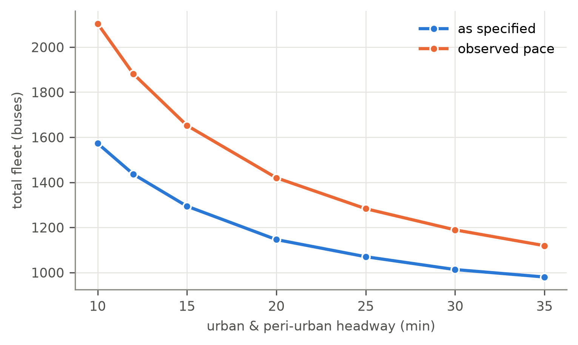
Figure S1. The fleet price of city frequency: total fleet against a common urban/peri-urban headway, as specified and at observed pace.
Policy (network level): the published plan is a defensible point on this frontier only if read as a lower bound — the realistic run-time scenarios all require more buses, and the one scenario that saves buses does so by withdrawing coverage.
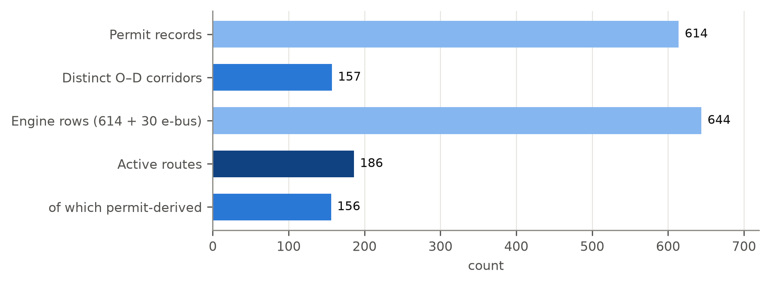
Figure 5. From permits to routes: 614 permit records resolve to 157 corridors; 156 of them are retained among the 186 active routes.
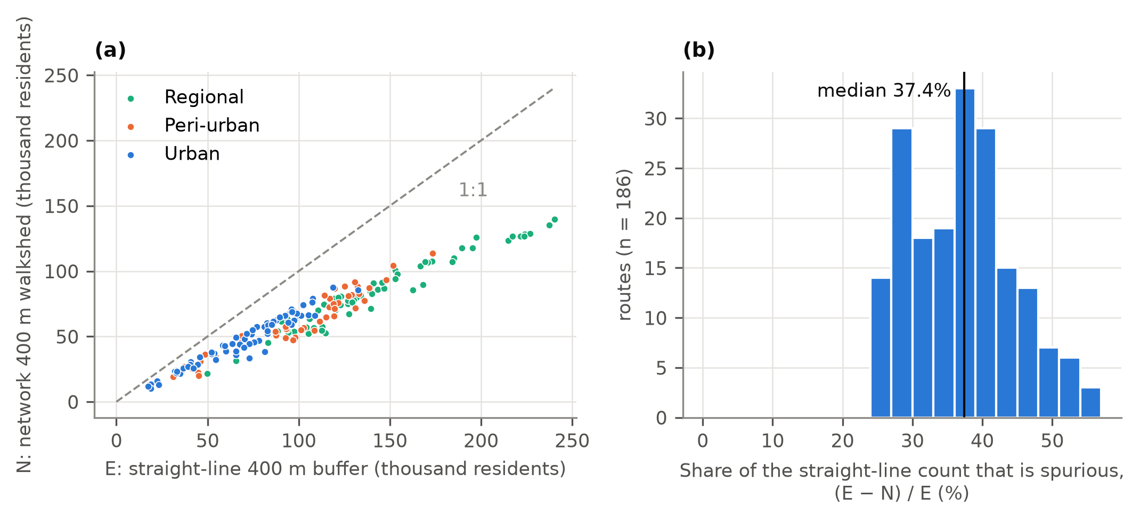
Figure 6. Euclidean against network walk catchments. Left: per-route residents within 400 m under each definition. Right: distribution of the Euclidean overstatement (median 37.4 %).
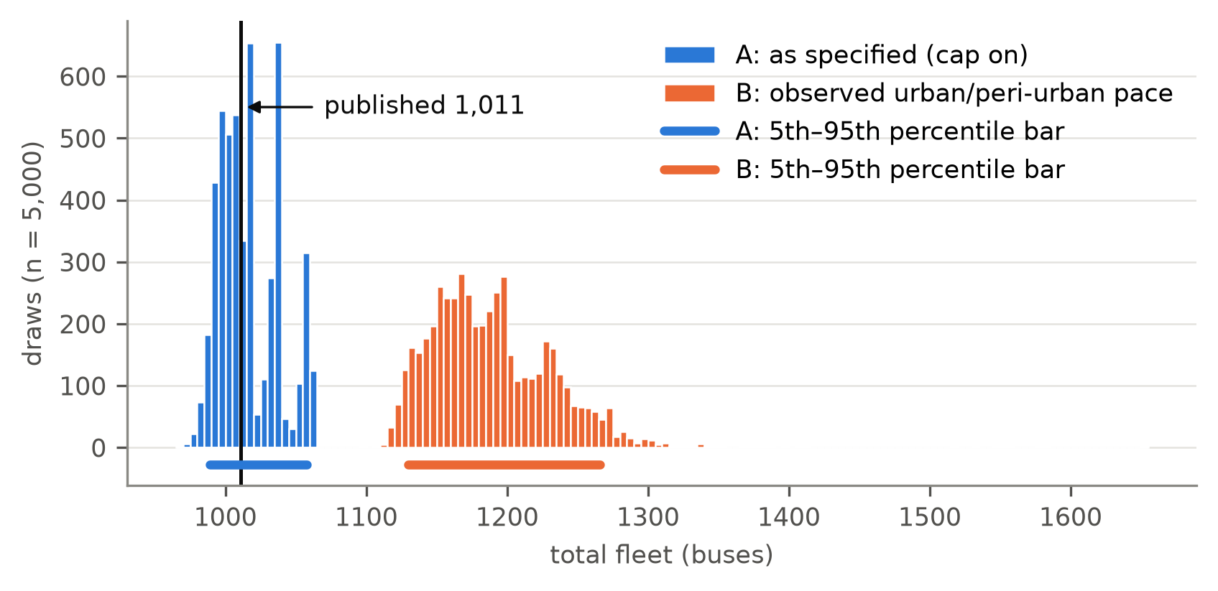
Figure 9. Fleet under joint parameter uncertainty, regimes A (as specified) and B (observed urban and peri-urban pace), against the published 1,011.
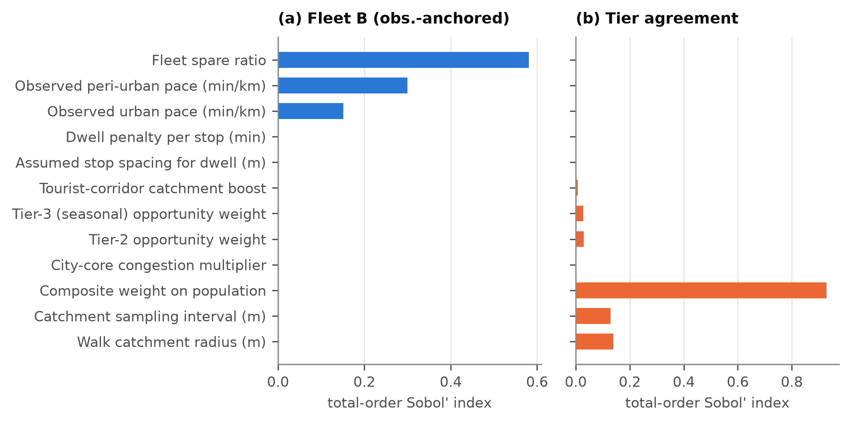
Figure 9b. Total-order Sobol' indices: which parameters drive fleet and tier uncertainty.
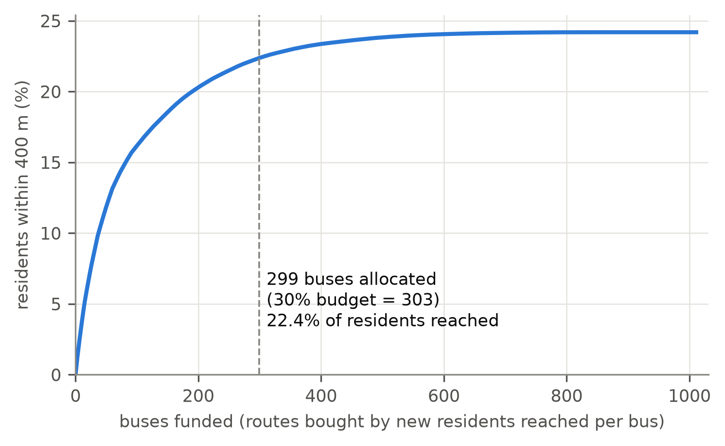
Figure S2. Funding-constrained sequencing: residents reached as routes are bought in order of new residents per bus. 30 % of the fleet reaches 92 % of the plan's coverage.

6. Validation

6.1 A convergent-validity frame, not a single test
A demand-free plan cannot be validated the way a demand model is, because there is no withheld ridership series to predict. We therefore adopt a convergent-validity design: six channels, each individually insufficient and each biased in a different direction, are assembled so that agreement among them raises confidence while any one disagreement localises a specific weakness. The target is explicitly decision-robustness — that the tier and fleet decisions survive scrutiny from every independent angle we can construct from open data — and never a claim that the composite index (Eq. 7) predicts travel demand. Table 7 records all six channels, their evidence source, test statistic, threshold, result, and status.
Two disclosures come first, not last. The one ridership dataset available — CHALO electronic-ticketing aggregates on the e-bus backbone — is not independent of the plan: the same published aggregate anchors the capture scale κ = 0.33 in the quarantined plausibility term (Eq. 8) and is offered as benchmark channel V2. V2 is therefore a consistency check, not an independent validation, and is reported as such. Second, the driver-GPS layer measures vehicle motion and geometry only; it carries zero ridership signal, so channel V4 validates the supply chain — geometry → speed → run time → cycle time → fleet — and nothing about demand.

6.2 The six channels and their status
V1 — Spatial cross-validation (executed, module v01). Does the population surface put people where buildings are? Two footprint layers are tested against the pre-declared threshold Spearman ρ > 0.60: volunteered OpenStreetMap buildings (OpenStreetMap contributors, 2024) and Microsoft's machine-detected Global ML Building Footprints. One limit is stated first: WorldPop uses building footprints as a covariate (Stevens et al., 2015; Lloyd et al., 2017), so agreement is partly expected by construction, and V1 is a consistency check on the spatial pattern, not an independent count. On the near-complete Microsoft layer (1.85 million footprints; 99.8 % of residents live in a 1 km cell that contains one), the surface passes at every scale: ρ = 0.975 for footprint area across the 186 route catchments (0.940 for building count), and 0.907–0.950 on the 1 km grid. OSM, by contrast, maps only 12,343 buildings — any footprint in just 4–31 % of populated cells, depending on district — and passes only at the route scale (0.657). The OSM weakness is therefore a mapping gap, not a population error.
V2 — Benchmark consistency (executed, module v02; circular, as disclosed in §6.1, and further because the engine floors the backbone fleet at CHALO's deployment on 2 of 30 routes). CHALO runs 98 buses on the 30 backbone routes at about 855 bus-trips a day (12-month mean); scaled to the plan's 15-minute headway that is 179–220 buses, depending on whether the operating day is taken as 13 or 16 hours. The plan's backbone fleet is 283, a ratio of 1.29–1.58: V2 fails the pre-registered ±15 % band under every service-day assumption, and the rank correlation between CHALO's per-route deployment and the plan's per-route fleet is weak (ρ = 0.22, p = 0.24). Even against the operator it was calibrated to, the plan provisions more buses per route than frequency scaling alone explains; V2 localises the disagreement to the backbone but cannot say whether it lies in the plan's cycle times or in CHALO's operation.
V3 — Expert elicitation (not conducted; §6.4). A Delphi/AHP panel would ground the index weights (target Kendall's W > 0.70). Meanwhile the weights are derived three data-driven ways (§4.5).
V4 — Supply-side GPS validation (established, module v04). The empirical layer is 2,526 service runs (2,426 after map-matching) from 157 driver app accounts, 6 February–29 June 2026; its results are detailed in §6.3. This is the study's one fully executed observational channel.
V5 — Global sensitivity (executed, a08/a09). Sobol' indices from 15,360 evaluations show two different stories. Tier membership depends almost entirely on the population weight of the index (total-order index 0.93); coverage on the walk-radius definition (0.97). The fleet as specified depends almost only on the spare ratio (0.94), because the per-km cap discards the run-time parameters; with the cap removed those same parameters swing the fleet by up to 956 buses.
V6 — Decision robustness (executed, a09). Tiers pass: agreement with the baseline partition is 97.8 % (90 % interval 94.6–100 %) against the 80 % target, and 179 of 186 routes keep their tier in more than 80 % of 5,000 draws. The fleet does not have a single robust value: 989–1,058 as specified, but 1,130–1,266 once urban and peri-urban run times follow observed pace, an interval that excludes the published 1,011. The decision that survives is the hierarchy; the fleet survives only as a range whose lower end the plan reports.

6.3 What the GPS actually shows
The GPS channel corroborates what it can see and falsifies two assumptions it cannot support. Geometry and moving speed pass: 183 of 186 planned alignments run over roads carrying bus traffic (median 94 % of length), and the City-Core congestion multiplier reproduces observed urban moving speed to +1.4 %. Dwell and run time fail: observed dwell is 1.76 min/km against the engine's 1.0, and is fixed layover rather than distance-proportional (R² = 0.03); modelled one-way time is a median 0.51 of observed, and the per-km cap that was meant as a guardrail binds on 169 of 186 routes while sitting below real pace (§5.3).
Two coverage metrics, never conflated. Alignment coverage (94 %) is not service validation: 66 of 186 routes recur as observed services, a lower bound set by partial app uptake, not a dormancy rate.
The supply chain reproduces. The cycle-time and fleet arithmetic reproduces the published plan on all 186 routes. The problem is not the formula but its inputs — the too-fast cap and the distance-proportional dwell — which is why V6 carries observed pace into the fleet. Taken together, the channels agree that geometry, network structure and hierarchy are sound and disagree, in a localised and explicable way, on time.

6.4 Demand-side corroboration as near-term work
The channels above validate the supply chain and the internal consistency of the index, not demand. Two steps should precede any live procurement decision: (i) the expert elicitation (V3), which V5 shows matters because the population weight governs the tiers; and (ii) a stratified on-street boarding count on retained corridors, to test the index against observed patronage and the POI layer against more than OpenStreetMap mapping effort. Neither was conducted. Until they are, the honest ceiling on the claim is decision-robustness of the supply plan, not demand validation.

7. Discussion and policy implications

7.1 What the results mean for planning under data scarcity
The demand dependency is severable. The conventional planning chain consumes demand data at four points (§1.3), but only one of them is load-bearing. Cycle time follows from distance, speed and dwell; fleet follows from cycle time and headway; coverage follows from geometry and population. Demand enters only at the frequency rule. Substituting a policy-anchored headway band for that rule leaves the rest of the chain intact and computable from open data. This is a structural observation about the method, not a claim about Kashmir, and it is the finding most likely to transfer.
Proxy error is tolerable because the decision is ordinal. The composite index is not asked to predict how many people will board; it is asked to sort corridors into three service tiers. A proxy can be badly wrong in level and still be right in order. This is why the paper reports tier stability under parameter perturbation rather than index accuracy against ridership — and why the honest ceiling on the claim is decision robustness, not demand validation.
Open data has crossed the threshold from assessment to planning. Gridded population, an open street network and an open routing engine are now jointly sufficient to produce a service plan with frequencies, a vehicle mix and a fleet count — not merely a diagnostic map. The constraint that has moved is data availability, not method.
Data scarcity is a design constraint, not an excuse. The counterfactual for a data-poor authority is not a better plan produced later from better data. It is no plan, indefinitely, while permits continue to be granted one at a time and in perpetuity. A defensible supply-side plan that is revised as data arrive dominates that counterfactual.

7.2 Instruments for the State Transport Authority
The results convert into four instruments rather than recommendations.
Convert permits into route-bundle contracts. The binding pathology identified in §3.5 is that a permit attaches to a vehicle and an area, in perpetuity, with no service obligation. Bundling permits by corridor and contracting for a route with a frequency is the minimum structural change that makes any plan enforceable.
Write the headway ceiling into permit conditions. The maximum-wait standard used in this plan — 15/20/35 minutes in urban and peri-urban tiers, and a hard 50-minute ceiling on rural lifeline services — is a publishable, auditable service standard. It is enforceable against a contracted bundle in a way it can never be against an area permit.
Publish the hierarchy as a statutory service standard, so that tier assignment is a public commitment rather than an internal planning artefact, and so that changes to it require justification.
Adopt gross-cost contracting with explicit operator absorption. The plan requires more buses than are currently operated, which means incumbent operators are absorbed rather than displaced in aggregate — but consolidation still redistributes who runs what.

7.3 Urban local bodies, land use and metropolitan governance
The plan crosses municipal boundaries, and no single agency holds the mandate for the network it describes — the statutory position set out in the "Policy Failure" block. The institutional implication is a unified metropolitan transport authority function: not necessarily a new agency, but a named body with the power to set network-level service standards across RTA, STA, Smart City and corporation services. Absent that function, this plan can be adopted in parts by each operator and coordinated by none, which reproduces the problem it diagnoses.

7.4 Smart City and electric-bus integration
The electric-bus backbone is the one part of the network that already has a designed service level (a 15-minute headway), published ridership aggregates, and electronic ticketing. It is therefore both the integration opportunity and a methodological hazard: the same ridership series calibrates the plausibility term in §4 and is offered as benchmark channel V2, which is why §6 discloses that circularity rather than resting validation on it. For policy, the practical point is that the e-bus corridors are the natural first site for the data-maturity transition described next — they are where fare-card data already exists.

7.5 A low-data planning framework and the data-maturity ladder
The framework defines four levels of data maturity, each of which unlocks a specific methodological upgrade:
- Level 0 — open data only. Gridded population, OSM network, open POIs, open routing. This is the whole framework as presented. It yields an ordinal service hierarchy, a headway plan and a fleet estimate.
- Level 1 — adds ward-level census population and a road-width/bridge-capacity register. Replaces modelled population with enumerated population, and converts vehicle-size allocation from a flat policy split into a physically constrained one.
- Level 2 — adds operator GPS traces. Replaces modelled runtime with observed runtime. The present study reaches this level for a subset of corridors and the effect is large.
- Level 3 — adds fare-card or automatic-passenger-count ridership. Permits genuine demand validation and closes the loop the paper deliberately leaves open.
The Sobol' decomposition (§5.7, §6.2) now ranks the rungs by what each would actually resolve, and the order is not the order of methodological dependency above:
- For the fleet, the cheapest datum is the operator's own vehicle-availability record. The spare ratio carries 55 % of fleet variance at observed pace (94 % as specified). It is not a demand datum at all and sits on no rung; a year of maintenance logs would pin it.
- Next, peri-urban GPS (Level 2). Observed peri-urban and urban pace together carry 45 % of fleet variance, peri-urban alone 32 % — and the present GPS has only nine peri-urban corridors. Extending instrumentation there buys more fleet certainty than any demand survey.
- For the hierarchy, demand-side weighting (Level 3, or the V3 panel). The population weight in the index carries 93 % of the variance in tier agreement; only observed ridership or an expert elicitation can fix it. Tiers are already 97.8 % stable, so this rung sharpens a decision that is largely made.
- Coverage is a definition, not an uncertainty. 97 % of its variance is the walk-radius choice (20.3 % of residents at 300 m, 34.5 % at 800 m); no dataset resolves it — a standard does.
Ward-level census population (Level 1) does not appear in the ranking because population uncertainty was not sampled; its value is therefore unmeasured here, not shown to be small.

7.6 Transferability: which cities, under what conditions
The framework's preconditions are modest and enumerable: an inherited route or permit register in digital or digitisable form; OSM road-network completeness sufficient for pedestrian routing (tested here at ρ = 0.915 against population density, F6); a gridded population product; and an authority willing to set service standards by policy rather than derive them from demand. Where those four hold, the method applies.
On scale: India alone has over 400 Class-I cities with no organised municipal bus network (§1.1), and the condition that defines them — permit-based provision without demand data — is the condition this framework targets. The wider Global South set of paratransit and minibus networks extends that population substantially.

7.7 Implementation sequencing under budget constraint
The question an authority actually asks is not "what is the optimal network?" but "if only part of the fleet is funded, what do I buy first?" The framework answers it directly: rank routes by accessibility gain per additional bus, and fund down that ranking until the budget is exhausted.
Run that way (a15, Table 8b), the answer is stark. Thirty per cent of the fleet — 303 buses, spent on 63 routes — reaches 22.4 % of the division's residents, 92 % of the coverage the full 1,011-bus plan achieves. Half of the plan's reach costs 54 buses; 90 % costs 264. The first routes bought are long radial lifelines (Srinagar–Aboora, Shopian–Srinagar, Bandipora–Baramulla), because a few buses on a long route put many residents inside a walkshed. The remaining 70 % of the fleet therefore buys frequency on corridors already reached, not reach. That split is the choice an authority should make explicitly: a coverage-first tranche that is cheap and nearly complete, followed by frequency tranches whose value depends on the ridership response §5.11 shows the plan is betting on.

7.8 Limitations
Stated flatly, because softening them invites reviewers to sharpen them.
- The index is a proxy, not observed demand, and is validated for ordinal decisions only. No claim is made that it predicts ridership.
- Population is modelled and 2011-anchored. WorldPop 2026 sits 4.4% below the 2011 Census total for the same ten districts, an implausible implied growth rate that is reported rather than corrected.
- Travel times are routing-engine estimates, and they understate observed in-motion times substantially (MAPE 65.1%; median planned-to-observed 0.51 — F3). Where GPS permitted re-anchoring, it was applied; most corridors have no GPS.
- Seasonal operability, bridge load limits and road width are not hard constraints in the model. They are acknowledged in the narrative and absent from the optimisation.
- Tourist demand is inferred from destinations, not arrivals, via a 1.3× multiplier on eight routes that contributes 285,914 synthetic headcount. It is parameterised and sensitivity-tested, not observed.
- Behavioural response is out of scope. No mode-shift or induced-demand elasticity is modelled. One consequence helps the argument rather than harming it: if the periphery is currently under-served, then observed travel patterns understate its potential, so a supply-side method that plans to population rather than to revealed trips is less biased against the periphery than a demand-driven one would be.
- The political feasibility of consolidating permits is not modelled (see FLAG 7-A).
- The external checks are not independent. The operator benchmark fails its band and is circular (V2); the building-footprint check passes strongly on Microsoft's footprints but is partly circular, because WorldPop uses footprints as a covariate (V1). Rural run time is unobserved, so the rural fleet in every scenario is as modelled.

Co-author block — "Policy Contribution"
The main contribution of this study is to look at how Srinagar can move from individual, area-based permit decisions towards planning the bus network as a whole. At present, detailed passenger-demand information is not readily available for conventional bus services. The study therefore explores whether available information on population, important activity locations, the road network and existing bus operations can be used to make better decisions about routes and fleet requirements. The purpose is not to suggest that open or proxy data can replace actual passenger data. Rather, it can provide a useful starting point where detailed data are not available. Such an approach can help identify areas where services overlap, areas that have limited connectivity and corridors where additional or better-distributed services may be required.
The approach is also relevant because public transport within the Srinagar Municipal Area is not confined to one permitting authority. Along with city services permitted by the RTA, buses originating from other districts may enter the Municipal Area under permits issued by the STA. A network-level assessment can therefore look at the transport services available to passengers across the Municipal Area, without necessarily requiring any change in the existing statutory powers of the RTA or STA.
Another practical contribution is that route rationalisation can be linked to actual service requirements. Instead of looking only at the number of routes, the study can help in considering the number of buses required, the frequency at which they should operate and the maximum time passengers should reasonably have to wait. This can provide a more useful basis for future decisions relating to route permits, service planning and, where appropriate, arrangements with bus operators.
The approach should also not be seen as a one-time exercise. As better information becomes available — such as passenger counts, boarding and alighting data, GPS records, ticketing information and Origin-Destination patterns — the proposed network can be reviewed and improved. In this way, the present exercise can serve as a starting point for a more evidence-based public transport planning system.
Finally, the study can help the Transport Department identify what information needs to be collected in the future and where it would be most useful. Instead of waiting for perfect data before undertaking any route planning, the authority can begin with the information that is available, identify its limitations and progressively improve the system as better data are collected. The broader policy contribution, therefore, is to provide a practical and adaptable way of moving from permit-by-permit decision-making towards integrated bus-network planning, while recognising the realities and limitations of the data currently available in Srinagar.

Table call for §7
- Table 8 — Policy instruments. Columns per the attachment: instrument · responsible agency · time frame · indicator · data required, with transferability conditions beneath. Status: not built. The instrument rows can be drafted today from §7.2 and §7.5; the "data required" column should be keyed to the data-maturity ladder levels, and — once a09 runs — ordered by the variance reduction each dataset delivers (FLAG 7-B).

8. Conclusions
This study rationalised an inherited stage-carriage network entirely from open data and with no demand feed. Spatial analysis of the register showed it to be a permit register, not a route register: 614 route records (445 permits and 169 timetabled services) describe 157 distinct corridors, which the plan reorganises into 186 active routes (32 trunk, 154 feeder) sized at a 1,011-vehicle fleet (187/754/70 HPV/MPV/LPV; +68.5 % over the operating baseline). The pipeline is reproducible end to end under a fixed seed.
The central methodological contribution is to measure catchments on a walkable pedestrian network rather than as straight-line buffers. This single change lowers measured population served by a median of 37.4 % per route and cuts headline division coverage from 35.5 % to 24.2 % — because network catchments are the exception, not the rule, in the rationalisation literature, the correction is roughly a third of the benefit that Euclidean methods report.
The study's other contributions are contributions of honesty. It shows the apparent 71 % "route reduction" is 99.4 % corridor retention plus a change of unit; it recovers an undocumented tourist multiplier that had injected 285,914 synthetic residents into a coverage numerator; and it demonstrates that an intended sanity cap silently governs cycle time on 90.9 % of routes while sitting below real pace. Carried through a joint uncertainty analysis, that finding turns the published 1,011 buses into the floor of a range: 1,130–1,266 once urban and peri-urban run times follow observed pace. The service hierarchy, by contrast, survives (97.8 % tier agreement), and a third of the fleet buys nine-tenths of the coverage.
On validation we are deliberately narrow. Supply-side GPS reproduces the geometry and urban moving speed and the fleet arithmetic reproduces exactly, but the operator benchmark fails its pre-registered band and is not independent, driver GPS carries no ridership signal, and the demand-side channels — an expert weight elicitation and an on-street boarding survey — remain near-term work (§6.4). The plan is therefore decision-robust, not demand-validated — the strongest honest claim available to a demand-free method, and one we intend to strengthen with the field corroboration set out above.
Because the four inputs — a gridded population surface, OpenStreetMap, a routing engine, and a permit list — exist for most Indian cities without an organised bus network, the framework transfers directly, with data maturity treated as a ladder whose rungs §7.5 ranks by the uncertainty each removes.
The sentence the whole design works to keep unwriteable is that the composite index bears no established relationship to travel demand. Four directions would close the gap: (i) a stratified boarding-count survey to test the index-demand link directly; (ii) the deferred Delphi/AHP elicitation to ground the weights; (iii) wider GPS instrumentation to replace the binding cap with measured pace; and (iv) explicit seasonal and dynamic demand modelling for the tourist economy the resident raster cannot see.

References
Adhvaryu, Chopde & Dashora (2019). Mapping public transport accessibility levels (PTAL) in India and its applications: A case study of Surat. Case Studies on Transport Policy, 7(2), 293–300. https://doi.org/10.1016/j.cstp.2019.03.004
Alsger, Mesbah, Ferreira & Safi (2015). Use of Smart Card Fare Data to Estimate Public Transport Origin–Destination Matrix. Transportation Research Record: Journal of the Transportation Research Board, 2535(1), 88–96. https://doi.org/10.3141/2535-10
Arbex & da Cunha (2015). Efficient transit network design and frequencies setting multi-objective optimization by alternating objective genetic algorithm. Transportation Research Part B: Methodological, 81, 355–376. https://doi.org/10.1016/j.trb.2015.06.014
Association of State Road Transport Undertakings (2024). SRTU Fleet Handbook 2024. https://www.asrtu.org/resource/front/uploads/STUs%20Fleet%20Book%202024.pdf.
Badami & Haider (2007). An analysis of public bus transit performance in Indian cities. Transportation Research Part A: Policy and Practice, 41(10), 961–981. https://doi.org/10.1016/j.tra.2007.06.002
Barrington-Leigh & Millard-Ball (2017). The world's user-generated road map is more than 80% complete. PLOS ONE, 12(8), e0180698. https://doi.org/10.1371/journal.pone.0180698
Barry, Freimer & Slavin (2009). Use of Entry-Only Automatic Fare Collection Data to Estimate Linked Transit Trips in New York City. Transportation Research Record: Journal of the Transportation Research Board, 2112(1), 53–61. https://doi.org/10.3141/2112-07
Barzegari, Taubkin, Barsukov & Nourinejad (2026). A comprehensive analysis of duplication in public transportation. Transportation Research Part A: Policy and Practice, 204, 104747. https://doi.org/10.1016/j.tra.2025.104747
Biba, Curtin & Manca (2010). A new method for determining the population with walking access to transit. International Journal of Geographical Information Science, 24(3), 347–364. https://doi.org/10.1080/13658810802646679
Bivina, Gupta & Parida (2019). Influence of microscale environmental factors on perceived walk accessibility to metro stations. Transportation Research Part D: Transport and Environment, 67, 142–155. https://doi.org/10.1016/j.trd.2018.11.007
Bok & Kwon (2016). Comparable Measures of Accessibility to Public Transport Using the General Transit Feed Specification. Sustainability, 8(3), 224. https://doi.org/10.3390/su8030224
Camporeale, Caggiani, Fonzone & Ottomanelli (2017). Quantifying the impacts of horizontal and vertical equity in transit route planning. Transportation Planning and Technology, 40(1), 28–44. https://doi.org/10.1080/03081060.2016.1238569
Carmody, Zhu, He, Santi & Ratti (2025). Identifying public transit deserts: A travel demand-independent persistent homology-based method. Transportation Safety and Environment, 7(2), tdaf015. https://doi.org/10.1093/tse/tdaf015
Ceder (2007). Public Transit Planning and Operation: Theory, Modelling and Practice. CRC Press. https://doi.org/10.1201/b12853
Ceder (2016). Public Transit Planning and Operation: Modeling, Practice and Behavior. CRC Press. https://doi.org/10.1201/b18689
Chen, Zhang, Li & Zhou (2014). B-Planner: Planning Bidirectional Night Bus Routes Using Large-Scale Taxi GPS Traces. IEEE Transactions on Intelligent Transportation Systems, 15(4), 1451–1465. https://doi.org/10.1109/tits.2014.2298892
Cipriani, Gori & Petrelli (2012). Transit network design: A procedure and an application to a large urban area. Transportation Research Part C: Emerging Technologies, 20(1), 3–14. https://doi.org/10.1016/j.trc.2010.09.003
Delbosc & Currie (2011). Using Lorenz curves to assess public transport equity. Journal of Transport Geography, 19(6), 1252–1259. https://doi.org/10.1016/j.jtrangeo.2011.02.008
Dumedah, Abass, Gyasi, Forkuor & Novignon (2023). Inefficient allocation of paratransit service terminals and routes in Ghana: The role of driver unions and paratransit operators. Journal of Transport Geography, 111, 103643. https://doi.org/10.1016/j.jtrangeo.2023.103643
Durán-Micco & Vansteenwegen (2022). A survey on the transit network design and frequency setting problem. Public Transport, 14(1), 155–190. https://doi.org/10.1007/s12469-021-00284-y
El-Geneidy, Grimsrud, Wasfi, Tetreault & Surprenant-Legault (2014). New evidence on walking distances to transit stops: identifying redundancies and gaps using variable service areas. Transportation, 41(1), 193–210. https://doi.org/10.1007/s11116-013-9508-z
Ergun & Kesten (2011). Alteration of bus routes in large-scale networks. Scientific Research and Essays, 6(28), 5865–5882. https://doi.org/10.5897/SRE11.814
Falchetta, Noussan & Hammad (2021). Comparing paratransit in seven major African cities: An accessibility and network analysis. Journal of Transport Geography, 94, 103131. https://doi.org/10.1016/j.jtrangeo.2021.103131
Farzin (2008). Constructing an Automated Bus Origin–Destination Matrix Using Farecard and Global Positioning System Data in São Paulo, Brazil. Transportation Research Record: Journal of the Transportation Research Board, 2072(1), 30–37. https://doi.org/10.3141/2072-04
Ferguson, Duthie, Unnikrishnan & Waller (2012). Incorporating equity into the transit frequency-setting problem. Transportation Research Part A: Policy and Practice, 46(1), 190–199. https://doi.org/10.1016/j.tra.2011.06.002
Fisher (1958). On grouping for maximum homogeneity. Journal of the American Statistical Association, 53(284), 789–798. https://doi.org/10.1080/01621459.1958.10501479
Geurs & van Wee (2004). Accessibility evaluation of land-use and transport strategies: review and research directions. Journal of Transport Geography, 12(2), 127–140. https://doi.org/10.1016/j.jtrangeo.2003.10.005
Guihaire & Hao (2008). Transit network design and scheduling: A global review. Transportation Research Part A: Policy and Practice, 42(10), 1251–1273. https://doi.org/10.1016/j.tra.2008.03.011
Gutierrez & Garcia-Palomares (2008). Distance-measure impacts on the calculation of transport service areas using GIS. Environment and Planning B: Planning and Design, 35(3), 480–503. https://doi.org/10.1068/b33043
Holmgren (2007). Meta-analysis of public transport demand. Transportation Research Part A: Policy and Practice, 41(10), 1021–1035. https://doi.org/10.1016/j.tra.2007.06.003
Hoonsiri, Kiattikomol & Chiarakorn (2020). Energy Saving and CO2 Reduction Potential from Partial Bus Routes Reduction Model in Bangkok Urban Fringe. Energies, 13(22), 5963. https://doi.org/10.3390/en13225963
Ibarra-Rojas, Delgado, Giesen & Munoz (2015). Planning, operation, and control of bus transport systems: A literature review. Transportation Research Part B: Methodological, 77, 38–75. https://doi.org/10.1016/j.trb.2015.03.002
Jenks (1967). The data model concept in statistical mapping. International Yearbook of Cartography, 7, 186–190.
Jolliffe (2002). Principal Component Analysis. Springer. https://doi.org/10.1007/b98835
Karner (2018). Assessing public transit service equity using route-level accessibility measures and public data. Journal of Transport Geography, 67, 24–32. https://doi.org/10.1016/j.jtrangeo.2018.01.005
Kepaptsoglou & Karlaftis (2009). Transit Route Network Design Problem: Review. Journal of Transportation Engineering, 135(8), 491–505. https://doi.org/10.1061/(asce)0733-947x(2009)135:8(491)
Kim, Kho & Kim (2019). A Transit Route Network Design Problem Considering Equity. Sustainability, 11(13), 3527. https://doi.org/10.3390/su11133527
Klopp & Cavoli (2019). Mapping minibuses in Maputo and Nairobi: engaging paratransit in transportation planning in African cities. Transport Reviews, 39(5), 657–676. https://doi.org/10.1080/01441647.2019.1598513
Liu & Rosenberg (2026). Quantifying the Accessibility to Public Transit in Rural Areas Using ArcGIS and GTFS. Papers in Applied Geography, 1–20. https://doi.org/10.1080/23754931.2026.2646852
Lloyd, Sorichetta & Tatem (2017). High resolution global gridded data for use in population studies. Scientific Data, 4, 170001. https://doi.org/10.1038/sdata.2017.1
Luo, Cats & van Lint (2020). Can passenger flow distribution be estimated solely based on network properties in public transport systems?. Transportation, 47(6), 2757–2776. https://doi.org/10.1007/s11116-019-09990-w
Luxen & Vetter (2011). Real-time routing with OpenStreetMap data. Proceedings of the 19th ACM SIGSPATIAL International Conference on Advances in Geographic Information Systems (GIS '11), 513–516. https://doi.org/10.1145/2093973.2094062
Mandl (1980). Evaluation and optimization of urban public transportation networks. European Journal of Operational Research, 5(6), 396–404. https://doi.org/10.1016/0377-2217(80)90126-5
Mittal & Ukkusuri (2025). Overcoming Data Scarcity in Transit Planning: A Novel Framework Combining Machine Learning and Metaheuristics. Data Science for Transportation, 7(1), 4. https://doi.org/10.1007/s42421-025-00116-6
Moran (1950). Notes on continuous stochastic phenomena. Biometrika, 37(1/2), 17–23. https://doi.org/10.1093/biomet/37.1-2.17
Murray (2001). Strategic analysis of public transport coverage. Socio-Economic Planning Sciences, 35(3), 175–188. https://doi.org/10.1016/S0038-0121(01)00004-0
OECD & European Commission, Joint Research Centre (2008). Handbook on Constructing Composite Indicators: Methodology and User Guide. OECD Publishing. https://doi.org/10.1787/9789264043466-en
OpenStreetMap contributors (2024). OpenStreetMap. https://www.openstreetmap.org.
Osuna & Newell (1972). Control Strategies for an Idealized Public Transportation System. Transportation Science, 6(1), 52–72. https://doi.org/10.1287/trsc.6.1.52
Pinelli, Nair, Calabrese, Berlingerio, Di Lorenzo & Sbodio (2016). Data-Driven Transit Network Design From Mobile Phone Trajectories. IEEE Transactions on Intelligent Transportation Systems, 17(6), 1724–1733. https://doi.org/10.1109/tits.2015.2496783
Pucher, Korattyswaropam, Mittal & Ittyerah (2005). Urban transport crisis in India. Transport Policy, 12(3), 185–198. https://doi.org/10.1016/j.tranpol.2005.02.008
Ruiz, Segui-Pons & Mateu-LLadó (2017). Improving Bus Service Levels and social equity through bus frequency modelling. Journal of Transport Geography, 58, 220–233. https://doi.org/10.1016/j.jtrangeo.2016.12.005
Saltelli, Ratto, Andres, Campolongo, Cariboni, Gatelli, Saisana & Tarantola (2008). Global Sensitivity Analysis: The Primer. John Wiley & Sons. https://doi.org/10.1002/9780470725184
Saltelli, Annoni, Azzini, Campolongo, Ratto & Tarantola (2010). Variance based sensitivity analysis of model output. Design and estimator for the total sensitivity index. Computer Physics Communications, 181(2), 259–270. https://doi.org/10.1016/j.cpc.2009.09.018
Shannon (1948). A mathematical theory of communication. Bell System Technical Journal, 27(3), 379–423. https://doi.org/10.1002/j.1538-7305.1948.tb01338.x
Shrivastav & Dhingra (2001). Development of Feeder Routes for Suburban Railway Stations Using Heuristic Approach. Journal of Transportation Engineering, 127(4), 334–341. https://doi.org/10.1061/(ASCE)0733-947X(2001)127:4(334)
Sobol', Ilya M. (2001). Global sensitivity indices for nonlinear mathematical models and their Monte Carlo estimates. Mathematics and Computers in Simulation, 55(1--3), 271–280. https://doi.org/10.1016/S0378-4754(00)00270-6
Stevens, Gaughan, Linard & Tatem (2015). Disaggregating census data for population mapping using random forests with remotely-sensed and ancillary data. PLOS ONE, 10(2), e0107042. https://doi.org/10.1371/journal.pone.0107042
Szeto & Wu (2011). A simultaneous bus route design and frequency setting problem for Tin Shui Wai, Hong Kong. European Journal of Operational Research, 209(2), 141–155. https://doi.org/10.1016/j.ejor.2010.08.020
Szeto & Jiang (2014). Transit route and frequency design: Bi-level modeling and hybrid artificial bee colony algorithm approach. Transportation Research Part B: Methodological, 67, 235–263. https://doi.org/10.1016/j.trb.2014.05.008
Sánchez-Atondo, García, Gutiérrez, Mungaray-Moctezuma, Montoya-Alcaraz & Calderón-Ramírez (2026). Reorganization of public transport systems in Global South cities and its relation with quality of life: A case study of Mexicali, Mexico. Transportation Research Interdisciplinary Perspectives, 36, 101859. https://doi.org/10.1016/j.trip.2026.101859
Tatem (2017). WorldPop, open data for spatial demography. Scientific Data, 4, 170004. https://doi.org/10.1038/sdata.2017.4
Tribby & Zandbergen (2012). High-resolution spatio-temporal modeling of public transit accessibility. Applied Geography, 34, 345–355. https://doi.org/10.1016/j.apgeog.2011.12.008
Vergel-Tovar, Goldwyn & Leape (2023). Digital traces: Mapping Bogotá’s unmapped transit network using smartphones and networked databases. Environment and Planning B: Urban Analytics and City Science, 50(2), 469–486. https://doi.org/10.1177/23998083221117831
Verma, Kumari, Tahlyan & Hosapujari (2017). Development of hub and spoke model for improving operational efficiency of bus transit network of Bangalore city. Case Studies on Transport Policy, 5(1), 71–79. https://doi.org/10.1016/j.cstp.2016.12.003
Vuchic (2005). Urban Transit: Operations, Planning, and Economics. John Wiley & Sons.
Walker (2008). Purpose-driven public transport: creating a clear conversation about public transport goals. Journal of Transport Geography, 16(6), 436–442. https://doi.org/10.1016/j.jtrangeo.2008.06.005
Walker (2011). Human Transit: How Clearer Thinking about Public Transit Can Enrich Our Communities and Our Lives. Island Press.
Wang, Attanucci & Wilson (2011). Bus Passenger Origin-Destination Estimation and Related Analyses Using Automated Data Collection Systems. Journal of Public Transportation, 14(4), 131–150. https://doi.org/10.5038/2375-0901.14.4.7
Welding (1957). The Instability of a Close-Interval Service. Journal of the Operational Research Society, 8(3), 133–142. https://doi.org/10.1057/jors.1957.21
Wessel & Farber (2019). On the accuracy of schedule-based GTFS for measuring accessibility. Journal of Transport and Land Use, 12(1). https://doi.org/10.5198/jtlu.2019.1502
Williams, White, Waiganjo, Orwa & Klopp (2015). The digital matatu project: Using cell phones to create an open source data for Nairobi's semi-formal bus system. Journal of Transport Geography, 49, 39–51. https://doi.org/10.1016/j.jtrangeo.2015.10.005
Yao (2007). Where are public transit needed – Examining potential demand for public transit for commuting trips. Computers, Environment and Urban Systems, 31(5), 535–550. https://doi.org/10.1016/j.compenvurbsys.2007.08.005
Yenisetty & Bahadure (2020). Measuring Accessibility to Various ASFs from Public Transit using Spatial Distance Measures in Indian Cities. ISPRS International Journal of Geo-Information, 9(7), 446. https://doi.org/10.3390/ijgi9070446
Yoo, Lee & Han (2023). A Reinforcement Learning approach for bus network design and frequency setting optimisation. Public Transport, 15(2), 503–534. https://doi.org/10.1007/s12469-022-00319-y
Zhao & Zeng (2008). Optimization of transit route network, vehicle headways and timetables for large-scale transit networks. European Journal of Operational Research, 186(2), 841–855. https://doi.org/10.1016/j.ejor.2007.02.005
Zou, Yun & Sun (2006). Entropy method for determination of weight of evaluating indicators in fuzzy synthetic evaluation for water quality assessment. Journal of Environmental Sciences, 18(5), 1020–1023. https://doi.org/10.1016/S1001-0742(06)60032-6

