3. Study area and data
Provenance and editorial status. The attachment assigns §3 to Krishna with a 1,100-word budget and supplies a subsection skeleton (§3.1–§3.6), three hints, a Figure 3 specification and a Table 2 specification, but no drafted prose. What follows is a draft written for co-author review. Nothing written by another author has been displaced: the attachment's substantial institutional block ("Policy Failure") is preserved verbatim in 01_introduction.md, and §3.3 below points to it rather than restating or replacing it.
Every quantity in this draft is traceable to an executed module — q01_data_quality, a01_build_walk_graph, a02_network_catchments, a02b_faithfulness, v04_gps_validation — and carries its finding ID (F1–F12) or claim ID (CL-xx). No number here is estimated. Body length below: ~1,180 words excluding flags.

3.1 Kashmir Division as a critical case
Case selection here is deliberate rather than convenient. A critical case for a demand-free planning method is one that maximises both terms of the problem: data scarcity and planning need. Kashmir Division maximises both. On scarcity, the conventional bus network has no fare-card system, no automatic passenger counting, no published GTFS feed, no household origin–destination survey, and operates under permits that record an area of operation rather than a route; field data collection is further constrained by seasonal closure and periodic security disruption. On need, the network is a 644-row permit register with heavy duplication on hospital and civic arterials, transit deserts on the periphery, hard physical barriers (the Jhelum crossings, and the Dal, Nigeen and Anchar lake systems), extreme seasonality, and a partially deployed electric-bus system operating under a different authority from the incumbent minibuses. A method that produces an implementable plan here is not thereby proven universal, but it has been tested against a harder combination of constraints than most secondary cities present.
The study area is the ten districts of Kashmir Division — Srinagar, Budgam, Ganderbal, Baramulla, Bandipora, Kupwara, Pulwama, Shopian, Anantnag and Kulgam — covering 15,948 km² with a modelled population of 6,584,762 (CL-11). Administrative geography is taken from OpenStreetMap boundary relations at admin_level 5 (10 districts) and 6 (39 tehsils), and all population denominators in this paper are computed by point-in-polygon against the ten-district union, not against a bounding box.
[FLAG 3-A — ⚠ scope: the attachment's §3.1 heading reads "The SMR as a critical case". Escalated as Decision 3.] "SMR" (Srinagar Metropolitan Region) is the barred legacy framing. The plan presented in §4–§6 is division-wide and its denominator is 6,584,762, not the ~1.66 million Srinagar urban agglomeration. This draft is written on the locked Kashmir-Division framing (STATUS.md §0, CLAIM_LEDGER.md §4). The heading has been changed accordingly — this is the one place in the four co-author sections where a co-author's heading has been altered rather than flagged, because leaving "SMR" in a section heading would propagate a barred scope into the table of contents. The co-authors should confirm.

3.2 Urban structure, population and opportunity distribution
The division is a single urban–rural basin with one dominant centre. Population is modelled from WorldPop 2026 at 100 m resolution (CL-11); opportunity is represented by 2,431 OpenStreetMap points of interest across 63 categories, grouped into three tiers by the weighting scheme set out in §4.4 (CL-20, CL-21).
The concentration of opportunity is itself a finding, and it constrains what the composite index can do. 65.3% of all points of interest in the division (1,588 of 2,431) fall inside Srinagar district (F5). Any index with an opportunity term will therefore score Srinagar corridors highly almost by construction, which is precisely why §4.5 reports the correlation between the population and opportunity components and §5.4 tests whether the composite adds information over population alone. It is also why the paper reports results under three independent weighting schemes rather than one.
Opportunity concentration is a property of the data as much as of the city, and a planning index that ignores it will recommend reinforcing the centre it was supposed to diagnose.

3.3 Existing supply and institutional structure
The operative fact about supply in this setting is that no single agency holds the network. Permits for services confined to one Regional Transport Authority's jurisdiction are issued by that RTA; services crossing RTA boundaries fall to the State Transport Authority; the electric-bus system is operated by a municipal Smart City special-purpose vehicle; and the state road transport corporation runs longer-distance services designated decades ago. Permits are granted in perpetuity and specify an area of operation rather than a route, and are not preceded by any assessment of duplication, service gaps, fleet requirement or frequency.
[FLAG 3-B — placement of the "Policy Failure" block.] The detailed statutory account of this arrangement — RTA/STA competence under the Motor Vehicles Act 1988, the Eastern/Western area classification, the perpetual validity of permits, the named overlapping and under-served corridors — is co-author prose that already exists, currently sitting at the end of §1 in 01_introduction.md where its author placed it. It is ~900 words and belongs here structurally (see FLAG PF-a). It has not been moved. If the co-authors agree to move it, §3.3 becomes that block plus the two paragraphs above as a lead-in, and §1 drops back within its 1,200-word budget. If they prefer it in §1, §3.3 should be cut to a cross-reference.
The paper's primary supply dataset is 614 route records (CL-01): 445 private stage-carriage permits from the Srinagar Regional Transport Office register and 169 scheduled services of the Jammu and Kashmir Road Transport Corporation, transcribed from its Kashmir Division timetable. With 30 electric-bus routes they give 644 rows. Its most important property is diagnosed in §3.5.

3.4 Data inventory
Table 2 carries the full inventory — source, resolution, processing, validation and limitations — for each dataset. The principal entries are: the permit register and corporation timetable (614 records); the OpenStreetMap road and pedestrian network, from which a walkable graph of 961,927 nodes, 973,569 edges and 23,323 km was constructed; OSRM road travel times; the WorldPop 2026 gridded population surface; the 2011 Census district totals used as an external check; 2,431 OSM points of interest; the electric-bus route set and its published ridership aggregates; OSM administrative boundaries at district and tehsil level; and a driver-application GPS corpus of 2,526 service runs (2,426 after map-matching) recorded by 157 driver app accounts between 6 February and 29 June 2026.
Complete provenance, licence terms and SHA-256 hashes for all staged inputs are recorded in data/MANIFEST.md in the companion repository.
[FLAG 3-C — Table 2 is partially blocked.] Rows for the permit register, OSM network, OSRM times, WorldPop, Census, POIs, e-bus routes/ridership and boundaries can all be filled from data/MANIFEST.md today. The attachment additionally specifies rows for Master Plan land use, terrain, water bodies, tourist arrivals, the fleet register and cost norms — none of which are staged in the repository. Either those datasets are obtained and staged, or those rows are struck from Table 2. They must not appear as inventory rows for data the study does not hold.

3.5 Data quality diagnostics
This subsection is what separates a paper from a consultancy report, and the diagnostics reported here are deliberately unflattering.
The permit register is not a route register (F1). The 614 records resolve to 157 distinct undirected origin–destination corridors, a mean of 3.91 permits per corridor and a maximum of 42 on the Hazratbal–Lal Ded corridor. This matters for how the headline result must be stated: the reduction from 644 rows to 186 active routes decomposes into 71.0 percentage points of change-of-unit and 0.2 percentage points of genuine consolidation, with 156 of 157 corridors retained (99.4%). Reporting a "71% route reduction" without that decomposition would be reporting the cleaning of a register as a planning achievement.
Modelled population runs below census (F2). WorldPop 2026 gives 6,584,763 against a 2011 Census total of 6,888,475 across the same ten districts — a ratio of 0.956, implying a −0.30% annual rate that is implausible for this region. The deficit is carried openly: it means coverage percentages in §5 are computed against a denominator that is, if anything, conservative.
OSM completeness licenses the walk graph (F6). The correlation between district population density and OSM road density is ρ = 0.915, indicating that mapping effort tracks settlement rather than leaving peripheral districts systematically blank. This is the empirical warrant for using an open street network as the catchment substrate, and it is reported because Barrington-Leigh and Millard-Ball (2017) give good reason to expect the opposite in some regions.
Geometry is faithful for most routes, and diagnosably unfaithful for the rest (F7). Of 186 active routes, 142 show close agreement between stated and routed distance (median error 0.245%, r = 0.995); 44 carry substituted road distances, each individually identified rather than averaged away.
Modelled runtime understates observed runtime (F3). Against the driver-GPS corpus, mean absolute percentage error between routing-engine time and observed in-motion time is 65.1%, and between planned and observed one-way time 47.6%, with a median planned-to-observed ratio of 0.51. This is the most consequential diagnostic in the paper and it is pursued in §6.
Observed activity is a lower bound, not a dormancy measure (F4, F12). GPS shows recurring service on 66 of 186 routes, while 183 of 186 route geometries lie on roads that buses demonstrably use. The gap between those two figures is app adoption, not service absence, and the smaller number must never be reported as a dormancy rate.
A register that has never been audited will always yield a spectacular reduction; the diagnostic obligation is to say how much of it is arithmetic.

3.6 Ethics, reproducibility and data availability
All analysis code, staged inputs and derived outputs are released in a public companion repository under GPL-3.0, with a fixed random seed (20260823), a pinned environment, and a claim ledger mapping every number in this paper to the module that produced it. Heavy binary inputs (the population raster and the cached walk graph) are excluded from version control and are documented with retrieval instructions and SHA-256 hashes in data/MANIFEST.md. Population, street-network, point-of-interest and administrative-boundary inputs are open data under their respective licences (WorldPop: CC BY 4.0; OpenStreetMap: ODbL).
[FLAG 3-D — ⚠ GPS ETHICS AND CONSENT IS UNANSWERED AND CAN SINK THE PAPER. Escalated as Decision 4.] The driver-GPS corpus (2,526 service runs, 157 driver app accounts) is the paper's strongest observational evidence and the whole of validation channel V4 rests on it. Before submission this subsection must state, in the author's own words and not in mine: (i) under what basis the location data were collected and whether drivers were informed that operational traces might be used for research; (ii) whether the released data are anonymised, and by what mechanism — the staged files use hashed driver identifiers, but hashing alone is not anonymisation if a trace can be re-identified from its home depot and daily pattern; (iii) whether an institutional ethics committee reviewed the study, granted an exemption, or was not consulted. "Not consulted" is an acceptable answer to write down; silence is not. Elsevier requires an ethics statement for human-subjects-adjacent data, and a reviewer who notices ~157 identifiable workers' movement traces with no consent paragraph will stop reading. This paragraph has been left deliberately blank rather than filled with a plausible-sounding statement.
[FLAG 3-E — reproducibility claim must be scoped honestly.] At the time of writing, 6 of 22 analysis modules are implemented and executed; the remainder are declared stubs. The sentence above therefore says "all analysis code … is released", which is true, and deliberately does not say "fully reproducible pipeline", which would not be. When the remaining modules land, this wording can be strengthened — and not before.

Figure and table calls for §3
- Figure 3 — Four-panel study area: (a) boundary and administrative units; (b) population density; (c) road hierarchy; (d) opportunity density. Status: not generated.
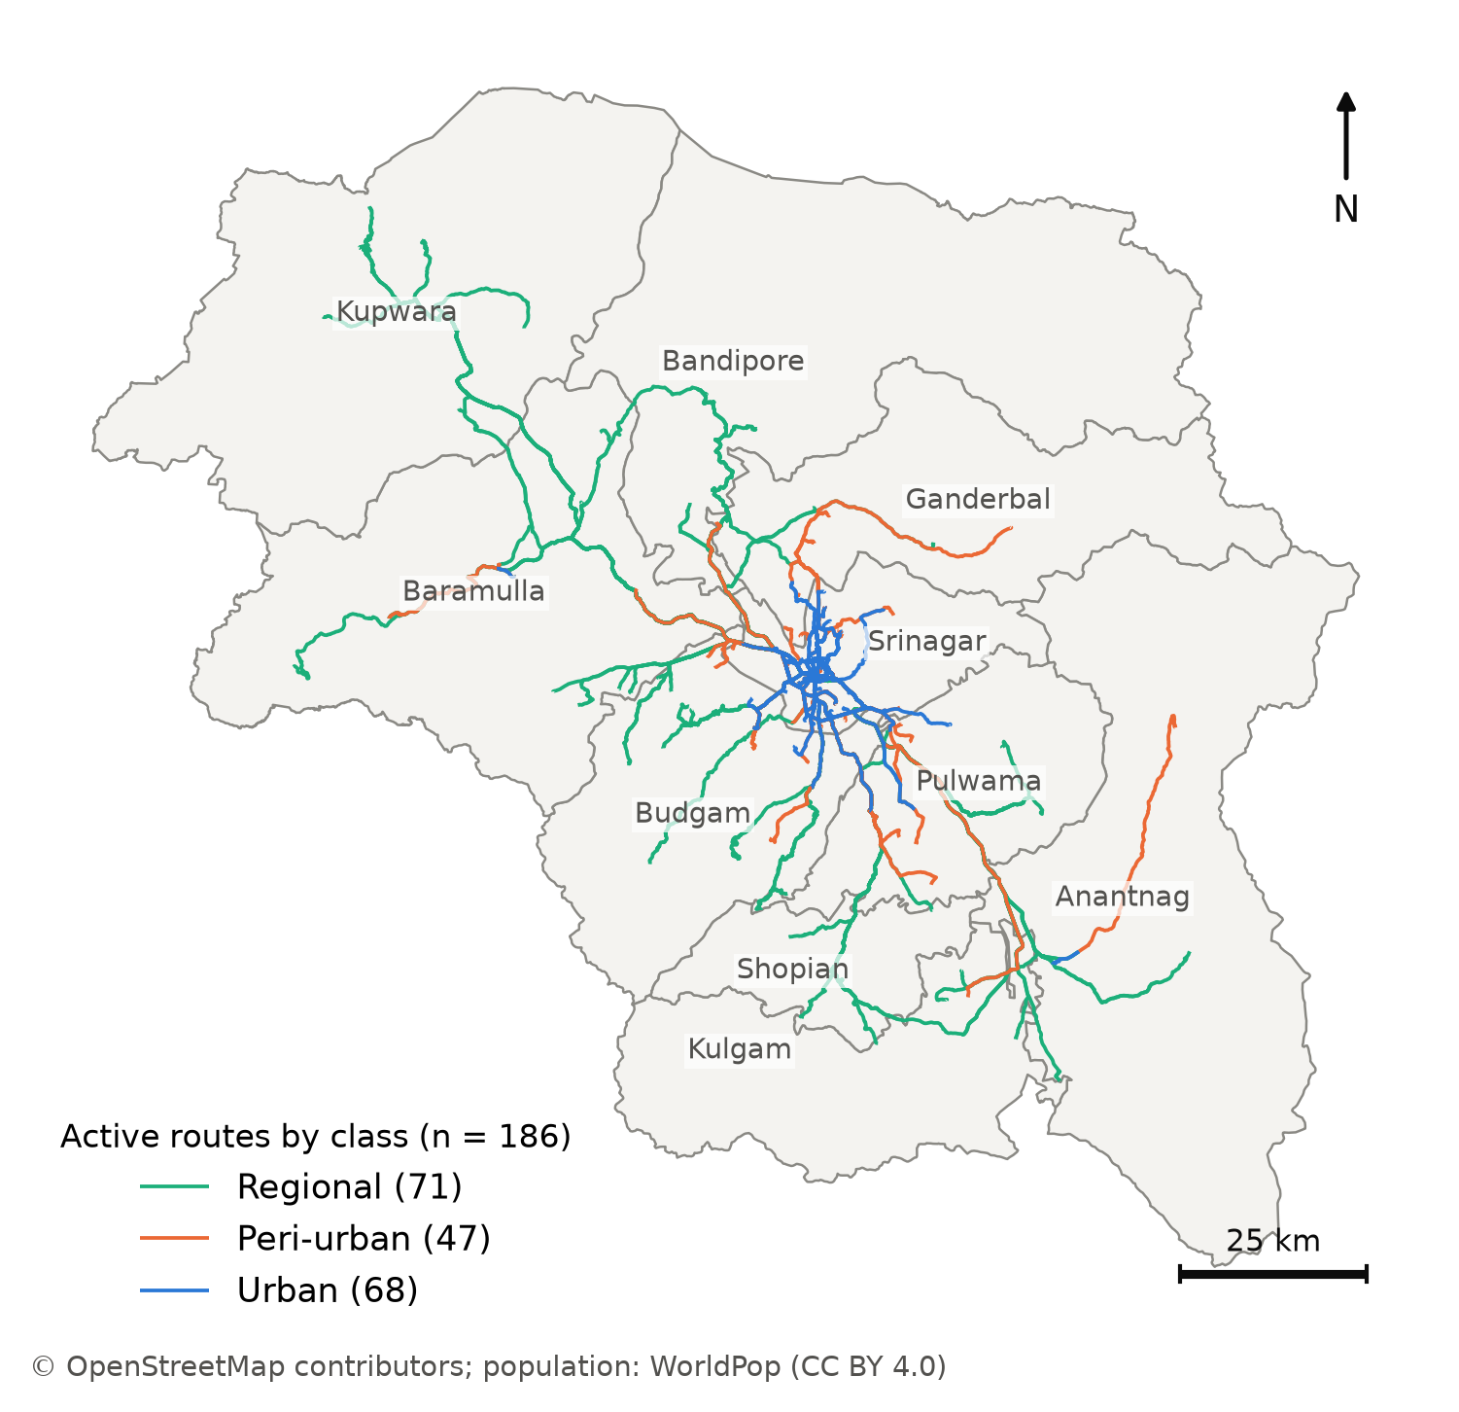
Figure 3. Study area: the ten districts of Kashmir Division and the 186 active routes of the rationalised plan by service class.
- Table 2 — Data inventory. Source · resolution · processing · validation · limitations, per dataset. Status: buildable today from data/MANIFEST.md for the staged datasets; see FLAG 3-C for the rows that reference data the study does not hold.
- Diagnostic detail behind §3.5 is already tabulated: table02a_permit_duplication, table02b_permit_activity, table02c_osm_completeness, table02d_worldpop_vs_census, table02e_poi_inventory, table02f_traveltime_error.

