Section 4: why each sentence is there
Companion to Section4_Methodology_v6.docx, 22 October 2026. Version 6 was written from a blank page with a new structure, using v5 only as a list of checked facts. Every sentence, equation, the table, the figure and the algorithm of Section 4 is listed in order with the reason it is in the section and the file or claim-ledger row that supports it. After each subsection, a second table lists what was considered and left out, and why. File paths are relative to E:\kash-paper unless they begin with another drive or folder.
Rules applied while writing: a sentence stays only if a reader needs it to repeat the method, to judge a choice, or to see a limitation; every number must trace to a file; nothing still waiting on an answer from a co-author is stated; and the draft followed the nature-writing method guide (each subsection: why the step is needed, what it does, its limits) and was checked with nature-polishing, paper-self-review, citation-verification, humanizer and academic-humanizer (no dashes, no stock phrases, claims no stronger than their evidence, every citation present in references.bib).
A human author still has to open each cited source and confirm it before submission. The evidence column records where the support is; it does not certify that a person has checked it.

4.1 Overview
No. | Sentence | Why it is there | Evidence
1 | Route planning usually starts from observed travel, but Kashmir Division has no origin-destination survey, fare-card records or passenger counts for its private and state-run buses; its only electronic ticketing is on the Srinagar Smart City e-bus service. | Opens with what planning normally needs and states the condition the whole method is designed for. | General knowledge of the field (Section 2 reviews it); co-author brief §3.1 (no fare-card system, no OD survey); data/raw/chalo_ridership.csv is the only ticketing record held.
2 | The method starts instead from the services already licensed and timetabled and returns a network in which every route has a service tier, a headway and a fleet. | Defines the input and the output in one sentence, which the rest of the section then builds. | Plan file data/raw/Rationalised_Routes_Kashmir_v3.csv (columns Priority_Band, Headway_Min, Fleet_Required).
3 | It has four stages (Fig. 4): records to corridors (Sections 4.2 and 4.3), what each route reaches (4.4 and 4.5), merging and ranking (4.5 to 4.7), and headways and fleets (4.7 and 4.8). | Gives the order of the section and ties it to Figure 4. | word_build/fig04_method_flow_v6.png; section structure.
4 | Sections 4.9 to 4.11 then describe where the e-bus operator's figures enter, the changes made to the plan before it was published, and how its decisions were tested. | Tells the reader that the non-open inputs and the hand changes are described separately, so the model can be read first. | Section structure.
Fig. 4 | 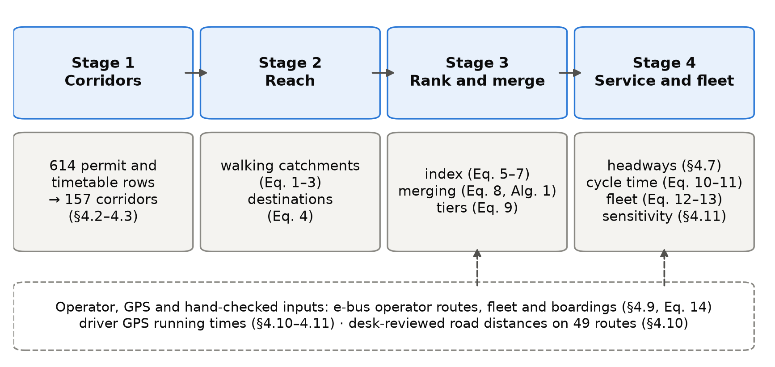  Figure 4. The four stages of the method with the equations that implement them. The dashed box lists the inputs that come from the e-bus operator, from driver GPS or from a desk review rather than from open data. | Shows the stages, the equation numbers and the non-open inputs at a glance. Drawn for v6 because the published figure carries v5 equation numbers and a 'QA gates' step that is not described. | paper/word_build/fig04_v6.py, in the style of analysis/fig_generate_all.py fig04_method_flow.
Considered and left out
Item | Reason
The research question and objectives | Stated in Section 1; repeating them costs words and adds nothing a reader needs to repeat the method.
A claim that many Indian regions lack origin-destination data | No source in the project measures this; the condition is stated for Kashmir only.
The before-and-after passenger survey (questionnaire, target 348 respondents) | Its design, the derivation of 348 and its timing are not yet confirmed, and its results belong to Section 6. When it is written up, the professor's references on passenger satisfaction (Singh and Kathuria, 2023; Eboli and Mazzulla, 2007; Tyrinopoulos and Antoniou, 2008; Allen et al., 2019) belong there, not in a description of the planning model.

4.2 Data
No. | Sentence | Why it is there | Evidence
5 | Table 4.1 lists the inputs; the existing services enter as 614 rows. | The paper's central count; the reader must know what the rows are before it is used. | CL-01; data/raw/existing-routes.csv.
6 | The 445 private permits come from the Srinagar Regional Transport Office, whose register is far more complete than those of the other nine Kashmir offices: 453 of its 1,259 rows name both ends of a route, against 133 of 1,742 elsewhere. | Gives the reason for using one office in a ten-district study, which a reviewer would ask, with the counts behind it. | Office filter in E:\kash\latlon.py lines 125-128; office counts from E:\kash\Mini Buses Routes in Srinagar.xlsx (MISSED_CONTEXT item 2).
7 | Of the office's 548 heavy-bus permits, 544 record no route, so the private permits in the input are almost all for minibuses. | The vehicle classes of Section 4.8 replace these permits, so the reader needs to know the input is minibus-dominated. | E:\audit\Kashmir_Transit_Audit_v3.3.7.md, Finding 2; existing-routes.csv has 4 HPV rows.
8 | The other 169 rows are scheduled services of the Jammu and Kashmir Road Transport Corporation, typed in from a scanned timetable. | Names the second source and its manual transcription, a known source of error. | existing-routes.csv (Regular 76, MPS 43, City 49, MTS 1); E:\kash\AUDIT_2026-06-21_SOURCE_RECHECK.md section A.
9 | Each row names an origin, a destination and a vehicle category, and 73% also list intermediate places. | Says what information the method can use from each row. | existing-routes.csv, Via_Points_Raw present on 73% of rows.
10 | Permits were used whether or not they were still in force, so the input describes the network as it has been permitted over time; in June 2026 only 96 of the 453 route-bearing Srinagar permits were valid. | Without this a reader would assume the plan rests on current permits. | E:\kash\FUNNEL_AUDIT.md section A (Permit Upto before 20 June 2026).
Table 4.1 | Table 4.1. Inputs to the method. Private stage-carriage permits, 445 rows: Srinagar Regional Transport Office register; not open: Existing route set / Scheduled services, 169 rows: Jammu and Kashmir Road Transport Corporation, Kashmir Division timetable, transcribed by hand; not open: Existing route set / E-bus routes, fleet and boardings: 30 routes, 98 buses, 11,632,326 boardings: Srinagar Smart City operator, May 2025 to April 2026; not open: Section 4.9 / Residents per 100 m cell: WorldPop constrained estimate, release R2025A (alpha): Catchments, coverage / Walking network, 2,431 points of interest, district boundaries: OpenStreetMap extract of 6 January 2026: Catchments, destinations, study region / Road distance and free-flow time: OSRM routing engine on the same extract: Cycle time / Bus positions: 2,526 service runs by 157 driver accounts: Driver smartphone application, 6 February to 29 June 2026; not open: Sections 4.10 and 4.11 | Gathers every input with its source, date and openness in one place, which a methods section needs for replication and which takes far fewer words as a table. | existing-routes.csv (Vehicle_Category: 445 private, 169 JKRTC); data/raw/chalo_ridership.csv (11,632,326; 30 routes; 98 buses, CL-36); WorldPop TIFF tags; OSM extract date (97_AUTHOR_ANSWERS); data/raw/pois.csv (2,431); v04_gps_validation.json corpus (2,526 runs, 157 accounts, 2026-02-06 to 2026-06-29).
11 | Running times come from a driver smartphone application that records positions about every 5 seconds; its sessions were split into service runs, map-matched with OSRM and grouped into corridors by their end points. | Introduces the GPS source, its sampling rate and how raw traces became the runs used later. | E:\bus-sathi-trace\PROFILE.md (median sampling interval 5 s); E:\bus-sathi-trace\README.md (sessionise, map-match, endpoint clustering).
12 | The runs are mostly in and around Srinagar and carry no information on passengers, so they are used only for running time. | Says where the runs are, which limits what they can test, and prevents the GPS being read as a demand source. | v04_gps_validation.json scope (Srinagar and immediate belt; does_not_validate).
13 | The population surface, an alpha release used as published, totals 95.6% of the 2011 Census count, but individual districts differ from the Census by up to 29%. | States the status of the dataset and bounds the error in every population figure, especially by district. | WorldPop release statement (audit research R2, item 7); q01_data_quality.json D4 (ratio_total 0.956; Kupwara 0.711; Ganderbal 1.202).
14 | Of the 2,431 points of interest, 65% lie in Srinagar district, which partly reflects how thoroughly each area has been mapped. | Warns that the destination score of Section 4.5 is weakest outside Srinagar. | CL-20, CL-21 (1,588 of 2,431).
15 | The study region Ω is the union of the ten district boundaries. | Defines the symbol used in Eqs. (1) to (3). | data/raw/kashmir_districts_osm.geojson (10 districts).
16 | Raster cell c, centred at x_{c}, holds ρ_{c} residents, and the region holds 6,584,762, the denominator of every coverage share in the paper. | Defines ρ and x and fixes one denominator so that every coverage figure is comparable. | CL-11; analysis/common.py STUDY_AREA_POPULATION.
17 | G = (V, E) is the walking network with edges weighted by length, and route r is a line of length ℓ(r). | Defines G and ℓ for Eqs. (1), (10) and (11). | analysis/a01_build_walk_graph.py.
18 | The open sources are WorldPop (Stevens et al., 2015; Tatem, 2017), OpenStreetMap (OpenStreetMap contributors, 2024) and OSRM (Luxen and Vetter, 2011), which was built on the same map extract as the walking network. | Cites each open source once and records that walking and driving share one map, a replication detail a reviewer would ask for. | references.bib; SHA-256 of E:\OSRM_Jammu\india-latest.osm.pbf equals PBF_SHA256_RECORDED in analysis/v01_spatial_crossval.py (681021c5...).
Considered and left out
Item | Reason
The 18,533 km length of the walking network | Describes size only; it belongs in the Section 3 data table.
The 43,809 GPS 'runs' given in Sections 3 and 6 | That figure counts each run once for every corridor it touches (17.3 per run). The data hold 2,526 distinct service runs (v04_gps_validation.json, corpus). Sections 3 and 6 need the same correction.
'180 drivers' for the GPS | 180 accounts opened the app; 157 recorded usable service runs. The identifier is an app account, not a verified person, so 'accounts' is used.
The 133 route-bearing rows held by the other nine Kashmir offices, by office | Kept to the total to save words; the office breakdown (Budgam 54, Ganderbal 29, Pulwama 28, Kulgam 17, others 5) is in MISSED_CONTEXT_2026-10-16.md.
The JKRTC fleet of 537 (ASRTU handbook) | Covers the whole state corporation, not the Kashmir services modelled; it belongs beside the baseline fleet in Section 5.
Consent and ethics for the GPS collection | Not resolved (decision 4); the ethics statement, not the method, must answer it.

4.3 From permit rows to corridors
No. | Sentence | Why it is there | Evidence
19 | Place names were geocoded with OpenStreetMap's Nominatim service within the district named in each record; names it could not place came from a gazetteer of 103 entries built from other geocoders and hand-placed points. | States the geocoder, the district restriction that removed an earlier error, and where the remaining locations come from. | E:\kash\geocode_common.py; engine CLAUDE.md v3.3.8; E:\kash\kashmir_gazetteer.csv (103 rows: arcgis 21, nominatim 19, photon 8, photon+arcgis 5, srinagar_pin 7, manual_pin 6, district_centre 37).
20 | In it, 37 villages that no source could locate sit at their district's centre, so routes ending there have approximate distances and catchments. | Discloses the largest known location error in the input. | Same file, source = district_centre (37).
21 | A permit licenses a vehicle, so several rows often describe the same route. | Gives the reason the next step is needed. | Register structure; CL-04 (mean 3.91 rows per corridor).
22 | Rows whose two end points match to within 11 m, in either direction, were treated as one corridor, and on this rule the 614 rows describe 157 corridors. | States the rule and its result so it can be repeated. | CL-02; analysis/q01_data_quality.py (D1).
23 | Most corridors have one row and the busiest, Hazratbal to Lal Ded, has 42, so a reduction in route numbers depends on the unit counted; Section 5 states it each time. | Shows how uneven the duplication is and warns that a 'reduction' depends on the unit. | CL-03; CL-04 (median 1).
Considered and left out
Item | Reason
'19 routes and 93 buses end at a district-centre point' | Could not be reproduced: matching names gives 13 routes and 55 buses, matching positions 5 to 21 routes. Left out until recomputed from the plan's endpoint coordinates.
Spelling-variant duplicates such as Ratnipora and Ratnipura | Known from ROUTE_NETWORK_INTEGRITY_v3.4.4.md, but not counted; the effect on the 157 corridors is unknown. Worth one sentence once counted.
The transcription error Soura/Buchpora in the timetable | One row; a detail for the supplement's data notes.

4.4 Walking catchments
No. | Sentence | Why it is there | Evidence
24 | A route serves the people who can walk to it. | Purpose of the subsection, in one line. | None needed.
25 | Many coverage measures use a straight-line buffer (Murray, 2001), which counts people across rivers, lakes and walls as served; the resulting error has been measured in several cities (Gutierrez and Garcia-Palomares, 2008; Biba et al., 2010; El-Geneidy et al., 2014). | Places the choice in the literature and names the error it avoids. | references.bib (four entries).
26 | Srinagar is divided by the Jhelum and its lakes, so catchments were measured on the walking network instead. | The local reason for the choice. | Geography (Section 3).
27 | Notional stops were placed every 250 m along each route and attached to the nearest network node, at a median distance of 11 m. | Replication detail, with the snapping error that bounds its accuracy. | analysis/a02_network_catchments.py (VIRTUAL_STOP_SPACING_M 250); a02_network_catchments.json snap_offset_median_m 11.0.
28 | A shortest-path search from all stops gives each node v its walking distance d(v) to the nearest stop. | Defines d(v) for Eq. (1). | a02_network_catchments.py.
29 | With a walking budget W = 400 m and an allowance τ = 100 m, one raster cell, for the last stretch off the network, the catchment of route r is | Gives both parameters; τ is tied to the raster resolution. | a02_network_catchments.py (WALK_BUDGET_M, TAU_M).
Eq. 1 | 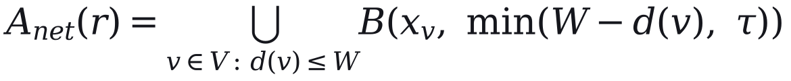 | Defines the catchment exactly; without it the method cannot be repeated. | a02_network_catchments.py.
30 | where B(x, δ) is the disc of radius δ centred on x. | Defines B. | Same.
31 | Its residents are | Introduces Eq. (2). | Same.
Eq. 2 | 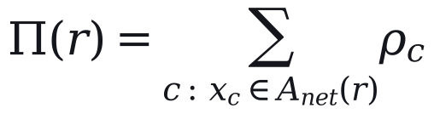 | Defines the resident count used by the index and by coverage. | a02_network_catchments.py.
32 | Routes that run side by side share residents, so their counts cannot be added. | Gives the reason for Eq. (3). | a02_network_catchments.py; audit Finding 9 (June 2026).
33 | For network totals each cell is split equally among the n_{c} routes whose catchments contain it, | Introduces the sharing rule. | a02_network_catchments.py.
Eq. 3 | 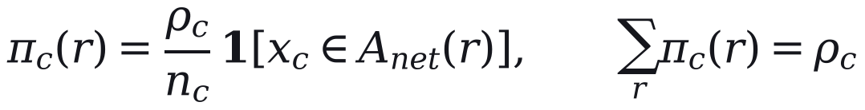 | States the sharing rule and shows that the shares sum to the combined catchment. | a02_network_catchments.py.
34 | so that the shares add up to the population of the combined catchment. | States the property that makes network totals valid. | Eq. (3).
35 | The budget W is varied from 300 to 800 m in Section 4.11. | Tells the reader that 400 m is tested, not assumed to be right. | analysis/a08a_catchment_grid.py; common.py PARAMETERS.
36 | Walking distance is the only access measure; the quality of the walking environment, which also affects willingness to walk (Bivina et al., 2019), is not modelled. | A limitation of the catchment, stated where it is defined. | references.bib bivina2019influence.
Considered and left out
Item | Reason
Citation of the Transit Capacity and Quality of Service Manual for 400 m | Nobody on the project has opened the page; the value is presented as a tested setting instead.
The UN indicator 11.2.1 (500 m) and Daniels and Mulley (2013) | Checked during the source research but not in references.bib; add both, then cite them here beside 400 m.
Size of the straight-line overstatement | A result (28.7% to 52.8% across settings); it belongs in Section 5.

4.5 Destinations and the composite index
No. | Sentence | Why it is there | Evidence
37 | Destinations show what a route connects residents to. | Purpose, and the reason the index has two parts. | None needed.
38 | They were counted as cumulative opportunities (Geurs and van Wee, 2004): point q counts towards route r when its walking distance to the nearest stop, d_{q}(r), is at most 250 m, with the weight α of its tier t(q), | Names the accessibility measure and gives the exact rule. | references.bib geurs2004accessibility; analysis/a03_index_weights.py (POI_BUDGET_M).
Eq. 4 | 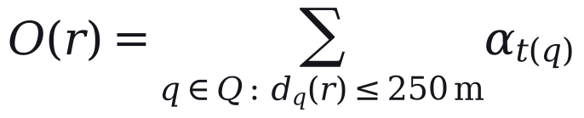 | Defines the destination score. | a03_index_weights.py.
39 | Tiers were assigned from OpenStreetMap tags and 67 name rules for known landmarks, with α = 1.00 for major destinations (1,030 points), 0.40 for others (1,080) and 0.60 for seasonal visitor sites (321). | Gives the weights and how many points each covers, so the score can be recomputed. | E:\kash\extract_pois_kashmir.py (NAME_OVERRIDES, 67 entries); data/raw/pois.csv; engine lines 225-232.
40 | The tiers are coarse: every mapped place of worship is in the top tier, accounting for 547 of its points. | Names the weakness before a reviewer finds it. | extract_pois_kashmir.py (place_of_worship mapped to tier 1); PARAMETERS_AND_DEFENSIBILITY.md group A.
41 | The weights and tier rules are our assumptions; no weights were elicited from experts. | Declares the judgement plainly. | PARAMETERS_AND_DEFENSIBILITY.md group A.
42 | The plan itself measured the 250 m in a straight line. | Records that the plan's own rule differs from the re-implementation. | Engine POI_BUFFER_M.
43 | Because a residential surface does not count visitors, the plan raised the resident count of the eight tourist routes, the set T, by a factor μ: | Gives the reason for the multiplier and says what it multiplies. v5 applied μ to the destination score, which is not what the engine does. | Engine transit_kashmir_v3.py line 1863 (Population_Served × TOURIST_POPULATION_MULTIPLIER); plan file Tourist_Corridor (8 active); analysis/a02b_faithfulness.py lines 35 and 153.
Eq. 5 |  | States the multiplier exactly, on the resident count. | Engine TOURIST_POPULATION_MULTIPLIER = 1.3.
44 | It changes their index but not network coverage. | Corrects the earlier impression that μ inflates coverage. | a02_network_catchments.py (no tourist multiplier in coverage); audit F-03-09.
45 | For a single ranking, both measures were divided by route length so that long routes do not score higher for length alone, density was capped at its 95th percentile so that a few very dense routes do not compress the rest, and each was rescaled across routes, | Purpose of the step, then each transformation with its reason. | Engine POP_CAP_PERCENTILE 95; a03_index_weights.py pop_score, poi_score.
Eq. 6 | 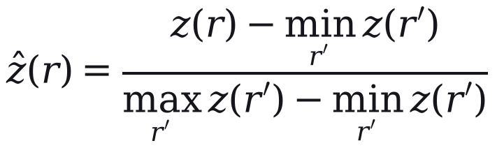 | Defines the rescaling. | analysis/common.py minmax.
46 | and the rescaled values were combined with weight β on residents (OECD and European Commission, Joint Research Centre, 2008): | Introduces Eq. (7) with the standard reference on composite indicators. | references.bib oecd2008handbook.
Eq. 7 |  | Defines the index. | Engine CDI_POP_WEIGHT 0.50.
47 | Here ẑ_{Π} and ẑ_{O} are the rescaled values of Π*(r)/ℓ(r) and O(r)/ℓ(r). | Links Eq. (7) to Eqs. (4) and (5). | a03_index_weights.py; engine CDI step.
48 | The two components are strongly correlated (Pearson's r = 0.89 with network catchments), so the index is close to a ranking by population density with a destination adjustment. | Says honestly how much the composite adds. | a03_index_weights.json pearson_r 0.8922 (network).
49 | Principal-component weights (Jolliffe, 2002) equal the equal weights when there are two components, so Section 5 compares equal weights with entropy weights (Shannon, 1948; Zou et al., 2006) and with β from 0.2 to 0.8. | Names the alternative weightings and why only two are distinct. | a03_index_weights.py distinct_weightings; common.py PARAMETERS (CDI_POP_WEIGHT range).
50 | The index indicates where demand is likely to be; it does not measure demand. | Prevents the index being read as a demand estimate. | Follows from the construction; no ridership enters Eqs. (1) to (7).
Considered and left out
Item | Reason
The ×1.25 weight on women-oriented destinations | Applies to 12 of 2,431 points and changes no tier; describing it would add an undefended number for no effect. Remove it from the engine description in the supplement too.
The re-tiering test (at most 4 of 186 routes change tier) | A result for Section 5.
The code's claim that education drives 30% of women's ridership | No file supports it; the operator's data carry no trip purpose.

4.6 Merging overlapping routes
No. | Sentence | Why it is there | Evidence
51 | Where several services share a road, the network should run one of them. | Purpose of the subsection. | None needed.
52 | Overlap between two routes is measured on 80 m buffers S(r) around their lines: | Introduces Eq. (8) with the buffer width. | Engine OVERLAP_BUFFER_M 80.
Eq. 8 | 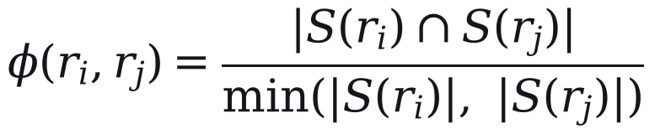 | Defines overlap exactly. | analysis/a08_sensitivity_oat.py merge_pairs.
53 | A trunk is the highest-ranked route of its overlap group, and a member joins it only when φ ≥ θ = 0.65 and their start points lie within 2.5 km; members are never merged with each other and e-bus routes are never absorbed (Algorithm 1). | States the trunk choice and both absorption conditions, with the two restrictions earlier drafts left out; they explain why so few corridors disappear. | Engine step 3; OVERLAP_THRESHOLD, OD_PROXIMITY_TOLERANCE_M; audit F-05-11.
54 | The buffer, θ and the 2.5 km tolerance are our assumptions. | Labels the values. | PARAMETERS_AND_DEFENSIBILITY.md group D.
Alg. 1 | Algorithm 1. Merging overlapping routes / Input: 644 candidate routes (614 permit and timetable rows and 30 e-bus routes); threshold θ. / 1. Group routes whose 80 m buffers overlap by at least θ. / 2. In each group, take the route with the highest index as trunk if it is at least 5 km long and above the 30th percentile of the index. / 3. Absorb a member into the trunk if φ ≥ θ and the two start points are within 2.5 km; otherwise keep the member as a feeder. / 4. Never absorb an e-bus route, and never merge two members with each other. / 5. Collapse routes on the same corridor, in either direction, into one service. / Output: 186 active routes (32 trunks and 154 feeders); 458 routes absorbed. | The procedure in a form that can be coded. | Engine step 3; CL-05 (644); plan file Action_Taken counts (186 = 32 + 154; 644 = 186 + 458).
55 | The rule is conservative: the 186 active routes keep 156 of the 157 corridors. | The outcome of the rule, in the unit of Section 4.3. | CL-08.
56 | The merge rule is not sampled in the uncertainty analysis; scenario S4 in Section 5, which lowers θ to 0.50 and merges connected groups, is its only test. | Discloses a gap in the uncertainty analysis where the rule is defined. | a15_scenarios.json S4; a09 parameters_not_sampled.
Considered and left out
Item | Reason
The 207 overlapping pairs left unmerged, and the 84-route result of merging connected groups | Results; scenario S4 in Section 5.
The trunk's road-role multiplier and the ×1.5 bonus for routes connecting to the e-bus network | Used only as tie-breaks when choosing a group's lead; listed in the parameter table of the supplement.

4.7 Service tiers and headways
No. | Sentence | Why it is there | Evidence
57 | Each route is typed by length as urban (under 15 km), peri-urban (15 to 40 km) or regional (over 40 km), unless its permit category indicates otherwise. | Defines the route type, which sets the headway rule, the cap and the minimum fleet below. | Engine route-type rule; PARAMETERS_AND_DEFENSIBILITY.md group C.
58 | Active routes were divided into tiers by Jenks natural breaks on the index, which make each tier as internally uniform as possible (Fisher, 1958; Jenks, 1967). | Names the classifier and its sources. | Engine step 5 (jenkspy); references.bib.
59 | The goodness of variance fit measures how well k tiers describe the index values y_{i}: | Introduces Eq. (9). | analysis/common.py goodness_of_variance_fit.
Eq. 9 | 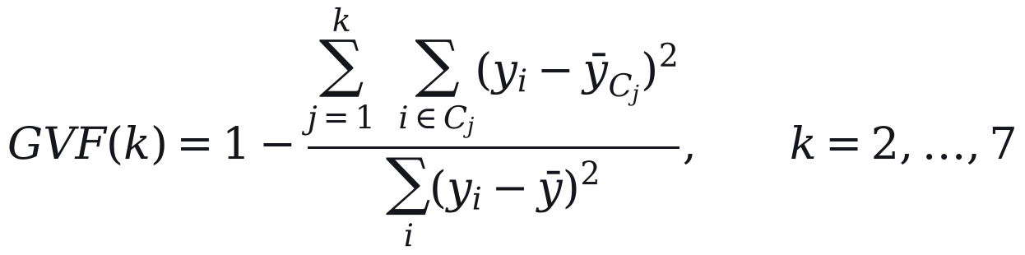 | Defines the fit statistic. | common.py goodness_of_variance_fit.
60 | The plan uses three tiers, which give a fit of 0.90 against 0.79 for two; three is thus the smallest number of tiers above 0.80, a threshold of our choosing and not a published standard. | Shows the fit supports three tiers without presenting the 0.80 rule as a derivation. | a04_class_count.json gvf_by_k (2: 0.786; 3: 0.902); gvf_threshold_source 'assumption'.
61 | Published tiers carry three overrides: e-bus routes are always in the top tier, routes within 250 m of 11 listed social destinations (four migrant townships and seven hospitals) rise from the lowest tier to the middle one, and a route lying close to a tier break, within 5% of the gap between the two breaks, can move one tier according to its road role. | Discloses every override that changes a published tier. The district-headquarters floor is not named separately: it applies only to regional routes already carrying the social flag, so it is part of the social rule. | Engine step 5 (CMP lock; Social_Flag; District_HQ_Floor at lines 2945-2960 requires Social_Flag; road-role tie-break, lines 2895-2925: band = 0.05 x (upper break - lower break)); attractor list lines 638-652 (4 townships, 3 Srinagar hospitals, 4 district hospitals; SOCIAL_FLAG_BUFFER_M = 250, line 384; the 500 m in the step-4b docstring is stale).
62 | Headways are service standards, set independently of the index. | Separates policy values from the method so the index is not credited with them. | Engine HEADWAY constants.
63 | E-bus routes run every 15 minutes, the operator's headway, other top-tier routes every 20 minutes and all other urban and peri-urban routes every 35 minutes. | Gives the urban standards. | Engine SSCL_TRUNK_HEADWAY_MIN, HEADWAY_HP_MIN, HEADWAY_MP_MIN, HEADWAY_MAX_MIN.
64 | On regional routes outside the e-bus network, the headway starts at 35 minutes and, when the estimated load of Section 4.9 is below a target of 55%, is lengthened in proportion and rounded to 40, 45 or 50 minutes. | Gives the regional rule, including the only place estimated demand changes a headway. | Engine apply_regional_demand_headway (headway = current × target load / load, bucketed); REGIONAL_HEADWAY_BUCKETS (35, 40, 45, 50); target load 0.55.
65 | In the published plan, 62 of these 67 routes run at 50 minutes and 5 at 35, so the rule acts in practice as a 50-minute maximum wait. | Shows what the rule does in practice, so it is not oversold as demand-responsive. | Plan file: Regional_District by Headway_Min (35: 5, 50: 62).
66 | Standards of this kind pursue what Walker (2008) calls a coverage goal, spreading service across an area whatever its ridership. | Gives the planning concept that justifies fixed standards without demand data. | references.bib walker2008purpose.
67 | Each route has one headway for the whole day. | Prevents the reader assuming time-of-day bands. | Plan file (one Headway_Min per route).
Considered and left out
Item | Reason
Peak, off-peak and evening headways (asked for in the co-author brief) | The plan has one headway per route; describing bands would misdescribe it.
Who set which headway rule (the regulator in two review rounds, the lead author for the regional rule) | Not yet confirmed that the paper may say so (decision A3).
Legacy headway floors by permit category ('city bus' at least 20, 'mps' at least 35) | Not yet shown to change nothing; check, then disclose in the supplement.
The agreement between published and index-only tiers (68.3%, 79.5% without e-bus routes) | A result for Section 5.

4.8 Cycle time and fleet
No. | Sentence | Why it is there | Evidence
68 | One-way running time is the free-flow road time, scaled for congestion, plus time lost at stops (Vuchic, 2005; Ceder, 2007): | Introduces Eq. (10) with its textbook sources. | references.bib.
Eq. 10 | 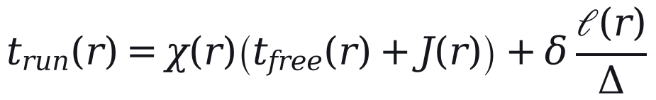 | Defines running time. | Engine compute_cycle_times; analysis/fleet_model.py.
69 | Here χ(r) is 2.2 for routes in the zone treated as the city core and 1.4 elsewhere; the core is bounded by a single line of latitude and contains 170 of the 186 routes. | Gives the values and discloses how crude the zone is. | Engine CITY_CORE_LAT_THRESHOLD 34.07; a08_sensitivity_oat.json congestion_disclosure (170).
70 | J(r) adds 8 minutes to routes that cross the Jhelum, and each stop costs δ = 0.5 minutes at a spacing of Δ = 500 m. | Gives the remaining constants. | Engine JHELUM_BRIDGE_BOTTLENECK_MIN, STOP_PENALTY_MIN, STOP_SPACING_M.
71 | These values are assumptions. | Labels them. | PARAMETERS_AND_DEFENSIBILITY.md group E.
72 | Cycle time is the round trip with layover, capped per kilometre: | Introduces Eq. (11). | None needed.
Eq. 11 |  | Defines the cap that sets most of the fleet. | Engine CYCLE_TIME_CAP_MIN_PER_KM; TERMINAL_LAYOVER_FACTOR.
73 | Here λ = 1.10 allows 10% of running time for layover, and ω is 4.0, 2.5 and 1.5 minutes per kilometre on urban, peri-urban and regional routes. | Gives the constants. | Engine constants.
74 | The cap was meant to catch implausible values, but it binds on 169 of the 186 routes, and on those Eq. (10) has no effect on the fleet. | The most important fact about the fleet model, stated where the model is defined. | CL-31.
75 | The urban cap is also faster than the median pace observed in driver GPS, 4.62 minutes per kilometre, which is why Section 4.11 sizes the fleet a second time from observed pace. | Explains why a second fleet estimate exists. | CL-32; a09 observed_pace_reconciliation (median_pace_effective 4.616).
76 | With headway h(r), the fleet on route r is | Introduces Eq. (12). | None needed.
Eq. 12 | 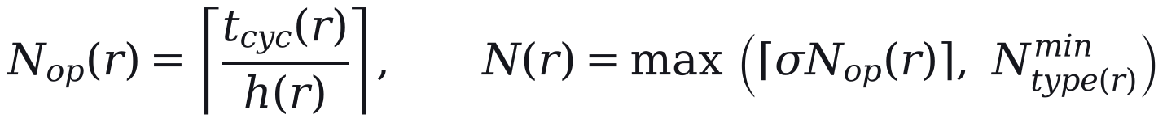 | Defines the fleet per route. | Engine step 8; fleet_model.py fleet_from_cycle.
77 | where the spare allowance σ = 1.15 is an assumption and N^{min} is two buses on urban and peri-urban routes and one on regional routes. | Gives the constants and their status. | Engine FLEET_SPARE_RATIO, MIN_FLEET_URBAN, MIN_FLEET_REGIONAL.
78 | On the e-bus routes, the set E, the operator's deployed fleet N^{emp}(r) is a floor, and the network total is | Introduces Eq. (13). | Engine step 9.
Eq. 13 |  | Gives the total and its two parts. | Plan file (non-e-bus 728, e-bus 283); CL-36.
79 | Of the buses, 187 are heavy (about 12 m), 754 medium (about 9 m) and 70 light (minibus): routes under 12 km get no heavy buses, heavy buses are at most half the fleet of longer routes, and e-bus routes keep the operator's split. | States the vehicle-class rules and the totals. | Engine _route_km_hpv_share; PARAMETERS_AND_DEFENSIBILITY.md group G; plan file HPV/MPV/LPV sums (187/754/70).
80 | An independent re-implementation of Eqs. (10) to (12) reproduces the published fleet on all 186 routes when given the plan's headways, its five GPS-timed cycle times (Section 4.10) and the e-bus floors. | Shows the equations describe what the plan did. | CL-55; a09_monte_carlo_sobol.json baseline_reproduction_decomposed.
Considered and left out
Item | Reason
GPS evidence against the 2.2 city-core multiplier and the 10% layover (core 1.39 times slower; median turnaround 24 minutes) | Results; Sections 5 and 6. The GPS project itself warns against turning the speed ratio into a multiplier.
The 'Srinagar Traffic Police bottleneck studies' named in the code for 2.2 | No such document exists in any project folder; it must never be cited.
The fallback speeds used when the routing engine is down | Not used in the published run.
Today's fleet (777) and the comparison with the plan | A result for Section 5.

4.9 Where the e-bus operator's figures enter
No. | Sentence | Why it is there | Evidence
81 | The method needs no observed demand for the routes it plans, but it uses the e-bus operator's figures where they exist, at five points: | States the limited claim the paper can defend and announces the list. | Engine code paths listed below.
82 | The 30 e-bus routes are added as they run and are never absorbed (Section 4.6). | Entry point 1. | Engine inject_cmp_trunk_routes.
83 | They sit in the top tier and run every 15 minutes, whatever their index (Section 4.7). | Entry point 2. | Engine SSCL_TRUNK_HEADWAY_MIN; CMP lock in step 5.
84 | Their fleet is at least the operator's deployed fleet (Eq. 13). | Entry point 3. | Engine step 9.
85 | The urban bus share and the scale of the ridership estimate below are set from the operator's boardings. | Entry point 4. | E:\kash\cross_evaluate.py lines 53-66; engine lines 540-547.
86 | On the 67 regional routes outside the e-bus network, that estimate can lengthen the headway (Section 4.7). | Entry point 5. | Engine apply_regional_demand_headway.
87 | The estimate sets these regional headways and the load factors and demand-sized fleet of Section 5, but not the route set or the tiers. | Limits the role of Eq. (14) before giving it. | Engine Phase 4; a07_load_factor.json; a17_demand_sized_fleet.json.
88 | For route r it is | Introduces Eq. (14). | None needed.
Eq. 14 | 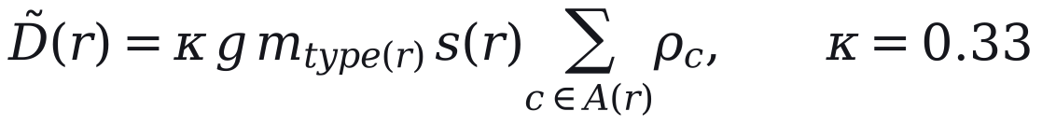 | Defines the estimate, including the trip rate. | Engine lines 518-547.
89 | where g = 1.6 trips per person per day is assumed, m is the bus share of trips for the route's type, A(r) is the route's catchment and s(r) is the share of its corridor's residents assigned to it. | Defines the symbols and marks the trip rate as an assumption; s replaces the σ of v5 so that σ means only the spare allowance. | Engine PHASE4_TRIP_RATE; E:\kash\cross_evaluate.py lines 68-75 cite per-rider app data the project does not hold.
90 | The urban share, 0.090, was backed out of the e-bus boardings for an assumed served population of about 222,000; the peri-urban and regional shares, 0.072 and 0.054, are 0.8 and 0.6 times it by assumption. | Says where each share comes from, so the reader sees that only one is anchored to data. | E:\kash\cross_evaluate.py lines 53-66; engine PHASE4_MODE_SHARE_BY_TYPE.
91 | The scale κ was fitted so that the estimate reproduces the operator's 11.63 million boardings of May 2025 to April 2026. | States what was fitted to what. | data/raw/chalo_ridership.csv (11,632,326); CL-59.
92 | Because κ, g and m multiply, only their product is identified, and because the estimate is fitted on the e-bus routes, any comparison with the operator's data (Section 6) is circular. | States the identification limit and the circularity once, plainly. | Follows from Eq. (14) and the fit.
93 | The demand-sized fleet in Section 5 holds this estimate fixed, although demand responds to the service offered (Holmgren, 2007). | Flags the main limit of the demand-sized comparison. | analysis/a17_demand_sized_fleet.py; references.bib holmgren2007meta.
Considered and left out
Item | Reason
The rank correlation of the estimate with e-bus boardings by route (0.22) | A result; Section 6.
The peak-hour share of 10.67% | One month, one operator; it enters the load factors reported in Section 5, where its scope is stated.

4.10 Changes made before publication
No. | Sentence | Why it is there | Evidence
94 | The plan evaluated in this paper differs from the model's output, because three changes were made before it was published. | Without this the reader would take the published plan for the model's output. | Engine version history (E:\kash\CLAUDE.md, v3.4.4 to v3.4.5-geo).
95 | First, all 186 routes were reviewed at a desk with an AI research assistant, which compared each modelled road distance with distances published online and recorded the websites consulted, though not the pages. | Says who reviewed, how, against what and with what record, so the reader can judge the review; it also discloses the AI use the journal requires. | E:\kash\ROUTE_DEEPDIVE_LEDGER.csv (186 rows, Sources column); ROUTE_DEEPDIVE_METHODOLOGY.md.
96 | It passed 93 routes, flagged 88 for review and failed 5. | The outcome of the review. | ROUTE_DEEPDIVE_LEDGER.csv verdicts (93/88/5).
97 | Where the two differed by more than 15% and the place names could be confirmed, the midpoint of the published range replaced the modelled distance, free-flow time was scaled in proportion and the fleet recomputed with Eqs. (10) to (12). | The replacement rule, so the change can be repeated. | E:\kash\apply_corrections_v344.py lines 70-100.
98 | Six routes were corrected individually, four of them by moving a misplaced end point and re-routing, and 43 by the rule. | How the 49 corrections divide. | E:\kash\corrections_applied_v344.csv (Confidence AUTO 43, HIGH 5, MED 1).
99 | The 49 corrected routes, 43 of which became shorter, need 207 buses instead of 247. | The size of the change on the fleet. | corrections_applied_v344.csv (Old_Fleet 247, New_Fleet 207).
100 | The other 44 flagged routes were left unchanged, mostly because the difference was within tolerance or the names could not be confirmed. | Accounts for every flagged route, so none is silently dropped. | E:\kash\corrections_deferred_v344.csv (44 rows).
101 | None of the replacement distances was measured on the ground. | The limitation a reviewer will ask about. | PENDING_DECISIONS Part D.
102 | Second, five routes were matched to GPS corridors with between 40 and 211 recorded runs each, and their cycle times were rebuilt from the measured moving speed, keeping the model's stop and junction allowances and lifting the cap. | Says which routes were re-timed, from how much data and by what rule. | E:\kash\apply_reality_v345.py; corrections_applied_v345.csv; E:\kash\CLAUDE.md v3.4.5 (40-211 runs); a09 baseline_reproduction_decomposed (5 of 5 recomputed).
103 | This raised the network fleet from 1,004 to 1,011 buses, and because these routes were fitted to the GPS they are kept out of the out-of-sample test in Section 6. | Gives the effect and the consequence for validation. | corrections_applied_v345.csv; v04_gps_validation.json in_sample.excluded_from_out_of_sample.
104 | Third, the headway standards of Section 4.7 were not fixed in advance; they were revised over about fifteen versions of the plan as it was reviewed, and across those versions the network fleet ranged from 855 to 1,144 buses. | Shows that the standards, which set about half the fleet, were negotiated rather than derived. | E:\kash\CLAUDE.md version table (v3.3.8 855; v3.4.1 1,144); audit 05 item B23.
Considered and left out
Item | Reason
A blind second review of 18 routes that agreed with the first | Both reviews were run by AI agents, so their agreement says little about accuracy.
The 13.3% mean difference between modelled and reviewed distances after correction | It compares the model with the review it was corrected to, so it is a consistency figure, not a test; it would mislead here.
The breakdown of the 44 unchanged routes | One clause covers it; the full list is in corrections_deferred_v344.csv for the supplement.
Who reviewed the headway standards | Decision A3 pending.
The fleet with the original routed distances on the 49 routes | Not yet computed properly (about 1,050 by simple addition); add as a sensitivity row when computed.

4.11 Sensitivity and uncertainty
No. | Sentence | Why it is there | Evidence
105 | Most of the values above are assumptions, so we test whether the tiers and the fleet would change if they were different. | Purpose of the subsection. | None needed.
106 | A one-at-a-time sweep varies each parameter over a range with the others held fixed. | First method. | analysis/a08_sensitivity_oat.py; common.py PARAMETERS.
107 | A Monte Carlo analysis then draws twelve inputs together 5,000 times, and Sobol' first-order and total-order indices (Sobol', 2001; Saltelli et al., 2008, 2010), estimated from a Saltelli design with 1,024 base samples (14,336 model runs), divide the variance of each output among the inputs. | Second and third methods, with design sizes for replication. | a09_monte_carlo_sobol.json (n_mc 5000, n_sobol_base 1024, n_sobol_evals 14336; 12 inputs).
108 | Catchment settings are evaluated separately on a grid of walking budgets from 300 to 800 m and stop spacings from 150 to 400 m. | The catchment grid, computed apart because it needs the network. | analysis/a08a_catchment_grid.py.
109 | Because the cap of Eq. (11) hides the running-time parameters on most routes, the fleet is computed in two regimes. | Gives the reason for two regimes. | CL-31.
110 | Regime A is the plan as specified. | Defines regime A. | a09 regime_definitions.A.
111 | In regime B, urban and peri-urban routes outside the e-bus network take their cycle time from the pace observed on 16 GPS corridors around Srinagar, 7 urban and 9 peri-urban. | Defines regime B and the evidence behind it. | a09_monte_carlo_sobol.json pace_priors (7 urban, 9 peri-urban; prior pool 16 corridors).
112 | The 5 routes of Section 4.10 use their own corridors, and 84 others take the median pace of their type. | Says how the GPS pace is assigned to routes. | a09 evidence_split (5 measured; 84 imputed: 54 urban, 30 peri-urban).
113 | The 30 e-bus routes and 67 regional routes keep their modelled cycle times, because no usable pace was observed for them. | Says which routes regime B leaves unchanged and why. | a09 evidence_split.unaffected_backbone (30), unaffected_regional (67; 2 corridors observed outside the belt, too few for a prior).
114 | Regime B is computed twice, once from overall pace and once from moving pace plus modelled stop time. | The two variants, so readers know the range depends on the method. | a09 regime_definitions (B_effective, B_moving).
115 | We report medians and 5th to 95th percentile ranges of the draws. | What is reported. | a09 interval_definition.
116 | These ranges depend on the input distributions we chose; they are not confidence intervals, and they leave out uncertainty in the route set because the merge rule is not sampled. | Prevents the ranges being read as confidence intervals or as covering the route set. | a09 interval_definition; parameters_not_sampled.
117 | The analysis tests whether the plan's decisions survive plausible changes in parameters and speeds; it does not test the plan against demand. | States the limit of the claim. | Follows from the design.
118 | All analyses run from frozen inputs in Python 3.14 with a fixed random seed (20260823), using SALib 1.5.2 for the Sobol' design and jenkspy 0.4.1 for natural breaks. | Software and versions for replication. | requirements.txt; common.py RANDOM_SEED; installed versions checked 16 October 2026.
Considered and left out
Item | Reason
The ranges themselves (fleet 989 to 1,058 in regime A; 1,130 to 1,266 in regime B) | Results; Section 5.
A statement that the code is released with the paper | The public repository has not been rebuilt, and during review it must be an anonymous mirror.
Pass marks for the GPS check (error under 20%, rank correlation over 0.5) | They belong with the check in Section 6, where it must also be said that they were set alongside the first results.

