Section 4: why each sentence is there
Companion to Section4_Methodology_v5.docx, 16 October 2026. Every sentence, equation and the algorithm of Section 4 is listed in order with the reason it is in the section and the file or claim-ledger row that supports it. After each subsection, a second table lists what was considered and left out, and why. File paths are relative to E:\kash-paper unless they begin with another drive or folder.
Rules applied while writing: a sentence stays only if a reader needs it to repeat the method, to judge a choice, or to see a limitation; every number must trace to a file; nothing still waiting on an answer from a co-author is stated; and the prose was checked against the installed writing skills (no dashes, no stock phrases, claims no stronger than their evidence).
A human author still has to open each cited source and confirm it before submission. The evidence column records where the support is; it does not certify that a person has checked it.

4.1 Framework overview
No. | Sentence | Why it is there | Evidence
1 | No origin-destination survey or ticketing data exist for the private and state-run bus services of Kashmir Division; the only electronic ticketing is on the Srinagar Smart City e-bus service. | Opens with the condition the method is built for, so every later choice can be read against it. | Co-author brief §3.1 (no fare-card system, no OD survey); data/raw/chalo_ridership.csv is the only ticketing record held.
2 | The framework takes the existing services as given and returns a network in which every route has a service tier, a headway and a fleet. | Defines the output, which the rest of the section builds step by step. | Plan file data/raw/Rationalised_Routes_Kashmir_v3.csv (columns Priority_Band, Headway_Min, Fleet_Required).
3 | It has four stages, shown in Fig. 4: checking the inputs, measuring what each route reaches on foot, merging and ranking routes, and sizing fleets and testing their sensitivity. | Gives the reader the order of Sections 4.2 to 4.9 and ties the text to Figure 4. | paper/figures/fig04_method_flow.png.
4 | The open inputs are the WorldPop constrained population surface at 100 m, release R2025A (Tatem, 2017; Stevens et al., 2015), OpenStreetMap (OpenStreetMap contributors, 2024), and the OSRM routing engine for road distance and free-flow time (Luxen and Vetter, 2011). | Names every open dataset and tool, with its version where one exists, so the work can be repeated. | WorldPop release from TIFF tags (audit FIX_STATE, 6 Oct); OSRM in E:\OSRM_Jammu; references.bib.
5 | The walking network and the routing engine were both built from the same OpenStreetMap extract, dated 6 January 2026. | A replication detail a reviewer would ask for, and it rules out a mismatch between walking and driving networks. | SHA-256 of E:\OSRM_Jammu\india-latest.osm.pbf equals PBF_SHA256_RECORDED in analysis/v01_spatial_crossval.py (681021c5...); extract date from lead-author answers (97_AUTHOR_ANSWERS).
6 | Three inputs are not open data: the regulator's permit register, the state transport corporation's timetable for Kashmir Division, and the ridership totals of the e-bus service; Section 4.5 lists where those totals enter. | The paper's claim depends on what is and is not open, so the closed inputs are named at the start. | Section 4.2 sources below; data/raw/chalo_ridership.csv.
Fig. 4 | 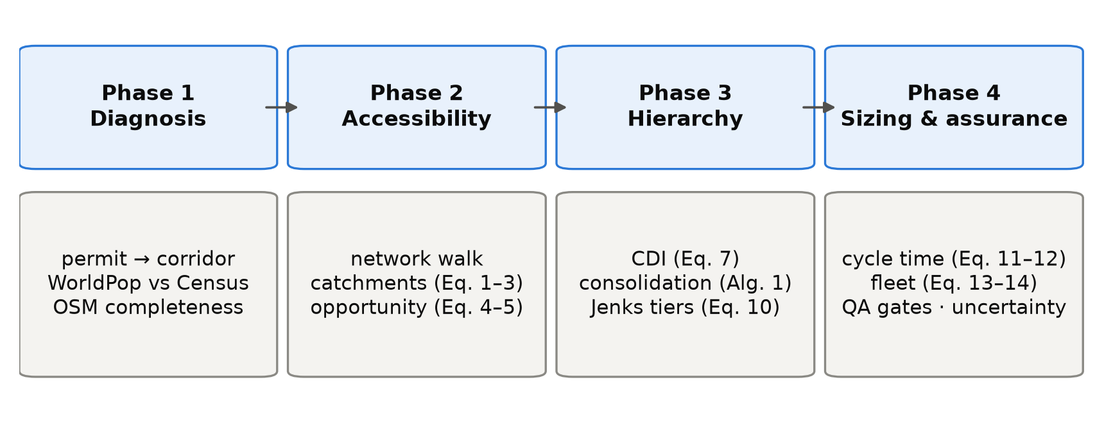  Figure 4. The four-phase method and the equations that implement each phase. | Shows the four stages and where each equation sits at a glance. The figure's last box still lists 'QA gates', which this version leaves out (the subsection waits on a check against the test suite); update the figure if that subsection stays out. | paper/figures/fig04_method_flow.png, generated by analysis/fig_generate_all.py; caption from paper/make_manuscript_pdf.py.
7 | The study region Ω is the union of the ten districts of Kashmir Division. | Defines the symbol used in Eqs. (1) to (3). | data/raw/kashmir_districts_osm.geojson (10 districts).
8 | The population surface assigns ρ_{c} residents to raster cell c, whose centre is x_{c}, and the region holds 6,584,762 residents, the denominator of every coverage share in the paper. | Defines ρ and x, and fixes the single denominator so that every coverage figure in the paper is comparable. | CL-11; analysis/common.py STUDY_AREA_POPULATION.
9 | G = (V, E) is the OpenStreetMap walking network with edges weighted by length, and a route r is a line of length ℓ(r). | Defines G and ℓ, used in Eqs. (1), (6) and (11). | analysis/a01_build_walk_graph.py.
Considered and left out
Item | Reason
A general statement that many Indian regions lack ticketing or origin-destination data | No source in the project quantifies it; the section states the condition for Kashmir only and leaves the general claim to Section 1.
The research question ('how far a bus network can be planned from the records that exist') | Stated in Section 1; repeating it here costs words and adds no method.
The research objectives O1 to O5 from the co-author brief | They belong to Section 1; repeating them here costs words and adds nothing to replication.

4.2 Data conditioning and network construction
No. | Sentence | Why it is there | Evidence
10 | The existing services enter as 614 rows from two sources. | The paper's central count is these 614 rows, so the reader must know what they are before the count is used. | CL-01; data/raw/existing-routes.csv.
11 | Of these, 445 are private stage-carriage permits from the register of the Srinagar Regional Transport Office, which records far more routes than the other Kashmir offices: 453 of its 1,259 rows name both ends of a route, against 133 of 1,742 rows in the other nine offices, which were not used. | Explains why one office was used and what was left out, which a reviewer of a ten-district study would ask. | existing-routes.csv Vehicle_Category (MPV 347, LPV 94, HPV 4); office filter in E:\kash\latlon.py lines 125-128; office counts from E:\kash\Mini Buses Routes in Srinagar.xlsx.
12 | Almost all of them are minibus permits, because 544 of the office's 548 heavy-bus permits record no route. | The vehicle classes of Section 4.8 depend on the permits replaced, so the reader needs to know the input is minibus-dominated. | E:\audit\Kashmir_Transit_Audit_v3.3.7.md, Finding 2; existing-routes.csv has 4 HPV rows.
13 | The other 169 rows are scheduled services of the Jammu and Kashmir Road Transport Corporation, transcribed by hand from its scanned Kashmir Division timetable, and they carry the network beyond Srinagar. | Names the second source and its manual transcription, a known error source. | existing-routes.csv (Regular 76, MPS 43, City 49, MTS 1); E:\kash\AUDIT_2026-06-21_SOURCE_RECHECK.md section A.
14 | Each row names an origin, a destination and a vehicle category, and about three quarters also list intermediate places. | Says what information the method can use from each row. | existing-routes.csv columns; Via_Points_Raw present on 73% of rows.
15 | Permits were included whether or not they were still in force, so the input describes the network as it has been permitted over time; in June 2026 only 96 of the 453 route-bearing Srinagar permits were valid. | A reader would otherwise assume the plan rests on current permits. | E:\kash\FUNNEL_AUDIT.md section A (Permit Upto before 20 June 2026).
16 | Because a permit licenses a vehicle, several rows often describe the same road. | Gives the reason the next step is needed. | Register structure; CL-04 (mean 3.91 rows per corridor).
17 | Matching the two ends of each row to within 11 m, ignoring direction, reduces the 614 rows to 157 distinct corridors. | States the rule and its result so it can be repeated. | CL-02; analysis/q01_data_quality.py (D1).
18 | Most corridors carry a single row, and the busiest, Hazratbal to Lal Ded, carries 42 permits, so every reduction reported later states its unit (Section 5). | Shows how uneven the duplication is and warns that a 'reduction' depends on the unit counted. | CL-03, CL-04 (median 1).
19 | Place names were geocoded against a gazetteer of 103 names; 37 villages that no geocoder could find were placed at the centre of their district, so distances and catchments for routes ending there are approximate. | Discloses the largest known location error in the input. | E:\kash\kashmir_gazetteer.csv: 103 rows, 37 with source district_centre(...).
20 | The population surface, an alpha release, was used as published; its ten-district total is 95.6% of the 2011 Census figure, but district totals differ from the Census by up to 29%, so district-level shares carry an error of that order. | Bounds the error in every population figure, especially by district. | q01_data_quality.json D4 (ratio_total 0.956; ratio_min Kupwara 0.711; ratio_max Ganderbal 1.202); WorldPop release statement (audit research R2, item 7).
21 | Two thirds of the 2,431 points of interest lie in Srinagar district, so the destination layer partly reflects how thoroughly each place has been mapped. | Warns that the destination score of Section 4.4 is weakest outside Srinagar. | CL-20, CL-21 (1,588 of 2,431, 65.3%).
22 | The plan evaluated in this paper is not the direct output of the planning model. | Without this the reader would take the published plan as the method's output. | Engine version history (E:\kash\CLAUDE.md, v3.4.4 to v3.4.5-geo).
23 | Three adjustments were made before publication. | Announces the list so the three items can be read together. | Same.
24 | The first was a route-by-route desk review of all 186 routes, carried out with an AI research assistant, which compared each modelled road distance with distances published online and recorded the websites consulted, though not the pages; 93 routes passed, 88 were marked for review and 5 failed. | Says who reviewed, how, against what, and with what record, so a reader can judge the review. | E:\kash\ROUTE_DEEPDIVE_LEDGER.csv (186 rows, Sources column); ROUTE_DEEPDIVE_METHODOLOGY.md.
25 | Where the two differed by more than 15% and the place names could be confirmed, the midpoint of the published range replaced the modelled distance, free-flow time was scaled to match, and cycle time and fleet were recomputed with the plan's formulas. | The replacement rule must be stated for the change to be repeatable. | E:\kash\apply_corrections_v344.py lines 70-100 (|delta| at least 16%, low-confidence filter, realmid, duration scaled by km ratio).
26 | Six routes were corrected individually, four of them by moving a misplaced end point and re-routing, and 43 followed the rule; together the 49 routes, 43 of which became shorter, need 207 buses instead of 247. | Gives the size of the change on the fleet, which is what the reader needs to weigh it. | E:\kash\corrections_applied_v344.csv (Confidence AUTO 43, HIGH 5, MED 1; Old_Fleet 247, New_Fleet 207; 43 shorter).
27 | The other 44 flagged routes were left unchanged, mostly because the difference was within tolerance or the place names could not be confirmed. | Accounts for every flagged route not corrected, so none is silently dropped. | E:\kash\corrections_deferred_v344.csv (44 rows by reason).
28 | None of the replacement distances was measured on the ground. | A limitation a reviewer will ask about; stating it closes the question. | Lead-author answer (Part D of PENDING_DECISIONS).
29 | Second, the cycle times of five routes were replaced with times measured from driver GPS traces on the same corridors (Section 6), which raised the network fleet from 1,004 to 1,011 buses. | The second adjustment; it also means these five routes cannot serve as an independent GPS test. | E:\kash\corrections_applied_v345.csv; analysis/fleet_model.py V345_MEASURED.
30 | Third, the headway rules described in Section 4.7 were not fixed in advance but revised about fifteen times as the plan was reviewed, and across these revisions the required fleet varied between 855 and 1,144 buses. | Shows that the headway rules, which set half the fleet, were negotiated, not derived. | E:\kash\CLAUDE.md version table (v3.3.8 855; v3.4.1 1,144); audit 05, item B23.
31 | Section 4.9 and Section 6 examine whether the plan's decisions hold under these adjustments. | Points to where the reader can see the consequences. | Section structure.
Considered and left out
Item | Reason
The 18,533 km length of the walking network | Describes size only and changes no decision; it belongs in the Section 3 data table.
'19 of the 186 routes (93 buses) end at a district-centre point' (earlier drafts) | Could not be reproduced today: matching route names to the 37 placements gives 13 routes and 55 buses, and matching map positions gives 5 to 21 routes. Left out until recomputed from the plan's endpoint coordinates.
A blind second review of 18 routes that agreed with the first | Both reviews were run by AI agents, so their agreement says little about accuracy; reporting it would overstate the check.
The breakdown of the 44 unchanged routes (14 within tolerance, 18 unconfirmed names, 11 e-bus loops, 1 unidentified) | Kept to one clause to save words; the full breakdown is in corrections_deferred_v344.csv for the supplement.
Who carried out the headway revisions (the regulator) | Not yet confirmed that the paper may say so (decision A3).

4.3 Route catchment delineation
No. | Sentence | Why it is there | Evidence
32 | To count the residents a route serves, we need to know who can walk to it. Coverage measures have a long history in transit planning (Murray, 2001), and many draw a straight-line buffer around a route, which counts people beyond rivers, lakes and walls as served; the resulting error has been measured in several cities (Gutierrez and Garcia-Palomares, 2008; Biba et al., 2010; El-Geneidy et al., 2014). | Places the method in the literature and names the error it corrects. | references.bib (four entries).
33 | Srinagar is divided by the Jhelum and its lakes, so we measured catchments on the walking network. | Gives the local reason for the choice. | Geography (Section 3).
34 | Notional stops were placed every 250 m along each route and attached to their nearest network node, with a median distance of 11 m. | Replication detail, with the snapping error that bounds its accuracy. | analysis/a02_network_catchments.py (VIRTUAL_STOP_SPACING_M 250); a02_network_catchments.json snap_offset_median_m 11.0.
35 | A shortest-path search from all stops at once gave each node v its walking distance d(v) to the nearest stop. | Defines d(v) for Eq. (1). | a02_network_catchments.py.
36 | With a walking budget W = 400 m, varied from 300 to 800 m in Section 4.9, and an off-network allowance τ = 100 m, the width of one raster cell, the catchment is | Gives both parameters and where their effect is tested; τ is justified by the raster resolution. | a02_network_catchments.py (WALK_BUDGET_M, TAU_M); common.py PARAMETERS range.
Eq. 1 | 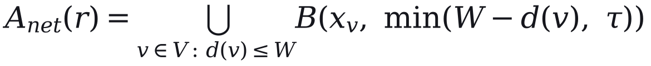 | Defines the catchment exactly; without it the method cannot be repeated. | a02_network_catchments.py.
37 | where B(x, δ) is the disc of radius δ centred on x; the residents of the catchment are | Defines B and introduces Eq. (2). | Same.
Eq. 2 | 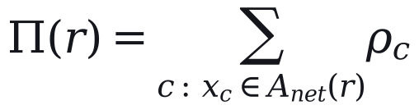 | Defines the resident count used by the index and by coverage. | a02_network_catchments.py.
38 | Neighbouring routes share residents, so per-route counts cannot be added; for network totals each cell is divided equally among the n_{c} routes that reach it: | Prevents the double counting that inflated earlier coverage figures. | a02_network_catchments.py; audit Finding 9 (June).
Eq. 3 | 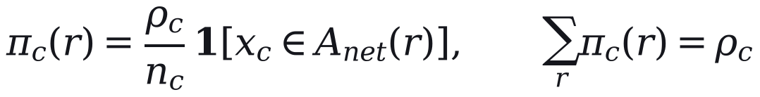 | States the sharing rule and shows that shares sum to the union. | a02_network_catchments.py.
39 | The shares then sum to the population of the combined catchment. | States the property that makes network totals valid. | Eq. (3).
40 | Walking distance is the only access measure; the quality of the walking environment, which also affects willingness to walk (Bivina et al., 2019), is not modelled. | A limitation of the catchment, stated where the method is defined. | references.bib bivina2019influence (cited in the professor's 2023 and 2025 papers).
41 | Section 5 reports how far network and straight-line catchments differ across these settings. | Points to the result without reporting it here. | a08a_catchment_grid.py, a02 tau sweep.
Considered and left out
Item | Reason
Citation of the Transit Capacity and Quality of Service Manual for the 400 m distance | The page has not been checked by anyone on the project; the value is presented as a tested setting instead.
The claim that Eq. (1) gives a lower bound on the straight-line error | Untrue at other settings (the measured gap ranges from 28.7% to 52.8%).

4.4 Weighted opportunity accessibility
No. | Sentence | Why it is there | Evidence
42 | To capture what a route connects people to, destinations were counted as cumulative opportunities (Geurs and van Wee, 2004). | Purpose first, then the named measure from the accessibility literature. | references.bib geurs2004accessibility.
43 | A point of interest is counted when it lies within 250 m of walking from the nearest stop of route r, a shorter distance than for residents; the plan itself used a 250 m straight-line buffer. | Gives the exact rule and records that it differs from the plan's own. | analysis/a03_index_weights.py (POI_BUDGET_M); engine POI_BUFFER_M.
44 | With d_{q}(r) the walking distance from point q to route r, | Defines the symbol in Eq. (4). | a03_index_weights.py.
Eq. 4 | 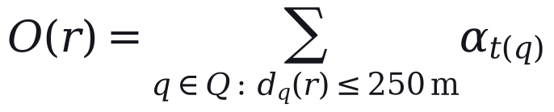 | Defines the destination score. | a03_index_weights.py.
45 | where t(q) is the tier of point q, with α = 1.00 for high, 0.40 for medium and 0.60 for seasonal points. | Gives the weights so the score can be recomputed. | a03_index_weights.py TIER_WEIGHT; engine lines 225-232.
46 | Tiers come from OpenStreetMap tags and 67 name rules for known landmarks, and they are coarse: every mapped place of worship is in the top tier, accounting for 547 of its 1,030 points. | Names the weakness specifically so a reviewer does not find it first. | E:\kash\extract_pois_kashmir.py (NAME_OVERRIDES, 67 entries; place_of_worship mapped to tier 1); data/raw/pois.csv.
47 | Visitors do not appear in a residential population surface, so the 8 active routes flagged as tourist corridors, the set T, receive a multiplier: | Justifies the multiplier before giving it. | Plan file Tourist_Corridor (8 active).
Eq. 5 |  | States the multiplier exactly. | Engine TOURIST_POPULATION_MULTIPLIER.
48 | The weights, the tier rules and μ are our assumptions, and no expert-elicited weights were obtained. | Declares the assumption plainly, which reviewers penalise less than hidden judgement. | PARAMETERS_AND_DEFENSIBILITY.md group A.
49 | In the plan, μ multiplied the resident count of the 8 routes and raised their index; it did not enter network coverage, which uses the combined catchment. | Corrects the earlier claim that μ inflated coverage. | Engine line 1863; audit F-03-09 (confirmed).
Considered and left out
Item | Reason
The ×1.25 weight on women-oriented destinations | It applies to 12 of 2,431 points and changes no class; describing it would add an undefended number for no effect.
The one-off re-tiering check (at most 4 of 186 routes change class) | A result, and not yet in the claim ledger; it belongs in Section 5.

4.5 Composite demand index
No. | Sentence | Why it is there | Evidence
50 | Ranking routes requires one score combining residents and destinations. | Purpose of the subsection. | None needed.
51 | Both measures were divided by route length, so long routes are not favoured for length alone, population density was capped at its 95th percentile to limit a few very dense routes, and each was rescaled across active routes, | Gives each transformation with its reason. | Engine POP_CAP_PERCENTILE 95; a03_index_weights.py pop_score, poi_score.
Eq. 6 | 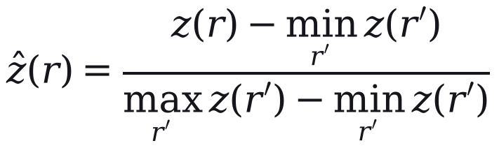 | Defines the rescaling. | common.py minmax.
52 | and combined with weight β on residents (OECD and European Commission, Joint Research Centre, 2008): | Introduces Eq. (7) with the standard reference for composite indicators. | references.bib oecd2008handbook.
Eq. 7 |  | Defines the index. | Engine CDI_POP_WEIGHT 0.50.
53 | Here ẑ_{Π} and ẑ_{O} are the rescaled values of Π(r)/ℓ(r) and O*(r)/ℓ(r). | Links Eq. (7) to Eqs. (2) and (5). | a03_index_weights.py.
54 | The two components are strongly correlated (Pearson 0.88 with straight-line and 0.89 with network catchments), so the composite adds little to either alone. | The brief asks whether the composite does any work; this answers it honestly. | a03_index_weights.json pearson_r 0.8779 (euclid), 0.8922 (net).
55 | With two components, principal-component weights (Jolliffe, 2002) reduce to equal weights, so we compare equal weights with Shannon-entropy weights (Shannon, 1948; Zou et al., 2006) and a sweep of β (Section 4.9). | Names the alternative weightings and why only two are distinct. | a03_index_weights.py distinct_weightings.
56 | The index indicates where demand is likely to be and does not measure it; observed ridership reaches the plan only through the e-bus operator's totals, at five points: | Prevents the reader from reading the index as demand, and announces the list. | Engine code paths listed below.
57 | The 30 e-bus routes are kept as they are and never merged (Section 4.6). | Entry point 1. | Engine inject_cmp_trunk_routes.
58 | They run every 15 minutes, the operator's headway, and sit in the top tier whatever their index (Section 4.7). | Entry point 2. | Engine SSCL_TRUNK_HEADWAY_MIN; CMP lock in step 5.
59 | Their fleet is the larger of the computed fleet and the operator's deployed fleet (Section 4.8). | Entry point 3. | Engine step 9 floor; Eq. (14).
60 | The urban bus share and the scale of the ridership estimate in Eq. (8) are both set from the operator's totals. | Entry point 4. | E:\kash\cross_evaluate.py lines 53-66 (mode share backed out of e-bus totals); engine lines 540-547 (scale).
61 | On the 67 rural routes outside the e-bus network, a low estimated load can lengthen the headway (Section 4.7). | Entry point 5. | Engine apply_regional_demand_headway.
62 | The ridership estimate, used only as a plausibility check, is | Introduces Eq. (8) and limits its role. | None needed.
Eq. 8 | 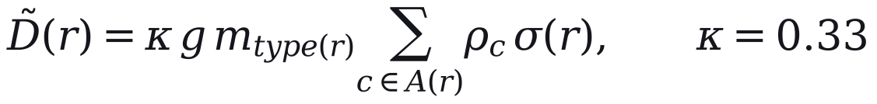 | Defines the estimate, including the trip rate the earlier draft omitted. | Engine lines 518-547.
63 | where g = 1.6 trips per person per day is assumed, m is the bus share of trips by route type, and σ(r) divides a corridor's residents among its routes. | Defines the remaining symbols and marks the trip rate as an assumption. | Engine PHASE4_TRIP_RATE; E:\kash\cross_evaluate.py lines 68-75 cite per-rider app data that the project does not hold.
64 | The urban share, 0.090, was backed out of the e-bus totals for an assumed served population of about 222,000; the peri-urban and regional shares, 0.072 and 0.054, are 0.8 and 0.6 of it by assumption. | Says where each share comes from, so the reader sees that only one is anchored to data. | E:\kash\cross_evaluate.py lines 53-66; engine PHASE4_MODE_SHARE_BY_TYPE comments.
65 | We fitted κ to the 11.63 million e-bus boardings of May 2025 to April 2026; because κ, g and m multiply, only their product is identified. | States what was fitted to what, and the identification limit. | data/raw/chalo_ridership.csv (11,632,326); CL-59.
66 | The method therefore needs no observed demand for the routes it plans but uses one operator's totals where they exist, and any comparison with that operator (Section 6) is circular. | The limited claim the paper can defend, stated once. | Follows from the five entry points.
Considered and left out
Item | Reason
Principal-component weights as a third weighting | With two components they equal equal weights, so they add nothing; one clause says so.

4.6 Permit consolidation
No. | Sentence | Why it is there | Evidence
67 | Where several services share a road, the network should run one. | Purpose of the subsection. | None needed.
68 | Overlap between two routes is measured on 80 m buffers S(r) of their lines: | Introduces Eq. (9) with the buffer width. | Engine OVERLAP_BUFFER_M 80.
Eq. 9 | 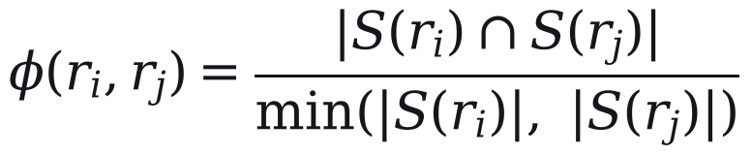 | Defines overlap exactly. | analysis/a08_sensitivity_oat.py merge_pairs.
69 | A route is absorbed into a trunk only if φ ≥ θ = 0.65, its start point lies within 2.5 km of the trunk's, and the trunk leads its group; members are never merged with one another. | States all three conditions; the third is the one earlier drafts left out. | Engine OVERLAP_THRESHOLD, OD_PROXIMITY_TOLERANCE_M; audit F-05-11.
70 | These conditions are why few distinct corridors disappear, and all three values are our assumptions; Algorithm 1 gives the procedure. | Explains the outcome and labels the values as assumptions. | CL-08.
Alg. 1 | Algorithm 1. Permit consolidation / Input: 644 candidate rows (614 permit and timetable rows, and 30 e-bus routes); overlap threshold θ. / 1. Group rows whose 80 m line buffers overlap by at least θ. / 2. In each group, make the route with the highest index the trunk, provided it is at least 5 km long and above the 30th percentile of the index. / 3. Absorb a member into the trunk only if at least θ of its buffer lies inside the trunk's and their start points are within 2.5 km; otherwise keep it as a feeder. / 4. Never absorb an e-bus route, and never merge two members with each other. / 5. Collapse rows that serve the same corridor, in either direction, into one service. / Output: 186 active routes (32 trunks and 154 feeders); 458 rows absorbed. | The procedure in a form that can be coded. | Engine step 3; CL-05 (644 rows); plan file Action_Taken counts.
71 | The plan keeps 156 of the 157 corridors. | The outcome of the rule. | CL-08.
72 | The merge rule is held fixed in the uncertainty analysis, and scenario S4 (Section 5), which lowers θ to 0.50 and merges connected groups, is the only test of the route set. | Discloses a gap in the uncertainty analysis where the method is defined. | a15_scenarios.json S4.
Considered and left out
Item | Reason
The number of overlapping pairs that remain unmerged (207) | A result for Section 5, not a description of the method.

4.7 Hierarchy and service standards
No. | Sentence | Why it is there | Evidence
73 | Routes were ranked by the index and divided by Jenks natural breaks, which make each class as uniform as possible (Jenks, 1967; Fisher, 1958). | Names the classifier and its source. | Engine step 5 (jenkspy); references.bib.
74 | The number of classes is the smallest k whose goodness of variance fit reaches 0.80, a threshold of our choosing: | States the rule and labels the threshold as an assumption. | analysis/a04_class_count.py GVF_THRESHOLD (marked 'assumption').
Eq. 10 | 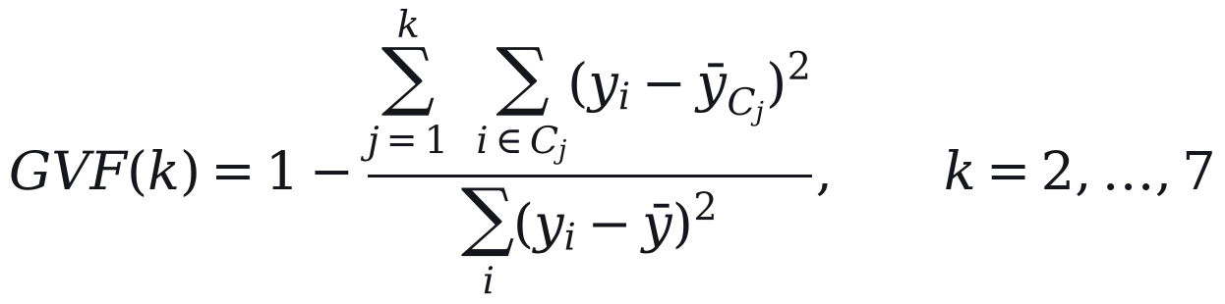 | Defines the fit statistic. | common.py goodness_of_variance_fit.
75 | Headways are policy values set independently of the index: 15 minutes on e-bus routes, 20 on other top-tier routes, 35 on the remaining urban and peri-urban routes, and 35 to 50 on rural routes, with 50 minutes the longest permitted wait. | Separates the policy values from the method so the reader does not credit the index with them. | Engine HEADWAY constants; REGIONAL_HEADWAY_BUCKETS.
76 | In the published plan, 62 of the 67 rural routes outside the e-bus network run at the 50-minute maximum and 5 at 35 minutes. | Shows that the load-based rural rule acts in practice as a fixed maximum. | Plan file: Regional_District by Headway_Min (15: 4 e-bus, 35: 5, 50: 62).
77 | Standards of this kind serve what Walker (2008) calls a coverage goal, which spreads service across an area whatever its ridership. | Gives the planning concept that justifies fixed standards without demand. | references.bib walker2008purpose.
78 | Published tiers also reflect overrides for e-bus routes, district headquarters and socially designated routes, and Section 5 compares them with tiers from the index alone; each route has one headway for the whole day. | Discloses the overrides and points to the comparison. | Engine step 5 overrides; a04_class_count.json published_vs_objective_agreement.
Considered and left out
Item | Reason
Peak, off-peak and evening headway bands (asked for in the brief) | The plan has one headway per route; describing bands would misdescribe it.
Who set which headway rule | Not yet confirmed that the paper may say so (decision A3).

4.8 Cycle time and fleet sizing
No. | Sentence | Why it is there | Evidence
79 | One-way running time is the free-flow time scaled for congestion, plus time at stops (Vuchic, 2005; Ceder, 2007): | Introduces Eq. (11) with its textbook source. | references.bib.
Eq. 11 | 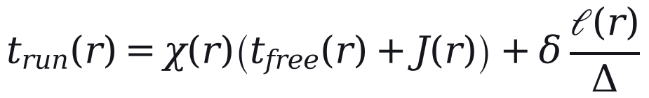 | Defines running time. | Engine compute_cycle_times; analysis/fleet_model.py.
80 | Here χ is 2.2 in the zone treated as the city core and 1.4 elsewhere; the core is bounded by a single line of latitude and includes 170 of the 186 routes. | Gives the values and discloses how crude the zone is. | Engine CITY_CORE_LAT_THRESHOLD 34.07; a08_sensitivity_oat.json congestion_disclosure (62+39+69 = 170).
81 | J(r) adds 8 minutes for a route crossing the Jhelum, and stops cost δ = 0.5 minutes at one every Δ = 500 m; these values are assumptions. | Gives the remaining constants and their status. | Engine JHELUM_BRIDGE_BOTTLENECK_MIN, STOP_PENALTY_MIN, STOP_SPACING_M.
82 | Cycle time is then capped per kilometre: | Introduces Eq. (12). | None needed.
Eq. 12 |  | Defines the cap that sets most of the fleet. | Engine CYCLE_TIME_CAP_MIN_PER_KM; TERMINAL_LAYOVER_FACTOR.
83 | Here λ = 1.10 allows for layover and the cap ω is 4.0, 2.5 and 1.5 minutes per kilometre for urban, peri-urban and regional routes. | Gives the constants. | Engine constants.
84 | The cap was meant to catch implausible values but binds on 169 of the 186 routes, where Eq. (11) therefore has no effect on the fleet. | The most important fact about the fleet model, stated where the model is defined. | CL-31.
85 | The urban cap is also faster than the median pace in driver GPS, 4.62 minutes per kilometre, so the fleet is sized a second time from observed pace (Section 4.9). | Explains why a second fleet estimate exists. | CL-32.
86 | The fleet on route r with headway h(r) is | Introduces Eq. (13). | None needed.
Eq. 13 | 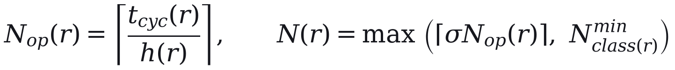 | Defines the fleet per route. | Engine step 8; fleet_model.py fleet_from_cycle.
87 | where the spare ratio σ = 1.15 is an assumption and the minimum is two vehicles on urban and peri-urban routes and one on regional routes. | Gives the constants and their status. | Engine FLEET_SPARE_RATIO, MIN_FLEET_URBAN, MIN_FLEET_REGIONAL.
88 | On the e-bus routes, the set E, the operator's deployed fleet N^{emp}(r) is a floor: | Introduces Eq. (14). | Engine step 9.
Eq. 14 |  | Gives the total and its two parts. | Plan file (non-SSCL 728, SSCL 283); CL-36.
89 | Buses are assigned to size classes (heavy, about 12 m; medium, about 9 m; light, a minibus) by route length and the classes of the rows replaced, with heavy buses at most half of a trunk's fleet: 187 heavy, 754 medium and 70 light in all. | States the class rule and totals, with the corrected meaning of 'medium'. | Engine _route_km_hpv_share, VEHICLE_CAPACITY comments; plan file HPV/MPV/LPV sums.
90 | An independent re-implementation of Eqs. (11) to (13) reproduces the published fleet on all 186 routes given the plan's headways, its five GPS-timed cycles and the e-bus floors; without the last two it matches 180 routes and gives 1,000 buses. | Shows the equations describe what the plan did. | CL-55; a09_monte_carlo_sobol.json baseline_reproduction_decomposed.
91 | Because the headways are policy values and demand responds to service (Holmgren, 2007), we also compute the fleet each route would need for its headway to reach a target peak load on Eq. (8), with demand held fixed. | Explains why a demand-sized comparison is computed. | analysis/a17_demand_sized_fleet.py; references.bib holmgren2007meta.
Considered and left out
Item | Reason
GPS evidence that the city-core multiplier and the 10% layover are too low (core 1.39 times slower; median turnaround 24 minutes) | Results, not method; they belong in Sections 5 and 6.
The 777-bus fleet today and the comparison with the plan | A result for Section 5.

4.9 Sensitivity and uncertainty
No. | Sentence | Why it is there | Evidence
92 | Most values above are assumptions, so we test whether the tiers and the fleet would change if they were different. | Purpose of the subsection. | None needed.
93 | A one-at-a-time sweep varies each parameter over its tested range with the others fixed. | First method. | analysis/a08_sensitivity_oat.py; common.py PARAMETERS.
94 | A Monte Carlo analysis then draws twelve inputs together 5,000 times, and Sobol' first-order and total-order indices (Sobol', 2001; Saltelli et al., 2008, 2010), from a Saltelli design of 1,024 base samples (14,336 evaluations), apportion the variance of each output among them. | Second and third methods, with design sizes for replication. | a09_monte_carlo_sobol.json (n_mc 5000, n_sobol_base 1024, n_sobol_evals 14336; 12 inputs).
95 | Catchment parameters are evaluated on a grid of walking budgets from 300 to 800 m and stop spacings from 150 to 400 m. | The catchment grid, computed separately because it needs the walking network. | analysis/a08a_catchment_grid.py.
96 | Because the cap of Eq. (12) hides the running-time parameters on most routes, the fleet is computed under two regimes: regime A is the plan as specified. | Reason for two regimes. | CL-31.
97 | In regime B, urban and peri-urban routes outside the e-bus network take their cycle time from the one-way pace observed in driver GPS on 16 corridors around Srinagar: five routes are measured directly and 84 take the pooled pace, while the 30 e-bus and 67 regional routes keep their modelled cycles because no pace was observed for them. | Defines regime B exactly and says which routes it leaves unchanged. | a09_monte_carlo_sobol.json evidence_split (5 measured, 84 imputed: 54 urban, 30 peri-urban).
98 | Regime B is computed from overall pace and, separately, from moving pace plus modelled dwell. | The two variants, so readers know the range is method-dependent. | a09 regime_definitions (B_effective, B_moving).
99 | We report medians and 5th to 95th percentile ranges of the draws. | What is reported. | a09 interval_definition.
100 | These depend on the input distributions we chose, are not confidence intervals, and exclude uncertainty in the route set because the merge rule is not sampled. | Prevents the ranges being read as confidence intervals or as covering the route set. | a09 interval_definition; parameters_not_sampled.
101 | The analysis tests whether decisions survive plausible changes in parameters and speed; it is not a check against demand. | States the limit of the claim. | Follows from the design.
102 | All analyses were run from frozen inputs in Python 3.14 with a fixed random seed (20260823), using SALib 1.5.2 for the Sobol' design and jenkspy 0.4.1 for natural breaks; package versions are pinned with the analysis code. | Software and versions, which methods sections require for replication. | requirements.txt; common.py RANDOM_SEED; installed versions checked 16 October 2026.
Considered and left out
Item | Reason
The ranges themselves (fleet 989 to 1,058 and 1,130 to 1,266) | Results; they belong in Section 5.
Statement that the code is released with the paper | The public repository has not been rebuilt, and during review it must be an anonymous mirror.

