4. Methodology

4.1 Overview
Route planning usually starts from observed travel, but Kashmir Division has no origin-destination survey, fare-card records or passenger counts for its private and state-run buses; its only electronic ticketing is on the Srinagar Smart City e-bus service. The method starts instead from the services already licensed and timetabled and returns a network in which every route has a service tier, a headway and a fleet.
It has four stages (Fig. 4): records to corridors (Sections 4.2 and 4.3), what each route reaches (4.4 and 4.5), merging and ranking (4.5 to 4.7), and headways and fleets (4.7 and 4.8). Sections 4.9 to 4.11 then describe where the e-bus operator's figures enter, the changes made to the plan before it was published, and how its decisions were tested.
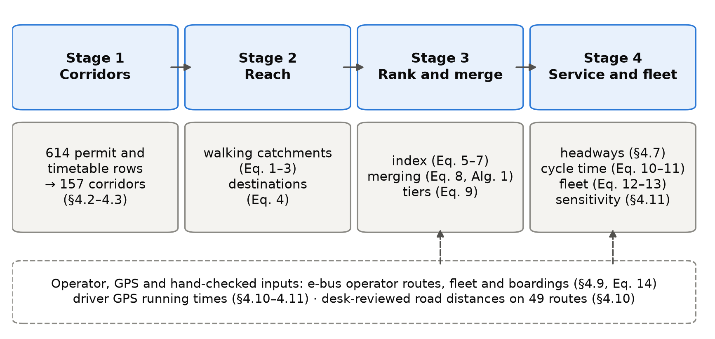
Figure 4. The four stages of the method with the equations that implement them. The dashed box lists the inputs that come from the e-bus operator, from driver GPS or from a desk review rather than from open data.

4.2 Data
Table 4.1 lists the inputs; the existing services enter as 614 rows. The 445 private permits come from the Srinagar Regional Transport Office, whose register is far more complete than those of the other nine Kashmir offices: 453 of its 1,259 rows name both ends of a route, against 133 of 1,742 elsewhere. Of the office's 548 heavy-bus permits, 544 record no route, so the private permits in the input are almost all for minibuses. The other 169 rows are scheduled services of the Jammu and Kashmir Road Transport Corporation, typed in from a scanned timetable. Each row names an origin, a destination and a vehicle category, and 73% also list intermediate places. Permits were used whether or not they were still in force, so the input describes the network as it has been permitted over time; in June 2026 only 96 of the 453 route-bearing Srinagar permits were valid.
Table 4.1. Inputs to the method.
Input | Source and date | Use
Private stage-carriage permits, 445 rows | Srinagar Regional Transport Office register; not open | Existing route set
Scheduled services, 169 rows | Jammu and Kashmir Road Transport Corporation, Kashmir Division timetable, transcribed by hand; not open | Existing route set
E-bus routes, fleet and boardings: 30 routes, 98 buses, 11,632,326 boardings | Srinagar Smart City operator, May 2025 to April 2026; not open | Section 4.9
Residents per 100 m cell | WorldPop constrained estimate, release R2025A (alpha) | Catchments, coverage
Walking network, 2,431 points of interest, district boundaries | OpenStreetMap extract of 6 January 2026 | Catchments, destinations, study region
Road distance and free-flow time | OSRM routing engine on the same extract | Cycle time
Bus positions: 2,526 service runs by 157 driver accounts | Driver smartphone application, 6 February to 29 June 2026; not open | Sections 4.10 and 4.11

Running times come from a driver smartphone application that records positions about every 5 seconds; its sessions were split into service runs, map-matched with OSRM and grouped into corridors by their end points. The runs are mostly in and around Srinagar and carry no information on passengers, so they are used only for running time.
The population surface, an alpha release used as published, totals 95.6% of the 2011 Census count, but individual districts differ from the Census by up to 29%. Of the 2,431 points of interest, 65% lie in Srinagar district, which partly reflects how thoroughly each area has been mapped.
The study region Ω is the union of the ten district boundaries. Raster cell c, centred at x_{c}, holds ρ_{c} residents, and the region holds 6,584,762, the denominator of every coverage share in the paper. G = (V, E) is the walking network with edges weighted by length, and route r is a line of length ℓ(r). The open sources are WorldPop (Stevens et al., 2015; Tatem, 2017), OpenStreetMap (OpenStreetMap contributors, 2024) and OSRM (Luxen and Vetter, 2011), which was built on the same map extract as the walking network.

4.3 From permit rows to corridors
Place names were geocoded with OpenStreetMap's Nominatim service within the district named in each record; names it could not place came from a gazetteer of 103 entries built from other geocoders and hand-placed points. In it, 37 villages that no source could locate sit at their district's centre, so routes ending there have approximate distances and catchments.
A permit licenses a vehicle, so several rows often describe the same route. Rows whose two end points match to within 11 m, in either direction, were treated as one corridor, and on this rule the 614 rows describe 157 corridors. Most corridors have one row and the busiest, Hazratbal to Lal Ded, has 42, so a reduction in route numbers depends on the unit counted; Section 5 states it each time.

4.4 Walking catchments
A route serves the people who can walk to it. Many coverage measures use a straight-line buffer (Murray, 2001), which counts people across rivers, lakes and walls as served; the resulting error has been measured in several cities (Gutierrez and Garcia-Palomares, 2008; Biba et al., 2010; El-Geneidy et al., 2014). Srinagar is divided by the Jhelum and its lakes, so catchments were measured on the walking network instead.
Notional stops were placed every 250 m along each route and attached to the nearest network node, at a median distance of 11 m. A shortest-path search from all stops gives each node v its walking distance d(v) to the nearest stop. With a walking budget W = 400 m and an allowance τ = 100 m, one raster cell, for the last stretch off the network, the catchment of route r is
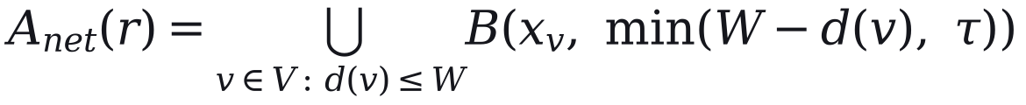 | (1)
where B(x, δ) is the disc of radius δ centred on x. Its residents are
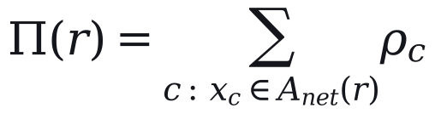 | (2)
Routes that run side by side share residents, so their counts cannot be added. For network totals each cell is split equally among the n_{c} routes whose catchments contain it,
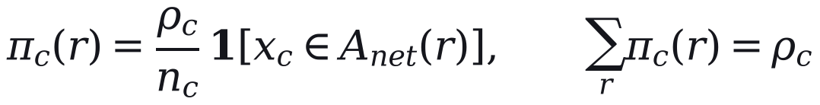 | (3)
so that the shares add up to the population of the combined catchment. The budget W is varied from 300 to 800 m in Section 4.11. Walking distance is the only access measure; the quality of the walking environment, which also affects willingness to walk (Bivina et al., 2019), is not modelled.

4.5 Destinations and the composite index
Destinations show what a route connects residents to. They were counted as cumulative opportunities (Geurs and van Wee, 2004): point q counts towards route r when its walking distance to the nearest stop, d_{q}(r), is at most 250 m, with the weight α of its tier t(q),
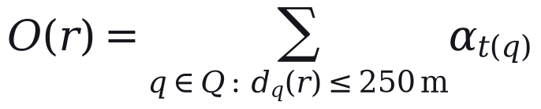 | (4)
Tiers were assigned from OpenStreetMap tags and 67 name rules for known landmarks, with α = 1.00 for major destinations (1,030 points), 0.40 for others (1,080) and 0.60 for seasonal visitor sites (321). The tiers are coarse: every mapped place of worship is in the top tier, accounting for 547 of its points. The weights and tier rules are our assumptions; no weights were elicited from experts. The plan itself measured the 250 m in a straight line.
Because a residential surface does not count visitors, the plan raised the resident count of the eight tourist routes, the set T, by a factor μ:
(5)
It changes their index but not network coverage.
For a single ranking, both measures were divided by route length so that long routes do not score higher for length alone, density was capped at its 95th percentile so that a few very dense routes do not compress the rest, and each was rescaled across routes,
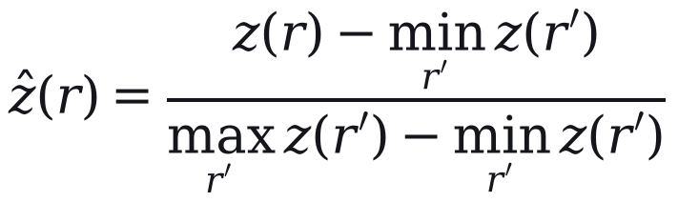 | (6)
and the rescaled values were combined with weight β on residents (OECD and European Commission, Joint Research Centre, 2008):
(7)
Here ẑ_{Π} and ẑ_{O} are the rescaled values of Π*(r)/ℓ(r) and O(r)/ℓ(r). The two components are strongly correlated (Pearson's r = 0.89 with network catchments), so the index is close to a ranking by population density with a destination adjustment. Principal-component weights (Jolliffe, 2002) equal the equal weights when there are two components, so Section 5 compares equal weights with entropy weights (Shannon, 1948; Zou et al., 2006) and with β from 0.2 to 0.8. The index indicates where demand is likely to be; it does not measure demand.

4.6 Merging overlapping routes
Where several services share a road, the network should run one of them. Overlap between two routes is measured on 80 m buffers S(r) around their lines:
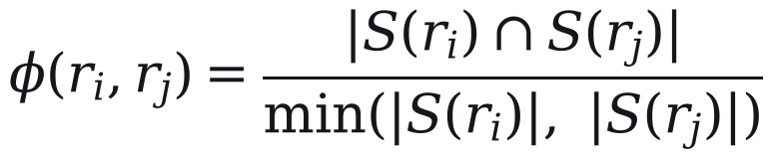 | (8)
A trunk is the highest-ranked route of its overlap group, and a member joins it only when φ ≥ θ = 0.65 and their start points lie within 2.5 km; members are never merged with each other and e-bus routes are never absorbed (Algorithm 1). The buffer, θ and the 2.5 km tolerance are our assumptions.
Algorithm 1. Merging overlapping routes
Input: 644 candidate routes (614 permit and timetable rows and 30 e-bus routes); threshold θ.
1. Group routes whose 80 m buffers overlap by at least θ.
2. In each group, take the route with the highest index as trunk if it is at least 5 km long and above the 30th percentile of the index.
3. Absorb a member into the trunk if φ ≥ θ and the two start points are within 2.5 km; otherwise keep the member as a feeder.
4. Never absorb an e-bus route, and never merge two members with each other.
5. Collapse routes on the same corridor, in either direction, into one service.
Output: 186 active routes (32 trunks and 154 feeders); 458 routes absorbed.
The rule is conservative: the 186 active routes keep 156 of the 157 corridors. The merge rule is not sampled in the uncertainty analysis; scenario S4 in Section 5, which lowers θ to 0.50 and merges connected groups, is its only test.

4.7 Service tiers and headways
Each route is typed by length as urban (under 15 km), peri-urban (15 to 40 km) or regional (over 40 km), unless its permit category indicates otherwise. Active routes were divided into tiers by Jenks natural breaks on the index, which make each tier as internally uniform as possible (Fisher, 1958; Jenks, 1967). The goodness of variance fit measures how well k tiers describe the index values y_{i}:
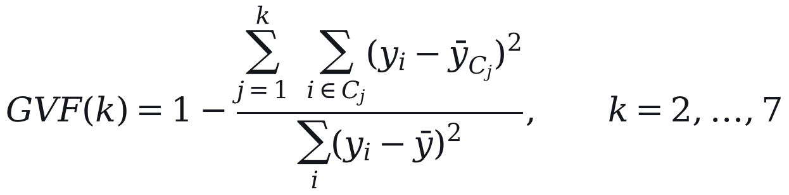 | (9)
The plan uses three tiers, which give a fit of 0.90 against 0.79 for two; three is thus the smallest number of tiers above 0.80, a threshold of our choosing and not a published standard. Published tiers carry three overrides: e-bus routes are always in the top tier, routes within 250 m of 11 listed social destinations (four migrant townships and seven hospitals) rise from the lowest tier to the middle one, and a route lying close to a tier break, within 5% of the gap between the two breaks, can move one tier according to its road role.
Headways are service standards, set independently of the index. E-bus routes run every 15 minutes, the operator's headway, other top-tier routes every 20 minutes and all other urban and peri-urban routes every 35 minutes. On regional routes outside the e-bus network, the headway starts at 35 minutes and, when the estimated load of Section 4.9 is below a target of 55%, is lengthened in proportion and rounded to 40, 45 or 50 minutes. In the published plan, 62 of these 67 routes run at 50 minutes and 5 at 35, so the rule acts in practice as a 50-minute maximum wait. Standards of this kind pursue what Walker (2008) calls a coverage goal, spreading service across an area whatever its ridership. Each route has one headway for the whole day.

4.8 Cycle time and fleet
One-way running time is the free-flow road time, scaled for congestion, plus time lost at stops (Vuchic, 2005; Ceder, 2007):
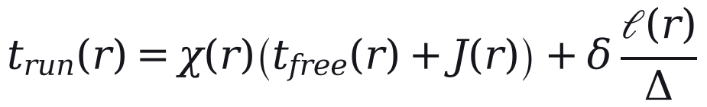 | (10)
Here χ(r) is 2.2 for routes in the zone treated as the city core and 1.4 elsewhere; the core is bounded by a single line of latitude and contains 170 of the 186 routes. J(r) adds 8 minutes to routes that cross the Jhelum, and each stop costs δ = 0.5 minutes at a spacing of Δ = 500 m. These values are assumptions. Cycle time is the round trip with layover, capped per kilometre:
(11)
Here λ = 1.10 allows 10% of running time for layover, and ω is 4.0, 2.5 and 1.5 minutes per kilometre on urban, peri-urban and regional routes. The cap was meant to catch implausible values, but it binds on 169 of the 186 routes, and on those Eq. (10) has no effect on the fleet. The urban cap is also faster than the median pace observed in driver GPS, 4.62 minutes per kilometre, which is why Section 4.11 sizes the fleet a second time from observed pace. With headway h(r), the fleet on route r is
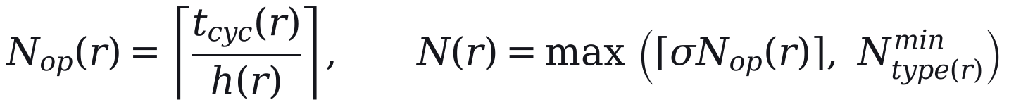 | (12)
where the spare allowance σ = 1.15 is an assumption and N^{min} is two buses on urban and peri-urban routes and one on regional routes. On the e-bus routes, the set E, the operator's deployed fleet N^{emp}(r) is a floor, and the network total is
(13)
Of the buses, 187 are heavy (about 12 m), 754 medium (about 9 m) and 70 light (minibus): routes under 12 km get no heavy buses, heavy buses are at most half the fleet of longer routes, and e-bus routes keep the operator's split. An independent re-implementation of Eqs. (10) to (12) reproduces the published fleet on all 186 routes when given the plan's headways, its five GPS-timed cycle times (Section 4.10) and the e-bus floors.

4.9 Where the e-bus operator's figures enter
The method needs no observed demand for the routes it plans, but it uses the e-bus operator's figures where they exist, at five points:
- The 30 e-bus routes are added as they run and are never absorbed (Section 4.6).
- They sit in the top tier and run every 15 minutes, whatever their index (Section 4.7).
- Their fleet is at least the operator's deployed fleet (Eq. 13).
- The urban bus share and the scale of the ridership estimate below are set from the operator's boardings.
- On the 67 regional routes outside the e-bus network, that estimate can lengthen the headway (Section 4.7).
The estimate sets these regional headways and the load factors and demand-sized fleet of Section 5, but not the route set or the tiers. For route r it is
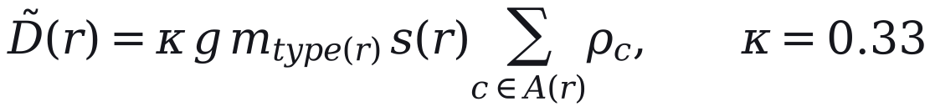 | (14)
where g = 1.6 trips per person per day is assumed, m is the bus share of trips for the route's type, A(r) is the route's catchment and s(r) is the share of its corridor's residents assigned to it. The urban share, 0.090, was backed out of the e-bus boardings for an assumed served population of about 222,000; the peri-urban and regional shares, 0.072 and 0.054, are 0.8 and 0.6 times it by assumption. The scale κ was fitted so that the estimate reproduces the operator's 11.63 million boardings of May 2025 to April 2026. Because κ, g and m multiply, only their product is identified, and because the estimate is fitted on the e-bus routes, any comparison with the operator's data (Section 6) is circular. The demand-sized fleet in Section 5 holds this estimate fixed, although demand responds to the service offered (Holmgren, 2007).

4.10 Changes made before publication
The plan evaluated in this paper differs from the model's output, because three changes were made before it was published.
First, all 186 routes were reviewed at a desk with an AI research assistant, which compared each modelled road distance with distances published online and recorded the websites consulted, though not the pages. It passed 93 routes, flagged 88 for review and failed 5. Where the two differed by more than 15% and the place names could be confirmed, the midpoint of the published range replaced the modelled distance, free-flow time was scaled in proportion and the fleet recomputed with Eqs. (10) to (12). Six routes were corrected individually, four of them by moving a misplaced end point and re-routing, and 43 by the rule. The 49 corrected routes, 43 of which became shorter, need 207 buses instead of 247. The other 44 flagged routes were left unchanged, mostly because the difference was within tolerance or the names could not be confirmed. None of the replacement distances was measured on the ground.
Second, five routes were matched to GPS corridors with between 40 and 211 recorded runs each, and their cycle times were rebuilt from the measured moving speed, keeping the model's stop and junction allowances and lifting the cap. This raised the network fleet from 1,004 to 1,011 buses, and because these routes were fitted to the GPS they are kept out of the out-of-sample test in Section 6.
Third, the headway standards of Section 4.7 were not fixed in advance; they were revised over about fifteen versions of the plan as it was reviewed, and across those versions the network fleet ranged from 855 to 1,144 buses.

4.11 Sensitivity and uncertainty
Most of the values above are assumptions, so we test whether the tiers and the fleet would change if they were different. A one-at-a-time sweep varies each parameter over a range with the others held fixed. A Monte Carlo analysis then draws twelve inputs together 5,000 times, and Sobol' first-order and total-order indices (Sobol', 2001; Saltelli et al., 2008, 2010), estimated from a Saltelli design with 1,024 base samples (14,336 model runs), divide the variance of each output among the inputs. Catchment settings are evaluated separately on a grid of walking budgets from 300 to 800 m and stop spacings from 150 to 400 m.
Because the cap of Eq. (11) hides the running-time parameters on most routes, the fleet is computed in two regimes. Regime A is the plan as specified. In regime B, urban and peri-urban routes outside the e-bus network take their cycle time from the pace observed on 16 GPS corridors around Srinagar, 7 urban and 9 peri-urban. The 5 routes of Section 4.10 use their own corridors, and 84 others take the median pace of their type. The 30 e-bus routes and 67 regional routes keep their modelled cycle times, because no usable pace was observed for them. Regime B is computed twice, once from overall pace and once from moving pace plus modelled stop time.
We report medians and 5th to 95th percentile ranges of the draws. These ranges depend on the input distributions we chose; they are not confidence intervals, and they leave out uncertainty in the route set because the merge rule is not sampled. The analysis tests whether the plan's decisions survive plausible changes in parameters and speeds; it does not test the plan against demand. All analyses run from frozen inputs in Python 3.14 with a fixed random seed (20260823), using SALib 1.5.2 for the Sobol' design and jenkspy 0.4.1 for natural breaks.

References cited in this section
Biba, Curtin & Manca (2010). A new method for determining the population with walking access to transit. International Journal of Geographical Information Science, 24(3), 347–364. https://doi.org/10.1080/13658810802646679
Bivina, Gupta & Parida (2019). Influence of microscale environmental factors on perceived walk accessibility to metro stations. Transportation Research Part D: Transport and Environment, 67, 142–155. https://doi.org/10.1016/j.trd.2018.11.007
Ceder (2007). Public Transit Planning and Operation: Theory, Modelling and Practice. CRC Press. https://doi.org/10.1201/b12853
El-Geneidy, Grimsrud, Wasfi, Tetreault & Surprenant-Legault (2014). New evidence on walking distances to transit stops: identifying redundancies and gaps using variable service areas. Transportation, 41(1), 193–210. https://doi.org/10.1007/s11116-013-9508-z
Fisher (1958). On grouping for maximum homogeneity. Journal of the American Statistical Association, 53(284), 789–798. https://doi.org/10.1080/01621459.1958.10501479
Geurs & van Wee (2004). Accessibility evaluation of land-use and transport strategies: review and research directions. Journal of Transport Geography, 12(2), 127–140. https://doi.org/10.1016/j.jtrangeo.2003.10.005
Gutierrez & Garcia-Palomares (2008). Distance-measure impacts on the calculation of transport service areas using GIS. Environment and Planning B: Planning and Design, 35(3), 480–503. https://doi.org/10.1068/b33043
Holmgren (2007). Meta-analysis of public transport demand. Transportation Research Part A: Policy and Practice, 41(10), 1021–1035. https://doi.org/10.1016/j.tra.2007.06.003
Jenks (1967). The data model concept in statistical mapping. International Yearbook of Cartography, 7, 186–190.
Jolliffe (2002). Principal Component Analysis. Springer. https://doi.org/10.1007/b98835
Luxen & Vetter (2011). Real-time routing with OpenStreetMap data. Proceedings of the 19th ACM SIGSPATIAL International Conference on Advances in Geographic Information Systems (GIS '11), 513–516. https://doi.org/10.1145/2093973.2094062
Murray (2001). Strategic analysis of public transport coverage. Socio-Economic Planning Sciences, 35(3), 175–188. https://doi.org/10.1016/S0038-0121(01)00004-0
OECD & European Commission, Joint Research Centre (2008). Handbook on Constructing Composite Indicators: Methodology and User Guide. OECD Publishing. https://doi.org/10.1787/9789264043466-en
OpenStreetMap contributors (2024). OpenStreetMap. https://www.openstreetmap.org.
Saltelli, Annoni, Azzini, Campolongo, Ratto & Tarantola (2010). Variance based sensitivity analysis of model output. Design and estimator for the total sensitivity index. Computer Physics Communications, 181(2), 259–270. https://doi.org/10.1016/j.cpc.2009.09.018
Saltelli, Ratto, Andres, Campolongo, Cariboni, Gatelli, Saisana & Tarantola (2008). Global Sensitivity Analysis: The Primer. John Wiley & Sons. https://doi.org/10.1002/9780470725184
Shannon (1948). A mathematical theory of communication. Bell System Technical Journal, 27(3), 379–423. https://doi.org/10.1002/j.1538-7305.1948.tb01338.x
Sobol' (2001). Global sensitivity indices for nonlinear mathematical models and their Monte Carlo estimates. Mathematics and Computers in Simulation, 55(1–3), 271–280. https://doi.org/10.1016/S0378-4754(00)00270-6
Stevens, Gaughan, Linard & Tatem (2015). Disaggregating census data for population mapping using random forests with remotely-sensed and ancillary data. PLOS ONE, 10(2), e0107042. https://doi.org/10.1371/journal.pone.0107042
Tatem (2017). WorldPop, open data for spatial demography. Scientific Data, 4, 170004. https://doi.org/10.1038/sdata.2017.4
Vuchic (2005). Urban Transit: Operations, Planning, and Economics. John Wiley & Sons.
Walker (2008). Purpose-driven public transport: creating a clear conversation about public transport goals. Journal of Transport Geography, 16(6), 436–442. https://doi.org/10.1016/j.jtrangeo.2008.06.005
Zou, Yun & Sun (2006). Entropy method for determination of weight of evaluating indicators in fuzzy synthetic evaluation for water quality assessment. Journal of Environmental Sciences, 18(5), 1020–1023. https://doi.org/10.1016/S1001-0742(06)60032-6

