4. Methodology

4.1 Framework overview
No origin-destination survey or e ticketing data exist for the private and state-run bus services of Kashmir Division; the only electronic ticketing is on the Srinagar Smart City e-bus service. The framework takes the existing services as given and returns a network in which every route has a service tier, a headway and a fleet.
It has four stages, shown in Fig. 4: checking the inputs, measuring what each route reaches on foot, merging and ranking routes, and sizing fleets and testing their sensitivity. The open inputs are the WorldPop constrained population surface at 100 m, release R2025A (Tatem, 2017; Stevens et al., 2015), OpenStreetMap (OpenStreetMap contributors, 2024), and the OSRM routing engine for road distance and free-flow time (Luxen and Vetter, 2011). The walking network and the routing engine were both built from the same OpenStreetMap extract, dated 6 January 2026. Three inputs are not open data: the regulator's permit register, the state transport corporation's timetable for Kashmir Division, and the ridership totals of the e-bus service; Section 4.5 lists where those totals enter.
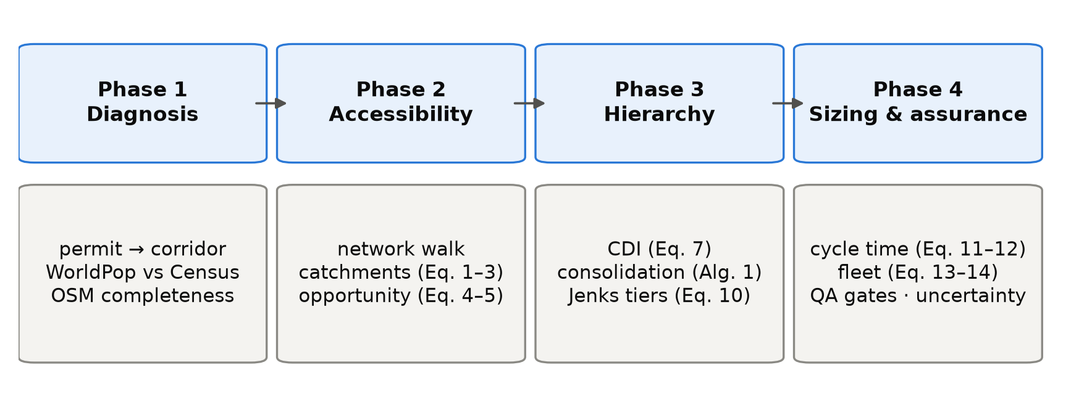
Figure 4. The four-phase method and the equations that implement each phase.
The study region Ω is the union of the ten districts of Kashmir Division. The population surface assigns ρ_{c} residents to raster cell c, whose centre is x_{c}, and the region holds 6,584,762 residents, the denominator of every coverage share in the paper. G = (V, E) is the OpenStreetMap walking network with edges weighted by length, and a route r is a line of length ℓ(r).

4.2 Data conditioning and network construction
The existing services enter as 614 rows from two sources. Of these, 445 are private stage-carriage permits from the register of the Srinagar Regional Transport Office, which records far more routes than the other Kashmir offices: 453 of its 1,259 rows name both ends of a route, against 133 of 1,742 rows in the other nine offices, which were not used. Almost all of them are minibus permits, because 544 of the office's 548 heavy-bus permits record no route. The other 169 rows are scheduled services of the Jammu and Kashmir Road Transport Corporation, transcribed by hand from its scanned Kashmir Division timetable, and they carry the network beyond Srinagar. Each row names an origin, a destination and a vehicle category, and about three quarters also list intermediate places. Permits were included whether or not they were still in force, so the input describes the network as it has been permitted over time; in June 2026 only 96 of the 453 route-bearing Srinagar permits were valid.
Because a permit licenses a vehicle, several rows often describe the same route. Matching the two ends of each row to within 11 m, ignoring direction, reduces the 614 rows into 157 distinct corridors. Most corridors carry a single row, and the busiest, Hazratbal to Lal Ded, carries 42 permits, so every reduction reported later states its unit (Section 5).
Place names were geocoded against a gazetteer of 103 names; 37 villages that no geocoder could find were placed at the centre of their district, so distances and catchments for routes ending there are approximate. The population surface, an alpha release, was used as published; its ten-district total is 95.6% of the 2011 Census figure, but district totals differ from the Census by up to 29%, so district-level shares carry an error of that order. Two thirds of the total 2,431 points of interest lie in Srinagar district, so the destination layer partly reflects how thoroughly each place has been mapped.
The plan evaluated in this paper is not the direct output of the given planning model. Three adjustments were made before publication. The first was a route-by-route review of all 186 routes, which ran with an AI research assistant, which compared each modelled road distance with distances published online and recorded the websites consulted, though not the pages; 93 routes passed, 88 were marked for review and 5 failed. Where the two differed by more than 15% and the place names could be confirmed, the midpoint of the published range replaced the modelled distance, free-flow time was scaled to match, and cycle time and fleet were recomputed with the plan's formulas. Six routes were corrected individually, four of them by moving a misplaced end point and re-routing, and 43 followed the rule; together the 49 routes, 43 of which became shorter, need 207 buses instead of 247. The other 44 flagged routes were left unchanged, mostly because the difference was within tolerance or the place names could not be confirmed. None of the replacement distances was measured on the ground.
Second, the cycle times of five routes were replaced with times measured from driver GPS traces on the same corridors (Section 6), which raised the network fleet from 1,004 to 1,011 buses. Third, the headway rules described in Section 4.7 were not fixed in advance but revised about fifteen times as the plan was reviewed, and across these revisions the required fleet varied between 855 and 1,144 buses. Section 4.9 and Section 6 examine whether the plan's decisions hold under these adjustments.

4.3 Route catchment delineation
To count the residents that a route can serve, we need to know who can walk to it. Coverage measures have a long history in transit planning (Murray, 2001), and many draw a straight-line buffer around a route, which counts people beyond rivers, lakes and walls as served; the resulting error has been measured in several cities (Gutierrez and Garcia-Palomares, 2008; Biba et al., 2010; El-Geneidy et al., 2014). Srinagar is divided by the Jhelum river and its lakes, so we measured catchments on the walking network.
Notional stops were placed every 250 m along each route and attached to their nearest network node, with a median distance of 11 m. A shortest-path search from all stops at once gave each node v its walking distance d(v) to the nearest stop. With a walking budget W = 400 m, varied from 300 to 800 m in Section 4.9, and an off-network allowance τ = 100 m, the width of one raster cell, the catchment is
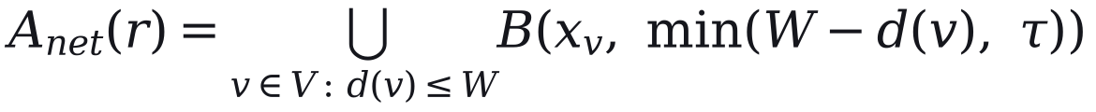 | (1)
where B(x, δ) is the disc of radius δ centred on x; the residents of the catchment are
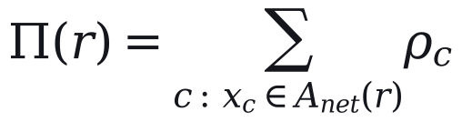 | (2)
Neighbouring routes share residents, so per-route counts cannot be added; for network totals each cell is divided equally among the n_{c} routes that reach it:
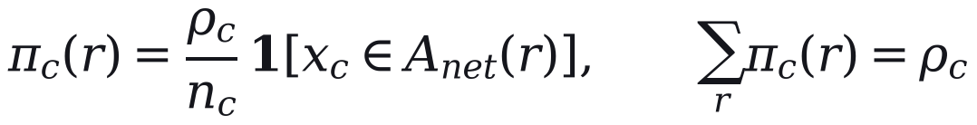 | (3)
The shares then sum to the population of the combined catchment. Walking distance is the only access measure; the quality of the walking environment, which also affects willingness to walk (Bivina et al., 2019), is not modelled. Section 5 reports how far network and straight-line catchments differ across these settings.

4.4 Weighted opportunity accessibility
To capture what a route connects people to, destinations were counted as cumulative opportunities (Geurs and van Wee, 2004). A point of interest is counted when it lies within 250 m of walking from the nearest stop of route r, a shorter distance than for residents; the plan itself used a 250 m straight-line buffer. With d_{q}(r) the walking distance from point q to route r,
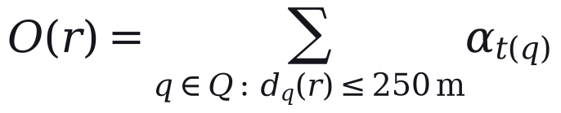 | (4)
where t(q) is the tier of point q, with α = 1.00 for high, 0.40 for medium and 0.60 for seasonal points. Tiers come from OpenStreetMap tags and 67 name rules for known landmarks, and they are coarse: every mapped place of worship is in the top tier, accounting for 547 of its 1,030 points. Visitors do not appear in a residential population surface, so the 8 active routes flagged as tourist corridors, the set T, receive a multiplier:
(5)
The weights, the tier rules and μ are our assumptions, and no expert-elicited weights were obtained. In the plan, μ multiplied the resident count of the 8 routes and raised their index; it did not enter network coverage, which uses the combined catchment.

4.5 Composite demand index
Ranking routes requires one aggregate score combining both residents and destinations. Both measures were divided by route length, so long routes are not favoured for length alone, population density was capped at its 95th percentile to limit a few very dense routes, and each was rescaled across active routes,
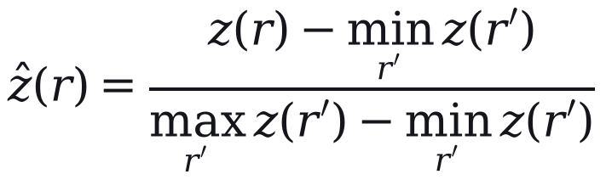 | (6)
and combined with weight β on residents (OECD and European Commission, Joint Research Centre, 2008):
(7)
Here ẑ_{Π} and ẑ_{O} are the rescaled values of Π(r)/ℓ(r) and O*(r)/ℓ(r). The two components are strongly correlated (Pearson 0.88 with straight-line and 0.89 with network catchments), so the composite adds little to either alone. With two components, principal-component weights (Jolliffe, 2002) reduce to equal weights, so we compare equal weights with Shannon-entropy weights (Shannon, 1948; Zou et al., 2006) and a sweep of β (Section 4.9).
The index indicates where demand is likely to be and does not measure it; observed ridership reaches the plan only through the e-bus operator's totals, at five points:
- The 30 e-bus routes are kept as they are and never merged (Section 4.6).
- They run every 15 minutes, the operator's headway, and sit in the top tier whatever their index (Section 4.7).
- Their fleet is the larger of the computed fleet and the operator's deployed fleet (Section 4.8).
- The urban bus share and the scale of the ridership estimate in Eq. (8) are both set from the operator's totals.
- On the 67 rural routes outside the e-bus network, a low estimated load can lengthen the headway (Section 4.7).
The ridership estimate, used only as a plausibility check, is
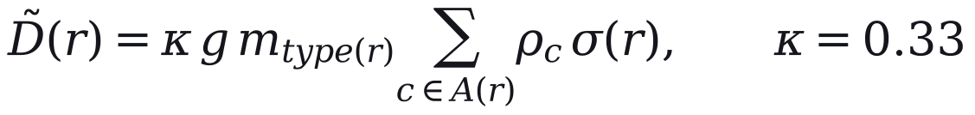 | (8)
where g = 1.6 trips per person per day is assumed, m is the bus share of trips by route type, and σ(r) divides a corridor's residents among its routes. The urban share, 0.090, was backed out of the e-bus totals for an assumed served population of about 222,000; the peri-urban and regional shares, 0.072 and 0.054, are 0.8 and 0.6 of it by assumption. We fitted κ to the 11.63 million e-bus boardings of May 2025 to April 2026; because κ, g and m multiply, only their product is identified. The method therefore needs no observed demand for the routes it plans but uses one operator's totals where they exist, and any comparison with that operator (Section 6) is circular.

4.6 Permit consolidation
Where several services share a road, the network should run one. Overlap between two routes is measured on 80 m buffers S(r) of their lines:
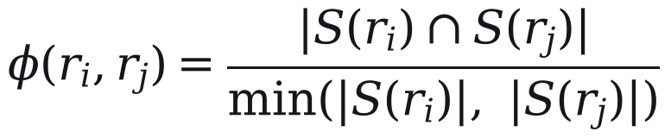 | (9)
A route is absorbed into a trunk only if φ ≥ θ = 0.65, its start point lies within 2.5 km of the trunk's, and the trunk leads its group; members are never merged with one another. These conditions are why few distinct corridors disappear, and all three values are our assumptions; Algorithm 1 gives the procedure.
Algorithm 1. Permit consolidation
Input: 644 candidate rows (614 permit and timetable rows, and 30 e-bus routes); overlap threshold θ.
1. Group rows whose 80 m line buffers overlap by at least θ.
2. In each group, make the route with the highest index the trunk, provided it is at least 5 km long and above the 30th percentile of the index.
3. Absorb a member into the trunk only if at least θ of its buffer lies inside the trunk's and their start points are within 2.5 km; otherwise keep it as a feeder.
4. Never absorb an e-bus route, and never merge two members with each other.
5. Collapse rows that serve the same corridor, in either direction, into one service.
Output: 186 active routes (32 trunks and 154 feeders); 458 rows absorbed.
The plan keeps 156 of the 157 corridors. The merge rule is held fixed in the uncertainty analysis, and scenario S4 (Section 5), which lowers θ to 0.50 and merges connected groups, is the only test of the route set.

4.7 Hierarchy and service standards
Routes were ranked by the index and divided by Jenks natural breaks, which make each class as uniform as possible (Jenks, 1967; Fisher, 1958). The number of classes is the smallest k whose goodness of variance fit reaches 0.80, a threshold of our choosing:
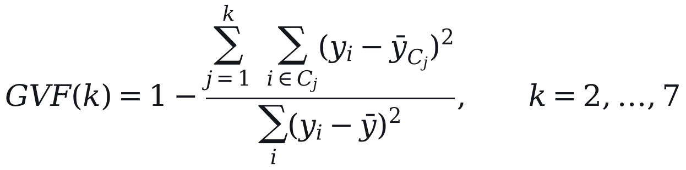 | (10)
Headways are policy values set independently of the index: 15 minutes on e-bus routes, 20 on other top-tier routes, 35 on the remaining urban and peri-urban routes, and 35 to 50 on rural routes, with 50 minutes the longest permitted wait. In the published plan, 62 of the 67 rural routes outside the e-bus network run at the 50-minute maximum and 5 at 35 minutes. Standards of this kind serve what Walker (2008) calls a coverage goal, which spreads service across an area whatever its ridership. Published tiers also reflect overrides for e-bus routes, district headquarters and socially designated routes, and Section 5 compares them with tiers from the index alone; each route has one headway for the whole day.

4.8 Cycle time and fleet sizing
One-way running time is the free-flow time scaled for congestion, plus time at stops (Vuchic, 2005; Ceder, 2007):
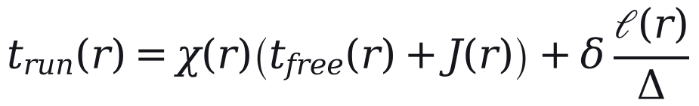 | (11)
Here χ is 2.2 in the zone treated as the city core and 1.4 elsewhere; the core is bounded by a single line of latitude and includes 170 of the 186 routes. J(r) adds 8 minutes for a route crossing the Jhelum, and stops cost δ = 0.5 minutes at one every Δ = 500 m; these values are assumptions. Cycle time is then capped per kilometre:
(12)
Here λ = 1.10 allows for layover and the cap ω is 4.0, 2.5 and 1.5 minutes per kilometre for urban, peri-urban and regional routes. The cap was meant to catch implausible values but binds on 169 of the 186 routes, where Eq. (11) therefore has no effect on the fleet. The urban cap is also faster than the median pace in driver GPS, 4.62 minutes per kilometre, so the fleet is sized a second time from observed pace (Section 4.9). The fleet on route r with headway h(r) is
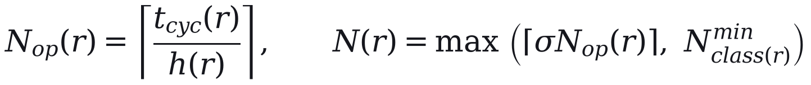 | (13)
where the spare ratio σ = 1.15 is an assumption and the minimum is two vehicles on urban and peri-urban routes and one on regional routes. On the e-bus routes, the set E, the operator's deployed fleet N^{emp}(r) is a floor:
(14)
Buses are assigned to size classes (heavy, about 12 m; medium, about 9 m; light, a minibus) by route length and the classes of the rows replaced, with heavy buses at most half of a trunk's fleet: 187 heavy, 754 medium and 70 light in all. An independent re-implementation of Eqs. (11) to (13) reproduces the published fleet on all 186 routes given the plan's headways, its five GPS-timed cycles and the e-bus floors; without the last two it matches 180 routes and gives 1,000 buses. Because the headways are policy values and demand responds to service (Holmgren, 2007), we also compute the fleet each route would need for its headway to reach a target peak load on Eq. (8), with demand held fixed.

4.9 Sensitivity and uncertainty
Most values above are assumptions, so we test whether the tiers and the fleet size would change if they were different. A one at a time sweep varies each parameter over its tested range with the others fixed. A Monte Carlo analysis then draws twelve inputs together 5,000 times, and Sobol' first-order and total-order indices (Sobol', 2001; Saltelli et al., 2008, 2010), from a Saltelli design of 1,024 base samples (14,336 evaluations), apportion the variance of each output among them. Catchment parameters are evaluated on a grid of walking budgets from 300 to 800 m and stop spacings from 150 to 400 m.
Because the cap of Eq. (12) hides the running-time parameters on most routes, the fleet is computed under two regimes: regime A is the plan as specified. In regime B, urban and peri-urban routes outside the e-bus network take their cycle time from the one-way pace observed in driver GPS on 16 corridors around Srinagar: five routes are measured directly and 84 take the pooled pace, while the 30 e-bus and 67 regional routes keep their modelled cycles because no pace was observed for them. Regime B is computed from overall pace and, separately, from moving pace plus modelled dwell.
We report medians and 5th to 95th percentile ranges of the draws. These depend on the input distributions we chose, are not confidence intervals, and exclude uncertainty in the route set because the merge rule is not sampled. The analysis tests whether decisions survive plausible changes in parameters and speed; it is not a check against demand. All analyses were run from frozen inputs in Python 3.14 with a fixed random seed (20260823), using SALib 1.5.2 for the Sobol' design and jenkspy 0.4.1 for natural breaks; package versions are pinned with the analysis code.

References cited in this section
Biba, Curtin & Manca (2010). A new method for determining the population with walking access to transit. International Journal of Geographical Information Science, 24(3), 347–364. https://doi.org/10.1080/13658810802646679
Bivina, Gupta & Parida (2019). Influence of microscale environmental factors on perceived walk accessibility to metro stations. Transportation Research Part D: Transport and Environment, 67, 142–155. https://doi.org/10.1016/j.trd.2018.11.007
Ceder (2007). Public Transit Planning and Operation: Theory, Modelling and Practice. CRC Press. https://doi.org/10.1201/b12853
El-Geneidy, Grimsrud, Wasfi, Tetreault & Surprenant-Legault (2014). New evidence on walking distances to transit stops: identifying redundancies and gaps using variable service areas. Transportation, 41(1), 193–210. https://doi.org/10.1007/s11116-013-9508-z
Fisher (1958). On grouping for maximum homogeneity. Journal of the American Statistical Association, 53(284), 789–798. https://doi.org/10.1080/01621459.1958.10501479
Geurs & van Wee (2004). Accessibility evaluation of land-use and transport strategies: review and research directions. Journal of Transport Geography, 12(2), 127–140. https://doi.org/10.1016/j.jtrangeo.2003.10.005
Gutierrez & Garcia-Palomares (2008). Distance-measure impacts on the calculation of transport service areas using GIS. Environment and Planning B: Planning and Design, 35(3), 480–503. https://doi.org/10.1068/b33043
Holmgren (2007). Meta-analysis of public transport demand. Transportation Research Part A: Policy and Practice, 41(10), 1021–1035. https://doi.org/10.1016/j.tra.2007.06.003
Jenks (1967). The data model concept in statistical mapping. International Yearbook of Cartography, 7, 186–190.
Jolliffe (2002). Principal Component Analysis. Springer. https://doi.org/10.1007/b98835
Luxen & Vetter (2011). Real-time routing with OpenStreetMap data. Proceedings of the 19th ACM SIGSPATIAL International Conference on Advances in Geographic Information Systems (GIS '11), 513–516. https://doi.org/10.1145/2093973.2094062
Murray (2001). Strategic analysis of public transport coverage. Socio-Economic Planning Sciences, 35(3), 175–188. https://doi.org/10.1016/S0038-0121(01)00004-0
OECD & European Commission, Joint Research Centre (2008). Handbook on Constructing Composite Indicators: Methodology and User Guide. OECD Publishing. https://doi.org/10.1787/9789264043466-en
OpenStreetMap contributors (2024). OpenStreetMap. https://www.openstreetmap.org.
Saltelli, Annoni, Azzini, Campolongo, Ratto & Tarantola (2010). Variance based sensitivity analysis of model output. Design and estimator for the total sensitivity index. Computer Physics Communications, 181(2), 259–270. https://doi.org/10.1016/j.cpc.2009.09.018
Saltelli, Ratto, Andres, Campolongo, Cariboni, Gatelli, Saisana & Tarantola (2008). Global Sensitivity Analysis: The Primer. John Wiley & Sons. https://doi.org/10.1002/9780470725184
Shannon (1948). A mathematical theory of communication. Bell System Technical Journal, 27(3), 379–423. https://doi.org/10.1002/j.1538-7305.1948.tb01338.x
Sobol' (2001). Global sensitivity indices for nonlinear mathematical models and their Monte Carlo estimates. Mathematics and Computers in Simulation, 55(1–3), 271–280. https://doi.org/10.1016/S0378-4754(00)00270-6
Stevens, Gaughan, Linard & Tatem (2015). Disaggregating census data for population mapping using random forests with remotely-sensed and ancillary data. PLOS ONE, 10(2), e0107042. https://doi.org/10.1371/journal.pone.0107042
Tatem (2017). WorldPop, open data for spatial demography. Scientific Data, 4, 170004. https://doi.org/10.1038/sdata.2017.4
Vuchic (2005). Urban Transit: Operations, Planning, and Economics. John Wiley & Sons.
Walker (2008). Purpose-driven public transport: creating a clear conversation about public transport goals. Journal of Transport Geography, 16(6), 436–442. https://doi.org/10.1016/j.jtrangeo.2008.06.005
Zou, Yun & Sun (2006). Entropy method for determination of weight of evaluating indicators in fuzzy synthetic evaluation for water quality assessment. Journal of Environmental Sciences, 18(5), 1020–1023. https://doi.org/10.1016/S1001-0742(06)60032-6

