Django:
High-level Python Web Framework Django is a free, open-source web framework written in Python.
It is a backend framework.

Companies Using Django
  - Instagram
  - Disqus
  - Spotify
  - YouTube

Advantages of Django:
- Loose Coupling
- Lesser Code
- Doesn’t Repeat
- Consistency
- Versatile

Work Flow:

Request from Client (Browser)
- A user sends a request by typing a URL or clicking a link.
- Example: http://127.0.0.1:8000/home/

URL Dispatcher (urls.py)
- Django checks the urls.py file to match the requested URL with a defined route.
- If found → request is passed to the corresponding view function.
- If not found → Django returns a 404 error.

View Function (views.py)
- The view processes the request.
- It may:
  - Fetch data from the Model (database).
  - Apply business logic.
  - Choose the correct Template to display.

Model (models.py)
- Models define the structure of the database (tables, fields, relationships).
- Django ORM translates Python objects ↔ database queries.
- Example: Student.objects.all() retrieves all students from the DB.

- ORM:
  - Object-Relational Mapper (It’s a bridge between Django models (Python classes) and the database (tables, rows, columns).
- Eg:
Models.py
class Student(models.Model):
name = models.CharField(max_length=100)
age = models.IntegerField()

Using ORM instead of SQL
students = Student.objects.all() // SELECT * FROM student;
student = Student.objects.get(id=1) // SELECT * FROM student WHERE id=1;
Student.objects.create(name="Alice", age=20) // INSERT INTO student ...
Template (templates/)
- Templates are HTML files with dynamic placeholders (using Django Template Language).
- The view passes data (context) into the template.
Response to Client
- Django combines the template with data → generates an HTML response.
- The response is sent back to the browser and displayed to the user.
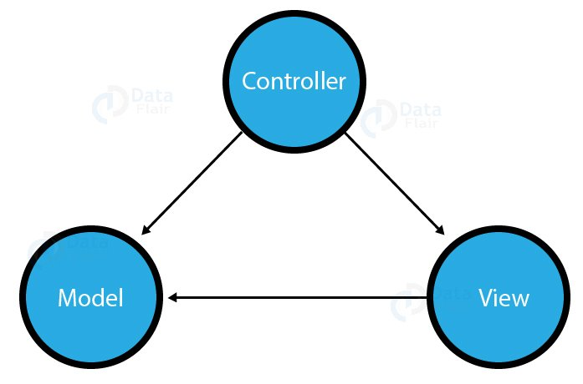
Create a virtual environment:
py -3 -m venv .venv
.venv\scripts\activate

Purpose:
- Project Isolation
- Version Control of Packages
- Prevent System-Wide Changes
Install the Django :
python -m pip install Django

Create the Django project:
django-admin startproject web_project

Create an empty database:
python manage.py migrate

Run the Django (using local host):
python manage.py runserver

Create a Django app:
python manage.py startapp hello

views.py
from django.http import HttpResponse
def home(request):
return HttpResponse("Hello, Django!")
urls.py (app)
from django.urls import path
from hello import views

urlpatterns = [
path("", views.home, name="home"),
]

urls.py (project)
from django.contrib import admin
from django.urls import include, path

urlpatterns = [
path("", include("hello.urls")),
path('admin/', admin.site.urls)
]

Output:
