Open Cart 3 Performance Test Report



14/02/2021 08:46 PM - 08:57 PM

# 1 Executive Summary

This is an example Executave Summary,

You should update this text with the details of your test.

# 2 Conclusion

This is where you should put your conclusion,

it should be based on the test results.

# 3 Test Result Summary

|  |  |  |  |  |  |  |  |  |
| --- | --- | --- | --- | --- | --- | --- | --- | --- |
| Result Name | Minimum | Average | 95%ile | Maximum | Std. Dev. | Pass | Fail | Other |
| OC3 Open Browser | 1.398 | 1.534 | None | 1.771 | 0.103 | 10 | 0 | 0 |
| OC3 Open Store Page | 0.42 | 0.823 | None | 3.838 | 1.061 | 10 | 0 | 0 |
| OC3 Open Menu Page | 0.139 | 0.356 | 0.529 | 3.235 | 0.477 | 41 | 0 | 0 |
| OC3 Open Product Page | 0.641 | 1.113 | 2.004 | 2.339 | 0.358 | 28 | 0 | 0 |
| OC3 Open Cart | 0.047 | 0.054 | 0.07 | 0.073 | 0.008 | 24 | 0 | 0 |
| OC3 Remove Item from Cart | 0.265 | 0.394 | 0.569 | 0.575 | 0.105 | 24 | 0 | 0 |
| OC3 View Cart | 0.188 | 0.422 | 0.723 | 0.764 | 0.168 | 24 | 0 | 0 |
| OC3 Return to Store Page | 0.203 | 0.643 | 2.775 | 3.769 | 0.775 | 30 | 0 | 0 |
| OC3 Search Store | 0.446 | 0.823 | 0.983 | 3.939 | 0.63 | 28 | 0 | 0 |
| OC3 Add Product to Cart | 0.257 | 0.276 | 0.301 | 0.48 | 0.043 | 25 | 1 | 0 |
| OC3 Close Browser | 0.227 | 0.259 | None | 0.357 | 0.039 | 10 | 0 | 0 |
| SSH: Post AUT Stats | 0.011 | 0.207 | 1.948 | 3.208 | 0.71 | 101 | 0 | 0 |

# 4 Table Of Contents

1 Executive Summary 2

2 Conclusion 3

3 Test Result Summary 4

4 Table Of Contents 5

5 Running Robots 7

5.1 Graph 7

5.2 Summary 7

5.3 Table 7

6 Response Time 8

6.1 Details 8

7 OC3 Response Time 10

7.1 Details 10

8 TPS Pass 11

8.1 Details 11

9 TPS Fail 13

9.1 Details 13

10 AUT 14

10.1 Web Server 14

11 AUT Metrics 17

12 Agents 19

12.1 Load 19

12.2 CPU 20

12.3 Memory 21

12.4 Network 22

12.5 Running Robots 23

12.6 Assigned Robots 24

12.7 rfswam agent versions 24

12.8 Selenium Versions 24

13 Agent Metrics 25

# 5 Running Robots

## 5.1 Graph

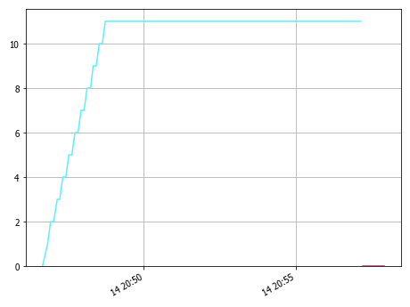

## 5.2 Summary

As you can see above we ramped up to nn robots and held at a steady state for mm minutes.

## 5.3 Table

|  |  |  |  |  |  |  |
| --- | --- | --- | --- | --- | --- | --- |
|  | PrimaryMetric | Minimum | Average | 95%ile | Maximum | Std. Dev. |
|  | 20210214_204637_browseOC100 | 0 | 9.943 | 11.0 | 11 | 2.545 |
|  | PreRun | 0 | 0.0 | None | 0 | 0.0 |

# 6 Response Time

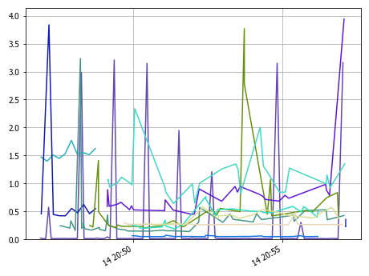

## 6.1 Details

|  |  |  |  |  |  |  |  |
| --- | --- | --- | --- | --- | --- | --- | --- |
|  | Result Name | Minimum | Average | 95%ile | Maximum | Std. Dev. | Count |
|  | OC3 Add Product to Cart | 0.257 | 0.276 | 0.301 | 0.48 | 0.043 | 25 |
|  | OC3 Close Browser | 0.227 | 0.259 | None | 0.357 | 0.039 | 10 |
|  | OC3 Open Browser | 1.398 | 1.534 | None | 1.771 | 0.103 | 10 |
|  | OC3 Open Cart | 0.047 | 0.054 | 0.07 | 0.073 | 0.008 | 24 |
|  | OC3 Open Menu Page | 0.139 | 0.356 | 0.529 | 3.235 | 0.477 | 41 |
|  | OC3 Open Product Page | 0.641 | 1.113 | 2.004 | 2.339 | 0.358 | 28 |
|  | OC3 Open Store Page | 0.42 | 0.823 | None | 3.838 | 1.061 | 10 |
|  | OC3 Remove Item from Cart | 0.265 | 0.394 | 0.569 | 0.575 | 0.105 | 24 |
|  | OC3 Return to Store Page | 0.203 | 0.643 | 2.775 | 3.769 | 0.775 | 30 |
|  | OC3 Search Store | 0.446 | 0.823 | 0.983 | 3.939 | 0.63 | 28 |
|  | OC3 View Cart | 0.188 | 0.422 | 0.723 | 0.764 | 0.168 | 24 |
|  | SSH: Post AUT Stats | 0.011 | 0.207 | 1.948 | 3.208 | 0.71 | 101 |

# 7 OC3 Response Time

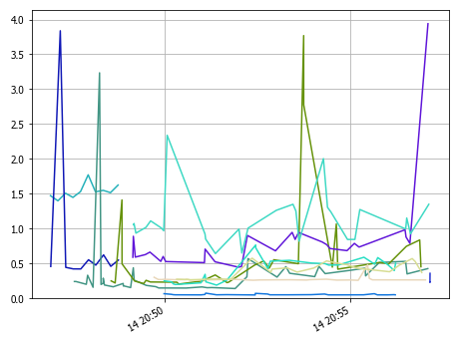

## 7.1 Details

|  |  |  |  |  |  |  |  |
| --- | --- | --- | --- | --- | --- | --- | --- |
|  | Result Name | Minimum | Average | 95%ile | Maximum | Std. Dev. | Count |
|  | OC3 Add Product to Cart | 0.257 | 0.276 | 0.301 | 0.48 | 0.043 | 25 |
|  | OC3 Close Browser | 0.227 | 0.259 | None | 0.357 | 0.039 | 10 |
|  | OC3 Open Browser | 1.398 | 1.534 | None | 1.771 | 0.103 | 10 |
|  | OC3 Open Cart | 0.047 | 0.054 | 0.07 | 0.073 | 0.008 | 24 |
|  | OC3 Open Menu Page | 0.139 | 0.356 | 0.529 | 3.235 | 0.477 | 41 |
|  | OC3 Open Product Page | 0.641 | 1.113 | 2.004 | 2.339 | 0.358 | 28 |
|  | OC3 Open Store Page | 0.42 | 0.823 | None | 3.838 | 1.061 | 10 |
|  | OC3 Remove Item from Cart | 0.265 | 0.394 | 0.569 | 0.575 | 0.105 | 24 |
|  | OC3 Return to Store Page | 0.203 | 0.643 | 2.775 | 3.769 | 0.775 | 30 |
|  | OC3 Search Store | 0.446 | 0.823 | 0.983 | 3.939 | 0.63 | 28 |
|  | OC3 View Cart | 0.188 | 0.422 | 0.723 | 0.764 | 0.168 | 24 |

# 8 TPS Pass

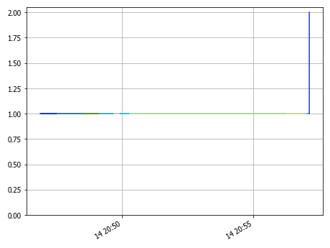

## 8.1 Details

|  |  |  |  |
| --- | --- | --- | --- |
|  | Result Name | Result | Count |
|  | SSH: Post AUT Stats | PASS | 101 |
|  | OC3 Open Menu Page | PASS | 41 |
|  | OC3 Return to Store Page | PASS | 30 |
|  | OC3 Search Store | PASS | 28 |
|  | OC3 Open Product Page | PASS | 28 |
|  | OC3 Add Product to Cart | PASS | 25 |
|  | OC3 View Cart | PASS | 24 |
|  | OC3 Remove Item from Cart | PASS | 24 |
|  | OC3 Open Cart | PASS | 24 |
|  | OC3 Open Store Page | PASS | 10 |
|  | OC3 Open Browser | PASS | 10 |
|  | OC3 Close Browser | PASS | 10 |

# 9 TPS Fail

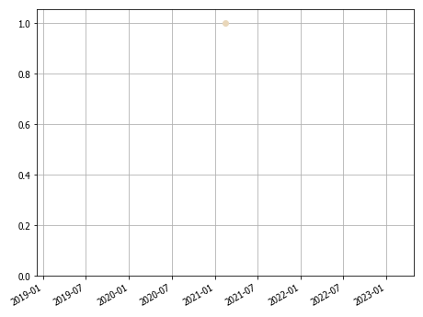

## 9.1 Details

|  |  |  |  |
| --- | --- | --- | --- |
|  | Result Name | Result | Count |
|  | OC3 Add Product to Cart | FAIL | 1 |

# 10 AUT

## 10.1 Web Server

### 10.1.1 CPU Idle

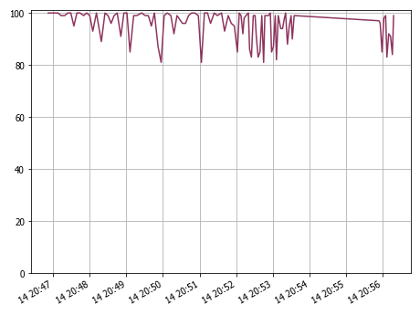

#### 10.1.1.1 Details

|  |  |  |  |  |  |  |
| --- | --- | --- | --- | --- | --- | --- |
|  | PrimaryMetric | Minimum | Average | 95%ile | Maximum | Std. Dev. |
|  | opencart3 | 81 | 95.535 | 100.0 | 100 | 5.825 |

### 10.1.2 Memory Free

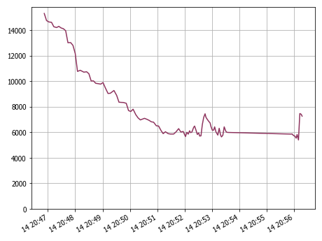

#### 10.1.2.1 Details

|  |  |  |  |  |  |  |
| --- | --- | --- | --- | --- | --- | --- |
|  | PrimaryMetric | Minimum | Average | 95%ile | Maximum | Std. Dev. |
|  | opencart3 | 5400 | 8059.921 | 14272.0 | 15312 | 2786.652 |

### 10.1.3 CPU Stolen

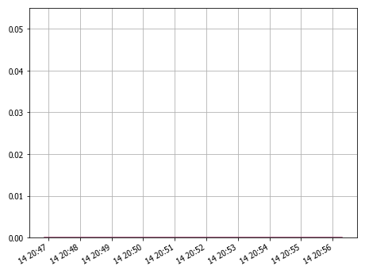

#### 10.1.3.1 Dteails

|  |  |  |  |  |  |  |
| --- | --- | --- | --- | --- | --- | --- |
|  | PrimaryMetric | Minimum | Average | 95%ile | Maximum | Std. Dev. |
|  | opencart3 | 0 | 0.0 | 0.0 | 0 | 0.0 |

# 11 AUT Metrics

|  |  |  |
| --- | --- | --- |
| PrimaryMetric | SecondaryMetric | MetricValue |
| opencart3 | lscpu: Architecture | x86_64 |
| opencart3 | lscpu: BogoMIPS | 5423.94 |
| opencart3 | lscpu: Byte Order | Little Endian |
| opencart3 | lscpu: CPU MHz | 2711.972 |
| opencart3 | lscpu: CPU family | 6 |
| opencart3 | lscpu: CPU op-mode(s) | 32-bit, 64-bit |
| opencart3 | lscpu: CPU(s) | 2 |
| opencart3 | lscpu: Core(s) per socket | 2 |
| opencart3 | lscpu: Flags | fpu vme de pse tsc msr pae mce cx8 apic sep mtrr pge mca cmov pat pse36 clflush mmx fxsr sse sse2 ht syscall nx rdtscp lm constant_tsc rep_good nopl xtopology nonstop_tsc pni pclmulqdq ssse3 cx16 pcid sse4_1 sse4_2 movbe popcnt aes xsave avx rdrand lahf_lm abm 3dnowprefetch invpcid_single kaiser fsgsbase avx2 invpcid rdseed clflushopt md_clear flush_l1d |
| opencart3 | lscpu: Hypervisor vendor | Oracle |
| opencart3 | lscpu: L1d cache | 32K |
| opencart3 | lscpu: L1i cache | 32K |
| opencart3 | lscpu: L2 cache | 256K |
| opencart3 | lscpu: L3 cache | 8192K |
| opencart3 | lscpu: Model | 142 |
| opencart3 | lscpu: Model name | Intel(R) Core(TM) i7-8559U CPU @ 2.70GHz |
| opencart3 | lscpu: NUMA node(s) | 1 |
| opencart3 | lscpu: NUMA node0 CPU(s) | 0,1 |
| opencart3 | lscpu: On-line CPU(s) list | 0,1 |
| opencart3 | lscpu: Socket(s) | 1 |
| opencart3 | lscpu: Stepping | 10 |
| opencart3 | lscpu: Thread(s) per core | 1 |
| opencart3 | lscpu: Vendor ID | GenuineIntel |
| opencart3 | lscpu: Virtualization type | full |
| opencart3 | lscpu: bitnami@opencart3 | ~$ |
| opencart3 | vmstat: CPU: Idle | 100 |
| opencart3 | vmstat: CPU: Stolen | 0 |
| opencart3 | vmstat: CPU: System | 0 |
| opencart3 | vmstat: CPU: User | 0 |
| opencart3 | vmstat: CPU: Wait | 0 |
| opencart3 | vmstat: IO: Blocks received | 0 |
| opencart3 | vmstat: IO: Blocks sent | 0 |
| opencart3 | vmstat: Memory: Buffers | 79200 |
| opencart3 | vmstat: Memory: Cache | 112820 |
| opencart3 | vmstat: Memory: Free | 15312 |
| opencart3 | vmstat: Memory: Swap | 274520 |
| opencart3 | vmstat: Processes: Runnable | 0 |
| opencart3 | vmstat: Processes: Uninterruptible | 0 |
| opencart3 | vmstat: Swap: Swapped In | 0 |
| opencart3 | vmstat: Swap: Swapped Out | 0 |
| opencart3 | vmstat: System: Context Switches/s | 377 |
| opencart3 | vmstat: System: Interrupts/s | 182 |

# 12 Agents

## 12.1 Load

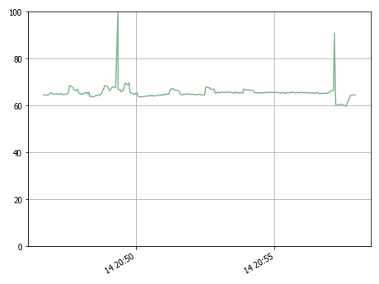

### 12.1.1 Details

|  |  |  |  |  |  |  |
| --- | --- | --- | --- | --- | --- | --- |
|  | PrimaryMetric | Minimum | Average | 95%ile | Maximum | Std. Dev. |
|  | DavesMBPSG | 59.7 | 65.669 | 67.9 | 100 | 2.712 |

## 12.2 CPU

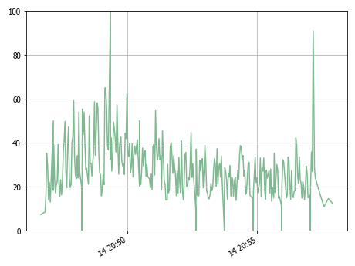

### 12.2.1 Details

|  |  |  |  |  |  |  |
| --- | --- | --- | --- | --- | --- | --- |
|  | PrimaryMetric | Minimum | Average | 95%ile | Maximum | Std. Dev. |
|  | DavesMBPSG | 0 | 27.939 | 52.3 | 100 | 12.697 |

## 12.3 Memory

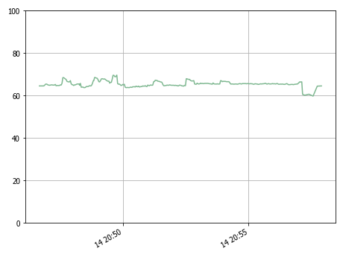

### 12.3.1 Details

|  |  |  |  |  |  |  |
| --- | --- | --- | --- | --- | --- | --- |
|  | PrimaryMetric | Minimum | Average | 95%ile | Maximum | Std. Dev. |
|  | DavesMBPSG | 59.7 | 65.469 | 67.8 | 69.6 | 1.288 |

## 12.4 Network

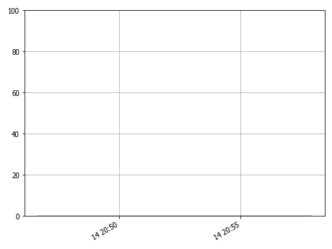

### 12.4.1 Details

|  |  |  |  |  |  |  |
| --- | --- | --- | --- | --- | --- | --- |
|  | PrimaryMetric | Minimum | Average | 95%ile | Maximum | Std. Dev. |
|  | DavesMBPSG | 0 | 0.0 | 0.0 | 0.0009765625 | 0.0 |

## 12.5 Running Robots

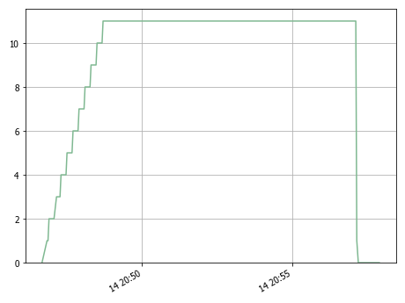

### 12.5.1 Details

|  |  |  |  |  |  |  |
| --- | --- | --- | --- | --- | --- | --- |
|  | PrimaryMetric | Minimum | Average | 95%ile | Maximum | Std. Dev. |
|  | DavesMBPSG | 0 | 9.811 | 11.0 | 11 | 2.761 |

## 12.6 Assigned Robots

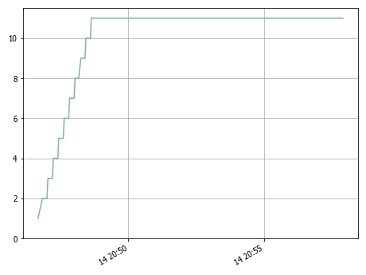

### 12.6.1 Details

|  |  |  |  |  |  |  |
| --- | --- | --- | --- | --- | --- | --- |
|  | PrimaryMetric | Minimum | Average | 95%ile | Maximum | Std. Dev. |
|  | DavesMBPSG | 1 | 10.12 | 11.0 | 11 | 2.221 |

## 12.7 rfswam agent versions

|  |  |  |
| --- | --- | --- |
|  | PrimaryMetric | MetricValue |
|  | DavesMBPSG | 0.6.4 |

## 12.8 Selenium Versions

|  |  |  |
| --- | --- | --- |
|  | PrimaryMetric | MetricValue |
|  | DavesMBPSG | 4.5.0 |

# 13 Agent Metrics

|  |  |  |
| --- | --- | --- |
| PrimaryMetric | SecondaryMetric | MetricValue |
| DavesMBPSG | AssignedRobots | 1 |
| DavesMBPSG | Browser: Chrome | 1 |
| DavesMBPSG | Browser: FireFox | 1 |
| DavesMBPSG | Browser: Safari | 1 |
| DavesMBPSG | CPU | 7.3 |
| DavesMBPSG | Custom: Zone 1 | 1 |
| DavesMBPSG | IPAddress | 192.168.13.141 |
| DavesMBPSG | LastSeen | 1613299600 |
| DavesMBPSG | Load | 64.5 |
| DavesMBPSG | MEM | 64.5 |
| DavesMBPSG | NET | 0 |
| DavesMBPSG | OS: Platform | macOS-11.2.1-x86_64-i386-64bit |
| DavesMBPSG | OS: Release | 20.3.0 |
| DavesMBPSG | OS: System | Darwin |
| DavesMBPSG | OS: Version | Darwin Kernel Version 20.3.0: Thu Jan 21 00:07:06 PST 2021; root:xnu-7195.81.3~1/RELEASE_X86_64 |
| DavesMBPSG | OS: Version: Major | 20 |
| DavesMBPSG | OS: Version: Minor | 20.3 |
| DavesMBPSG | RFSwarmAgent: Version | 0.6.4 |
| DavesMBPSG | RobotFramework: Libraries | sshlibrary, sikulilibrary, seleniumlibrary, requests, pythonlibcore, jsonvalidator |
| DavesMBPSG | RobotFramework: Library: jsonvalidator | 2.0.0 |
| DavesMBPSG | RobotFramework: Library: pythonlibcore | 2.2.1 |
| DavesMBPSG | RobotFramework: Library: requests | 0.8.0 |
| DavesMBPSG | RobotFramework: Library: seleniumlibrary | 4.5.0 |
| DavesMBPSG | RobotFramework: Library: sikulilibrary | 2.0.0 |
| DavesMBPSG | RobotFramework: Library: sshlibrary | 3.6.0 |
| DavesMBPSG | Robots | 0 |
| DavesMBPSG | Status | Ready |