

UNIVERSITY OF KWAZULU NATAL SCHOOL OF MATHEMATICS, STATISTICS AND COMPUTER SCIENCE

**Comparison of Metaheuristic Approaches for Blood Assignment Problems**

*Author*: Prinolan Govender *Supervisor*: A. Ezugwu

A THESIS SUBMITTED IN FULFILLMENT OF THE REQUIREMENTS FOR THE DEGREE OF MASTERS OF SCIENCE IN THE UNIVERSITY OF KWAZULU-NATAL SCHOOL OF MATHEMATICS,

STATISTICS AND COMPUTER SCIENCE

**List of figures**

|  |  |
| --- | --- |
| Figure | Description |
| 1 | Illustrates the FIFO system for blood unit distribution. |
| 2 | Flowchart representation of the daily events that occur within the blood bank |
| 3 | Flowchart representation of the steps conducted in this study |
| 4 | Pie chart representation of race groups in South Africa |
|  |  |
|  |  |
|  |  |

**List of tables**

|  |  |
| --- | --- |
| Table | Description |
| 1 | Blood compatibility representation |
| 2 | Blood proportions in South Africa |
| 3 | Terms from educational institutions in South Africa |
| 4 | Public holidays in South Africa |
|  |  |
|  |  |
|  |  |

**1. Introduction**

**1.1 Background**

Human blood management is characterized by a string of factors which can prove to be complicated over time [1]. Blood banks often face the scenario of insufficient whole blood (WB) units in storage to allocate to patients in need. A WB unit is comprised of four main components, with each component serving a specific purpose within the blood cell [2].

1. Red blood cell (RBC): Carries oxygen (O2) throughout the body, and removes Carbon Dioxide (CO2).
2. White blood cell (WBC): Fights against biological threats within the body, and are known as the body’s immune system.
3. Platelets (PLT): Seals of wounds and prevents bleeding.
4. Plasma: Transports nutrients and proteins to parts of the body, and holds RBC, WBC and PLT cells.

Majority of WB units in blood banks are usually attained through voluntary donations, after which, the process of blood screening is initiated to identify any potential blood related threats that could harm the receiving patient. Any infected blood donations are immediately discarded, whilst the other donations deemed as clean, and stored in ideal conditions to be used for future distribution. It is possible for each component of a blood cell to be used individually for various medical scenarios, however this study will neglect the individual usage of blood components and focus on the overall WB unit. In accordance to the ABO blood system (a system used to classify the nature of an individual’s blood type) [3], blood within humans have four different blood groups, namely A, B, AB, O. With the introduction of a Rhesus (Rh) value which can either be positive (+) or negative (-) ends up doubling the initial blood groups which results in eight different blood types. The different blood types play a vital role with regards to storage, and distribution. In terms of storage, certain blood types are considered as rare, as very few individuals carry this particular blood type, for example the blood type *-* is extremely scarce within the South African population as 1% of the total population carry *AB-* blood. With regard to distribution, the relevance of blood types and compatibility plays an important role during transfusion. Cases have risen when medical knowledge was insufficient, where patients received incompatible blood types which has adverse health effects resulting in blood clumping (also referred to as agglutination), which can be life threatening.

The demand for WB units can be decomposed into two main scenarios. The first scenario relates to premeditated medical events which are in need of WB units, this can involve events such as general surgeries. The premeditated events allow the blood bank to allocate adequate amounts of WB units towards the desired patient, in addition if the blood banks have inadequate amount of WB units to meet the demand, then it still leave the blood bank adequate time to import additional units from external sources. The second scenario relates to unforeseen patients who are in immediate need of WB units. Blood banks tend to struggle to fulfil this type of demand if a large influx of patients are in need of treatment involving blood units at the same time. Most blood banks tend to stock-pile WB units and other blood products during period of expected sudden trauma. However, this is not a solution as demand for WB units can still out-weigh the on hand supply. The act of importing additional WB units raises the expenses incurred by the blood bank. Another factor which can contribute towards additional expenses relates to expiration of WB units. Expiry of units occurs when the WB units exceeds the expected shelf-life, the act of disposing the WB units in an appropriate manner increases the blood banks expenses. The act of freezing blood units can prolong the lifespan of the cells, however this study will ignore such WB units. The proposed blood assignment method generally seeks to minimize wastage of blood products by efficiently assigning blood to patient and preserving blood stock pile by allocating available blood to different blood types.

The blood assignment problem (BAP) is a combinatorial optimization problem which tries to efficiently assign WB units to patients in need, whilst trying to minimize the amount of importation and expiry within the blood bank. The BAP being an NP-hard problem with numerous complex components and constraint can be very difficult to model mathematically. Such constraints include: daily demand, cross-matching blood types, importing additional blood units and expiring WB units when they have exceeded their shelf-life. In addition, this study is from a perspective of the South African National Blood Service (SANBS) and in relation to the South African population.

**1.2 Problem Statement**

The demand received for WB units must be met. With this in mind, if the daily demand exceeds the current supply at hand, then additional WB units must be imported from external sources in order to satisfy the demand. Blood banks receive WB units which are largely contributed from voluntary donations from donors. These fresh WB units enter a queuing system also referred to as the First-in First-out (FIFO) method, this implies that the oldest WB units would be used first with the newer units being placed at the back of the queue to be used at a later time. In Fig.1, the process of using the FIFO system for distributing the WB units is illustrated.

Enter

Exit

WB Unit

Queue

Fig. 1: Illustration of the FIFO process for WB units

In Fig. 1, the round shapes represent WB units, with the numbers ranging from 1 to n, were n represents any positive integer. The WB units proceed to follow the queue until it exits, thus implying that the WB unit is being distributed to a patient. Note that in Fig. 1, there is no reference to any blood type, as this process occurs regardless. The effect of implementing the FIFO system aims at minimizing expiry among WB units, as the oldest WB units are being utilised first, thus decreasing its exposure to storage time. Any WB units that have exceeded their respective shelf-life are discarded from storage, which is a negative connotation for the blood bank as this incurs additional expenses and implies that the blood bank is not utilises resources in an effective manner. It would be appropriate for a patient to receive blood relating to their specific type, however a situation might arise where there is inadequate supply of WB units pertaining to that specific blood type. When this occurs, various processes are put in place, so as to satisfy the immediate demand. First, the request will try to be satisfied by using other compatible blood types. Each blood type must first try and satisfy the demand pertaining to their own types, once their respective demands have been met, only then can alternative compatibility distribution be employed. compatibility distribution in this study relates to using the remaining units from each blood type and redistributing those units to other compatible blood types. The process of redistribution minimizes additional blood importation from external sources, and manages resources more effectively. However, if redistributing remaining WB units still cannot satisfy the demand in a day, only then would additional WB units be imported from external sources. However, the importation of WB units incurs additional expenses for the blood bank, and must therefore be minimized. The BAP can be summarized into four major components.

1. Supply: Stock on hand at any given moment.
2. Demand: Relates to both planned and unplanned requests for WB units.
3. Importation: Utilizes additional WB units from external sources in order to satisfy demand.
4. Expiry: Occurs when WB units exceed their shelf-life.

In Fig. 2, the flowchart depicting the steps taken each day within the blood bank for the management of WB units is illustrated. Furthermore, it also illustrates the steps that must be fulfilled in order for additional WB unit importation to occur.

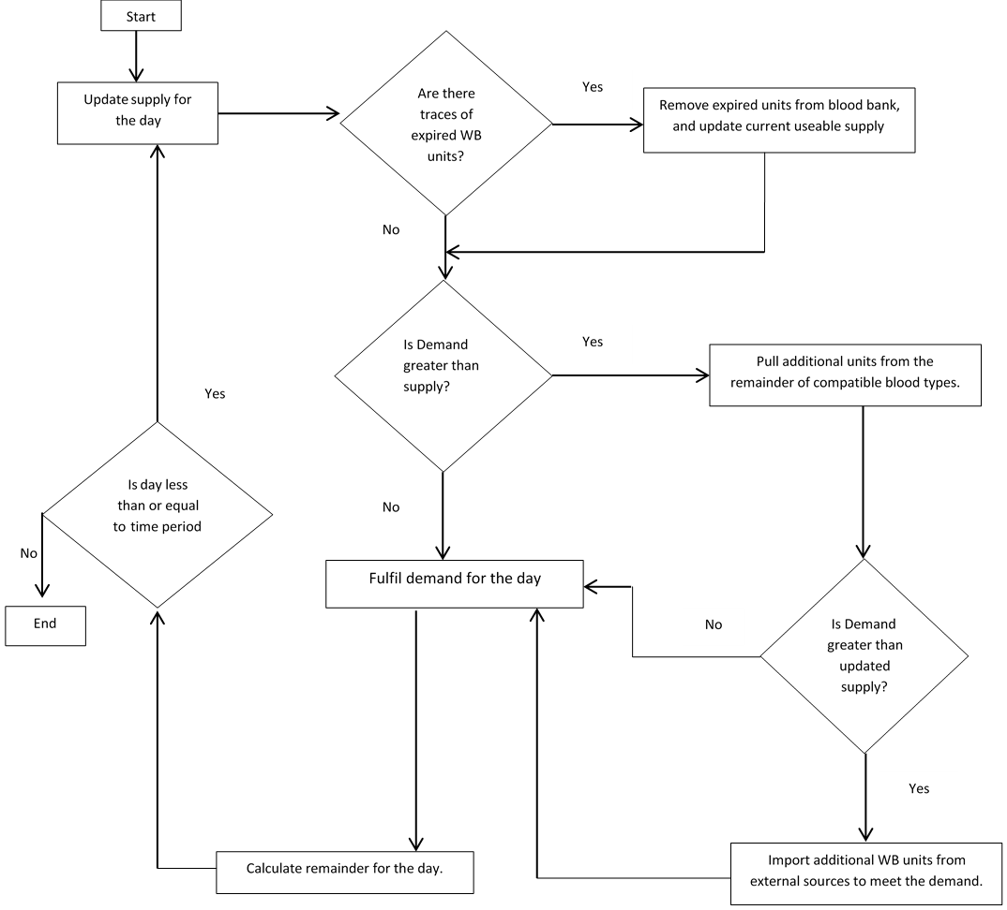

Fig 2: Flow diagram representing the daily processes that occur within the blood bank in this study

**1.3 Motivation**

The notion of optimization can successfully be applied to various complex decision making or allocation problems [4]. The BAP as aforementioned is considered as an NP-hard problem, due to the complexities associated with blood assignment [5]. Prior literatures specifically dedicated to the BAP is relatively scarce, with only a handful of study tackling the problem from an optimization perspective.

The importance of this study is to develop a generalised mathematical model and explore the possibility of employing different metaheuristic algorithms to solve the BAP. As part of this thesis technical contribution, five different global optimization algorithms are implemented for the BAP. The developed algorithms include: Genetic Algorithm (GA), Particle Swarm Optimization (PSO), Duelling Algorithm (DA), Symbiotic Organism Search (SOS), and the Grey Wolf Optimizer (GWO). The BAP can also be seen as a perishable inventory problem, this study can therefore contribute towards future research relating to blood and other relatable perishable inventory problems. Prior research suffered with the inability of using appropriate real-world datasets to evaluate the effectiveness of their proposed implementations for the BAP. Due to confidentiality issues, this study also could not utilize real-world datasets. To confront this challenge, datasets were stochastically generated, as it is the case with other existing related work. In addition, this study tries to utilise events and statistics prevalent to the South Africa people. By utilising such factors, the datasets (even through randomly generated) can try to reduce such randomness when generating values for demand of WB units. The rationale behind generating datasets using a stochastic approach lies behind social convention, that the demand for WB units should have certain trends. For example, the demand for WB units should have a greater need during months that experience more public holidays or breaks from educational institutions due to higher levels of dangerous activity such as drunk driving, and criminal activity.

Expenses are an aspect that must be within any organization, and SANBS is no different. In accordance to [5], SANBS require various equipment and chemicals in order to test and store WB units. Testing WB units is a vital component to any blood bank to ensure that the units are viable (Do not contain any form of diseases), and do not transmit any pathogens to receiving patients. A study conducted in [6] emphasized the four main activities related to blood and blood product management and these includes:

1. **Production costs:** These relate to costs of running blood campaign collections, also included in this amount will be procedures related to testing the WB units.
2. **Expiry costs:** WB units have a lifespan spanning between 30-35 days, once a WB unit has exceeded its lifespan, there are costs attached to incinerating the units.
3. **Inventory costs:** Costs associated with keeping WB units at optimum temperatures and in an adequate environment.
4. **Importation costs:** If in the event the supply on hand does not cover the demand for that day, additional WB units will have to be imported in order to fulfil the remaining demand.

This study will only focus on costs related to expiry and importation, as by minimizing the objective function of the BAP, this will relatively lower other forms of costs incurred by the blood bank.

**1.4 Aims and Objectives**

The main aim of this project is to acquire an in-depth understanding of the BAP inventory management process and to also proffer best alternative global optimization solution approach to the BAP. The work done in this study attempts to offer content which could possibly advance the research of the BAP or similar perishable inventory related problems. In addition, this study tries to implement a more accurate method when generating stochastic datasets. The following are some objectives that will be accomplished in this study.

1. Develop a robust blood bank management policy which aims at efficiently using WB units.
2. Implement five population-based metaheuristic algorithms, each combined with the blood bank assignment policy for solving the BAP. The algorithms include: GA, PSO, DA, SOS and GWO.
3. Generate a variety of stochastically based datasets for the evaluation of the proposed metaheuristic blood assignment methods. In addition, to also examine how efficient the blood bank is able to distribute WB units, and to test the levels of importation and expiry that might be faced. The datasets will embody various situations that the blood bank may experience during the course of its existence.
4. Comparative analysis of the five algorithms through rigorous statistical analyse so as to determine the best performed algorithm for the BAP.

By completing the aims and objectives listed above, this will allow for a functioning system to work the BAP, and for it to be extensively reviewed.

**1.5. Scope and limitations**

Due to the complex nature of the BAP, certain assumptions will be introduced in order to develop a mathematical model that would be adequate for the problem at hand.

1. Race, gender, age and other contributing traits that characterize an individual will be ignored. The focus of the study is solely based on blood units.
2. All WB units will be deemed as “clean”, this means that no WB unit will contain pathogens.
3. A year will consist of 365 days.
4. The lifespan of a WB unit will be 30 days. This is in accordance to the study conducted in [7].
5. The first day (day 1) will have no carryover of WB units from the previous day.
6. All blood types will first fulfil requests associated with their blood types, after which the remainder from each blood group can contribute to other compatible blood types.

An additional limitation relates to the use of datasets in this study. Due to confidentiality issues, datasets where randomly generated using percentage bounds to generate values for supply. The concept of percentage bound is elucidated in chapter

**1.6. Methodology**

The

***Step 1:*** Conduct a thorough literature review to obtain an in-depth understanding of blood banking, and implement an appropriate policy for issuing WB units.

***Step 2:*** Transform and hybridize the five existing standard metaheuristic algorithms with the proposed blood banking policy and make the methods suitable for solving the BAP.

***Step 3:*** Since the datasets are stochastically generated, certain restrictions must be followed in order to mimic real life scenarios that may be faced by the blood bank at any given moment.

***Step 4:*** The effectiveness of the five metaheuristic algorithms with respect to their applications on the BAP, are evaluated based on the stochastic datasets generated.

***Step 5:*** Computational results are used to determine the superiority of each algorithm. More so, in order to establish which algorithm performed best for this problem, the objective function comes into play when assessing the algorithms output.

***Step 6:*** Record results in a manner that aids in identifying the better algorithm both analytically and visually.

***Step 7:*** Using the graphs and tables that were recorded in step 6. It is now possible to examine each algorithm output more extensively.

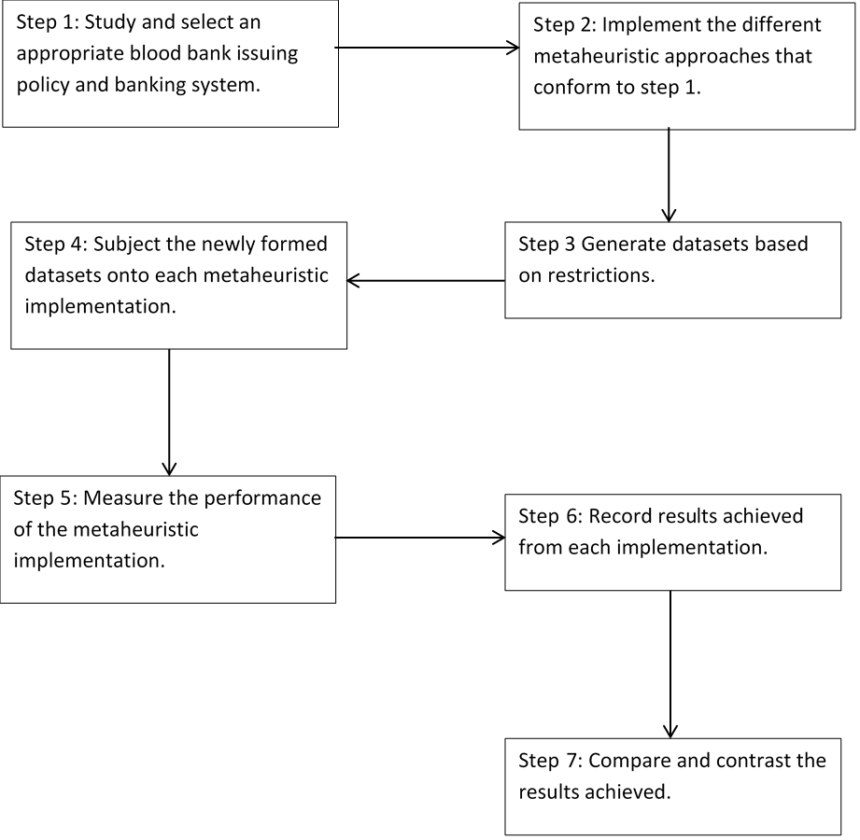

Fig. 3: Flowchart representation of the steps conducted in this study of the BAP.

**1.7 Thesis Layout**

The remainder of this Thesis will be organized as follows. Chapter 2 will extensively review prior literatures on the BAP. (Chapter 3 and 4 not really sure what to write here, don’t worry, I will adivse you later, we have them already). Whilst Chapter 5 will include the final remarks relating to the BAP in this study as well as future directions.

**2. Literature review**

The following chapter serves as some insight with regards to previous literatures that have studied the blood management process as well as research conducted in relation to the BAP. In order to understand the BAP, it is important to obtain an in-depth understanding with regards to individual components that compile the BAP. Due to the nature of data generation, it is also imperative to understand certain attributes which pertain to the South Africa population.

**2.1 Preliminaries on Blood**

Blood transfusions save thousands of lives on a daily basis by means of medical treatment [8]. However, before divulging into the mathematical and computational components of prior research, blood itself has been extensively researched with the aim of improving health care for individuals. Experiments relating to blood transfusion was conducted in several steps, first blood was transfused between animals, and then from animal into man, with the first evidence of a transfusion occurring in 1666 within Oxford [9]. Since then the advancements of medical technology has assisted with the understanding of blood compatibility and transfusion. Using any incompatible blood type for transfusion often resulted in blood clumping and other negative side effects upon the patient. Back in 1927, antigens A and B where discovered followed by antigen O, which resulted in the widely known ABO blood grouping system [10]. With the introduction of an Rh value (mentioned in chapter 1), this further resulted to eight different blood types found in humans. Below is table 1 which illustrates the compatibility among blood types, note that “YES” implies that they are compatible, and “NO” indicates that they are not compatible.

Table 1: Representation of blood compatibility

|  |  |  |  |  |  |  |  |  |
| --- | --- | --- | --- | --- | --- | --- | --- | --- |
| Blood Types | A+ | A- | B+ | B- | AB+ | AB- | O+ | O- |
| A+ | YES | YES | NO | NO | NO | NO | YES | YES |
| A- | NO | YES | NO | NO | NO | NO | NO | YES |
| B+ | NO | NO | YES | YES | NO | NO | YES | YES |
| B- | NO | NO | NO | YES | NO | NO | NO | YES |
| AB+ | YES | YES | YES | YES | YES | YES | YES | YES |
| AB- | NO | NO | NO | YES | NO | YES | NO | YES |
| O+ | NO | NO | NO | NO | NO | NO | NO | YES |
| O- | NO | NO | NO | NO | NO | NO | NO | YES |

Even though blood is donated as whole units, the units can still be separated into its various components, these components can be used accordingly. For example, blood platelets can solely be utilized for patients with bleeding disorders [11]. The act of separating components for individual usage fully maximizes its utility at aiding patients with various health issues.

WB units are stored in freezers at certain temperatures in order to prolong their lifespan. Depending on the anticoagulant (a solution used to preserve WB units) used within the blood unit, temperatures inside these freezers range between 2-4 degrees Celsius with a lifespan ranging between 28-42 days [12]. Cryo-preservation relates to freezing WB units in order to drastically prolong their lifespan and can be viable for up to 10 years [13]. However the act of freezing can be time consuming and incur additional costs by the blood bank. These WB units also follow specific guidelines when thawing out and require sophisticated equipment during the cryo-preservation process.

**2.2 Overview of Metaheuristics**

The following study implemented a diverse ranged of nature inspired metaheuristics in order to work the BAP. The list includes GA, PSO, DA, SOS and the GWO, each of which have been implemented in various optimization problems in the past. A metaheuristic is defined as a “high level problem independent algorithm framework that provides a set of strategies to develop heuristic optimization algorithms”, unlike normal heuristics which are problem dependent [14]. Though the algorithms vary with regard to structure and implementation, the overall goal of generating potential solutions and selecting the best outcome remains the same. A massive advantage of using a metaheuristic algorithm lies in its ability for the algorithm to find a good solution with minimal computational effort or iterative methods.

GA is an extensively research algorithm with a wide-range of application to solve complex optimization problems. Introduced by Koza in 1994 [15], GA utilises sub procedures in order to morph a potential solution in order to obtain an improved solution. The school timetabling problem (STP) has been extensively studied by various researchers with many implementations utilising the GA or a hybridized version to work the problem. The report conducted by [16] summarized various hybrid implementations and compared results obtained from the various hybrid GA algorithms for the STP. Another use of GA was exemplified in the bus driver scheduling problem (BSP). The study by [17] modified a GA by implementing a "pieces-of-work" coding scheme which was broken into two aspects, the first being the duties and secondly the pieces of work. The chromosome was created using each piece of work representing a gene. Dias’s work showed a unique implementation of GA for solving the BSP, and proved to produce quick and satisfactory results.

The development of the PSO has been accredited to Kennedy and Eberhart [18]. PSO has been applied to many problems like artificial neural network training, fuzzy control, pattern classification and function optimization. In recent years, PSO has received a lot of recognition due to its fast convergence rate and ease for implementing the algorithm to solve problems. The job shop scheduling (JSS) problem is a well-known optimization problem, with the objective of minimizing completion time for all jobs to be completed, a study conducted by Liu [19] applied PSO towards the JSS which resulted in a positive outcome of the PSO successfully achieving the JSS objective function.

The DA is an optimization algorithm which is based on how humans fight and learn from each other in order to improve their fighting capabilities [20]. A study conducted by Biyanto [21] compared the GA and DA algorithms using two benchmarks which were maximization problems, results indicated that the DA approach achieved better and faster solutions, DA achieved solutions in 143 iterations, whilst GA needed 166 iterations. Biyanto further compared the DA algorithm to the PSO and Imperialist Competitive Algorithm (ICA), and discovered that DA achieved better results than PSO with regards computational time.

The parallel machine scheduling problem (PMSP) is a combinatorial optimization problem which has been extensively research. The problem consists of similar or unrelated types of multiple numbers of machines in which jobs can simultaneously be scheduled. Ezugwu [22] performed an improved SOS algorithm to solve the PMSP with the objective of minimizing makespan. The SOS algorithm was formly introduced by Cheng and Prayogo in 2014 in which the algorithm was implemented to solve numerical engineering optimization problems [23]. Ezugwu’s study compared the results of the SOS implementation to previous work and found that the SOS algorithm outperforms for all the problem instances that were tested.

The real power economic dispatch (RPED) relates to allocating optimal power generation towards thermal units without violating constraints within the system. The RPED is considered as a non-linear problem, and was studied by Venkatakrishnan [24]. Venkatakrishnan implemented the GWO algorithm to try and solve the RPED, whilst examining the algorithms effectiveness, robustness and feasibility. The tests were conducted with different kinds of constraints with results achieving minimum fuel expenditure.

Overall, metaheuristics have been implemented on a variety of complex problems. The literatures mentioned above are just some of the studies in which GA, PSO, DA, SOS and GWO were examined. Even though metaheuristics differ with regards to implementation and structure, the overall aim relates to obtaining the best solution to solve a problem. The following research tries to contribute towards the study of these metaheuristics in reference to the aspect of medicinal optimization.

**2.3 Blood management**

Apart from the BAP, various components of blood management have been scrutinized over the years in order to make every aspect as efficient as possible. Blood management is defined as the appropriate use of blood and blood components with the aim of minimizing their usage [25]. The following section will have an in-depth analysis of prior research pertaining to WB and blood product management.

The study conducted by Kaveh [4] worked towards minimizing the distance between blood centres and hospitals by means of graph partitioning coupled with metaheuristic algorithms namely Colliding bodies optimization (CBO). Results indicated that the proposed algorithm performed satisfactory in relation to optimal points of view and computational time. Another study which focused on blood bank locations was conducted by Banthao [26], the study focused on three main costs which was in need of minimization namely: fixed costs, delivery costs and emergency referral costs. The capacitated location problem with emergency referral model (CLPER) incorporates decision making processes to determine the optimal number and locations for blood banks. Banthao formulated the CLPER as an integer programming model, and used real-world data from the Thai Red Cross Society. Results stated that the maximum distance between blood bank and hospital is 45 kilometres. Rusman [27] incorporated a single and double allocation model which implied that the demand for blood can either be supplied from a single or from two blood banks with both models being represented by an integer programming model. Overall, the study indicated which blood banks offered the lowest delivery costs.

Studies pertaining to the BAP mainly analyse the overall blood bank issuing policy, and find ways to try and minimize expiration and importation of additional blood units from external sources. Research conducted by [3], [7], [8] and [28] followed the same overall structure with regards to mathematical model, but differed with regard of the metaheuristic algorithms implemented to work the BAP. Other similarities between the mentioned literatures lie with regard to the objective function of minimizing overall blood importation from external sources and dataset generation. In terms of datasets, data had to be randomly generated due to confidentiality issues when trying to obtain real-world datasets. The datasets tested a variety of situations such as examining how a blood bank would cope when demand for blood units exceeded supply and vice versa.

Adewumi [3] conducted an in-depth study mainly pertaining to GA and hybrid GA implementations. The metaheuristic algorithms used within this study included GA, Adaptive Genetic Algorithm (AGA), Simulated, Annealing Genetic Algorithm (SAGA), Adaptive, Simulated Annealing, Genetic Algorithm (ASAGA) and the Hill Climbing (HC) Algorithm. In addition, the study also looked at the simple assignment algorithm (SAA) in comparison to the multiple knapsack assignment (MKA). The simple assignment approach states that blood units are set aside to meet the demand for the day, and once these units are set aside, they cannot be selected again. On the other hand, the MKA investigated if cross-matching between blood types can satisfy the demand in a day. Results indicated that all of the algorithm implementations achieved optimal fitness with the HC algorithm demonstrated greater results, whilst the MKA proved efficient in minimizing the amount of imported blood units. Olusanya’s [7] research implemented the PSO in conjunction with the MKA policy. Also demonstrated in this research was the FIFO issuing system which was incorporated to minimize expiry. Results proved that the PSO implementation produced satisfactory results with low importation levels and no form of expiry. Another study conducted by Adewumi [8] implemented different metaheuristic techniques namely the Tabu search (TS) and Simulated annealing (SA) to optimize the BAP, also included in this study was the hybridization between TS and SA. The hybrid implementation used TS in order to obtain the initial solutions to the BAP which was then passed onto SA for better exploitation. Results indicated that TS does not produce an efficient solution, whilst SA and the hybrid approach both fared well in optimizing the BAP. The final study that will be analysed relates to the work done by Igwe [28], who implemented two local searches which included the Greedy randomized adaptive search procedure (GRASP) and Dynamic Programming (DP) in conjunction with the MKA. DP showed to import $O^{+}$ and $O^{-}$ blood rather heavily for the first 50 days until levelling out, whilst GRASP imported gradually as the days increased. GRASP did seem to cope much better than DP when demand exceeded supply for blood units. Igwe also concluded that population based algorithms tend to produce better results than local searches.

**2.4 The South African Population**

Due to this study incorporating certain statistics from the South African population for generating datasets, it is therefore necessary to study certain attributes that pertain to South Africa. South Africa is known for its diversity in culture and race, race refers to a person ethnicity. South Africa has four common race groups namely Black, White, Indian and Coloured, with approximately 44 million people living in the country [29]. Below is fig. 4 which is a pie chart representation of the race group percentages in South Africa.

Fig 4: Pie chart representation of the current race group proportions in South Africa adapted from [7]

In accordance to fig. 4, the percentage of Black citizens in South Africa is 80.6%, Coloured is 8.7%, the White race group stands at 8.2% and finally the Indian race group of 2.6%. Race plays a role with regards to screening blood units before distributing it to future patients. Due to the Black race group being predominant within South Africa, it is therefore applicable that a larger proportion of blood diseases are linked to the Black community. In 2017, the percentage of Acquired immune deficiency syndrome (AIDS) related deaths stood at 25.03% [29]. Human immunodeficiency virus (HIV) and AIDS are blood related diseases which breaks down an individual’s immune system making them susceptible to other infections an illnesses [30]. Currently there is no cure for HIV/AIDS, with South Africa have the fourth highest HIV/AIDS prevalence rate of 18.9% [31].

Table 2: Illustrates the proportion of blood types found in the South African Population adapted from [7]

|  |  |  |  |  |  |  |  |  |
| --- | --- | --- | --- | --- | --- | --- | --- | --- |
| Blood Type | A+ | A- | B+ | B- | AB+ | AB- | O+ | O- |
| Proportion (%) | 32 | 5 | 12 | 2 | 3 | 1 | 39 | 6 |

Due to the variety of culture in South Africa, the country also experiences a number of different public holidays. These holidays are derived from a variety of events, some of which are issued to honour the past of South African history, whilst others are cultural based. In addition to public holidays, educational facilities such as schools and tertiary institutes take mid-term breaks. The importance of these dates relates to the social behaviour aspect that will be represented in the BAP model. In theory, individuals indulge in more dangerous activities during months with more breaks and public holidays, therefore leading to an increase in demand of blood and blood products. Reports have shown that South Africa experience an increase in the amount of drunk driving levels during Easter [32], therefore blood banks tend to stock-pile blood products for precautionary measures.

Table 3: Represents the starting month and ending month of most educational institutions in South Africa [33].

|  |  |  |
| --- | --- | --- |
| Educational institutions terms | Start Month | End Month |
| 1 | January | March |
| 2 | April | June |
| 3 | July | September |
| 4 | October | December |

Table 4: Represents the public holidays in South Africa within a year

|  |  |
| --- | --- |
| Date | Percentage bound (%) |
| 1 January | New year’s day |
| 21 March | Human Rights day |
| 14 April | Good Friday |
| 17 April | Family day |
| 27 April | Freedom day |
| 1 May | Workers day |
| 16 June | Youth day |
| 9 August | Woman’s day |
| 24 September | Heritage day |
| 16 December | Day of recognition |
| 25 December | Christmas day |
| 26 December | Boxing day |

The following chapter has provided more in-depth knowledge pertaining to blood, metaheuristics, blood management and the South African population. The following study tries to further the research for the BAP by implementing five population based metaheuristics and comparing the results between the implementations as well as previous literatures in order to establish the superior algorithm. The relevance of incorporating South African statistics tries to minimize randomness when generating stochastic datasets. Previous work dealing with the BAP also suffered with the issue of obtaining real-world datasets and therefore randomly generated their own data in accordance to certain restrictions. The method implemented in this study for generating data tries to bridge the gap from previous work, and can also contribute towards future work pertaining to inventory management problems.

**References**

[1]: Hess. S, Coullard. C., Daskin. M, Hurter. A, (1997), A case study in platelet inventory management. In Proceedings of the 6th Industrial Engineering Research Conference. Atlanta: Institute of Industrial Engineers (pp. 801-6).

[2]: Basu. D, Kulkarni. R, (2018), Overview of blood components and their preparation, Department of pathology and transfusion medicine, Pondicherry, India

[3]: Adewumi, A., Budlender, N. and Olusanya, M., 2012, June. Optimizing the assignment of blood in a blood banking system: some initial results. In Evolutionary Computation (CEC), 2012 IEEE Congress on (pp. 1-6). IEEE.

[4]: Kaveh. A, Ghobadi. M, (2015), A multistage algorithm for blood banking supply chain allocation problem, University of Science and Technology, Iran.

[5]: South African National Blood Service, Product Price List, Available at: https://sanbs.org.za/product-price-list/, accessed on [17-07-2018]

[6]: Haijema. R, Wal. J, van Dijk. N, (2005), Blood platelet production: Optimization

by dynamic programming and simulation, Department of Quantitative Economics,

Amsterdam, Netherlands

[7]: Olusanya. O, Arasomwan. MA, Adewumi AO, (2014), Particle swarm optimization algorithm for optimizing assignment of blood in blood banking system, University of KwaZulu Natal, School of Mathematics, statistics and computer science, Durban, South Africa

[8]: Adewumi. A.O, (2014), Using metaheuristics techniques to optimize the blood assignment problem, University of KwaZulu Natal, School of Mathematics, statistics and computer science, Durban, South Africa

[9]: Giangrande. P.L.F, (2001), The history of blood transfusion, Oxford Haemophilia centre, Oxford, United Kingdom.

[10]: Reid. M.E, Lomas-Francis. C, (2004), The blood group antigen Fac-Book, (3rd ed), Academic Press

[11]: Albdulwahab U.S, (1996), blood platelet bank inventory management: an approximate dynamic programming approach, KAA university, Saudi Arabia.

[12]: Hardwick. J, (2008), Blood storage and transportation, ISBT science series vol.3, pp. 177-196.

[13]: Chaudhari. C.N, (2008), Frozen red blood cells in transfusion, INHS Jeevanti, India, MJAFI vol 65, issue 1, pp.55-58.

[14]: Sorensen. K, Metaheuristics- The metaphor exposed, Belgium, International Transactions in operational research, pp. 3-18.

[15]: Radalo. A, Pillay. N, (2017), An investigation of dynamic fitness measure for genetic programming. Expert systems with application, pp.52-72.

[16]: Pillay. N, (2013), A survey of school timetabling research, School of Computer Science, University of KwaZulu-Natal, Pietermaritzburg, South Africa, Spring Science+business media.

[17]: Dias. T, Sousa. J, Cunha. J, (2001), A Genetic Algorithm for the Bus Driver

Scheduling Problem, Portugal, Porto, The Journal of the Operational Research Society

Vol 53 issue 3, pp. 324-335.

[18]: Bonyadi. M.R, Michalewicz. Z, (2017), Particle swarm optimization for single objective continuous space problems: A review, Massachusetts Institute of Technology, Massachusetts, United states of America, Evolutionary Computation vol 25, issue. 1, pp.1-54.

[19]: Liu. Zhixiong, (2007), Investigation of Particle Swarm Optimization for Job Shop Scheduling Problem, Haikou, China, Third International Conference on Natural Computation vol 5.

[20]: Biyanto. T.R, Fibrianto H.Y, Nugroho G, Listijorini E, Budiati T, Huda H, (2016), Duelist Algorithm: An algorithm by how duelist improve their capabilities in a duel, Indonesia.

[21]: Biyanto. T.R, Fibrianto H.Y,(2016), Duelist Algorithm: An Algorithm in Stochastic Optimization Method, Research Center for Metrology - The Indonesian Institute of Sciences Lembaga Ilmu Pengetahuan Indonesia (LIPI), Jakarta, Indonesia

[22]:Ezugwu. A.E, Adeleke. O.J, Viriri. S, (2018), Symbiotic organisms search algorithm for the unrelated parallel machines scheduling with sequence-dependent setup times, University of KwaZulu Natal, School of Mathematics, statistics and computer science, Durban, South Africa, PLOS ONE

[23]: Cheng M.Y., Prayogo D. and Tran D.H., (2015). Optimizing multiple-resources leveling in multiple projects using discrete symbiotic organisms search. Journal of Computing in Civil Engineering, 30(3), p.04015036.

[24]: Venkatakrishnan. G.R, Rengaraj. R, Salivahanan. S, (2018), Grey Wolf Optimizer to Real Power Dispatch with Non-Linear Constraints, Department of Electrical and Electronics Engineering, SSN College of Engineering, Chennai, India, CMES vol 115 issue 1, pp 25-45.

[25]: Goodnough. L.T, Shander. A, (2012), Patient blood management, Departments of Pathology and Medicine, Stanford University School of Medicine, Stanford, California, Anesthesiology vol. 116, pp. 1367-1376

[26]: Banthao. J, Phongchai. J, (2012), An analysis of alternative blood bank locations with emergency referral, San Francisco, United states of America, Proceedings of the world congress on Engineering and Computer Science vol. 2, pp. 978-988.

[27]: Rusman. M, Rapi. A, (2014), Blood banks location model for blood distribution planning in Makassar City, Department of Industrial Engineering Hasanuddin University, Makassak.

[28]: Igwe. K, Adewumi. A.O, (2013), On the performance of GRASP and dynamic programming for the blood assignment problem, University of KwaZulu Natal, School of Mathematics, statistics and computer science, Durban, South Africa.

[29]: Mid year population estimates report, (2017),Statistics South Africa, pp 1-9

[30]: Lewis. R, (1992), Life, New York: State University of New York, C. Brown publishers

[31]: <https://www.worldatlas.com/articles/countries-with-the-highest-rates-of-hiv-aids.html>, visited [23-07-2018]

[32]: https://www.news24.com/SouthAfrica/News/easter-road-death-toll-up-by-14-from-last-year-20180417, visited: [23-07-2018]

[33]: http://www.schoolterms.co.za/2018.html, visited: [23-07-2018]