## East West University

**Department of Computer Science and Engineering**

## A/2, Jahurul Islam Avenue, Jahurul Islam City, Aftabnagar, Dhaka

**Lab Manual:** 04

**Lab Topic:** String and Two-Dimensional Array Manipulations

**Course Code:** CSE110 (Object Oriented Programming)

**Course Instructor:** Tanni Mittra, Senior Lecturer, CSE

**Lab Objective**

1. **Apply** concepts of two dimensional arrays and String
2. **Write** and **execute** programs using these concepts in Java.

**Lab Problems**

**01:** Write a program that randomly fills in 0s and 1s into a 4-by-4 matrix, prints the matrix, and finds the first row and column with the most 1s. Here is a sample run of the program:

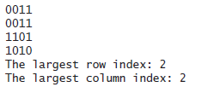

**02:** Write a method that checks whether a string is a valid password. Suppose the password rules are as follows:

* A password must have at least eight characters.
* A password consists of only letters and digits.
* A password must contain at least two digits.

Write a program that prompts the user to enter a password and displays Valid Password if the rules are followed or Invalid Password otherwise.

**03:** Suppose the weekly hours for all employees are stored in a two-dimensional array. Each row records an employee’s seven-day work hours with seven columns. For example, the following array stores the work hours for eight employees. Write a program that displays employees and their total hours in decreasing order.

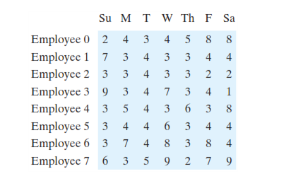

04: Write a java program to Sort N number of strings entered by keyboard in Lexicographical Order (Dictionary Order).

Enter 5 words: R programming

JavaScript

Java

C programming

C++ programming

In the lexicographical order:

C programming

C++ programming

Java

JavaScript

R programming

05: Write a program to sort a two-dimensional array according to the values in any given column

Input: If our 2D array is given as (Order 4X4)

39 27 11 42

10 93 91 90

54 78 56 89

24 64 20 65

Sorting it by values in column 3

Output: 39 27 11 42

24 64 20 65

54 78 56 89

10 93 91 90