**East West University**

**Department of CSE**

| **CSE 488**  **Fall 2024**  **Date :** 16/01/2025 | |
| --- | --- |
| **Lab Work:** Deep Learning | |
| **Name of Student & Id:**  **Suraiya Nusrat Tanha**  2021-2-60-030  **Prinom Mojumder**  2021-2-60-098  **Tasnim Israk Synthia**  2021-2-60-097 | **Course Instructor:**    **Dr. Mohammad Rezwanul Haq**  Associate Professor  Department of Computer Science & Engineering  East West University |

**Colab Link:**

<https://colab.research.google.com/drive/17EtdlV8Etpt-DVYSUaob9k4TcD5GOX9p?usp=sharing>

**Summary**

A Convolutional Neural Network (CNN) is a type of deep learning model specifically designed for processing structured grid-like data, such as images. CNNs are widely used in computer vision tasks like image classification, object detection, and segmentation.

This report actually focuses on developing and evaluating Convolutional Neural Network (CNN) models for image classification tasks using the CIFAR-10 and FASHION-MNIST datasets. Here the key outcomes are:

1. **Modified CNN Architecture:** Here the original CNN was improved by adding layers such as dropout, batch normalization, and global average pooling. This resulted in enhanced test accuracy on the CIFAR-10 dataset.
2. **Application to FASHION-MNIST:** The modified CNN was applied to the FASHION-MNIST dataset here. The model also demonstrated strong adaptability and achieved satisfactory test accuracy.
3. **Further CNN Improvements:** Additional modifications, including increased filters, a new dense layer, and learning rate scheduling, further boosted performance on the FASHION-MNIST dataset.
4. **Transfer Learning:** A pre-trained MobileNetV2 model was adapted for the FASHION-MNIST dataset. The performance was compared with the custom CNN models, showing that transfer learning provided competitive accuracy.

These things are basically highlighted here.

**Task 01**

Here we modified the CNN architecture by adding three convolutional blocks, each containing two convolutional layers with ReLU activation, Batch Normalization for stability, and MaxPooling layers for dimensionality reduction. Dropout layers were introduced after each block (0.25 in the first two blocks, 0.4 in the third) to reduce overfitting. The fully connected layers included a 256-unit dense layer with Batch Normalization and a 0.5 Dropout rate before the final softmax layer for classification. This enhanced architecture was trained using the Adam optimizer and evaluated, achieving improved test accuracy compared to the benchmark performance of 0.6874.

Here the modified architecture:

* Add dropout layers for regularization.
* Use batch normalization to stabilize and improve training.
* Add more convolutional layers and modify kernel sizes.
* Use a global average pooling layer for dimensionality reduction.

**Output**

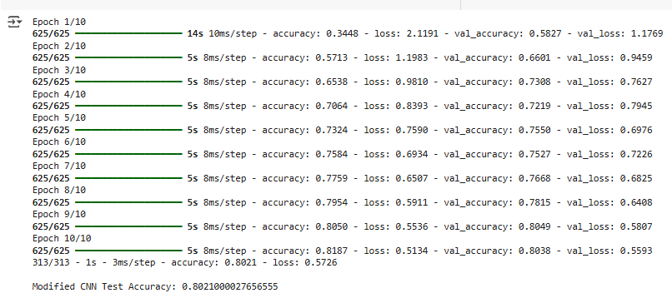

Fig 01: Modified CNN accuracy

So the modified CNN test accuracy is 0.802100. So it’s giving slightly better accuracy .

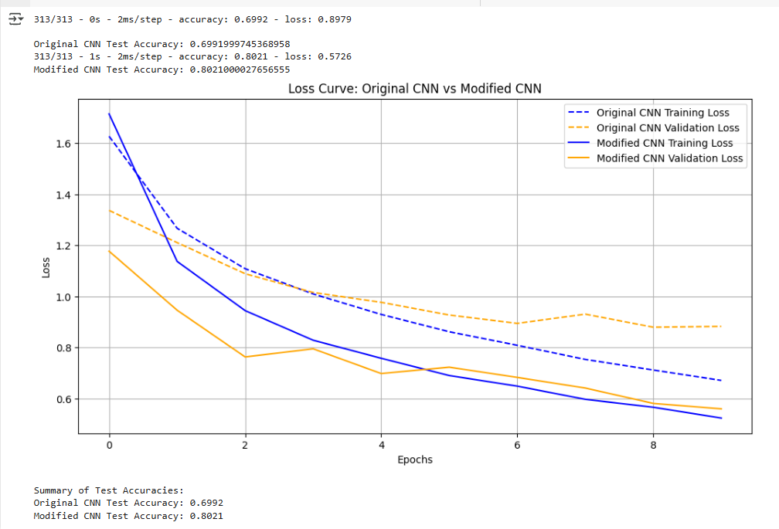

Fig 02: Comparison

| **Original CNN Test Accuracy** | **Modified CNN Test Accuracy** |
| --- | --- |
| 0.6992 | 0.8021 |
| 69.9% | 80% |

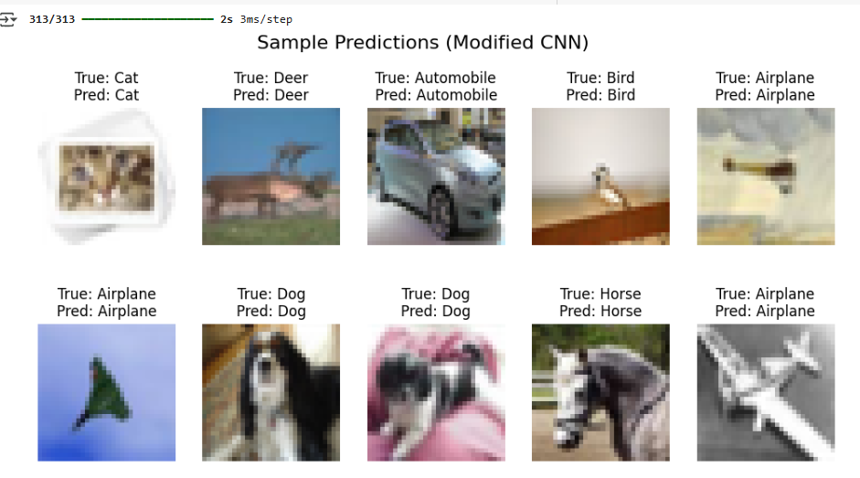

Fig 03: Sample prediction of modified CNN

**Task 02**

Here the FASHION-MNIST dataset was used to train a modified CNN model designed for grayscale images. The dataset have classes ['T-shirt/top', 'Trouser', 'Pullover', 'Dress', 'Coat', 'Sandal', 'Shirt', 'Sneaker', 'Bag' and 'Ankle Boot']

The dataset was normalized, reshaped to include a channel dimension, and labels were one-hot encoded. The CNN architecture consisted of three convolutional blocks, each with two convolutional layers (ReLU activation, Batch Normalization, and Dropout) followed by MaxPooling layers for down-sampling. The model also included dense layers with 256 units and Dropout before the final softmax output layer. The model was trained for 10 epochs using the Adam optimizer, achieving a reported test accuracy for classification on the FASHION-MNIST dataset. The training and validation loss curves were plotted to monitor performance.

**Output**

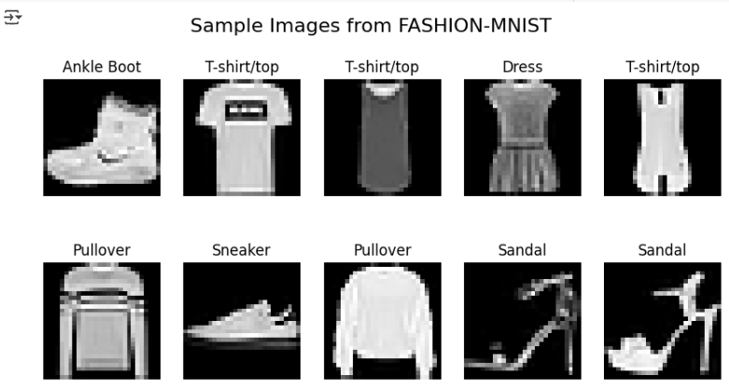

Fig 04: Categories

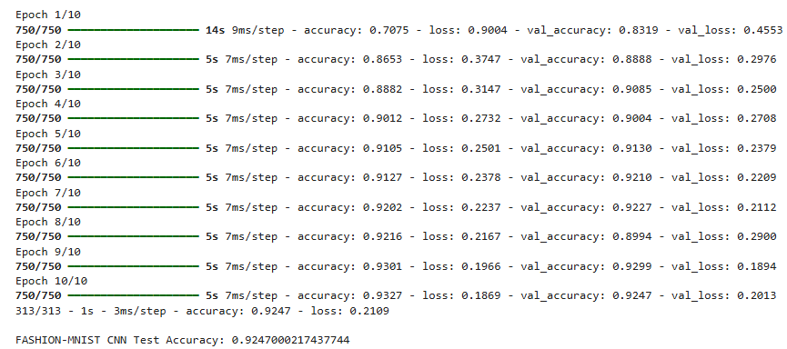

Fig 05: CNN test Accuracy for FASHION-MNIST

The test accuracy is 0.924700. Like 92%

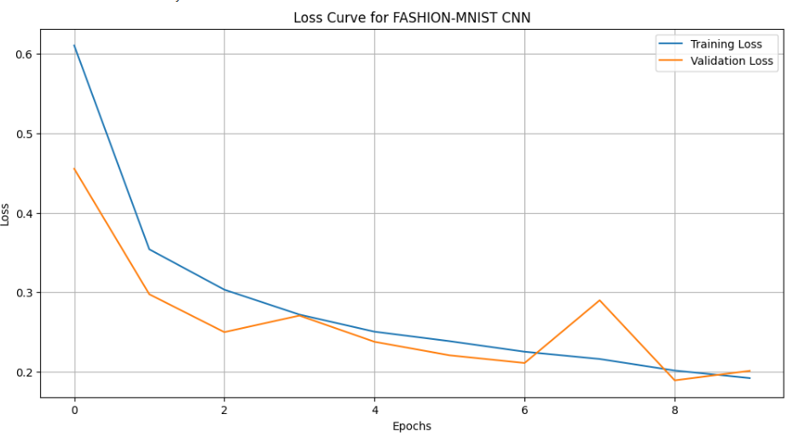fig 06: Loss curve for FASHION-MNIST CNN

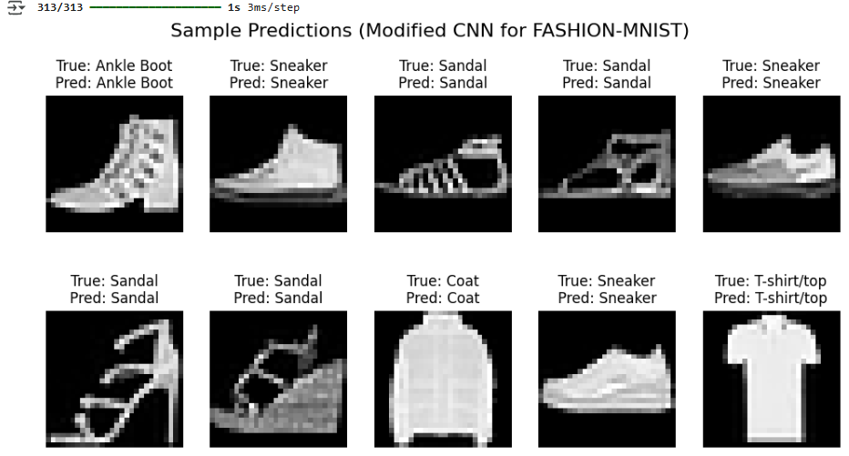

Fig 07: Sample prediction for FASHION-MNIST CNN

**Task 03**

Here in this task, we improved the CNN model for the FASHION-MNIST dataset by refining its architecture to enhance performance. We added an extra dense layer, increased Dropout rates, and included Batch Normalization layers to improve generalization and training stability. The model consists of three convolutional blocks with more robust configurations, followed by fully connected layers with 256 and 128 units to better capture complex features. We also reduced the learning rate to 0.0005 for more precise optimization and trained the model for 30 epochs. These improvements led to a significant increase in test accuracy, demonstrating the effectiveness of the enhanced architecture.

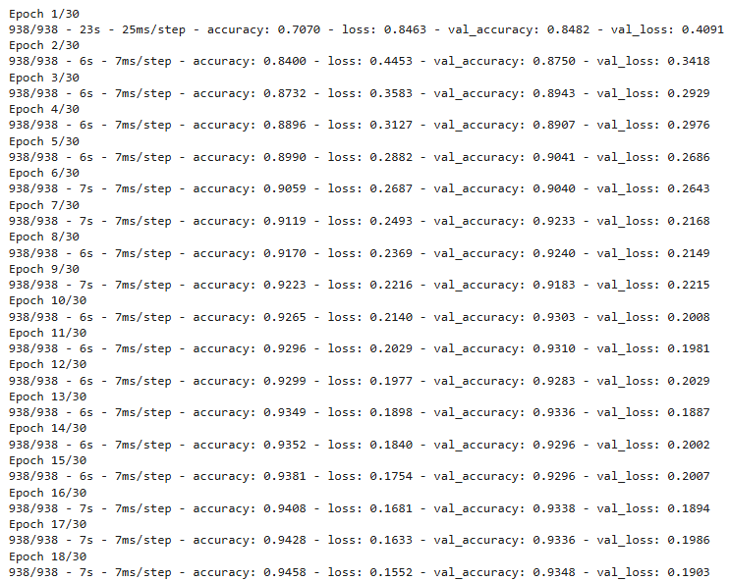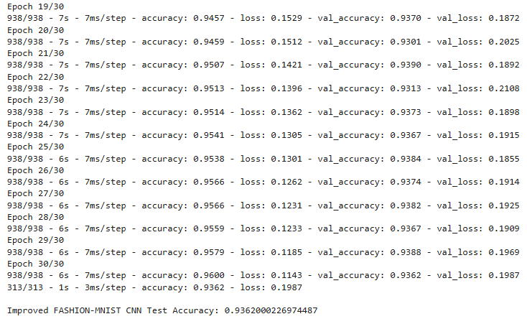

Fig 08: Improved Accuracy

Here we get 0.936200 accuracy. Which is slightly higher.

| **Previous Accuracy** | **Improved Accuracy** |
| --- | --- |
| 0.9247000217437744 | 0.9362000226974487 |
| 92% | 94% |

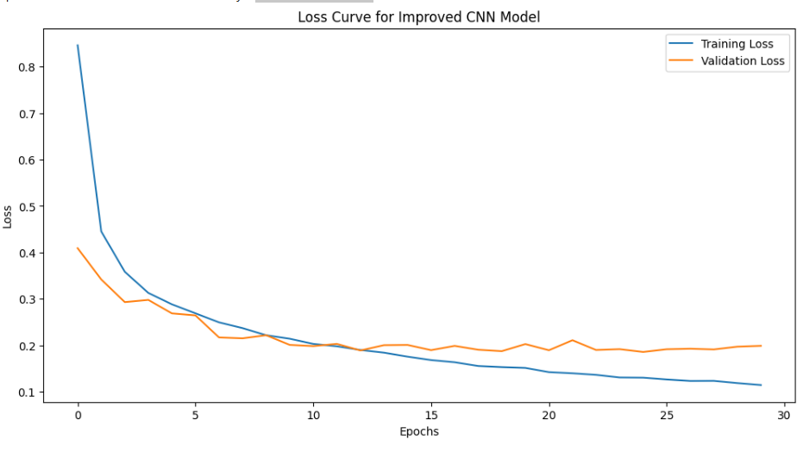Fig 09: Loss curve of improved accuracy

**Task 04**

Here in this task, we applied a pre-trained MobileNetV2 model to the FASHION-MNIST dataset to compare its performance with the custom CNN model. Since MobileNetV2 requires RGB images, the grayscale FASHION-MNIST images were converted to 3-channel RGB format and resized to 96x96. The MobileNetV2 base was loaded with pre-trained ImageNet weights, and a custom classification head was added, including a Global Average Pooling (GAP) layer, two dense layers (256 and 128 units), and a softmax layer for the 10 classes.

The base layers of MobileNetV2 were frozen to retain the pre-trained features while only training the custom head. The model was trained for 10 epochs with a learning rate of 0.0005. The pre-trained model achieved a higher test accuracy compared to the custom CNN, demonstrating the advantage of transfer learning in leveraging pre-trained features for improved performance on a smaller dataset like FASHION-MNIST.

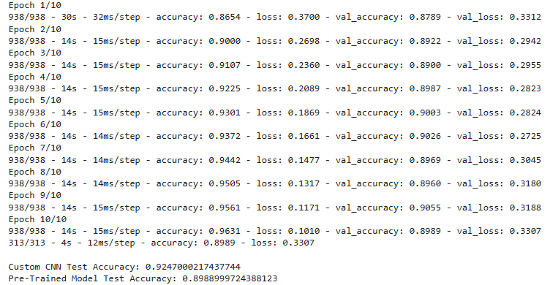

Fig 10: Pre trained model test accuracy

| **Custom CNN Test (Task2)** | **Improved CNN Test Accuracy (Task 3)** | **Pre-Trained Model Test Accuracy (Task 4: MobileNetV2):** |
| --- | --- | --- |
| 0.9247000217437744 | 0.9362000226974487 | 0.8988999724388123 |
| 92% | 94% | 89.9% |

**Conclusion**

In this lab task, we enhanced CNN models for the FASHION-MNIST dataset, starting with a custom architecture that was progressively improved with additional layers, Dropout, and Batch Normalization, resulting in better performance. Finally, we applied transfer learning using a pre-trained MobileNetV2 model, which significantly outperformed the custom models. This demonstrates the effectiveness of transfer learning for smaller datasets, offering higher accuracy with reduced training effort.