**Team Name:** Print_Shop

**Team Members:** Jeandre Stapleberg, Henk Pieterse, Widske Posthumous, Zane Bauermeister

**Target customer segment**

|  |  |
| --- | --- |
| **Demographic Segmentation** | **Age**: +18, **Gender**: All, **Income**: +R50 000 per annum, **Education**: Secondary training, marital status: N/A |
| **Geographic Segmentation** | **Country:** South Africa, **Province:** All |
| **Psychographic Segmentation** | **Personality:** Creative, innovative, **Attitude:** Business driven, **Values:** Quality, **Interests**: In marketing their brand or just being creative and adding to their fashion or style their accessories. |
| **Technographic Segmentation** | **Mobile-use:** Regular mobile use, **desktop-use:** Regular use, **Apps**: Higher time spent on using apps, **Software**: IOs/ Android, windows 8/ 10 |
| **Behavioral Segmentation** | **Tendencies:** Prospective clients try to advertise but usually find it a hassle and they are forced to pay large amounts of money to receive marketing advise.  **Habits:** Prospective clients tend to only advertise when budgets allow for it. |
| **Needs-Based Segmentation** | Prospective clients need an online based design and custom print shop that is feasible, reliable and easy to use anytime. From corporate gifting and dress code, to labelling and packaging. |
| **Value-Based Segmentation** | Small- Medium enterprises will carry most economic value on a regular basis, Larger companies will carry low volumes with higher values. |

**Problem you’re solving:** Providing fast solutions to corporate printing and branding without skipping on quality

**Description of solution:** We print and provide assistance in rebranding your corporate image keeping your corporate image visible.

**Things you have in common:** Share common interest in coding and design.

1. **Where can we find people who are in our customer segment?**
2. **Conducted interviews**
3. **What assumptions do you currently have about your target customers?**
   1. My target customer wants to be able to design and print their creation on accessories and corporate dress to market effortlessly all at one place.

My customer prefers to be able to freely design and have items printed in high quality with vinyl over matt and gloss.

* 1. My customer values user friendly apps and websites with reliable customer service.

1. **Formulate at least two interview questions you can ask to determine whether or not your assumptions are correct:**
   1. Which type of printing do you usually use?
   2. Are you currently using an online platform to print?
   3. Would you advertise more if you could design and print all in one place?
2. **Formulate at least two interview questions that will help you better understand how your target customer currently completes their tasks/solves their problems:**
   1. Where are you currently doing your printing?
   2. Do you “shop” for the most reasonable prices or the highest quality printing?
3. **Formulate two additional questions that you can ask to determine if your product is a good fit for your customer:**
   1. Would you prefer an online site or mobile app to design, create and print effortlessly on your accessories or gifts?
   2. Would you rebrand your corporate image if you had more control over the design and frequency of your advertisements?
4. **Copy questions you’ve come up with to the Customer Interview Form. Make Copies of the Form and use it to take note as you conduct interviews.**
5. **Decide which team members would be responsible for the interviews:** Zane Bauermeister.

**Market Research Findings**

1. **What is your main customer segment?**
2. Small-Medium Enterprizes's , Prospective designers.
3. **What are your customers primary pains or gains?**
4. Finding affordable and reliable printers to advertise their brands/products/services.
5. **What is the primary problem your product can solve or what gain can it create?**
6. User friendly online based all in 1 print shop that could satisfy your business needs.
7. **What are your customers current options for dealing with their problems or achieving the same gain?**
8. They have to design and print at more than one place adding to costs.
9. **How does your product compare to the other options your customer has?**
10. The idea seems feasible at this point.
11. **Why does you customer need your product?**
12. With the current economy everyone cuts on cost doesn’t matter how small. A lot is to save with our products/services without cutting down on advertising or just designing.
13. **What capabilities does your product need to have in order to solve your customers problem?**
14. Variety of products and services with good customers support and a reliable webapp.

**TOP 3 COMPETITORS**

1. 3@1 PRINTERS Cradlesstone
   1. Direct Competitor
   2. Offers t-shirt, corporate gifts, accessories and stationary printing
   3. Customers enjoy their vast variety of printing options
   4. Customers experienced bad customer support and rushed print jobs
   5. Our printing is online based and has a full comprehensive system to handle customer support
2. Royal Print & Stationary
   1. Direct competitor
   2. Offers business branded car magnets and stationary printing
   3. Customers appreciate the variety of branding options
   4. Bad reviews regarding customer service
   5. Our business will hold the advantage of having a website and mobile app, which is user friendly
3. Banderaz Print
   1. Indirect competitor
   2. Offers vehicle branding, packaging and barcode printing
   3. Customers have enjoyed great customer service
   4. Lack of variety in products and services
   5. Our advantages will be to have a large variety of products and services to grow till we are your 1 stop printing shop.

**Customer Persona**

Name: Nick Davis

Age: 32

Title: Mr.

Jobs:

* functional – Business owner
* Social – Providing an income and employment
* Emotional – Employer, father, husband

Pain points and troubles – As a new business owner he wants to advertise his products and services all at one place for a reasonable price

Goals and Motivation – To improve his brand image and draw in more customers, letting his business grow and be known through advertising.

Technical Ability :

Spending time on technology has made him very knowledgeable. This he accomplished through spending 2-3 hours a day on his mobile phone, desktop pc and tablet.

Environment:

* Physical – Startup business located from home or a small business in his hometown.
* Social – Culture of everyone has a mobile device and knowledge of the internet.
* Technological – Internet is widely available to majority of prospective clients.

Additional notes: Nick has a startup business which he would like to brand with his own designs and have it advertised to capture the attention of his prospective clients through printing on t-shirts, accessories and corporate gifts.

**Define System requirements**

Use Case 1: Browsing the Page

Actor: Prospective client

Trigger: Prospective client browses through different product/services pages and description pages.

Pre-conditions: Prospective client is connected to the internet, via mobile or desktop.

Post-conditions: Browser/App opens a new window to display product pages with descriptions with links to the Contact Us.

Flow:

* 1. Prospective client is connected to the internet.
  2. Client opens the webpage via a mobile device or desktop.
  3. The Webpage will display to a user-friendly home page.
  4. The client will select the product page to evaluate if we are able to satisfy a need.
  5. The Webpage will include a visible link to the Contact Us pages to easily assist the client in purchases or inquiries.

Use Case 2: Login and Purchase

Actor: Prospective Client

Trigger: Client is interested in the products and wants to log in and start purchase or designing their own brands.

Pre-conditions: The client should already be on the home page of the website/app.

Post-conditions: The website will open to login window capturing the personal information of the user to store for their purchase info.

Flow:

* 1. The user is currently on the home page of the website/app.
  2. The system will prompt a login or register window where the user's personal information will be stored for future purchases.
  3. The user will be redirected to the products pages after sign-in or registering.
  4. The system will display products and services with images and links to the Contact Us page.
  5. The user is now free to select and purchase any windows on the webpage and website.

Use Case 3: Customer Care

Actor: The User

Trigger: The user has feedback on products or services. The user may have inquiries about products or general help form customer support.

Pre-conditions: The user is logged into the website/app and on the Contact Us page.

Post-conditions: The system will display various sources of contact information like numbers, addresses, locations and support email.

Flow:

* 1. The user selects the Contact Us page.
  2. The system opens a new window/page to display various contact information.
  3. The user can trigger the email, maps and telephone link to contact support.

**Evaluate User Experience**

**What are the three things you use this app to do?**

* Design
* Advertising
* Print

**Which feature of the app let you accomplish these goals?**

* Design canvas
* Share design
* Create website

**Are some features missing?**

* Video editing

**What do you as a user need to do to interact with these features?**

* Be connected to the internet
* Use a paid premium membership subscription

**How many clicks does it take to accomplish your goals?**

* 10-50

**Paper frame**

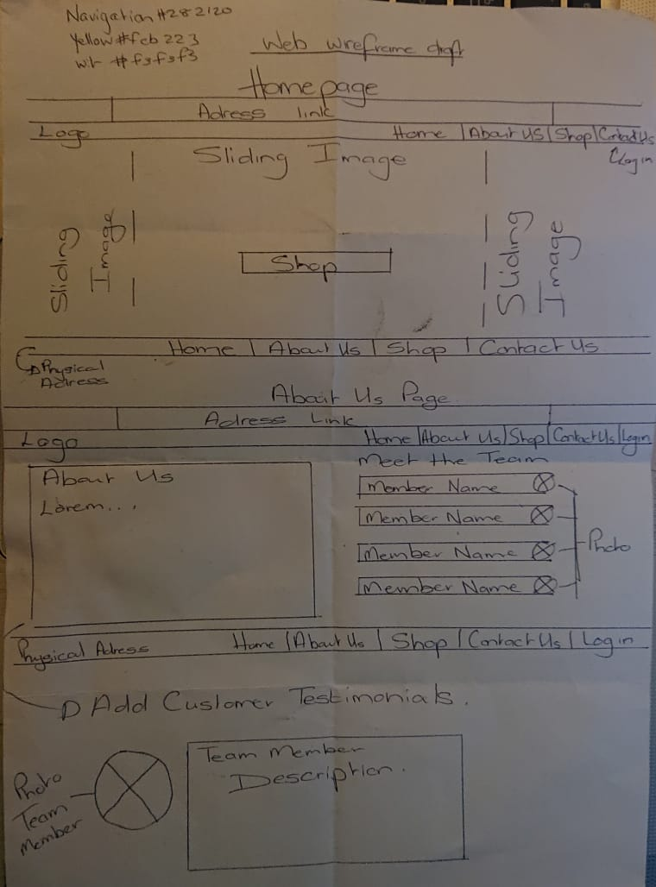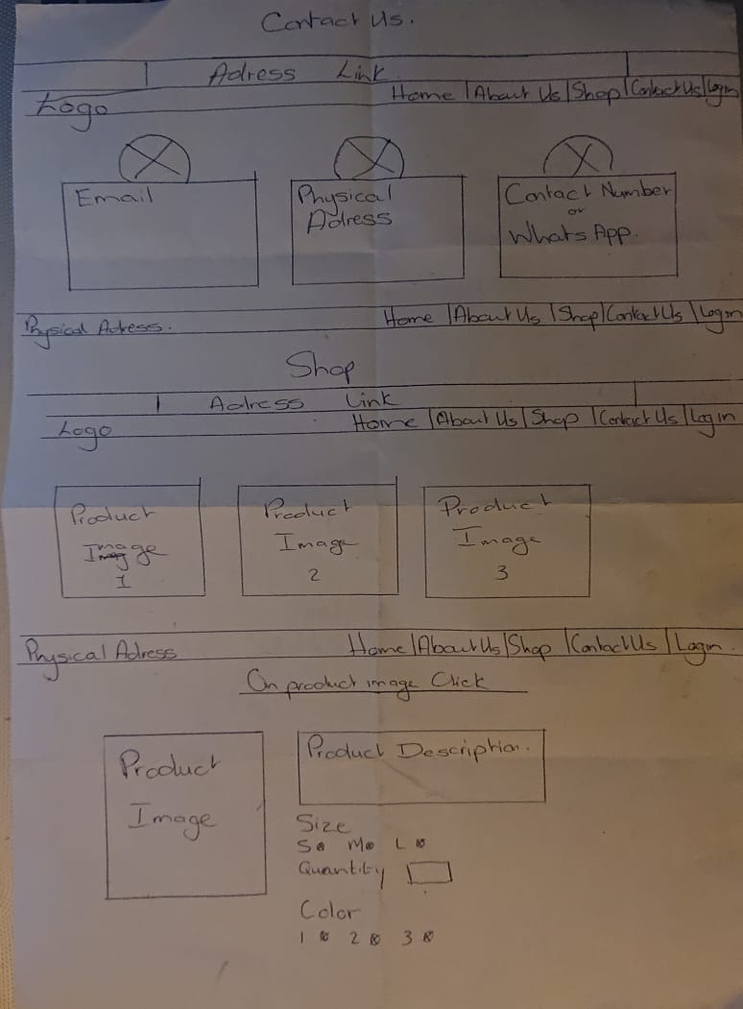

**Wire Frame**

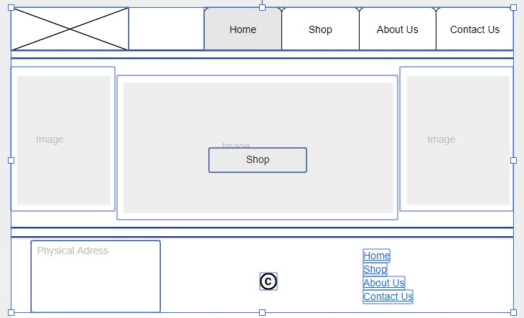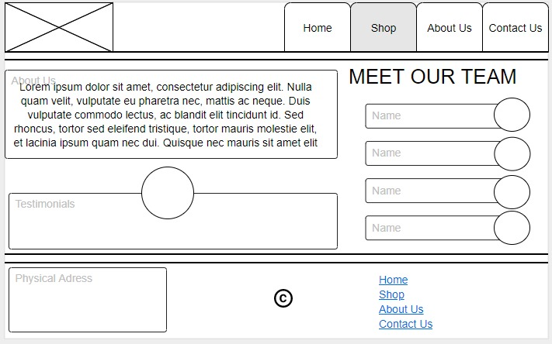

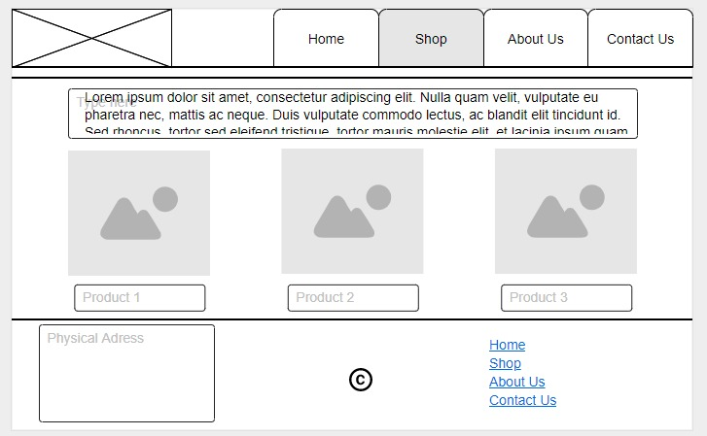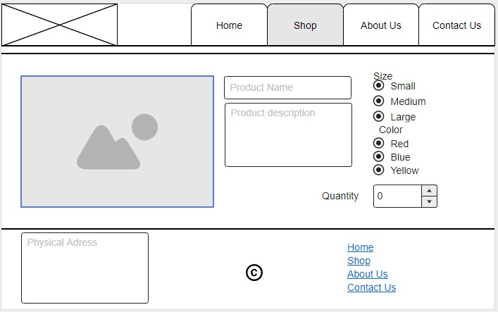

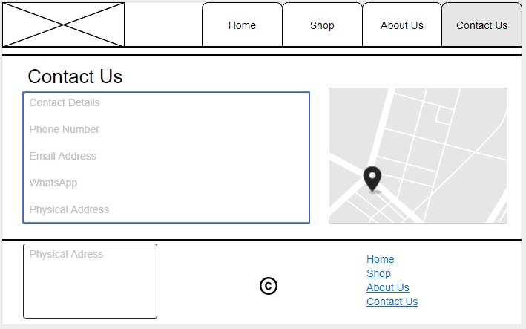

**Sources:**

<https://www.w3schools.com/tags/att_input_type_radio.asp>

<https://wp-en.oberlo.com/wp-content/uploads/2020/01/morning-1772286_1280.jpg>

<https://lh3.googleusercontent.com/proxy/FIfkzJvAauxcOfBaFQ5f7GE9GFnNY0zgnhWoVKldCCxZGHtUu27Km5x1rxTMWwWuYn_bM0dvqAtLwiQEES7Z9TFi_aJqIRtnLs2kNUkXGOYiZuxndN1JwFngGw>

<https://docs.microsoft.com/en-us/azure/azure-sql/database/connect-query-vscode>