# SMLM_data_processing documentation

The MATLAB app allows to evaluate single molecule localization microscopy data in the form of tiff image stacks (time series) taken in a total internal reflection fluorescence (TIRF) microscope. It estimates 3D position, signal and background level for each individual molecule.

To avoid localization biases, the app allows the user to measure optical aberrations present in the microscope by taking a z-stack of a small (e.g. 100 nm) fluorescent bead. This feature makes it also possible to evaluate data taken with engineered PSFs (e.g. using a cylindrical lens).

The app consists of three parts that can be also run individually:

|  |  |
| --- | --- |
| **„SMLM_data_processing.mlapp“** | The main app |
| **“construct_PSF.mlapp”** | An app to construct point spread functions, which can be loaded into and used in the main app |
| **“aberration_measurement.mlapp”** | An app to estimate pupil phase aberrations from a previously recorded z-stack of a single fluorescent bead |

1. Installation

Unpack the zip archive and double click on the apps to install them in Matlab. They will appear in the MATLAB “apps” bar. **When executing the apps, be sure that the Matlab path is set to the path where the folders “example data” and “user data” are located**. The latter contains files that characterize the PSF, objective lenses, cameras and aberrations. Otherwise, the app fails to load the default PSF at startup.

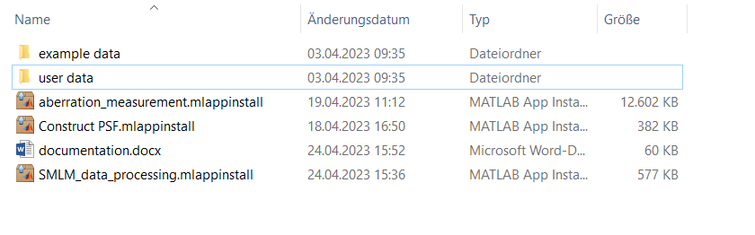

1. SLM_data_processing

Fig. 1.1. shows the “define PSF” tab as it should appear at startup.

The **text box** contains info about the PSF such as name, defocus value, oversampling value, the used camera and objective lens (an explanation to these parameters is found in chapter 3).   
The **figure on the right** allows one to inspect the PSF for all z-values it supports. The z-value is defined as the position of a molecule form the coverslip and ranges from 0 to $λ_{em}/3$ (a third of the peak emission wavelength).

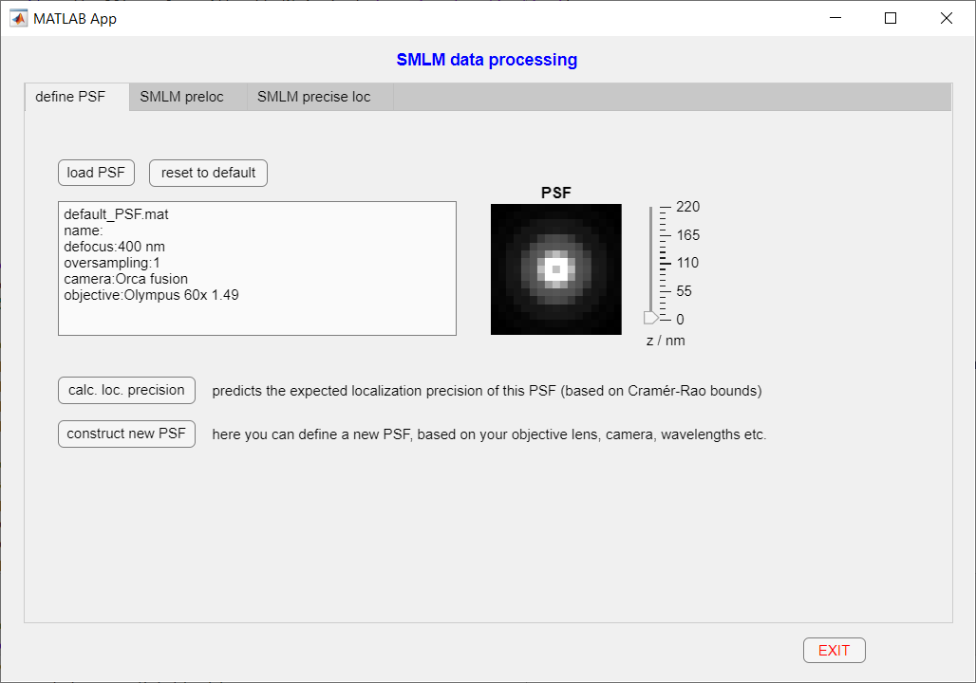

Figure 1.1. The "define PSF" tab of the main app. It allows the user to load and inspect point spread functions (PSF) created by the app “construct_PSF.mlapp”.

|  |  |
| --- | --- |
| **reset to default** | Resets the PSF to the default PSF. To change the default PSF to a user-defined one, you have to construct it in “construct_PSF.mlapp” and save it as “default_PSF.mat” in the folder “.\user data\PSFs”. |
| **calc. loc. precision** | displays the expected localization precision of the PSF using Cramér Rao lower bounds. |
| **construct new PSF** | Launches the app “construct_PSF.mlapp” |

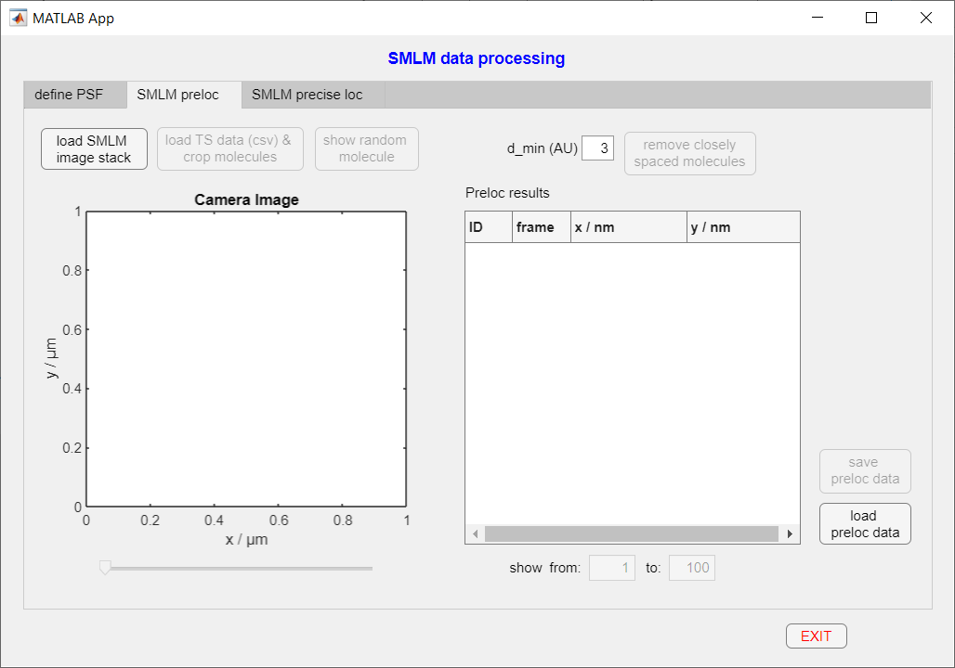

Abbildung 1.2. "SMLM preloc" tab.