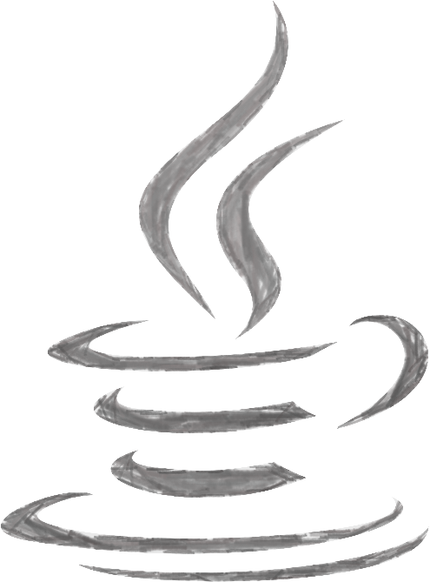

Practical File for

**Programming in Java**

Paper Code –

32341201

Submitted By –

Anshul Verma

College Roll No. – 19/78065

B.Sc. (Hons) Computer Science

Submitted To –

Ms. Parul Jain

Department of Computer Science

**Atma Ram Sanatan Dharma College**

University of Delhi

Index

|  |  |  |
| --- | --- | --- |
| S.No. | Topic | Page No. |
| 1 | Practical #01 | 02 - 03 |
| 2 | Practical #02 | 04 - 06 |
| 3 | Practical #03 | 07 - 10 |
| 4 | Practical #04 | 11 – 12 |
| 5 | Practical #05 | 13 - 16 |
| 6 | Practical #06 | 17 - 18 |
| 7 | Practical #07 | 19 - 20 |
| 8 | Practical #08 | 21 - 23 |
| 9 | Practical #09 | 24 - 25 |
| 10 | Practical #10 | 26 - 28 |
| 11 | Practical #11 | 29 - 31 |
| 12 | Practical #12 | 32 - 36 |
| 13 | Practical #13 | 37 - 50 |

Practical 1

Design a class Complex having a real part (x) and an imaginary part (y). Provide methods to perform the following on complex numbers:   
a) Add two complex numbers.

b) Multiply two complex numbers.

c) toString() method to display complex numbers in the form:

x + i y

Code :

**/**** ComplexNumber.java ****/**

public class ComplexNumber{

    double x, y;

    ComplexNumber(){

        this.x = 0;

        this.y = 0;

    }

    ComplexNumber(double r, double i){

        this.x = r;

        this.y = i;

    }

    // Addition of two complex numbers

    public static ComplexNumber add(ComplexNumber a, ComplexNumber b) {

        ComplexNumber n = new ComplexNumber();

        n.x = a.x + b.x;

        n.y = a.y + b.y;

        return n;

    }

    // Multiplication of two complex numbers

    public static ComplexNumber multiply(ComplexNumber a, ComplexNumber b) {

        ComplexNumber n = new ComplexNumber();

        n.x = (a.x*b.x) - (a.y*b.y);

        n.y = (a.x*b.y) + (a.y*b.x);

        return n;

    }

    public String toString() {

        return ("( " + this.x + " + " + this.y + "i )");

    }

    public static void main(String[] args) {

        ComplexNumber n1 = new ComplexNumber(1,1);

        ComplexNumber n2 = new ComplexNumber(1,1);

        System.out.println("\n Adding two numbers...\n");

        ComplexNumber addN = add(n1,n2);

        System.out.println(n1.toString() + " + " + n2.toString() + " = " + addN.toString());

        System.out.println("\n Multiplying two numbers...\n");

        ComplexNumber mulN = multiply(n1,n2);

        System.out.println(n1.toString() + " * " + n2.toString() + " = " + mulN.toString());

    }

}

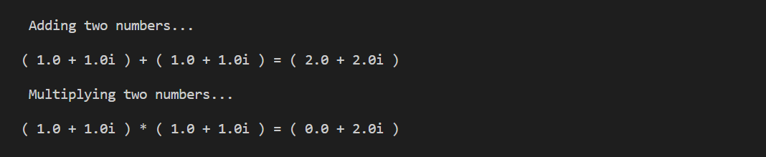Output :

Practical 2

Create a class TwoDim which contains private members as x and y coordinates in package P1. Define the default constructor, a parameterized constructor and override toString() method to display the co-ordinates. Now reuse this class and in package P2 create another class ThreeDim, adding a new dimension as z as its private member. Define the constructors for the subclass and override toString() method in the subclass also. Write appropriate methods to show dynamic method dispatch. The main() function should be in a package P.

Code :

**/**** P1/TwoDim.java ****/**

package P1;

public class TwoDim {

    private int x;

    private int y;

    public TwoDim() {

        this.x = 0;

        this.y = 0;

    }

    public TwoDim(int x, int y) {

        this.x = x;

        this.y = y;

    }

    @Override

    public String toString() {

        return "Coordinates are : x = " + this.x + ", y = " + this.y;

    }

}

**/**** P2/ThreeDim.java ****/**

package P2;

import P1.TwoDim;

public class ThreeDim extends TwoDim {

    private int z;

    public ThreeDim() {

        super();

        this.z = 0;

    }

    public ThreeDim(int x, int y, int z) {

        super(x, y);

        this.z = x;

    }

    @Override

    public String toString() {

        return super.toString() + ", z = " + this.z;

    }

}

**/**** P/Main.java ****/**

package P;

import P1.TwoDim;

import P2.ThreeDim;

public class Main {

    public static void main(String[] args) {

        TwoDim obj = new TwoDim(4, 6);

        System.out.println("\n" + obj);

        obj = new ThreeDim(3, 4, 9);

        System.out.println(obj);

    }

}

Output :

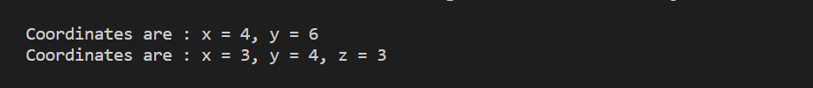

Practical 3

Define an abstract class Shape in package P1. Inherit two more classes: Rectangle in package P2 and Circle in package P3. Write a program to ask the user for the type of shape and then using the concept of dynamic method dispatch, display the area of the appropriate subclass. Also write appropriate methods to read the data. The main() function should not be in any package.

Code :

**/**** P1/Shape.java ****/**

package P1;

public abstract class Shape {

    public abstract void get() throws java.io.IOException;

    public abstract double area() throws java.io.IOException;

}

**/**** P2/Rectangle.java ****/**

package P2;

import P1.Shape;

import java.io.*;

public class Rectangle extends Shape {

    private double l, b;

    public void get() throws java.io.IOException {

        BufferedReader br = new BufferedReader(new InputStreamReader(System.in));

        System.out.print("\nEnter the length of Rectangle : ");

        l = Double.parseDouble(br.readLine());

        System.out.print("Enter the beadth of Rectangle : ");

        b = Double.parseDouble(br.readLine());

    }

    public double area() throws java.io.IOException {

        get();

        return l * b;

    }

}

**/**** P3/Circle.java ****/**

package P3;

import P1.Shape;

import java.io.*;

public class Circle extends Shape {

    private double r;

    public void get() throws java.io.IOException {

        BufferedReader br = new BufferedReader(new InputStreamReader(System.in));

        System.out.print("\nEnter the Radius of circle : ");

        r = Double.parseDouble(br.readLine());

    }

    public double area() throws java.io.IOException {

        get();

        return Math.PI * (r * r);

    }

}

**/**** Main.java ****/**

import java.io.*;

import P1.Shape;

import P2.Rectangle;

import P3.Circle;

public class Main {

    public static void main(String[] args) throws java.io.IOException {

        BufferedReader br = new BufferedReader(new InputStreamReader(System.in));

        System.out.println("\nSelect a Shape : 1) Rectangle, 2) Circle");

        System.out.print("1 or 2 ? : ");

        Shape shape;

        switch (Integer.parseInt(br.readLine())) {

            case 1:

                shape = new Rectangle();

                System.out.println("\n> Area : " + shape.area() + " sq. units");

                break;

            case 2:

                shape = new Circle();

                System.out.println("\n> Area : " + shape.area() + " sq. units");

                break;

            default:

                System.out.println("\nInvalid Choice!");

                break;

        }

    }

}

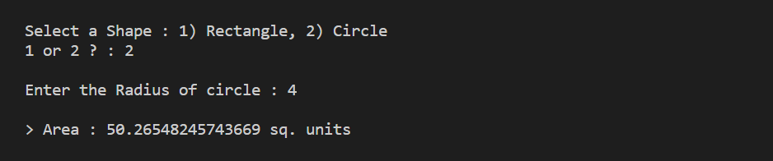Output :

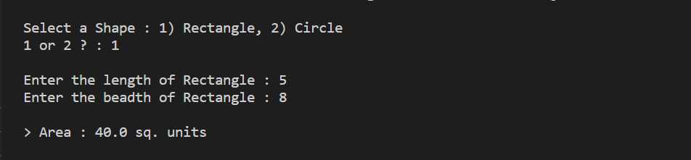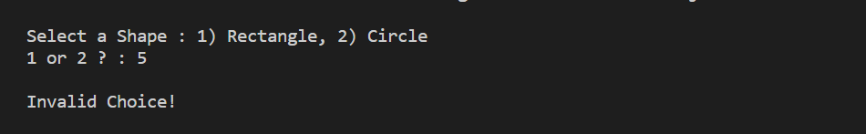

Practical 4

Create an exception subclass UnderAge, which prints “Under Age” along with the age value when an object of UnderAge class is printed in the catch statement. Write a class exceptionDemo in which the method test() throws UnderAge exception if the variable age passed to it as argument is less than 18. Write main() method also to show working of the program.

Code :

**/**** UnderAgeException.java ****/**

public class UnderAgeException extends Exception {

    int age;

    UnderAgeException(int age) {

        this.age = age;

    }

    @Override

    public String getMessage() {

        return "Under Age : " + this.age;

    }

}

**/**** exceptionDemo.java ****/**

import java.util.Scanner;

public class exceptionDemo {

    public static void test(int age) throws UnderAgeException {

        if (age < 18)

            throw new UnderAgeException(age);

    }

    public static void main(String[] args) {

        Scanner sc = new Scanner(System.in);

        System.out.print("\nEnter the age : ");

        int age = sc.nextInt();

        try {

            test(age);

            System.out.println(">> Test Sucessful");

        } catch (UnderAgeException e) {

            System.err.println(e.getMessage());

            System.out.println(">> Test Unsucessful");

        } finally {

            sc.close();

        }

    }

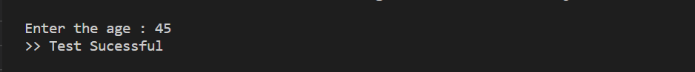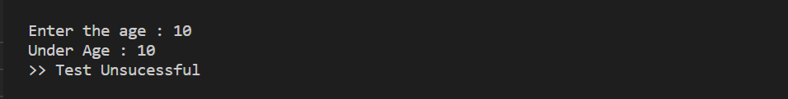Output :

Practical 5

Write a program to implement stack. Use exception handling to manage underflow and overflow conditions.

Code :

**/**** StackException.java ****/**

public class StackException extends Exception {

    String message;

    StackException(String message) {

        this.message = message;

    }

    @Override

    public String getMessage() {

        return message;

    }

}

**/**** Stack.java ****/**

public class Stack {

    private int tos;

    private int[] elements;

    private int size;

    Stack(int size) {

        this.tos = -1;

        this.size = size;

        elements = new int[this.size];

    }

    public void push(int e) throws StackException {

        if (tos == size - 1)

            throw new StackException("Stack Overflow : could not push, stack is full");

        else {

            elements[++this.tos] = e;

            System.out.println(e + " pushed into Stack");

        }

    }

    public int pop() throws StackException {

        if (tos < 0)

            throw new StackException("Stack Underflow : could not pop, stack is empty");

        else

            return this.elements[tos--];

    }

    public int peek() throws StackException {

        if (tos < 0)

            throw new StackException("Stack Underflow : could not peek, stack is empty");

        else

            return this.elements[tos];

    }

    public int tos() {

        return this.tos;

    }

    @Override

    public String toString() {

        return "Stack : size = " + this.size;

    }

**/**** Main.java ****/**

import java.util.Random;

public class Main {

    public static void main(String[] args) {

        int r;

        Stack s = new Stack(5);

        Random random = new Random(1242);

        System.out.println("\nCreated a stack : " + s.toString());

        System.out.println("Pushing into stack...");

        while (true) {

            r = random.nextInt(100);

            System.out.println("Pushing " + r + " into stack");

            try {

                s.push(r);

                System.out.println("Elements in stack : " + s.tos() + 1);

            } catch (StackException e) {

                System.err.println(e.getMessage());

                break;

            }

        }

        System.out.println("Popping from stack...");

        while (true) {

            r = random.nextInt(100);

            System.out.println("Pushing " + r + " into stack");

            try {

                System.out.println("Popped " + s.pop() + " from stack");

            } catch (StackException e) {

                System.err.println(e.getMessage());

                break;

            }

        }

    }

}

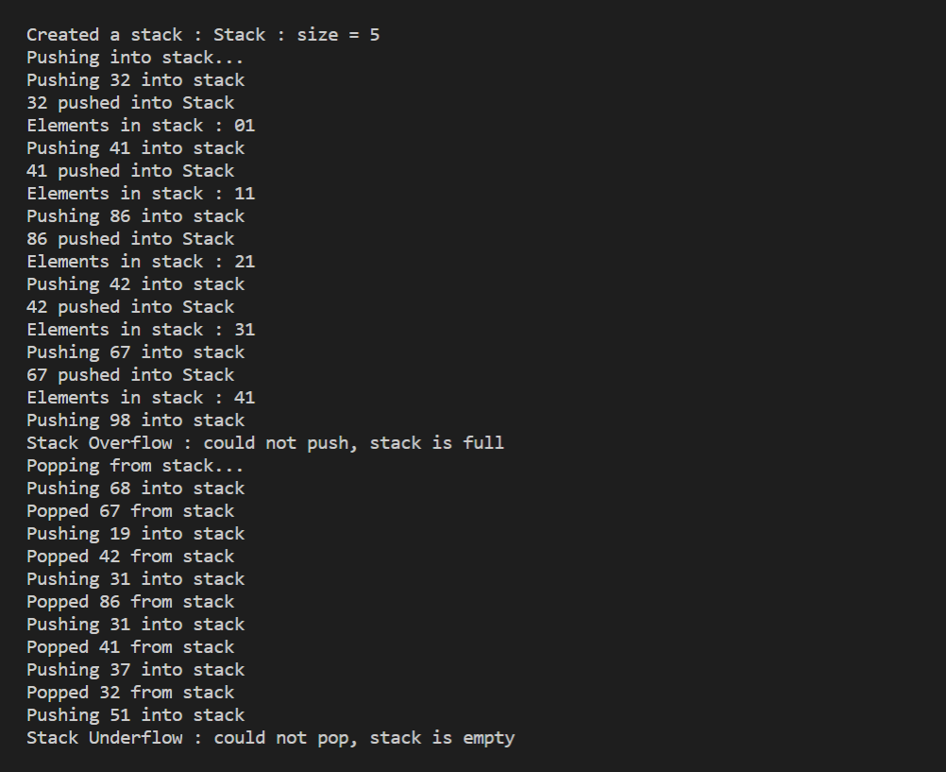Output :

Practical 6

Write a program that copies content of one file to another. Pass the names of the files through command-line arguments.

Code :

**/**** FileCopy.java ****/**

import java.io.*;

public class FileCopy {

    public static void main(String[] args) throws Exception {

        if (args.length != 2)

            System.out.println("\nCorrect Usage : java FileCopy <filename1.txt> <filename2.txt>");

        else {

            FileInputStream fin = new FileInputStream(args[0]);

            FileOutputStream fout = new FileOutputStream(args[1]);

            int i;

            System.out.println("\nCopying data from " + args[0] + " to " + args[1] + "....");

            while ((i = fin.read()) != -1) {

                fout.write(i);

            }

            System.out.println(">> Copying Done!");

            fin.close();

            fout.close();

        }

    }

}

**/**** original.txt ****/**

>> Anshul Verma

>> ARSD College

>> BSc (Hons) Computer Science

Output :

**/**** copied.txt ****/**

>> Anshul Verma

>> ARSD College

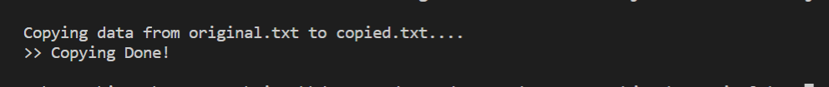>> BSc (Hons) Computer Science

**Error :**

Practical 7

Write a program to read a file and display only those lines that have the first two characters as '//' (Use try with resources).

Code :

**/**** FilteredDisplay.java ****/**

import java.io.*;

public class FilteredDisplay {

    public static void main(String[] args) {

        if (args.length != 1)

            System.err.println("\nCorrect Usage : java FilteredDisplay <filename.txt>");

        else {

            try (BufferedReader br = new BufferedReader(new FileReader(args[0]))) {

                String line;

                System.out.println("\nReading " + args[0] + "...\n");

                while ((line = br.readLine()) != null) {

                    if (line.trim().substring(0, 2).equals("//")) {

                        System.out.println(line);

                    }

                }

                br.close();

            } catch (final Exception e) {

                System.err.println(e.getMessage());

            }

        }

    }

}

**/**** file.txt ****/**

/start

Name :

//Anshul Verma

College :

//ARSD College

Course :

//BSc (Hons) Computer Science

//end

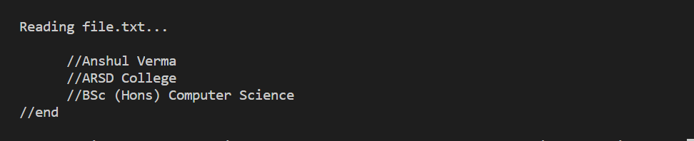Output :

**Error :**

Practical 8

Write a program to create a frame using AWT. Implement mouseClicked(), mouseEntered() and mouseExited() events such that:

a) Size of the frame should be tripled when mouse enters it.

b) Frame should reduce to its original size when mouse is clicked in it.

c) Close the frame when mouse exits it.

Code :

**/**** DemoAWT1.java ****/**

import java.awt.*;

import java.awt.event.*;

public class DemoAWT1 {

    public static void main(String[] args) {

        int width = 300, height = 150;

        Frame fr = new Frame("AWT Demo 1");

        Label l1 = new Label();

        Label l2 = new Label(width + "x" + height);

        l1.setBounds(50, 50, 100, 25);

        l2.setBounds(50, 75, 100, 25);

        l1.setAlignment(Label.CENTER);

        l2.setAlignment(Label.CENTER);

        fr.add(l1);

        fr.add(l2);

        fr.setSize(width, height);

        fr.setLayout(null);

        fr.setVisible(true);

        fr.addWindowListener(new WindowAdapter() {

            public void windowClosing(WindowEvent we) {

                fr.dispose();

            }

        });

        fr.addMouseListener(new MouseListener() {

            public void mousePressed(MouseEvent e) {

            }

            public void mouseReleased(MouseEvent e) {

            }

            public void mouseExited(MouseEvent e) {

                l1.setText("Mouse Exited");

                l2.setText(fr.getWidth() + "x" + fr.getHeight());

                fr.dispose();

            }

            public void mouseEntered(MouseEvent e) {

                l1.setText("Mouse Entered");

                fr.setSize(fr.getWidth() * 3, fr.getHeight() * 3);

                l2.setText(fr.getWidth() + "x" + fr.getHeight());

            }

            public void mouseClicked(MouseEvent e) {

                l1.setText("Mouse Clicked");

                fr.setSize(width, height);

                l2.setText(fr.getWidth() + "x" + fr.getHeight());

            }

        });

    }

}

Output :

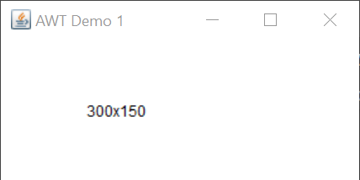

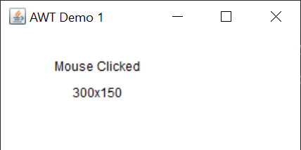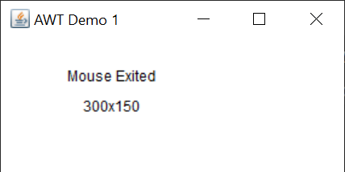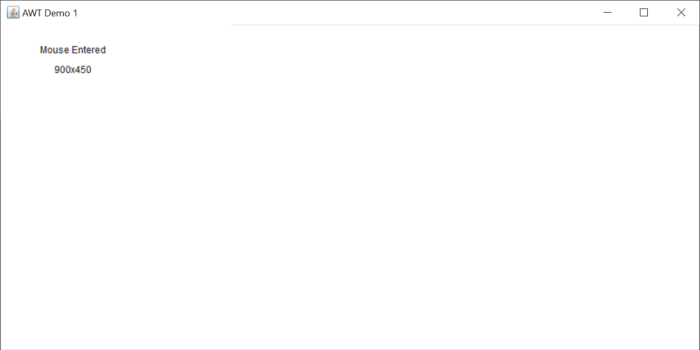

Practical 9

Using AWT, write a program to display a string in frame window with pink color as background.

Code :

**/**** DemoAWT2.java ****/**

import java.awt.*;

import java.awt.event.*;

public class DemoAWT2 extends Frame {

    Label l;

    DemoAWT2() {

        super("AWT Demo 2");

        l = new Label("This is a string.");

        l.setBounds(100, 50, 100, 25);

        l.setAlignment(Label.CENTER);

        this.add(l);

        this.setSize(300, 125);

        this.setBackground(Color.PINK);

        this.setVisible(true);

        this.addWindowListener(new WindowAdapter() {

            public void windowClosing(WindowEvent we) {

                dispose();

            }

        });

    }

    public static void main(String[] args) {

        new DemoAWT2();

    }

}

Output :

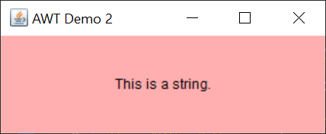

Practical 10

Using AWT, write a program to create two buttons named “Red” and “Blue”. When a button is pressed the background color should be set to the color named by the button’s label.

Code :

**/**** DemoAWT3.java ****/**

import java.awt.*;

import java.awt.event.*;

public class DemoAWT3 extends Frame implements ActionListener {

    Button btnRed, btnBlue;

    DemoAWT3() {

        super("AWT Demo 3");

        btnRed = new Button("Red");

        btnRed.setBounds(50, 100, 300, 50);

        btnRed.addActionListener(this);

        btnBlue = new Button("Blue");

        btnBlue.setBounds(50, 200, 300, 50);

        btnBlue.addActionListener(this);

        this.add(btnRed);

        this.add(btnBlue);

        this.setSize(400, 350);

        this.setLayout(null);

        this.setVisible(true);

        this.addWindowListener(new WindowAdapter() {

            public void windowClosing(WindowEvent e) {

                dispose();

            }

        });

    }

    @Override

    public void actionPerformed(ActionEvent e) {

        if (e.getSource() == btnBlue) {

            this.setBackground(Color.BLUE);

        }

        if (e.getSource() == btnRed) {

            this.setBackground(Color.RED);

        }

    }

    public static void main(String[] args) {

        new DemoAWT3();

    }

}

Output :

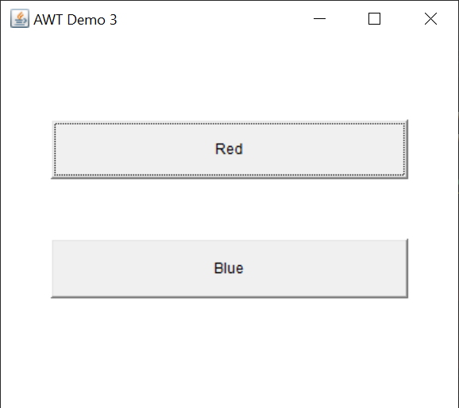

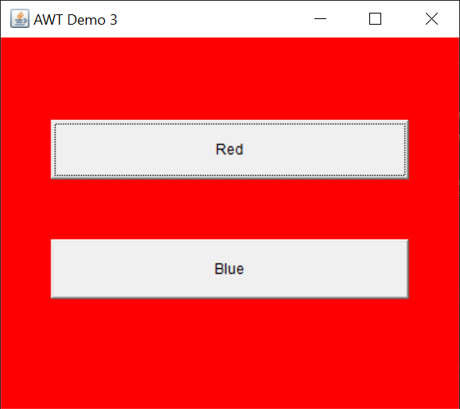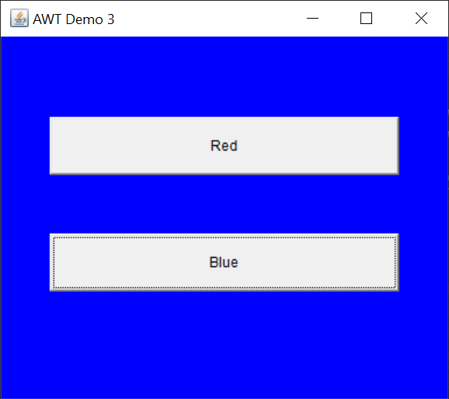

Practical 11

Using AWT, write a program which responds to KEY_TYPED event and updates the status window with message (“Typed character is: X”). Use adapter class for other two events.

Code :

**/**** DemoAWT4.java ****/**

import java.awt.*;

import java.awt.event.*;

public class DemoAWT4 extends Frame {

    Label l1, l2, l3;

    DemoAWT4() {

        super("AWT Demo 3");

        l1 = new Label();

        l1.setBounds(50, 50, 300, 50);

        l1.setAlignment(Label.CENTER);

        l2 = new Label();

        l2.setBounds(50, 100, 300, 50);

        l2.setAlignment(Label.CENTER);

        l3 = new Label();

        l3.setBounds(50, 150, 300, 50);

        l3.setAlignment(Label.CENTER);

        this.add(l1);

        this.add(l2);

        this.add(l3);

        this.setSize(400, 250);

        this.setLayout(null);

        this.setVisible(true);

        this.addKeyListener(new KeyAdapter() {

            @Override

            public void keyTyped(KeyEvent e) {

                l1.setText("Typed Character is : " + e.getKeyChar());

            }

            @Override

            public void keyPressed(KeyEvent e) {

                l2.setText("Pressed Character is : " + e.getKeyChar());

            }

            @Override

            public void keyReleased(KeyEvent e) {

                l2.setText("No Key is pressed");

                l3.setText("Released Character is : " + e.getKeyChar());

            }

        });

        this.addWindowListener(new WindowAdapter() {

            public void windowClosing(WindowEvent e) {

                dispose();

            }

        });

    }

    public static void main(String[] args) {

        new DemoAWT4();

    }

}

Output :

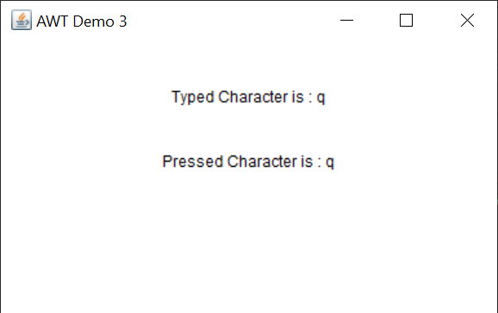

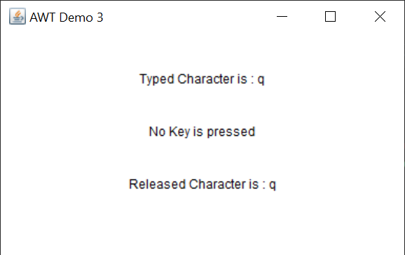

Practical 12

Using AWT, write a program to create two buttons labelled ‘A’ and ‘B’. When button ‘A’ is pressed, it displays your personal information (Name, Course, Roll No, College) and when button ‘B’ is pressed, it displays your CGPA in previous semester.

Code :

**/**** Info.java ****/**

import java.awt.*;

import java.awt.event.*;

public class Info extends Frame implements ActionListener {

    Panel pnl;

    Label lName, lCourse, lRollNo, lCollege;

    Button btnClose;

    Info() {

        super("Personal Information");

        lName = new Label("Name     :  Anshul Verma");

        lName.setBounds(50, 50, 300, 50);

        lCourse = new Label("Course   :  BSc (Hons) Computer Science");

        lCourse.setBounds(50, 100, 300, 50);

        lRollNo = new Label("Roll No. :  19/78065");

        lRollNo.setBounds(50, 150, 300, 50);

        lCollege = new Label("College  :  ARSD College");

        lCollege.setBounds(50, 200, 300, 50);

        btnClose = new Button("Close");

        btnClose.setBounds(100, 300, 200, 50);

        btnClose.addActionListener(this);

        pnl = new Panel();

        pnl.setLayout(null);

        pnl.add(lName);

        pnl.add(lCourse);

        pnl.add(lRollNo);

        pnl.add(lCollege);

        pnl.add(btnClose);

        this.add(pnl);

        this.setSize(400, 450);

        this.setVisible(true);

        this.addWindowListener(new WindowAdapter() {

            public void windowClosing(WindowEvent e) {

                dispose();

            }

        });

    }

    public void actionPerformed(ActionEvent e) {

        dispose();

    }

}

**/**** CGPA.java ****/**

import java.awt.*;

import java.awt.event.*;

public class CGPA extends Frame implements ActionListener {

    Label lCGPA;

    Button btnClose;

    CGPA() {

        super("CGPA");

        lCGPA = new Label("Previous Semester CGPA : 8.32");

        lCGPA.setBounds(50, 50, 300, 50);

        btnClose = new Button("Close");

        btnClose.setBounds(100, 150, 200, 50);

        btnClose.addActionListener(this);

        this.add(lCGPA);

        this.add(btnClose);

        this.setSize(400, 250);

        this.setLayout(null);

        this.setVisible(true);

        this.addWindowListener(new WindowAdapter() {

            public void windowClosing(WindowEvent e) {

                dispose();

            }

        });

    }

    public void actionPerformed(ActionEvent e) {

        dispose();

    }

}

**/**** DemoAWT5.java ****/**

import java.awt.*;

import java.awt.event.*;

public class DemoAWT5 extends Frame implements ActionListener {

    Button btnA, btnB;

    DemoAWT5() {

        super("AWT Demo 5");

        btnA = new Button("A");

        btnA.setBounds(50, 100, 300, 50);

        btnA.addActionListener(this);

        btnB = new Button("B");

        btnB.setBounds(50, 200, 300, 50);

        btnB.addActionListener(this);

        this.add(btnA);

        this.add(btnB);

        this.setSize(400, 350);

        this.setLayout(null);

        this.setVisible(true);

        this.addWindowListener(new WindowAdapter() {

            public void windowClosing(WindowEvent e) {

                dispose();

            }

        });

    }

    @Override

    public void actionPerformed(ActionEvent e) {

        if (e.getSource() == btnA) {

            new Info();

        }

        if (e.getSource() == btnB) {

            new CGPA();

        }

    }

    public static void main(String[] args) {

        new DemoAWT5();

    }

}

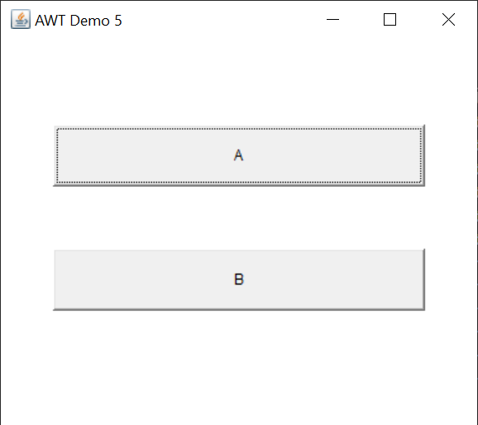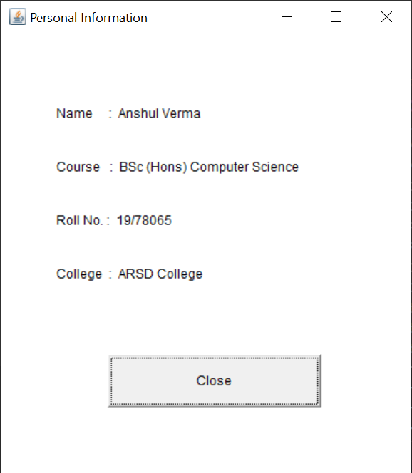Output :

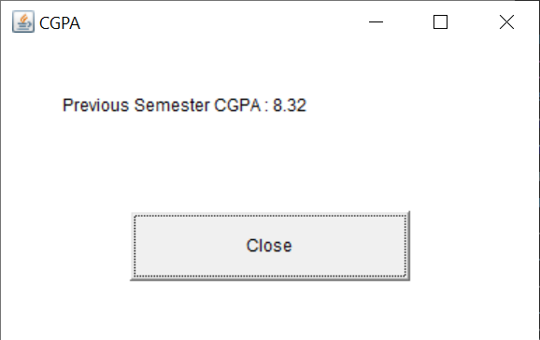

Practical 13

Rewrite all the above GUI programs using Swing.

**----------------------- 1 -------------------------**

Code :

**/**** DemoSwing1.java ****/**

import javax.swing.*;

import java.awt.event.*;

public class DemoSwing1 {

    int width = 300, height = 150;

    JLabel jLbl1, jLbl2;

    DemoSwing1() {

        JFrame jFrame = new JFrame("Swing Demo 1");

        jFrame.setLayout(null);

        jFrame.setSize(width, height);

        jFrame.setDefaultCloseOperation(JFrame.EXIT_ON_CLOSE);

        jLbl1 = new JLabel("", JLabel.CENTER);

        jLbl2 = new JLabel(width + "x" + height, JLabel.CENTER);

        jLbl1.setBounds(50, 50, 100, 25);

        jLbl2.setBounds(50, 75, 100, 25);

        jFrame.add(jLbl1);

        jFrame.add(jLbl2);

        jFrame.setVisible(true);

        jFrame.addMouseListener(new MouseListener() {

            public void mousePressed(MouseEvent e) {

            }

            public void mouseReleased(MouseEvent e) {

            }

            public void mouseExited(MouseEvent e) {

                jLbl1.setText("Mouse Exited");

                jLbl2.setText(jFrame.getWidth() + "x" + jFrame.getHeight());

                jFrame.dispose();

            }

            public void mouseEntered(MouseEvent e) {

                jLbl1.setText("Mouse Entered");

                jFrame.setSize(jFrame.getWidth() * 3, jFrame.getHeight() * 3);

                jLbl2.setText(jFrame.getWidth() + "x" + jFrame.getHeight());

            }

            public void mouseClicked(MouseEvent e) {

                jLbl1.setText("Mouse Clicked");

                jFrame.setSize(width, height);

                jLbl2.setText(jFrame.getWidth() + "x" + jFrame.getHeight());

            }

        });

    }

    public static void main(String[] args) {

        SwingUtilities.invokeLater(new Runnable() {

            @Override

            public void run() {

                new DemoSwing1();

            }

        });

    }

}

Output :

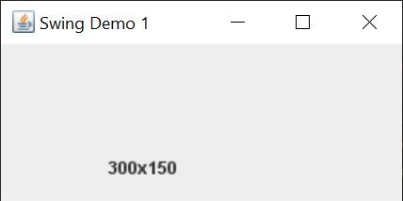

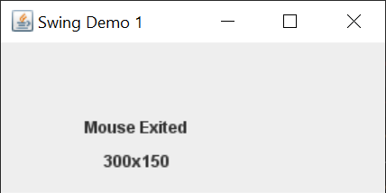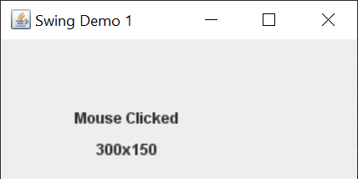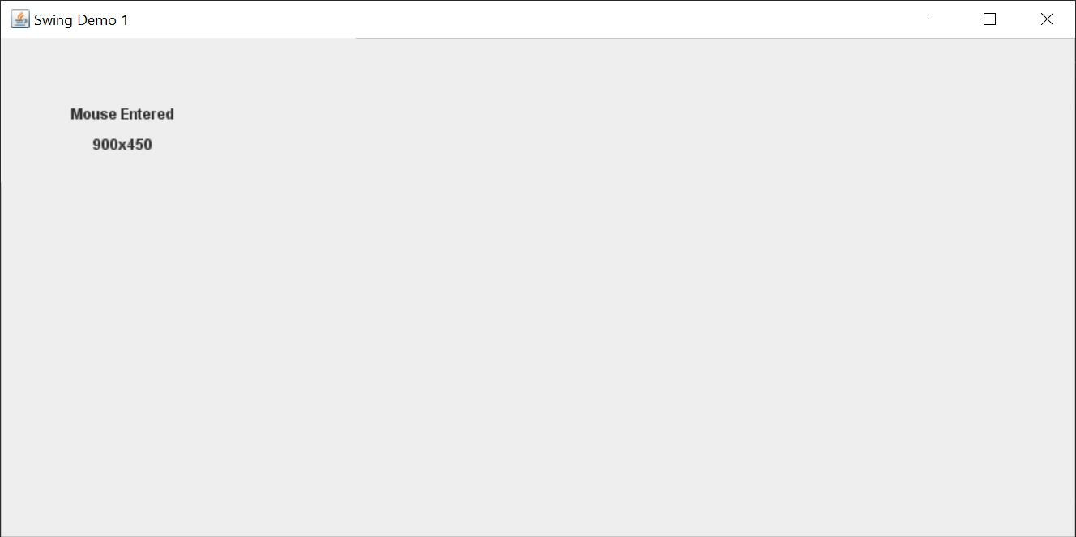

**----------------------- 2 -------------------------**

Code :

**/**** DemoSwing2.java ****/**

import javax.swing.*;

import java.awt.Color;

import java.awt.event.*;

public class DemoSwing2 {

    DemoSwing2() {

        JFrame jFrame = new JFrame("Swing Demo 2");

        JLabel jLbl = new JLabel("This is a string.", JLabel.CENTER);

        jLbl.setBounds(100, 50, 100, 25);

        jFrame.add(jLbl);

        jFrame.setSize(300, 125);

        jFrame.getContentPane().setBackground(Color.PINK);

        jFrame.setVisible(true);

        jFrame.setDefaultCloseOperation(JFrame.EXIT_ON_CLOSE);

    }

    public static void main(String[] args) {

        SwingUtilities.invokeLater(new Runnable() {

            @Override

            public void run() {

                new DemoSwing2();

            }

        });

    }

}

Output :

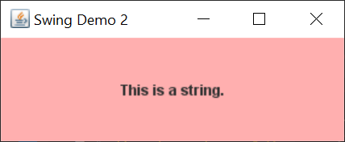

**----------------------- 3 -------------------------**

Code :

**/**** DemoSwing3.java ****/**

import javax.swing.*;

import java.awt.Color;

import java.awt.event.*;

public class DemoSwing3 implements ActionListener {

    JFrame jFrame;

    JButton jbtnRed, jbtnBlue;

    DemoSwing3() {

        jFrame = new JFrame("Swing Demo 3");

        jbtnRed = new JButton("Red");

        jbtnRed.setBounds(50, 100, 300, 50);

        jbtnRed.addActionListener(this);

        jbtnBlue = new JButton("Blue");

        jbtnBlue.setBounds(50, 200, 300, 50);

        jbtnBlue.addActionListener(this);

        jFrame.add(jbtnRed);

        jFrame.add(jbtnBlue);

        jFrame.setSize(400, 350);

        jFrame.setLayout(null);

        jFrame.setVisible(true);

        jFrame.setDefaultCloseOperation(JFrame.EXIT_ON_CLOSE);

    }

    @Override

    public void actionPerformed(ActionEvent e) {

        if (e.getSource() == jbtnBlue) {

            jFrame.getContentPane().setBackground(Color.BLUE);

        }

        if (e.getSource() == jbtnRed) {

            jFrame.getContentPane().setBackground(Color.RED);

        }

    }

    public static void main(String[] args) {

        SwingUtilities.invokeLater(new Runnable() {

            @Override

            public void run() {

                new DemoSwing3();

            }

        });

    }

}

Output :

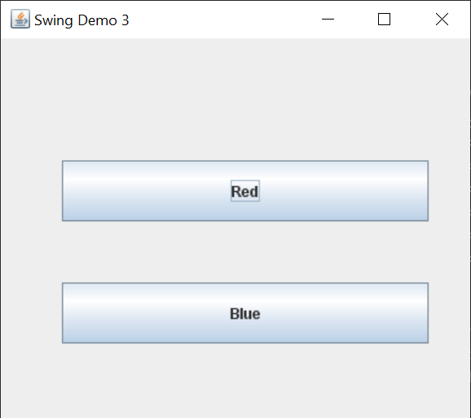

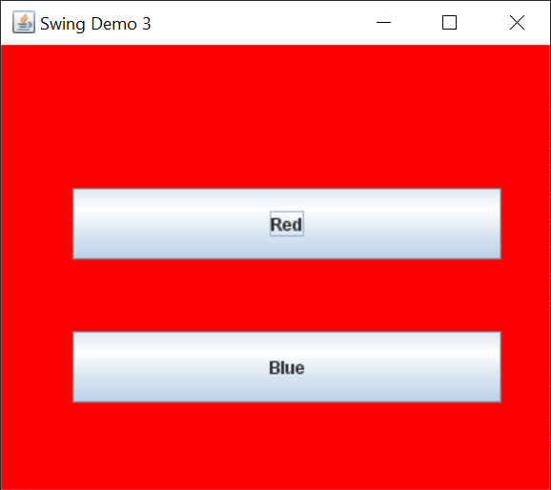

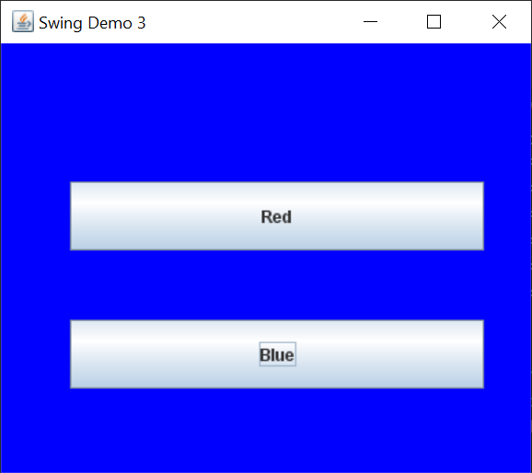

**----------------------- 4 -------------------------**

Code :

**/**** DemoSwing4.java ****/**

import javax.swing.*;

import java.awt.event.*;

public class DemoSwing4 {

    JLabel jl1, jl2, jl3;

    DemoSwing4() {

        JFrame jFrame = new JFrame("Demo Swing 4");

        jl1 = new JLabel("", JLabel.CENTER);

        jl1.setBounds(50, 50, 300, 50);

        jl2 = new JLabel("", JLabel.CENTER);

        jl2.setBounds(50, 100, 300, 50);

        jl3 = new JLabel("", JLabel.CENTER);

        jl3.setBounds(50, 150, 300, 50);

        jFrame.add(jl1);

        jFrame.add(jl2);

        jFrame.add(jl3);

        jFrame.setSize(400, 250);

        jFrame.setLayout(null);

        jFrame.setVisible(true);

        jFrame.setDefaultCloseOperation(JFrame.EXIT_ON_CLOSE);

        jFrame.addKeyListener(new KeyAdapter() {

            @Override

            public void keyTyped(KeyEvent e) {

                jl1.setText("Typed Character is : " + e.getKeyChar());

            }

            @Override

            public void keyPressed(KeyEvent e) {

                jl2.setText("Pressed Character is : " + e.getKeyChar());

            }

            @Override

            public void keyReleased(KeyEvent e) {

                jl2.setText("No Key is pressed");

                jl3.setText("Released Character is : " + e.getKeyChar());

            }

        });

    }

    public static void main(String[] args) {

        SwingUtilities.invokeLater(new Runnable() {

            @Override

            public void run() {

                new DemoSwing4();

            }

        });

    }

}

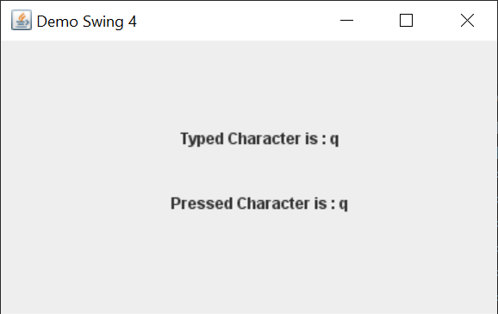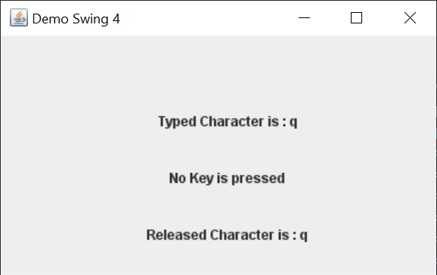Output :

**----------------------- 5 -------------------------**

Code :

**/**** Info.java ****/**

import javax.swing.*;

import java.awt.event.*;

public class Info {

    Info() {

        JFrame jFrame = new JFrame("Personal Information");

        JLabel jlName = new JLabel("Name     :  Anshul Verma");

        jlName.setBounds(50, 50, 300, 50);

        JLabel jlCourse = new JLabel("Course   :  BSc (Hons) Computer Science");

        jlCourse.setBounds(50, 100, 300, 50);

        JLabel jlRollNo = new JLabel("Roll No. :  19/78065");

        jlRollNo.setBounds(50, 150, 300, 50);

        JLabel jlCollege = new JLabel("College  :  ARSD College");

        jlCollege.setBounds(50, 200, 300, 50);

        JButton jbtnClose = new JButton("Close");

        jbtnClose.setBounds(100, 300, 200, 50);

        jbtnClose.addActionListener(new ActionListener() {

            public void actionPerformed(ActionEvent e) {

                jFrame.dispose();

            }

        });

        JPanel jPanel = new JPanel();

        jPanel.setLayout(null);

        jPanel.add(jlName);

        jPanel.add(jlCourse);

        jPanel.add(jlRollNo);

        jPanel.add(jlCollege);

        jPanel.add(jbtnClose);

        jFrame.add(jPanel);

        jFrame.setSize(400, 450);

        jFrame.setVisible(true);

        jFrame.setDefaultCloseOperation(JFrame.EXIT_ON_CLOSE);

    }

}

**/**** CGPA.java ****/**

import javax.swing.*;

import java.awt.event.*;

public class CGPA {

    CGPA() {

        JFrame jFrame = new JFrame("CGPA");

        JLabel jlCGPA = new JLabel("Previous Semester CGPA : 8.32");

        jlCGPA.setBounds(50, 25, 300, 50);

        JButton jbtnClose = new JButton("Close");

        jbtnClose.setBounds(100, 125, 200, 50);

        jbtnClose.addActionListener(new ActionListener() {

            public void actionPerformed(ActionEvent e) {

                jFrame.dispose();

            }

        });

        jFrame.add(jlCGPA);

        jFrame.add(jbtnClose);

        jFrame.setSize(400, 250);

        jFrame.setLayout(null);

        jFrame.setVisible(true);

        jFrame.setDefaultCloseOperation(JFrame.EXIT_ON_CLOSE);

    }

}

**/**** DemoSwing5.java ****/**

import javax.swing.*;

import java.awt.event.*;

public class DemoSwing5 implements ActionListener {

    JButton jbtnA, jbtnB;

    DemoSwing5() {

        JFrame jFrame = new JFrame("Swing Demo 1");

        JPanel jPanel = new JPanel();

        jbtnA = new JButton("A");

        jbtnA.setBounds(50, 50, 300, 50);

        jbtnA.addActionListener(this);

        jbtnB = new JButton("B");

        jbtnB.setBounds(50, 150, 300, 50);

        jbtnB.addActionListener(this);

        jPanel.add(jbtnA);

        jPanel.add(jbtnB);

        jPanel.setLayout(null);

        jFrame.add(jPanel);

        jFrame.setSize(400, 300);

        jFrame.setVisible(true);

        jFrame.setDefaultCloseOperation(JFrame.EXIT_ON_CLOSE);

    }

    @Override

    public void actionPerformed(ActionEvent e) {

        if (e.getSource() == jbtnA) {

            new Info();

        }

        if (e.getSource() == jbtnB) {

            new CGPA();

        }

    }

    public static void main(String[] args) {

        SwingUtilities.invokeLater(new Runnable() {

            @Override

            public void run() {

                new DemoSwing5();

            }

        });

    }

}

Output :

