Assignment-8:
Q1. Display all flights.
Query: db.flights.find({})
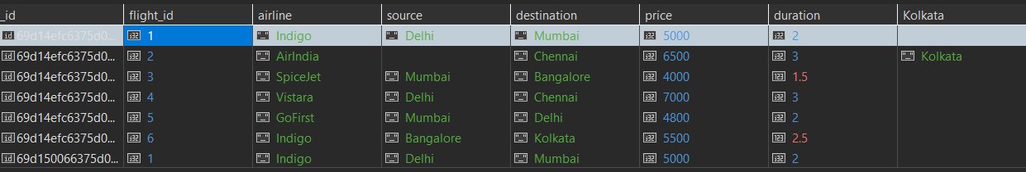

Q2. Display passenger_name and city from bookings.
Query: db.bookings.find({}, { passenger_name: 1, city: 1, _id: 0 })
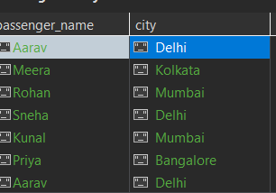
Q3. Find flights where source is Delhi.
Query: db.flights.find({ source: "Delhi" })
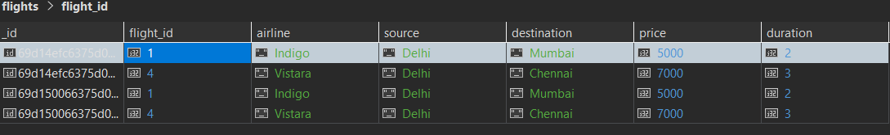
Q4. Find bookings where seats = 1.
Query: db.bookings.find({ seats: 1 })
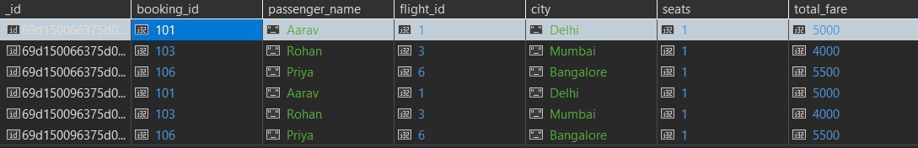
Q5. Sort flights by price in ascending order.
Query: db.flights.find({}).sort({ price: 1 })
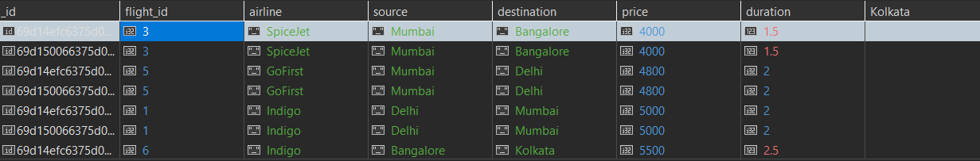
Q6. Display top 2 bookings with highest total_fare.
Query: db.bookings.find({}).sort({ total_fare: -1 }).limit(2)
Q7. Find flights where price is greater than 5000.
Query: db.flights.find({ price: { $gt: 5000 } })
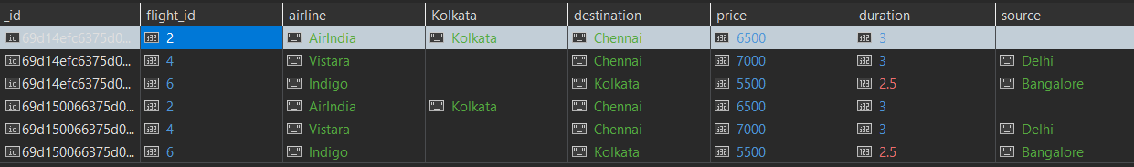
Q8. Display flights where destination is not Chennai.
Query: db.flights.find({ destination: { $ne: "Chennai" } })
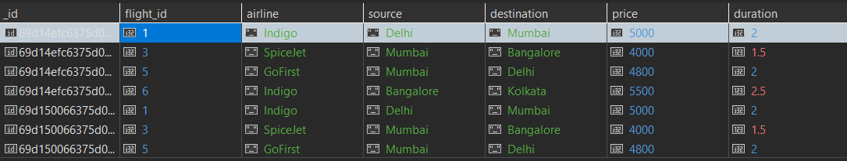
Q9. Find bookings where seats are between 1 and 2.
Query: db.bookings.find({ seats: { $gte: 1, $lte: 2 } })
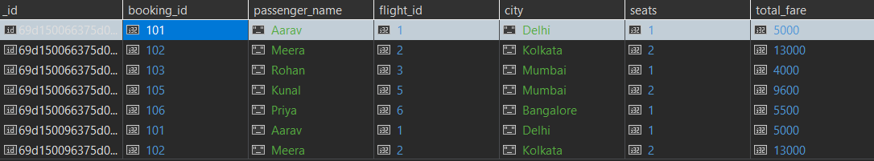
Q10. Update price by +500 for flights of airline "Indigo".
Query: db.flights.updateMany({ airline: "Indigo" }, { $inc: { price: 500 } })
Q11. Delete bookings where seats are greater than 2.
Query: db.bookings.deleteMany({ seats: { $gt: 2 } })
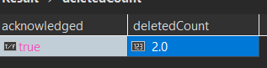
Q12. Find total fare collected city-wise. (Aggregation)
Query: db.bookings.aggregate([{ $group: { _id: "$city", totalFare: { $sum: "$total_fare" } } }])
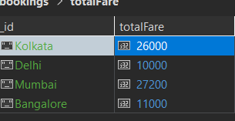
Q13. Find average flight price per airline. (Aggregation)
Query: db.flights.aggregate([{ $group: { _id: "$airline", avgPrice: { $avg: "$price" } } }])
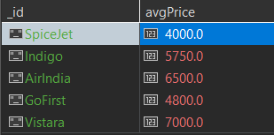
Q14. Display airlines where average price is greater than 5500. (Aggregation + filter
Query: db.flights.aggregate([{ $group: { _id: "$airline", avgPrice: { $avg: "$price" } } }, { $match: { avgPrice: { $gt: 5500 } } }])
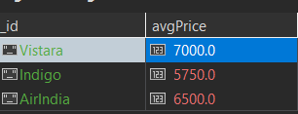
Q15. Find maximum total_fare among bookings for each city. (Aggregation)
Query: db.bookings.aggregate([{ $group: { _id: "$city", maxFare: { $max: "$total_fare" } } }])
