ASSIGNMENT-9
Name : Prionti Majumder
Roll: CSE 204
Table:members
member_id | name | plan | city | fee
1 | Aarav | Gold | Delhi | 5000
2 | Meera | Silver | Mumbai | 3000
3 | Rohan | Gold | Bangalore | 5500
4 | Sneha | Platinum | Delhi | 7000
5 | Kunal | Silver | Chennai | 3200

Table : sessions
session_id | member_id | trainer | duration | calories
101 | 1 | Raj | 60 | 400
102 | 2 | Simran | 45 | 300
103 | 3 | Raj | 70 | 500
104 | 4 | Aman | 80 | 600
105 | 5 | Raj | 50 | 350
Questions:
Q1. Display all members
Query:db.members.find()
Output:
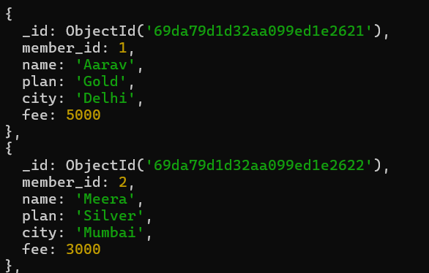
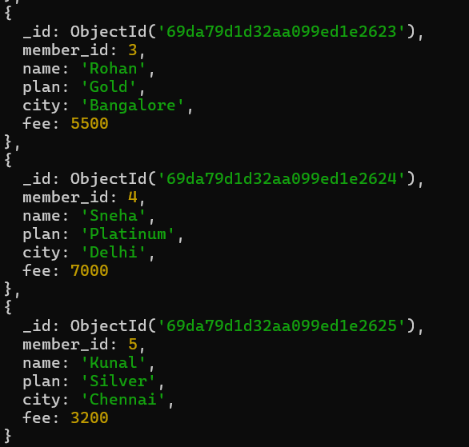
Q2. Show name and plan only
Query: db.members.find({}, {name:1, plan:1, _id:0})
Output:
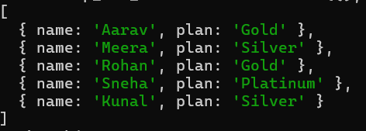
Q3. Find members from Delhi
Query: db.members.find({city:"Delhi"})
Output:
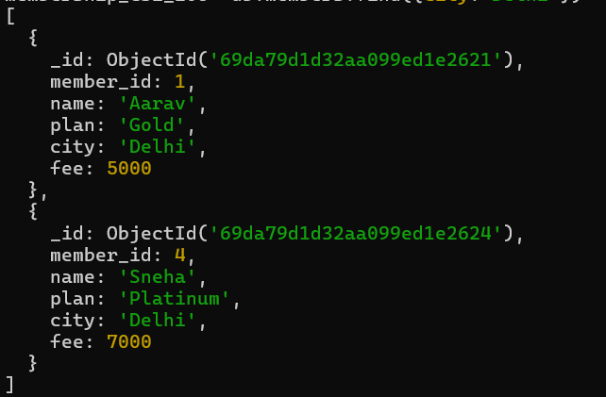
Q4. Find sessions with duration > 60
Query: db.sessions.find({duration:{$gt:60}})
Output:
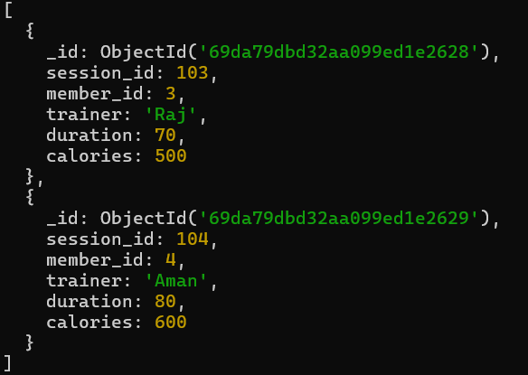
Q5. Sort members by fee descending
Query: db.members.find().sort({fee:-1})
Output:
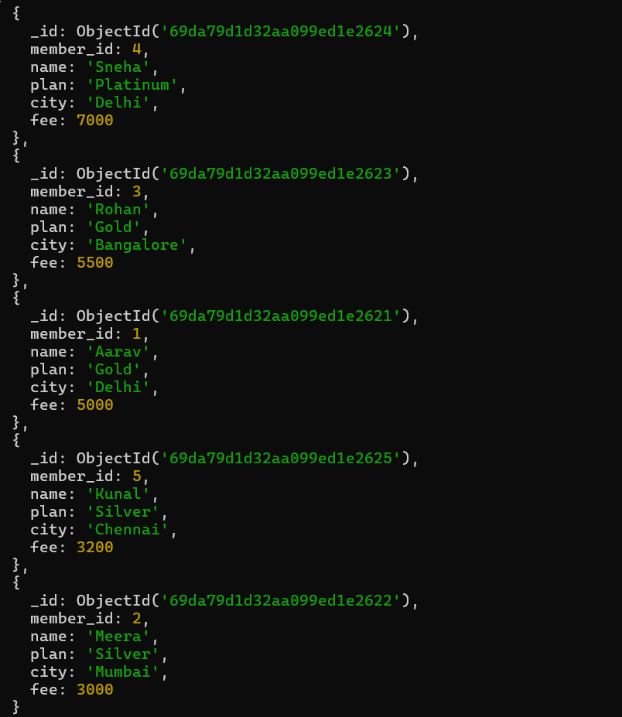
Q6. Update fee +500 for Gold members
Query: db.members.updateMany({plan:"Gold"}, {$inc:{fee:500}})
Output:
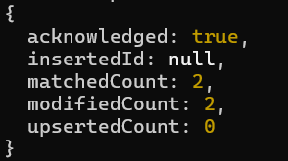
Q7. Delete members with fee < 3500
Query: db.members.deleteMany({fee:{$lt:3500}})
Output: { acknowledged: true, deletedCount: 2 }
Q8. Insert a new member
Query: db.members.insertOne({member_id:6, name:"Ankit", plan:"Gold", city:"Kolkata", fee:6000})
Output:{acknowledged: true,
insertedId: ObjectId('69da8066d32aa099ed1e262b')}
Q9. Average fee per plan
Query: db.members.aggregate([{$group:{_id:"$plan", avgFee:{$avg:"$fee"}}}])
Output:
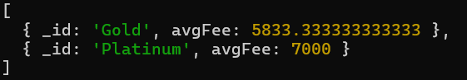
Q10. Total calories burned per trainer
Query: db.sessions.aggregate([{$group:{_id:"$trainer", totalCalories:{$sum:"$calories"}}}])
Output:
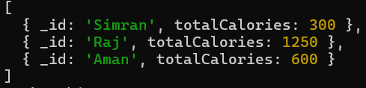
Q11. Maximum fee per city
Query: db.members.aggregate([{$group:{_id:"$city", maxFee:{$max:"$fee"}}}])
Output:
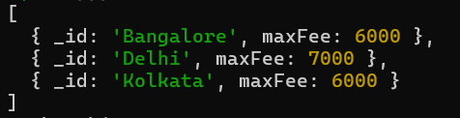
Q12. Count members per plan
Query: db.members.aggregate([{$group:{_id:"$plan", count:{$sum:1}}}])
Output:
Q13. Trainers with avg calories > 400
Query: db.sessions.aggregate([{$group:{_id:"$trainer", avgCalories:{$avg:"$calories"}}}, {$match:{avgCalories:{$gt:400}}}])
Output:
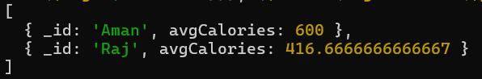
Q14. Total duration per member_id
Query: db.sessions.aggregate([{$group:{_id:"$member_id", totalDuration:{$sum:"$duration"}}}])
Output:
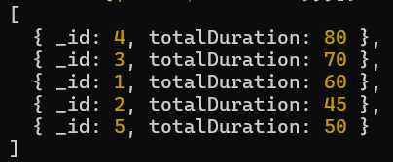
Q15. Join members with sessions
Query: db.members.aggregate([{$lookup:{from:"sessions", localField:"member_id", foreignField:"member_id", as:"session_details"}}])
Output:
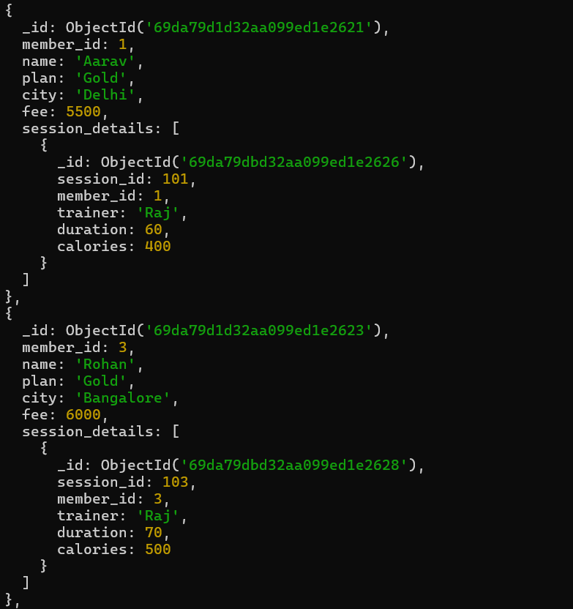
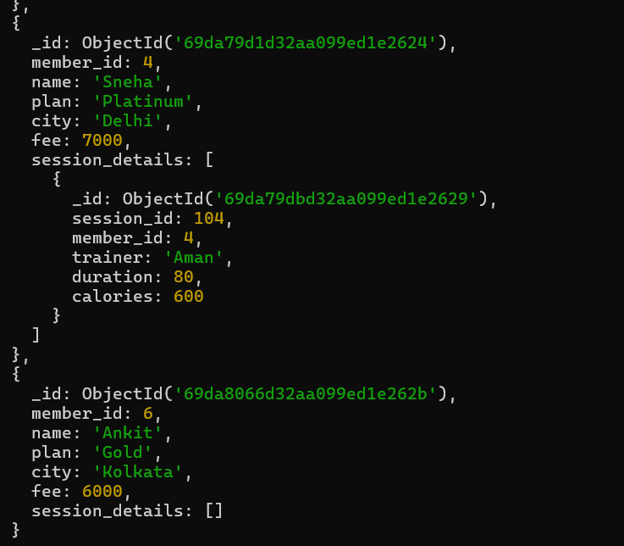

Q16. Show members who have sessions
Query: db.members.aggregate([{$lookup:{from:"sessions", localField:"member_id", foreignField:"member_id", as:"session"}}, {$match:{"session.0":{$exists:true}}}])
Output:
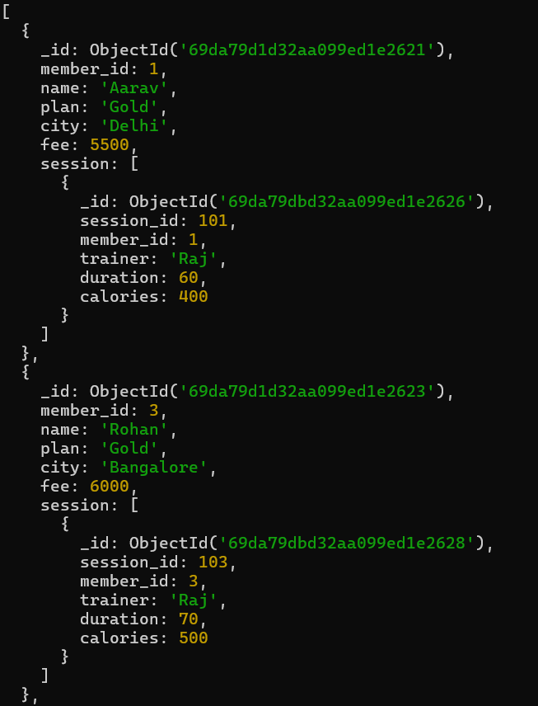

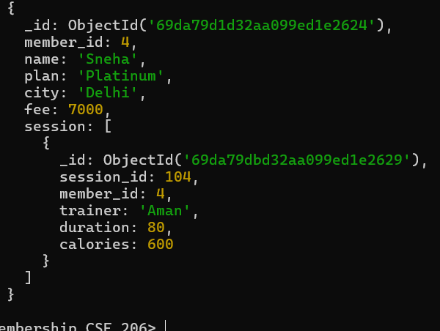
Q17. Create index on city
Query: db.members.createIndex({city:1})
Output: city_1
Q19. Create compound index on plan and fee
Query: db.members.createIndex({plan:1, fee:-1})
Output: plan_1_fee_-1
Q20. Display 2nd and 3rd highest fee members
Query: db.members.find().sort({fee:-1}).skip(1).limit(2)
Output:

Compass output: members collection
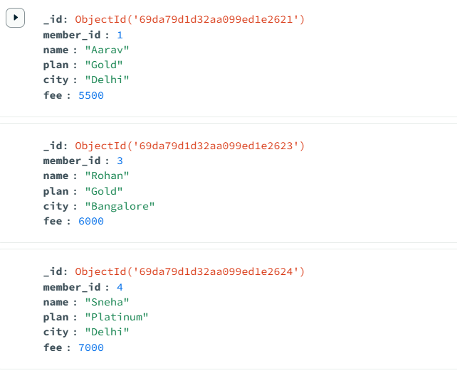
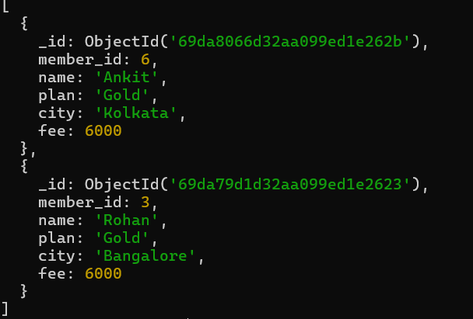
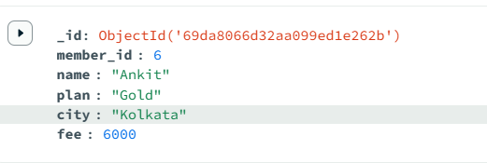
Compass output: sessions collection
