Table of Contents

Document Version 2

1. Purpose 3

1.1. Intended Audience 3

1.2. Intended Use 3

1.3. Scope 3

1.4. Definitions and Acronyms 3

2. Overall System Description 4

2.1. Use Case Diagrams 4

2.2. System Architecture 5

2.3. Functional Requirements 6

2.3.1. Function xxxx 6

2.3.2. Function yyyy 7

2.3.3. Function zzzz 7

3.1. Non-Functional Requirements 8

3.1.1. Non-Functional Requirement xxxx 8

4. Software Architecture 9

4.1. Static Software Architecture 9

# Document Version

|  |  |  |  |  |
| --- | --- | --- | --- | --- |
| No | Update | Name | Date | Version |
| 1. | Initial version | Priscilla | 15th June 2024 | 1.0 |
| 2. | Initial version | Ke Liang | 16th June 2024 | 2.0 |
| 3. | Initial version | Priscilla | 19th June 2024 | 3.0 |
| 4. | Initial version | Yohann | 23rd June 2024 | 4.0 |
| 5. | Initial version | Kayshavv | 24rd June 2024 | 5.0 |

# Purpose

## Intended Audience

This SRS document describes the System Requirements and Software Design for an IoT Smart Vending Machine and the target audience are System and Software Engineers working on the development of this project.

## Intended Use

The SRS defines the overall System Architecture and Requirements as well as the Software Architecture and Design. This document also contains the definition of the System Requirements which shall be used as the input for System Test cases and Software Unit Test cases.

## Scope

This report details the development of an IoT Smart Vending Machine and covers the following key features:

1. User Interface (UI) of website

2. Payment and security system

3. Security Features (Anti-theft system)

4. Maintenance access

## Definitions and Acronyms

|  |  |
| --- | --- |
| **Acronym** | **Description** |
| RFID | Radio Frequency Identification |
| LCD | Liquid Crystal Display |
| NFC | Near Field Communication |
| SW | Software |
| HW | Hardware |
| HMI | Human Machine Interaction |
| UI | User Interface |
| HPM | High Powered Mode |
| LPM | Low Powered Mode |

# Overall System Description

## Use Case Diagrams

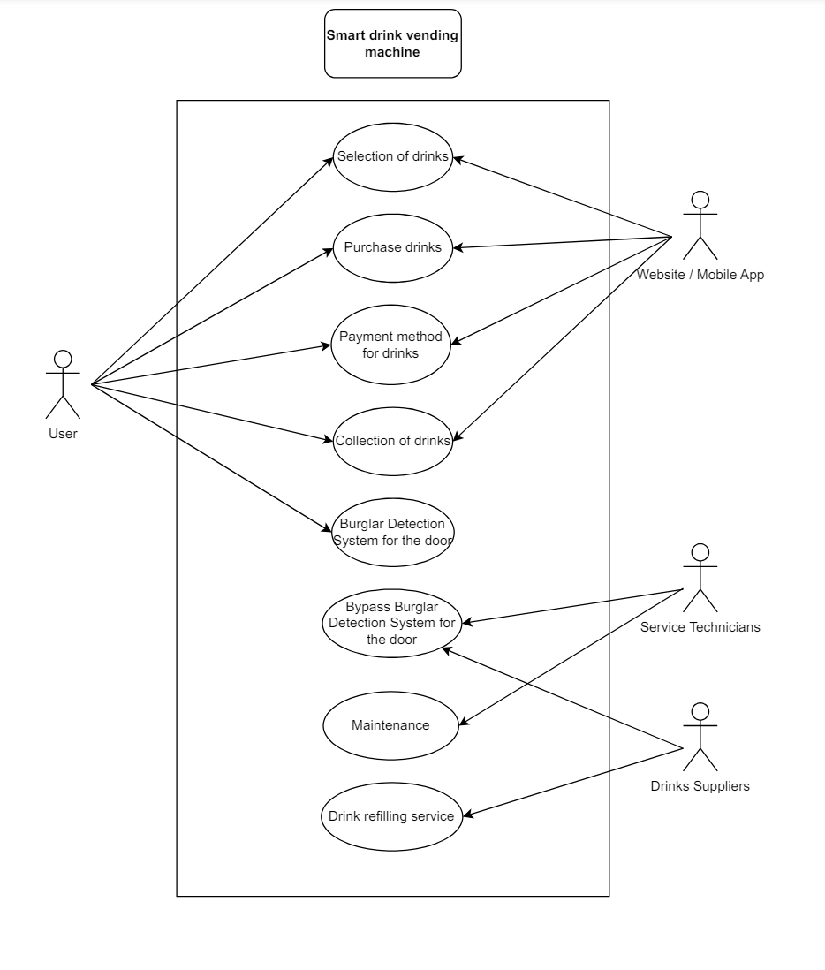

## System Architecture

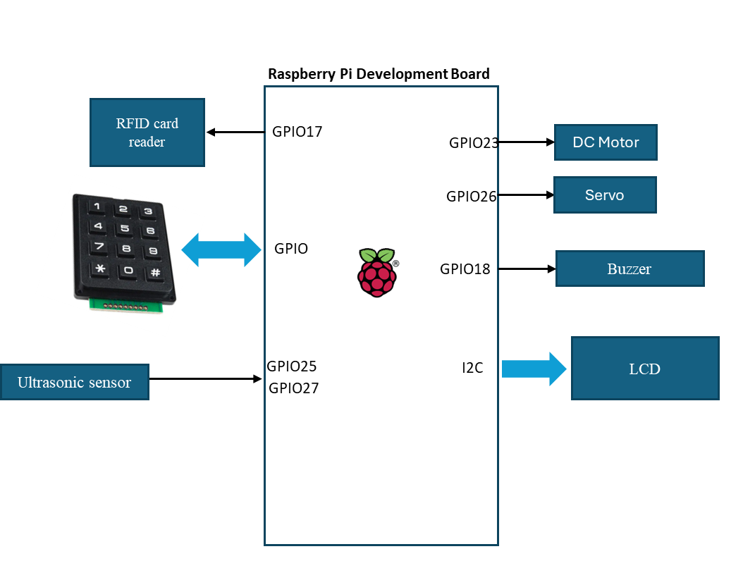

RFID card reader is used for payment for drinks

LCD and Keypad is for selection of drinks

Ultrasonic sensor is placed facing the inside of the door. If pulse takes too long to be received, the buzzer will trigger, signalling that someone has forcefully pried open the vending machine door.

DC Motor and Servo are used to get the drink after customer has paid

## Functional Requirements

### 2.3.1 Start Up and Main Menu

|  |  |
| --- | --- |
| REQ-ID | Requirements |
| **REQ-01** | When the Vending Machine is powered on, the following options of drinks will be displayed on the Main Menu of the LCD Screen to the user. (Select drink using Numeric Keypad)    E.g.  1) Ice Lemon Tea  2) Sprite  ...  12) Milo |
| **REQ-02** | In the Main Menu defined in REQ-01, if a selection of the drink is made on the Numeric Keypad, the following options will be displayed on the LCD Screen to the user.    1) Payment via RFID Card Reader  2) Payment via QR Code / Barcode |
| **REQ-03** | In the Main Menu defined in REQ-01, if no selection of drink is made after 30 seconds, the LCD should display the following text for 5 seconds and then turn off the LCD display and back light and enter Low Power Mode as defined in REQ-34.  Line 1 = “Thank you”  Line 2 = “Machine is idling” |

### 2.3.2 Purchasing of drink physically

|  |  |
| --- | --- |
| **REQ-04** | If the user selects “1) Payment via RFID Card Reader” in REQ-02, then the flowchart defined in Figure 1 shall be implemented. |

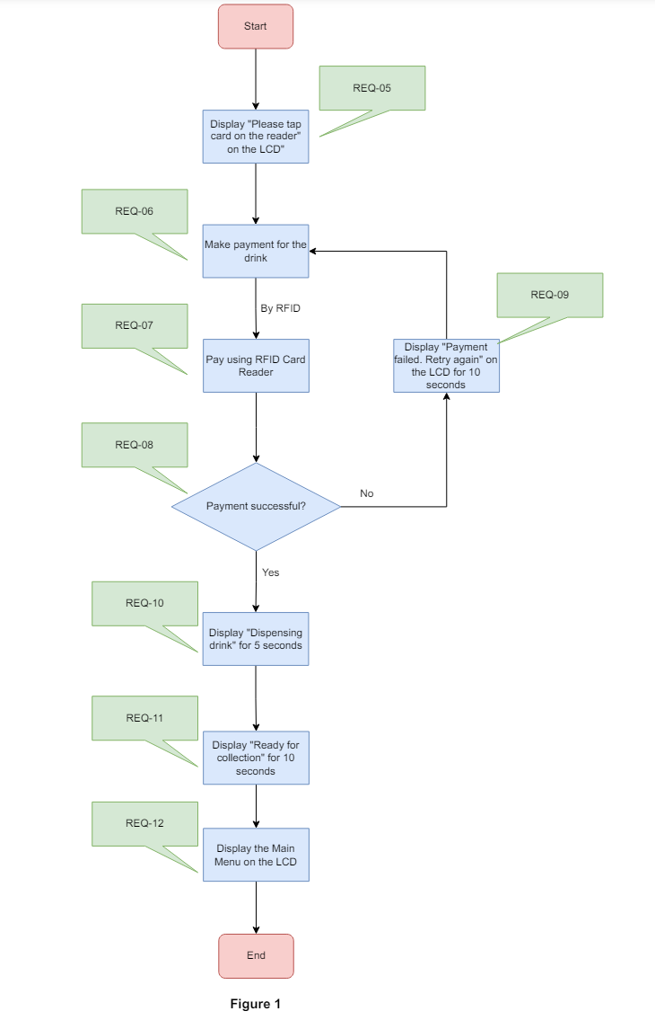

Based on the flowchart defined in Figure 1 when the user chooses to pay via RFID Card Reader, the LCD will display “Please tap card on the reader” to notify the user so that he can start his payment. Once the user taps his card, the Vending Machine will check if payment is successful. If the payment fails, the LCD will display “Payment failed. Retry again” to notify the user to retry his payment. Once the payment is successful, the LCD will display “Dispensing drink”. When the drink is ready to be collected, the LCD will then display “Ready for collection”. The LCD will then display the Main Menu defined in REQ-01 after 10 seconds.

### 2.3.3 Purchasing of drink remotely

|  |  |
| --- | --- |
| **REQ-13** | If the user selects “2) Payment via QR Code / Barcode” in REQ-02, then the flowchart in Figure 2 shall be implemented. |

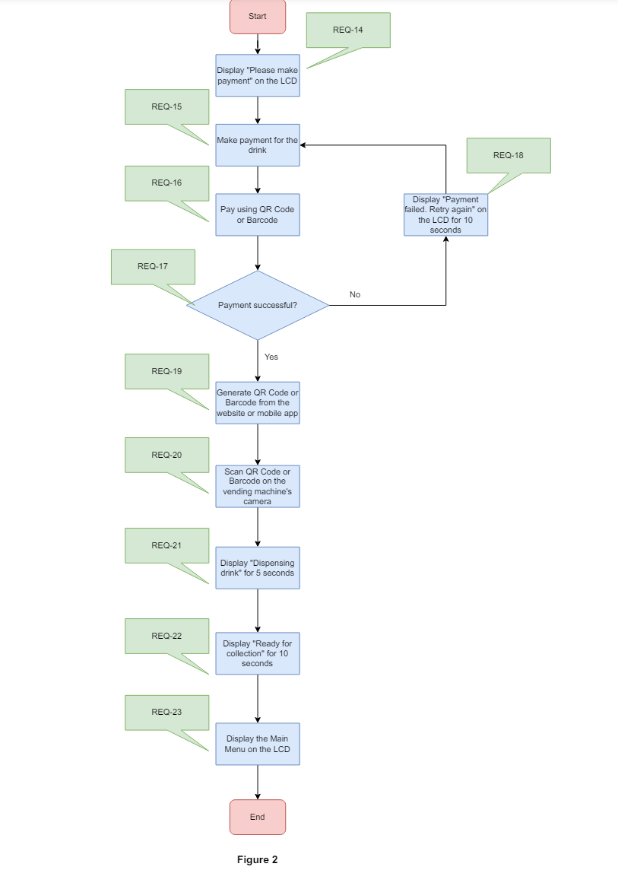 Based on the flowchart defined in Figure 2 when the user chooses to pay via QR Code or Barcode, the LCD will display “Please make payment” to notify the user that he can begin his payment. He will then proceed to pay via QR Code or Barcode. The Vending Machine will then check if the payment is successful. If the payment fails, the LCD will display “Payment failed. Retry again” to notify the user to retry his payment method again. Once the payment is successful, a QR Code or Barcode will be generated by the website or mobile app. The user will then scan the generated QR Code or Barcode at the Vending Machine’s camera. Upon scanning the QR Code or Barcode, the LCD will display “Dispensing drink”. Once the drink is ready to be collected, the LCD will display “Ready for collection”. The LCD will display the Main Menu defined in REQ-01 after 10 seconds.

2.3.4 Security measures

|  |  |
| --- | --- |
| **REQ-24** | If the vending machine is forcefully being pried open, the Burglar Detection System will be detected, and the buzzer will be activated. |

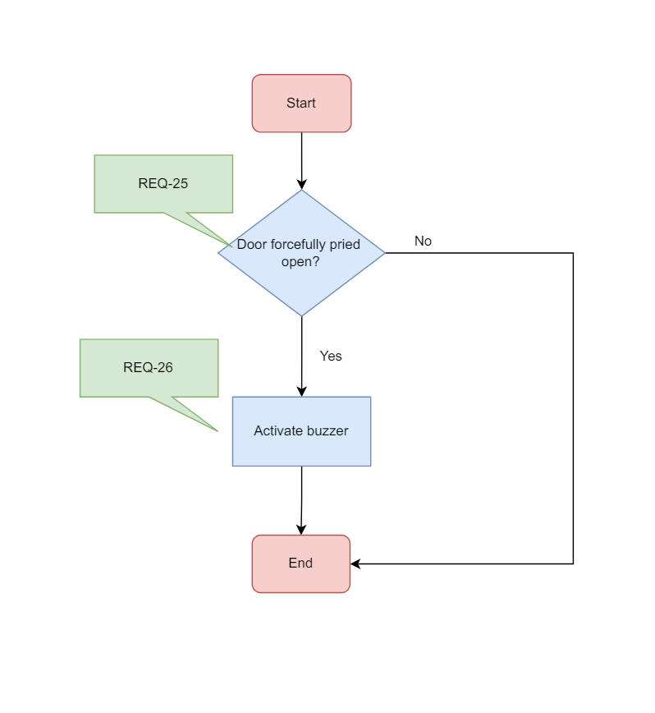

**Figure 3**

### Based on the flowchart defined in Figure 3, when the Burglar Detection System detects abnormal activities such as the Vending machine Door being forcefully pried open, the buzzer alarm will be activated. However, if the door is not forcefully pried open, there will be no changes done.

### 2.3.5 Technicians use for maintenance

|  |  |
| --- | --- |
| **REQ-27** | At the Main Menu defined in REQ-01, the technicians and drink suppliers will key in a user code using the Numeric Keypad. The flowchart in Figure 4 will then be implemented. |

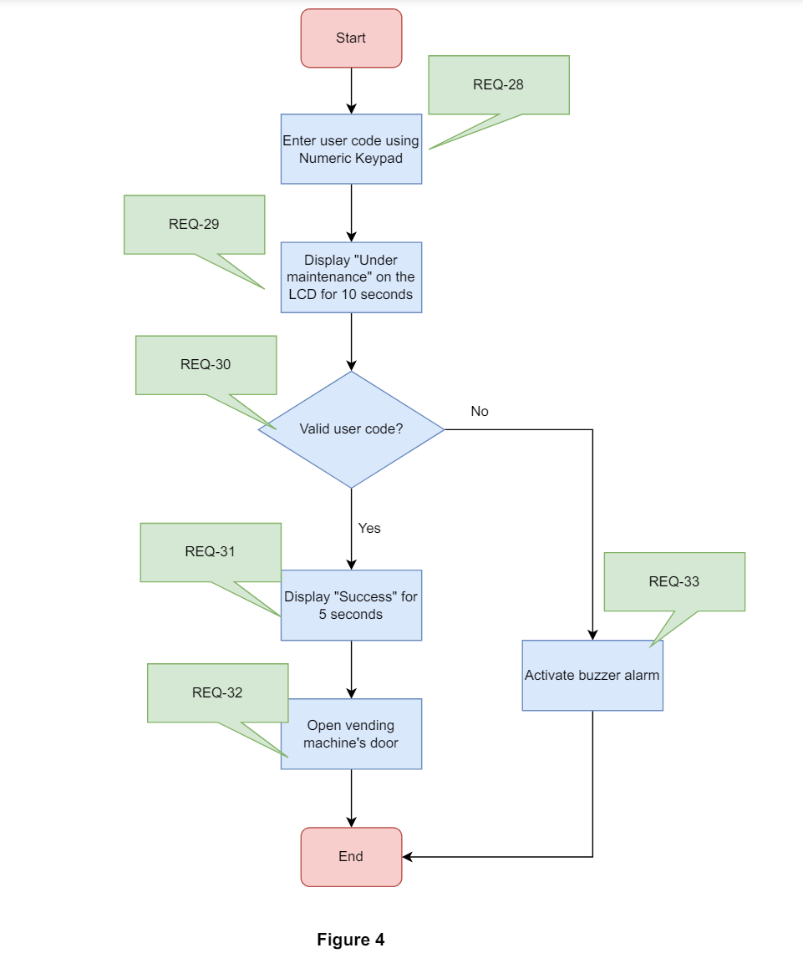

Based on the flowchart defined in Figure 4, when the Drinks Suppliers or the Service Technicians key in the user code using the Numeric Keypad, the LCD will display “Under Maintenance”. The Vending Machine will check if the user code is valid. If it is invalid, the buzzer alarm will be activated. However, if the user code is valid, the LCD will display “Success” and the Vending Machine’s door will be unlocked, allowing the Drinks Suppliers and Service Technicians to do their respective roles.

## Non-Functional Requirements

### 2.4.1 Power Management

The Vending Machine has 2 Power Modes as defined in the State Machine diagram in Figure below. The transitions between LPM and HPM are triggered by the events labelled “evGetDrink” and “evEnterWakeup”. Conditions for trigger the events are defined in the requirements below.

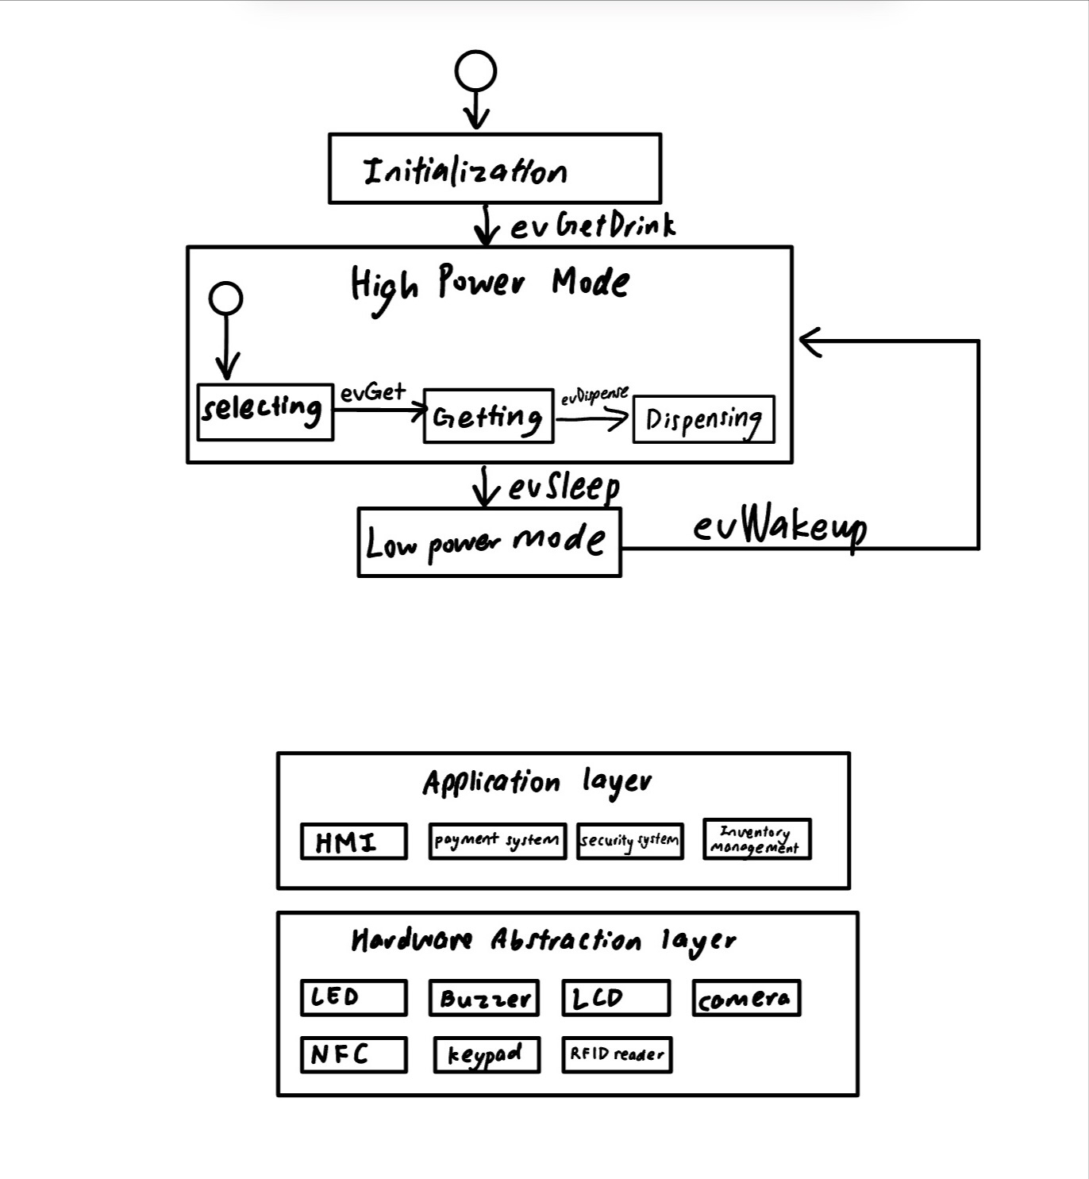

Figure 5

The state machine above begins in the Initialization state and transitions to the High Power Mode upon receiving the evGetDrink event. Within the High Power Mode, the system follows a sequence of states starting with Selecting, then Getting, through evGet, and finally to Dispensing through evDispense. Once the drink is dispensed, the system can either go to a Low Power Mode with the evSleep event or remain in High Power Mode. In Low Power Mode, the system awaits the evWakeup event to return to High Power Mode, ready to start the process again.

|  |  |
| --- | --- |
| REQ_ID | Requirement |
| REQ-33 | “evWakeup” Trigger Condition 1  When the user presses any button on the Numeric Keypad. |
| REQ-34 | “evSleep” Trigger Condition 2 When no button is pressed on the Numeric Keypad in REQ-01 for 30 seconds. |
| REQ-35 | “evSleep” Trigger Condition 2  When there is no card in contact with the RFID Card Reader for 10 seconds. |

# Software Architecture

## Static Software Architecture

The Software Architecture defines the various Software Components that are developed to realize the implementation of the system requirements.



Figure 6

The Application Layer of the system includes components such as the User Interface, which provides a touchscreen or keypad and LCD screen for selecting drinks and a web application for remote purchasing. The Payment Processing System integrates with RFID card readers, QR code, and barcode payment systems, utilizing a secure method for transactions. The Order Management System handles drink selections, transactions, and generates/verifies QR codes or barcodes for drink collection. The Security Management System monitors for forced entry and activates an alarm if tampering is detected, while the Access Management System provides user authentication for technicians and suppliers.

The Hardware Abstraction Layer consists of input devices (RFID reader, QR/barcode scanner, keypad, camera), output devices (LCD screen, buzzer). These components work together to ensure the seamless operation of the smart vending machine.