Table of Contents

Document Version 2

1. Purpose 3

1.1. Intended Audience 3

1.2. Intended Use 3

1.3. Scope 3

1.4. Definitions and Acronyms 3

2. Overall System Description 4

2.1. Use Case Diagrams 4

2.2. System Architecture 5

2.3. Functional Requirements 6

2.3.1. Function xxxx 6

2.3.2. Function yyyy 7

2.3.3. Function zzzz 7

3.1. Non-Functional Requirements 8

3.1.1. Non-Functional Requirement xxxx 8

4. Software Architecture 9

4.1. Static Software Architecture 9

# Document Version

|  |  |  |  |  |
| --- | --- | --- | --- | --- |
| No | Update | Name | Date | Version |
| 1. | Initial version | Priscilla | 15th June 2024 | 1.0 |
| 2. | Initial version | Ke Liang | 16th June 2024 | 2.0 |
| 3. | Initial version | Priscilla | 19th June 2024 | 3.0 |
| 4. | Initial version | Yohann | 23rd June 2024 | 4.0 |
| 5. | Initial version | Kayshavv | 24rd June 2024 | 5.0 |
| 6. | Updated version | Yohann | 11th August 2024 | 6.0 |

# Purpose

## Intended Audience

This SRS document describes the System Requirements and Software Design for an IoT Smart Vending Machine and the target audience are System and Software Engineers working on the development of this project.

## Intended Use

The SRS defines the overall System Architecture and Requirements as well as the Software Architecture and Design. This document also contains the definition of the System Requirements which shall be used as the input for System Test cases and Software Unit Test cases.

## Scope

This report details the development of an IoT Smart Vending Machine and covers the following key features:

1. User Interface (UI) of website

2. Payment and security system

3. Security Features (Anti-theft system)

4. Maintenance access

## Definitions and Acronyms

|  |  |
| --- | --- |
| **Acronym** | **Description** |
| RFID | Radio Frequency Identification |
| LCD | Liquid Crystal Display |
| NFC | Near Field Communication |
| SW | Software |
| HW | Hardware |
| HMI | Human Machine Interaction |
| UI | User Interface |
| HPM | High Powered Mode |
| LPM | Low Powered Mode |

# Overall System Description

## Use Case Diagrams

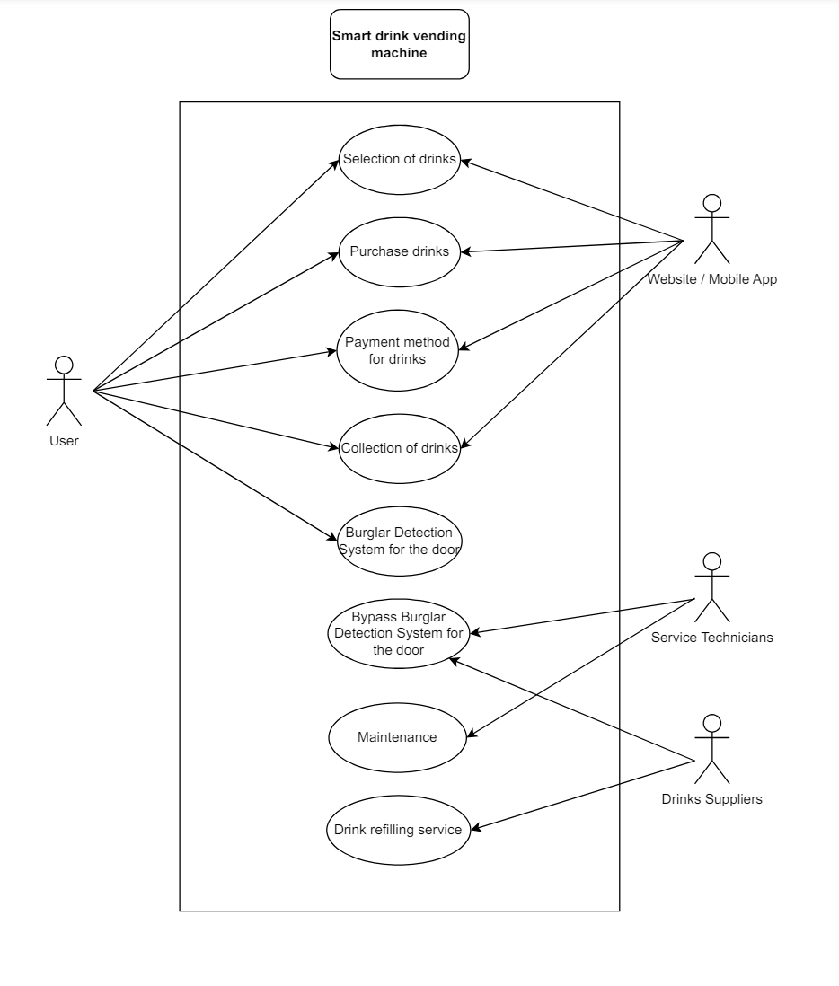

## System Architecture

RFID card reader is used for payment for drinks

LCD and Keypad is for selection of drinks

Switch is to show that the door is being pried open.

DC Motor and Servo are used to get the drink after customer has paid

## Functional Requirements

### 2.3.1 Start Up and Main Menu

|  |  |
| --- | --- |
| REQ-ID | Requirements |
| **REQ-01** | When the Vending Machine is powered on, it will ask the customer if they are ordering drinks or collecting drinks by displaying it on the LCD board. The customer will reply by using the keypad.    Line 1 = “1) Order drinks”  Line 2 = “2) Collect drinks” |
| **REQ-02** | If “1” was pressed on the keypad, the vending machine will prompt the customer to enter the drink code which is 1-9. When the customer has decided on the drink, they will press “*” as the conformation button. If they pressed wrongly, the customer could press “#” to return to the main menu in REQ-01.  Line 1 = “Enter drink code” |
| **REQ-03** | If a valid drink code is pressed and “*” is pressed to confirm the order the flowchart defined in figure 1 shall be implemented |

### 2.3.2 Collection of drinks after remote purchase

|  |  |
| --- | --- |
| **REQ-13** | If the user selects “2) Collect drinks” in REQ-01, then the flowchart defined in Figure 2 shall be implemented. |

### 2.3.3 Idle mode

|  |  |
| --- | --- |
| **REQ-23** | At any time if no buttons on the keypad are pressed for 30 seconds or if there are no inputs received by the RFID reader of Pi cam, the machine will be put to idle. Flowchart in figure 3 will be implemented. |

2.3.4 Security

|  |  |
| --- | --- |
| **REQ-29** | At any time if the switch is switched on (left position). Flowchart in figure 4 will be implemented. |

2.3.5 Maintenance

|  |  |
| --- | --- |
| **REQ-37** | When technician wants to restock the drinks in the vending machine without triggering the security system. Flowchart in figure 5 will be implemented. |

### 2.3.6 Remote payment

|  |  |
| --- | --- |
| **REQ-27** |  |

## Non-Functional Requirements

### 2.4.1 Power Management

The Vending Machine has 2 Power Modes as defined in the State Machine diagram in Figure below. The transitions between LPM and HPM are triggered by the events labelled “evGetDrink” and “evEnterWakeup”. Conditions for trigger the events are defined in the requirements below.

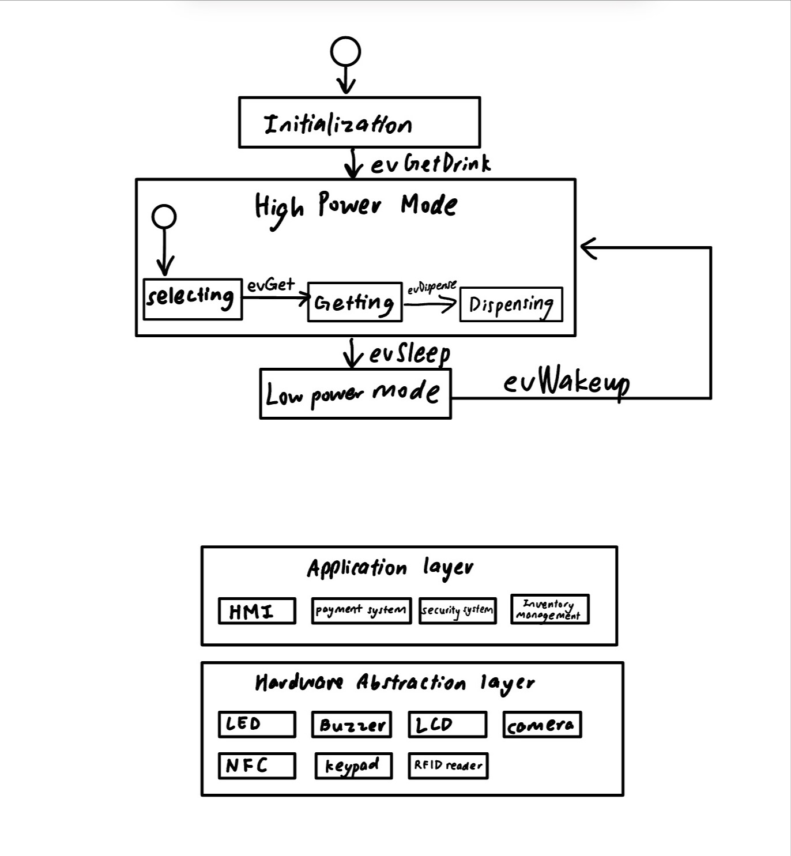

Figure 5

The state machine above begins in the Initialization state and transitions to the High Power Mode upon receiving the evGetDrink event. Within the High Power Mode, the system follows a sequence of states starting with Selecting, then Getting, through evGet, and finally to Dispensing through evDispense. Once the drink is dispensed, the system can either go to a Low Power Mode with the evSleep event or remain in High Power Mode. In Low Power Mode, the system awaits the evWakeup event to return to High Power Mode, ready to start the process again.

|  |  |
| --- | --- |
| REQ_ID | Requirement |
| REQ-33 | “evWakeup” Trigger Condition 1  When the user presses any button on the Numeric Keypad. |
| REQ-34 | “evSleep” Trigger Condition 2 When no button is pressed on the Numeric Keypad in REQ-01 for 30 seconds. |
| REQ-35 | “evSleep” Trigger Condition 2  When there is no card in contact with the RFID Card Reader for 10 seconds. |

# Software Architecture

## Static Software Architecture

The Software Architecture defines the various Software Components that are developed to realize the implementation of the system requirements.



Figure 6

The Application Layer of the system includes components such as the User Interface, which provides a touchscreen or keypad and LCD screen for selecting drinks and a web application for remote purchasing. The Payment Processing System integrates with RFID card readers, QR code, and barcode payment systems, utilizing a secure method for transactions. The Order Management System handles drink selections, transactions, and generates/verifies QR codes or barcodes for drink collection. The Security Management System monitors for forced entry and activates an alarm if tampering is detected, while the Access Management System provides user authentication for technicians and suppliers.

The Hardware Abstraction Layer consists of input devices (RFID reader, QR/barcode scanner, keypad, camera), output devices (LCD screen, buzzer). These components work together to ensure the seamless operation of the smart vending machine.