Priscella Maenar 104511548
COS10033 Assignment 2

Program Description
The purpose of this program is to create a tour booking program that will issue a ticket with unique ticket ID. The ticket will have details such as ID number, number of guests(adult and child), total price, discount, the tour name, pickup/airport location, airport pickup cost, customer name and contact, ticket status, and name of the sales executive who issues the ticket.
There are 3 different tour types, CityTour, Attractions and InterstateInternational tour. For CityTour, customer will not be asked for pickup details. For Attractions, customer is required to choose a pickup location but no pickup cost will be incurred. For InterstateInternational tour, customer will be asked for boarding airport and whether customer wants to be picked up and dropped off to/from that airport and additional cost will be incurred for the pickup dropoff.
There are limited availability for CityTour and Attractions. the maximum capacity is 40 for each tour. Whereas, for InterstateInternational tour, there is no capacity limit.
In the InterstateInternational tour, there are the Interstate tour and the International tour. Customer booking the Interstate tour(Cairns, Gold Coast) is not required to purchase insurance cover, it is optional. However for International tour(Phuket, Pattaya, Singapore), customer must purchase insurance cover. In the case where customer choose not to add the insurance cover, booking will fail and no ticket will be issued. In addition, for InterstateInternational tour, the program will ask for customer name and contact number.
Customer can choose to refund booking but only 75% of the total price will be refunded to the customer. Upon successful refund, the ticket will not be deleted from the system; instead, the status will change to "Cancelled" and the total price will show the rest of the 25% of the price.
The booking data will be stored in a data.txt file when option "X" (exit program) is chosen. In that same .txt file, Admin and sales executive login details will also be stored. If no sales executive account exists, the account can be created by logging in as Admin. To access the program, sales executive will need to login with his/her account. When login is successful, the booking menu will then show. The program will then read from data.txt file if ticket booking data exists. If data exists, the program will read the data from the file and load it. When option "E" (list sales) is selected, tickets that have been successfully booked in previous login session (if exists) will be shown. Updated data will then be written to the data.txt file when exiting the program.

Source Code
Account.java
//Priscella Maenar 104511548 - COS10033 Assignment 2
//Account.java
import java.io.*;

public class Account implements Serializable {
private String username;
private String password;
private String name;

//constructor
public Account(String name, String username, String password) throws illegalArgException {
this.name=name;
this.username=username;
if(!(password.isEmpty())) { this.password=password; }
else { throw new illegalArgException("Password cannot be empty. Account creation failed."); }
}

public String getUsername() { return this.username; }
public String getPassword() { return this.password; }
public String getSEName() { return this.name; }

public String toString() {
return (" Issued By: "+this.name);
}
}

Insurance.java
//Priscella Maenar 104511548 - COS10033 Assignment 2
//Insurance.java
public interface Insurance {
public abstract double Insurance(int capacity, int userInput);
}

Customer.java
//Priscella Maenar 104511548 - COS10033 Assignment 2
//Customer.java
import java.io.*;

public class Customer implements Insurance, Serializable{
private String name;
private String contact;
private double insurance;

//constructor
public Customer(String name, String contact) {
this.name=name;
this.contact=contact;
}

//get set method
public String getCustName() {return this.name;}
public String getCustContact() {return this.contact;}
public double getInsurance() {return this.insurance;}
public void setInsurance(Tour tour, double insuranceAmt) throws illegalArgException {
if(tour.compareTo("International")==0) {
if(insuranceAmt==0){
throw new illegalArgException("Ticket Reservation failed. Insurance cover is needed for International tour");
}else { this.insurance=insuranceAmt; }
}else { this.insurance=insuranceAmt; }
}

public String toString() {
return (" Customer Name: "+this.getCustName()+" Contact: "+this.getCustContact()+" Insurance($): "+this.getInsurance());
}

public double Insurance(int pax, int userInput) { //to calc insurance cover
double insurance=0.0;
if(userInput!=1) { insurance=0.0; }
else {
while(pax>0) {
if(pax<=0) {break;}
else if(pax==1) { pax=pax-1; insurance=insurance+200.0; }
else if(pax==2) { pax=pax-2; insurance=insurance+350.0; }
else if(pax>=3 && pax<=5) {
if(pax==3) { pax=pax-3; }
if(pax==4) { pax=pax-4; }
else { pax=pax-5; }
insurance=insurance+500.0;
}else { pax=pax-5; insurance=insurance+500.0; }
}
}return insurance;
}
}

Tour.java
//Priscella Maenar 104511548 - COS10033 Assignment 2
//Tour.java
import java.io.*;
import java.util.*;

abstract class Tour implements Comparable<String>, Serializable{
private String type;
private int capacity;
private double aPrice;
private double cPrice;

//constructor
public Tour(String type, double aPrice, double cPrice){
this.aPrice=aPrice;
this.cPrice=cPrice;
this.type=type;
this.type=type;
}

//get and set method
public double getaPrice() { return this.aPrice; }
public double getcPrice() { return this.cPrice; }
public String getType() { return this.type; }
public int getCapacity() { return this.capacity; }
public void setCapacity(int capacity) { this.capacity=capacity; }

public String toString() {
return (" ");
}

@Override
public int compareTo(String tourType) {
if((this.type).equals(tourType)) { return 0; }
else { return -1; }
}
}

class CityTour extends Tour{
private String name;
//constructor
public CityTour(String type, double aPrice, double cPrice, String name) {
super(type, aPrice, cPrice);
this.name=name;
}

public String getName() { return this.name; }

public String toString() {
String temp=super.toString();
return (temp+"Tour: "+this.name);
}
}

class Attractions extends Tour{
private String name;
//constructor
public Attractions(String type, double aPrice, double cPrice, String name){
super(type, aPrice, cPrice);
this.name=name;
}
public String getName() { return this.name; }

public String toString() {
String temp=super.toString();
return (temp+"Tour: "+this.name);
}
}

class InterstateInternational extends Tour{
private String name;
//constructor
public InterstateInternational(String type, double aPrice, double cPrice, String name){
super(type, aPrice, cPrice);
this.name=name;
this.setCapacity(40);
}
public String getName() { return this.name; }

public String toString() {
String temp=super.toString();
return (temp+"Tour: "+this.name);
}
}

Ticket.java
//Priscella Maenar 104511548 - COS10033 Assignment 2
//Ticket.java
import java.io.*;
import java.util.*;

class illegalArgException extends Exception {
public illegalArgException(String msg) {
super(msg);
}
}

public class Ticket implements Serializable{
private int ticketID;
private int adultPax;
private int childPax;
private double disc;
private String pickup;
private double pickupCost;
private double total;
private String status;
public Tour tour;
public Customer customer;
public Account account;

//Constructor
public Ticket(int ticketID, int adultPax, int childPax, Account acc) throws illegalArgException {
this.ticketID=ticketID;
this.status="Valid";
this.adultPax=adultPax;
this.childPax=childPax;
this.account=acc;
}

//set and get method
public int getID() {return this.ticketID;}
public int getAdultPax() {return this.adultPax;}
public int getChildPax() {return this.childPax;}
public double getTotal() {return this.total;}
public double getDisc() {return this.disc; }
public String getPickup() {return this.pickup;}
public double getPickupCost() {return this.pickupCost;}
public String getStatus() {return this.status;}
public void setPickup(String pickup) {this.pickup=pickup; }
public void setStatus(String status) {this.status=status;}
public void setTotal(double total) {this.total=total;}
public void setDisc(double totalBeforeDisc) {this.disc=0.0;}
public void addTour(Tour tour) { this.tour=tour; }
public double calcTotal() {
double total=(this.adultPax*this.tour.getaPrice())+(this.childPax*this.tour.getcPrice());
return total;
}
public double refund() {
double refundRate=0.75;
double refundAmt=refundRate*this.total;
this.total=this.total-refundAmt;
this.disc=0.0;
return refundAmt;
}
public void setPickupCost(int pax, Scanner in) { //for pickupCost for Interstate/International tour
double pickupCost=150.0;
if(pax>6) {
System.out.print("Number of guests more than 6. Enter airport Pickup & Drop Off cost: $");
pickupCost=in.nextDouble();
}
System.out.println("Enter 1 to Add airport Pickup & Drop Off at the destination for $"+pickupCost+" OR enter any other number to skip. ");
int choice=in.nextInt();
in.nextLine();
if(choice!=1) { pickupCost=0.0; }
this.pickupCost=pickupCost;
}

public String toString() {
return ("TicketID: "+this.ticketID+" Adult(pax): "+this.adultPax+" Child(pax): "+this.childPax+" Status: "+this.status+this.account.toString()+" Total($): "+this.total);
}
}

class NormalTic extends Ticket{ //disc 0%, no disc
//constructor
public NormalTic(int ticketID, int adultPax, int childPax, Account acc) throws illegalArgException{
super(ticketID, adultPax, childPax, acc);
}

public String toString(){
String temp=super.toString();
temp=temp+(" Discount($): "+this.getDisc()+"\n "+this.tour.toString()+" PickUp/Airport: "+this.getPickup()+" AirportP&D($): "+this.getPickupCost());
if(this.customer!=null && this.customer!=null){
temp=temp+"\n "+this.customer.toString();
}
return temp;
}
}
class FamilyTic1 extends Ticket{ //1 adult 1 child or 2 adult 1 child
private double discRate; //disc 10%
private double disc;
//constructor
public FamilyTic1(int ticketID, int adultPax, int childPax, Account acc) throws illegalArgException{
super(ticketID, adultPax, childPax, acc);
this.discRate=0.10;
}

public void setDisc(double totalBeforeDisc) {
this.disc=totalBeforeDisc*this.discRate;
this.setTotal(totalBeforeDisc-this.disc);
}

public String toString(){
String temp=super.toString();
temp=temp+(" Discount10%($): "+this.disc+"\n "+this.tour.toString()+" PickUp/Airport: "+this.getPickup()+" AirportP&D($): "+this.getPickupCost());
if(this.customer!=null && this.customer!=null){
temp=temp+"\n "+this.customer.toString();
}
return temp;
}
}
class FamilyTic2 extends Ticket{ //4 pax or more
private double discRate; //disc 15%
private double disc;
//constructor
public FamilyTic2(int ticketID, int adultPax, int childPax, Account acc) throws illegalArgException{
super(ticketID, adultPax, childPax, acc);
this.discRate=0.15;
}

public void setDisc(double totalBeforeDisc) {
this.disc=totalBeforeDisc*this.discRate;
this.setTotal(totalBeforeDisc-this.disc);
}

public String toString(){
String temp=super.toString();
temp=temp+(" Discount15%($): "+this.disc+"\n "+this.tour.toString()+" PickUp/Airport: "+this.getPickup()+" AirportP&D($): "+this.getPickupCost());
if(this.customer!=null && this.customer!=null){
temp=temp+"\n "+this.customer.toString();
}
return temp;
}
}

FileInputOutput.java
//Priscella Maenar 104511548 - COS10033 Assignment 2
//FileInputOutput.java
import java.util.*;
import java.io.*;

class Data implements Serializable {
private ArrayList<Account> aList;
private ArrayList<Ticket> tList;
private CityTour[] cTour;
private Attractions[] attractions;

//constructor
public Data(ArrayList<Account> aList, ArrayList<Ticket> tList, CityTour[] ctour, Attractions[] attr) {
this.aList=aList;
this.tList=tList;
this.cTour=ctour;
this.attractions=attr;
}

public ArrayList<Account> getAccList() { return this.aList; }
public ArrayList<Ticket> getTicList() { return this.tList; }
public CityTour[] getCityTour() { return this.cTour; }
public Attractions[] getAttractions() { return this.attractions; }
}

public class FileInputOutput {
public static Data readFile(String fName) throws Exception {
Data data=null;
FileInputStream fi=null;
ObjectInputStream oi=null;
try {
fi = new FileInputStream(fName);
oi = new ObjectInputStream(fi);
while(true) { data=(Data) oi.readObject();}
}catch (Exception e) {
if(e.getMessage()!=null) {
System.out.println("data.txt file does not exist. Creating file with admin login details stored in it.\nUsername/Password: Admin\n");
}
}finally {
if(oi!=null){oi.close();}
if(fi!=null) {fi.close();}
}
return data;
}

public static void writeFile(Data data, String fName) {
try {
FileOutputStream fo = new FileOutputStream("data.txt");
ObjectOutputStream oo = new ObjectOutputStream(fo);
oo.writeObject(data);
fo.close();
oo.close();
}
catch(Exception e) { System.out.println(e.getMessage()); }
}

public static ArrayList<Account> readLoginFromFile(Data data, String fName, Scanner in) throws Exception {
int addMoreAcc=1;
ArrayList<Account> accList=new ArrayList<Account>();
if(data.getAccList().isEmpty()) {
data.getAccList().add(new Account("Admin", "Admin", "Admin")); //admin login
writeFile(data, fName); //write admin details to file
}
while(addMoreAcc==1) {
if(data.getAccList().size()==1) { //admin login exists but no sales executives login exist
System.out.print("No Sales Executive Account Exists. Create new Sales Executive Accounts.\nEnter Admin username to login: ");
String username=in.nextLine();
System.out.print("Enter Admin password to login: ");
String password=in.nextLine();
if(username.equals("Admin") && password.equals("Admin")) {
boolean loginCorrect=false;
while(loginCorrect==false) {
Account acc=addSalesExecAcc(in);
if(acc!=null) {
data.getAccList().add(acc);
System.out.println("Sales Executive Account Successfully created.");
loginCorrect=true;
}
}
}else {System.out.println("Wrong Admin username/password. Please retry\n");}
}
if(data.getAccList().size()>1) { //sales executives login exist
System.out.println("\n"+(data.getAccList().size()-1)+" Sales Executive Account Exists.\nEnter 1 to add more Sales Executive account OR any other number to login with existing account.");
addMoreAcc=in.nextInt();
in.nextLine();
if(addMoreAcc==1) {
Account acc=addSalesExecAcc(in);
if(acc!=null) {
data.getAccList().add(acc);
System.out.println("Sales Executive Account Successfully created.");
}
}else {break;}
}
}writeFile(data, fName);
return data.getAccList();
}

public static Account addSalesExecAcc(Scanner in) {
Account acc=null;
String username="null", password="null", name="null";
try {
System.out.print("Enter Sales Executive Name: ");
name=in.nextLine();
System.out.print("Enter username: ");
username=in.nextLine();
System.out.print("Enter password: ");
password=in.nextLine();
acc=new Account(name, username, password);

}catch( illegalArgException e ) {System.out.println(e.getMessage());}
return acc;
}

public static Account SalesExecLogin(ArrayList<Account> accList, Scanner in){
Account acc=null;
String username="null", password="null";
boolean loginCorrect=false;
while(loginCorrect==false) {
System.out.print("Enter Username: ");
username=in.nextLine();
for(Account a : accList) {
if(a==null) { break; }
if(a.getUsername().equals(username)) {
acc=a;
break;
}
}if(acc!=null) {
System.out.print("Enter Password: ");
password=in.nextLine();
if(password.equals(acc.getPassword())) { loginCorrect=true; }
else { System.out.println("Wrong password. Please retry\n"); }
}else {System.out.println("Username not found. Please retry\n"); }
}
return acc;
}
}

StageD.java (main)
//Priscella Maenar 104511548 - COS10033 Assignment 2
//StageD.java

import java.io.*;
import java.lang.reflect.Type;
import java.util.*;

public class StageD {

public static void main(String[] args) throws Exception {
Scanner input = new Scanner(System.in);
CityTour[] ctour=new CityTour[5];
Attractions[] attr=new Attractions[4];
InterstateInternational[] inter=new InterstateInternational[5];
ArrayList<Account> accList=new ArrayList<Account>();
ArrayList<Ticket> ticList=new ArrayList<Ticket>();
Ticket tic=null;
String choice="null",tourName="null", pickup="N/A", fileName="data.txt";
int choice2=0, adultPax=0, childPax=0, capacity=40, uInput=0;
double ticketsTotal=0;
boolean bookingSuccessful=true;

Data data=FileInputOutput.readFile(fileName);
if(data==null) { data=new Data(accList, ticList, ctour, attr); }

//add login details to accList if it does not exist and store to file permanently.
//Username/password: Admin
accList=FileInputOutput.readLoginFromFile(data, fileName, input); //read ticket, tour, customer file data as well

//sales executive login
Account salesExec=FileInputOutput.SalesExecLogin(accList, input);

data=FileInputOutput.readFile(fileName); //update data by reading file after logging in
accList=data.getAccList();
ticList=data.getTicList();
ctour=data.getCityTour();
attr=data.getAttractions();
int ticketCount=1+ticList.size(); //overall ticket count for ticket ID

do {
printMenu();
choice=input.nextLine();
switch(choice) {
case "A":
int buyMoreTic=1, index=0, count=0;
ticketsTotal=0;
while(buyMoreTic==1) {
boolean enoughCapacity=true; bookingSuccessful=true;
do {
printTourAttrMenu();
System.out.print("\nWhich tour/attractions do you wish to buy ticket/s for: ");
choice2=input.nextInt();
if(choice2<1 || choice2>14) {System.out.println("Invalid input. Please enter 1-14");}
}while(choice2<1 || choice2>14);
tourName=tourName(choice2); //to get tour/attractions name
System.out.println("Booking tickets for "+tourName+".");
System.out.print("How many adult tickets (Max 40): ");
adultPax=input.nextInt();
System.out.print("How many child tickets (Max 40): ");
childPax=input.nextInt();
input.nextLine();

//max 40
if(adultPax>40 || childPax>40 ||(adultPax+childPax)>40) {
System.out.println("Number of Adults and/or Child cannot be more than 40.");
enoughCapacity=false;
}

//check if the tour still has enough capacity for the no of child/adult the user input.
Ticket t=null;
t=searchTourName2(ticList, tourName);
if(ticList!=null && t!=null) {
enoughCapacity=enoughCapacity(t.tour, (adultPax+childPax));
}
//if the tour still has enough capacity
if(enoughCapacity==true) {
if((adultPax==1 && childPax==1) || (adultPax==2 && childPax==1)) {
FamilyTic1 temp=new FamilyTic1(ticketCount, adultPax, childPax, salesExec);
tic=(FamilyTic1)temp;
}else if((adultPax+childPax)>=4) {
FamilyTic2 temp=new FamilyTic2(ticketCount, adultPax, childPax, salesExec);
tic=(FamilyTic2)temp;
}else {
NormalTic temp=new NormalTic(ticketCount, adultPax, childPax, salesExec);
tic=(NormalTic)temp;
}
count++; //ticket creation count while still in option A. count will reset once option A is selected again.
ticketCount++; //overall ticket count for ticket ID

if(choice2>=1 && choice2<=5) {
index=tourIndex(choice2);
if(ctour[index]==null) {
ctour[index]=cityTour(tourName, adultPax, childPax);
ctour[index].setCapacity(capacity);
}
ctour[index].setCapacity((ctour[index].getCapacity())-adultPax-childPax);
tic.setPickup(pickup);
tic.addTour(ctour[index]);
}else if(choice2>=6 && choice2<=9){
int pickupChoice=0;
do {
System.out.print(" 1-Travel Australia CBD Office\n 2-Flinders Station\n 3-Southern Cross Station\n 4-Queen Victoria Market\n 5-Melbourne Museum\nChoose a PickUp location: ");
pickupChoice=input.nextInt();
pickup=pickupLoc(pickupChoice);
}while(!(pickupChoice>0 && pickupChoice<6));
index=tourIndex(choice2);
if(attr[index]==null) {
attr[index]=attr(tourName, adultPax, childPax);
attr[index].setCapacity(capacity);
}
attr[index].setCapacity((attr[index].getCapacity())-adultPax-childPax);
tic.setPickup(pickup);
tic.addTour(attr[index]);
}else if(choice2>=10 && choice2<=14) {
index=tourIndex(choice2);
if(inter[index]==null) {
inter[index]=inter(tourName, adultPax, childPax);
}
tic.addTour(inter[index]);

//airport pickup
System.out.print("Enter boarding airport: ");
pickup=input.nextLine();
tic.setPickup(pickup);
tic.setPickupCost((adultPax+childPax), input);
System.out.print("For interstate/international tour, enter Customer Name and Contact.\nName: ");
String name=input.nextLine();
System.out.print("Contact No.: ");
String contactNo=input.nextLine();
tic.customer=new Customer(name, contactNo);

//Insurance
System.out.println("Enter 1 to Add Insurance Cover for the tour OR enter any other number to skip. ");
uInput=input.nextInt();
double insurance=tic.customer.Insurance((adultPax+childPax), uInput);
if(uInput==1) {
System.out.println("The tour is being planned for "+(adultPax+childPax)+" guest/s. The Insurance cover would cost $"+insurance+".\nEnter 1 to add insurance OR other number to skip.");
uInput=input.nextInt();
}
insurance=tic.customer.Insurance((adultPax+childPax), uInput);
try {
tic.customer.setInsurance(tic.tour, insurance);
}catch (illegalArgException e) {
System.out.println(e.getMessage());
ticketCount--;
bookingSuccessful=false; count--;
}

}
if(bookingSuccessful!=false) {
tic.setTotal(tic.calcTotal()); //total before disc
tic.setDisc(tic.getTotal());
ticketsTotal=ticketsTotal+tic.getTotal();
ticList.add(tic);
}
}

System.out.println("\nEnter 1 to reserve another tour/attraction ticket to this customer\nOR press any other number if you do not wish to reserve more ticket.");
System.out.print("Enter your choice: ");
buyMoreTic=input.nextInt();
input.nextLine();
if(buyMoreTic!=1) {
break;
}
}
if(count==0) {System.out.println("\nTicket reservation unsuccessful. No ticket/s have been reserved"); break;}
for(int i=ticList.size()-count; i<ticList.size(); i++) {
System.out.println();
System.out.println(ticList.get(i));
}
System.out.println("\nTotal --- : $"+ticketsTotal);
break;
case "B":
System.out.print("Enter Ticket ID to search: ");
int searchID=input.nextInt();
Ticket t=searchID(ticList, searchID);
if(t==null){ System.out.println("Ticket ID not found."); }
else { System.out.println(t); }
input.nextLine();
break;
case "C":
double refund=0;
System.out.print("Enter Ticket ID for refund: ");
searchID=input.nextInt();
input.nextLine();
t=searchID(ticList, searchID);
if(t==null){ System.out.println("Ticket ID not found."); }
else {
System.out.println(t);
if(t.getStatus().equals("Cancelled")) { System.out.println("This ticket is already cancelled"); break; }
System.out.println("\nCancelling this ticket will refund you 75% of the ticket price\nEnter 1 to proceed with the cancellation OR any other number to abort.");
uInput=input.nextInt();
input.nextLine();
if(uInput!=1) {System.out.println("Refund aborted."); break;}
refund=t.refund();
int newCap=t.tour.getCapacity()+t.getAdultPax()+t.getChildPax();
t.tour.setCapacity(newCap);
t.setStatus("Cancelled");
System.out.println("Ticket cancelled. $"+refund+" has been refunded to you.");
}
break;
case "D":
printAvailability(ctour, attr);
break;
case "E":
if(ticList.isEmpty()) { System.out.println("\nNo tickets have been reserved."); break;}
System.out.println("Reserved Tickets:");
for(int i=0; i<ticList.size(); i++) {
System.out.println();
System.out.println(ticList.get(i));
}
ticketsTotal=calcTotal(ticList);
System.out.println("\nTotal --- : $"+ticketsTotal);
break;
case "F":
printTourAttrMenu();
System.out.print("\nSelect the tour number: ");
int tourNum=input.nextInt();
input.nextLine();
tourName=tourName(tourNum);
ArrayList<Ticket> tList=new ArrayList<Ticket>();
tList=searchTourName(ticList, tourName);
if(tList.isEmpty()) { System.out.println("\nNo tickets reserved for this tour."); break; }
for(int i=0; i<tList.size(); i++) {
System.out.println();
System.out.println(tList.get(i));
}ticketsTotal=calcTotal(tList);
System.out.println("\nTotal --- : $"+ticketsTotal);
break;
case "G":
System.out.println("Choose Sales Executive to show sales.");
showSEname(accList);
System.out.print("Enter Sales Executive Name: ");
String SEname=input.nextLine();
boolean checkInput=checkUserInputSEname(accList, SEname);
if(checkInput==false) { System.out.println("Sales Executive name not found."); break; }
tList=searchSEticket(ticList, SEname);
if(tList.isEmpty()) { System.out.println("No tickets issued by the selected Sales Executive."); break;}
for(int i=0; i<tList.size(); i++) {
System.out.println();
System.out.println(tList.get(i));
}ticketsTotal=calcTotal(tList);
System.out.println("\nTotal by "+SEname+" --- : $"+ticketsTotal);
break;
case "X":
data=new Data(accList, ticList, ctour, attr);
FileInputOutput.writeFile(data, fileName);
System.out.println("Exiting...");
break;
default:
System.out.println("Invalid user input. Please enter A-F or X.");
break;
}

}while(!(choice.equals("X")));
}

//methods
public static void printMenu() { //main menu
System.out.println("\nTravel Australia Ticket Reservation.");
System.out.println(" A-Reserve Ticket\n B-Search Ticket\n C-Refund Ticket\n D-List Availability\n E-List Sales\n F-List Sales for a Tour\n G-Show Sales by Sales Executives\n X-Exit");
System.out.print("Enter your choice: ");
}
public static void printAMenu() { //menu for choice A
System.out.println("\nWhich Type of tour do you wish to book\n A-City Tour\n B-Attractions");
System.out.print("Enter your choice: ");
}
public static void printTourAttrMenu() { //tour & attraction menu
System.out.println("\nCity Tour\t\t\t\t\t|Attractions");
System.out.println(" 1-Melbourne City\t\t\t\t| 6-Great Ocean Road\n 2-Melbourne City + Yarra River Boat Cruise\t| 7-Yarra Valley Wine Tasting\n 3-Yarra River Cruise + Melbourne Zoo\t\t| 8-Wilson Prom\n 4-Melbourne City + Melbourne Zoo\t\t| 9-Phillip Island + Penguin Parade\n 5-Melbourne City + Melbourne Aquarium\t\t|");
System.out.println("\t\t\t\t\t\t|\nQueensland Tour \t\t\t\t|International Tour");
System.out.println(" 10-Cairns\t\t\t\t\t| 12-Phuket\n 11-Gold Coast\t\t\t\t\t| 13-Pattaya\n\t\t\t\t\t\t| 14-Singapore");
}
public static boolean bookingFailed() {
System.out.println("Ticket Reservation failed. Cannot book International tour without insurance cover.");
return false;
}
public static String tourName(int choice) {
String name="null";
switch(choice) {
case 1:
name="Melbourne City"; break;
case 2:
name="Melbourne City + Yarra River Boat Cruise"; break;
case 3:
name="Yarra River Cruise + Melbourne Zoo"; break;
case 4:
name="Melbourne City + Melbourne Zoo"; break;
case 5:
name="Melbourne City + Melbourne Aquarium"; break;
case 6:
name="Great Ocean Road"; break;
case 7:
name="Yarra Valley Wine Tasting"; break;
case 8:
name="Wilson Prom"; break;
case 9:
name="Phillip Island + Penguin Parade"; break;
case 10:
name="Cairns"; break;
case 11:
name="Gold Coast"; break;
case 12:
name="Phuket"; break;
case 13:
name="Pattaya"; break;
case 14:
name="Singapore"; break;
}
return name;
}

public static boolean enoughCapacity(Tour tour ,int capacity) {
if(tour.getCapacity()<capacity) {
System.out.println("Not enough capacity for the tour selected.");
return false;
}else {return true;}
}
public static String pickupLoc(int choice) {
String pickup="null";
switch(choice) {
case 1: pickup="Travel Australia CBD Office"; break;
case 2: pickup="Flinders Station"; break;
case 3: pickup="Southern Cross Station"; break;
case 4: pickup="Queen Victoria Market"; break;
case 5: pickup="Melbourne Museum"; break;
default: System.out.println("Invalid user input. Please enter 1-5\n"); break;
} return pickup;
}
public static int tourIndex(int choice) {
if(choice==1 || choice==6 || choice==10) {return 0;}
if(choice==2 || choice==7 || choice==11) {return 1;}
if(choice==3 || choice==8 || choice==12) {return 2;}
if(choice==4 || choice==9 || choice==13) {return 3;}
else {return 4;} //for choice==5, choice==14
}
public static CityTour cityTour(String tourName,int adultPax, int childPax) {
String type="CityTour";
CityTour ctour=null;
switch(tourName) {
case "Melbourne City":
ctour=new CityTour(type, 35.00, 25.00, tourName); break;
case "Melbourne City + Yarra River Boat Cruise":
ctour=new CityTour(type, 65.00, 40.00, tourName); break;
case "Yarra River Cruise + Melbourne Zoo":
ctour=new CityTour(type, 75.00, 45.00, tourName); break;
case "Melbourne City + Melbourne Zoo":
ctour=new CityTour(type, 65.00, 40.00, tourName); break;
case "Melbourne City + Melbourne Aquarium":
ctour=new CityTour(type, 75.00, 45.00, tourName); break;
}
return ctour;
}
public static Attractions attr(String tourName,int adultPax, int childPax) {
String type="Attractions";
Attractions attr=null;
switch(tourName) {
case "Great Ocean Road":
attr=new Attractions(type, 135.00, 90.00, tourName); break;
case "Yarra Valley Wine Tasting":
attr=new Attractions(type, 85.00, 60.00, tourName); break;
case "Wilson Prom":
attr=new Attractions(type, 110.00, 90.00, tourName); break;
case "Phillip Island + Penguin Parade":
attr=new Attractions(type, 160.00, 120.00, tourName); break;
}
return attr;
}
public static InterstateInternational inter(String tourName,int adultPax, int childPax) {
String type1="Interstate", type2="International";
InterstateInternational inter=null;
switch(tourName) {
case "Cairns":
inter=new InterstateInternational(type1, 850.00, 700.00, tourName); break;
case "Gold Coast":
inter=new InterstateInternational(type1, 600.00, 450.00, tourName); break;
case "Phuket":
inter=new InterstateInternational(type2, 1350.00, 1100.00, tourName); break;
case "Pattaya":
inter=new InterstateInternational(type2, 1400.00, 1150.00, tourName); break;
case "Singapore":
inter=new InterstateInternational(type2, 1200.00, 1000.00, tourName); break;
}
return inter;
}

public static void printAvailability(CityTour[] citytour, Attractions[] attractions) {
int capacity=0;
System.out.println("Tour Availability:");
for(int i=0; i<citytour.length; i++) {
if(citytour[i]!=null) { capacity=citytour[i].getCapacity(); }
else { capacity=40; }
System.out.println("Tour: "+tourName(i+1)+"\n Capacity: "+capacity);
}
for(int j=5; j<(5+attractions.length); j++) {
if(attractions[j-5]!=null) { capacity=attractions[j-5].getCapacity(); }
else { capacity=40; }
System.out.println("Tour: "+tourName(j+1)+"\n Capacity: "+capacity);
}
}

public static double calcTotal(ArrayList<Ticket> ticketList) {
double total=0.0;
for(Ticket t:ticketList) {
total=total+t.getTotal();
}
return total;
}

public static Ticket searchID(ArrayList<Ticket> ticketList, int searchID) {
Ticket tic=null;
for(Ticket t:ticketList) {
if(t.getID()==searchID) {
tic=t;
break;
}
}
return tic;
}
//search tour Name for array list
public static ArrayList<Ticket> searchTourName(ArrayList<Ticket> ticketList, String searchName) {
ArrayList<Ticket> tic=new ArrayList<Ticket>();
for(Ticket t:ticketList) {
if(t.tour instanceof CityTour) {
if((((CityTour) t.tour).getName()).equals(searchName)) {
tic.add(t);
}
}else if(t.tour instanceof Attractions){
if((((Attractions) t.tour).getName()).equals(searchName)) {
tic.add(t);
}
}else {
if((((InterstateInternational) t.tour).getName()).equals(searchName)) {
tic.add(t);
}
}
}
return tic;
}
//search tour name for Ticket
public static Ticket searchTourName2(ArrayList<Ticket> ticketList, String searchName) {
Ticket tic=null;
for(Ticket t:ticketList) {
if(t.tour instanceof CityTour) {
if((((CityTour) t.tour).getName()).equals(searchName)) {
tic=t;
break;
}
}else if(t.tour instanceof Attractions){
if((((Attractions) t.tour).getName()).equals(searchName)) {
tic=t;
break;
}
}else {
if((((InterstateInternational) t.tour).getName()).equals(searchName)) {
tic=t;
break;
}
}
}
return tic;
}
//search and show sales executive
public static void showSEname(ArrayList<Account> accList){
ArrayList<Account> aList=new ArrayList<Account>();
Account acc=null;
for(int i=1; i<accList.size(); i++) {
aList.add(accList.get(i));
}
for(Account a:aList) {
acc=a;
System.out.println(acc.getSEName());
}
}
//check if user input SEname
public static boolean checkUserInputSEname(ArrayList<Account> accList, String searchName) {
boolean isFound=false;
for(Account a:accList) {
if(a.getSEName().equals(searchName)) {
isFound=true;
break;
}
}return isFound;
}
//search tickets issued by sales executive
public static ArrayList<Ticket> searchSEticket(ArrayList<Ticket> ticketList, String searchName) {
ArrayList<Ticket> tList=new ArrayList<Ticket>();
for(Ticket t:ticketList) {
if(t.account.getSEName().equals(searchName)) {
tList.add(t);

}
}return tList;
}
}

Output
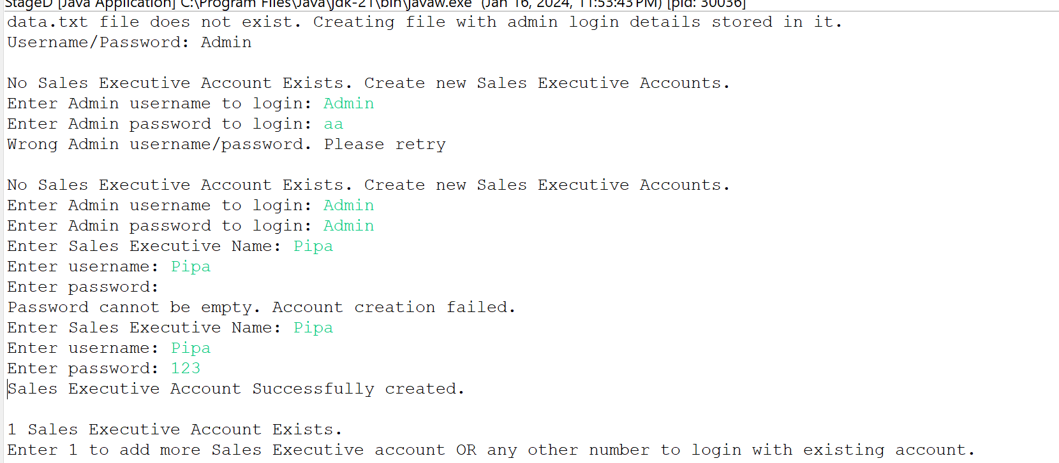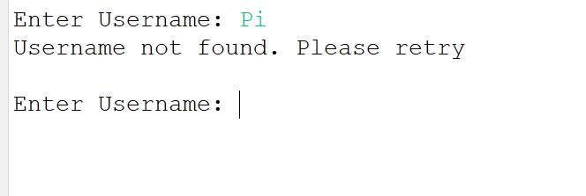
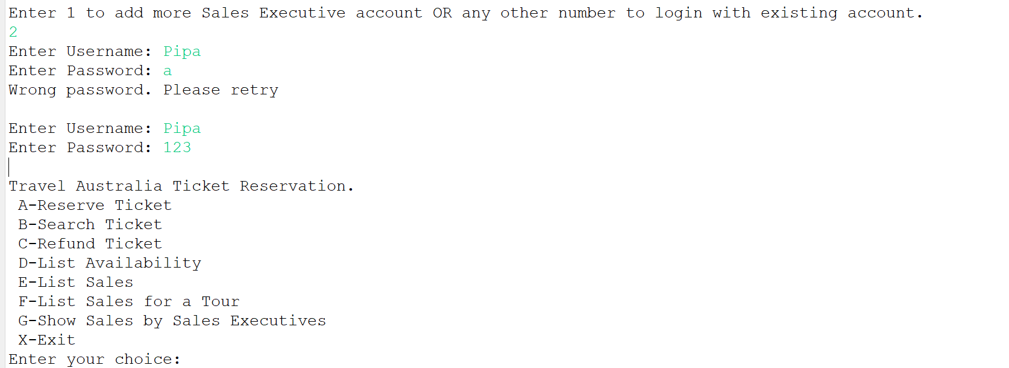
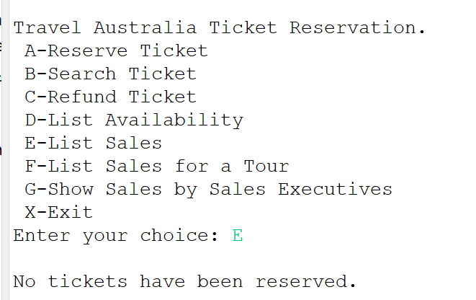
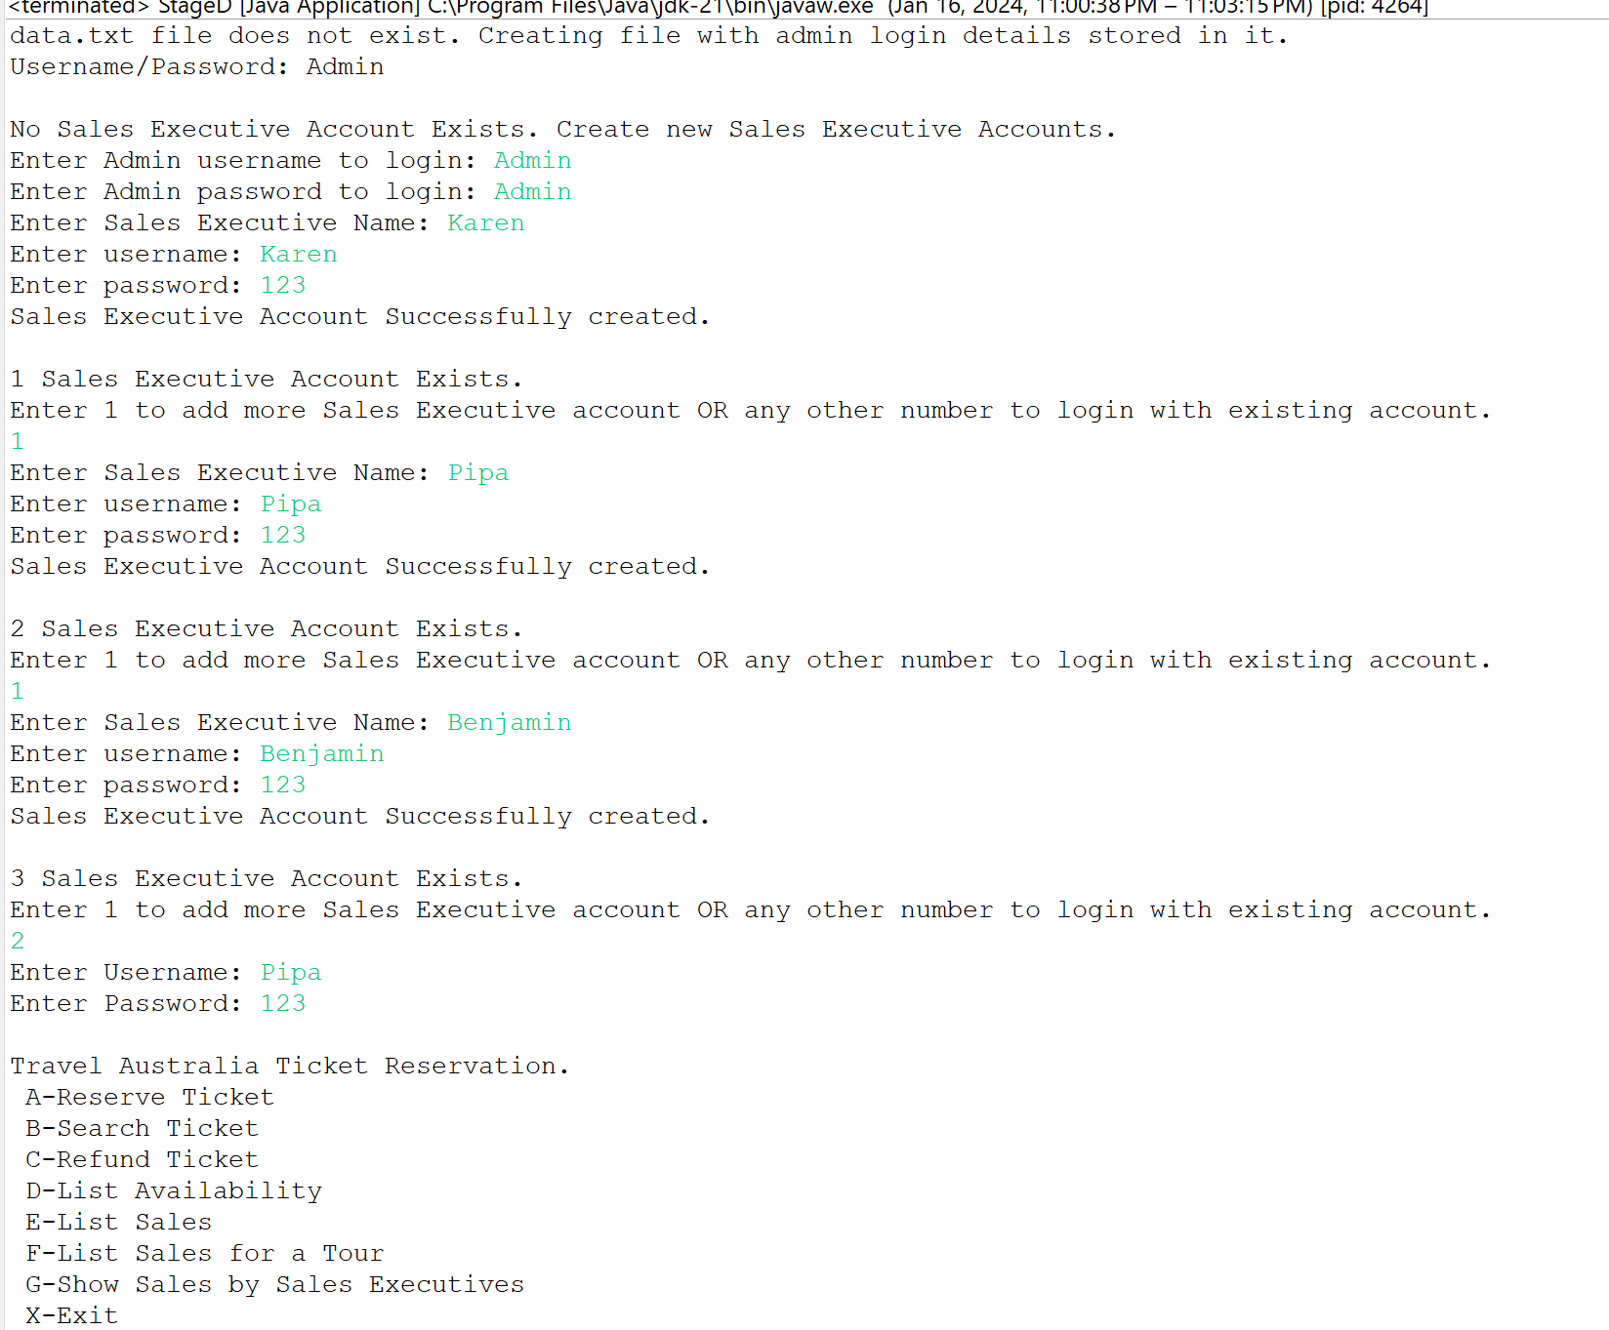
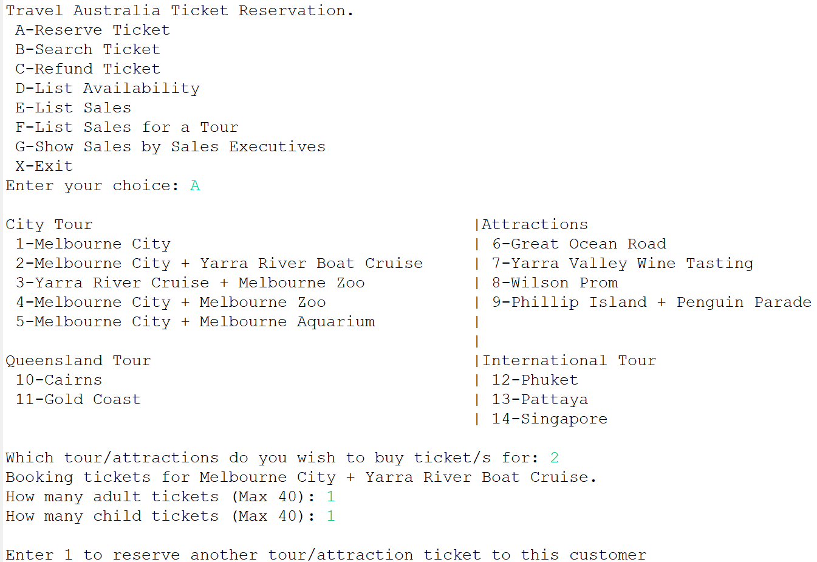
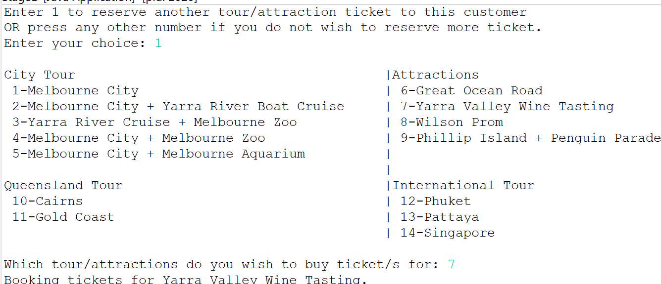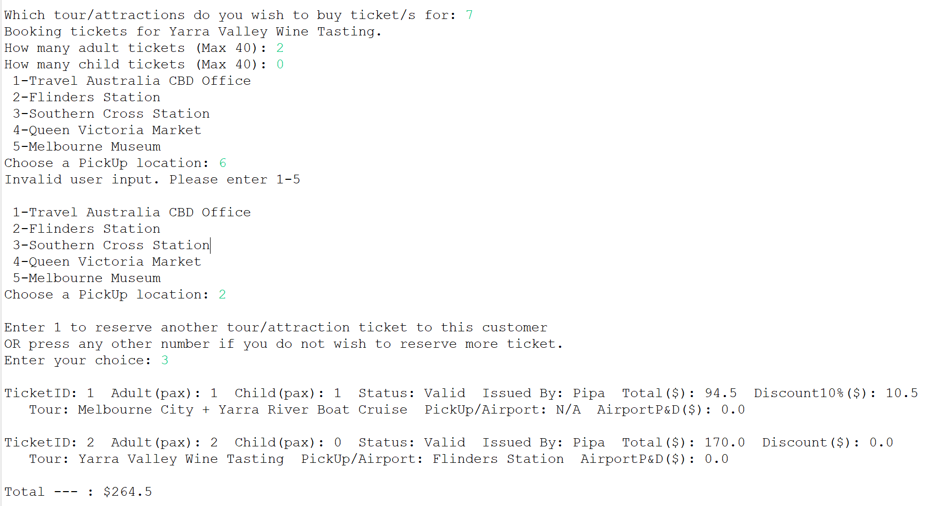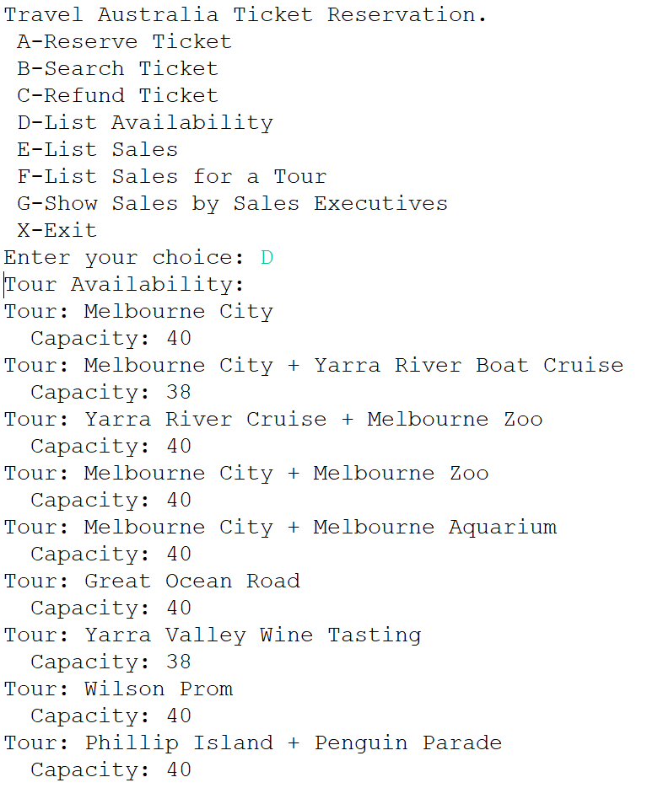
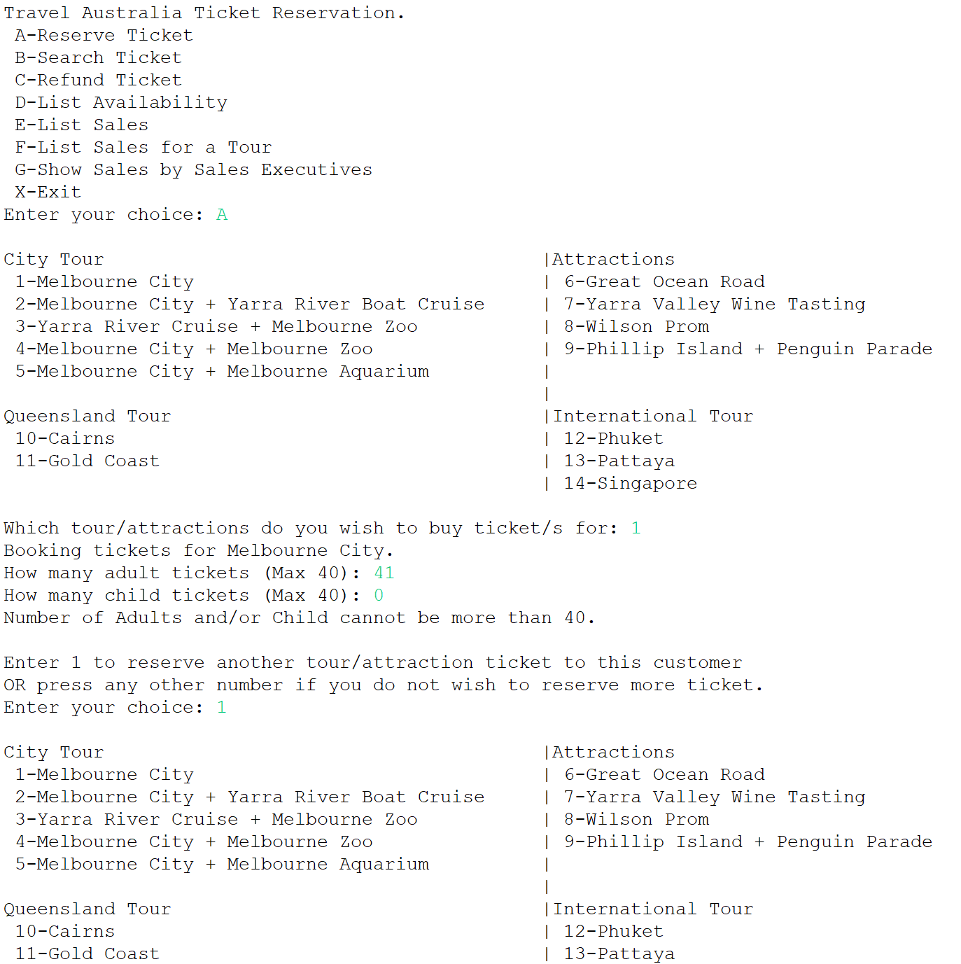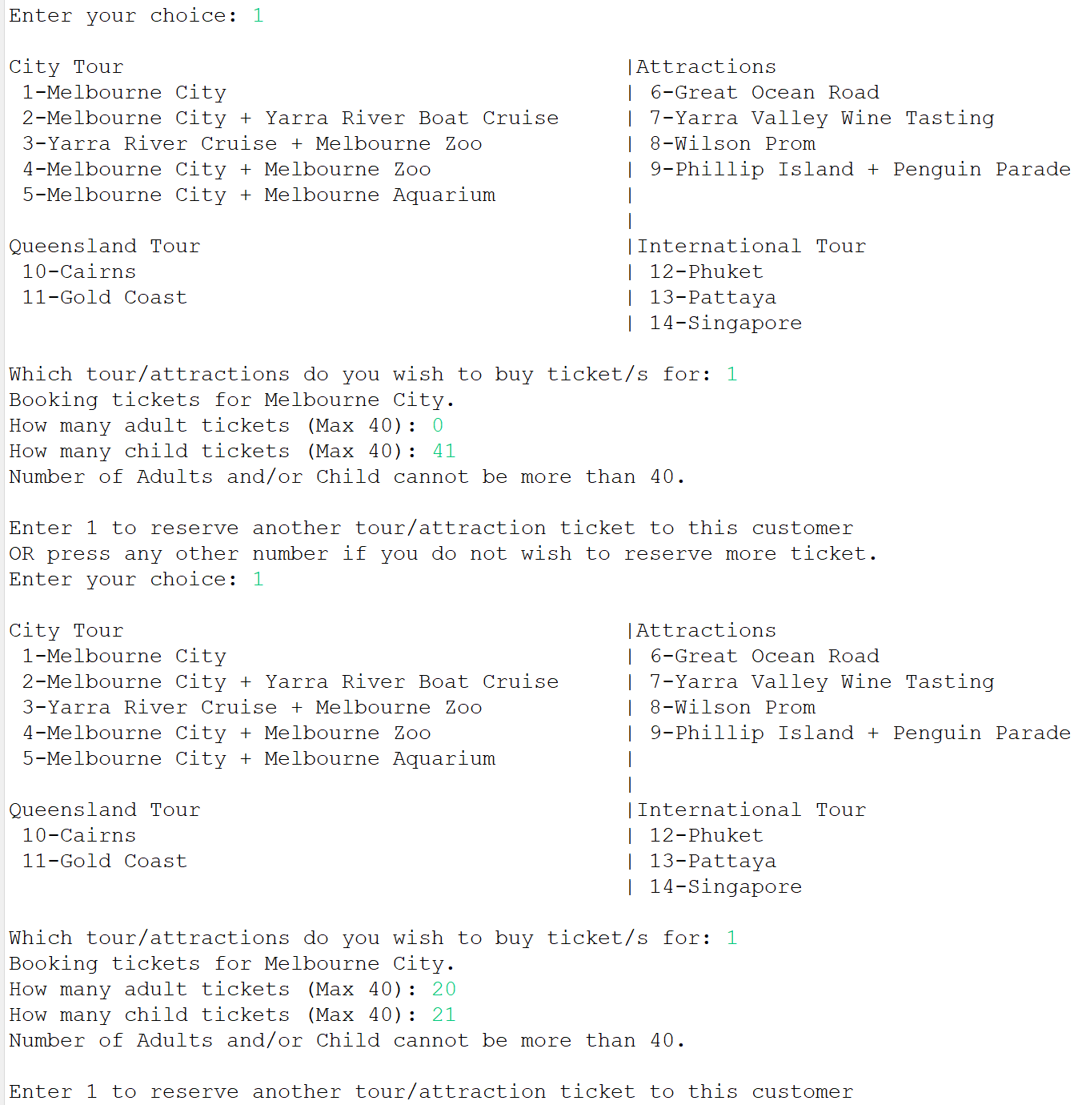
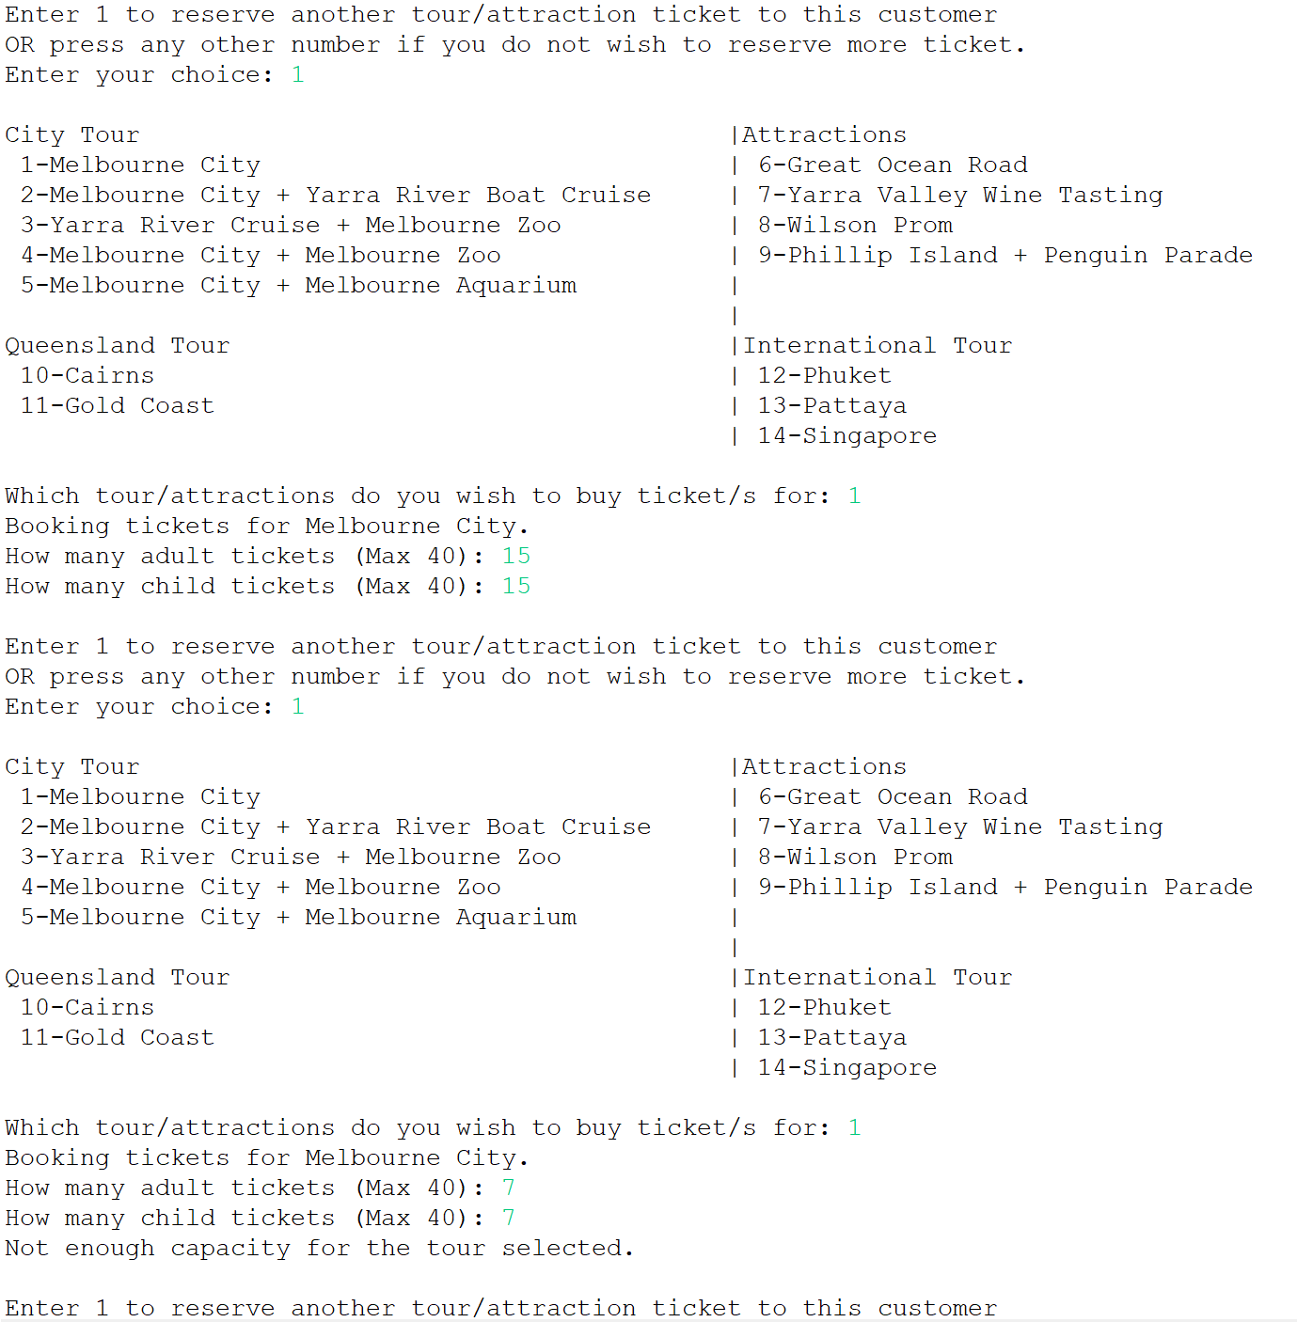
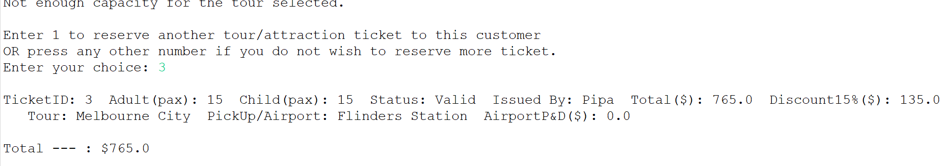
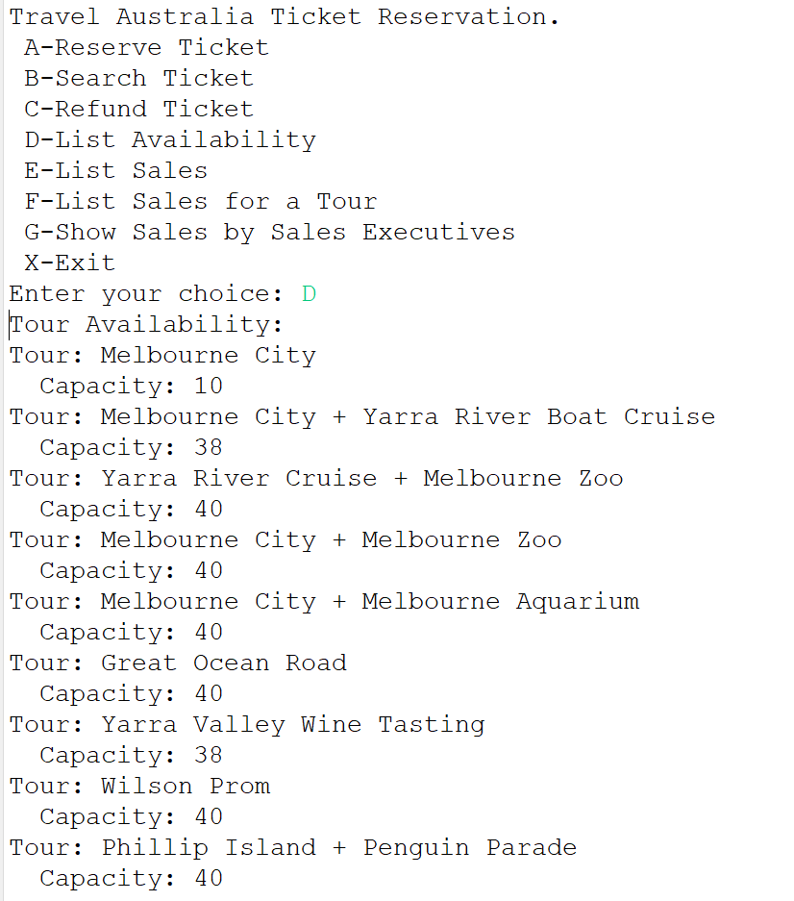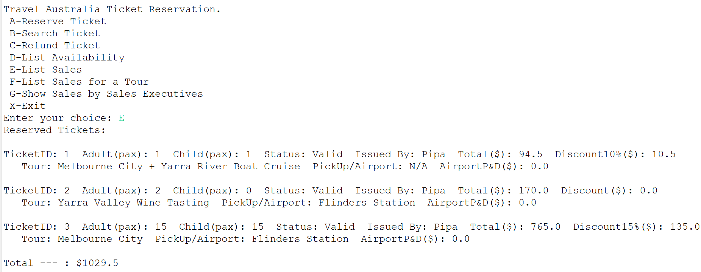
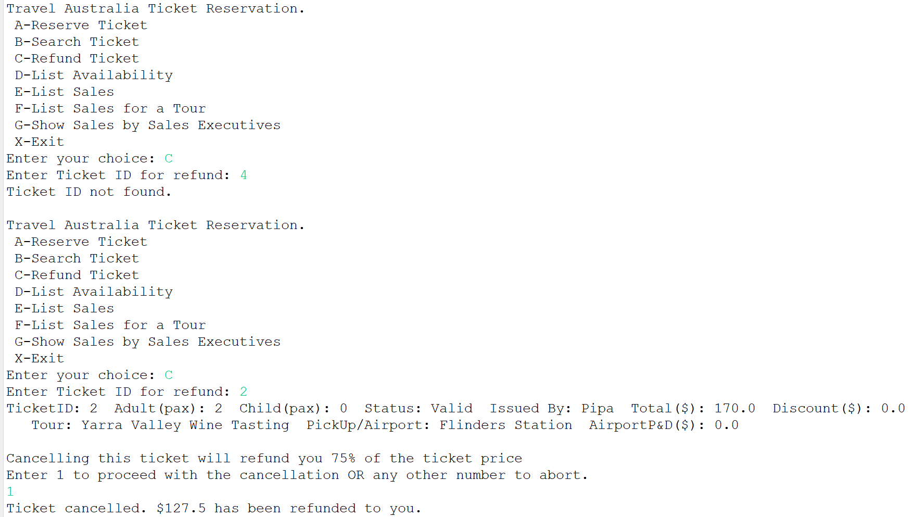
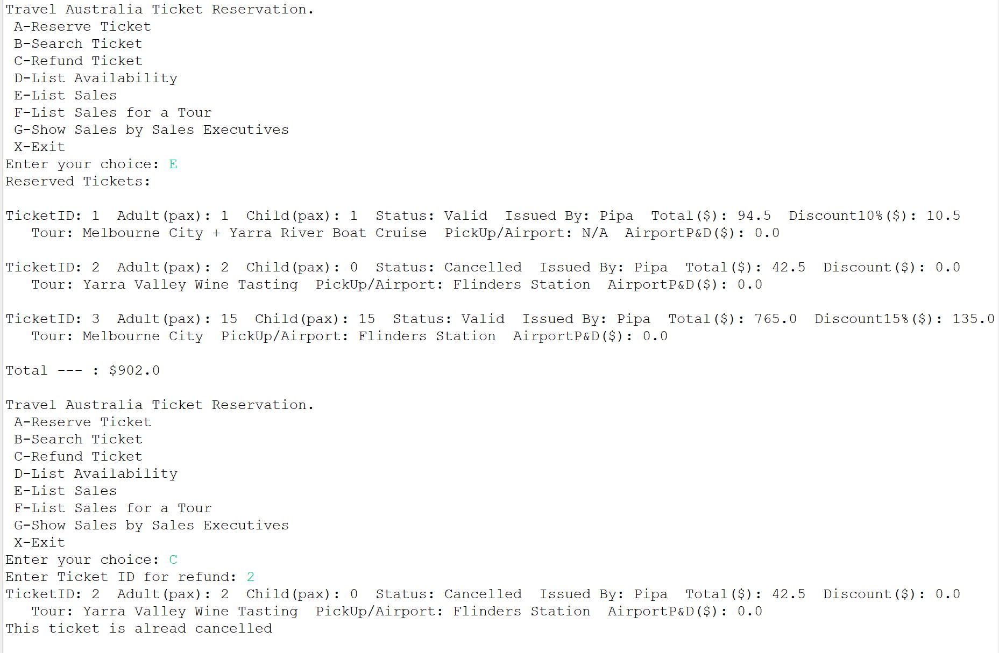
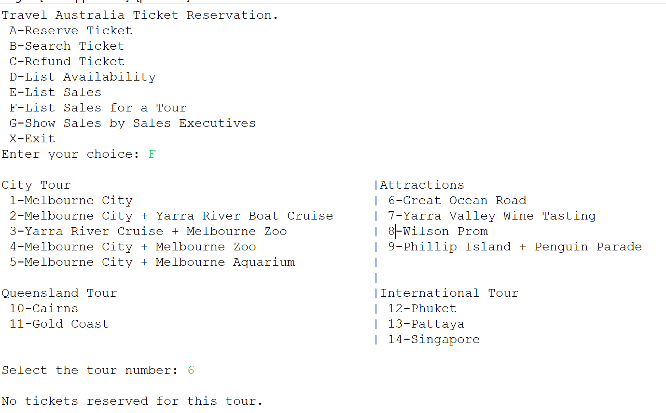
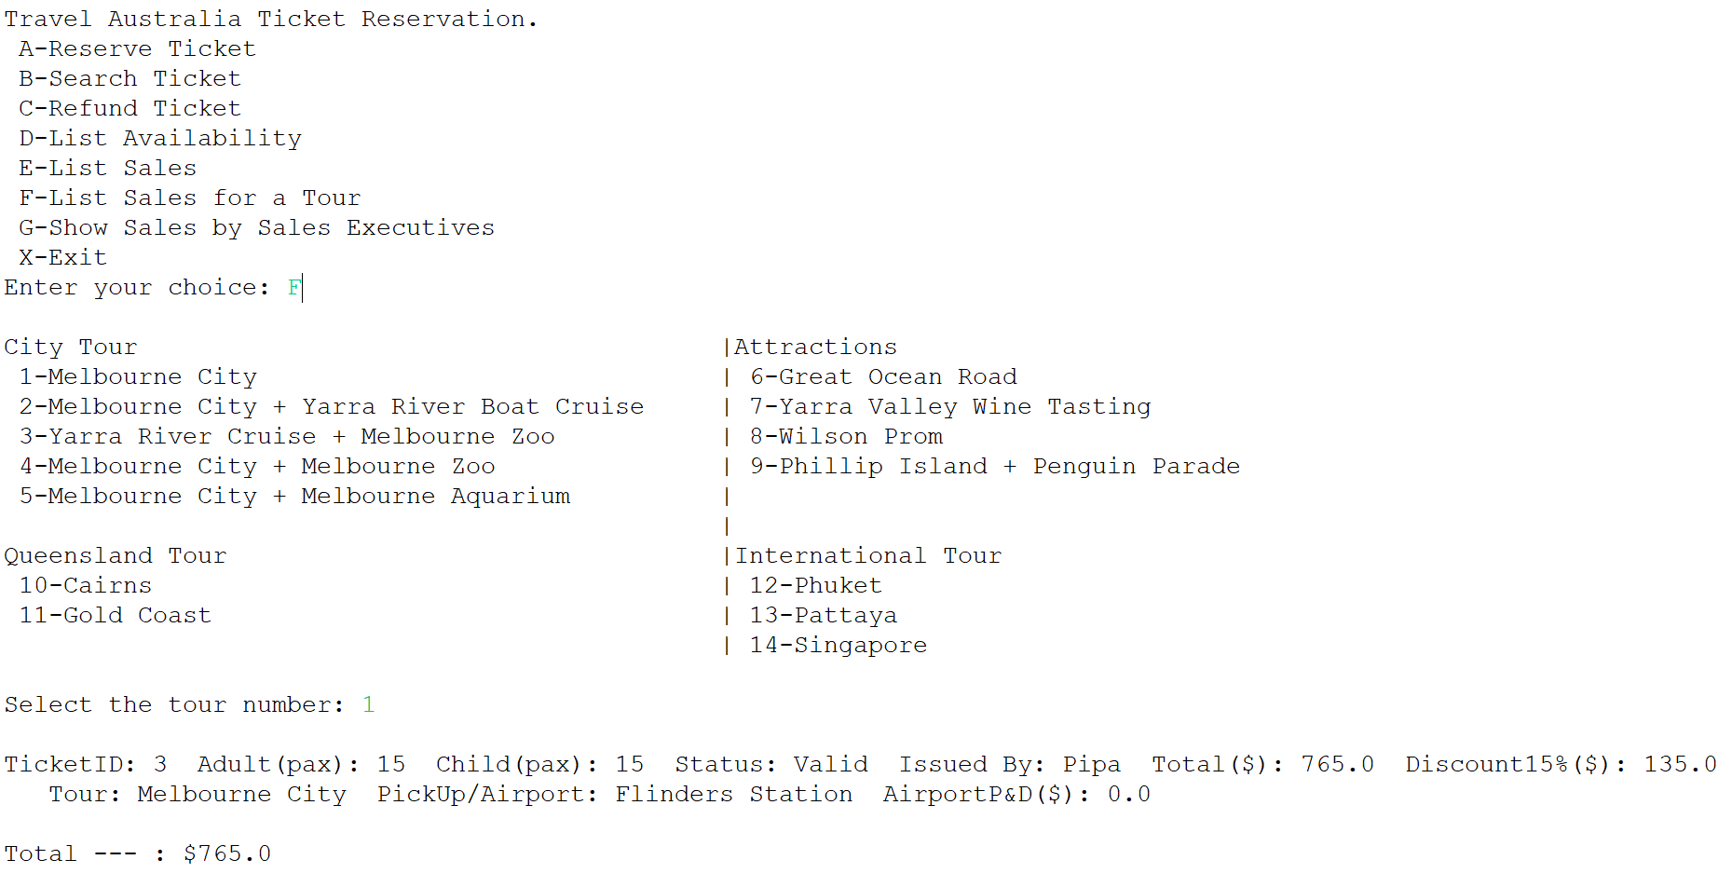
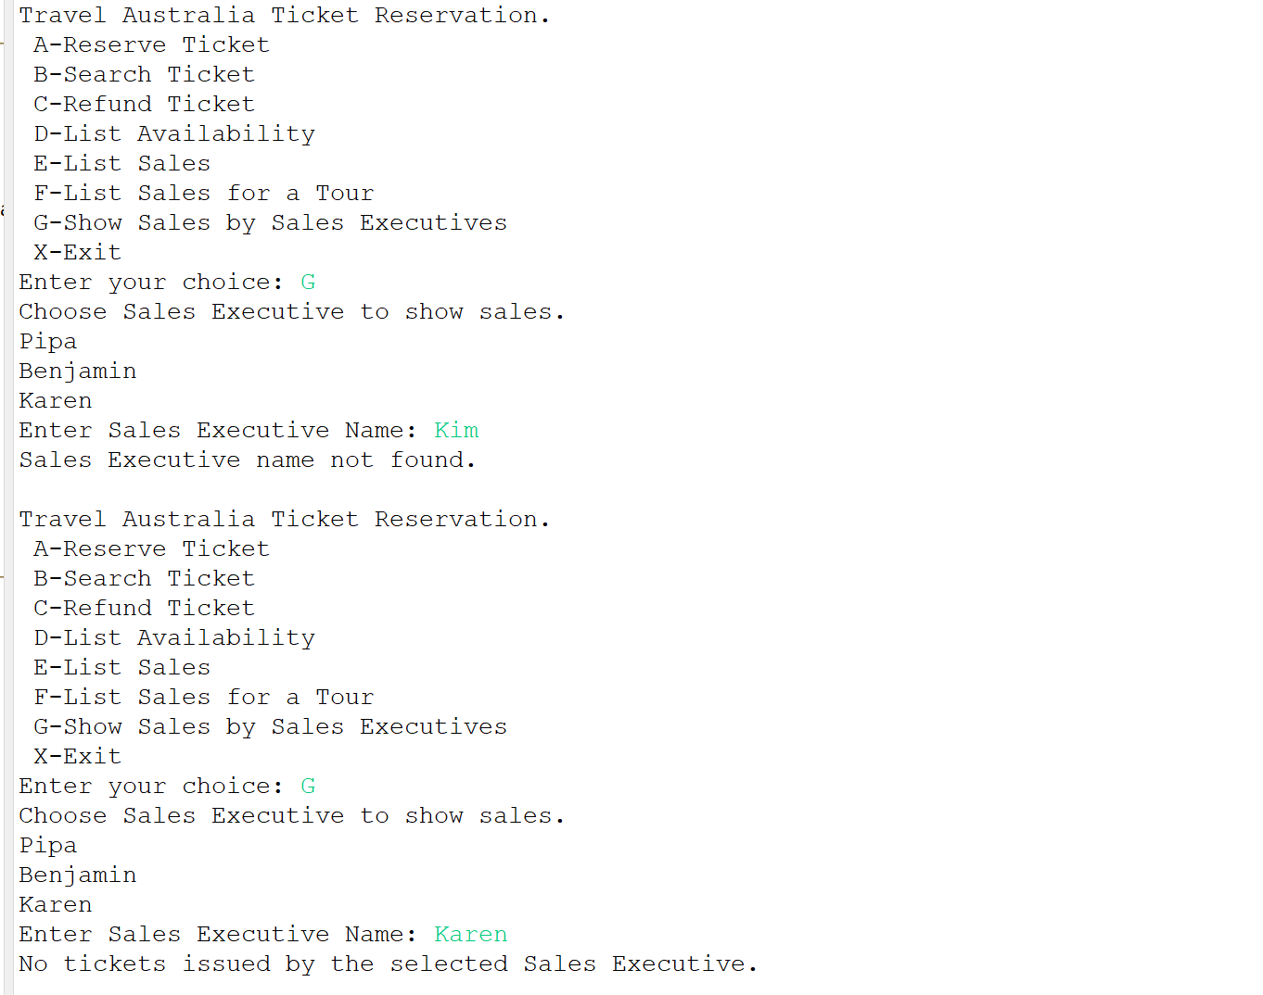
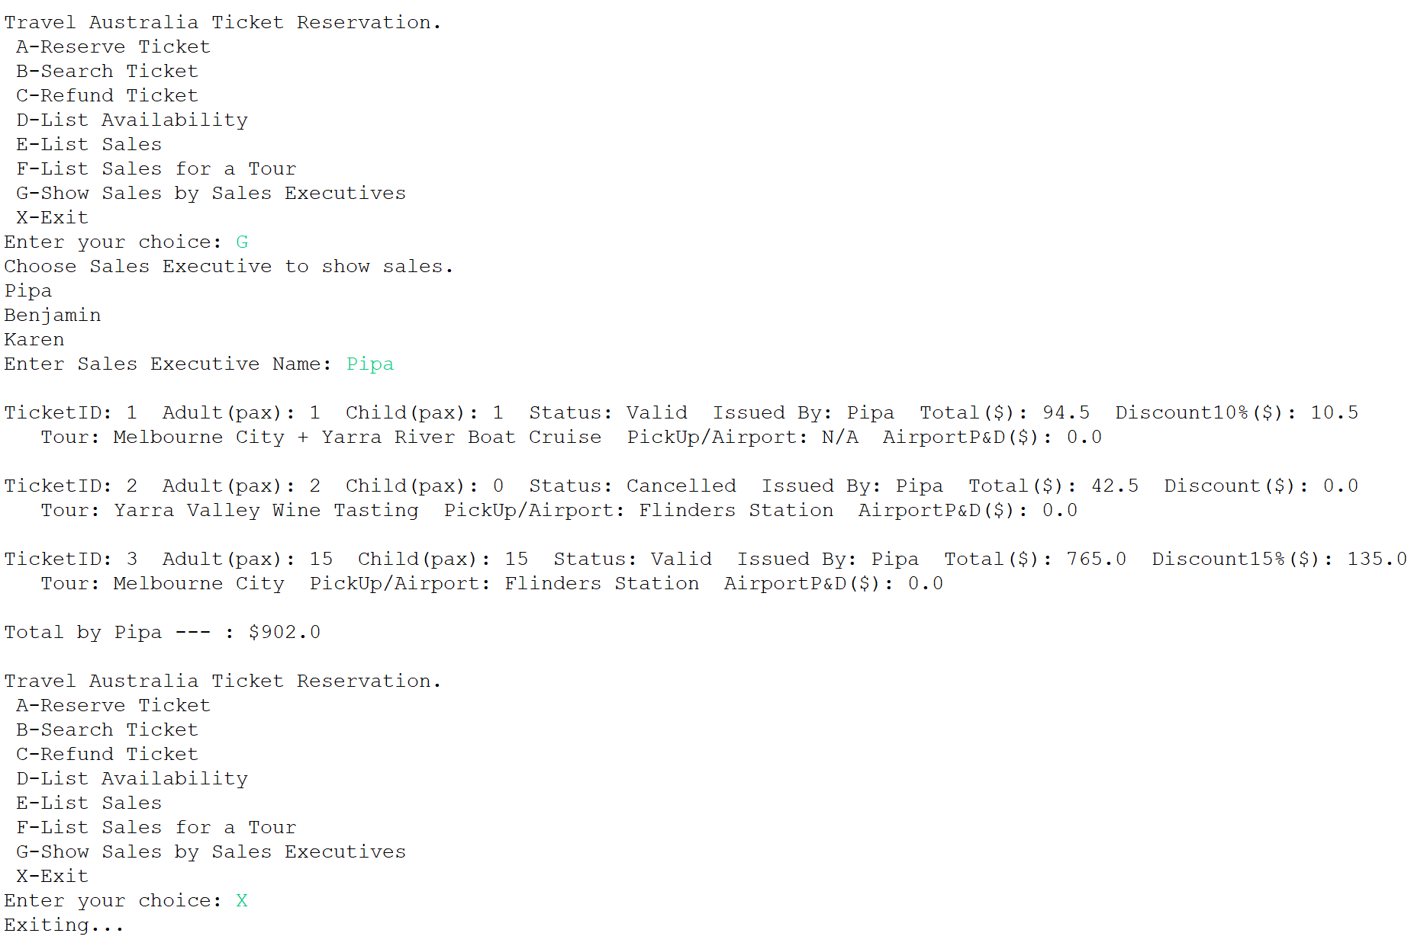
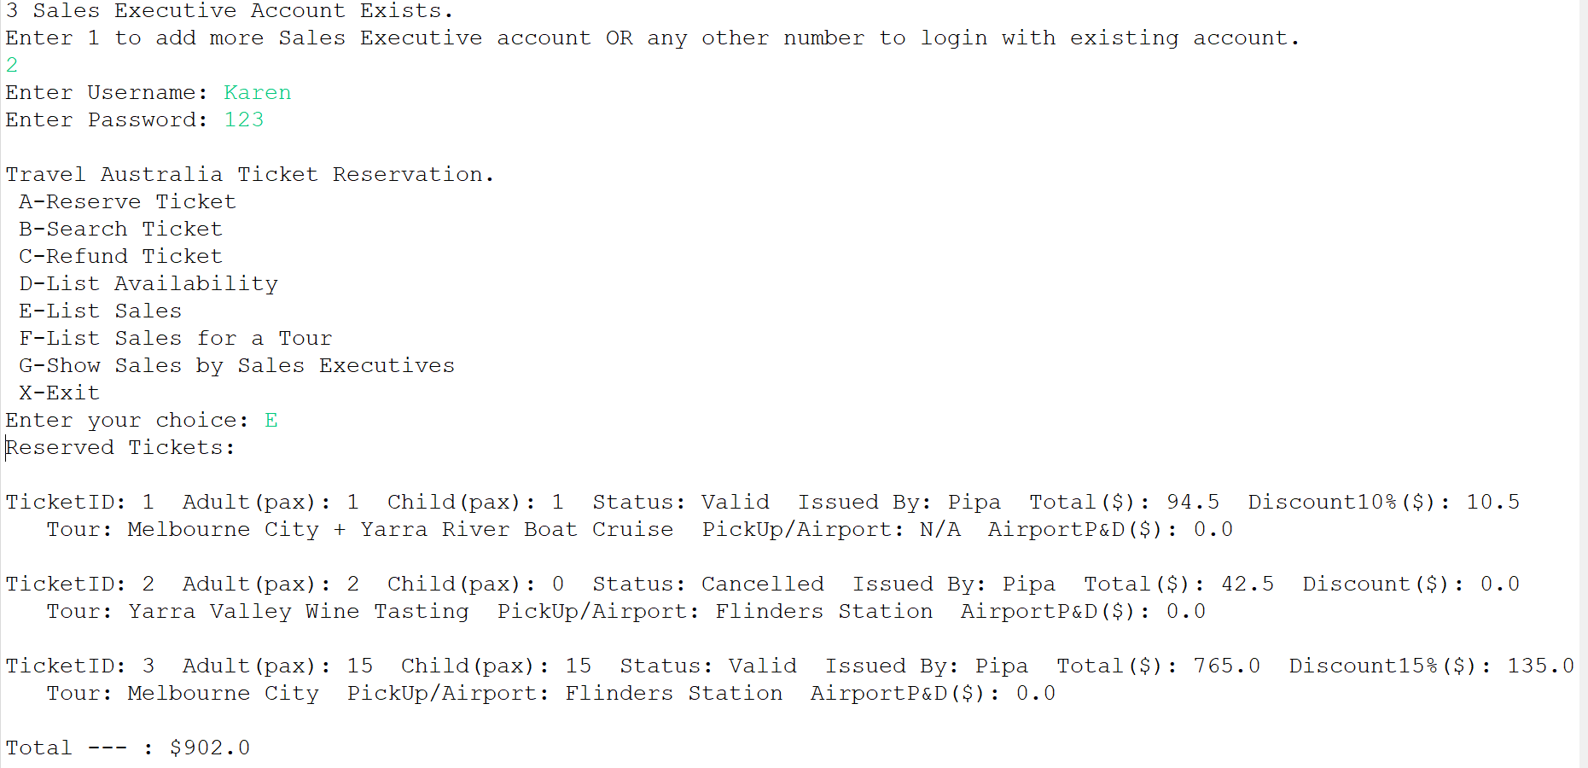
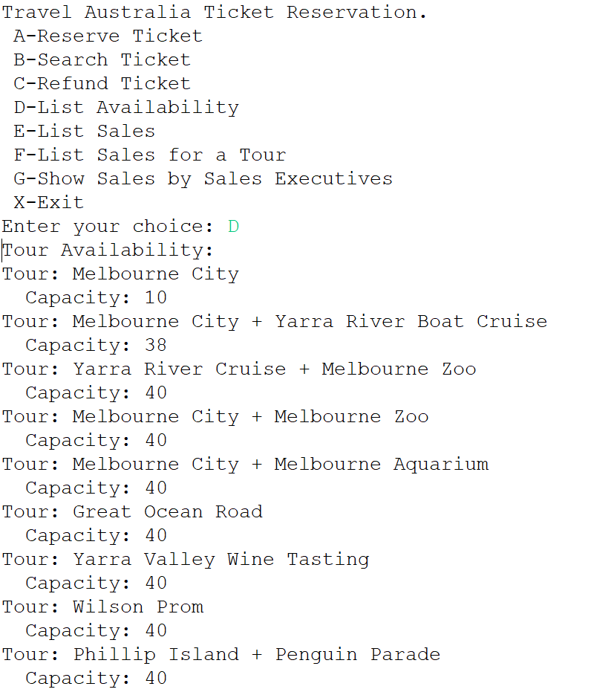
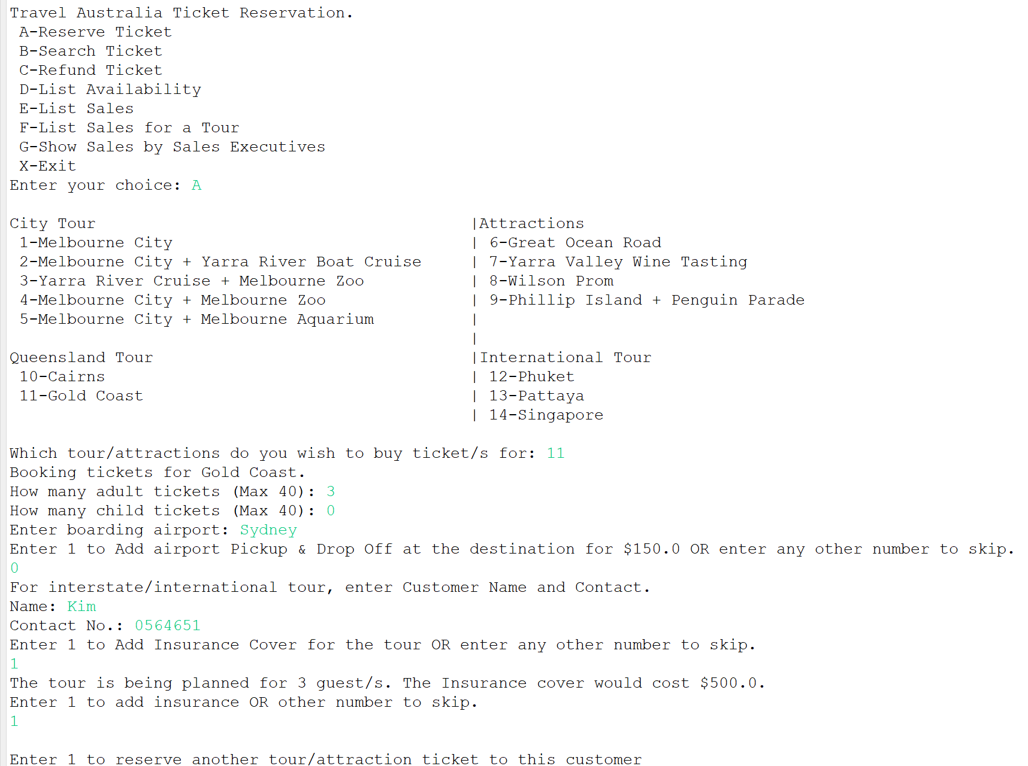
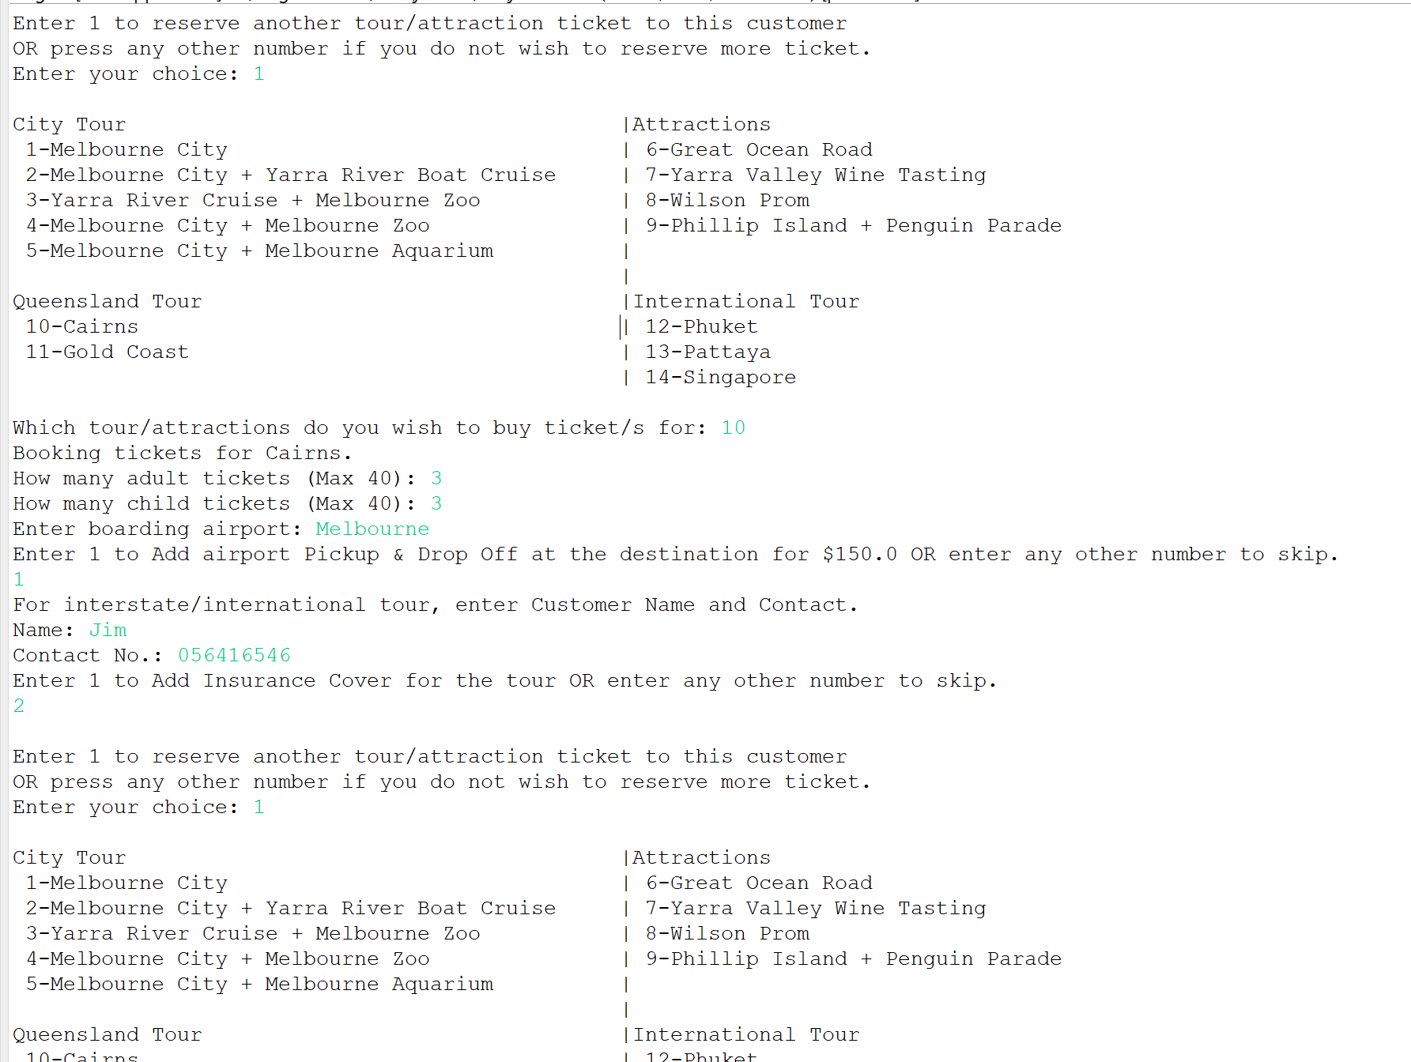
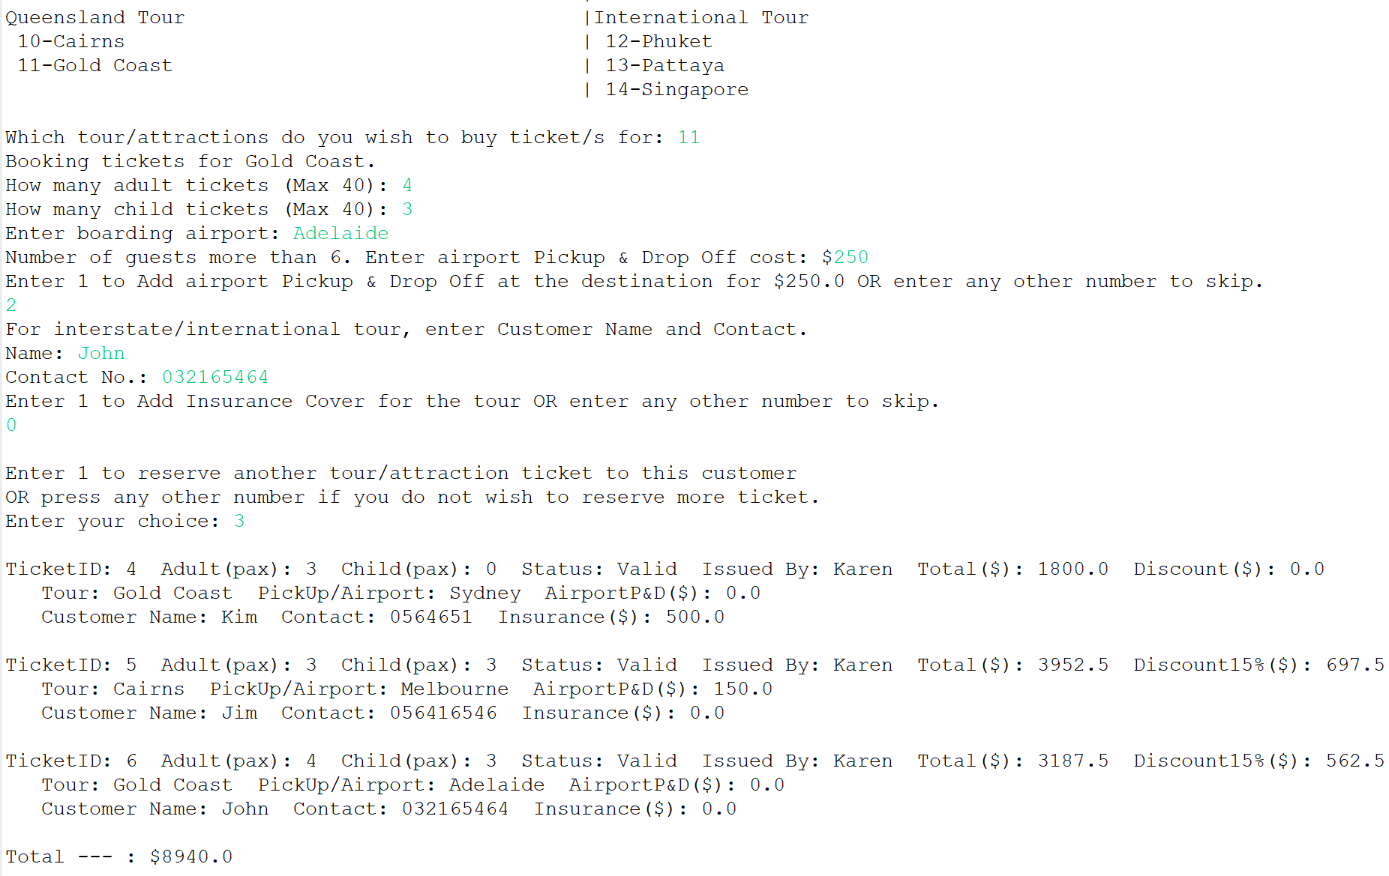
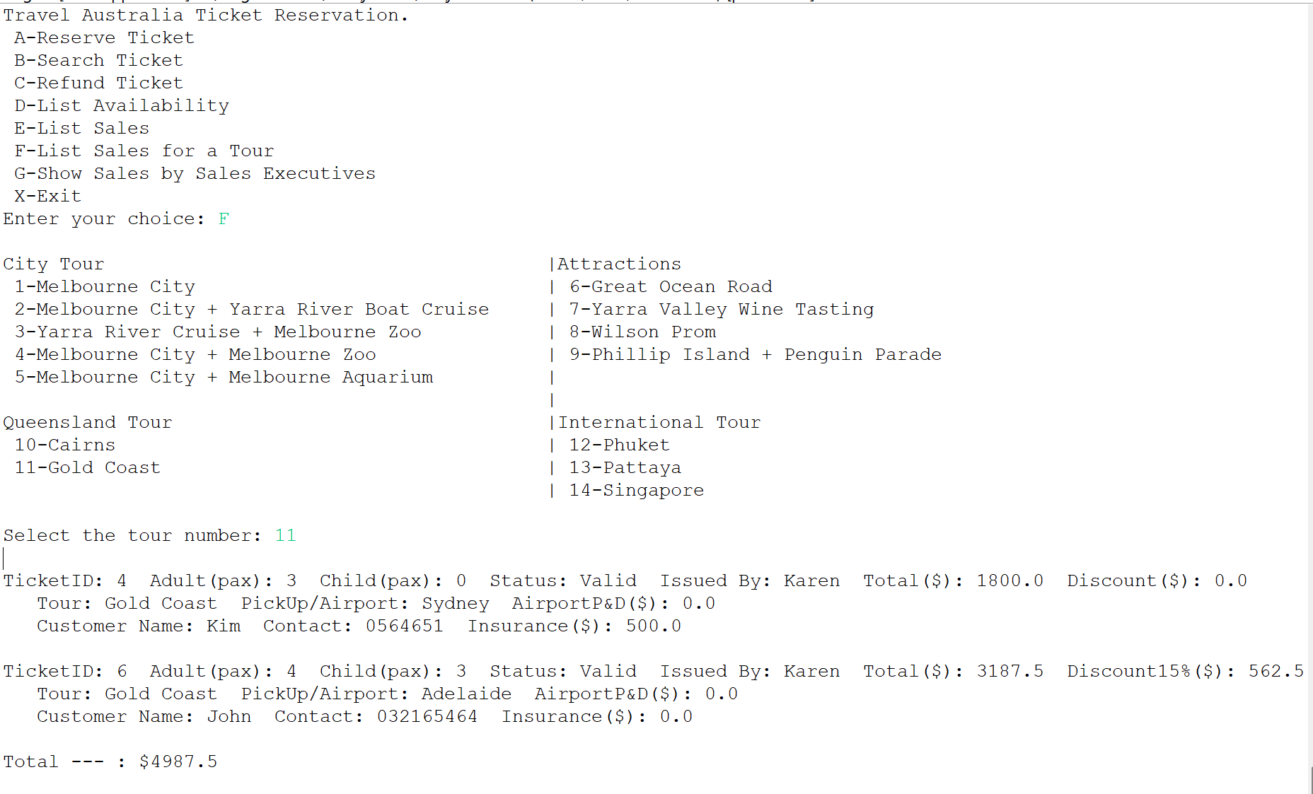
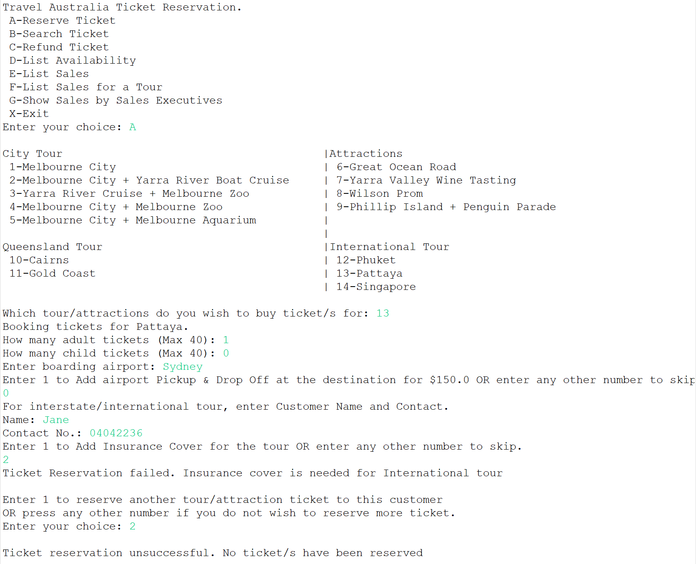
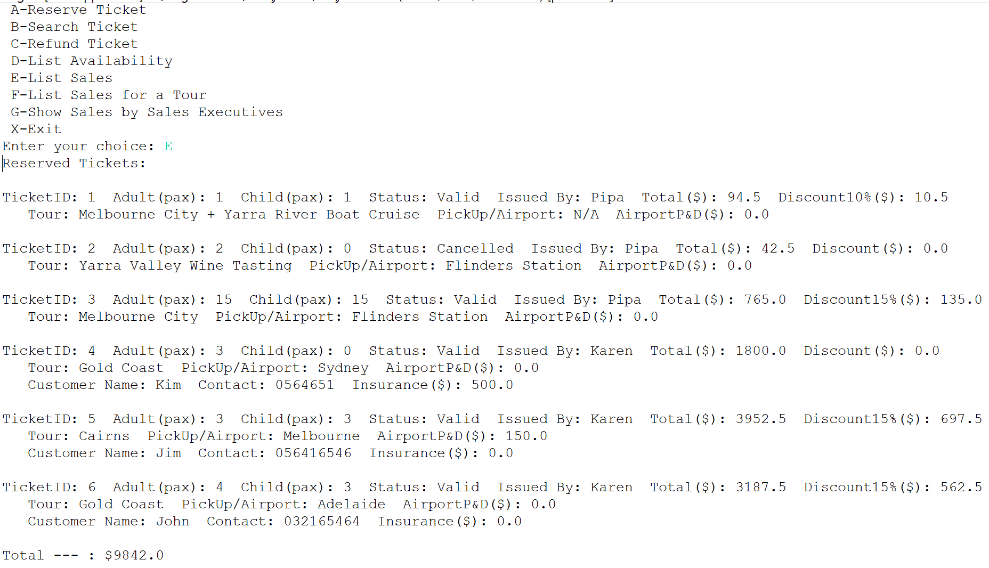
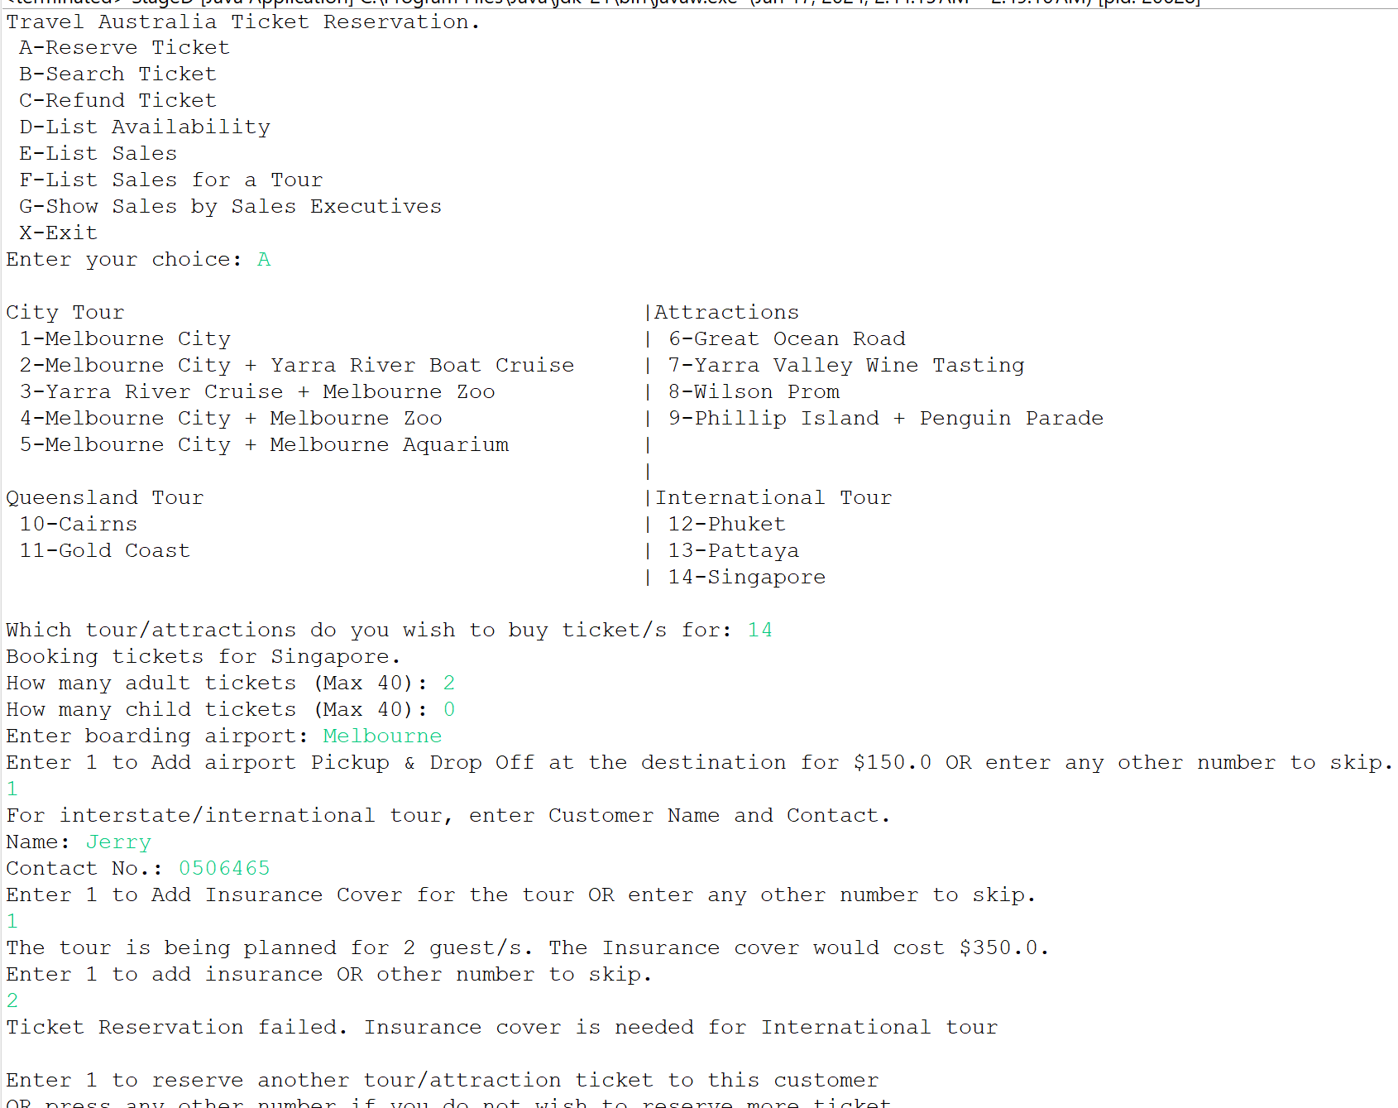
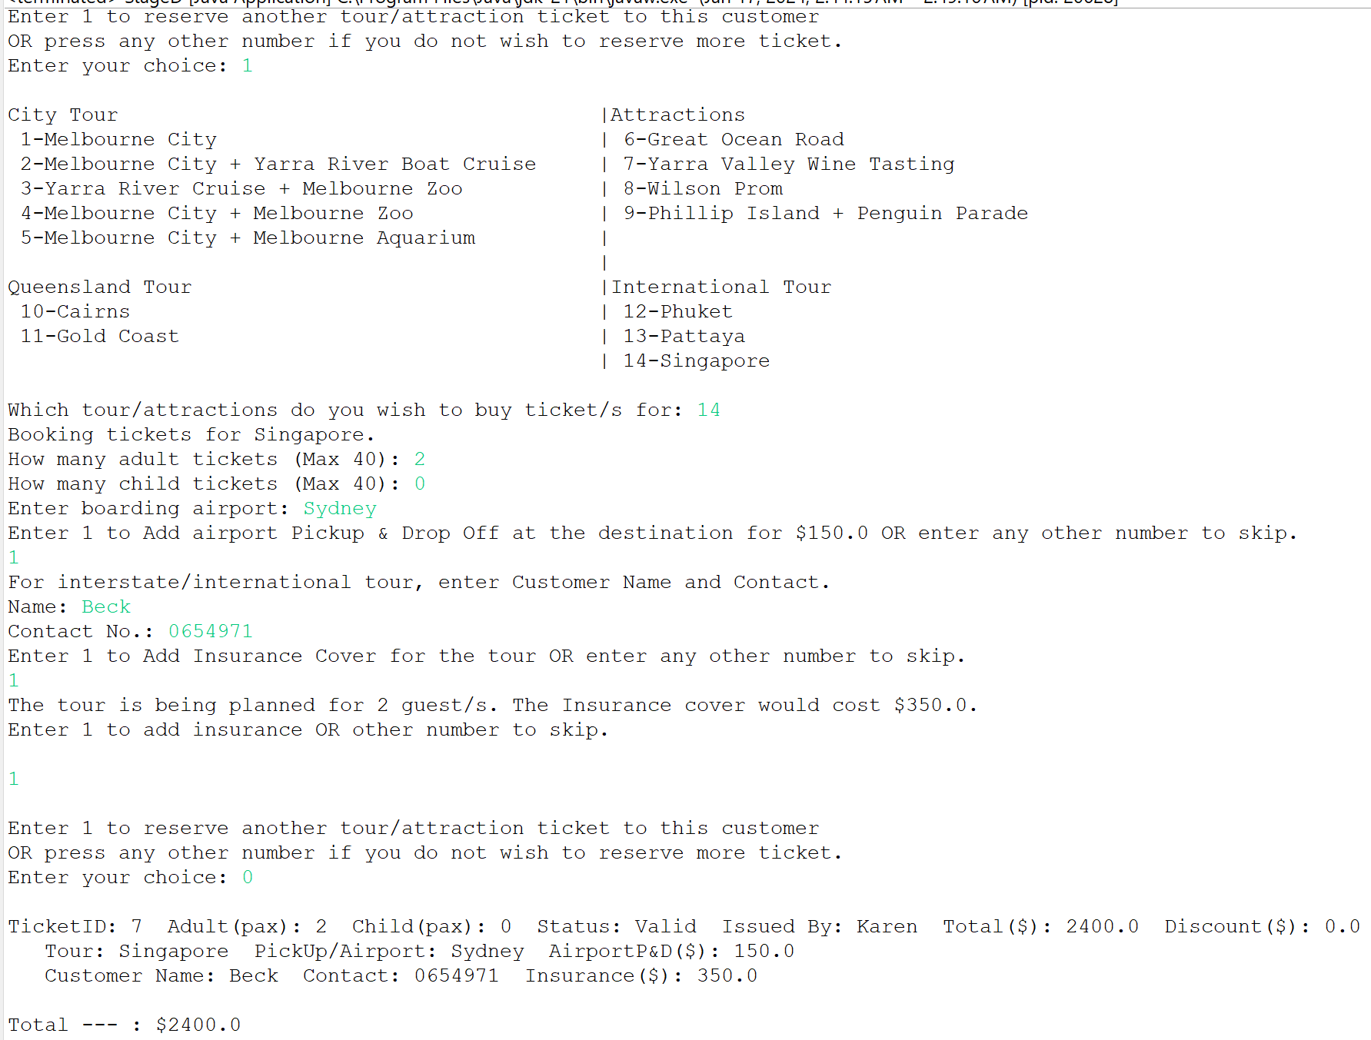
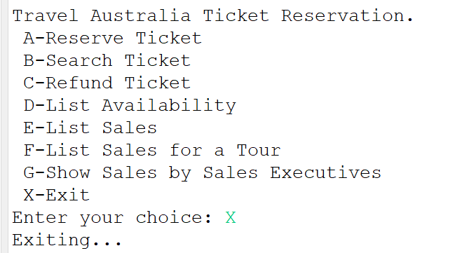
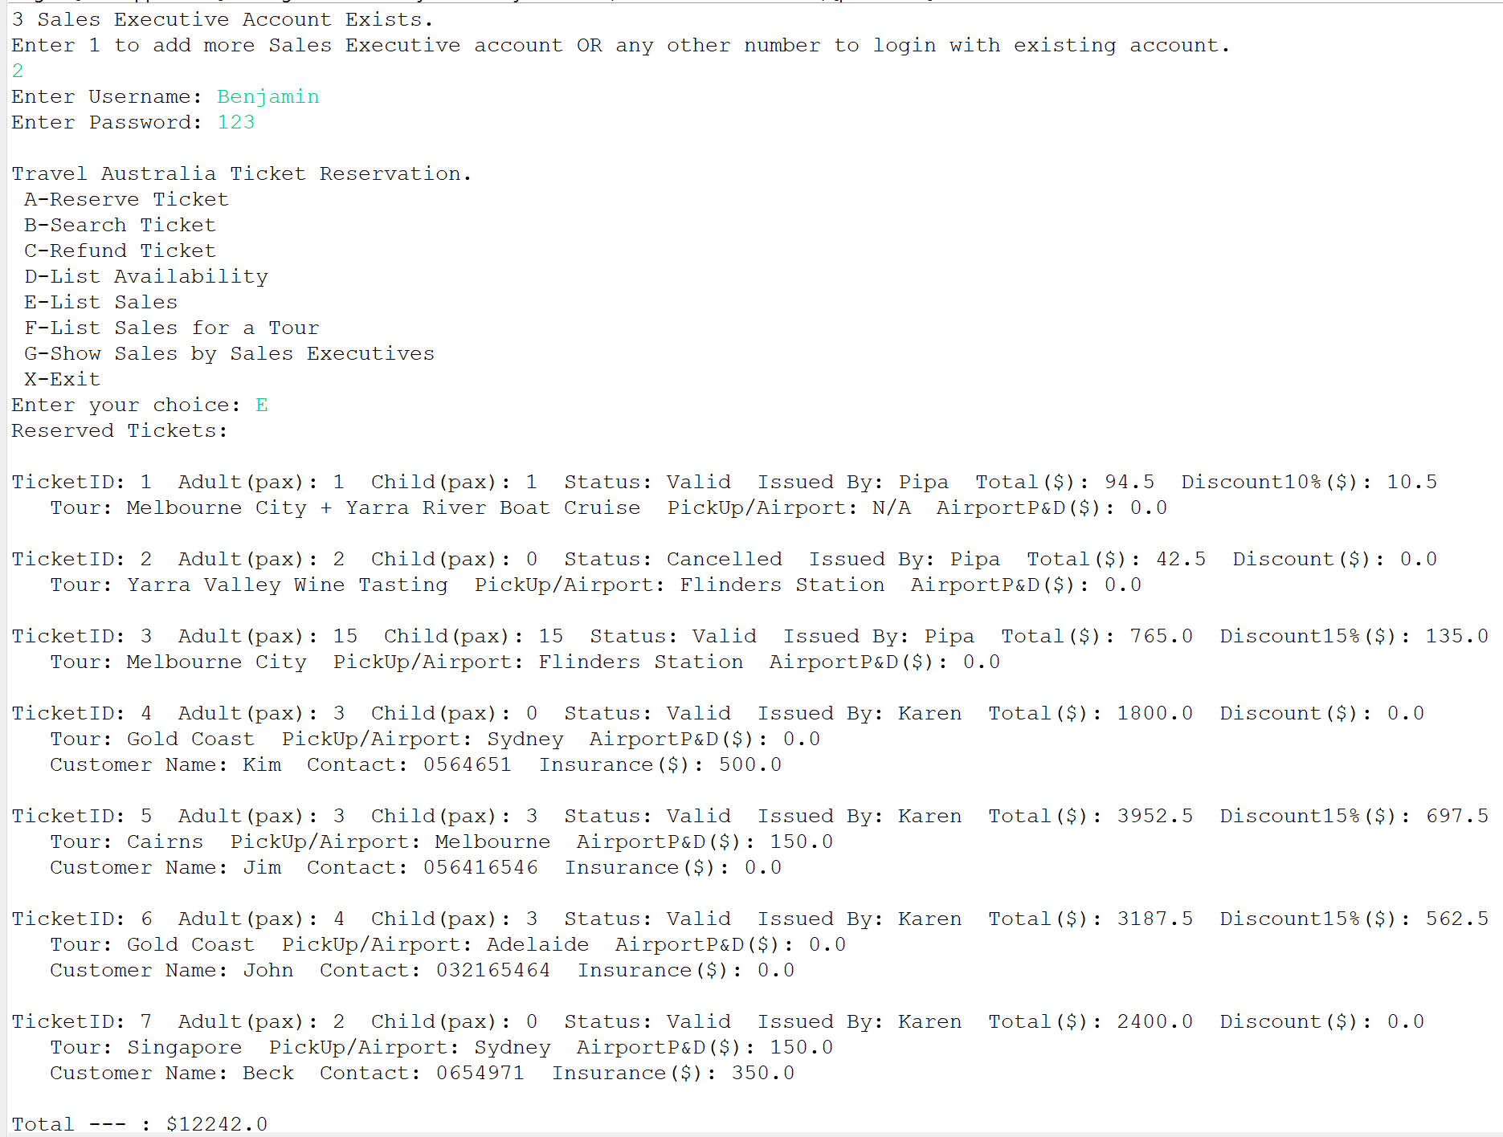
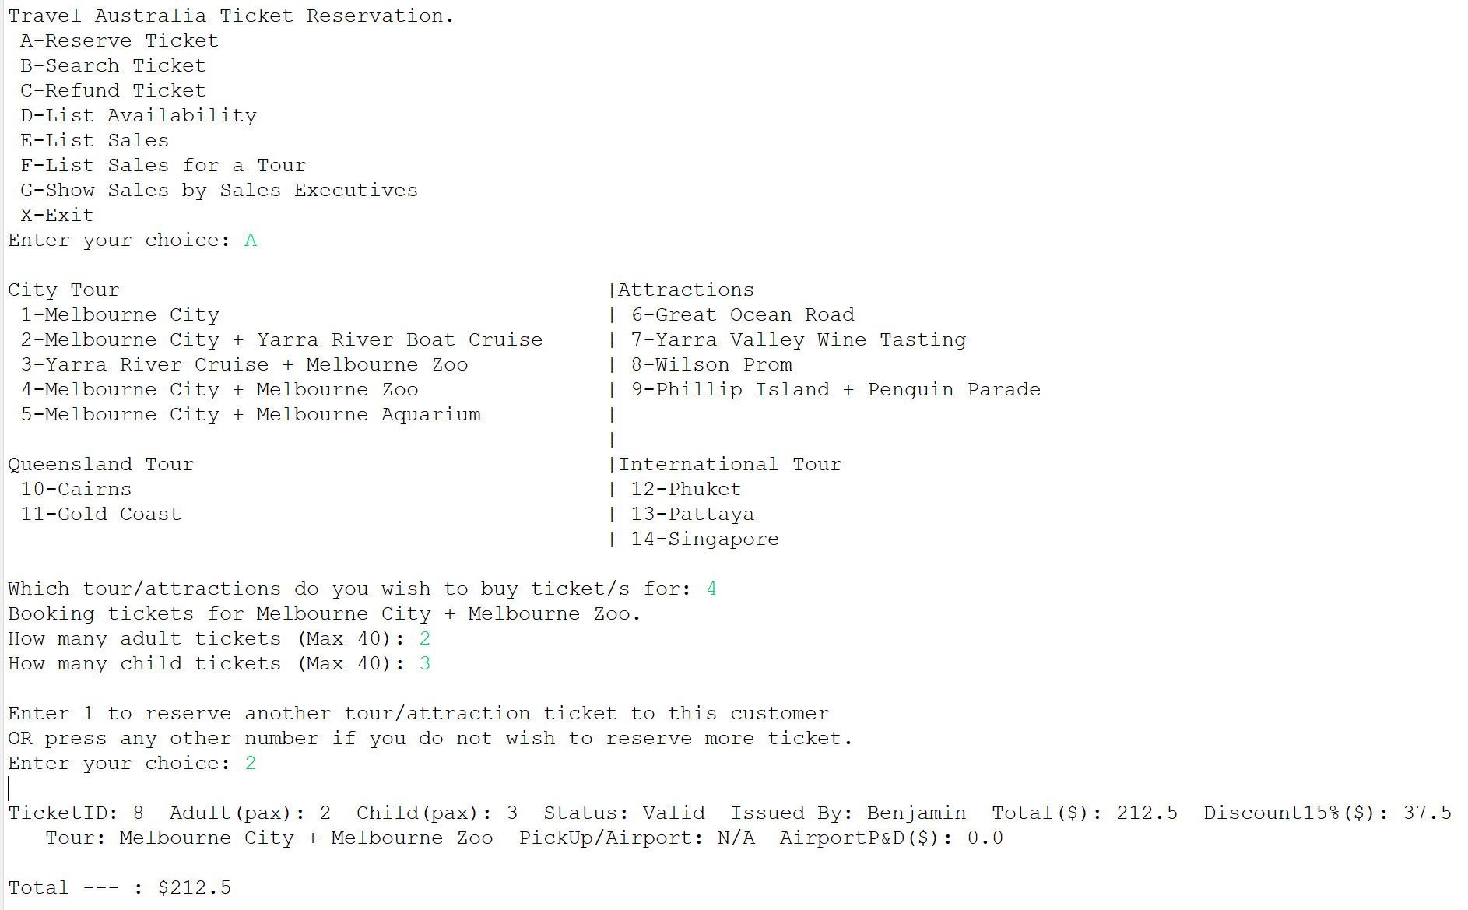
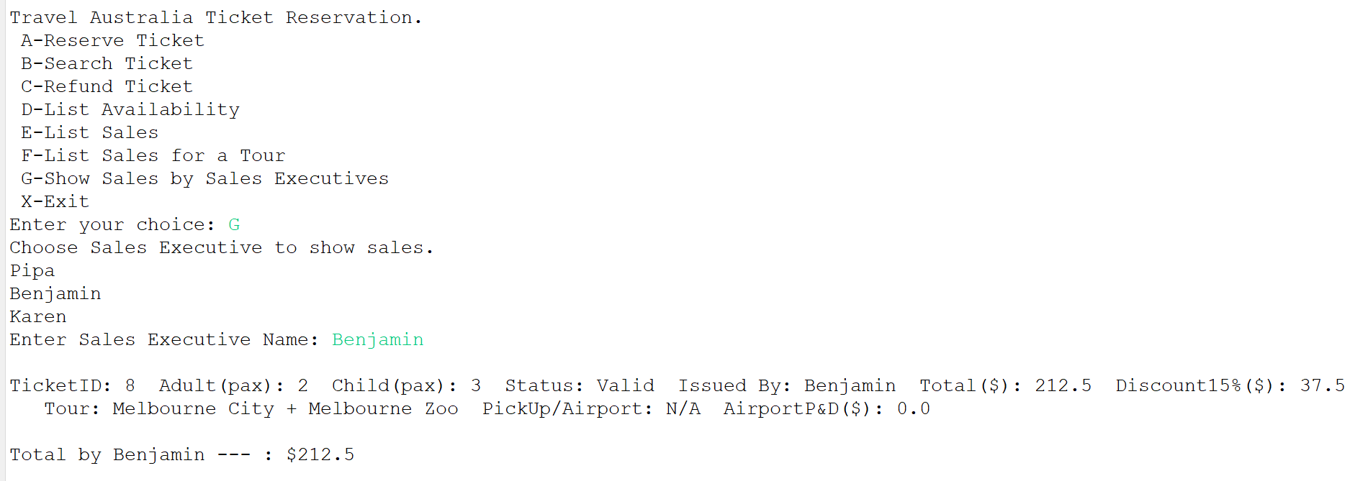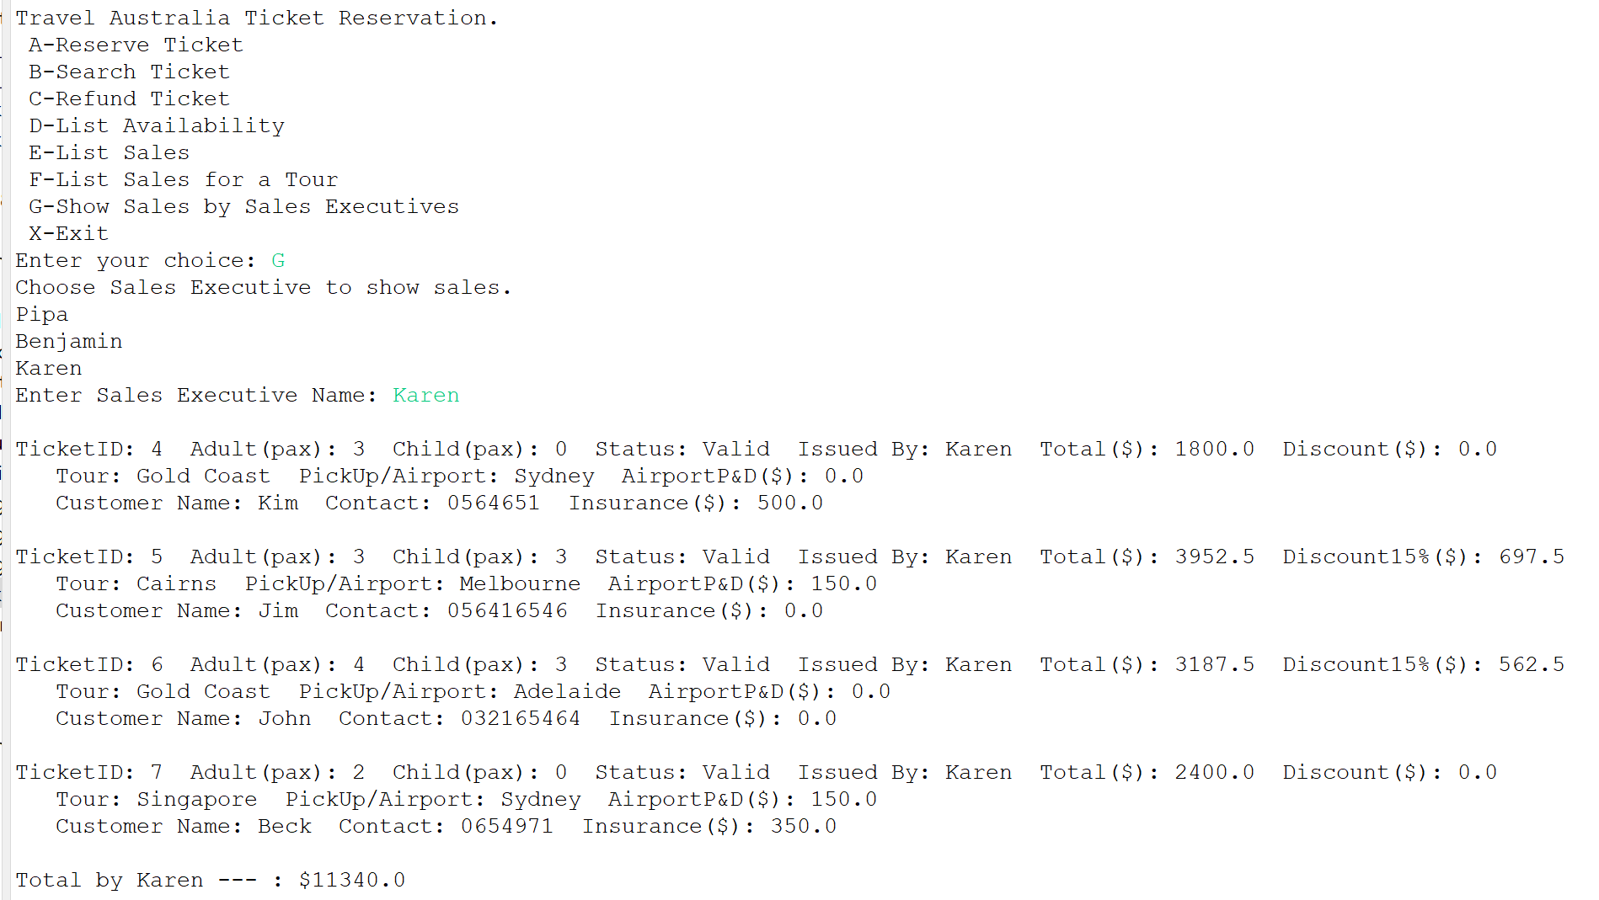
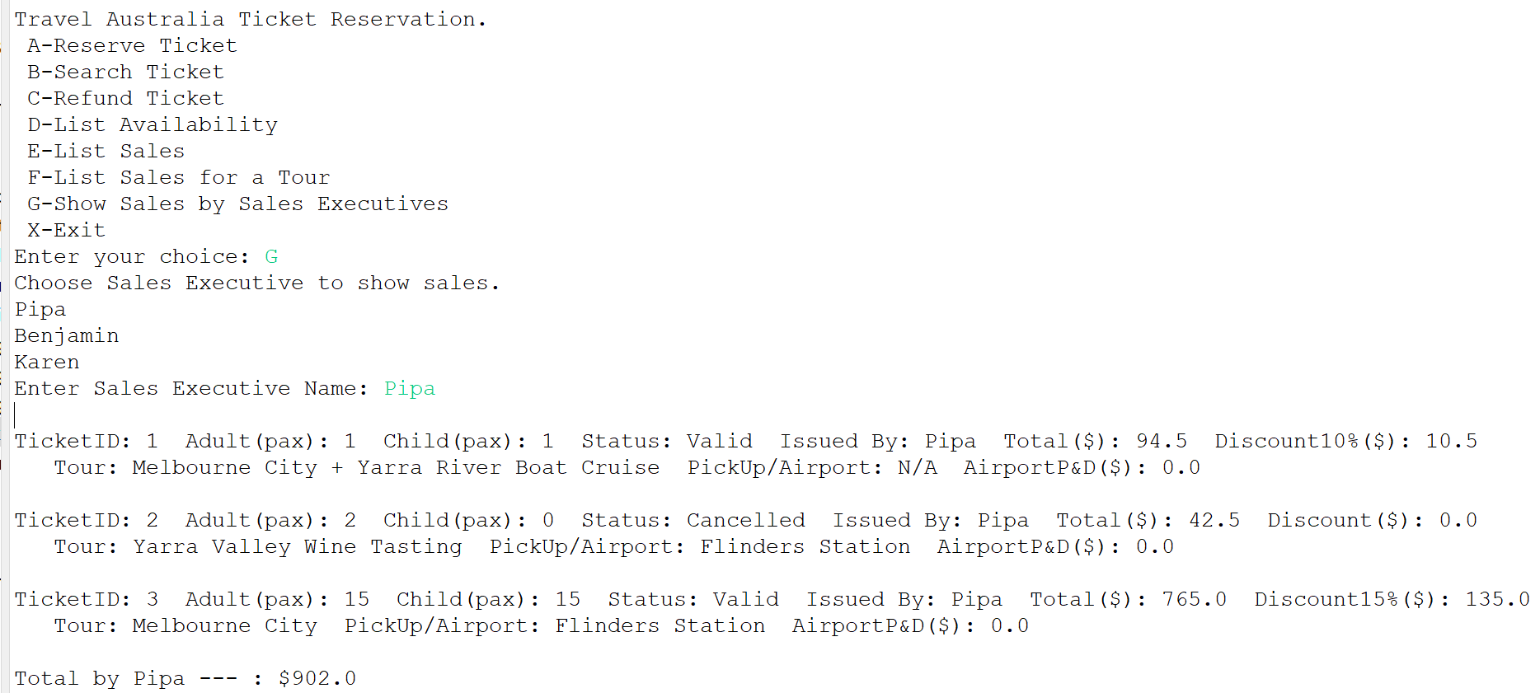
Junit
Source Code
import static org.junit.jupiter.api.Assertions.*;
import org.junit.jupiter.api.Test;

class JunitTest {

@Test
void test1() throws illegalArgException {
//Valid

Account salesExec1=new Account("Ben", "Ben", "B123");
Ticket t1=new Ticket(1, 2, 0, salesExec1);
Ticket t2=new Ticket(2, 1, 2, salesExec1);

//getStatus() method
assertEquals("Valid", t1.getStatus()); //status="valid" is automatically created when new ticket is created
assertNotNull(t2.getStatus());

//setTotal() method
t1.setTotal(220.0);
t2.setTotal(300.0);
assertEquals(220, t1.getTotal());
assertEquals(300.0, t2.getTotal());

//refund() method
t1.refund();
t2.refund();
assertEquals(55.0, t1.getTotal()); //refund 75%, keep 25%
assertNotNull(t2.getTotal());

}

@Test
void test2() throws illegalArgException {
//Invalid

Account salesExec1=new Account("Benjamin", "Ben", "B123");
Ticket t1=new Ticket(1, 2, 0, salesExec1);
//getStatus() method
assertEquals("null", t1.getStatus());
}

@Test
void test3() throws illegalArgException {
//Invalid

Account salesExec2=new Account("Pipa", "Pipa", "P123");
Ticket t1=new Ticket(1, 2, 0, salesExec2);
//setTotal() method
t1.setTotal(250.0);
assertNull(t1.getTotal());
}

@Test
void test4() throws illegalArgException {
//Invalid

Account salesExec2=new Account("Pipa", "Pipa", "P123");
Ticket t1=new Ticket(1, 2, 0, salesExec2);

//refund() method
t1.setTotal(100.0);
t1.refund();
assertEquals(0, t1.getTotal()); //not supposed to be 0
//should be 25% of 100.0 = 25.0
}
}

Output
