Assignment 1 – Introduction to Linux Basic Commands
Name: MABHYALA Priscia Student ID: 26046

Question 1: If you are in the P3 directory, write the command to go to your home directory.
Relative path: cd ../../..
This command navigates step by step up the directory tree until reaching the home directory.
Absolute path: cd /home/username
This command directly moves to the home directory using its full path.

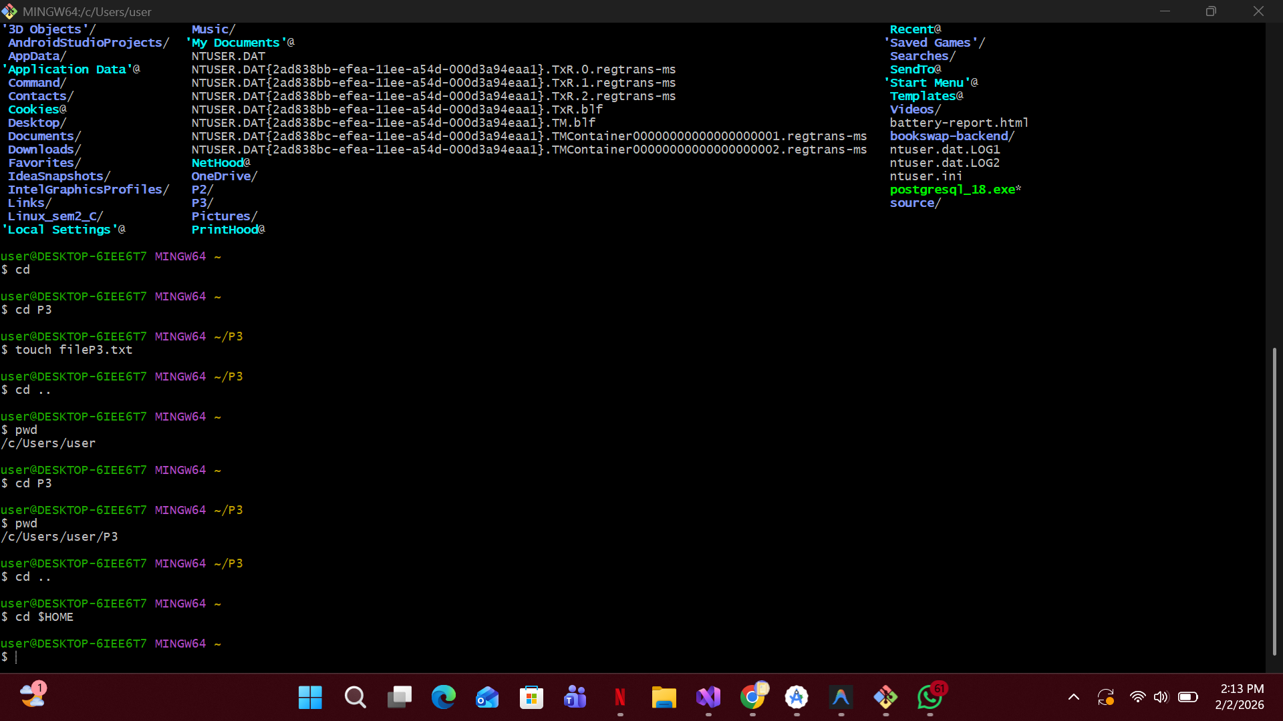

Question 2: Write the command to show a long listing of Here.
Relative path (from Command directory):
ls -l ../Here
This command displays detailed information about files in the Here directory.
Absolute path: ls -l /home/username/Here
This command lists files using the full directory path.
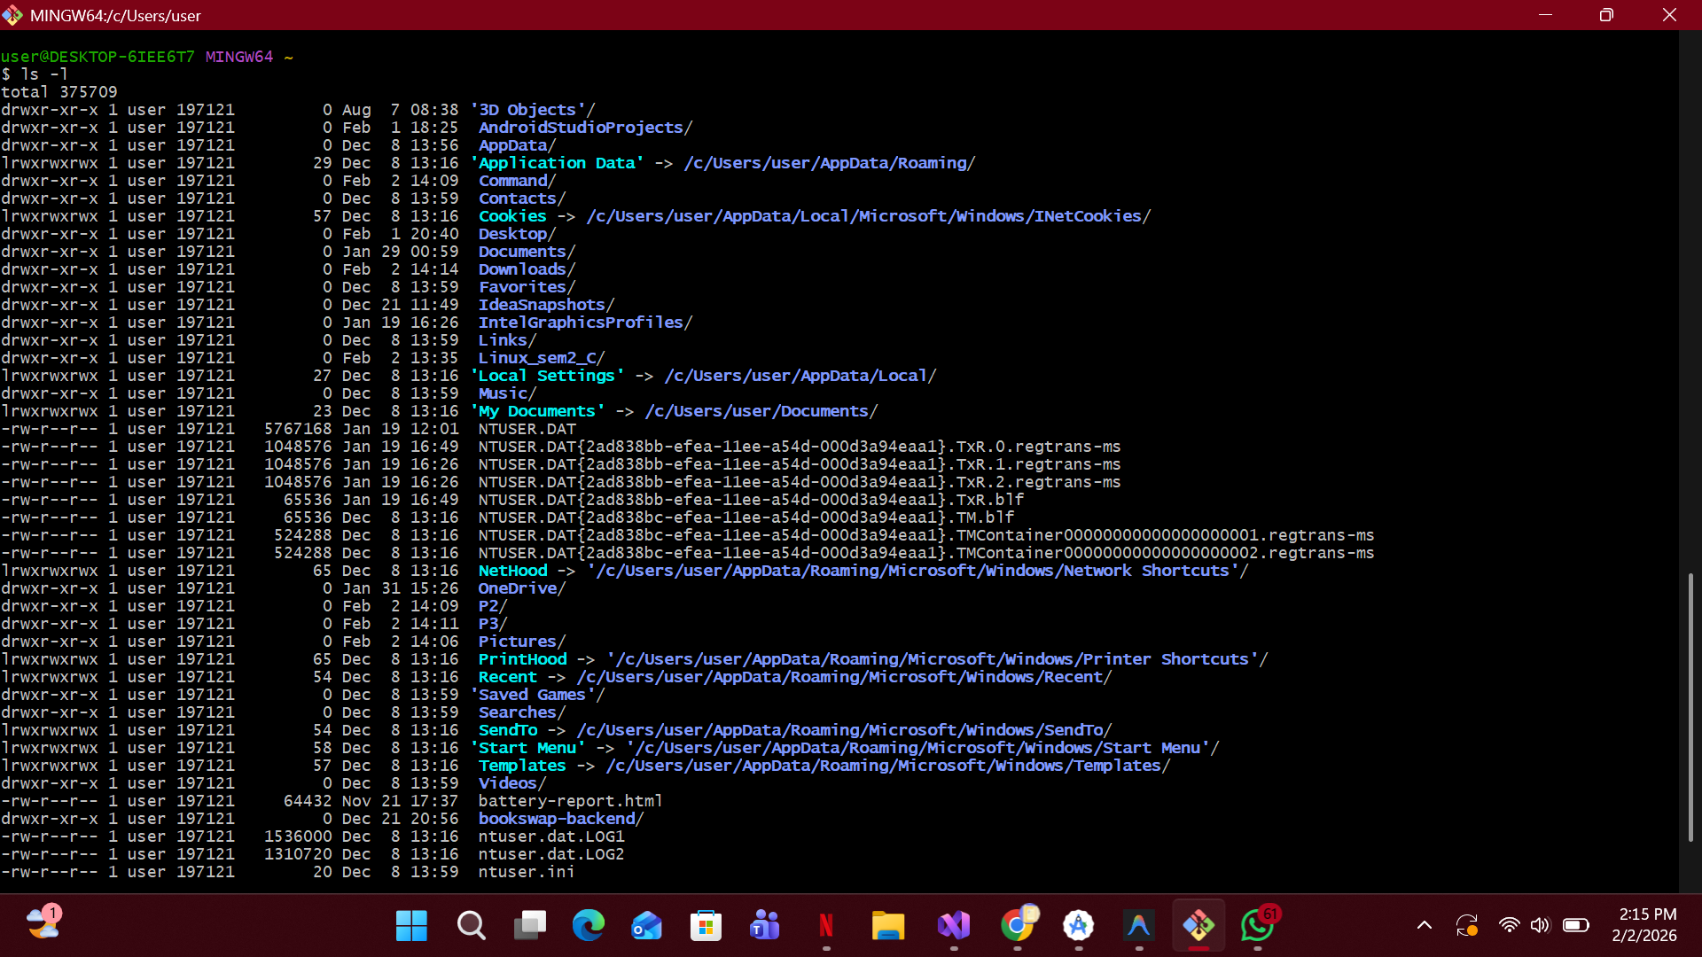
Question 3: Write the command to copy the directory P3 to the Command directory.
From P2 (relative path): cp -r ../P3 Command/
The -r option is used to copy the entire directory.
From P3 (relative path): cp -r . ../Command/
This copies the current directory into Command.
From Command (relative path): cp -r ../P3 .
This copies P3 into the current directory.
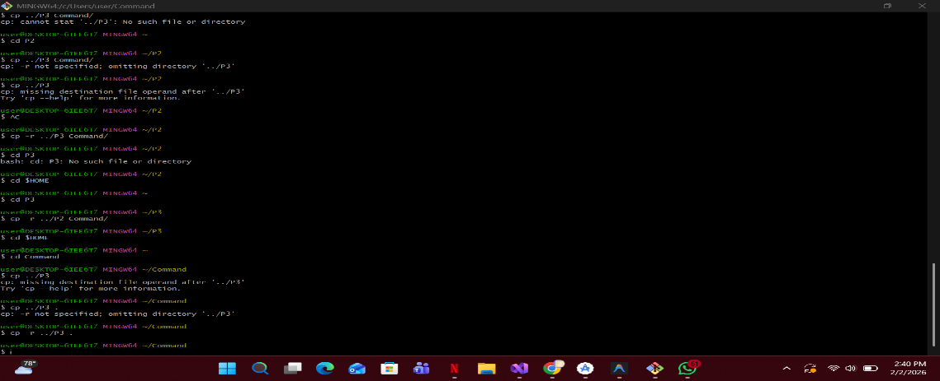
Absolute path: cp -r /home/username/P3 /home/username/Command/
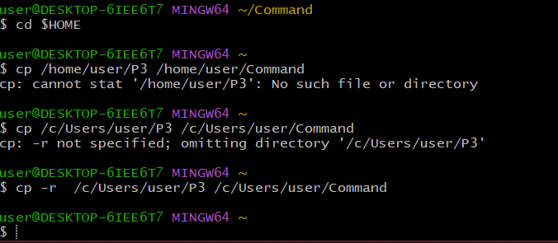
Question 4: Write the command to copy the files inside P3 to the Command directory.
From P2 (relative path): cp -r ../P3/* Command/
This copies only the contents of P3.
From P3 (relative path): cp -r * ../Command/
This copies all files inside P3.
From Command (relative path): cp -r ../P3/* .
This copies files from P3 into the current directory.
Absolute path: cp -r /home/username/P3/* /home/username/Command/
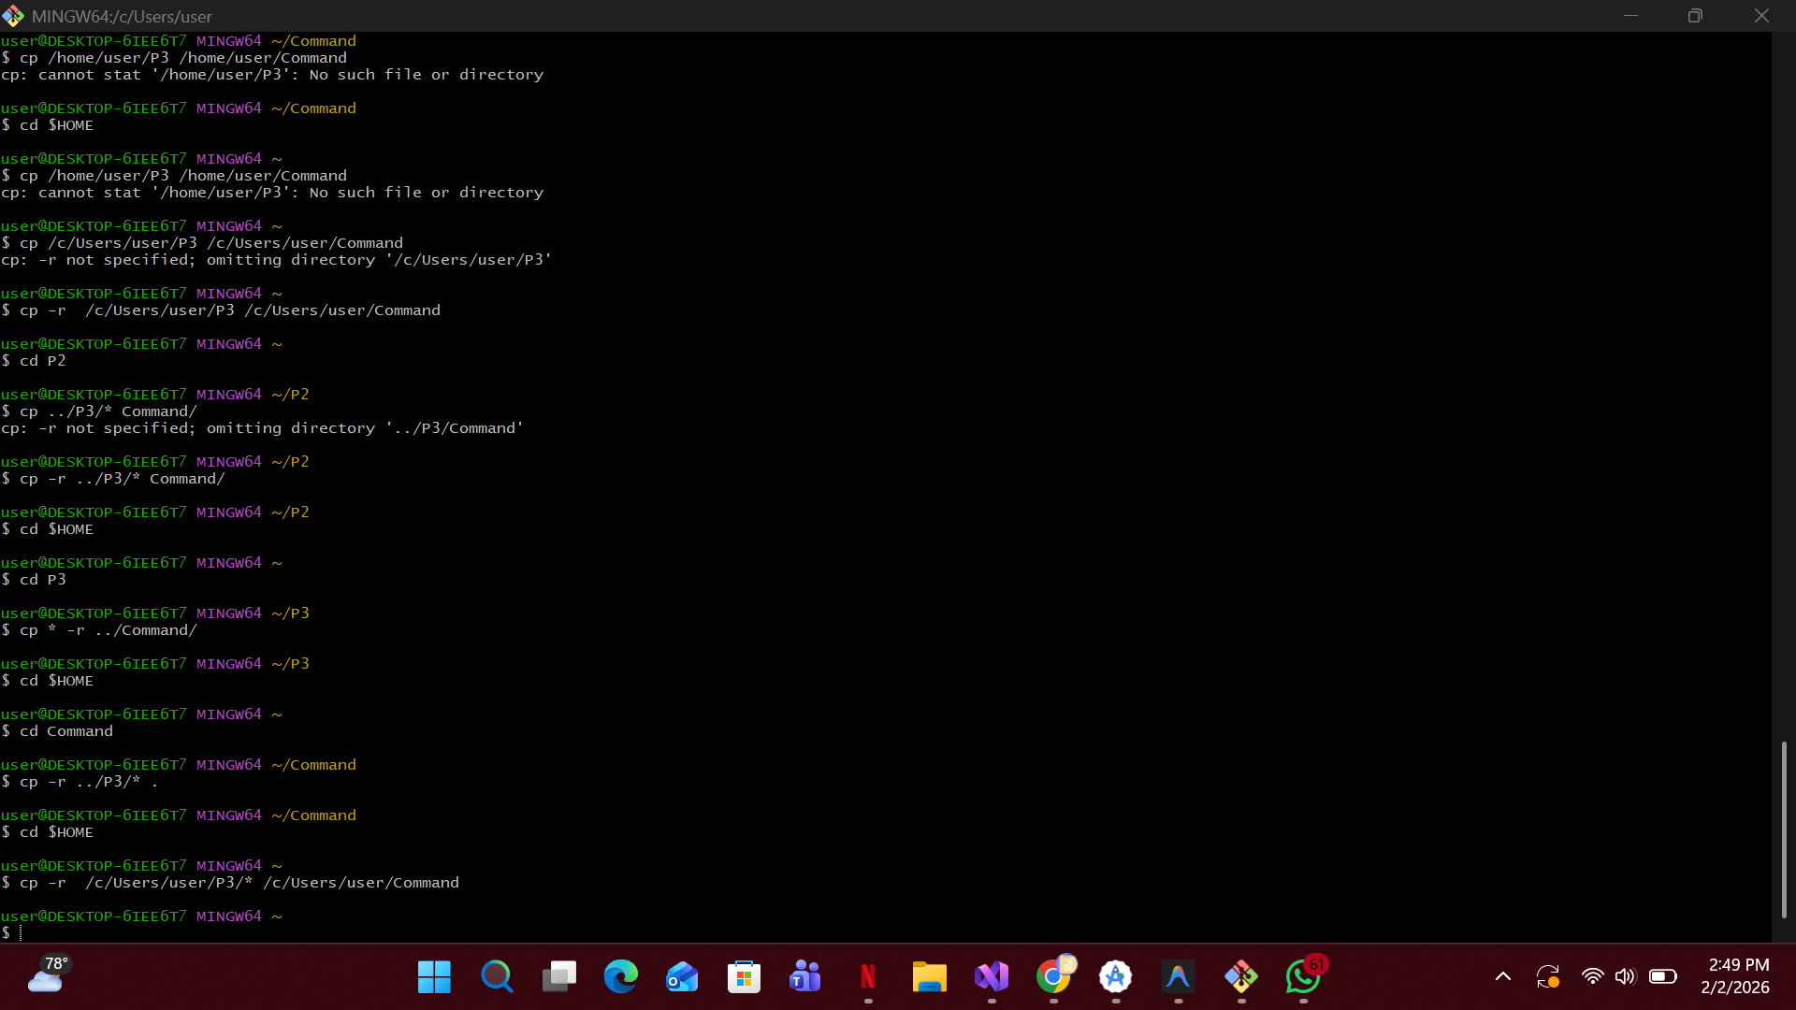
Question 5: Difference between Question 3 and Question 4.
Question 3 copies the entire P3 directory including its name, while Question 4 copies only the files inside P3 without copying the directory itself.

Question 6: Meaning of colors in Linux.
Blue indicates directories, yellow indicates executable files. The file named hereWeAre should be displayed in yellow because it is an executable file.

