ractical 1

For doing this practical at home
Software | Windows | Mac
R | https://cran.r-project.org/bin/windows/base/ | https://cran.r-project.org/bin/macosx/
R Studio | https://posit.co/download/rstudio-desktop/
GIT | https://github.com/git-guides/install-git

Purpose of the Practicals
Practical sessions are your time to consolidate your knowledge from the lectures and tutorials and to build your practical programming and analytical skills and implementing them yourself. This means that you have to do an effort to write R code and complete proposed tasks and the teaching team is there to help and solve the issues that you encounter.
• Ask the teaching team questions- as may as you need to. If you are stuck, did not find the answer
online, or don’t know what to do- please ask the teaching team. We are there to help you build
your skills and understanding. If the teaching staff are busy with other students, also try posting your query to the Slack #practicals discussion
• Please do not expect for practical session to be another lecture- the teaching team is there to
help, and provide explanation and support, but it is your work that the session is focusing on.
If you are waiting for the practical to start, fill in the questionnaire at:
https://forms.office.com/e/6dj62K4W8a
Whose answers will form a dataset in future practicals.

Install and Use Slack
Welcome to the 7COM1079 course. In it, we will use collaboration tools common in Software Development and learn how to analyze data using R. The technologies we particularly wish you to understand are:
- Slack
- Data Analysis (using R and R Studio)
The first practical is mainly to get you started on these. You will also need to install these on your computers at home – but all are free to use. To do that look at the section at the end.

Using Slack
The first part of the practical is to make you join our Slack workspace for the course. To do this go to:
https://join.slack.com/t/7com1079-0901-2026-27/shared_invite/zt-4bsurnp0n-hS0RwR8zmGSdWTj4_MxZaQ
This should prompt you to associate your uh email with the course slack workspace. Please do use your uh email rather than your personal email – even if your uh mail is forwarded to that personal email. If you are not sure what your herts email is, login to https://office.herts.ac.uk then click on the Outlook Icon 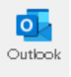after "Apps".
Or just type in https://outlook.office.com/mail/ (though make sure you have logged into herts’ Office365 first.)
Slack is an application which is both a standalone app (which can be downloaded – see the section at the end. But in the labs we will just access our "Slack Workspace" through the browser.
When you have used that email address to sign up to Slack, do the following 4 tasks
- Go into the introductions channel (#introductions) and introduce yourself
- Look at some of the other introductions made by people on the course and give them some feedback by emoji:
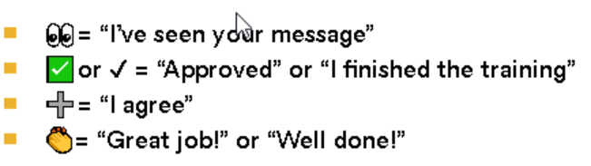
- Use the @username to get the attention of someone else on the course. If you don’t know them, ask your neighbour in the practical to give you their name, then message them
- Try to set up your preferences in slack by clicking on the 3 dots beside “More”, then click on “Preferences”
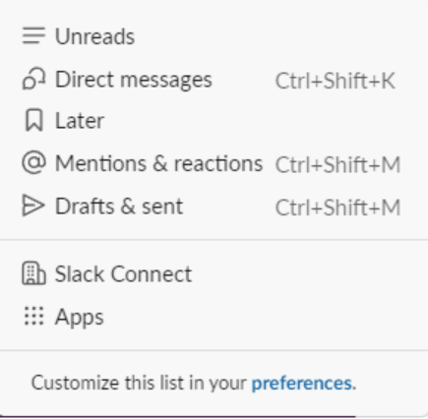
Particularly, click on your notification preferences. When you use slack, you will get alerts all the time, when messages have been sent, or when someone has put some feedback on some comment of yours. A good idea is to set some boundaries – namely around when you will be listening to messages and when not. Specify the hours when you are happy to be notified (you will need to scroll down to see this part of the form)
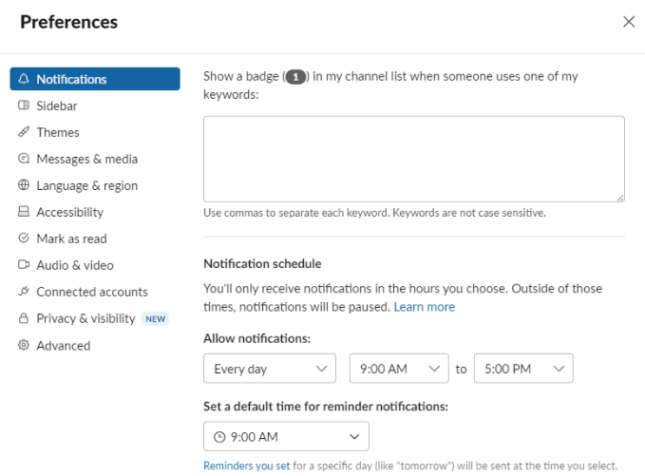

You can also customize the sounds made by Slack for notifications. Anyway, try to set up Slack in such a way that it is comfortable for you to use. You might also wish to install it on mobile phones. But again, if you do so, make sure that you are not pestered by notifications at unsocial hours.

Using R Studio
R is what we will be getting you to use in order to run statistical queries on your datasets. In this course you cover 1 dataset for your first (individual) assignment, and another dataset for your second (group) assignment.
The first dataset is allocated randomly. To find out which dataset, you will cover, go to:
https://herts.instructure.com/courses/131877/assignments/483635
There you should find out which dataset you will be covering for assignment 1. Make sure you type in the 5 character code (e.g. ds999) into the textbox to confirm your allocation.
Once you have done that, you can open it in R if you want. See the section right at the end for that.

Next, open R Studio on the lab machines. If you just type R Studio in the search bar at the bottom of the screen you should see the icon appear in the list of programs | 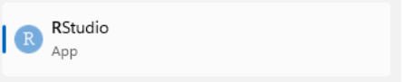

Open RStudio – this should make the following interface appear
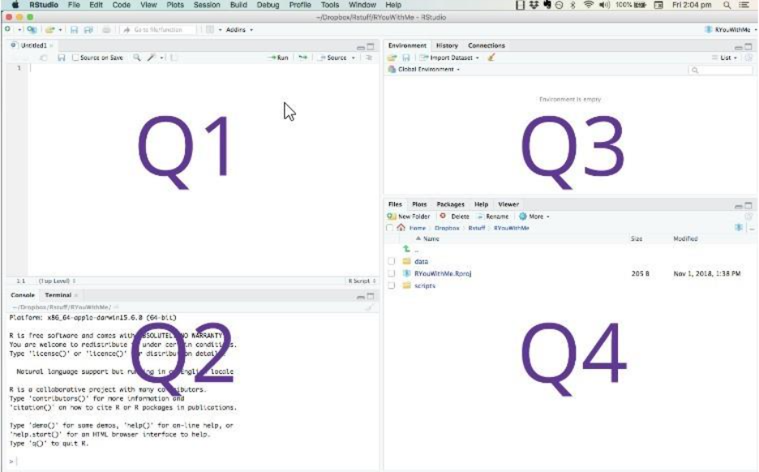
Q1 - contains: script, data, command to run script
Your written R Scripts will appear here, but also data (for instance a spreadsheet you might have imported) – also any variables can be inspected here. Data variables and code will appear in their separate tabs
Q2 - contains: console
This is where you can run commands. In the tab “console” you can run R commands over any data imported or variables created, in the “Terminal” console you can make operating system commands
Q3 - contains: environment
Essentially this is a visual representation of all the current variables available in the session, clicking on any one of them will make that variable appear in Q1
Q4 - contains: files, plots, packages, help as tabs
Files just shows the files in a folder, plots displays any graphs generated by your code (unless specifically sent to a file as a graphic or a pdf), and packages shows the packages currently being used

Using the Console
At this point you should start by just playing with R commands in the Q2 quadrant
After R is started, there is a console awaiting for input. At the prompt (>), you can enter numbers and perform calculations.
> 1 + 2
[1] 3
Try to do some simple calculations here. For instance convert pounds to dollars or rupees. Convert today’s temperature into Fahrenheit.
-----------------

Like Python, R can be used in interactive mode, in a console where you just type commands. This is very useful since yu can try out commands and later combine them all into a single script. Commands.

Importing Data in R Studio
Now lets jump right in and read some datasets. We will be using R for the statistics part of the course, and we shall go into much more detail about that. In the File menu, choose the option "New Project" , and when the following dialog comes up, choose "Version Control", then Git
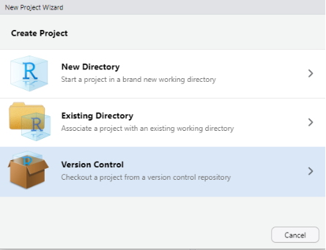 | 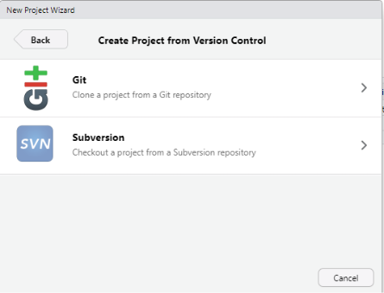
Git is a technology which we will go into in much more detail when you start your group project, but for this practical we are just going to use it as a convenient way to download some datasets for you to play with as we learn statistics using R.
When the following dialog comes up copy the text below as the repository url:  https://github.com/fivethirtyeight/data.git  For the project directory name choose anything you want. practical_1 might be a good idea (btw its always best to use underlines, not spaces in folder and file names)  For the box "Create project in..." - maybe choose somewhere in your office365 space in order that you have access to these files in future practicals | 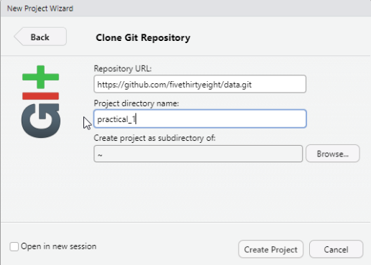

This is quite a large download. In the University labs it should be very quick but at home it might take a while. It belongs to a US website called fivethirtyeight.com - which became famous in 2008 because it predicted exactly, state by state the winner of the presidential election which no-one had done before.
When it opens you should have a screen something like this:
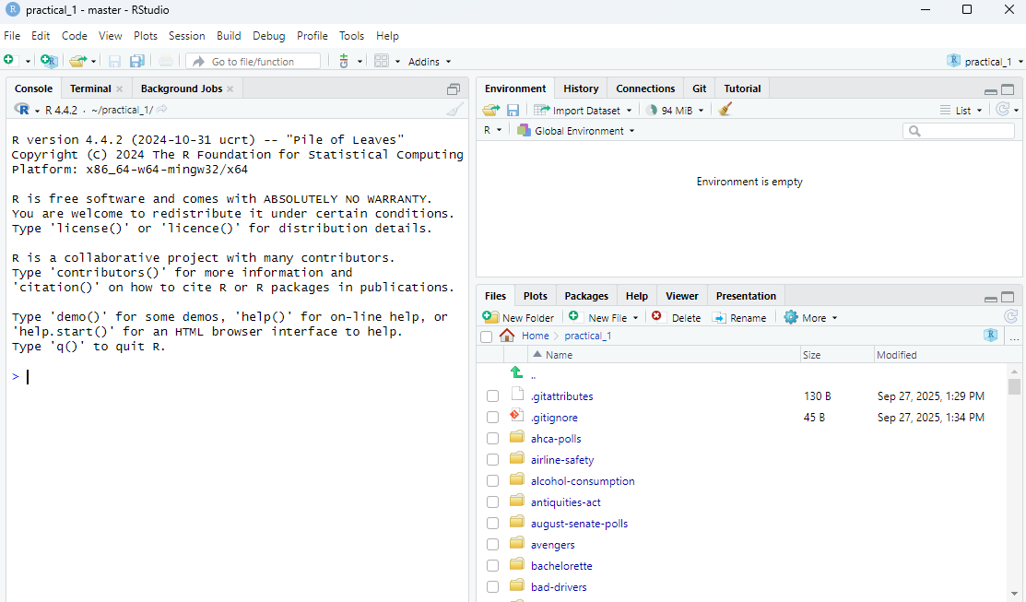

In the bottom right quadrant, click on the folder bad_drivers
You should then see the following screen. Click on the .csv file (a spreadsheet) and choose | 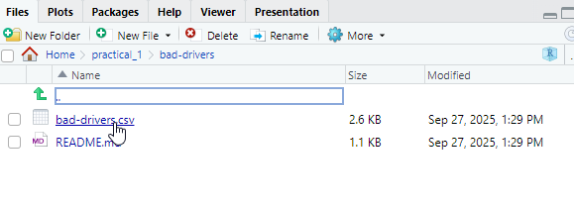
Import dataset | 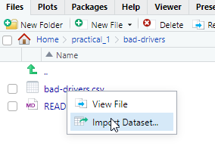

When you do, a dialog comes up, which asks you if you are ok with how it has interpreted the dataset, and gives you options.-
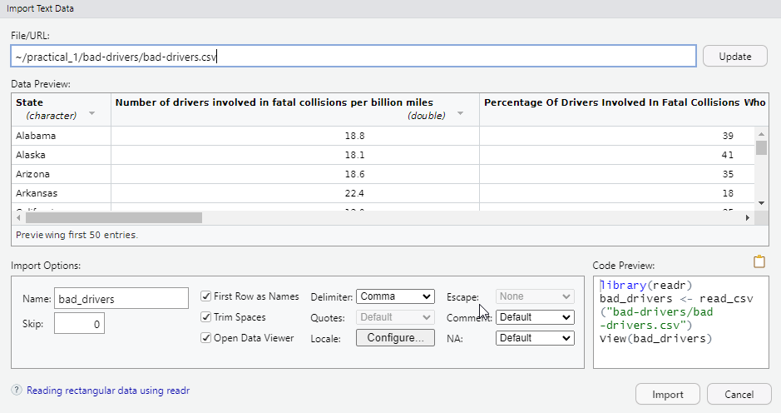
commands generated
dataframe name
creates names for columns
If you click on the import button, R then imports the data and it is shown in the top left corner.
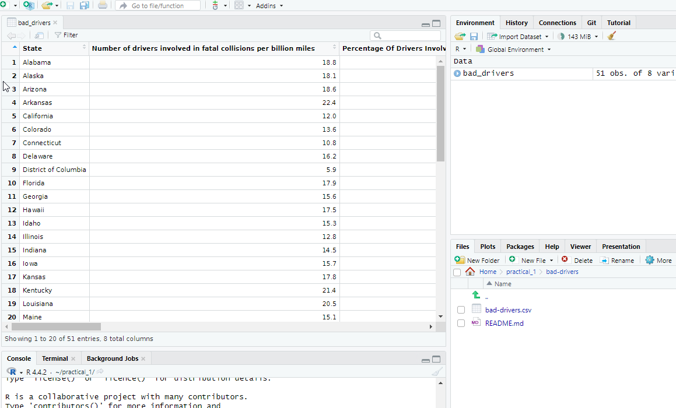
This is a dataset about driving accidents in the USA. But that is not a sufficient description. Lets explore it using R.
Querying the Data in R
Unlike in Excel, where we import the data, and then use the GUI to do various things like sorting columns, in R, everthing is done by a command. We can list the data in a particular column by just doing this command
print(datasetname$columnname)
So if we want to see all the items in the first column we type:
bad_drivers$State
Here we can see there is one row of data per state.
If we want to know how many rows there are in the dataframe we can use the command nrow. In the console type
nrow(bad_drivers)
We know that the United States consists of 50 States and the District of Columbia, so that sounds about right. (By the way this is something you should always do when looking at data: ask yourself does the result I am seeing align with what I already know?. In some cases, where the data belongs to a field so specific, you might not be able to ask yourself this question, but whenever you can, do so).
Now lets list all the different column names. To do that, run this function
colnames(bad_drivers)
As you will see, some of the column names are very long. That is good from the point of understandability, but it will make it hard for us to run operations on those columns. For example, the name of the 2nd column is:
Number of drivers involved in fatal collisions per billion miles
To actually print all the values in that column we will need to use back-ticks (back ticks are these things: ``
print(bad_drivers$`Number of drivers involved in fatal collisions per billion miles`)
But this is ugly and makes it hard to code with.
Very often the first thing you will need to do in R, is to rename the columns. The easiest way is one by one, by number. For example, instead of Number of drivers involved in fatal collisions per billion miles, lets change that to nDeadDriversPerBillMiles. This column is the second column so do this
colnames(bad_drivers)[2] <- "nDeadDriversPerBillMiles"
You'll notice the strange <- operator. This is often used instead of equals (=) in R. What I have said there is: change the name of column 2 to nDeadDriversPerBillMiles
Now lets do the same for the other columns
colnames(bad_drivers)[3] <- "pcDeadSpeeding"
colnames(bad_drivers)[4] <- "pcDeadAlcohol"
colnames(bad_drivers)[5] <- "pcDeadUndistracted"
colnames(bad_drivers)[6] <- "pcDeadFirstAccident"
colnames(bad_drivers)[7] <- "premiums"
colnames(bad_drivers)[8] <- "lossesPerDriver"

An important point here however, is that we have changed the dataframe (the object in memory containing the data), not the actual csv file. This is why R is preferred to Excel in any kind of data science. The initial data is left intact, but the operations done on it (the commands) are openly visible. Whereas in Excel, when you do operations on the data, you also change the data itself.
Now we have reorganized the columns, lets try to find out some facts. Using the command mean() we can get the average for each column. To get average number of people in each state who have fatal car accidents per billion miles driven we do the command
mean(bad_drivers$nDeadDriversPerBillMiles)
A richer command which we can run on single columns is summary. If we run the command
summary(bad_drivers$pcDeadAlcohol)
We get

Min 1st Qu. Median Mean 3rd Qu. Max.
16.00 28.00 30.00 30.69 33.00 44.00
What the summary does not give us however, is the standard distribution. The measurement of how much the values differ across the sample. To get that, do this command
sd(bad_drivers$pcDeadAlcohol)
We find the lowest reported value for percent of fatal accident victims impaired by alcohol is 16%. The highest is 44%. The average is 30%. The median (the ranked middle value) is 30.39. The first quartile is 28.00 and the 3rd quartile is 33. By this is meant, if we sorted the data, where would the first 25% of values sit below, and where would the highest 25% of values sit above. This can tell us a lot about the skew of the data.
The next command to help you get a feel for the data is the command which.min and which.max. Rather than just seeing these numbers we want to know which states, maybe are particularly bad for fatal alcohol related accidents.
If we type the command
print(which.min(bad_drivers$pcDeadAlcohol))
We get the number 45. Which means the 45th row in the dataframe has the lowest number for the number of fatal accidents involving alcohol
To find the State in the 45th row we could do this:
print(bad_drivers$State[45])
But we can also put them both together
print(bad_drivers$State[which.min(bad_drivers$pcDeadAlcohol)])

Now you know that, find out the following:
Which state has the highest percentage of fatalities caused by speeding, and which the lowest? Hawaii and Nebrasaka
Which state has the highest premiums? Which state has the lowest? New Jersey and Idaho
To check your understanding and your familiarity with the commands covered so far, go to:
https://herts.instructure.com/courses/124322/quizzes/169576
(This quiz contains a random 10 questions out of 49. If you successfully answered one quiz, do it again, and you will be presented with different questions)

Finally there is the concept of an R Script. In R Studio, choose to create an R Script as follows:
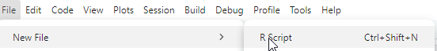
When you have done that, try to put together all the commands you have done since the beginning of the tutorial. You can gain access to all the previous commands by just using the up arrow (on your keyboard) at the R prompt. Go back to the start of the tutorial (by repeatedly using the up arrow), get the first commands (importing the dataset), copy and paste them into your script (but you will have to remove the initial > when the commands are in the script itself. When you have done that, save the file, using the File->Save As command
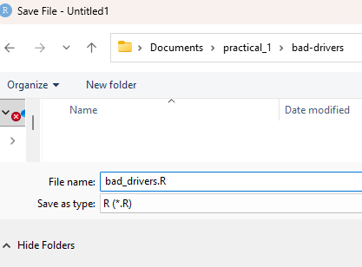
And when you have done that, click the option "Source"
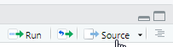
That runs the entire script. Run your script and see how it works.
If you want to import your assignment 1 data into R Studio do it in this order

Create an empty folder and put your .csv or .xlsx files into it
Then in R Studio, choose New Project, and when the dialog comes up, choose "Existing Directory".  When prompted, navigate to the folder you placed your spreadsheets in. Then in the interface, click in the 4th quadrant on the bottom right and choose "Files". Then click on the spreadsheet – it should give you an option to show, or import. Choose "import", that way your data will appear in a readable way. | 