Table of Contents
1. Project Scope 2
2. Objectives 2
3. Initial Design Plan 2
4. Technical Details 2
4.1 Backend Structure 2
4.2 Frontend Structure 6
4.3 Database Design 9
5. User Guide 16
5.1. Logging In 16
5.2. Dashboard Overview 16
5.3. Managing Products 17
5.4. Managing Orders 17
5.5. Managing Shipments 17
5.6. Search and Filter 17
5.7. Logout 18
6. Screenshots 18
Login Screen: 18
Dashboard screen: 19
Products Screen: 19
New Product addition Screen: 20
Edit Products screen: 20
Order screen: 21
New order screen: 21
New shipment screen: 22

Project Scope
The Warehouse Inventory Management System is a web-based application designed to manage products, warehouses, orders, and shipments efficiently. It allows administrators to track product quantity, add/edit products, create shipments, and manage orders from a central dashboard.

Objectives
- Maintain an up-to-date inventory across multiple warehouses.
- Facilitate order and shipment management.
- Provide real-time dashboard overview for products, orders, and shipments.
- Support role-based access (admin and regular users).

Initial Design Plan
- Frontend: Responsive single-page application (SPA) using HTML, CSS, and JavaScript.
- Backend: PHP with RESTful API endpoints.
- Database: MySQL for storing products, warehouses, orders, shipments, and suppliers.
- Features:
  - Dashboard overview.
  - Products CRUD (Create, Read, Update, Delete).
  - Order creation and tracking.
  - Shipment management with new warehouse/product creation.
  - User authentication with session management

Technical Details

Backend Structure
- backend/index.php — Main API router directing requests to appropriate endpoints (products.php, orders.php, shipments.php, auth.php).
- backend/config/db.php — Database connection and session handling.
- backend/api/warehouse.php — Returns a list of warehouses with total stock using SQL JOINs.
- Logic: Uses LEFT JOIN to get all warehouses and sum their stock quantities. COALESCE ensures that warehouses with no inventory still return 0.

config/db.php
- Purpose: Provides a single point of database connection and session management for the backend.
- Key functionality:
  - Connects to MySQL using PDO with proper error handling.
  - Sets PDO::ATTR_ERRMODE to ERRMODE_EXCEPTION to catch SQL errors.
  - Starts PHP session for authentication.

index.php – API Router
- Acts as the single entry point for all API requests.
- Responsibilities:
- Parse the requested URI.
- Determine which API endpoint should handle the request (products.php, orders.php, etc.).
- Set HTTP headers for JSON responses and CORS.
- Handle OPTIONS requests for preflight in CORS.
- Return 404 for unknown endpoints.
- Request Flow Example:
- Request: GET /api/products
- index.php matches '/api/products'
- loads api/products.php
- executes requested action (GET, POST, PUT, DELETE)
- returns JSON response

API Endpoints Overview
Endpoint | Method(s) | Description
/api/auth.php | POST, GET | Handles login, logout, and session verification.
/api/products.php | GET, POST, PUT, DELETE | Manage products and warehouse stock.
/api/orders.php | GET, POST, DELETE | Create, view, and delete customer orders.
/api/shipments.php | GET, POST | Track shipments in and out of warehouses.
/api/warehouse.php | GET | Returns a list of all warehouses with total stock.
/api/supplier.php | GET | Returns a list of suppliers for dropdowns in forms.

products.php Logic
- Supported Methods:
  - GET → List all products or a single product by id.
  - POST → Add a new product (can create a warehouse and inventory if needed).
  - PUT → Update product details and/or stock in a warehouse.
  - DELETE → Remove a product.
- Highlights:
  - Uses require_auth() to ensure only logged-in users can make changes.
  - Uses prepared statements to prevent SQL injection.
  - Calculates total stock across warehouses using JOIN with inventory.

auth.php Logic
- Supported Methods:
  - POST → Login (task=login) or Logout (task=logout)
  - GET → Get current logged-in user (task=me)
- Highlights:
  - Uses PHP sessions to track authentication state.
  - Validates credentials against the users table.
  - Returns user info including role for frontend permission control.

warehouse.php Logic
- Supported Methods:
  - GET → List all warehouses along with total stock per warehouse
- Highlights:
  - Uses LEFT JOIN with inventory to calculate stock quantities.
  - Ensures warehouses with no stock still appear (COALESCE).
  - Groups results by warehouse for easy display in the frontend.
  - Read-only API; no POST/PUT/DELETE implemented.

orders.php Logic
- Supported Methods:
  - GET → List all orders or a single order by ID
  - POST → Create a new order with products
  - DELETE → Delete an existing order
- Highlights:
  - Validates stock availability before creating an order.
  - Maintains order items in a separate order_items table.
  - Supports recent order retrieval for dashboard.
  - Uses prepared statements to prevent SQL injection.

products.php Logic
- Supported Methods:
  - GET → List all products or a single product by ID
  - POST → Add a new product (can create a warehouse and inventory if needed)
  - PUT → Update product details and/or stock in a warehouse
  - DELETE → Remove a product
- Highlights:
  - Uses require_auth() to ensure only logged-in users can make changes.
  - Uses prepared statements to prevent SQL injection.
  - Calculates total stock across warehouses using JOIN with inventory.
  - Supports CRUD for both products and associated warehouse quantities.

shipments.php Logic
- Supported Methods:
  - GET → List all shipments
  - POST → Create a new shipment (IN/OUT), optionally creating new products or warehouses
- Highlights:
  - Tracks products per shipment in shipment_items table.
  - Updates inventory automatically based on shipment type (IN increases, OUT decreases stock).
  - Uses prepared statements for security.
  - Returns enriched data including product and warehouse details for frontend display.

Security and Authentication
- Authentication is session-based.
- auth.php sets a session variable $_SESSION['user'] on successful login.
- require_auth() checks for this session and prevents unauthorized access to API endpoints.
- API responses always return JSON, including error messages and status codes.

Summary of Request Flow
- Client request → fetch() from frontend (app.js).
- API Router → index.php identifies endpoint and includes the corresponding PHP file.
- Endpoint logic → Queries database, performs CRUD actions, validates input.
- Response → JSON data is returned to the frontend.
- Frontend → app.js receives response and updates the UI dynamically.

Frontend Structure
frontend/index.html — Main HTML layout with navigation and main container.
frontend/css/style.css — Styles for SPA including buttons, tables, forms, and responsive design.
frontend/js/app.js — Handles SPA logic, API calls, authentication, and rendering views.
- Key Features:
  - Dashboard: Fetches and displays recent products, orders, and shipments.
  - Products Page: CRUD operations with warehouse quantity management.
  - Orders Page: Create and delete orders with stock validation.
  - Shipments Page: Create shipments with options to add new warehouse/product.
  - Authentication: Login/logout with session tracking.

index.html
- Purpose: Main entry point of the application.
- Features:
  - Contains the <nav> element for page navigation: Dashboard, Products, Orders, Shipments.
  - Login/Logout buttons that appear based on authentication state.
  - <main> container where all dynamic content (pages/forms/tables) is rendered.
  - Optional global search bar for Products, Orders, and Shipments.

css/style.css
- Purpose: Provides all styling for the SPA.
- Features:
  - Layout: .app class centers content with padding and max-width.
  - Navigation: Buttons styled with .active state, responsive layout for smaller screens.
  - Cards: .page-card used for all main content sections (forms, tables, dashboard).
  - Tables: .table styled with borders, padding, and alternating headers.
  - Forms: .form-group and .input-field for labels and inputs.
  - Buttons: .btn-primary for actions, .btn-secondary for secondary actions, .btn-del for delete.
  - Responsive: Media query ensures nav and search input adjust on small screens.

js/app.js
- Purpose: Core logic of the SPA — handles dynamic rendering, API interactions, authentication, and user actions.
- Key Responsibilities:
  - Routing & Navigation:
    - Clicking nav buttons triggers functions like renderDashboard(), renderProducts(), etc.
    - Updates active button state with setActive().
  - API Calls:
    - Uses a central api() helper to fetch or modify data from backend endpoints.
    - Handles GET, POST, PUT, DELETE requests and error catching.
  - Authentication:
    - login() and logout() functions manage sessions via auth.php.
    - init() checks current user session and renders appropriate view/nav.
  - Dashboard:
    - Fetches recent products, orders, and shipments.
    - Displays tables summarizing stock, order status, and shipment info.
  - Products Page:
    - CRUD operations for products: add new, edit, delete.
    - Manages stock per warehouse with quantity input and validation.
    - Search functionality filters products dynamically.
  - Orders Page:
    - Create new orders with product selection and stock validation.
    - Delete orders.
    - Displays recent orders with quantities and status.
  - Shipments Page:
    - Create shipments with options to select or add new warehouses/products.
    - Tracks shipment type (IN/OUT), warehouse, products, quantity, and optional reference.
  - Dynamic Forms:
    - Forms dynamically render fields depending on selections (e.g., new warehouse or product).
    - Automatically generates SKU codes for new products.

SPA Behavior
- Single page load — content updates dynamically inside <main> without refreshing.
- Uses JavaScript event listeners to handle user actions: button clicks, form submissions, search input.
- Centralized API communication ensures consistency and reusable logic across views.
- Authentication state controls UI visibility: only logged-in users see nav and “New” buttons.
Summary of Key Features
Feature | Description
Dashboard | Overview of recent products, orders, and shipments.
Products Page | CRUD products, manage warehouse stock, filter by search.
Orders Page | Create/delete orders, validate stock availability.
Shipments Page | Add shipments, add new warehouse/product on the fly, track stock movement.
Authentication | Login/logout with session handling, controls access to admin features.

Database Design

Database Overview
The database is designed to manage a warehouse inventory system. It stores information about:
- Products
- Warehouses
- Inventory (product quantities per warehouse)
- Suppliers
- Orders
- Shipments
- Users (for authentication)
The database is implemented in MySQL and uses foreign keys to maintain relationships between tables, ensuring referential integrity and consistency.

Tables and Structure

1. Warehouses
Stores information about each warehouse.
Column | Type | Description
id | INT (PK, AI) | Unique warehouse identifier
name | VARCHAR(255) | Warehouse name
location | VARCHAR(255) | Optional location of warehouse

2. Products
Stores all product details.
Column | Type | Description
id | INT (PK, AI) | Unique product identifier
sku | VARCHAR(50) | Stock Keeping Unit
name | VARCHAR(255) | Product name
description | TEXT | Product description
acquire_cost | DECIMAL(10,2) | Cost to acquire product
price | DECIMAL(10,2) | Selling price
supplier_id | INT (FK) | Links to suppliers.id
created_at | TIMESTAMP | Timestamp when product added

3. Suppliers
Stores supplier information.
Column | Type | Description
id | INT (PK, AI) | Unique supplier ID
name | VARCHAR(255) | Supplier name
contact_email | VARCHAR(255) | Optional email
phone | VARCHAR(50) | Optional phone

4. Inventory
Tracks how much of each product is stored in each warehouse.
Column | Type | Description
id | INT (PK, AI) | Unique inventory record
product_id | INT (FK) | Links to products.id
warehouse_id | INT (FK) | Links to warehouses.id
quantity | INT | Number of units available in warehouse

5. Orders
Tracks customer orders.
Column | Type | Description
id | INT (PK, AI) | Unique order ID
order_number | VARCHAR(100) | Unique order identifier
customer_name | VARCHAR(255) | Customer who placed the order
status | ENUM | PENDING, FULFILLED, CANCELLED
created_at | TIMESTAMP | Order creation time

6. Order Items
Stores individual products per order.
Column | Type | Description
id | INT (PK, AI) | Unique record ID
order_id | INT (FK) | Links to orders.id
product_id | INT (FK) | Links to products.id
qty | INT | Quantity of product ordered

7. Shipments
Tracks movement of products into/out of warehouses.
Column | Type | Description
id | INT (PK, AI) | Unique shipment ID
shipment_type | ENUM | IN or OUT
warehouse_id | INT (FK) | Warehouse associated with shipment
reference | VARCHAR(100) | Optional shipment reference
shipper_name | VARCHAR(255) | Optional shipper name
receiver_name | VARCHAR(255) | Optional receiver name
origin | VARCHAR(255) | Optional origin
destination | VARCHAR(255) | Optional destination
weight | DECIMAL(10,2) | Optional weight of shipment
created_at | TIMESTAMP | Time shipment was created

8. Shipment Items
Products included in shipments.
Column | Type | Description
id | INT (PK, AI) | Unique record ID
shipment_id | INT (FK) | Links to shipments.id
product_id | INT (FK) | Links to products.id
qty | INT | Quantity of product shipped

9. Users
Tracks application users and roles.
Column | Type | Description
id | INT (PK, AI) | Unique user ID
username | VARCHAR(100) | Username/email
password_hash | VARCHAR(255) | Hashed password
role | ENUM | admin or user

Relationships and Joins
- Products ↔ Inventory ↔ Warehouses
- One product can exist in many warehouses → Many-to-Many relationship managed via the inventory table.
- Enables tracking how many units of each product exist per warehouse.
- Example Join: Get total stock per product across all warehouses:
SELECT p.id, p.name, COALESCE(SUM(i.quantity), 0) AS total_stock
FROM products p
LEFT JOIN inventory i ON p.id = i.product_id
GROUP BY p.id;
- Orders ↔ Order Items ↔ Products
- Each order can have multiple products → One-to-Many relationship from orders to order items.
- Useful to fetch order details including product names and quantities.
- Example Join: List order items with product names:
SELECT o.order_number, p.name, oi.qty
FROM orders o
JOIN order_items oi ON o.id = oi.order_id
JOIN products p ON oi.product_id = p.id;

- Shipments ↔ Shipment Items ↔ Products & Warehouses
- Each shipment contains multiple products and is associated with a specific warehouse.
- Tracks movement of stock in or out of a warehouse.
- Example Join: Get shipments with product and warehouse details:
SELECT s.id, s.shipment_type, w.name AS warehouse, p.name AS product, si.qty
FROM shipments s
JOIN shipment_items si ON s.id = si.shipment_id
JOIN products p ON si.product_id = p.id
JOIN warehouses w ON s.warehouse_id = w.id;

- Suppliers ↔ Products
- Each product can have a supplier → One-to-Many relationship from suppliers to products.
- Useful to filter products by supplier or calculate total products supplied.
- Example Join: List products with supplier names:
SELECT p.name AS product, s.name AS supplier
FROM products p
LEFT JOIN suppliers s ON p.supplier_id = s.id;

UPDATE inventory
SET quantity = :quantity
WHERE product_id = :id AND warehouse_id = :warehouse_id;
- Delete product and associated inventory:
DELETE FROM products WHERE id = :id;
DELETE FROM inventory WHERE product_id = :id;

SQL Queries Used in Warehouse Inventory App

1. Products Module
Fetch all products with total stock and warehouse locations:
SELECT p.*,
COALESCE(SUM(i.quantity), 0) AS total_stock,
GROUP_CONCAT(CONCAT(w.name, ' (', w.location, ')') SEPARATOR ', ') AS locations
FROM products p
LEFT JOIN inventory i ON p.id = i.product_id
LEFT JOIN warehouses w ON i.warehouse_id = w.id
GROUP BY p.id
ORDER BY p.id DESC;
Fetch a single product by ID including warehouses:
SELECT p.*,
i.warehouse_id, i.quantity, w.name AS warehouse_name, w.location
FROM products p
LEFT JOIN inventory i ON p.id = i.product_id
LEFT JOIN warehouses w ON i.warehouse_id = w.id
WHERE p.id = :id;
Insert new product (and optional warehouse/inventory):
INSERT INTO products (sku, name, description, acquire_cost, price, supplier_id)
VALUES (:sku, :name, :description, :acquire_cost, :price, :supplier_id);

INSERT INTO warehouses (name, location) VALUES (:warehouseName, :warehouseLocation);
INSERT INTO inventory (product_id, warehouse_id, quantity) VALUES (:product_id, :warehouse_id, :quantity);
Update product and warehouse quantity:
UPDATE products
SET name = :name, acquire_cost = :acquire_cost, price = :price
WHERE id = :id;

UPDATE inventory
SET quantity = :quantity
WHERE product_id = :id AND warehouse_id = :warehouse_id;
Delete product and associated inventory:
DELETE FROM products WHERE id = :id;
DELETE FROM inventory WHERE product_id = :id;

2. Orders Module
Fetch all orders with total items and product names:
SELECT o.*,
SUM(oi.qty) AS total_items,
GROUP_CONCAT(p.name SEPARATOR ', ') AS products
FROM orders o
LEFT JOIN order_items oi ON o.id = oi.order_id
LEFT JOIN products p ON oi.product_id = p.id
GROUP BY o.id
ORDER BY o.created_at DESC;
Fetch single order by ID:
SELECT * FROM orders WHERE id = :id;
Insert new order and order items; update inventory:
INSERT INTO orders (order_number, customer_name, status) VALUES (:order_number, :customer_name, 'pending');

INSERT INTO order_items (order_id, product_id, qty) VALUES (:order_id, :product_id, :qty);

UPDATE inventory
SET quantity = quantity - :qty
WHERE product_id = :product_id AND warehouse_id = :warehouse_id;
Delete order and its items:
DELETE FROM order_items WHERE order_id = :id;
DELETE FROM orders WHERE id = :id;

3. Shipments Module
Fetch all shipments with warehouse and products info:
SELECT s.*,
w.name AS warehouse,
GROUP_CONCAT(p.name SEPARATOR ', ') AS products,
SUM(si.qty) AS total_items
FROM shipments s
LEFT JOIN shipment_items si ON s.id = si.shipment_id
LEFT JOIN products p ON si.product_id = p.id
LEFT JOIN warehouses w ON s.warehouse_id = w.id
GROUP BY s.id
ORDER BY s.created_at DESC;
Insert new shipment and shipment items; update inventory:
INSERT INTO shipments (shipment_type, warehouse_id, reference)
VALUES (:shipment_type, :warehouse_id, :reference);

INSERT INTO shipment_items (shipment_id, product_id, qty)
VALUES (:shipment_id, :product_id, :qty);

-- For OUT shipment
UPDATE inventory
SET quantity = quantity - :qty
WHERE product_id = :product_id AND warehouse_id = :warehouse_id;

-- For IN shipment
INSERT INTO inventory (product_id, warehouse_id, quantity)
VALUES (:product_id, :warehouse_id, :qty)
ON DUPLICATE KEY UPDATE quantity = quantity + :qty;

4. Suppliers Module
Fetch all suppliers:
SELECT * FROM suppliers ORDER BY name ASC;

5. Warehouses Module
Fetch all warehouses:
SELECT * FROM warehouses ORDER BY name ASC;

6. Authentication Module
Login (fetch user by username):
SELECT * FROM users WHERE username = :username LIMIT 1;
Check session / logged-in user:
SELECT * FROM users WHERE id = :user_id;

Key Design Principles
- Normalized Design:
  - Avoids redundant data by splitting products, warehouses, inventory, orders, and shipments into separate tables.
- Referential Integrity:
  - Foreign keys enforce consistency (e.g., inventory records must reference valid products and warehouses).
- Scalable:
  - Many-to-many relationships (products ↔ warehouses) handled through junction tables (inventory).
- Flexible Queries:
  - Use of JOINs allows fetching combined data for dashboards and reports without duplicating data.

User Guide

Logging In
- Open index.html in your browser.
- Click Login on the top right.
- Enter your email and password and click Login.
- Admin users will have access to all features, while regular users have limited access.

Dashboard Overview
- Shows a summary of:
  - Products: ID, SKU, name, stock, and location.
  - Orders: Last 5 orders with quantity and status.
  - Shipments: Last 5 shipments with warehouse, type, and date.
- Navigation: Use top buttons to switch to Products, Orders, or Shipments.

Managing Products
- Go to Products tab.
- Click New (admin only) to add a product:
  - Fill details: SKU (auto-generated), Name, Description, Cost, Price, Supplier, Warehouse, Quantity.
  - Click Save to add the product.
- Edit Product: Click Edit button next to a product.
- Delete Product: Click Delete button next to a product.

Managing Orders
- Go to Orders tab.
- Click New Order (admin only):
  - Select a product and quantity.
  - Enter customer name.
  - Click Create.
- Delete Order: Click Delete button next to an order.

Managing Shipments
- Go to Shipments tab.
- Click New Shipment (admin only):
  - Select Shipment Type (IN/OUT).
  - Select existing warehouse or add new warehouse.
  - Select product or add new product.
  - Enter quantity and optional reference.
  - Click Create.

Search and Filter
- Use the search input on Products, Orders, or Shipments pages to filter the table by name, SKU, or order number in real-time.

Logout
- Click Logout on the top right to end the session.

Screenshots

Login Screen:
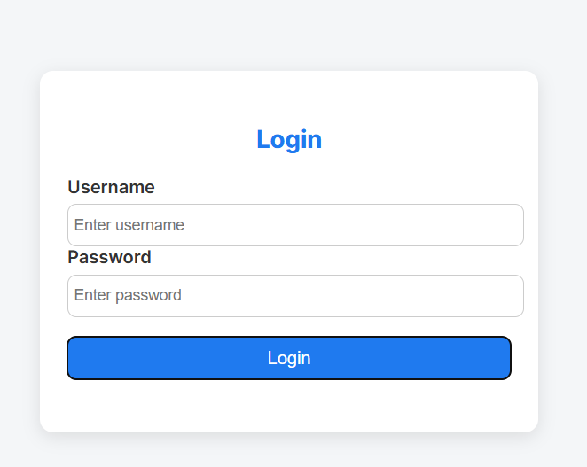

Dashboard screen:
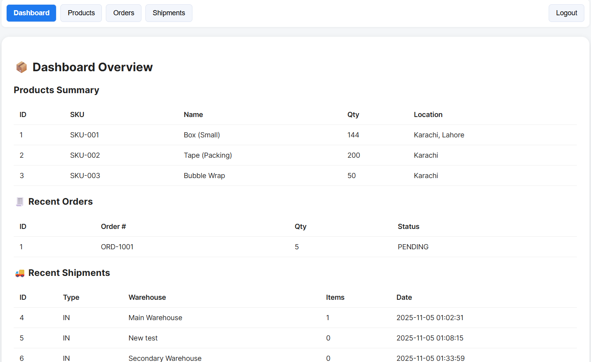

Products Screen:
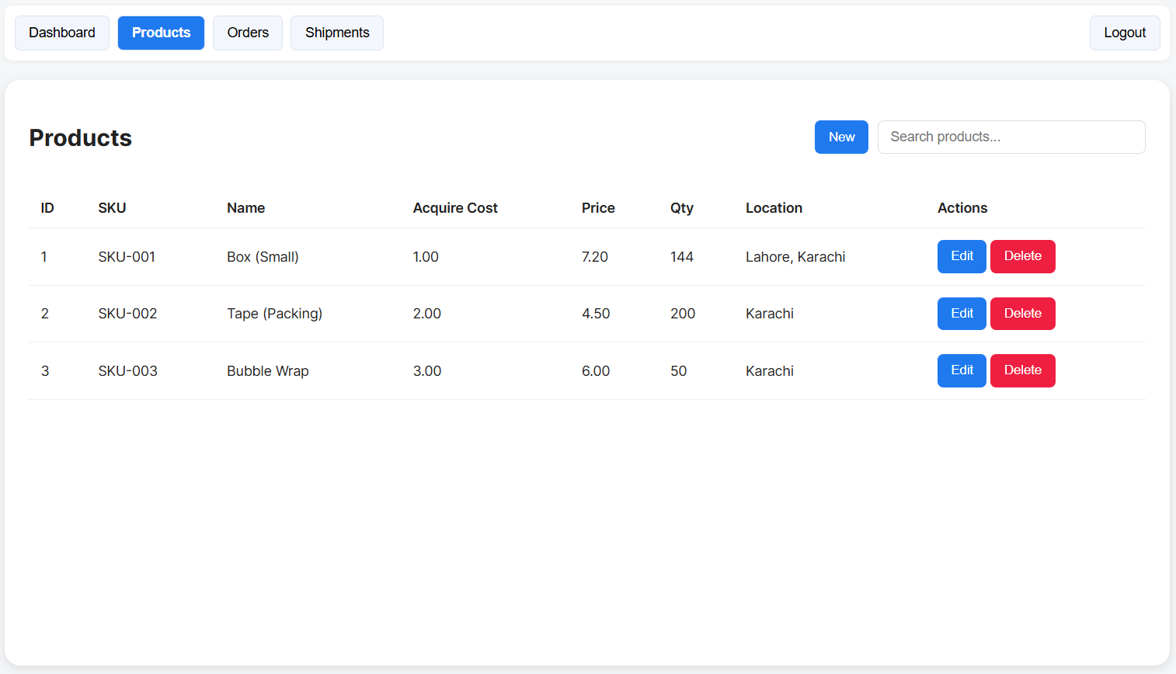

New Product addition Screen:
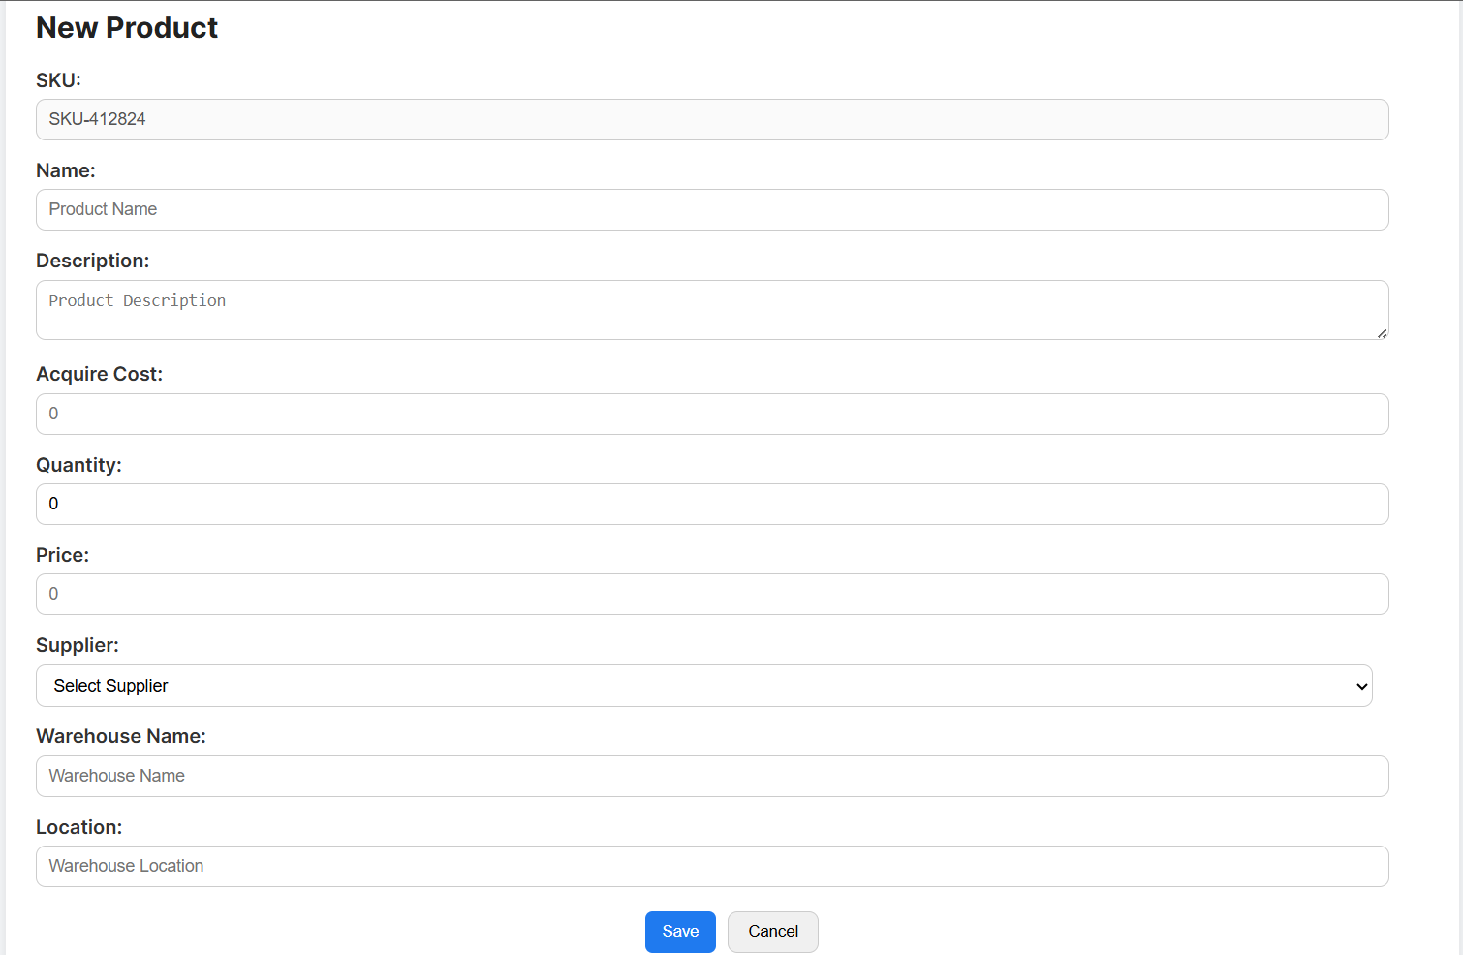

Edit Products screen:
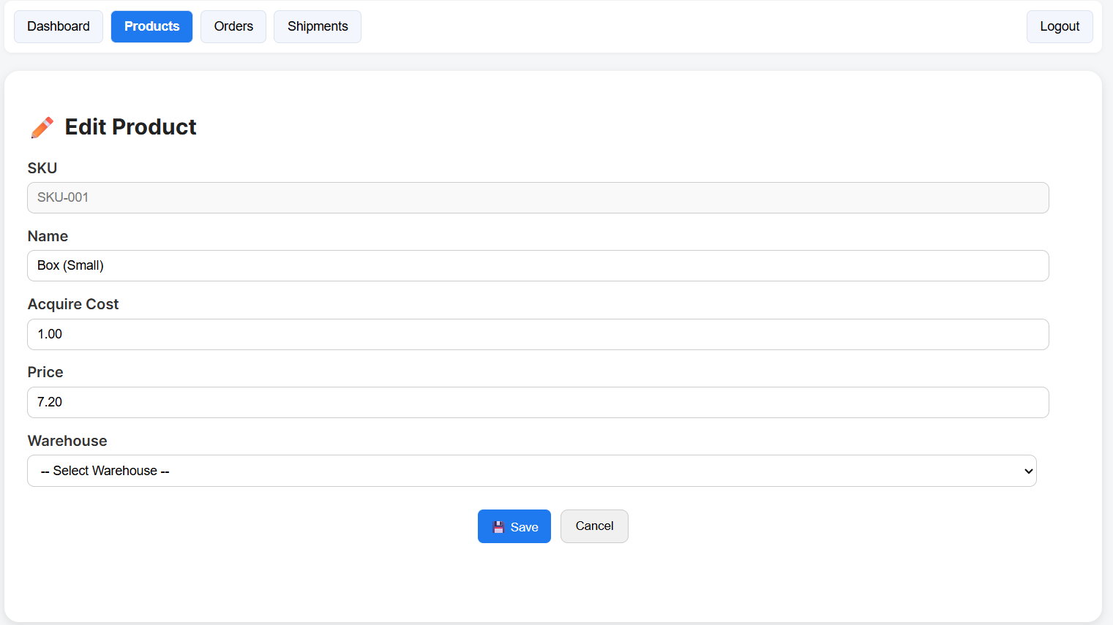

Order screen:
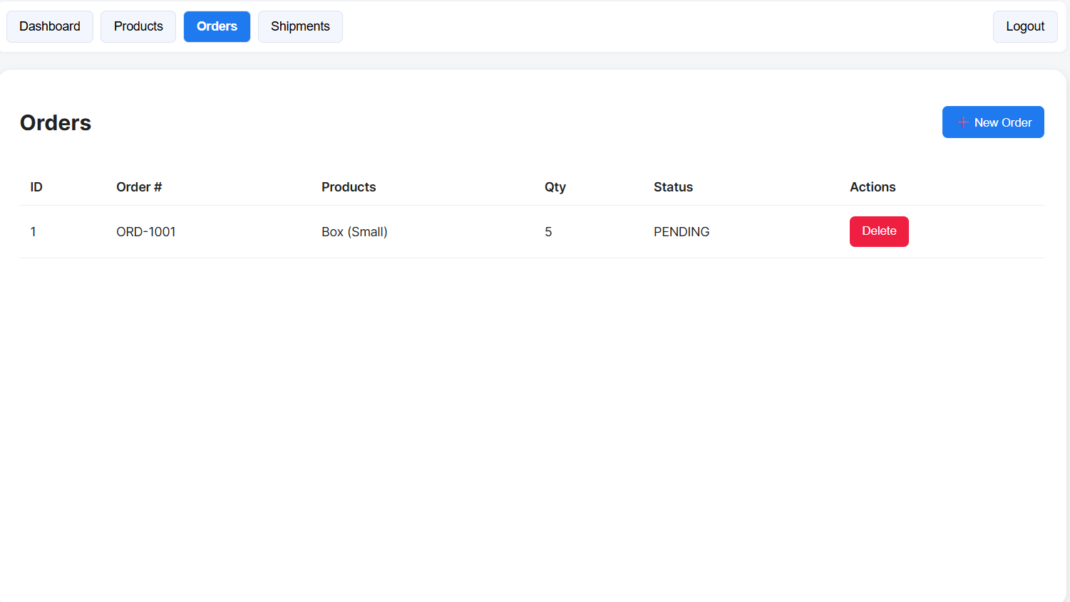

New order screen:
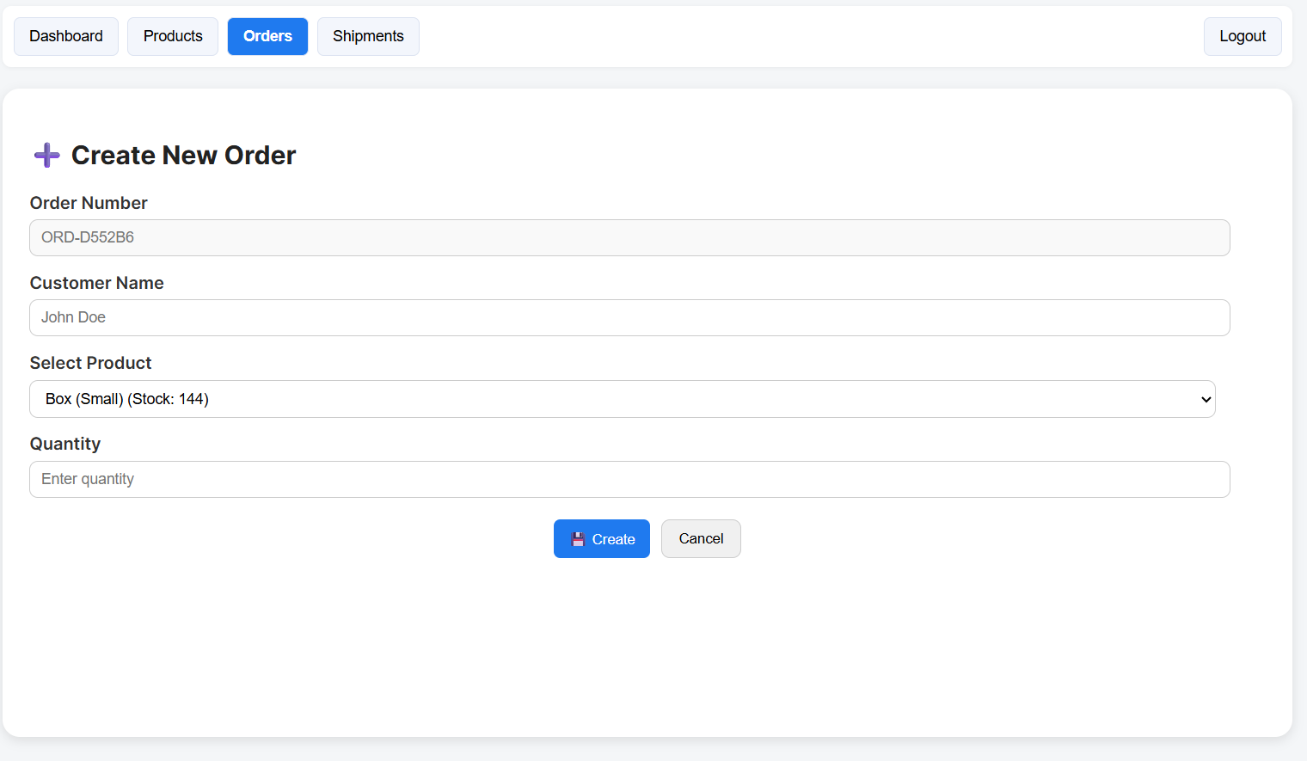Shipment Screen:
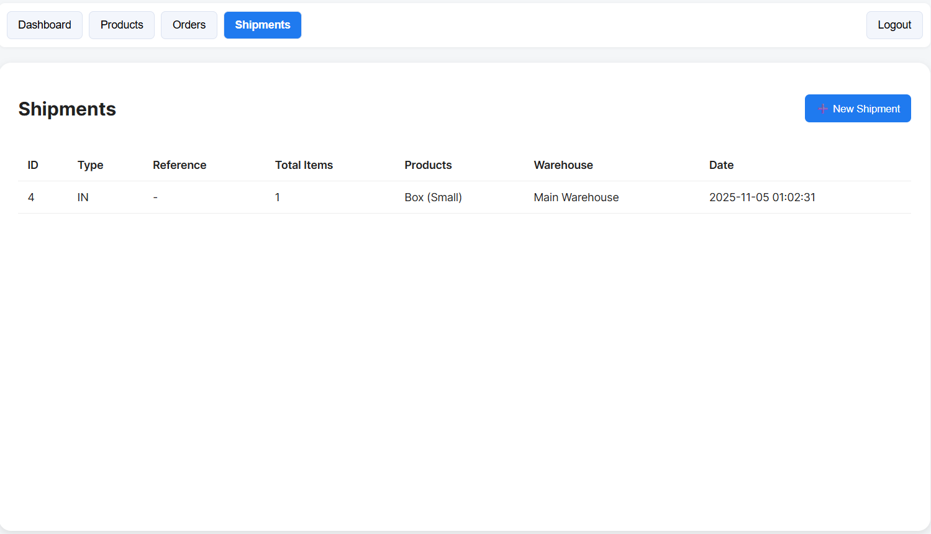

New shipment screen:
