Integrated Data Analytics Project Report
CQC Engagement Prediction System — A Diagnostic Tool for Amari Eden Living and Programs
Priscilla Oluwandara Silva | BAN6800 Final Project

1. Business Process Identification and Problem Definition
Amari Eden Living and Programs, a senior creative wellness social enterprise in Edmonton, Alberta, faces a structural problem common across senior social enterprises: programming decisions are made on precedent and assumption rather than evidence. The organization's root cause, traced through a 5 Whys analysis in Module 2, is that organizations default to measuring what is easy to observe — attendance — rather than what is actually meaningful: wellbeing and engagement measured together. A program can be genuinely beneficial to a participant's wellbeing and still fail to create real impact if it is not something the participant actually wants to engage with.
This problem connects directly to Amari Eden's strategic goals as a for-profit social enterprise balancing mission with sustainability. Evidence-based programming decisions are not a peripheral improvement; they are a condition of the organization's stated double-bottom-line viability. The original project scope, established in Module 1, sought to identify two relationships simultaneously — participant engagement and wellbeing, and wellbeing and organizational sustainability. This proved too wide to operationalize within the project's timeline, and the scope was deliberately narrowed by Module 2 to a single, sharper question: which factors, already present in successful programs, explain that success, and how can they be strengthened. This is a strengths-based reframing rather than a deficit-based one — the project identifies what is already working, rather than only flagging what is failing.

Ethical AI Charter
The system's ethical foundation, established in Module 1 and reaffirmed throughout, is built around counteracting mission drift: resource-allocation guidance must never quietly favor easier-to-reach populations or facilities over those with genuine higher need, and no prediction may be treated as a mandate rather than a starting point for human judgment. The full Ethical AI Framework, including the Algorithmic Impact Assessment, Regulatory Compliance Report, Public Trust Statement, and Governance Structure, is provided as an accompanying document.

2. Project Overview and Documentation
The project followed an Agile-inspired iterative structure across five modules, each building on verified outputs from the last. Initial planning (Module 1-2) targeted CDC BRFSS survey data paired with Yelp review sentiment to measure senior wellbeing and engagement; both proved inaccessible or insufficiently structured within the project's timeline and scope. Module 3 pivoted to UK Care Quality Commission (CQC) regulatory data (Care Quality Commission, 2026) as an accessible, real, sufficiently large proof-of-concept — a deliberate substitution disclosed explicitly throughout, not a claim that this is Amari Eden's own operational data.
Key stakeholders are Amari Eden and comparable organizations as primary users seeking to optimize programming; grant organizations, funders, and government bodies as secondary users seeking evidence of effective practice; and senior participants themselves as the indirect population this project is explicitly designed to keep visible in resource-allocation decisions, rather than reduced to a statistic.
The complete project repository, containing all code, notebooks, configuration files, and tests from Modules 2 through 5, is available at: https://github.com/PriscillaOluwandaraSilva/senior-wellbeing-analytics.

3. Data Pipeline Design
The pipeline moves raw CQC data through six verified stages: ingestion, filtering to care homes rated on the Responsive domain, cleaning, transformation of categorical ratings into a numeric engagement_score, integration with facility metadata, and formal validation. Starting from 319,798 raw domain-rating records, filtering and cleaning produced 17,030 relevant rows; a Great Expectations validation check subsequently caught 3,247 duplicate facility records — the same physical location registered under multiple specialisms — which were resolved by retaining the first occurrence, an arbitrary but explicitly documented limitation. The final validated dataset comprises 13,693 unique facilities. This entire chain is formally encoded as an Apache Airflow DAG, so the required execution order (ingest before filter, filter before clean, and so on) is an explicit, machine-readable property of the code itself rather than an informal convention.
Data quality and integrity are maintained through three concrete mechanisms: an automated Great Expectations suite (row count, null checks, valid value ranges, uniqueness), the Airflow DAG referenced above, and a custom regex-based anonymization scan confirming no individual-level personal data exists in the dataset. That scan's single false-positive category — care home business names using "@" stylistically, such as "Coopers@Ambleside" — was investigated and documented rather than silently dismissed, demonstrating the check was genuinely applied rather than assumed to pass.
Bias detection at the raw-data level (Fairlearn) found only small variation in engagement_score by region (difference 0.08, ratio 0.97) and by provider size (difference 0.02, ratio 0.99) — evidence against strong bias in the underlying data, prior to any predictive model being built. This is a distinct, earlier check than the model-level fairness analysis in Section 5: Section 3's check asks whether the raw data itself is skewed; Section 5's check asks whether a trained model's predictions are fair. Conflating the two would misrepresent what each actually measures. Full governance and privacy documentation, including data classification (public, low-sensitivity), access control, and retention policy, is maintained in the repository's docs/ directory.

4. Predictive Model Development and Validation
Two algorithms were trained and compared: Logistic Regression and Random Forest, both addressing a severe class imbalance (93.5% high-engagement, 6.5% needs-improvement) via balanced class weighting. An initial version predicted engagement from administrative facility attributes (region, provider size); this was deliberately reframed after review revealed these features were not genuinely actionable and produced a severely unfair model. The final version predicts from four CQC quality-of-care domain scores — Safe, Effective, Caring, and Well-led — chosen because they represent dimensions an organization can actually act upon.
This reframing improved ROC-AUC from approximately 0.59 to 0.87 and resolved the fairness violation from a failing disparate impact ratio of 0.145 to a passing 0.864, without any explicit bias mitigation technique applied — evidence that the original unfairness was substantially attributable to using administrative proxies as predictive features. Hyperparameters were tuned via 5-fold cross-validated grid search, and the best-performing model was registered to the MLflow (MLflow, 2026) Model Registry as "cqc_engagement_predictor," version 1.
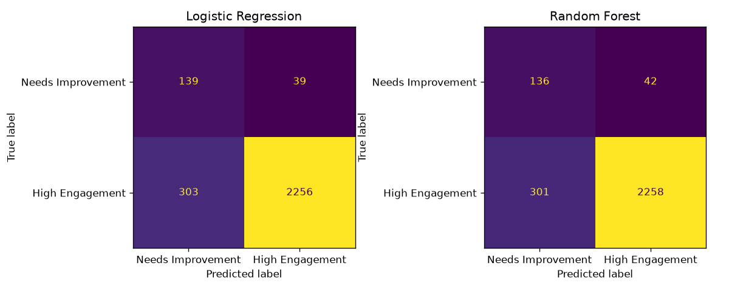
Figure 1. Confusion matrices, final Logistic Regression and Random Forest models.
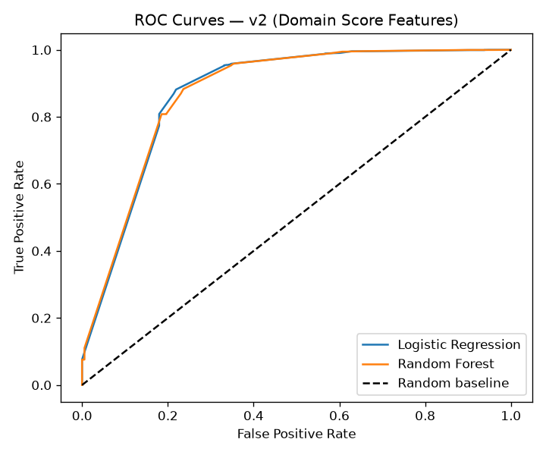
Figure 2. ROC curves, both models, against the random-guess baseline.
Both models converge to near-identical performance (ROC-AUC 0.873), favoring Logistic Regression on parsimony grounds for any real deployment, since a simpler model is easier to audit and explain to non-technical stakeholders such as facility managers or funders, at essentially no cost in predictive performance. This convergence is itself informative: when features carry a strong, fairly linear relationship with the target, a simpler linear model can match a more flexible ensemble method, suggesting the relationship between quality-of-care scores and engagement is not a complex, highly non-linear pattern requiring Random Forest's additional flexibility to capture.
A documented limitation is that Safe, Effective, Caring, Well-led, and the Responsive target are all scored during the same CQC inspection visit, raising a genuine "halo effect" concern about the correlation's causal interpretation — disclosed explicitly rather than treated as a settled causal finding. A related limitation is feature skew: Safe (skew coefficient -1.70) and Effective (-1.93) cluster heavily around a score of 3, limiting the model's ability to distinguish sharply within the most common score band. An internal-consistency check found that 99.5 percent of facilities scored within one point of themselves across all four dimensions — most organizations are uniformly strong or uniformly weak rather than mixed — while the small minority (61 facilities) with genuine internal inconsistency showed a specific, interpretable pattern: 66 percent combined high Caring with low Well-led, suggesting compassionate frontline staff can coexist with weak leadership structures, which supports treating these as genuinely distinct signals rather than redundant measures of the same underlying quality.
During model selection, other algorithm families beyond Logistic Regression and Random Forest were reviewed for their potential fit, including K-Nearest Neighbors (KNN), documented in applied retail forecasting work by Odegua (2020). KNN was not adopted for this project's binary classification task, but its similarity-based approach is noted here as a genuinely promising direction for future extensions of this system — particularly for matching seniors to programs on a recommendation-system basis, or for diagnostic-style pattern matching against known engagement profiles, should Amari Eden's own dataset grow large enough to support it.

5. Explainable AI (XAI) and Fairness Analysis
SHAP (Lundberg and Lee, 2017) identifies Well-led (leadership and governance) as the dominant predictor, with an importance more than double the next feature, Effective — a finding independently corroborated by the raw coefficient sizes in the underlying Logistic Regression model.
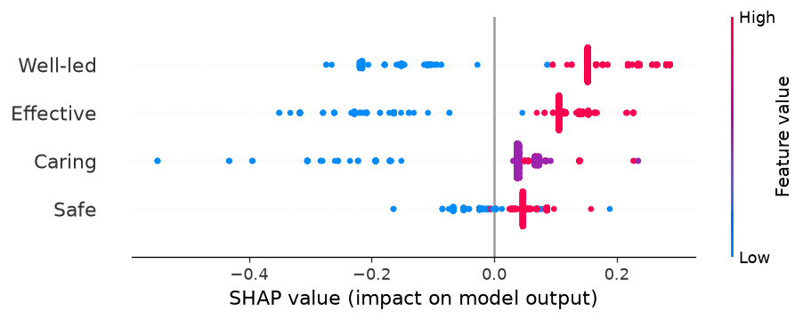
Figure 3. SHAP global feature importance, final Random Forest model.
Local explanations (LIME) for individual facilities confirm the same pattern at the case level. A counterfactual analysis found that improving Safe, Caring, or Well-led by a single point each independently flips a struggling facility's prediction to high-engagement — a materially more actionable finding than the administrative-feature version, where a prediction could flip purely from a region change, an attribute no facility can act on.

Fairness Metrics and Mitigation
Disparate impact ratio (0.864) passes the standard 0.80 threshold; demographic parity difference (0.123) is small. Equalized odds difference (0.304) remains elevated and is disclosed as an unresolved limitation, not papered over. No explicit bias mitigation technique was applied to the final model, since the primary fairness metric already passed without one — better feature selection resolved most of the disparity as a side effect, a finding itself worth noting as evidence that feature-level fairness audits can be a more effective first-line safeguard than post-hoc algorithmic correction.
A full Model Card, documenting intended use, performance, fairness findings, and limitations in standardized form, is maintained in the repository. Explanations (SHAP values, LIME outputs, counterfactual results) are stored as versioned artifacts alongside each model run in the MLflow tracking database, providing an audit trail independent of this report's narrative.

6. Insight Communication and Visualization
Findings were translated for a non-technical stakeholder audience through a 12-slide presentation and a live interactive dashboard, deliberately separated from the technical Q&A backup deck to keep the primary narrative accessible without sacrificing the ability to answer a sharper technical question if one arises. The dashboard (https://senior-wellbeing-analytics-kwppqd6woxnezaznmga2z8.streamlit.app/) includes a What-If Analysis tab allowing a stakeholder to adjust a hypothetical facility's four scores and see the predicted engagement likelihood update live, directly demonstrating the SHAP finding that leadership moves the prediction more than any other single factor — a stakeholder can, for instance, hold three scores constant and move only the Well-led slider to see the outsized effect for themselves, rather than being asked to trust a static chart.
Business implications were deliberately grounded in Amari Eden's actual operating model rather than left generic: the leadership finding directly validates the organization's existing 26-plus hour facilitator training pathway as an evidence-backed investment priority, and the proposed next step — beginning structured session-level engagement scoring — was designed to plug directly into Amari Eden's existing hospital volunteer pilot process, which already documents engagement outcomes as a precondition for conversion to a paid contract. A dedicated Session Observation Form and a self-calibrating engagement prediction spreadsheet template were built alongside the core system, so that once Amari Eden's own facilitators begin logging real session data, the same underlying method — measure quality dimensions, standardize, weight by regression, rank by coefficient size — can be re-applied directly to Amari Eden's own context rather than remaining dependent on the UK proof-of-concept indefinitely.

7. Implementation and Monitoring Plan

Deployment Overview
The system is deployed as three services: a live FastAPI prediction endpoint (https://analytics-for-social-enterprises.onrender.com/docs), the stakeholder Streamlit (Streamlit, 2026) dashboard (https://senior-wellbeing-analytics-kwppqd6woxnezaznmga2z8.streamlit.app/), and a monitoring dashboard tracking performance and fairness metrics over time from the MLflow experiment log. All three are also defined as containerized services via Docker Compose for reproducible local deployment. A GitHub Actions CI/CD workflow runs an 11-test automated suite (six API behavior tests, five data quality invariant tests mirroring the Great Expectations checks) on every push to the main branch, so that a regression in either model behavior or data integrity is caught automatically rather than discovered downstream.

Performance Tracking KPIs
- ROC-AUC maintained above 0.70 — the minimum acceptance threshold established in Module 4
- Disparate impact ratio maintained above 0.80
- Equalized odds difference actively tracked and targeted for reduction below 0.30

Continuous Fairness Monitoring Plan
Consistent with established practice for maintaining model performance after deployment (Tanuwidjaja, 2023), the monitoring dashboard's Drift & Alerts tab documents baseline fairness values and alert thresholds. In production use, fairness metrics should be recalculated monthly against newly scored facilities and compared to these baselines; a drop in disparate impact ratio below 0.80, or an increase in equalized odds difference above 0.40, should trigger a mandatory review before continued operational use.

Model and Bias Drift Detection
Model drift is monitored via the same performance KPIs tracked over successive MLflow-logged runs. Bias drift specifically requires re-running the Module 4 Fairlearn (Fairlearn, 2026) analysis against new data on the same cadence as performance monitoring, since a model can remain accurate in aggregate while its fairness properties silently degrade for specific subgroups.

Incident Response Plan
If a fairness or performance threshold breach is confirmed, the response sequence is: (1) immediately flag the affected model version in the registry as under review, (2) pause any active resource-allocation recommendations derived from that version, (3) investigate whether the cause is data drift, a genuine model failure, or a change in the underlying population, (4) document findings and remediate before returning the model to active use. This mirrors the escalation path defined in the Ethical AI Framework's Governance Structure.

Decommissioning Plan
Should this system be retired — for instance, once Amari Eden's own engagement data supersedes the UK CQC proof-of-concept — decommissioning requires: formally archiving the final model version and its full MLflow history rather than deleting it, notifying any organizations relying on its output with adequate transition time, and retaining the validated dataset and documentation for audit purposes even after the live system is taken offline.

8. Ethical AI Framework Summary
The full Ethical AI Framework — Algorithmic Impact Assessment, Regulatory Compliance Report, Public Trust Statement, and Governance Structure — is provided as a standalone accompanying document. In summary: three risks are actively tracked (mission drift, regional/institutional bias, recommendation misuse), each with a documented mitigation, alongside a fourth, newly added risk specific to this project's proof-of-concept design — context transfer risk, acknowledging that findings derived from UK regulatory data may not transfer unchanged to Amari Eden's Canadian context. The applicable regulatory framework is Canada's PIPEDA, pending Amari Eden's own future data collection, since the current CQC dataset is UK public-sector regulatory data rather than personal data; HIPAA, GDPR, and CCPA were each individually assessed and confirmed not applicable, since no US health data, EU resident data, or California consumer data is processed at this stage.
Oversight is structured as mandatory human review of every recommendation before it reaches a client organization, supplemented by periodic review from an external advisor with public-health or gerontology expertise — a governance structure sized appropriately for an early-stage venture without an existing internal compliance function, rather than an aspirational structure the organization cannot realistically sustain. This audit process itself was applied reflexively during the writing of this report: each of the five prior modules was checked against the others for contradictions before this synthesis was written, per the explicit requirement that a report summarizing each module in isolation, without reconciling discrepancies between them, does not constitute genuine integration. One material discrepancy was found and corrected — Module 1's original Risk Register and Fairness Objective referenced the BRFSS dataset and individual-level underrepresentation risk, both specific to a data source that was ultimately not used in the final pipeline. These sections were revised directly in the source document to reflect the actual CQC-based, facility-level system that was built, rather than left as an artifact describing a project that no longer exists.

References
Care Quality Commission. 2026. Care directory with ratings (04 August 2026) [Data set]. CQC. https://www.cqc.org.uk/system/files/2026-08/04_August_2026_Latest_ratings.ods
Fairlearn. 2026. Fairlearn (Version 0.14.0) [Computer software]. https://fairlearn.org
Lundberg, Scott M., and Su-In Lee. 2017. "A Unified Approach to Interpreting Model Predictions." Advances in Neural Information Processing Systems 30.
MLflow. 2026. MLflow [Computer software]. https://mlflow.org
Odegua, Rising. 2020. "Applied Machine Learning for Supermarket Sales Prediction." ResearchGate. https://www.researchgate.net/publication/338681895
Streamlit. 2026. Streamlit (Version 1.62.0) [Computer software]. https://streamlit.io
Tanuwidjaja, Olivia. 2023. "Guide to Successful ML Model Deployment for Data Analysts." Towards Data Science, April 11, 2023. https://medium.com/data-science/guide-to-successful-ml-model-deployment-for-data-analysts-e5b893260926

