Visualisation – COSC 6344

Assignment – 1

1. Individual Plots

Particle – 1

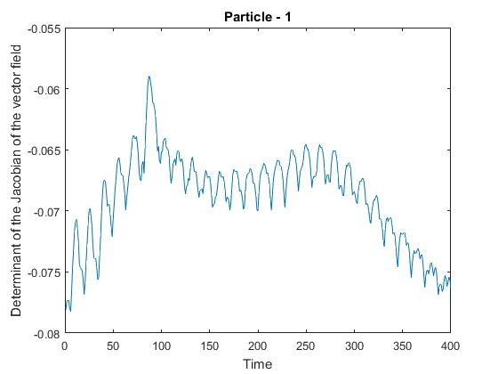

a. The general trend is fluctuating and the particle is oscillating. There are no flat or smooth regions. This means that the velocity and rotation of the flow is sharply increasing and then decreases. The wave is in a zig-zag manner which shows that the . The determinant values are always negative. This shows that divergence of the particles is less and the rotation of the particles is more. The particles move with some rotation and the rotation peaks at a point and then fluctuates.

b. The maximum point is at unit time : 87 is -0.0589972

c. The outliers are the peak at 87, around 0, around 400 units of time. The mea is -0.06887

Particle – 2

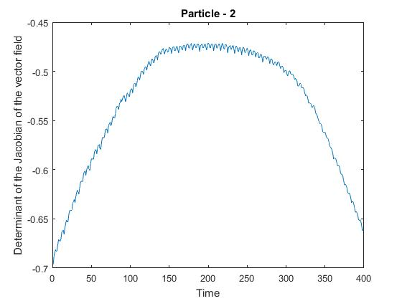

1. The graph is sinusoidal and it gradually increases then the values are flat for more than 100 units of time then decreases. The rotation of the flow is more than the divergence of the flow because all the values are less than 0.
2. The graph peaks at time 200 where the value is -0.660764.
3. There are no outliers.

Particle – 3

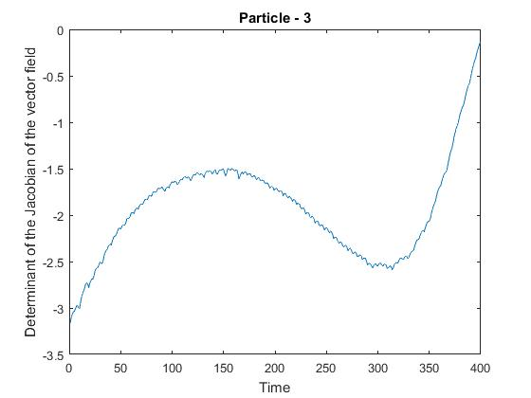

1. The graph is sinusoidal initially and then becomes exponential. There are no flat surfaces as the velocity and rotation are always constantly changing. The rotation of the particles is greater than the divergence because the values are less than 0. But after 300 time units the determinant increases steeply approaching to 0.
2. The largest value is -0.129522 at time 400 time units.
3. The sudden sharp increase after 375 units of time is the outlier because the value is deviated from the mean(-1.929) by a large value.

Particle – 4

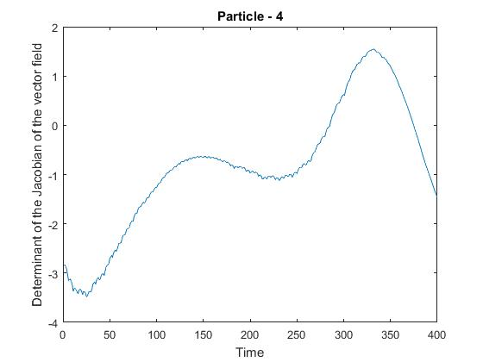

1. The graph is a fluctuating polynomial. There are no flat surfaces on the graph. But there is a gradual increase until it reaches the local maximum peak and then dips a little and then steeply rises to the highest point and sharply fall down. Initially all the values are negative, this shows that the rotation of the flow is more than the divergence but the particle shows more divergence after 280 time units as the values of the determinant are more positive.
2. The value 1.54418 at time 332 is the maximum.
3. The outliers are values around 25 units of time and around 332 units of time because they are largely deviated from the mean -0.8481482.

Particle – 5

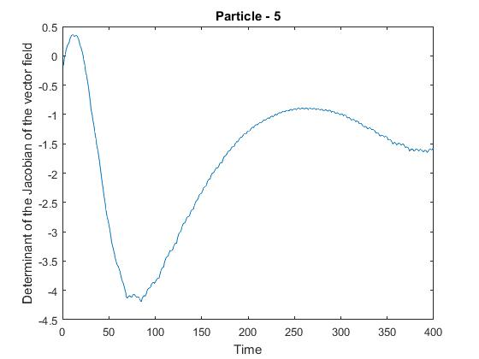

1. The graph is fluctuating. The change in flow of velocity sharply falls and then gradually increases. There are no flat regions but the particle has a smooth behavior. The values are negative which shows that the rotation is more than the divergence.
2. The maximum is 0.357401 at 11 time units
3. The outlier is at around 75 units of time where the graph dips suddenly and rises again. This point has the maximum deviation and the mean(-1.76730) of the graph will be more closer to the other points if this sudden dip is not occurring.

Another outlier can also be at around 10 units of time.

Particle – 6

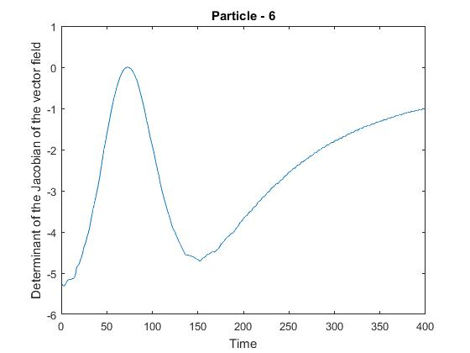

1. The graph is fluctuating. The velocity of the flow increases sharply and then falls rapidly and then there is a gradual increase in the velocity. There are no flat regions in the graph. The values are all less than 0. This shows that the rotation of the particle is more than the divergence of the particle.
2. The value 0.00131935 is maximum at time 73 units.
3. Outliers are the initial point from 0 units of time and the peak at 73.the mean is -2.5822 and the standard deviation is 1.43. The peak is more than 2 standard deviation away.

Particle – 7

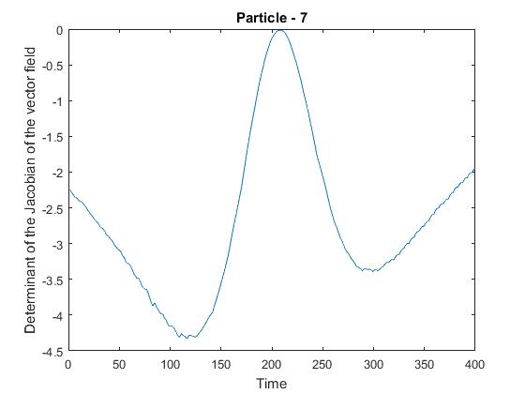

1. The particle is showing a fluctuating graph. The velocity first decreases and then increases sharply and reaches the maximum and then decreases sharply and then increases. There are no flat surfaces or a particular trend. It is a distorted sine wave. And the particle shows more rotation than divergence because all the values are negative.
2. The maximum value is -0.0154835 at 208.
3. Outliers : The points at about 120, 210 can be considered as outliers since they have the maximum deviation. The mean of the points is (-2.6709786) and standard deviation is (1.127). The peak at 210 is more than 2 standard deviations away.

Particle – 8

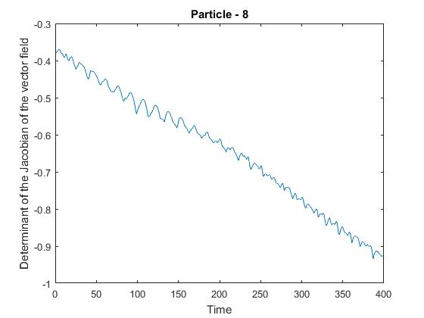

1. The particle shows a vibrating velocity and decreasing gradually with time. There are no flat surfaces. This shows that the particle is moving slower with time and also the rotation of the particle is more than the divergence of the particle.
2. The maximum value is -0.369969 at time 5 units.
3. There are no outliers.

Particle – 9

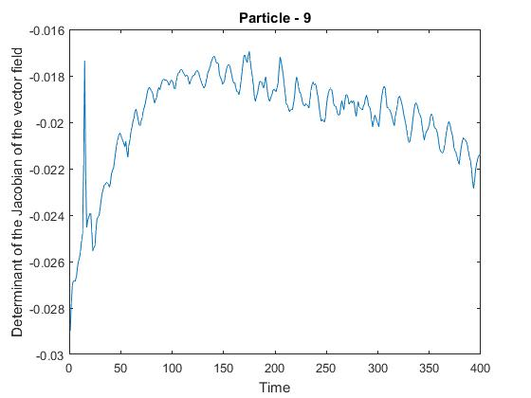

1. The particle shows a fluctuating nature in its velocity but the general trend is increasing and then decreasing. The particle does not show any constant velocity. The values are negative shows that the rotation of the particle is more than the divergence of the particle.
2. The maximum is -0.0169587 at time 175 units
3. Yes there is an outlier at 15 units of time with value -0.0173442 which shows an abnormal sudden increase in value.
4. Combined Plots

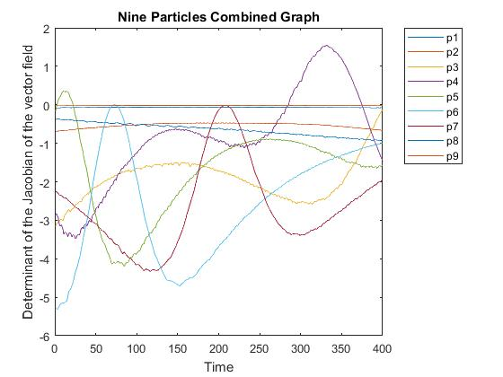

* 1. The largest and smallest overall values in terms of magnitude areParticle 9 (-7.9084748) and Particle 7 (-1068.3914).

* 1. Particle 6 has the largest deviation (1.4302359251311)
  2. The data can be largely classified into 3 clusters based on their values.

1. Particles 1,2,8,9 – These particles show a lot of vibration i.e their values oscillate in small intervals and all of them have negative values which shows that their rotation is more than their divergence. The range of these values is 0 to -1.
2. Particles 3,6,7 – These particles are sinusoidal but not completely and show some fluctuations but they have values lesser than cluster 1. The range of these data series is greater than cluster 1.
3. Particles 4,5 – They also show sinusoidal properties but some data points have positive values as well showing that their divergence is more pronounced than the rotation at those points of time. The range of the data points is spread across.
   1. Cluster -2 (Particles 3,6,7) has the smallest values. All of its values are negative and of larger magnitude. This shows that particles 3,6,7 are moving with less velocity but are rotating more. The absolute value tells us how much the function dilates volumes in the neighborhood of the particle. So with larger magnitude they are dilating more.
   2. Yes, it can be observed that particles with lower values of magnitude (i.e which are near to the 0 mark) are showing oscillations in their graphs than the particles with greater magnitude values. Even though the rotation is more pronounced than the divergence they are vibrating.

And particles with lower magnitudes don’t have a pronounced sinusoidal waves than the other particles.