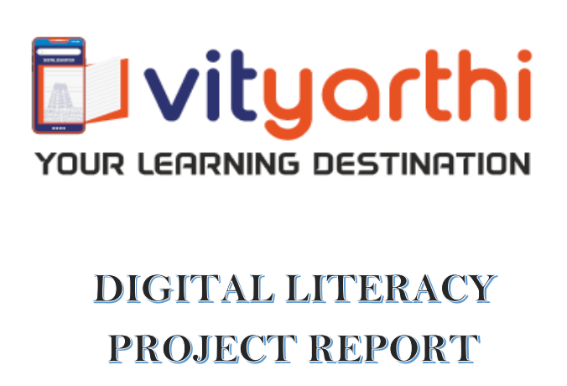
Name: PRISHA GABBAD
Registration Number: 25BCY10139
Course: CSE0001 Digital Literacy
Faculty: KANNAN
Slot: F22
Branch: CSE Cyber Security and Digital Forensic
University: VIT Bhopal University

Index
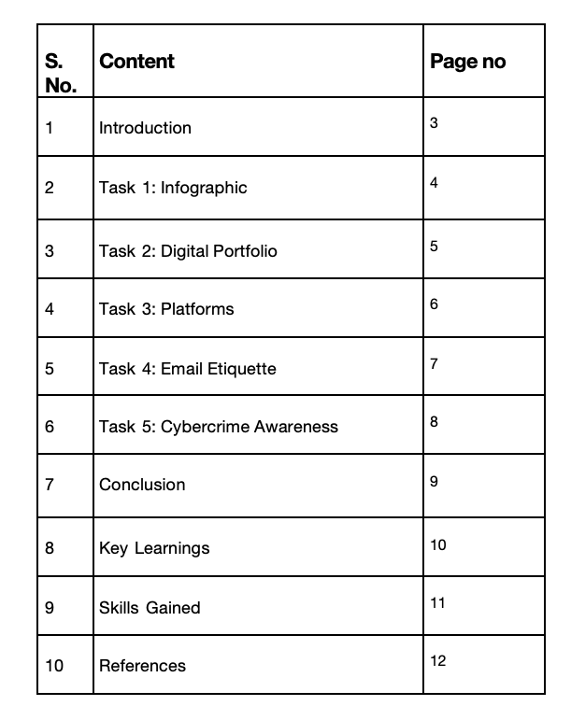

Introduction

Digital literacy refers to the ability to effectively use digital tools and platforms for communication, learning, and professional growth. In today’s academic environment, students are expected to interact with technology regularly, making digital literacy an essential skill.
This project provided practical exposure to multiple platforms and tools. It helped me understand how to:
- Use digital tools efficiently
- Communicate professionally online
- Maintain online safety and awareness
Through hands-on tasks, I improved my technical, analytical, and communication skills, which are essential for both academic and professional success.

Task 1: Infographic

For this task, I used Canva to design a one-page infographic titled Digital Literacy for College Students. The infographic visually represents important aspects of digital literacy in a structured and engaging format.
My design includes:
- Definition of digital literacy
- Useful digital tools for students
- Safe internet practices
- Email etiquette guidelines
I used icons, color themes, and section-based layouts to ensure clarity and readability. The goal was to make the information easy to understand at a glance.
One interesting/difficult aspect:
- The most challenging part was fitting multiple topics into a single page without making it cluttered.
- I found it interesting to use visuals instead of long text to communicate information effectively.
This task improved my creativity and helped me understand how visual communication plays a key role in digital literacy.

Task 2: Digital Portfolio

In this task, I created profiles on GitHub, LinkedIn,Stack overflow and Kaggle which are important platforms for students.
Platforms and their uses:
- GitHub: Used for storing, managing, and showcasing projects
- LinkedIn: Used for professional networking and career opportunities
- Stack Overflow: Used by programmers and developers to fins answer to a specific coding problem
- Kaggle: used as an online community for data science and machine learning
I added basic academic details and ensured that my profiles were clean and professional.
My future plan (next 4 years):
- Use GitHub to upload academic and personal projects
- Use LinkedIn to build connections and explore internships
- Use HackerRank regularly to improve coding skills
This task helped me understand the importance of building a strong digital presence and how these platforms contribute to career growth.

Task 3: Platforms

In this task, I worked with HackerRank, Google Forms, and Google Sheets to understand practical applications of digital tools.
What I practiced/built:
- Solved a beginner-level coding problem on HackerRank
- Created a Google Form quiz on digital literacy
- Linked the form to a Google Sheets response sheet
Solving the coding problem helped me understand basic programming logic and how online judges work. Creating the Google Form helped me learn how to collect and organize data efficiently.
Academic benefits:
- Improves coding and problem-solving skills
- Helps in conducting surveys and collecting data
- Enhances ability to analyze responses using spreadsheets
This task showed how digital platforms can support learning and collaboration in academics.

Task 4: Email Etiquette

Poor digital communication can lead to serious misunderstandings. For example, a student might send an email to a professor without a subject line, proper greeting, or clear message. This can cause confusion or even result in the email being ignored.
Problems caused:
- Miscommunication
- Delay in response
- Negative impression
What could be done differently:
- Use a clear and relevant subject line
- Start with a polite greeting
- Write a concise and clear message
- Maintain a respectful and professional tone
Following proper email etiquette ensures effective communication and helps maintain professionalism in academic and professional settings.

Task 5: Cybercrime Awareness

While researching cybercrime, I was surprised by how common and easy it is for people to become victims of online scams, especially phishing and financial fraud. Many users unknowingly share sensitive information due to lack of awareness.
What surprised me:
- Cybercrimes can happen through simple links or messages
- Even educated users can fall victim to scams
One habit I will change:
- I will be more cautious while clicking links or sharing personal information
- I will verify sources before trusting any online message
This task made me more aware of digital risks and the importance of safe internet practices in daily life.

Conclusion

This project helped me develop a deeper understanding of digital literacy and its importance. I gained practical experience using various tools and improved my technical and communication skills.
Overall, this project has prepared me to:
- Use digital tools effectively
- Communicate professionally
- Stay safe online
These skills will be valuable for my academic journey and future career.

Key Learnings

- Gained a clear understanding of digital literacy and its importance in academic and professional environments.
- Learned how to effectively use multiple digital platforms such as GitHub, LinkedIn, HackerRank, Canva, and Google Forms.
- Understood the importance of maintaining a professional digital presence through properly structured online profiles.
- Developed awareness about cybersecurity risks, including phishing, fraud, and unsafe online practices.
- Learned how to present information visually using infographics, making complex ideas easy to understand.
- Improved knowledge of data collection and analysis using tools like Google Forms and Google Sheets.
- Gained insight into professional communication, especially writing formal emails with proper etiquette.
- Understood how digital tools can be used for collaboration, learning, and project management.

Skills Gained

- Technical Skills:
  - Basic programming and problem-solving using HackerRank
  - Using GitHub for file management and project organization
  - Creating and managing online forms and response sheets
- Communication Skills:
  - Writing formal and professional emails
  - Structuring clear and concise digital messages
  - Understanding tone and etiquette in online communication
- Design Skills:
  - Creating visually appealing infographics using Canva
  - Organizing content using layouts, icons, and color schemes
  - Presenting information in a clear and engaging format
- Analytical Skills:
  - Identifying online risks and evaluating digital information
  - Understanding cybercrime patterns and prevention methods
  - Analyzing responses collected through forms

- Organizational Skills:
  - Managing multiple tasks and platforms efficiently
  - Structuring files and folders correctly in GitHub
  - Maintaining a clean and professional project repository

References

- Canva (https://www.canva.com)
- GitHub (https://github.com)
- LinkedIn (https://www.linkedin.com)
- HackerRank (https://www.hackerrank.com)
- Stack overflow (https://stackoverflow.com/)
- Kaggle (https://www.kaggle.com/)

