Language models for value-informed proxy decision support
Supplemental Appendix

Table of Contents
- LLM Choice & Temperature Fine-Tuning
- Supplementary Figures
- STROBE Checklist
- Dyad Cohort and Value Questionnaires
- Scenario Texts
- Patient-Proxy Dyads: Multiple Choice Answers
- Full Prompt Texts
- Real EHR Patient Cohort Assembly
- EHR-driven LLM Treatment Recommendations
- Clinical Adjudication of LLM Outputs
- Data Analysis
- Supplementary Table
- LLM Uncertainty Testing and Analysis
- Simulation Studies
- References

- LLM Choice & Temperature Fine-Tuning
We used the 8 billion parameter Llama 3.1 model, trained on over 15 trillion multilingual tokens of publicly available and human annotated data sources, which we favored for its relatively unrestricted access, code transparency, and flexibility in hyperparameter modulation. We accessed Llama 3.1 through the Ollama Application Programming Interface (API) with the ollama.chat function in Python. Although using contemporary, closed-source LLMs might boost performance, we see value in using earlier iterations of an open-source model that is more easily accessible to others and offers greater code transparency and hyperparameter selection options (e.g., temperature modulation). Furthermore, we are limited to those models that can be run within a contained, confidential environment to avoid sharing private patient data.

We tested the reproducibility and accuracy of the LLM outputs for the dyad agreement portion of the study through additional fine-tuning of the temperature parameter to find the optimum value at which the output agreed most with the patient’s choices. The LLM temperature parameter controls the probability distribution of the model output tokens, where temperatures ranging from zero to 2 are more predictable, repetitive, and deterministic in LLaMa3. At higher temperatures, that is > 1, the model output is more creative and random but may be prone to errors. To maximize the model’s decision-making function and reasoning, we tested its reproducibility by running the responses under 11 temperatures between 0.0 and 2.0 at intervals of 0.2 for each dyad.

We found that lower LLM temperatures generally produced the highest levels of agreement with the smallest confidence intervals between the LLM answers and human subject, especially when additional value questionnaire information was included. The overall best value for highest agreement appeared to be 0.2, thus, we selected this temperature for the overall agreement analysis presented in the main manuscript. However, it should be noted that there was a significant overlap in confidence intervals within LLM prompt type groups. Agreement when temperate was most deterministic (temperature = 0.0) did not show significant improvement over the value of 0.2 and produced results with lower agreement on average across all prompts.

- Supplementary Figures

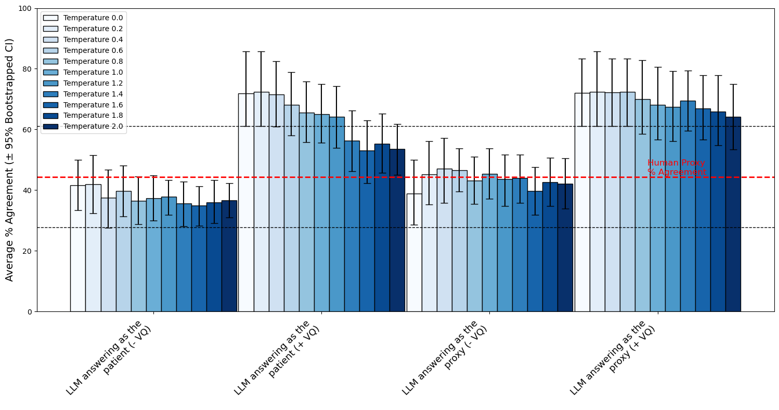
Figure S1A. Results from the temperature trials showing the average agreement (+/- 95 Bootstrapped Confidence Intervals [CI]) across the 10 repetition trials and 12 dyads for each of the tested temperature values ranging from 0.0 to 2.0. Average agreement was calculated as the percentage of times the human proxy or LLM produced the same answer as the human participant across the three scenarios and ranged from 0 (no matching answers) to 100 (all answers matched). The horizontal red dotted line represents the average agreement of the human proxy with the human participant (44.7%), with the horizontal black lines representing the 95% CI range (28.6-61.9). Results are shown for four model prompts: 1) LLM answering as the participant with no additional information from the value questionnaires (no VQ), 2) LLM answering as the participant and provided with the value questionnaire answers (+ VQ), 3) LLM answering as a proxy with no VQ, and 4) LLM answering as the proxy with VQ.
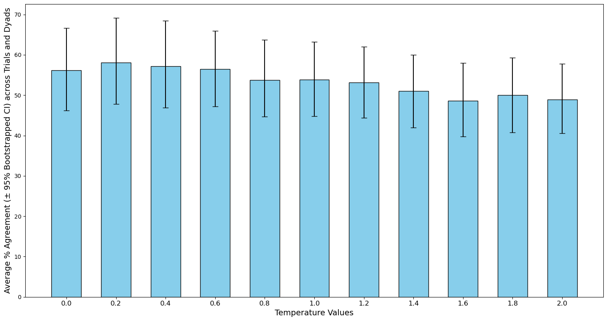
Figure S1B. Results from the temperature trials showing the average agreement (+/- 95 Bootstrapped Confidence Intervals [CI]) across the 10 repetition trials and 12 dyads for each of the tested temperature values ranging from 0.0 to 2.0. Average agreement was calculated as the percentage of times the human proxy or LLM produced the same answer as the human participant across the three scenarios and ranged from 0 (no matching answers) to 100 (all answers matched). The horizontal red dotted line represents the average agreement of the human proxy with the human participant (44.7%), with the horizontal black lines representing the 95% CI range (28.6-61.9). Results shown in this figure are averaged across the four model prompts.

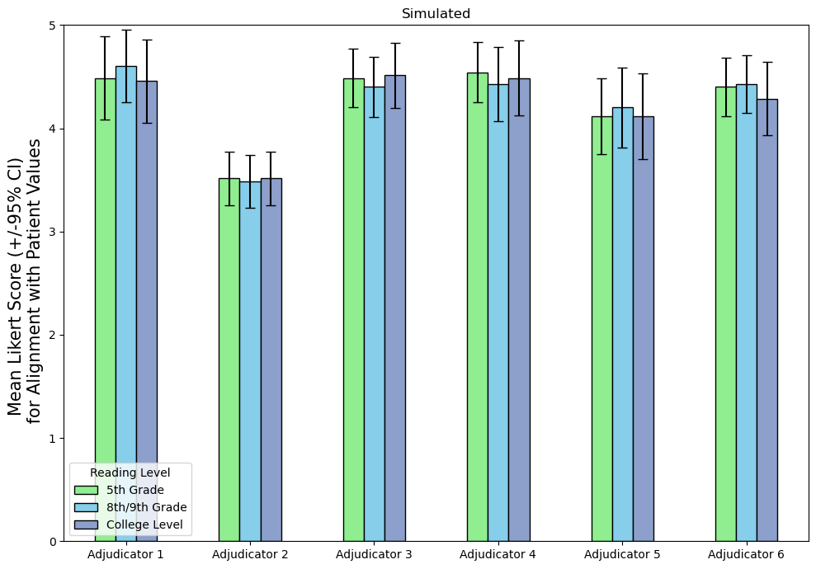
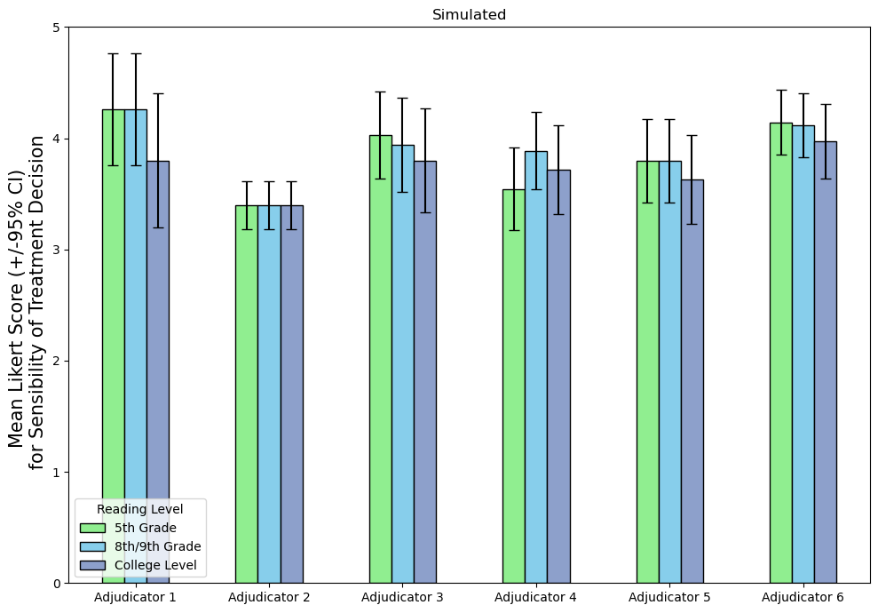
A
B

Figure S2. Mean Likert Scores (+/- 95% bootstrapped confidence intervals) shown for each of the six adjudicators and reading levels across the simulated cohort. Adjudicators 1-3 represent the clinical experts and adjudicators 4-6 represent the medical students. Adjudicators assessed the Large Language Model (LLM) treatment recommendation in accordance with A) whether the recommendation aligns with the patient’s values, and B) whether the recommendation represents a sound and sensible clinical decision.
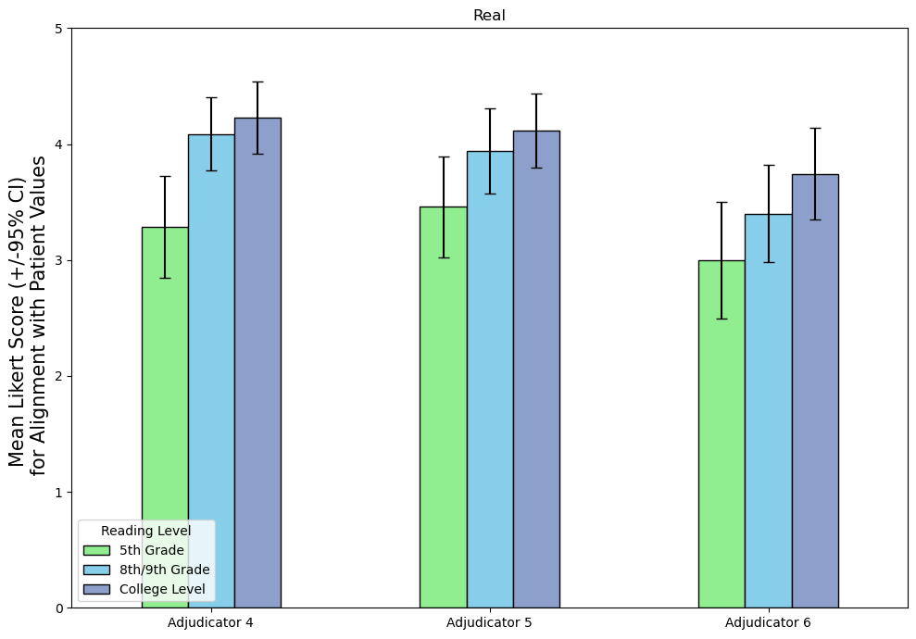
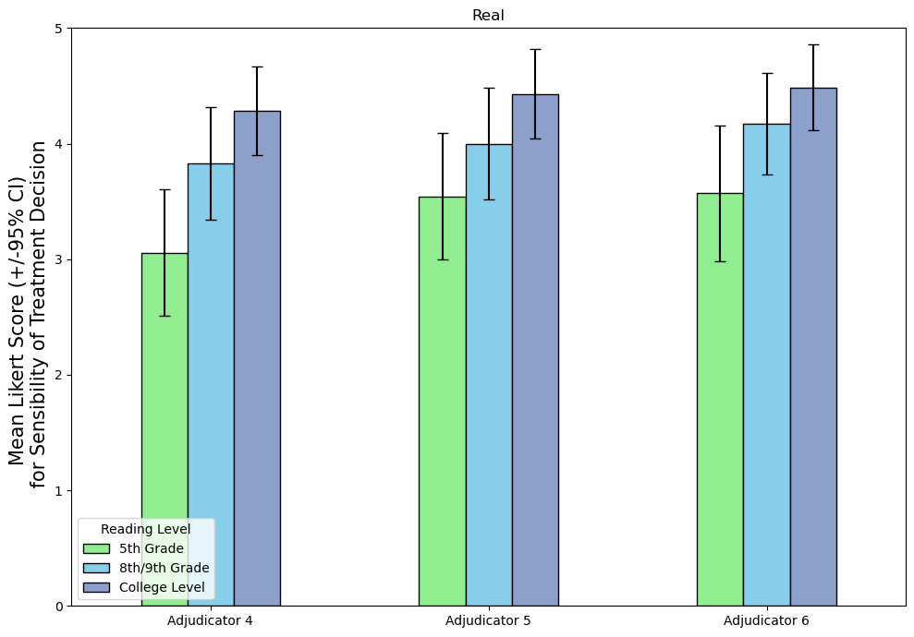
A
B

Figure S3. Mean Likert Scores (+/- 95% bootstrapped confidence intervals) shown for each of the three medical student adjudicators (adjudicators 4-6) and reading levels for the EHR real cohort datasets. Adjudicators assessed the Large Language Model (LLM) treatment recommendation in accordance with A. whether the recommendation aligns with the patient’s values and B. whether the recommendation represents a sound and sensible clinical decision.

- Simulated Scenarios B. Real EHR Cohort Scenarios
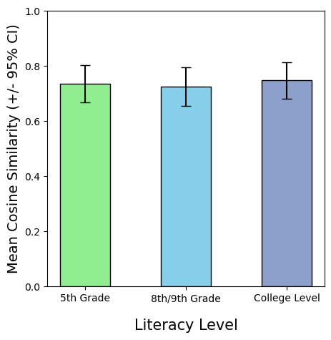
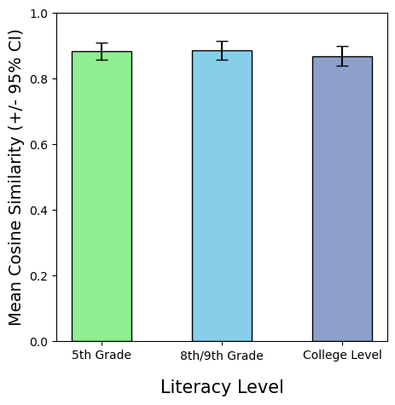
Reading Level
Reading Level
A
B

Figure S4. Sample consistency (SC) in Large Language Model (LLM) treatment recommendations for A. the 35 simulated scenarios, and B. the 35 EHR cohort real patients calculated as mean cosine similarity (+/- 95% Bootstrapped Confidence Intervals) between pairwise LLM outputs across 10 model runs. Results are shown for the three reading level value profiles: fifth grade, eighth or ninth grade and college graduate level.

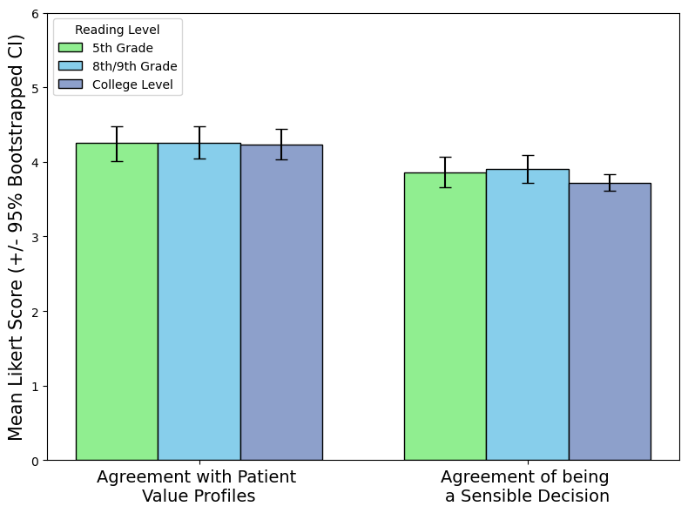

Figure S5. Adjudication of Large Language Model (LLM) treatment recommendations at the three reading levels (fifth grade, eighth grade or college graduate level) averaged across adjudicators and the 35 simulated scenarios (+/- 95% Bootstrapped Confidence Intervals (CI)). LLM treatment recommendations were assessed using Likert Scoring (0 = no agreement, 5 = perfect agreement) in accordance with 1) did the recommended treatment match the values of the patient stated in the value profiles, and 2) was the recommended treatment a sensible and sound decision for the patient.

- STROBE Checklist
Checklist of items that should be included in reports of cohort studies.
 | Item No | Recommendation | Page No
Title and abstract | 1 | (a) Indicate the study’s design with a commonly used term in the title or the abstract | 1
 |  | (b) Provide in the abstract an informative and balanced summary of what was done and what was found | 3
Introduction
Background/rationale | 2 | Explain the scientific background and rationale for the investigation being reported | 4
Objectives | 3 | State specific objectives, including any prespecified hypotheses | 4
Methods
Study design | 4 | Present key elements of study design early in the paper | 5
Setting | 5 | Describe the setting, locations, and relevant dates, including periods of recruitment, exposure, follow-up, and data collection | 5
Participants | 6 | (a) Give the eligibility criteria, and the sources and methods of selection of participants. Describe methods of follow-up | 5,6
 |  | (b) For matched studies, give matching criteria and number of exposed and unexposed | NA
Variables | 7 | Clearly define all outcomes, exposures, predictors, potential confounders, and effect modifiers. Give diagnostic criteria, if applicable | 5,6,7
Data sources/ measurement | 8* | For each variable of interest, give sources of data and details of methods of assessment (measurement). Describe comparability of assessment methods if there is more than one group | 5,6,7
Bias | 9 | Describe any efforts to address potential sources of bias | 5,6
Study size | 10 | Explain how the study size was arrived at | 5,6
Quantitative variables | 11 | Explain how quantitative variables were handled in the analyses. If applicable, describe which groupings were chosen and why
Statistical methods | 12 | (a) Describe all statistical methods, including those used to control for confounding | 7,8
 |  | (b) Describe any methods used to examine subgroups and interactions | NA
 |  | (c) Explain how missing data were addressed | NA
 |  | (d) If applicable, explain how loss to follow-up was addressed | NA
 |  | (e) Describe any sensitivity analyses | 6,7,8
Results
Participants | 13* | (a) Report numbers of individuals at each stage of study—eg numbers potentially eligible, examined for eligibility, confirmed eligible, included in the study, completing follow-up, and analysed | 5,6, S3
 |  | (b) Give reasons for non-participation at each stage | NA
 |  | (c) Consider use of a flow diagram | Fig. 1
Descriptive data | 14* | (a) Give characteristics of study participants (eg demographic, clinical, social) and information on exposures and potential confounders | S3
 |  | (b) Indicate number of participants with missing data for each variable of interest | NA
 |  | (c) Summarise follow-up time (eg, average and total amount) | NA
Outcome data | 15* | Report numbers of outcome events or summary measures over time | NA
Main results | 16 | (a) Give unadjusted estimates and, if applicable, confounder-adjusted estimates and their precision (eg, 95% confidence interval). Make clear which confounders were adjusted for and why they were included | 8,9
 |  | (b) Report category boundaries when continuous variables were categorized | 8,9
 |  | (c) If relevant, consider translating estimates of relative risk into absolute risk for a meaningful time period | NA
Other analyses | 17 | Report other analyses done—eg analyses of subgroups and interactions, and sensitivity analyses | NA
Discussion
Key results | 18 | Summarise key results with reference to study objectives | 8, 10
Limitations | 19 | Discuss limitations of the study, taking into account sources of potential bias or imprecision. Discuss both direction and magnitude of any potential bias | 11
Interpretation | 20 | Give a cautious overall interpretation of results considering objectives, limitations, multiplicity of analyses, results from similar studies, and other relevant evidence | 9,10,  11,12
Generalisability | 21 | Discuss the generalisability (external validity) of the study results | 11,12
Other information
Funding | 22 | Give the source of funding and the role of the funders for the present study and, if applicable, for the original study on which the present article is based | 2
*Give information separately for exposed and unexposed groups.
Note: An Explanation and Elaboration article discusses each checklist item and gives methodological background and published examples of transparent reporting. The STROBE checklist is best used in conjunction with this article (freely available on the Web sites of PLoS Medicine at http://www.plosmedicine.org/, Annals of Internal Medicine at http://www.annals.org/, and Epidemiology at http://www.epidem.com/). Information on the STROBE Initiative is available at http://www.strobe-statement.org.

- Dyad Cohort and Value Questionnaires
We enrolled 15 dyads (15 patients and 15 proxies, N = 30) for the Dyad Study. Human proxies fell within three categories: spouse 73% (n = 11), parent-child 20% (n = 3), and sibling 7%, (n = 1). All participants achieved a minimum of high school level of education (Grade 12 and above), with half holding a bachelor’s degree or higher. Most were 45 years or older (73%), 67% earned more than $45,000 annually, 57% were female, 87% were non-Hispanic and 60% identified as African American or Black.

The Value-Living Questionnaire (VLQ) is a validated instrument adopted from acceptance and commitment therapy to measure value and value-living from a behavioral perspective¹. Values are a set of ideals, interests, principles, or standards that a person endorses and commits to as good.² Value-living is defined as living according to one’s personal values.³ Together, they are an integral part of maintaining and building flexible behavior.⁴ VLQ is composed of 20 questions and divided into two sets with 10 domains per set (Family, Intimacy, Being Social, Parenting, Work, Education, Recreation, Spiritual, Community, and Self-Care). The first set asked the respondents about their ideal personal values in 10 domains and the second set assessed their current behavior in those domains.

The Compassion and Choices values worksheet houses a survey with 14 questions about core values at the end-of-life (quality of life, pain free, no physical limitations, maintaining independence, mental alertness, leaving money, avoiding treatment, relating to family, leaving memories, quick death, living long as possible, natural course of death, spirituality, and medical research).⁵ The respondents would rank the importance of each of the core values in their present status. The goal of both questionnaires was to assist the participants with identifying their most important values and what values in the domains mattered most near the end-of-life. Participants completed informed consent forms and provided value and end-of-life treatment preferences over the phone or face-to-face.

- Scenario Texts
Eight Adapted Simulated Scenario Texts for Dyad Analysis
Scenario 1
Age: 43. Background: You enjoy an active lifestyle. You like marathons, hiking, and rock climbing. You have been married for 20 years and have two children (16 years and 12 years). You have occasional seasonal allergies, but otherwise, you have been in good health. Living Situation: You live in a two-story home with a large backyard with a garden. Together with your spouse, you take care of the children, managing their daily activities, schoolwork, and extracurricular activities. Event: On one of your rock-climbing adventures at the gym, you fell from a significant height although you were using a safety harness. The angle and force of the fall caused you to hit your head hard against the climbing wall and you lost consciousness. You were examined by medical personnel on site at the gym who transported you to the hospital. The ER diagnosed you with a traumatic brain injury and you were unable to communicate or make decisions for yourself for some time. However, you did get better over the next year. On one occasion when you were taking a shower, you noticed a lump in your upper left thigh. The lump seemed to be getting bigger over time, so you decided to talk with your doctor. Out of precaution, the doctor took a biopsy. Investigations: The biopsy revealed a high-grade soft tissue sarcoma (a malignant cancer). An MRI of the leg and pelvis was done, and it confirmed the cancer had spread to the nearby structures. Clinical Decision: Because the cancer had spread, treatment had to be aggressive. The best chance for a cure would be to remove part of your hip bone [hemipelvectomy] and amputate your left leg at the hip.
Scenario 2
Age: 20. Background: You are a university student studying literature. You are an introvert and struggle with severe depression, but you have sought counseling through the university’s mental health services. You are an only child, and your parents live in another city, about a 3-hour drive away. Living Situation: You live alone in a single room in the university dormitory and have a few close friends, but mostly you keep to yourself. Your grades are great, and you are passionate about poetry and literature. Event: Emergency services were called to the university dormitory after reports of a fire. Upon arrival, they found you with extensive burn injuries. Initial investigation suggested you tried to set yourself on fire in your room. Investigations: You were taken to the nearest burn center, and they confirmed that you had third-degree burns covering approximately 80% of your total body, including your face, chest, arms, and legs. Due to the severity of the burns and a potential airway problem, you were placed on a breathing machine (intubated) and sedated. Clinical Decision: The burn and surgical teams were faced with the challenge of how to care for you because you have a high risk of infection, complications, and death. They decided to keep you stable, making sure you have adequate fluid intake and that they prevent you from getting an infection. Long-term, you will require multiple surgeries, skin grafts (replacing burnt skin with good skin), and extensive rehab. Since you had prior mental health challenges and your injuries were severe, they insisted on a psychiatric evaluation and support.
Scenario 3
Age: 35. Background: You are an accomplished architect, and your work was featured in various architectural magazines. Aside from your professional achievements, you were an active community volunteer, often leading urban gardening projects and neighborhood clean-ups. Living Situation: You live in a penthouse of a building you designed, with a rooftop garden. Event: While attending a construction site for a new project, an unexpected structural collapse occurred, and you were trapped under heavy debris for several hours before rescue teams could safely extract you. You were immediately transported to the trauma center of a nearby hospital with multiple injuries. Investigations: On evaluation, they diagnosed you with severe traumatic brain injury (TBI), multiple rib fractures, a punctured lung, and a crushed pelvis. Clinical Decision: They placed you on a ventilator due to respiratory distress and performed emergency surgery to stabilize your injuries. After the surgery, they kept you in a coma to help minimize your brain injury. The medical team stated that there was a high chance you will have long-term mental impairment if you did recover, or you will remain in coma state.
Scenario 4
Age: 70. Background: You are a retired librarian who has lived a rich and fulfilling life. You have two adult children and four grandchildren. You recently had vascular surgery because of peripheral vascular disease (disease of the blood vessel). Three days after your surgery and while in the hospital, you had multiple conversations about how content you were with your life and would like "nature run its course" rather than pursue aggressive medical treatment. Living Situation: You live alone in a small apartment after losing your spouse five years ago. Your children visit frequently, and you enjoy spending time reading and gardening. Event: A week after your operation, you started to have symptoms of respiratory distress. You developed a fever, persistent cough, and had difficulty breathing. Because of that, you were placed on a ventilator and the team put you to sleep (sedation), but you still did not improve. Investigations: They frequently checked your oxygen saturation level, but it kept on decreasing rapidly. So, they did a chest X-ray, and it was confirmed that you had severe COVID-19 pneumonia. Clinical Decision: The medical team decided to consider an advanced treatment due to the severity of the pneumonia and your decreasing oxygen levels. They decided on Extracorporeal membrane oxygenation (ECMO) as it could potentially support your lungs and give you a chance of recovery. However, the hospital has limited ECMO machines, and there are other critically ill COVID-19 patients who might also benefit from use of this machine.
Scenario 5
Age: 77. Background: You are a widow(er) and retired from a career in accounting. You have a history of multiple heart diseases and diabetes, but you have never smoked. However, your spouse smoked for many years and exposed you to second-hand smoke during that time. Living Situation: You live alone in a one-bedroom apartment and have two adult children who live nearby and visit frequently. They assist you with grocery shopping, house chores, and take you to doctor’s appointment. Event: One day, you were admitted to the hospital with severe breathlessness and fatigue. The initial evaluation suggested severe heart failure. Investigations: The medical team find out that your heart condition is very poor, and you were expected to survive for just a few months. During your hospitalization, they ordered a routine chest Xray which showed a small mass in your right lung. Clinical Decision: The standard treatment for a mass is biopsy. If the biopsy is positive for cancer, then, the next step would be removal of the mass. However, given your severe heart failure and your survival diagnosis, the surgery would pose a high risk, even death.
Scenario 6
Age: 69. Background: You are a retired schoolteacher and widowed about a decade ago. You have two grown-up children and three grandchildren, and you were diagnosed with chronic obstructive pulmonary disease (COPD). He had spent many years of smoking, but quit 5 years ago. Living Situation: You live in a senior community where you have many friends. Your daughter lives nearby and visits often, helping you with errands and doctor's appointments. Event: You were admitted to the hospital after a minor fall at your home. Though you didn't get any fractures, your oxygen levels were unstable, meaning you had a COPD exacerbation episode. Investigations: During your hospital stay, your breathing difficulties got worse and then you started to have trouble swallowing, especially coughing during meals. A swallow evaluation showed muscle weakness from the result of having COPD for a long time. Clinical Decision: The standard approach for difficulty in swallowing is to consider inserting a tube in the stomach [percutaneous endoscopic gastrostomy (PEG)] for adequate nutrition. However, given your overall health status and your advanced COPD, the team felt a conservative management with dietary modifications might be more appropriate.
Scenario 7
Age: 68 years. Background: You are a former coal miner who was diagnosed with chronic obstructive pulmonary disease (COPD) fifteen years ago. Over the years, your health has progressively declined. You have been on home oxygen therapy for the past five years and have had multiple hospital admissions due to exacerbations of your COPD. Living Situation: You are widowed and have lived alone since your spouse passed away three years ago. Since then, your adult son has taken an active role in your care, assisting you with medical appointments and managing your medications. Event: You were brought to the emergency department with a severe shortness of breath following a minor respiratory infection. Investigations: You were placed on a ventilator when examination showed that you had respiratory failure. Clinical Decision: Despite treatments, you did not show significant improvement. In addition, you were on a ventilator for a long time and the doctors were concerned about ventilator-associated complications. The team assessed that you might do better with a tracheostomy (a hole in your throat) which will be necessary for you to breathe better for the rest of your life.
Scenario 8
Age: 78. Background: You are a former university professor that has been living with advanced Parkinson's disease for over a decade. You have issues with moving around and frequent falls. You also have a history of hypertension and chronic kidney disease. Despite these health challenges, you always maintained a positive outlook. During one of your outpatient visits, you mentioned that you wanted all possible treatments, even if the chances of recovery were slim. You always expressed a wish to "fight every battle, no matter the odds." Living Situation: You lived alone but had a regular caretaker that came to help you daily. Event: You were admitted to the hospital following a significant fall at home, resulting in a hip fracture. During the hospital stay, you developed a hospital-acquired infection which led to an infection spreading to the blood. Clinical Decision: The infection in the blood combined with other conditions resulted in a rapid decline in your health. You became unstable and required blood pressure support. The medical team provided you with a strong antibiotic and gave you IV fluid regularly, but improvement in your condition was uncertain.

Thirty-five Simulated Scenario Texts for Simulated Cohort
Scenario 1
Patient Name: Mrs. Clara Martinez. Age: 57 years. Background: Mrs. Clara Martinez was a successful architect, known for her innovative designs and passion for sustainable architecture. Ten years ago, Clara was diagnosed with a benign brain tumor, which resulted in her undergoing a partial brain lobectomy. Since the surgery, Clara has experienced cognitive and motor deficits. She requires assistance with most daily activities and has occasional seizures, but she still enjoys moments of clarity and connection with her surroundings, especially when listening to music or when with her family. Current Living Situation: Clara resides in a care facility specializing in patients with neurological disorders. Her room is adorned with photos of her designs, her family, and tokens from her travels. Her two children visit her regularly, bringing along her young grandchildren, who Clara clearly recognizes and adores. Presenting Complaint: Clara was admitted to the hospital with symptoms of severe flank pain, fever, and nausea. Investigations revealed bilateral hydronephrosis, likely due to obstructing kidney stones. Clinical Findings: Due to Clara's complex medical history and the risks associated with anesthesia, the urology team is hesitant about performing a traditional stone removal procedure. They consider placing nephrostomy tubes as an alternative to alleviate the obstruction and allow for kidney drainage. Clinical Decision Point: The medical team, along with Clara's eldest daughter (who acts as her medical proxy), needs to decide on the best course of action. The decision to place nephrostomy tubes must be weighed against potential complications, Clara's current quality of life, and the long-term care implications of such a procedure.
Scenario 2
Patient Name: Mr. Leo Jackson. Age: 32 years. Background: Mr. Leo Jackson has been incarcerated for the past seven years for a series of violent offenses. Over the past three years, the prison staff has observed a marked change in his behavior, noting increasing paranoia, auditory hallucinations, and severe mood swings. Diagnosed with psychosis, Leo has been resistant to medical and psychiatric interventions, often refusing medications. Current Situation: Leo is currently held in a high-security prison. While he is segregated from the general prison population due to his mental health condition, he still finds ways to harm himself. Presenting Complaint: Over the past month, Leo has been involved in three separate incidents where he stabbed himself in the abdomen with makeshift sharp objects. Each episode seems to be triggered by his belief that he's being "controlled" by an external force, which he thinks resides in his stomach. Clinical Findings: Each self-inflicted injury required surgical intervention. The repeated abdominal wounds have caused significant internal damage, and there are concerns about the potential for life-threatening injuries if the behavior continues. Psychiatric evaluations have confirmed severe psychosis, with Leo exhibiting clear delusions and a lack of insight into his condition. Clinical Decision Point: The medical and psychiatric teams are faced with the challenge of ensuring Leo's safety while addressing his underlying mental health condition. There's a debate about the ethics and practicalities of placing him in a more restrictive environment or using more assertive medical interventions to manage his psychosis.
Scenario 3
Patient Name: Mr. Alex Martinez. Age: 32 years. Background: Alex Martinez is an energetic young father of two children, aged 4 and 6. He works as a firefighter and is known in his community for his dedication and bravery. His wife, Isabella, often spoke of his determination, describing him as someone who never backed down from a challenge and always ""fought"" through difficult situations. Living Situation: Unknown. Presenting Complaint: Alex was involved in a major vehicular accident while responding to an emergency call. He sustained multiple injuries, the most severe being a traumatic brain injury. Clinical Situation: Despite the initial resuscitative efforts and neurosurgical interventions, Alex's condition deteriorated, leading him into a persistent vegetative state. He was dependent on mechanical ventilation and required nutritional support. After several weeks in the ICU with no significant improvement in his neurological status, the medical team approached the subject of long-term care. Given his stable but unresponsive condition, they recommended a tracheostomy and a percutaneous endoscopic gastrostomy (PEG) placement for long-term ventilation and feeding. Isabella was overwhelmed with the decision. She recalled Alex's fighting spirit and believed that he would want every chance to recover, no matter how long it took. However, she also grappled with the reality of his condition and the potential implications for their young children.
Scenario 4
Patient Name: Mrs. Lillian ""Lily"" Green. Age: 73 years. Background: Mrs. Lillian Green, affectionately known as ""Lily"" in her community, was a celebrated local artist, creating vibrant landscapes and portraits. A few years ago, she was diagnosed with early-onset Parkinson's disease, which slowly began to affect her mobility and fine motor skills, making painting increasingly difficult. Despite her health challenges, she remained upbeat and continued to teach art classes to children in her community. Current Living Situation: Lily lived alone in a charming cottage filled with her artworks. She has a son and daughter, both living out of state, and three grandchildren whom she adores. Presenting Complaint: Lily was found unresponsive in her art studio by a neighbor. She was immediately rushed to the hospital. Preliminary assessments indicated she might have ingested a significant quantity of medications. Clinical Findings: Upon stabilization, the medical team discovered that Lily's liver was severely compromised, likely due to the ingestion of a high dose of acetaminophen. Acetylcysteine, an antidote for acetaminophen overdose, can potentially save her liver and her life but needs to be administered promptly. Clinical Decision Point: The challenge arises from a letter found in her art studio, which, while not a formal legal document, expressed her feelings of despair at the progression of her disease and her wish not to be subjected to aggressive medical interventions should her condition deteriorate. With Lily currently not lucid enough to make decisions, the medical team must decide how to proceed, given the life-saving potential of the antidote versus the sentiments expressed in her letter.
Scenario 5
Patient Name: Mrs. Clara Martinez. Age: 72 years. Background: Mrs. Clara Martinez is a 72-year-old retired librarian, a passionate reader, and a longtime supporter of community education. Clara has a doting husband, two adult children, and several grandchildren. Over the past year, Clara's family noticed increasing forgetfulness and a decline in her ability to handle daily tasks independently. Given a strong family history of Alzheimer's disease, the family initially assumed Clara was showing early signs of dementia. Current Living Situation: Clara and her husband, Miguel, live in a countryside home. Miguel has been Clara's primary caregiver, especially with her increasing memory issues, with their children and a home nurse offering additional support. Presenting Complaint: Clara was recently brought to the hospital with signs of bowel obstruction, including severe abdominal pain, bloating, and vomiting. Medical evaluations revealed an obstructing mass in the colon, which was diagnosed as colon cancer. To the family's shock, subsequent investigations also revealed metastatic lesions in the brain, offering an alternative explanation to her memory and cognitive issues. Clinical Findings: The primary colon tumor is causing significant obstructive symptoms. Clara's recent cognitive decline, earlier attributed to potential early-onset dementia, now seems related to the brain metastases. This complicates the decision-making process regarding her care. Clinical Decision Point: The medical team is contemplating palliative debulking surgery for Clara's colon tumor to alleviate the obstructive symptoms. The surgery isn't curative but aims to improve quality of life. However, the presence of brain metastases and their potential influence on her cognitive function adds complexity to the decision.
Scenario 6
Patient Name: Mrs. Margaret Anderson. Age: 92 years. Background: Mrs. Margaret Anderson is a 92-year-old woman who once worked as a school principal. She was diagnosed with dementia several years ago and, due to her deteriorating cognitive function, was placed in a nursing home where she receives round-the-clock care. She has outlived her spouse and friends, and her only remaining family is a niece who lives in another state. Current Living Situation: Mrs. Anderson resides in a nursing home that caters to patients with advanced cognitive disorders. The staff are familiar with her care needs, and she has a routine that includes daily walks in the garden and music therapy. Her niece visits once a year and occasionally communicates with the nursing home staff to check on her aunt's well-being. Presenting Complaint: The nursing home staff noticed that Mrs. Anderson has been uncomfortable and often touching her posterior region. Upon examination, they identified a rectal prolapse. Clinical Findings: The rectal prolapse is causing Mrs. Anderson discomfort, but she is unable to communicate the extent of her symptoms effectively due to her advanced dementia. The nursing home staff have been managing it with manual reduction and supportive measures, but the prolapse frequently recurs. Clinical Decision Point: Rectal prolapse can be surgically corrected, but given Mrs. Anderson's age, cognitive status, and overall frailty, the procedure poses significant risks. The medical team is debating whether a surgical correction, such as a rectopexy, is appropriate or whether conservative management should continue.
Scenario 7
Patient Name: Mr. Lucas Bennett. Age: 24 years. Background: Mr. Lucas Bennett is a 24-year-old individual with a known history of severe schizophrenia. Lucas was diagnosed in his late teens and has had multiple hospitalizations due to his psychiatric condition. Despite medical management, his schizophrenia remains only partially controlled, with periods of lucidity interspersed with acute episodes. Before his diagnosis, Lucas was an aspiring musician and had a close circle of friends. Current Living Situation: Lucas resides in a group home that specializes in the care of individuals with severe psychiatric conditions. The staff are well-acquainted with his medical and psychiatric history. His parents are involved in his life, visiting weekly and participating actively in both his psychiatric and medical care decisions. Presenting Complaint: Lucas had previously undergone surgery for a complicated intestinal issue, resulting in the creation of an ileostomy. Now, with the underlying issue resolved, he is a candidate for an elective ileostomy takedown. Clinical Findings: The site of the ileostomy is healthy, and previous imaging studies indicate that the takedown procedure has a good chance of success. However, Lucas's psychiatric condition poses a challenge. While he expresses a desire to have the ileostomy reversed during his moments of lucidity, his consent and understanding of the procedure can fluctuate with his mental state. Clinical Decision Point: The medical team recognizes the potential benefits of the ileostomy takedown for Lucas's physical health and quality of life. However, ensuring informed consent and post-operative compliance, given his severe schizophrenia, is a significant concern.
Scenario 8
Patient Name: Mr. William (Bill) Carter. Age: 65 years. Background: Mr. William Carter, a Vietnam war veteran, had been living alone since his wife passed away a decade ago. He was known to have chronic obstructive pulmonary disease (COPD) from a long history of smoking and a recent diagnosis of early-stage Alzheimer's disease. Current Living Situation: Living alone at home in an apartment. Presenting Complaint: A neighbor found Bill unresponsive in his apartment and promptly called emergency services. He was rushed to the hospital where he was intubated and placed on mechanical ventilation due to acute respiratory failure, likely secondary to a COPD exacerbation. Clinical Situation: While Bill's respiratory status was stabilized in the ICU, further evaluation revealed a massive stroke, which was likely the precipitating event for his respiratory failure. The prognosis was grim, with minimal chance of meaningful neurological recovery. The medical team initiated efforts to contact Bill's next of kin to discuss his care plan. According to the hospital's previous records, Bill's emergency contact was listed as his son, who lived out of state. However, multiple attempts to reach him were unsuccessful. No other immediate family members were listed or known to the hospital staff.
Scenario 9
Patient Name: Isabella Torres. Background: Isabella Torres, an accomplished architect, had a flair for blending modern designs with sustainable elements. Her work was featured in various architectural magazines, and she was known for her dedication to creating eco-friendly urban spaces. Aside from her professional achievements, Isabella was an active community volunteer, often leading urban gardening projects and neighborhood clean-ups. Living Situation: She lived in a penthouse of a building she designed, with a rooftop garden that was her personal haven. Presenting Complaint: While attending a construction site for a new project, an unexpected structural collapse occurred. Isabella was trapped under heavy debris for several hours before rescue teams could safely extract her. She was immediately transported to the trauma center of a nearby hospital with multiple injuries. Clinical Findings: Isabella was found to have a severe traumatic brain injury (TBI), multiple rib fractures, a punctured lung, and a crushed pelvis. She was intubated due to respiratory distress and required emergency surgery to stabilize her pelvic injuries. Clinical Decision Point: Isabella remained in a comatose state due to her TBI. Neurological assessments painted a grim picture; there was a significant possibility of long-term cognitive impairment or a persistent vegetative state. Isabella had previously shared with her sister, Maria, her thoughts on life-sustaining treatments following a documentary they watched together on TBI patients. She had expressed a strong wish against prolonged life support or interventions. Now, with Isabella's condition uncertain and the potential for some recovery, albeit with significant impairments, Maria faced a heart-wrenching decision.
Scenario 10
Patient Name: Mr. Robert (Bob) Mitchell. Age: 68 years. Background: Mr. Robert Mitchell, a former coal miner, was diagnosed with chronic obstructive pulmonary disease (COPD) fifteen years ago. Over the years, his lung function has progressively declined. He has been on home oxygen therapy for the past five years and has had multiple hospital admissions due to exacerbations of his COPD. Bob's wife passed away three years ago, and since then, his adult son, Mike, has taken an active role in his care, assisting with medical appointments and managing his father's medications. Living situation: Living at home. Presenting Complaint: Bob was brought to the emergency department with severe shortness of breath following a minor respiratory infection. He was promptly intubated and placed on mechanical ventilation due to respiratory failure. Clinical Situation: Despite aggressive treatments, Bob's condition did not show significant improvement. Prolonged intubation raised concerns about potential ventilator-associated complications. The pulmonology team assessed that transitioning to a tracheostomy might be necessary for long-term ventilation. However, given his advanced COPD and overall poor prognosis, the effectiveness and appropriateness of such an intervention are uncertain. Previous Discussions: Mike recalled discussions with his father about his COPD journey. Bob had been explicit that while he wanted treatments to alleviate discomfort or distress, he did not want prolonged life-sustaining interventions if they wouldn't lead to meaningful recovery or a reasonable quality of life. He had seen fellow miners endure prolonged hospital stays and had always expressed a desire to avoid similar situations.
Scenario 11
Patient Name: Ms. Alexandra (Alex) Hayes. Age: 52 years. Background: Ms. Alexandra Hayes, a former journalist, was diagnosed with amyotrophic lateral sclerosis (ALS) seven years ago. ALS, a progressive neurodegenerative disease, has severely affected her muscle function, rendering her almost completely paralyzed. She communicates primarily through an eye-tracking device. Prior to her diagnosis, Alex was an avid traveler, often writing about her adventures in various international publications. Current Living Situation: Unknown. Presenting Complaint: Alex was admitted to the hospital for a routine respiratory assessment, given the progression of her ALS and its impact on her respiratory muscles. During her admission, she experienced a significant respiratory compromise requiring BiPAP support. Clinical Situation: After stabilization, Alex, through her communication device, expressed a clear and consistent desire not to continue with life-sustaining measures, including BiPAP. She conveyed feelings of profound suffering due to her condition, stating that the progression of her ALS had robbed her of a life she recognized and valued. Alex mentioned that she had contemplated end-of-life options in jurisdictions where assisted dying is legal and had been researching this prior to her recent hospitalization. Family Input: Alex's siblings, who had been her primary caregivers since the ALS diagnosis, were torn. While they deeply empathized with her suffering, the thought of actively assisting or supporting her wish to end her life was emotionally challenging. They struggled with understanding her perspective, grappling with their feelings of loss, guilt, and the ethical implications of her request.
Scenario 12
Mrs. Lydia Bennett is a 43-year-old accountant who enjoys an active lifestyle, including marathons, hiking with her family, and rock climbing. She has been married for 20 years to Mr. Thomas Bennett. They have two children: a teenage son, Jacob (16 years old), and a daughter, Emma (12 years old). Lydia has always been in good health. The Bennett family lives in a two-story home with a large backyard where Lydia maintained a garden. Lydia had been the primary caregiver for the children. Thomas is supportive and shares household responsibilities, but his job keeps him busy during weekdays. Presenting Complaint: Over the past few months, Lydia noticed a growing lump on her upper thigh, close to her hip. Initially dismissing it as a possible muscle strain or benign growth, she grew concerned when the lump increased in size and became painful. During a weekend visit to a local rock-climbing gym, Lydia experienced a fall from a significant height, causing her to hit her head hard against the climbing wall. She was immediately rendered unconscious and was quickly transported to the hospital. Upon evaluation, she was diagnosed with a traumatic brain injury, leaving her incapacitated and unable to communicate or make decisions for herself. Investigations: A biopsy of the lump was performed, revealing a high-grade soft tissue sarcoma. An MRI of the leg and pelvis confirmed the aggressive nature of the tumor, which had invaded nearby structures. Clinical Decision Point: The presence of the high-grade soft tissue sarcoma necessitates aggressive intervention. The best chance for a cure would be a hemipelvectomy, a radical surgery that involves amputation of the leg at the hip, along with a portion of the pelvis. However, Lydia's traumatic brain injury complicates the decision-making and potential recovery process.
Scenario 13
Patient Name: Mr. Raymond ""Ray"" Mitchell. Age: 52 years. Background: Ray Mitchell was a travel writer, having visited over 50 countries and authored several books on his adventures. He has a zest for life, always seeking out new experiences and cultures. He's been married to his college sweetheart, Diane, for 30 years, and they have two adult children. Living Situation: Unknown. Presenting Complaint: Over the past few months, Ray began experiencing unexplained fatigue, weight loss, and occasional headaches. Concerned, Diane convinced him to see their family physician. Clinical Findings: Extensive investigations revealed a grim diagnosis: Ray had an aggressive form of cancer that had originated in the lungs and spread diffusely, with metastasis to the liver, bones, and brain. The brain metastasis explained his headaches and some recent memory lapses. Clinical Situation: The oncology team presented the findings to Ray and Diane. Due to the widespread nature of the disease, curative treatment was not an option. However, palliative treatments, including radiation for the brain metastasis and chemotherapy, could potentially prolong his life and alleviate some symptoms. These treatments, while offering some benefits, also come with significant side effects. Upon hearing the news, Ray was devastated. He expressed a desire to spend his remaining time as comfortably as possible, even if it meant forgoing aggressive treatments. However, Diane struggled with this, citing their family's history of ""fighting till the end"" and hoping that treatment might give them a bit more time together. Just a week after this discussion, Ray was urgently readmitted to the hospital. The brain metastasis had led to a significant bleed, rendering him unconscious and unable to make decisions for himself.
Scenario 14
Patient Name: Mrs. Grace Hamilton. Age: 70 years. Background: Mrs. Grace Hamilton is a retired librarian who has lived a rich and fulfilling life. She has two adult children and four grandchildren all of whom live in the United Kingdom. Recently, she underwent a distal bypass surgery due to peripheral vascular disease. During her post-op recovery in the hospital, she had multiple conversations with a resident doctor. She frequently expressed her contentment with the life she's lived and shared her philosophy of ""letting nature run its course"" rather than pursuing aggressive medical interventions. Current Living Situation: Prior to her hospitalization for the bypass surgery, Mrs. Hamilton lived alone in a small apartment, having lost her husband five years ago. Her children visit her frequently, and she enjoys spending time reading and gardening. Presenting Complaint: A few days post-operation, Mrs. Hamilton started showing symptoms of respiratory distress. She developed a fever, persistent cough, and difficulty breathing, quickly requiring emergent intubation and sedation. She continues to decompensate. Clinical Findings: Upon evaluation, Mrs. Hamilton's oxygen saturation was found to be decreasing rapidly. A chest X-ray and subsequent tests confirmed a diagnosis of severe COVID-19 pneumonia. Clinical Decision Point: Given the severity of her pneumonia and her decreasing oxygen levels, the medical team is considering advanced interventions. Extracorporeal membrane oxygenation (ECMO) could potentially support her lungs and give her a chance of recovery. However, the hospital has limited ECMO machines, and there are other critically ill COVID-19 patients who might also benefit from the intervention.
Scenario 15
Raymond Foster, a 72-year-old retired marine engineer, has a known history of peripheral vascular disease (PVD), a condition he's managed for over a decade with medications and lifestyle modifications. An avid fisherman, Raymond's happiest moments were spent by the lakeside, teaching his grandchildren the intricacies of the sport. Despite his PVD, he remained active, though at a slower pace, and frequently declined more aggressive treatments for his condition, opting for conservative management. Approximately six months ago, Raymond developed a minor wound on his left foot after a fishing trip. Given his PVD, the wound's healing was compromised. Over time, despite medical interventions, the wound worsened, becoming chronic and showing signs of deep infection. On multiple consultations, Raymond was advised to consider amputation, given the extent of tissue damage and the high risk of systemic infection. He consistently and categorically refused, expressing a deep-seated fear of losing his foot and the perceived loss of autonomy that might accompany such a procedure. Recently, Raymond's condition took a sharp turn for the worse. He presented to the emergency department with high fever, confusion, and hypotension. Investigations revealed that the infection from his foot had spread, leading to sepsis. With his mental state altered due to the septicemia, Raymond was unable to make or communicate decisions regarding his care. Raymond's son, acting as his medical proxy, was confronted with a heart-wrenching decision. Armed with the knowledge of his father's past refusals, but also faced with the immediate threat to Raymond's life, he expressed a desire for the medical team to proceed with the amputation, hoping it would give his father a fighting chance at survival.
Scenario 16
Background: Mrs. Eleanor Mitchell, a 78-year-old retired school teacher, has been married for 55 years to her husband, Mr. Albert Mitchell. They have one child, Laura, who lives in a different city due to her job but visits as often as she can. Eleanor has a history of multiple comorbidities, including type 2 diabetes, atrial fibrillation, hypertension, and chronic obstructive pulmonary disease (COPD) on 2L home O2. She also underwent a hip replacement surgery three years ago, a coronary artery bypass graft surgery five years ago, and has a history of cholecystectomy. Before this episode, Eleanor was already somewhat frail. She relied heavily on Albert for many daily tasks and had a visiting nurse who came in twice a week to assist with her medications and monitor her overall health. Their home is a single-story house, but it's not fully equipped for someone with severe functional disabilities. They have a close-knit community and neighbors who check on them regularly. Laura, their daughter, is supportive but also has commitments in her own city and can't be present all the time. Presenting Complaint: Eleanor was brought to the emergency department with sudden onset severe abdominal pain, nausea, and vomiting. She described the pain as sharp and constant. She also noticed that her stools had become dark and tarry. Clinical Findings: Upon examination, Eleanor's abdomen was distended with absent bowel sounds. Her blood pressure was slightly lowered, and her heart rate was elevated. Investigations: An urgent CT angiogram revealed signs consistent with acute mesenteric ischemia, a condition where blood flow to the intestines is blocked. Lab results also showed elevated lactate levels, further confirming the diagnosis. Clinical Decision Point: Eleanor's condition is life-threatening. The surgical team discussed the situation with her and her family. The only potential lifesaving intervention is a bowel resection surgery. However, even if successful, this surgery would leave Eleanor dependent on Total Parenteral Nutrition (TPN) because a significant part of her intestines would need to be removed. This would mean she'd need intravenous nutrition for the rest of her life. Additionally, the surgery and the post-operative period would likely leave her further debilitated, making her dependent on others for most, if not all, of her activities of daily living (ADLs).
Scenario 17
Patient Name: Mr. Daniel Wallace. Age: 32 years. Background: Mr. Daniel Wallace is a 32-year-old software developer known for his affable nature and dedication to his job. He has a close group of friends and an estranged relationship with his family. Before his hospitalization, there were no known records or clear history of depression, addiction, or any other psychiatric illness. Current Living Situation: Daniel shares an apartment with two roommates in the city. He has been distant from his family for years, and his friends and roommates are his primary support system. Presenting Complaint: Daniel was found by a roommate in a confused state at their shared apartment and was immediately rushed to the hospital. The initial assessment suggested severe hepatic encephalopathy. Clinical Findings: Further investigations revealed fulminant hepatic failure. History from the roommate and findings from the apartment indicated a potential overdose of Tylenol combined with alcohol consumption. Clinical Decision Point: Given the extent of liver damage and the severity of the hepatic encephalopathy, Daniel is a potential candidate for an urgent liver transplant. However, the circumstances leading to his condition, including the possible overdose and alcohol consumption, raise questions about the potential risks and benefits of transplantation, especially considering the scarcity of donor organs.
Scenario 18
Background: Mr. Albert Mitchell, a 79-year-old former history teacher, has over the past few years become largely bed-bound due to a confluence of medical conditions, including advanced heart failure, chronic obstructive pulmonary disease (COPD), and osteoarthritis. Despite these health challenges, Albert's spirit remained undiminished. He took great pleasure in simple joys, like reading historical novels or watching his grandchildren play in the garden from his bedroom window. His laughter was a common sound in the house, echoing his belief that while his body might be limited, his zest for life was not. Living Situation: Living at home. Presenting Complaint: Recently, Albert began to complain of a sudden, sharp pain in his chest and back. He was rushed to the hospital where imaging revealed an aortic dissection, a serious condition where the inner layer of the aorta tears, allowing blood to surge through the tear and causing the inner and middle layers of the aorta to separate. Clinical Decision Point: The cardiovascular surgical team assessed Albert's condition and determined that while surgery could potentially repair the dissection, given Albert's multiple comorbidities, the risks were substantial. There was a significant chance he might not survive the surgery or the immediate post-operative period. Additionally, even if he did survive, the intensive recovery could further compromise his already limited quality of life. The medical team, considering the potential futility of the procedure and the likely burdens it would place on Albert, hesitated in recommending the operation. However, Albert's family, driven by their love and the desire to have every possible moment with him, insisted on the surgery. They fervently believed that any chance, no matter how slim, was worth taking to prolong his life.
Scenario 19
Patient Name: Mr. James Walters. Age: 40 years. Background: Mr. James Walters was born with severe congenital neurocognitive deficits. Over the past decade, James has become morbidly obese, with a BMI of 48. He has developed secondary complications like type 2 diabetes, obstructive sleep apnea, and hypertension. Living Situation: He has always required assistance with many daily activities and has lived in a care facility since his teenage years. Presenting Complaint: James's primary care physician, noting the progressive worsening of his obesity-related conditions and the challenges in achieving weight loss through conventional methods, referred him to a bariatric surgeon for evaluation. Clinical Situation: The bariatric surgeon determined that James is a candidate for gastric bypass surgery, a procedure that could significantly reduce his weight and improve or resolve many of his obesity-related health issues. However, the surgery comes with risks, requires a commitment to post-operative dietary changes, and entails regular follow-up visits. Given James's cognitive condition, he is unable to provide informed consent or fully understand the implications of the surgery. His understanding of the procedure, its benefits, and its risks is limited. Family Input: James's older sister, Marie, is his legal guardian. She is apprehensive about the surgery. While she recognizes the potential benefits for James's physical health, she is concerned about his ability to adhere to post-operative requirements, given his cognitive limitations. She wonders if the potential improvements in his health are worth the surgical risks and the potential challenges in post-operative care.
Scenario 20
Patient Name: Mrs. Grace Anderson. Age: 85 years. Background: Mrs. Grace Anderson is an 85-year-old former schoolteacher, renowned for her love of literature and her involvement in community plays. Widowed with no children, Grace has always been fiercely independent and lived life on her terms. However, over the past year, Grace's cognitive faculties have been deteriorating, with her neurologist diagnosing her with advanced Alzheimer's disease. Current Living Situation: Grace lives in her cherished childhood home, surrounded by books, artworks, and memories of her late husband. She has a close circle of friends and former students who visit regularly, and she remains a beloved figure in the community. Presenting Complaint: Grace was admitted to the hospital following a minor fall at home. While the fall itself caused no significant injury, routine examinations revealed she had a slow-growing, non-aggressive form of lymphoma. Due to her advanced Alzheimer's, Grace is unable to understand her diagnosis or participate in decisions regarding her care. Clinical Findings: The oncology team believes that Grace's lymphoma, given its non-aggressive nature, doesn't necessarily require immediate treatment. However, treatment could potentially prolong her life. Clinical Decision Point: The medical team, in collaboration with Grace's appointed healthcare proxy, is faced with the challenge of discussing treatment options. The value of initiating potentially aggressive chemotherapy, with its associated risks and benefits, needs to be weighed against Grace's current quality of life and the values she held before her cognitive decline.
Scenario 21
Background: Mrs. Evelyn Brooks, an 83-year-old, once a renowned pianist, spent her golden years surrounded by music, often reminiscing about her performances around the world. Her graceful fingers, which once danced on piano keys, now mostly rested due to advanced rheumatoid arthritis. However, her spirit was untouched by her physical limitations. She cherished her time spent with her family, especially her great-granddaughter, Lucy, who showed a budding interest in music. Evelyn lived in an old Victorian house, filled with mementos of her illustrious career. She had a dedicated caregiver due to her limited mobility but remained mentally sharp. During one of her afternoon piano lessons with Lucy, Evelyn suddenly complained of severe breathlessness and chest pain. An ambulance was promptly called, and she was rushed to the nearest hospital. Preliminary investigations revealed a massive pulmonary in one of the pulmonary arteries in her lung. Clinical Decision Point: The medical team quickly assessed that a procedure to remove or dissolve the clot could potentially save Evelyn's life. However, given her age and multiple comorbidities, including her heart condition and recent history of gastrointestinal bleeding, the procedure carried significant risks. There was a substantial possibility she could suffer from major complications, including severe bleeding, during or after the procedure. The medical team, understanding the gravity of Evelyn's situation, was concerned about the procedure's potential benefits against its risks. Yet, Evelyn's family, having seen her indomitable spirit and her joy in life, especially in her bond with young Lucy, were adamant. They wanted the medical team to do everything in their power to save her, valuing every potential moment with their beloved matriarch.
Scenario 22
Background: Mrs. Naomi Lewis is a 65-year-old retired schoolteacher, known for her dedication to her students and her active involvement in community service. A devout member of a tight-knit religious community, she holds strong beliefs that heavily influence her decisions, including medical ones. Presenting Complaint: Naomi began experiencing severe chest pains while at a community gathering. Recognizing the symptoms, a fellow attendee called for an ambulance, and she was rushed to the emergency department. The initial assessment indicated that Naomi had suffered a myocardial infarction (heart attack). Clinical Situation: The cardiology team identified a significant blockage in one of Naomi's coronary arteries. The recommended treatment is an emergent coronary angioplasty with stent placement. The procedure, while routine and having a high success rate, does carry some risks, especially without the use of certain blood products due to potential bleeding complications. Upon reviewing Naomi's medical chart, the team noticed a note indicating her refusal of certain blood-derived products based on her religious beliefs. The specific products the cardiologists would typically use during angioplasty to prevent clotting complications are among those she has refused. Family Input: Naomi's daughter, Rachel, arrives at the hospital and confirms her mother's religious stance. She emphasizes that while they want the best care for Naomi, it has to be within the boundaries of their faith. However, Naomi's longtime friend, Elaine, pulls a doctor aside and shares that Naomi had confided in her about feeling conflicted; while she deeply respected her community's beliefs, she also expressed a wish to live long enough to see her grandchildren grow up, even if it meant bending some religious rules.
Scenario 23
Patient Name: Ms. Sarah Jensen. Age: 28 years. Background: Ms. Sarah Jensen, a marine biologist, had recently relocated to the coastal town for a research project on local marine ecosystems. Known for her adventurous spirit, she often went diving alone, documenting her findings. Sarah lived a private life, and while she had made a few acquaintances in the town, she hadn't established close connections yet. Current Living Situation: Unknown. Presenting Complaint: One evening, local fishermen found Sarah floating unconscious near the shore. She was immediately brought to the local hospital. The initial assessment suggested she had a diving accident, possibly due to equipment failure or encountering marine wildlife. Clinical Situation: Sarah was stabilized in the emergency department, but her oxygen levels had dropped significantly during the incident, leading to hypoxic brain injury. She was intubated, placed on mechanical ventilation, and admitted to the ICU. Over the next few days, despite optimal medical management, her neurological status did not show significant improvement. The hospital staff tried to locate any of Sarah's emergency contacts. They reached out to her research institute, but the only contact information available was that of her elderly mother living in another country. Calls to the provided number went unanswered. No other immediate family or close friends were known.
Scenario 24
Background: Mr. James Fletcher is a 78-year-old former jazz musician who spent decades touring and performing. He's known for his charismatic presence and deep love for music. He has a wife, two children, and several grandchildren. James has been a smoker for the majority of his life, often pairing his cigarettes with a glass of whiskey. Current Living Situation: James and his wife, Lorraine, live in a quiet suburban home filled with memorabilia from his music career. Their children visit frequently, and one of them, a nurse, has taken an active role in understanding and managing James's health situation, especially given his recent cognitive decline. Presenting Complaint: Over the past few months, James began losing weight and experiencing difficulty swallowing, particularly with solid foods. Concerned, his family encouraged him to seek medical attention. Clinical Findings: An endoscopy revealed a sizable tumor in the middle third of James's esophagus. A biopsy confirmed the diagnosis of esophageal cancer. Further imaging showed that the cancer has locally advanced but there's no evidence of distant metastases. Complication: As James's treatment was being discussed, he suffered a significant stroke, which severely impacted his cognitive function. He now struggles with speech, understanding, and decision-making. While he occasionally has moments of clarity, they are fleeting, and he cannot consistently participate in discussions about his care. Clinical Decision Point: With James's new incapacitation, the decision falls to his family and his designated medical proxy. The medical team is faced with the challenge of discussing aggressive treatment options, including surgery and chemoradiation, versus palliative care approaches.
Scenario 25
Background: Mr. Michael Rodriguez, or ""Mike"" to those close to him, aged 58, worked as a bank manager for over three decades. About ten years ago, he married his second wife, Clara, a devout Jehovah's Witness. Out of love for Clara and a desire to be part of her community, Mike converted to her faith, although those close to him knew that his adherence to the church's practices was intermittent. Presenting Complaint: Mike suddenly collapsed while at work and was immediately rushed to the emergency department. Initial assessment indicated a ruptured aortic aneurysm - a life-threatening condition. Clinical Situation: An emergent surgical repair of the aneurysm is required to save Mike's life. However, given the extent of the rupture, the surgery will undoubtedly require blood transfusions. Jehovah's Witnesses, due to their religious beliefs, generally refuse blood transfusions, even in life-threatening situations. The medical team quickly discovers Mike's religious affiliation from his medical record and a pendant he's wearing. They are faced with the challenge of needing to transfuse to save his life, while also respecting his potential religious objections. Family Input: When Clara arrives at the hospital, she's distraught. She firmly states that as a Jehovah's Witness, Mike would not want a blood transfusion. However, Mike's adult children from his first marriage arrive soon after and contest this. They argue that while Mike respected his wife's beliefs and occasionally attended services, he had expressed doubts about the blood transfusion doctrine to them in private. They insist he would want any life-saving measures, including transfusion, if it meant more time with his family. The medical team is now faced with a time-sensitive and ethically challenging decision.
Scenario 26
Background: Mr. Ronald Harris is a 76-year-old former firefighter, celebrated for his tales of heroism and unity. Diagnosed with early-stage Alzheimer's, Ronald had been managing his symptoms reasonably well with medications. He lost his wife five years ago, and his only son, Peter, who is in his early 40s and works as a bank manager, visits him periodically. Current Living Situation: Ronald has been transitioned to a long-term care facility, where he has a private room adorned with memorabilia from his firefighting days. The staff have grown fond of him, even with the challenges his care presents. Presenting Complaint: Ronald was discovered by a neighbor at the foot of his staircase after a fall. Immediate medical attention revealed a significant spinal cord injury that resulted in paralysis from the waist down. Coupled with his cognitive difficulties, independent living became unfeasible. New Developments: Over time, Ronald developed a large sacral decubitus ulcer due to his immobility and the challenges of managing his personal hygiene, given his cognitive and physical impairments. Regular soilage from bowel movements further exacerbated the wound, increasing the risk of infection and complicating wound care. Clinical Decision Point: While treating the decubitus ulcer is a priority, the recurrent contamination from bowel movements makes wound care challenging. Peter, after discussing with the medical team and researching on his own, is leaning towards the creation of an ostomy as a solution to manage the fecal contamination, hoping it would promote wound healing and improve his father's overall quality of life. However, such a procedure, while potentially beneficial, is not without risks, especially given Ronald's age and overall health status.
Scenario 27
Patient Name: Mr. Robert ""Bobby"" Mitchell. Age: 64 years. Background: Mr. Robert Mitchell, known to his friends as ""Bobby,"" has lived a hard life, marked by decades of smoking, drug use, and heavy alcohol consumption. A former construction worker, Bobby had his share of ups and downs, with periods of unemployment and brushes with the law. Over the years, he's become largely sedentary, spending his days at a local bar or in front of his television. He's vocal about his disdain for prolonged medical treatments, often proclaiming to friends and anyone who would listen that he'd ""rather die than be put on dialysis."" Current Living Situation: Bobby lives alone in a one-bedroom apartment, filled with remnants from his past - old vinyl records, construction tools, and faded photographs. He has no known immediate family but is known by a close-knit group of friends from the bar. Presenting Complaint: Bobby was found disoriented and confused in his apartment by a neighbor who then called for medical help. He was immediately taken to the hospital. Clinical Findings: Initial evaluations revealed that Bobby was suffering from acute on chronic kidney disease. His creatinine and urea levels were alarmingly high, and other lab findings suggested that toxins were building up in his body due to kidney failure. Clinical Decision Point: The nephrology team believes that Bobby might benefit from temporary dialysis, which could help clear the toxins from his system and potentially restore some kidney function. However, given Bobby's repeated statements against dialysis, the medical team faces an ethical dilemma.
Scenario 28
Background: Mrs. Aisha Al-Farouq, aged 68, immigrated from a conservative region in the Middle East two decades ago. Mrs. Al-Farouq has limited proficiency in English and typically relies on her eldest son, Omar, to assist with medical appointments. Living Situation: She lives with her husband and is frequently visited by her three adult children and their families. Medical History: Mrs. Al-Farouq has a history of osteoarthritis and mild type 2 diabetes. Presenting Complaint: For the past six months, she has experienced worsening abdominal pain. Imaging revealed a sizable mass in her lower abdomen, suspected to be ovarian in origin. Clinical Situation: The gynecologic oncologist, after evaluating the images and initial biopsy, suspects an ovarian malignancy. Surgery is recommended both for definitive diagnosis and potential curative treatment. The procedure would involve a total abdominal hysterectomy and bilateral salpingo-oophorectomy. Upon discussing the findings and recommended surgery, Omar asked to speak privately with the physician, away from his mother. Outside the room, Omar expressed concerns about the proposed surgery. He worried about his mother's potential emotional distress, not just from the diagnosis, but also from the nature of the surgery. He asked if there were any alternatives, and if not, he requested that the detailed specifics of the procedure not be discussed with his mother. Current Dilemma: The medical team is now faced with an ethical challenge. They believe that the surgery is in Mrs. Al-Farouq's best interest, but they must also consider the cultural and emotional implications for the patient and her family. The team needs to decide how to communicate effectively and sensitively, ensuring that Mrs. Al-Farouq's rights as a patient are respected, while also honoring the cultural wishes of the family.
Scenario 29
Background: Mr. Albert Reynolds is a 77-year-old widower, retired from a career in accounting. He has a history of multiple cardiac comorbidities and diabetes. Albert lost his wife five years ago and since then has led a predominantly sedentary lifestyle. He never smoked, but his wife was a smoker for many years, exposing him to second-hand smoke for a considerable duration. Current Living Situation: Albert lives alone in a one-bedroom apartment. His two adult children live nearby and visit him frequently. They assist with grocery shopping, house chores, and accompany him to doctor's appointments. Presenting Complaint: Albert was admitted to the hospital with severe breathlessness and fatigue. Initial evaluations indicated severe heart failure. Clinical Findings: Upon admission, Albert's heart failure was managed, but his prognosis was determined to be poor with an expected survival of just a few months. During his hospitalization, he started experiencing difficulties in urination, indicating urinary retention. Investigations: A urological assessment revealed that Albert had benign prostatic hyperplasia (BPH), a common condition in older men where the prostate gland enlarges, leading to urinary retention. Clinical Decision Point: While the standard treatment for BPH causing significant symptoms is a transurethral resection of the prostate (TURP), given Albert's severe heart failure and poor prognosis, the procedure poses significant risks. The medical team believes that placing a suprapubic catheter (a catheter placed directly into the bladder through the abdominal wall) would alleviate the urinary retention without the risks of surgery. However, Albert's family insists on the TURP, believing it to be the ""standard"" treatment.
Scenario 30
Patient Name: Mrs. Helena Ruiz. Age: 68 years. Background: Mrs. Helena Ruiz, a retired librarian with a 40-year tenure, was diagnosed with advanced Chronic Obstructive Pulmonary Disease (COPD) five years ago. Prior to her diagnosis, Helena was an active participant in community events, frequently organizing book clubs and reading sessions at the local library. Current Living Situation: She lived alone in her ancestral home, with a well-maintained garden that she tended to every weekend. Presenting Complaint: Helena was found by a neighbor in her garden, experiencing acute respiratory distress. Initial assessment in the emergency department indicated hypoxia with decreased oxygen saturation levels. Given her known COPD and the current respiratory distress, the clinical recommendation leaned towards intubation and mechanical ventilation to stabilize her condition. Clinical Context: Despite the urgency, Helena's previously documented healthcare preferences indicated a strong aversion to invasive respiratory support, specifically the use of a ventilator.
Scenario 31
Patient Name: Mrs. Eleanor Green. Age: 76 years. Background: Mrs. Eleanor Green, once an active school principal, was diagnosed with vascular dementia three years ago. Since the diagnosis, she has shown a consistent decline in cognitive abilities, often struggling with memory and complex tasks. Living situation: As her condition progressed, her eldest daughter and son-in-law took on the role of her primary caregivers, ensuring she received proper care and support in her daily life. They adapted their home environment to accommodate Eleanor's needs, installed safety measures, and attended regular medical check-ups with her. Presenting Complaint: Eleanor's recent hospital admission followed an unexpected syncopal episode at home. After stabilizing her, the medical team carried out a series of diagnostic tests to determine the cause. The results were concerning: imaging and biopsy confirmed the presence of pancreatic cancer, which had already metastasized to her liver. Clinical Situation: The oncology team, after a comprehensive review, concluded that while chemotherapy might offer a temporary slowdown in the cancer's progression, it was not curative. Given Eleanor's age, her underlying dementia, and the advanced nature of the cancer, they recognized that the treatment might come with a set of challenges and could impact her already compromised quality of life. Previous Discussions: Eleanor's daughter recalled past conversations, predating Eleanor's significant cognitive decline. Eleanor had expressed a clear wish to prioritize comfort over aggressive treatments if ever faced with a terminal illness, especially if the treatments were unlikely to restore or significantly extend quality life.
Scenario 32
Background: Mrs. Edith Collins, aged 94, a retired schoolteacher, has been living in a nursing home for the past six years due to advanced dementia. Her cognitive decline has been progressive, and she is mostly non-verbal, requiring assistance with all activities of daily living. Edith has a history of hypertension, osteoarthritis, and a prior hip fracture. Living Situation: Living in a nursing home for the past six years. Presenting Complaint: During a routine medical checkup at the nursing home, irregularities in Edith's heartbeat were detected. Further evaluation at the hospital confirmed new-onset atrial fibrillation (AFib). Clinical Situation: Atrial fibrillation, especially in the elderly, increases the risk of stroke. Anticoagulation therapy is commonly prescribed to reduce this risk. However, anticoagulants also come with an increased risk of bleeding, which can be especially concerning in older adults who might be prone to falls or have other contraindications. Given Edith's advanced dementia, she cannot participate in the decision-making process regarding her treatment. The medical team reviewed her charts and found no prior discussions or directives related to this potential scenario. Family Input: Edith's daughter, Laura, is her medical power of attorney. When contacted and informed of her mother's condition, Laura found herself torn. On one hand, she wanted to protect her mother from a potential stroke, but she also feared the risk of a major bleeding event, especially given her mother's prior hip fracture and potential for falls. Laura recalled her mother's general wish to avoid aggressive interventions in her later years, but there was no specific directive about situations like this.
Scenario 33
Background: Daniel Nguyen, aged 42, was a passionate mountaineer, having scaled several challenging peaks around the world. His tales of adventure and close calls with nature made him a popular speaker at adventure camps and schools. Professionally, Daniel was a software engineer, but he always joked that the mountains were his true calling. He was married with two young children, and the family often went on camping trips together. Presenting Complaint: During a solo climbing expedition, Daniel suffered a fall from a considerable height. Due to the challenging terrain, it took several hours before he could be airlifted to the nearest trauma center. On arrival, Daniel was in critical condition. He had multiple compound fractures, internal bleeding, and a severe head injury. Immediate surgical interventions were required to address the internal bleeding and stabilize the fractures. Despite successful surgeries to address his physical injuries, Daniel's neurological status remained a concern. He showed minimal brain activity, suggesting a diffuse axonal injury, a type of traumatic brain injury that can lead to permanent coma or vegetative state. In past conversations with his wife, Clara, especially after risky expeditions, Daniel had often reflected on the impermanence of life. He once mentioned that he would never want to be kept alive by machines without the hope of interacting with his loved ones or experiencing the world around him. As days turned into weeks with no significant improvement, Clara was faced with an agonizing decision. The medical team, having done all they could, presented the prognosis and possible outcomes. Clara grappled with the painful choice of continuing aggressive treatments in the hope of a miracle or honoring what she believed were Daniel's wishes regarding quality of life.
Scenario 34
Background: Mr. Robert Dawson is a 58-year-old homeless veteran. He served two tours overseas during his younger years but struggled with post-traumatic stress disorder (PTSD) upon his return. This led to difficulties in maintaining stable employment and relationships. Over the years, he's become estranged from any family and has been living on the streets, occasionally accessing veteran support services and shelters. Current Living Situation: Rob mostly lives on the streets, occasionally accessing shelters during extreme weather conditions. He has a few close friends among the homeless community who look out for one another but has no reliable or consistent support system. He often relies on soup kitchens and veteran outreach programs for meals. Presenting Complaint: Over the past year, Rob has been losing weight and noticed blood in his stool. Recently, he started experiencing abdominal pain and increased fatigue. Clinical Findings: On examination, Rob looked malnourished with signs of peripheral vascular disease evident in his lower extremities. A digital rectal exam revealed a palpable mass. Investigations: Work up revealed a T4 rectal tumor. A subsequent CT scan showed the tumor had invaded nearby structures but no distant metastasis. Clinical Decision Point Before Incident: The oncology team discussed Rob's condition with him. Given the size and location of the tumor, combined with his peripheral vascular disease, chemoradiation would typically be the first line of treatment. However, considering Rob's unstable living situation, there are concerns about his ability to reliably attend appointments and manage potential side effects. The alternative would be a radical surgery, a pelvic extirpation, which would result in both a urostomy and colostomy. After understanding the implications, Rob stated he did not want the surgery, citing his inability to manage the post-operative requirements. Acute Development: Shortly after, Rob was brought into the emergency department with signs of severe sepsis. Investigations revealed a perforation in the rectum, likely from the tumor, leading to the sepsis. Rob's condition deteriorated rapidly, and he became unconscious, unable to provide consent or make decisions for himself.
Scenario 35
Background: Ms. Julia Roberts is a 50-year-old graphic designer with a passion for arts and crafts. She was actively involved in community events and workshops and loved spending weekends at local art galleries. Julia has been living with her partner, Samantha, for the past 20 years. They were never legally married, but they built a life together, sharing a close-knit circle of friends. Julia's immediate family includes her parents and a younger brother. Current Living Situation: Julia and Samantha live in a cozy apartment filled with Julia's artwork. Both Samantha and Julia's family have been present at the hospital, but their differing views on Julia's care have created tension. Presenting Complaint: Julia suffered a sudden and severe stroke, which left her neurologically devastated. She's currently in the Intensive Care Unit (ICU) and has been unable to regain significant brain function. Clinical Findings: Julia is currently on mechanical ventilation due to her inability to breathe on her own. She is also unable to swallow or take in nutrition orally. Clinical Decision Point: Given the prolonged need for ventilation and the challenges with feeding, the medical team is considering a tracheostomy to facilitate long-term ventilation and a percutaneous endoscopic gastrostomy (PEG) tube for nutritional support. However, Samantha believes that Julia wouldn't want to live with such interventions, given the quality of life they would offer. She is advocating for withdrawal of care, believing it aligns more closely with Julia's values and wishes. In contrast, Julia's immediate family, particularly her parents, want all life-sustaining treatments to continue, holding onto hope for any potential improvement.

- Patient-Proxy Dyads: Multiple Choice Answers
The five multiple choice answers provided to the patient, proxy or Large Language Model (LLM) to choose from in relation to the hypothetical scenarios:
  - Do not perform CPR if it does not improve a chance at full or partial recovery.
  - Do not use a ventilator if it does not allow you a chance at full or partial recovery.
  - Kept comfortable and pain free while nature takes its course.
  - Everything to be done even if it looks like there is no chance of full or partial recovery.
  - Proxy to make this decision on his or her own.

Presented below are the confusion matrices showing the distribution of multiple-choice answers between patient and proxy in response to the hypothetical scenarios. We show below two confusion matrices, the first contains all dyads, and the second shows the answers after we remove the three dyads who selected option #5 (Proxy to make this decision on his or her own). Rows are represented by the patients and columns by the proxies. Values represent total number of answers at each combination.

 | ANSWER 1 | ANSWER 2 | ANSWER 3 | ANSWER 4 | ANSWER 5
ANSWER 1 | 0 | 1 | 2 | 0 | 0
ANSWER 2 | 0 | 0 | 0 | 1 | 1
ANSWER 3 | 4 | 2 | 16 | 5 | 2
ANSWER 4 | 0 | 0 | 1 | 3 | 0
ANSWER 5 | 1 | 0 | 0 | 0 | 3

 | ANSWER 1 | ANSWER 2 | ANSWER 3 | ANSWER 4
ANSWER 1 | 0 | 1 | 1 | 0
ANSWER 2 | 0 | 0 | 0 | 1
ANSWER 3 | 3 | 1 | 14 | 8
ANSWER 4 | 0 | 0 | 5 | 2

- Full Prompt Texts

PROMPT 1: DYAD COHORT – patient with no value information
“### TASK: Imagine that you are the patient in this scenario: {SCENARIO_TEXT}. A major clinical decision needs to be made for your treatment in this scenario, and there are five possible choices that you can choose from: {ANSWERS}.
Imagining that you are the patient, choose only one of the answers that you think would be most appropriate to be applied in this situation using the information in the scenario. Give your answer as a single number corresponding to one of the 5 options.“

PROMPT 2: DYAD COHORT – proxy with no value information
“### TASK: Imagine that you are the decision-making proxy (e.g. family member or friend) of the patient in this scenario: {SCENARIO_TEXT}. A major clinical decision needs to be made by you for the patient's treatment in this scenario, and there are five possible choices that you can choose from: {ANSWERS}.
Imagining that you are the proxy, choose only one of the answers that you think would be most appropriate to be applied in this situation using the information in the scenario. Give your answer as a single number corresponding to one of the 5 options.”

PROMPT 3: DYAD COHORT – patient with value information added
“### TASK: Imagine that you are the patient in this scenario: {SCENARIO_TEXT}. The patient (you) was first asked to fill out two questionnaires about your values and wishes in life. These are your answers: {VALUES}. A major clinical decision needs to be made for your treatment in this scenario, and there are five possible choices that you can choose from: {ANSWERS}.
Imagining that you are the patient, choose only one of the answers that you think would be most appropriate to be applied in this situation using the information in the scenario and the questions from the values questionnaires. Give your answer as a single number corresponding to one of the 5 options.”

PROMPT 4: DYAD COHORT – proxy with value information added
“### TASK: Imagine that you are the decision-making proxy (e.g. family member or friend) of the patient in this scenario: {SCENARIO_TEXT}. The patient was first asked to fill out two questionnaires about their values and wishes in life. These are their answers: {VALUES}. A major clinical decision needs to be made by you for the patient's treatment in this scenario, and there are five possible choices that you can choose from: {ANSWERS}.
Imagining that you are the proxy, choose only one of the answers that you think would be most appropriate to be applied in this situation using the information in the scenario and the questions from the values questionnaires. Give your answer as a single number corresponding to one of the 5 options.”

PROMPT 5: EHR Cohort – summarization and clinical decisions extraction
“Here is a set of clinical notes for a single patient admitted to hospital: {NOTES}. Use these notes to complete the following tasks:
Task 1) Summarize the clinical notes in as much detail as possible. Include information about the reason for admission, possible diagnoses, symptoms, comorbidities, family history, previous procedures or surgeries, lifestyle, and other useful information like background, living arrangements or family circumstances.
Task 2) List all of the major clinical decisions, treatments, and procedures done or being considered for this patient, including hospital admission, all operations and major procedures, and discharge.
Task 3) Identify the primary decision made for the patient while in the hospital (i.e. the main procedure or surgery). Only pick one from the list of major clinical decisions in Task 2.”

PROMPT 6: EHR Cohort – raw value extraction
“Here is a clinical note relating to a single patient admitted to hospital: {NOTES}. Your task is to extract any specific information about the values and preferences of this patient from this note. Look for things mentioning the importance of certain life aspects e.g. family, relationships, finances, travel, religion etc. and also the patient's wishes regarding end-of-life care, plus any mention of advanced care planning or advanced directives.
If there are specific values and preferences mentioned output them, but do not include any information which is not specifically mentioned in the notes and do not infer or generate new information. If there is no information output a single answer '*No Information*'. Do not output any other text.”

PROMPT 7: EHR Cohort – value profile generation
“Here is a list of values and preferences relating to a single patient admitted to hospital: {NOTES}. Your task is to use this to write a summary as a paragraph of text. Include information about family, relationships, finances, travel, religion, lifestyle etc., and the patient's wishes regarding end-of-life care, plus any mention of advanced care planning or advanced directives. Use only information from the summary - do not generate new information or add anything new. Please make each answer at least 5-10 sentences long. You should give your answer written in three different styles:
- In the style of a 5th grade reading level. This is very easy to read and easily understood by an average 11-year-old student. This includes short sentences and words with fewer syllables.
- In the style of an 8th or 9th grade reading level. This is plain English and easily understood by 13- to 15-year-old students. Sentences will be longer with more words with multiple syllables.
- In the style of a college graduate. This is very difficult to read and best understood by university graduates. This will be longer sentences with multi-syllabic words.
Give your answers formatted so that each new style paragraph starts and ends with *** “

PROMPT 8: EHR Cohort - treatment suggestion
“Here is some information about a patient in hospital: {SUMMARY}. Here is also some information about their values and wishes: {VALUES}. Complete these two tasks:
- Summarize the primary treatment decision in less than 5 words.
- Using the patient's values, output whether the patient should have been treated using the main treatment outlined - Yes or No, and give a reason?
Do not suggest additional treatments.”

PROMPT 9: Simulated Cohort – value profile generation
“Here is some information about a patient in hospital: {SCENARIO}. Using this information, your task is to generate a paragraph of text summarizing the values and preferences of this patient. You might include things about the importance of certain life aspects e.g., family, finances, travel and their wishes regarding end-of-life care. It is acceptable to infer or generate new information. Please make each answer at least 10 sentences long. You should give your answer written in three different styles:
- In the style of a 5th grade reading level. This is very easy to read and easily understood by an average 11-year-old student. This includes short sentences and words with fewer syllables.
- In the style of an 8th or 9th grade reading level. This is plain English and easily understood by 13- to 15-year-old students. Sentences will be longer with more words with multiple syllables.
- In the style of a college graduate. This is very difficult to read and best understood by university graduates. This will be longer sentences with multi-syllabic words.
Give your answers formatted so that each paragraph starts and ends with *** ”

PROMPT 10: Simulated Cohort - treatment suggestion
“Here is some information about a patient in hospital: {SCENARIO}. Here is also some information about their values and wishes: {VALUES}. Using this information, your task is to answer two questions:
- What is the treatment being considered by the doctors for this patient? Provide the answer in no more than 5 words if possible.
- Given the values of the patient, should the patient be treated using this treatment?”

- Real EHR Patient Cohort Assembly
The University of Florida Integrated Data Repository (UF IDR) served as an honest broker to assemble the real patient cohort (‘EHR cohort’) from retrospective electronic health record (EHR) data. We selected all patient IDs where the hospital admission resulted in planned or unplanned surgery. All patient surgeries occurred between the dates of 3 March 2012 to 30 January 2023 across one of five major UF care sites: Gainesville, Jacksonville, Jacksonville North, Leesburg or The Villages. We then sub-set our dataset to patients who were incapacitated (either on hospital admission or at some point during their hospital stay) during a period of 6 to 72 hours prior to the surgical procedure. We used four criteria to filter our database for incapacitated patients: 1) a positive Confusion Assessment Method (CAM) assessment for delirium⁶, 2) a Richmond Agitation-Sedation Scale score of greater than or equal to three indicating severe agitation⁷, 3) a Glasgow Coma Scale (GCS) score⁸ below 14, and 4) a GCS verbal score below 5. We obtained all clinical notes up to the exact time of surgery for 35 randomly selected patients meeting these criteria and had at least 10 clinical notes between 6 and 72 hours before the beginning of surgery.

We further refined the clinical note types for this patient subset to those that we deemed most relevant to inform the treatment decision for an incapacitated patient. These note types broadly included progress note, consult note, plan of care, history and physical, anesthesia-related, procedure note, treatment plan, discharge summary, and advanced care planning notes. We also excluded notes written by certain provider types that we deemed had less influence on the treatment decision e.g. student, graduate or assistant level positions, specialist therapists (occupational, physical, speech therapy) and other clerical or researcher level positions. The information for each individual note for a single patient occupied a single row in a table, with column headings of Note ID, Datetime, Note Type and Note Text. The final number of individual notes across each patient ranged from 11 to 483 (mean = 116.6, SD = 125.3). We carried out text processing and cleaning for each note text per patient, including removing de-identified placeholders e.g. [**DATE**] or [**NAME**] and removing all excess spaces.

- EHR-driven LLM Treatment Recommendations
We assembled 35 full sets of clinical notes (hereafter ‘EHR cohort’) from individuals whose hospital admissions led to elective or emergency surgery, each of whom was incapacitated 6 to 72 hours prior to the procedure according to Confusion Assessment Method (CAM) scores⁶, Richmond Agitation-Sedation Scale (RASS) scores⁷, and Glasgow Coma Scale (GCS)⁸ scores. We first tested LLM capacity to summarize clinical information and extract patients’ values and preferences, which may become important when next-of-kin human proxies or ADs are unavailable or provide insufficient guidance; previous work suggests potential utility for inferring patient preferences. We passed in the 10 most recent preoperative notes for each patient and asked the LLM to summarize reasons for admission, diagnoses, and major clinical decisions. We then passed each note for each patient individually to the model and asked for extraction of specific information pertaining to family, relationships, finances, travel, religion, or end-of-life care. Extracted values were appended to a list for each patient.
Using patients’ value lists, we prompted the LLM (prompts are listed in Appendix 7) to generate three value profiles summarizing patients’ values and preferences in sentence form at three different reading levels based on the Flesch Kincaid Grade Levels⁹: 1) 5th grade: short sentences, monosyllabic words, very easy to read and understand by an average 11-year-old, 2) 8th or 9th grade: plain English, longer sentences, more multisyllabic words, easily understood by 13–15-year-olds, and 3) college graduate: more difficult to read with longer sentences and many multisyllabic words. We passed clinical note summaries and value profiles at three different reading levels for each patient to the model and asked: 1) “What is the treatment being considered for this patient?”, and 2) “Given the values of the patient, should the patient receive this treatment?” We tested LLM uncertainty using the sample consistency method (as illustrated in Appendix 2, Figure S4).

- Clinical Adjudication of LLM Outputs
Three clinical board-certified experts with experience in clinical decision-making and three current medical students adjudicated the LLM outputs. Adjudication followed a similar process to Nolan et al.¹⁰, whereby each LLM treatment recommendation was scored using the Likert scale for agreement. (1 = strongly disagree, 2 = disagree, 3 = neutral, 4 = agree, and 5 = strongly agree)¹¹. All adjudicators scored the simulated cohort. Due to time constraints for the clinical experts, only the medical students completed the adjudications of the EHR cohort. However, in our analysis, there was no significant difference between the medical students or the clinical experts in Likert scoring for the simulated cohort either overall (t = -1.325, d.f. = 626, p = 0.186), or for each individual reading level (5th grade: t = -0.481, d.f. = 631, p = 0.631, 8th/9th grade: t = -0.980, d.f. = 631, p = 0.328, college graduate: t = -0.821, d.f. = 631, p = 0.412). Thus, we deemed that the omission of the clinical experts from the EHR cohort adjudications should not impact comparison between the simulated and EHR cohort scorings.

Adjudicators evaluated LLM treatment decisions against two criteria: 1) the extent of agreement that the LLM treatment recommendation fulfils the wishes and preferences of each patient based on the value profiles written at the alternative reading levels, and 2) the extent of agreement that the recommended treatment represents a medically plausible and reasonable decision regardless of a patient’s wishes and preferences (e.g., “cause a life-threatening stroke” might seem partially consistent with the values of a patient who does not wish to prolong their life, seek functional recovery, or impose financial strain on those who will survive them, but would not be a clinically sensible medical treatment in most settings),. Mean adjudicator scores (+/- 95% confidence intervals) were calculated across patients for each reading level. We also convert scores to a % of agreement e.g. a score of 2 out of 5 = 40% agreement, and report both raw scores and % agreement in our results.
We also asked the medical student adjudicators to rate the LLM summarization and value profile creation processes out of a score of 10 for accuracy and we used clustered bootstrapping with 1000 iterations to compute 95% confidence intervals on the accuracy scores. Accuracy was defined as how closely the LLM summaries match either the original set of clinical notes, or how closely the value profiles matched the list of LLM extracted values. Adjudicators also provided additional written comments for their accuracy score to help avoid ambiguity and for reference if necessary. Confidence intervals on mean accuracy scores between the three adjudicators were small, thus suggesting that, although rating is subjective, adjudicators scored accuracy in very similar ways.
None of the authors who wrote the original simulated scenarios were involved in adjudication, and all adjudicators were blinded to judgments of other adjudicators. ANOVA tests were used to assess significant differences in adjudicator scoring and model performance across reading levels and cohorts.

- Data Analysis
Dyad Cohort
Data: Data collected for each dyad included captured integer responses from the patient, proxy and LLM corresponding to one of five discrete, multiple-choice options for three scenarios. Responses for each dyad were then converted to the percentage of answers that matched across the three scenarios e.g. patient and proxy matched 2 out of 3 answers = 66.6%.
Bootstrapping: To compute 95% confidence intervals on all means, we used a clustered bootstrap procedure. Dyads were treated as independent sampling units, and bootstrap samples were drawn by resampling dyads with replacement. For each resampled dyad, we averaged agreement across the three scenarios within that dyad and then computed the mean agreement per comparison type. This process was repeated 1,000 times to generate the bootstrap distribution of the mean, from which 95% confidence intervals were derived. Clustered bootstrapped was also used for our temperature trials.
Significance Testing: We tested for differences between LLM–patient and proxy–patient agreement using a repeated-measures ANOVA with Comparison Type as the within-subjects factor, dyad as the subject-level random effect, and answer (percentage agreement) as the dependent variable. The model specification was:
Y_{ij} =μ+α_{j} +b_{i} +ε_{ij}
Where:
Y_{ij} = percentage agreement for dyad i under comparison type j
μ = overall mean agreement
α_{j} = fixed effect of comparison type j
b_{i} = random effect for dyad i, b_{i}∼N(0,σ_{b}²)
ε_{ij} = residual error, ε_{ij}∼N(0,σ²)

Comparison type (j) included four levels (LLM answering as the proxy without Values, LLM answering as the proxy with Values, LLM answering as the patient without Values, LLM answering as the patient with Values). The analysis revealed a significant main effect of comparison type on agreement scores: F(4, 44) = 4.26, p < 0.01. Although statistical significance was observed in preliminary analyses, given the small sample size (n = 12 dyads), we do not report these p-values in the main manuscript. Instead, we focus on bootstrapped confidence intervals and mean agreement scores, which provide more robust estimates of effect sizes.

EHR Cohort
Data: Data collected included 1) EHR note accuracy scores out of 10 (and converted to percentages) from the three adjudicators (medical students) rating the accuracy of LLM summarization of the last 10 pre-operative clinical notes, 2) EHR note accuracy scores out of 10 (and converted to percentages) from the three adjudicators (medical students) rating the accuracy of LLM value profiles matching the compiled list of extracted patient values from their complete set of clinical notes, 3) adjudicator Likert scoring (on a scale of 1-5 with 5 being highest agreement) for each of the 35 scenarios assessing a) the extent of agreement that the LLM treatment recommendation fulfils the wishes and preferences of each patient based on the value profiles written at the alternative reading levels, and 2) the extent of agreement that the recommended treatment represents a medically plausible and reasonable decision regardless of a patient’s wishes and preferences. Likert scores were averaged across adjudicator and reading level, and across all reading levels.
Bootstrapping: To compute 95% confidence intervals on all means, we also used a clustered bootstrap procedure that accounted for the non-independence of observations. The independent unit was defined as the unique combination of scenario and/ or adjudicator. For each bootstrap iteration, we resampled these scenario–adjudicator units with replacement and retained all associated reading-level evaluations. We then computed mean accuracy or Likert score across the resampled dataset. This procedure was repeated 1,000 times to generate a bootstrap distribution of the mean, from which 95% confidence intervals were derived.
Significance Testing: We used a linear mixed-effects model to examine the effects of reading level and score type on Likert-scale scores. The model included reading level (5th Grade, 8th/9th Grade, College Level) and Score Type (matching patient values or being a sound and sensible clinical decision) as fixed effects, and adjudicator as a random effect to account for repeated measurements across scenarios. The dependent variable was the score. The model was fit using REML and followed the following specifications:
Let Y_{ijk} denote the Likert score for scenario i, reading level j, and adjudicator k. The model was specified as:
Y_{ijk}=β₀+β₁RL_{j}+β₂ST_{i}+u_{k}+ε_{ijk}
Where:
Y_{ijk} = Likert score
β₀ = overall intercept
RL_{j} = fixed effect of reading level j
ST_{i} = fixed effect of score type
u_{k} = random intercept for adjudicator k, u_{k}∼N(0,σ_{u}²)
ε_{ijk} = residual error, ε_{ijk}∼N(0,σ²)

The model included 630 observations across 3 adjudicators. Mixed-effects modeling revealed that scores increased significantly with reading level (8th/9th Grade: +0.56, p = 0.002; College Level: +0.78, p < 0.001) relative to 5th Grade, while no significant differences were observed between score types (A1 vs. A2; p = 0.432), and no interactions were detected, indicating that reading level effects were consistent across score types.
We also used a linear mixed-effects model to examine the effects of reading level on the manually adjudicated accuracy score of value profile creation. The model included reading level (5th Grade, 8th/9th Grade, College Level) as a fixed effect, and adjudicator as a random effect to account for repeated measurements across scenarios. The dependent variable was the accuracy score. The model was fit using restricted maximum likelihood (REML). The analysis included 630 observations across 3 adjudicators. Linear mixed-effects modeling showed that reading level significantly accuracy of value profile creation. Accuracy was higher for profiles written at 8th/9th Grade (β = 0.78, SE = 0.17, z = 4.72, p < 0.001) and college level (β = 1.14, SE = 0.17, z = 6.90, p < 0.001). Random effects indicated some variability between adjudicators (variance = 1.26).

- Supplementary Table

Table S1. Fleiss’ Kappa Agreement Coefficients for Inter-Rater Reliability between adjudicators using the Likert Scoring System to assess whether the Large Language Model (LLM) treatment recommendations align with patient value profiles and whether they are sound and sensible medical decisions. Fleiss’ Kappa was calculated separately for the simulated cohort (number of adjudicators = 6) and the real patient cohort (number of adjudicators = 3). None of the Fleiss’ Kappa Coefficients showed significant agreement compared to that expected by chance.
Scoring Question | Cohort | True Probability of Agreement | Expected Probability of Agreement | Coefficient Value
Agreement that the recommended treatment aligns with patient values | Simulated | 0.405 | 0.393 | 0.020
 | EHR | 0.288 | 0.275 | 0.018
Agreement that the recommended treatment represents a sound and sensible decision | Simulated | 0.413 | 0.253 | 0.214
 | EHR | 0.619 | 0.401 | 0.364

- LLM Uncertainty Testing and Analysis
We tested LLM uncertainty in treatment recommendations using the high performing sample consistency method outlined by Savage et al.¹² whereby the same prompt is run through a model multiple times to obtain a measure of inter-response agreement (consistency) and thus uncertainty. We ran the treatment recommendation prompts a total of 10 times and calculated sentence embedding cosine similarity with the pre-trained Sentence Transformers model 'all-MiniLM-L6-v2', through HuggingFace¹³. This converts the LlaMa3 outputs to numeric embeddings capturing the semantic text meaning that can be compared to assess similarity in meaning.

Average sample consistency (SC) for the simulated scenarios showed high levels of similarity for all reading levels (fifth grade: 0.765 (95% CI: 0.695 - 0.835), eighth/ ninth grade: 0.746 (95% CI: 0.686 - 0.806), and college level: 0.748 (95% CI: 0.678 - 0.818), with values close to 1 indicating semantic similarity and consistency across outputs. SC was higher at all reading levels for the real patients than the simulated scenarios and showed strong similarity across outputs (5th grade: 0.885 (95% CI: 0.882 - 0.888), 8th/ 9th grade: 0.885 (95% CI: 0.882 - 0.888), and college level: 0.876 (95% CI: 0.873 - 0.879). Bootstrapped confidence intervals around the SC means were smaller for the real patients than the simulated scenarios for all reading levels.

- Simulation Studies
Alongside the EHR cohort, similar to our original pilot study, we created a simulated cohort by selecting 35 of the 50 scenarios from our proof-of-concept study¹⁰ (see Appendix 5 for Scenario Texts), excluding 15 scenarios in which our previous modeling approach erred due to ambiguous phrasing regarding the clinical decision. As with the EHR cohort, we generated value profiles for each simulated patient at varying reading levels by passing the scenario text to the LLM with a request to generate three paragraphs summarizing the values and treatment preferences of each patient at the three reading levels. One difference compared to the EHR cohort was that for our simulated scenarios we experimented with raising the temperature parameter for the LLM to 0.5 toward an optimal balance among randomness, creativity, and precision, and generating inferred or novel information. This allowed the generation of value profiles of sufficient length and breadth for human adjudication, which also yielded stable performance.
We then passed in the simulated scenario texts with the value profiles at alternative reading levels for each patient and asked the LLM: 1) what is the treatment being considered for this patient, and 2) given the values of the patient, should the patient receive this treatment? We tested LLM uncertainty in recommendations using the sample consistency method.
Human adjudicator scoring for the simulated scenarios demonstrated 85% agreement that LLM recommendations honored patients’ value profiles (mean Likert score: 4.25, 95% CI: 4.15 - 4.36), and 77% agreement that the LLM recommendations were sensible clinical decisions (mean Likert score: 3.83, 95% CI: 3.72 - 3.94). Mixed-effects modeling, accounting for repeated ratings by each adjudicator, revealed no significant effect of reading level on scores (8th/9th grade vs. 5th grade: β = 0.00, SE = 0.11, p = 1.00; College vs. 5th grade: β = -0.03, SE = 0.11, p = 0.79), indicating that mean ratings were consistent across reading levels.

- References

- Wilson KG, Sandoz EK, Kitchens J, Roberts M. The valued living questionnaire: Defining and measuring valued action within a behavioral framework. Psychol Rec 2010;60:249–272. DOI: 10.1007/BF03395706.
- Harold J. Between intrinsic and extrinsic value. J Soc Philos 2005;36(1), 85–105. DOI: 10.1111/j.1467-9833.2005.00260.x.
- Wong D, Miller H, Lawson D, et al. Development of the Valued Living Questionnaire - Comprehension support version (VLQ-CS) and validation in adults with acquired brain injury. Disabil Rehabil 2024;12;1-9. DOI:10.1080/09638288.2024.2315510.
- Dahl J. Valuing in ACT. Curr Opin in Psychol 2015(2);43-46. DOI: 10.1016/j.copsyc.2015.03.001.
- Compassion and Choices.org. Values worksheet. https://compassionandchoices.org/resource/values-worksheet/. Assessed May 19, 2024
- Inouye SK, van Dyck CH, Alessi CA, Balkin S, Siegal AP, Horwitz RI. Clarifying confusion: the Confusion Assessment Method. A new method for detection of delirium. Ann Intern Med 1990;113:941-8. DOI: 10.7326/0003-4819-113-12-941.
- Sessler CN, Gosnell MS, Grap MJ, et al. The Richmond agitation–sedation scale: validity and reliability in adult intensive care unit patients. Am J Respir Crit Care Med 2002;166:1338–44. DOI: 10.1164/rccm.2107138.
- Teasdale G, Jennett B. Assessment of coma and impaired consciousness. A practical scale. Lancet 1974;13;2(7872):81-4. DOI: 10.1016/s0140-6736(74)91639-0.
- Flesch R. A new readability yardstick. J Appl Psychol 1948; 32:221–33. DOI: 10.1037/h0057532.
- Nolan VJ, Balch JA, Baskaran NP, et al. Incorporating patient values in large language model recommendations for surrogate and proxy decisions. Crit Care Explor 2024;12;6(8):e1131. DOI: 10.1097/CCE.0000000000001131.
- Likert R, "A technique for the measurement of attitudes." Archives of Psychology 1932;22,140,55.
- Savage T, Wang J, Gallo R, et al. Large language model uncertainty proxies: discrimination and calibration for medical diagnosis and treatment. J Am Med Inform Assoc 2025;1;32(1):139-149. DOI: 10.1093/jamia/ocae254.
- Hugging Face. (n.d.). Sentence Transformers: all-MiniLM-L6-v2. Retrieved from https://huggingface.co/sentence-transformers/all-MiniLM-L6-v2.

