Predicting Feedback Quality Scores Using Language Models

Methods
Overview
There are a total of 1509 comments that have been rated by two raters. Each comment was scored using the QuAL (Quality of Assessment for Learning) score, a 0-5 point scale rating system based on the summation of a score of evidence (0-3 points), suggestion (0-1 point), and connection (0-1 point). If the total QuAL scores showed a difference of more than 1 point between the two raters, that comment was then scored by a third rater.
We first split the set of comments into training (80%), validation (10%), and test (10%) sets. We then created four subsets of comments and scores to fit four separate models: 1) a model using only scores from the first rater, 2) a model using only scores from the second rater, 3) a model using scores from comments where there was complete agreement across all three metrics (918 comments out of the 1509), and 4) a model using scores from both raters across all comments. For this last model we collapsed the rater-specific scores within each split to create a multi-rater dataset, thus for each comment, there were two sets of scores from each rater (ignoring rater 3 for now). Each comment only appears once in either train, validation or test set, to prevent data leakage.
We used a pre-trained clinical machine learning model to predict the ratings of the clinical comments for each of the three categories (evidence, suggestion and connection). Comments were first tokenized, converting them into numerical representations the model can process, and were then passed to the model. The model has separate output “heads” to predict each score: an ordinal head for evidence and binary heads for suggestion and connection. During training, the model learned all three tasks simultaneously. After training, performance was evaluated on the test set.

Technical Specifications
We selected BioClinicalBERT (“emilyalsentzer/Bio_ClinicalBERT”), a pre-trained transformer model accessed through HuggingFace, tailored to clinical and biomedical text that can generate appropriate embeddings for downstream tasks. All comments were tokenized using the HuggingFace AutoTokenizer for BioClinicalBERT. Maximum number of tokens for a comment was 393; therefore, the standard BERT window length of 512 was suitable for this task. Each tokenized comment was converted into input IDs and attention masks suitable for model input.
We used a multi-task model architecture with separate output heads for each target. Evidence was treated as an ordinal variable with a dedicated ordinal regression head, while suggestion and connection were modeled as binary outcomes using linear layers. A dropout layer was applied to the [CLS] embedding before passing it to the output heads.
The model was trained using the summation of ordinal cross-entropy for evidence and binary cross-entropy for suggestion and connection. Mean-squared error was calculated for the total score. Training was performed over 50 epochs with AdamW optimization and early stopping with a patience value of 10. Evaluation metrics included accuracy, F1 score, sensitivity and specificity for individual tasks and mean squared error for the total score, computed on the held-out test set.

Alternative Approach: Reclassifying Evidence as Binary
Based on our initial results, we found predictions of evidence as an ordinal 0-3 point score were significantly worse than those for suggestion and connection (Table 1). Thus, we tested an alternative set of models where we reclassified evidence into a binary score: scores of 0 or 1 became 0 (no evidence present), and scores of 2 or 3 became 1 (evidence is present). Our model architecture and training processes remained the same except for replacing the ordinal regression head with a binary linear layer for prediction of evidence.

Results
Inter-rater Reliability and Scoring Similarity
Raters disagreed a total of 420 times (27.8% of comments) on evidence scores when classed as ordinal, 101 times (6.7% of comments) on suggestion scores and 130 times (8.6% of comments) on connection scores. When classified as binary, raters disagreed a total of 128 times (8.5% of comments). Inter-rater reliability between the two primary raters was assessed using Cohen’s κ, with weighted κ applied to the ordinal evidence score and unweighted κ to the binary scores. Inter-rater reliability was substantial for evidence as ordinal (κ = 0.75), evidence as binary (κ = 0.69), and connection (κ = 0.64), and very high for suggestion (κ = 0.84). Only 20 comments differed in QuAL score by more than one point between raters and thus received a third rating.

Overall Model Performance
Overall model performance was strong across the three annotated outcomes for all models (Table 1). The lowest mean squared error (MSE) of 0.384 was achieved by the model fitted with the no-disagreement subset of scores, showing the benefits of removing noise from the input data compared to the model with all comments, or for each rater-specific model.
Performance was initially highest for suggestion and connection (the binary outcomes) when evidence was treated as an ordinal variable (Table 1). Suggestion predictions achieved accuracies of 90–96% and F1 scores ranging from 0.84 to 0.93, with the strongest results in the no-disagreement subset (accuracy = 0.96, F1 = 0.93). Sensitivity and specificity were both high for suggestion, indicating balanced performance and reliable detection of both presence and absence of suggestions in comments. Connection predictions were more variable: specificity remained consistently high (93–98%) but sensitivity showed greater fluctuation (0.43–0.78), particularly in rater-specific models, suggesting the model tended to under-predict the presence of connections. The no-disagreement model again performed best (sensitivity = 0.60–0.78), though still more modest than for suggestion.
For evidence, performance depended strongly on whether the score was treated as an ordinal (0–3) or binary (0/1) variable. As an ordinal outcome, evidence achieved accuracies of 0.68–0.81 and F1 scores of 0.68–0.81 across subsets. When recategorized as a binary variable, evidence performance substantially improved, with accuracies of 0.90–0.94, F1 scores of 0.94–0.97, and consistently high sensitivity. This confirms that collapsing evidence into a simpler binary distinction reduces ambiguity and leads to more reliable predictions.
When evidence was recategorized as a binary variable (0/1), the models produced substantially higher MSE values for the total QuAL score (MSE = 4.353–4.830 across subsets). This increase reflects the reduced numerical range of the binary evidence predictions relative to the true 0–3 evidence scale rather than a deterioration in classifier performance. Consequently, MSE values in the binary-evidence condition should be interpreted with caution, as they are not directly comparable to those from the ordinal evidence models. However, it should be noted that once again, the best performing model was the no-disagreement subset.

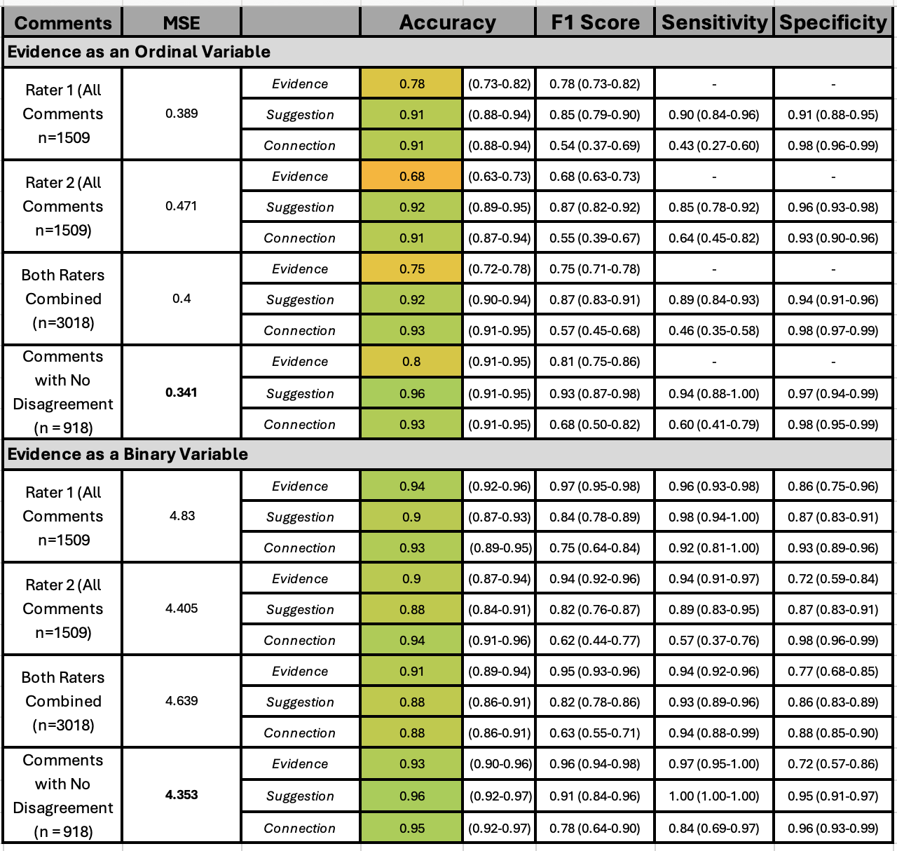
Table 1. Evaluation metrics on the test dataset including Mean Squared Error (MSE) for the total QuAL score, and accuracy, F1 score, specificity and sensitivity for the three outcomes: evidence (0-3) or binary (0/1), suggestion (0/1) and connection (0/1). Results are shown for the four alternate comment subsets: Rater 1 only, Rater 2 only, all rater comments, only comments with complete agreement.

Table 1 (Raw). Evaluation metrics on the test dataset including Mean Squared Error (MSE) for the total QuAL score, and accuracy, F1 score, specificity and sensitivity for the three outcomes: evidence (0-3) or binary (0/1), suggestion (0/1) and connection (0/1). Results are shown for the four alternate comment subsets: Rater 1 only, Rater 2 only, all rater comments, comments with agreement.
Comments | MSE |  | Accuracy | F1 Score | Sensitivity | Specificity
Evidence as an Ordinal Variable
Rater 1 (All Comments  n =1509) | 0.389 | Evidence | 0.78 (0.73-0.82) | 0.78 (0.73-0.82) | - | -
Rater 1 (All Comments  n =1509) | 0.389 | Suggestion | 0.91 (0.88-0.94) | 0.85 (0.79-0.90) | 0.90 (0.84-0.96) | 0.91 (0.88-0.95)
Rater 1 (All Comments  n =1509) | 0.389 | Connection | 0.91 (0.88-0.94) | 0.54 (0.37-0.69) | 0.43 (0.27-0.60) | 0.98 (0.96-0.99)
Rater 2 (All Comments  n =1509) | 0.471 | Evidence | 0.68 (0.63-0.73) | 0.68 (0.63-0.73) | - | -
Rater 2 (All Comments  n =1509) | 0.471 | Suggestion | 0.92 (0.89-0.95) | 0.87 (0.82-0.92) | 0.85 (0.78-0.92) | 0.96 (0.93-0.98)
Rater 2 (All Comments  n =1509) | 0.471 | Connection | 0.91 (0.87-0.94) | 0.55 (0.39-0.67) | 0.64 (0.45-0.82) | 0.93 (0.90-0.96)
Both Raters Combined  (n = 3018) | 0.400 | Evidence | 0.75 (0.72-0.78) | 0.75 (0.71-0.78) | - | -
Both Raters Combined  (n = 3018) | 0.400 | Suggestion | 0.92 (0.90-0.94) | 0.87 (0.83-0.91) | 0.89 (0.84-0.93) | 0.94 (0.91-0.96)
Both Raters Combined  (n = 3018) | 0.400 | Connection | 0.93 (0.91-0.95) | 0.57 (0.45-0.68) | 0.46 (0.35-0.58) | 0.98 (0.97-0.99)
Comments with No Disagreement (n = 918) | 0.341 | Evidence | 0.80 (0.75-0.85) | 0.81 (0.75-0.86) | - | -
Comments with No Disagreement (n = 918) | 0.341 | Suggestion | 0.96 (0.94-0.98) | 0.93 (0.87-0.98) | 0.94 (0.88-1.00) | 0.97 (0.94-0.99)
Comments with No Disagreement (n = 918) | 0.341 | Connection | 0.93 (0.89-0.96) | 0.68 (0.50-0.82) | 0.60 (0.41-0.79) | 0.98 (0.95-0.99)
Evidence as a Binary Variable
Rater 1 (All Comments  n =1509) | 4.830 | Evidence | 0.94 (0.92-0.96) | 0.97 (0.95-0.98) | 0.96 (0.93-0.98) | 0.86 (0.75-0.96)
Rater 1 (All Comments  n =1509) | 4.830 | Suggestion | 0.90 (0.87-0.93) | 0.84 (0.78-0.89) | 0.98 (0.94-1.00) | 0.87 (0.83-0.91)
Rater 1 (All Comments  n =1509) | 4.830 | Connection | 0.93 (0.89-0.95) | 0.75 (0.64-0.84) | 0.92 (0.81-1.00) | 0.93 (0.89-0.96)
Rater 2 (All Comments  n =1509) | 4.405 | Evidence | 0.90 (0.87-0.94) | 0.94 (0.92-0.96) | 0.94 (0.91-0.97) | 0.72 (0.59-0.84)
Rater 2 (All Comments  n =1509) | 4.405 | Suggestion | 0.88 (0.84-0.91) | 0.82 (0.76-0.87) | 0.89 (0.83-0.95) | 0.87 (0.83-0.91)
Rater 2 (All Comments  n =1509) | 4.405 | Connection | 0.94 (0.91-0.96) | 0.62 (0.44-0.77) | 0.57 (0.37-0.76) | 0.98 (0.96-0.99)
Both Raters Combined  (n = 3018) | 4.639 | Evidence | 0.91 (0.89-0.94) | 0.95 (0.93-0.96) | 0.94 (0.92-0.96) | 0.77 (0.68-0.85)
Both Raters Combined  (n = 3018) | 4.639 | Suggestion | 0.88 (0.86-0.91) | 0.82 (0.78-0.86) | 0.93 (0.89-0.96) | 0.86 (0.83-0.89)
Both Raters Combined  (n = 3018) | 4.639 | Connection | 0.88 (0.86-0.91) | 0.63 (0.55-0.71) | 0.94 (0.88-0.99) | 0.88 (0.85-0.90)
Comments with No Disagreement (n = 918) | 4.353 | Evidence | 0.93 (0.90-0.96) | 0.96 (0.94-0.98) | 0.97 (0.95-1.00) | 0.72 (0.57-0.86)
Comments with No Disagreement (n = 918) | 4.353 | Suggestion | 0.96 (0.92-0.97) | 0.91 (0.84-0.96) | 1.00 (1.00-1.00) | 0.95 (0.91-0.97)
Comments with No Disagreement (n = 918) | 4.353 | Connection | 0.95 (0.92-0.97) | 0.78 (0.64-0.90) | 0.84 (0.69-0.97) | 0.96 (0.93-0.99)

