Two nested loops iterate through every particle. The particle in the outer loop, $i$, is compared to every other particle $j$ in the inner loop. The Euclidean distance between $i$ and $j$ is calculated. If it is smaller than $0.01$, the particles are merged. The resultant particle $p$ has mass equal to $m_{i}+m_{j}$; the velocity of $p$ is calculated using classical mechanics as if $i$ and $j$ had collided. Various pointers are decremented to remove $j$. If the two particles do not merge, the force they exert on each other is calculated. Once all particles have been considered, a second loop updates the position and velocity of each particle using the calculated forces.

In this simulation, two collisions occur. Timesteps were in the range $\left[9.9×{10}^{-9}, 7.3×{10}^{-6}\right]$, with the latter the largest timestep to yield collision points. The accuracy of the simulation is measured using the Euclidean distance between the first and second collision points, $d$. Results are plotted below. It is clear that $d$*does* converge, to approximately $0.7565$, and that a timestep of approximately $1×{10}^{-7}$ is sufficient to achieve this.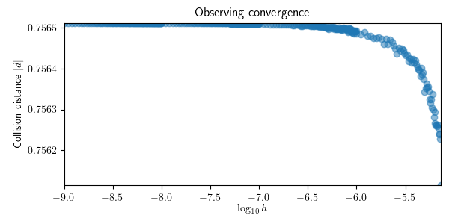

The order of convergence $p$ can be calculated using the difference between two errors of different timesteps $h$ and $\frac{h}{2}$, as ${y_{h}-y}_{\frac{h}{2}}$ can be experimentally measured: $e_{h}-e_{\frac{h}{2}}={y_{h}-y}_{\frac{h}{2}}= C\left(1-\frac{1}{2^{p}}\right)∙h^{p}$. Using an initial value $h= 7.3×{10}^{-6}$, below is plotted the distance $|d|$ between the second collision points at timesteps $h$ and $\frac{h}{2}$ against $h$. Fitting a curve to the data using results in values of $p≈1.98$ and $C≈1.9×{10}^{7}$.

