Practical-1

Practical Title: Project Initiation, Requirement Analysis, Sitemap, Wireframe, and GitHub Setup
Problem Definition: Initiate the semester-long Student Hub portal by identifying the problem scope, user roles, key modules, navigation flow, and minimum 10 pages. Create a sitemap, low-fidelity wireframe, project folder structure, README file, and GitHub repository.
A. Theory
1. What is URL and parts of URL?
Answer:
A URL (Uniform Resource Locator) is the address of a web page on the internet. It helps the browser find and open a website.
References: https://www.geeksforgeeks.org/computer-networks/components-of-url/ https://www.ibm.com/think/topics/url

- How does HTML file process in web browser?
Answer:
When we enter a URL, the browser requests the HTML file from the server. The browser reads the HTML code, loads CSS and JavaScript, and then displays the webpage on the screen. References:
https://www.cloudflare.com/learning/serverless/glossary/client-side-rendering/ https://www.geeksforgeeks.org/web-tech/how-does-a-web-browser-work/

- How will page navigation flow managed among all HTML pages?
Answer:
Every page has navigation links that connect to other HTML pages.
References: https://www.w3schools.com/html/html_links.asp https://www.geeksforgeeks.org/html/html-links/

- How will GitHub commits be maintained after each practical?
Answer:
After completing each practical, the updated files will be saved, committed, and pushed to GitHub with a clear commit message.
References: https://docs.github.com/en/get-started/using-git/about-git https://www.w3schools.com/git/git_commit.asp

- Implementation/ Output/Result Key Modules
Home - Login - Dashboard – Profile – Courses - Attendance - Assignments - Results Timetable - Notifications – Settings.

- Evidence of Work (Screenshots)
Description: figure 1.1 sitemap of student portal :
The Student Hub Portal sitemap shows the overall navigation structure of the website. It starts with the Home Page, followed by the Login Page, where students access the portal. After login, the Main Menu provides access to Dashboard, Profile, Courses, Attendance, Assignments, Results, Timetable, Notifications, and Settings. The Dashboard also provides quick links to Library, Course Materials, Fee Payment, Academic Calendar, Support, and Transcripts.

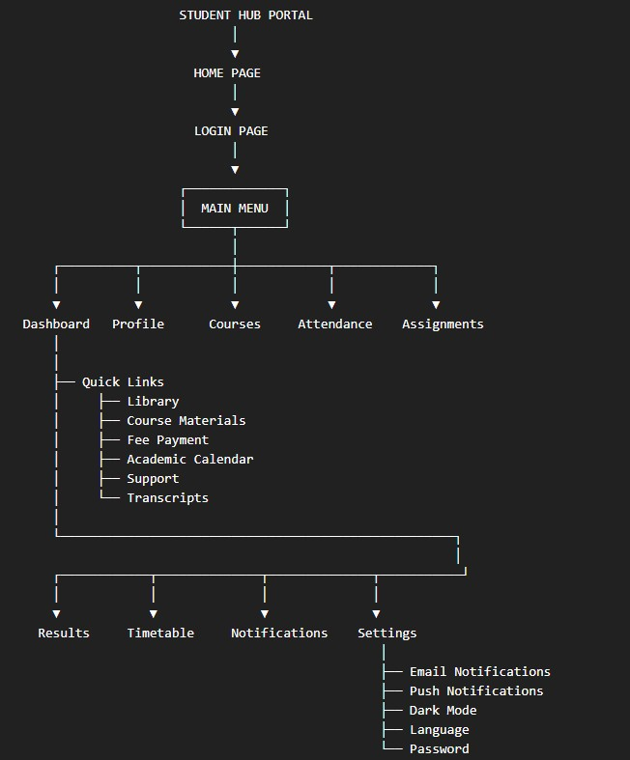

Description: figure 1.2 home page :
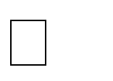
- The Home Page is the starting point of the Student Hub Portal.
- It provides access to the student login.
- Students can enter their Student ID and password.
- It provides navigation to the main portal.
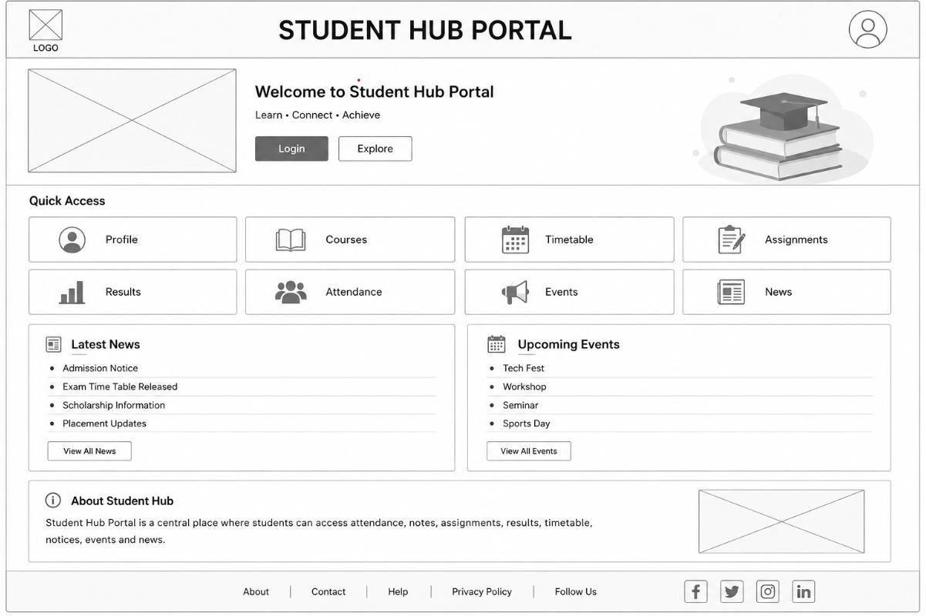

Description: figure 1.3 Login page :
  - The Login Page allows students to sign in to the portal.
  - It contains Student ID and Password fields.
  - Students can select Remember Me and use the Login option.
  - A Forgot Password option is also provided.

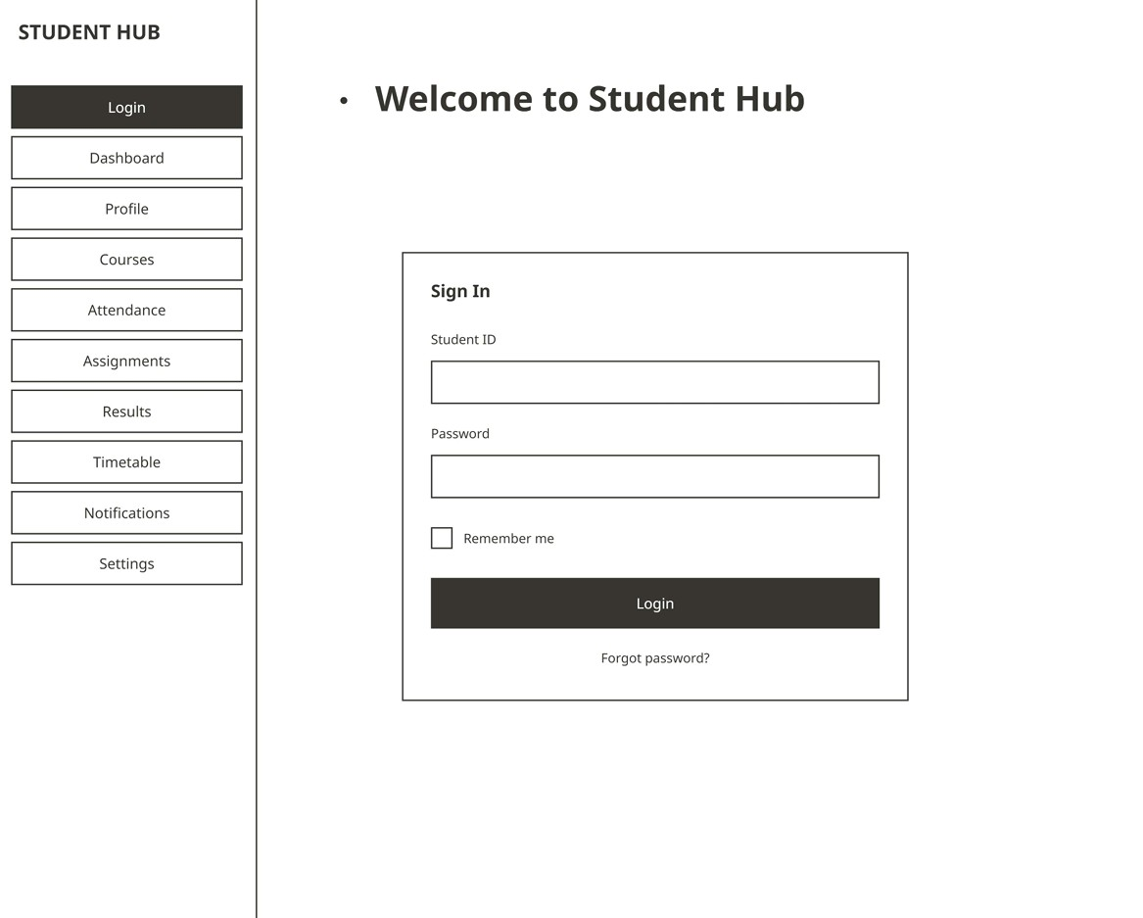

Description: figure 1.4 Dashboard page :
  - The Dashboard provides an overview of important student information.
  - It shows Courses, Attendance, Assignments, and Results.
  - It also displays important notifications.
  - Quick Links include Library, Course Materials, Fee Payment, Academic Calendar, Support, and Transcripts.

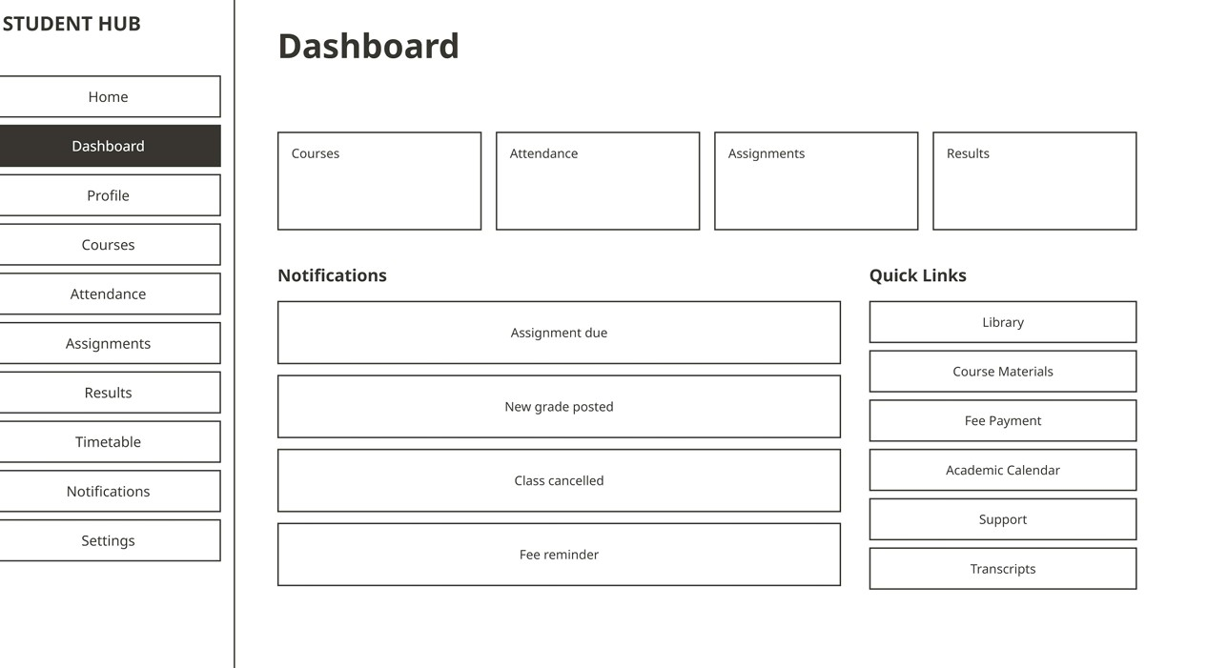
Description: figure 1.5 profile page :
- The Profile Page displays the student's personal information.
- It contains Name, Email, Phone, Student ID, and Address.
- Academic information includes Branch, Year, and Semester.
- An Edit option is provided to update the information.
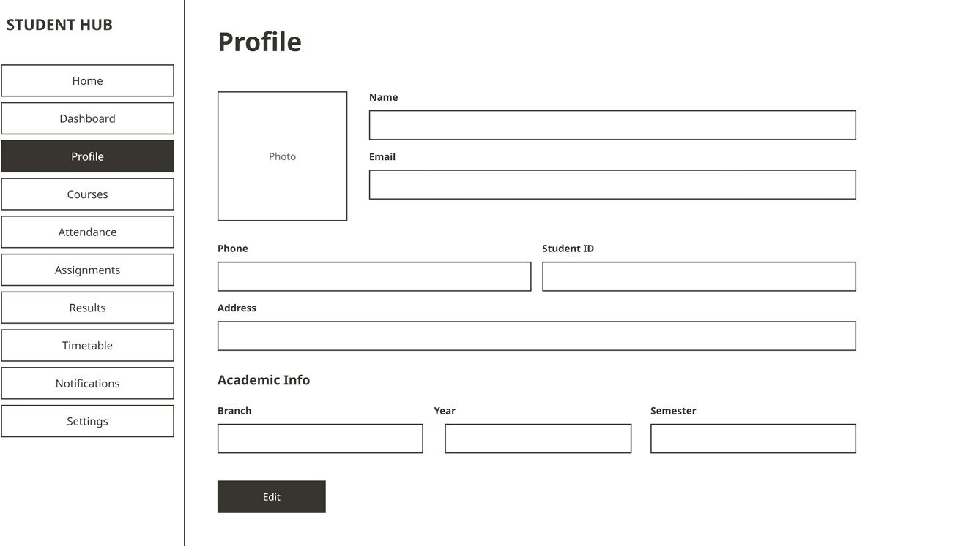
Description: figure 1.6 Courses page :
- The Courses Page displays the student's enrolled courses.
- It provides separate sections/cards for course information.
- Students can view their available academic courses.
- It helps students easily access their course details.

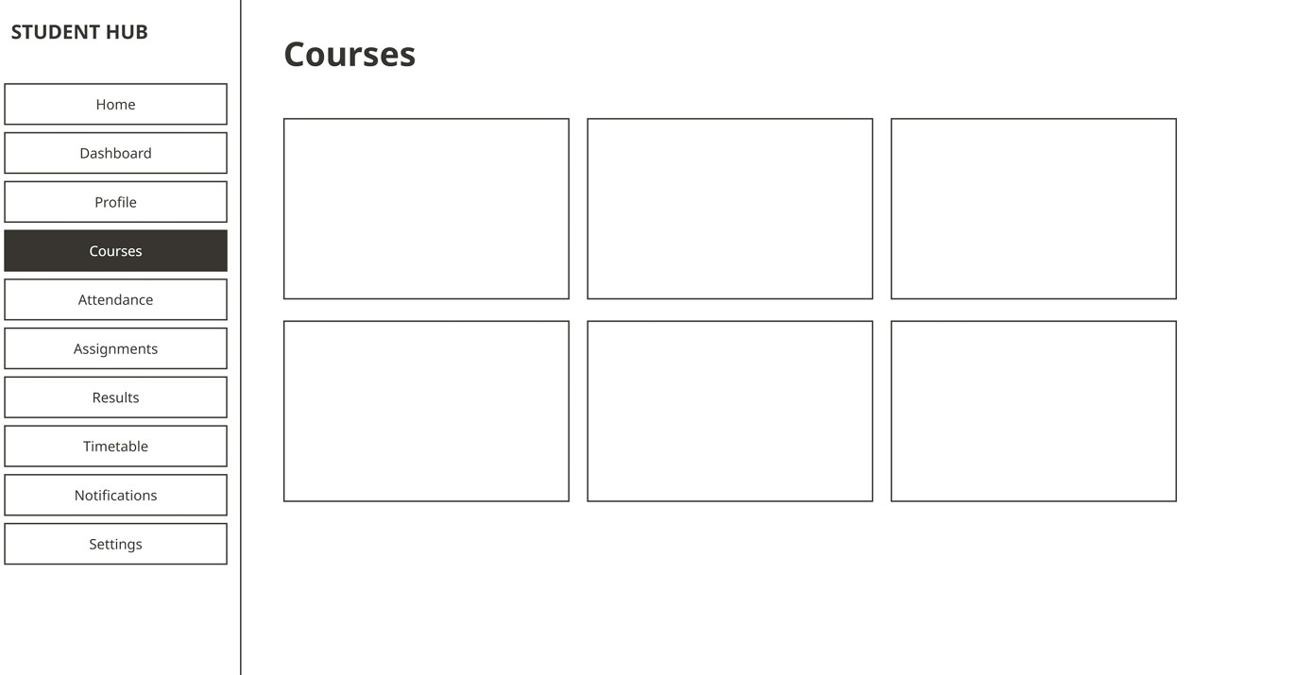
Description: figure 1.7 attendance page :
- The Attendance Page displays the student's attendance information.
- It shows the Overall Attendance percentage.
- Course-wise attendance is displayed with attended information and percentage.
- It helps students monitor their attendance.

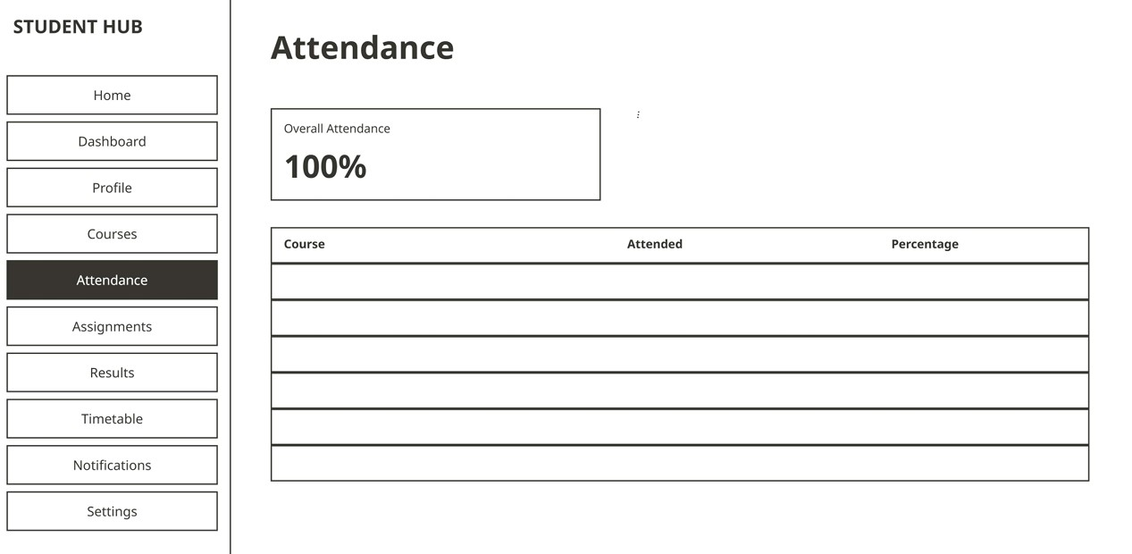

Description: figure 1.8 assignments page :
- The Assignments Page displays academic assignments.
- It contains information such as Title, Due Date, and Status.
- Students can check their assignment deadlines.
- It helps students track their assignment progress.
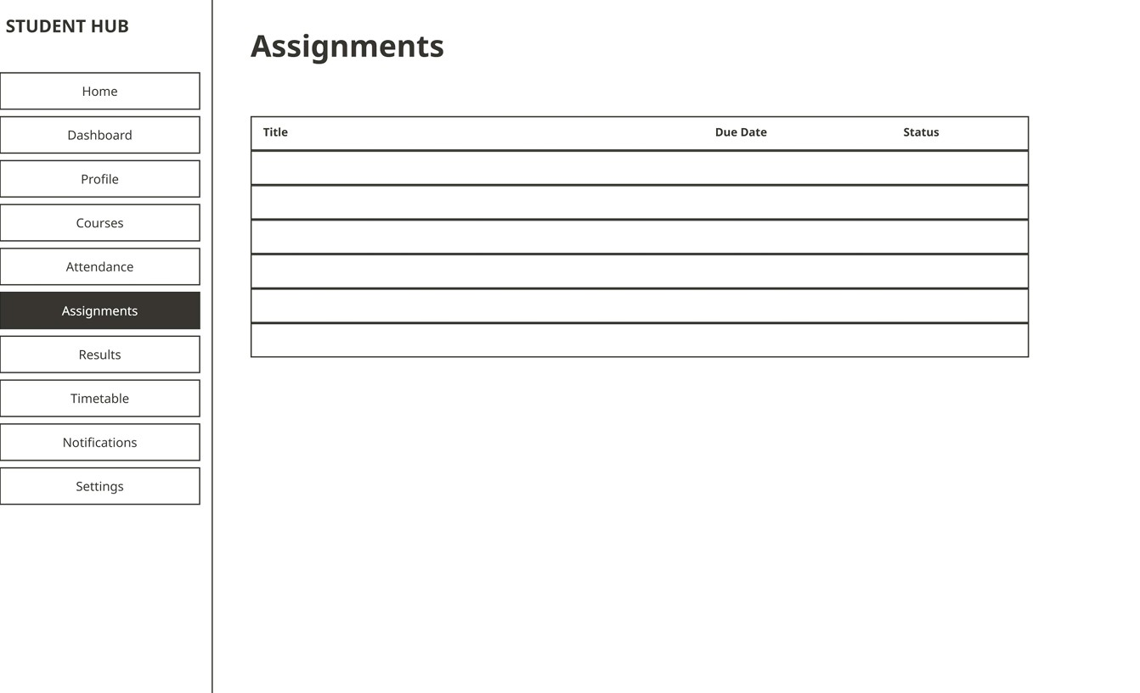

Description: figure 1.9 result page :
- The Results Page displays the student's academic performance.
- Students can select a semester to view results.
- It shows Course, Credits, and Grade information.
- It also displays SGPA and CGPA.
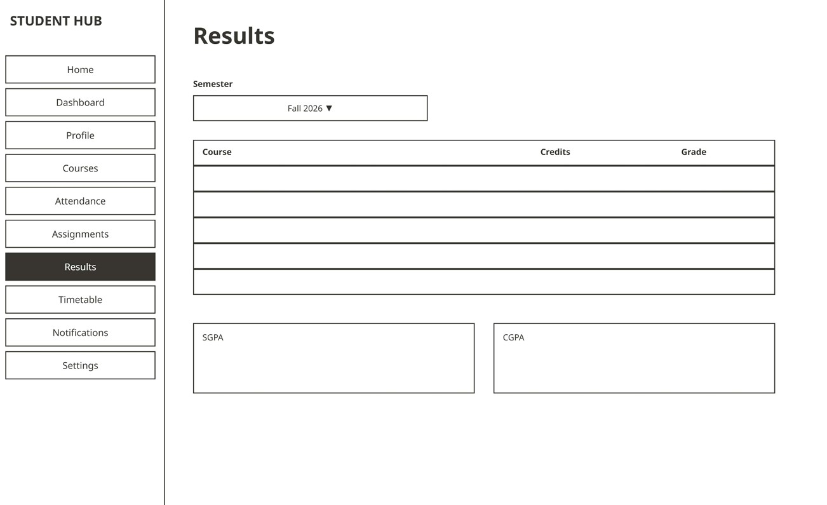

Description: figure 1.10 Time table page :
- The Timetable Page displays the student's class schedule.
- It organizes classes according to time and days.
- The displayed days include Monday to Thursday.
- It helps students know their daily class schedule.

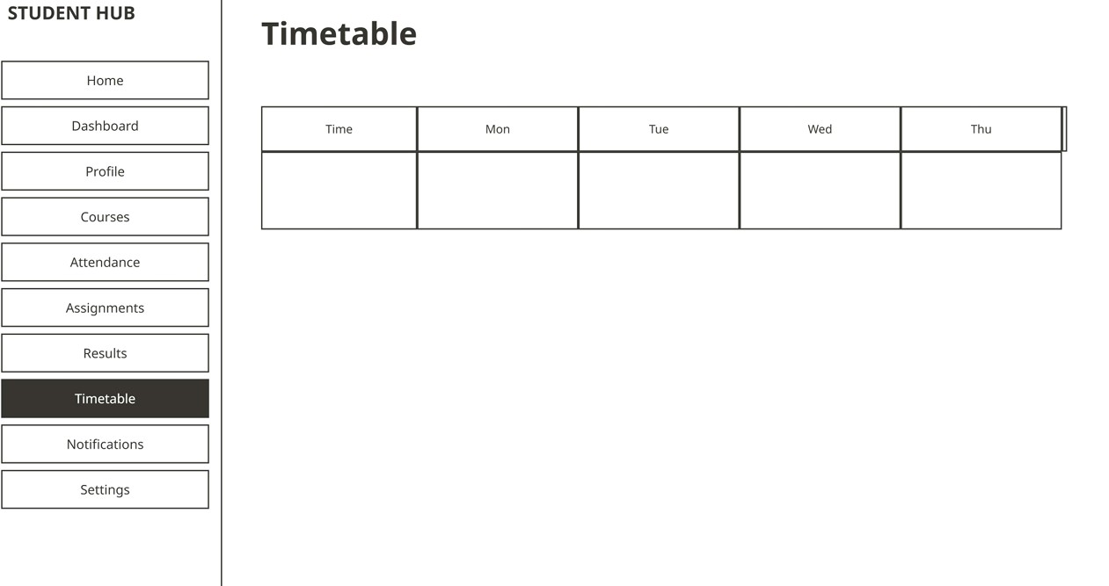

Description: figure 1.11 Notification page :
- The Notifications Page displays important student updates.
- Notifications include Assignment due dates.
- It also shows new grade posted and class cancelled notifications.
- This page helps students stay informed about important changes.

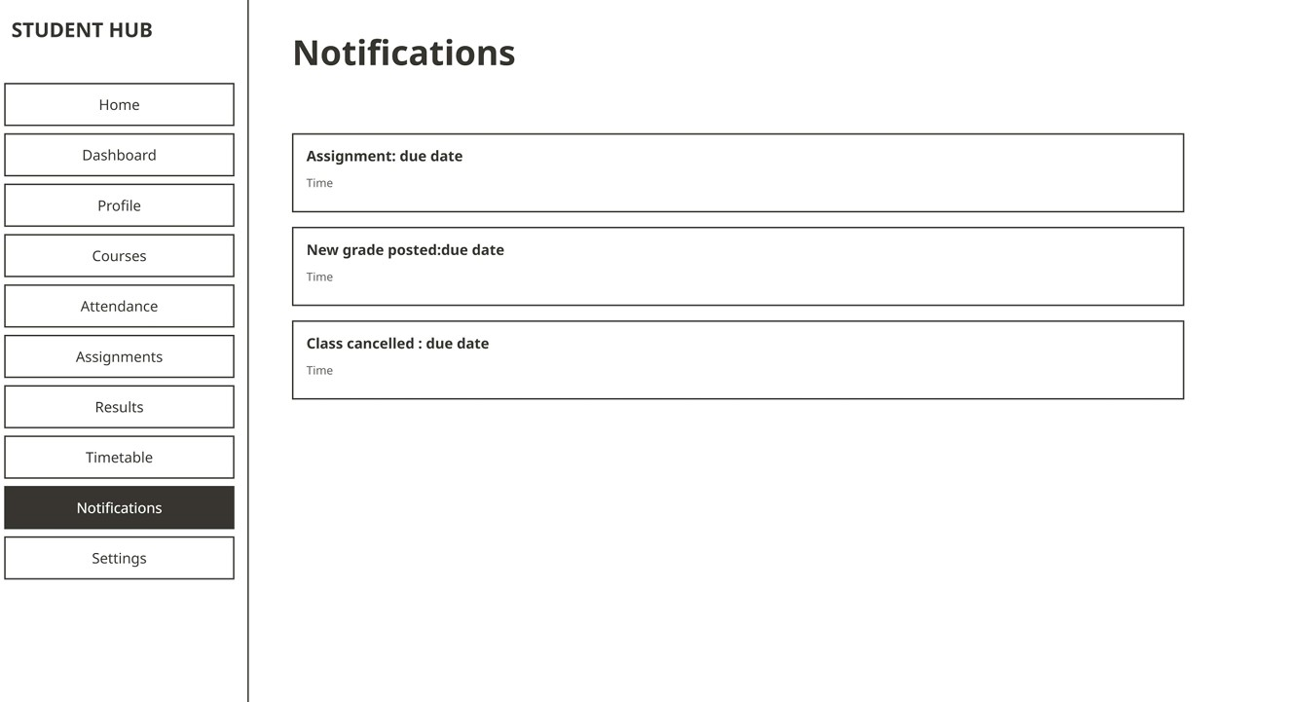
Description: figure 1.12 Settings page :
- The Settings Page allows students to manage portal preferences.
- It includes Email Notifications, Push Notifications, and Dark Mode.
- Students can change the Language and Password.
- A Log out option is also provided.

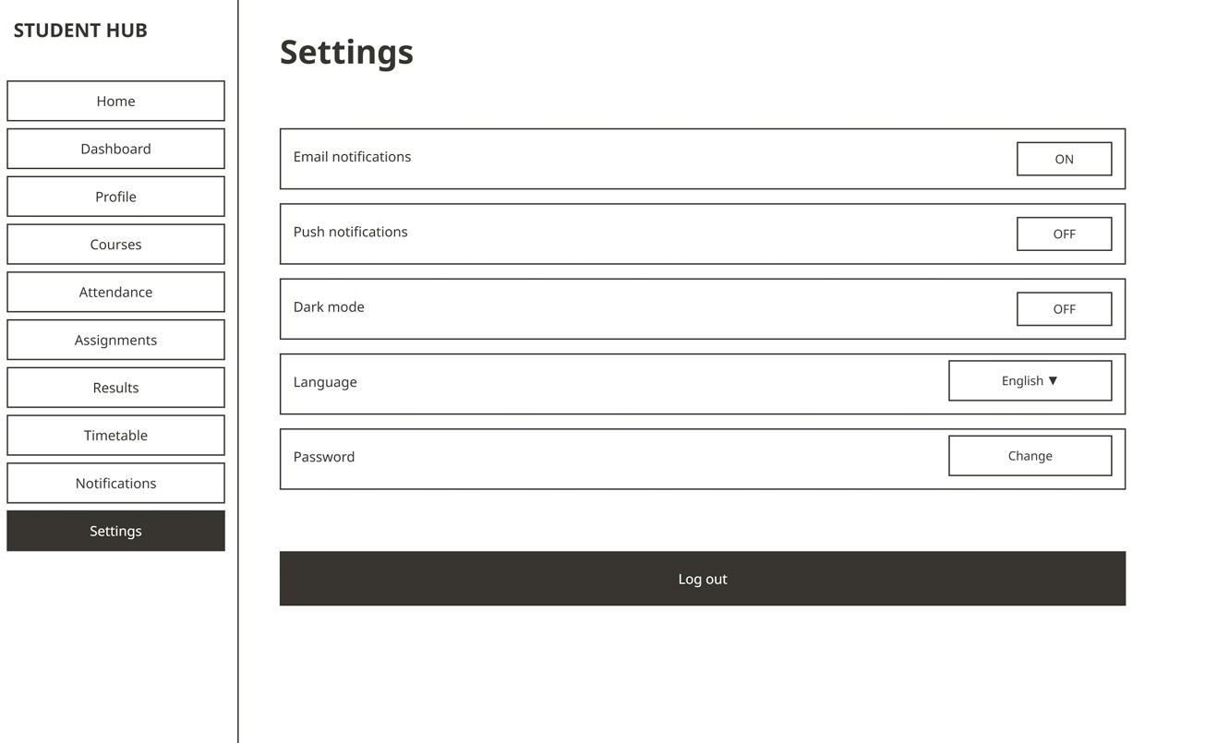

- GitHub Repository Link:
Link: https://github.com/PritTejani7/student-hub

- Challenges Faced:
I have problem in how to make Github Repo. and add my wireframe pdf in my git hub account so I am fixed this problem by asking to AI.

F. Learning Outcomes:
I am learning many things like how to make a wireframe for my practical 1 and how to use a git hub account for my repositories.

Faculty Remarks:

