Practical - 10
Practical Title: Secure Login/Logout with Sessions, Role-Based Access, Timeout, and Remember-Me Token

Problem Definition: Develop secure login and logout functionality using PHP sessions. Verify password using password_verify(), regenerate session ID after login, restrict dashboard access, implement role-based redirection, session timeout, and optional secure remember-me token.

Theory

Are sessions started and destroyed securely?
Answer: Yes, sessions start with session_start() and destroy cleanly via session_unset() and session_destroy().

Is password_verify() used correctly?
Answer: Yes, it verifies raw user input against the stored bcryt password hash.

3. Is unauthorized dashboard access blocked?
Answer: Yes, unauthenticated requests are checked via session variables and redirected to login.php.

4. Is session timeout implemented?
Answer: Yes, timestamps in $_SESSION[‘last_activity’] automatically expire inactive sessions.

5. Are admin and student users redirected to appropriate dashboards?
Answer: Yes, role checks direct users to admin.php or dashboard.php accordingly.

Implementation/ Output/Result

Feature | Implementation
Authentication | Validates password with password_verify()
Sessions | Managed via session_start() and session_destroy()
Access Guard | Redirects unauthorized users to login.php
TImeout | Auto-expires idle sessions using last_activity
Role Routing | Redirects to admin.php or dashboard.php

Evidence of Work (Screenshots)

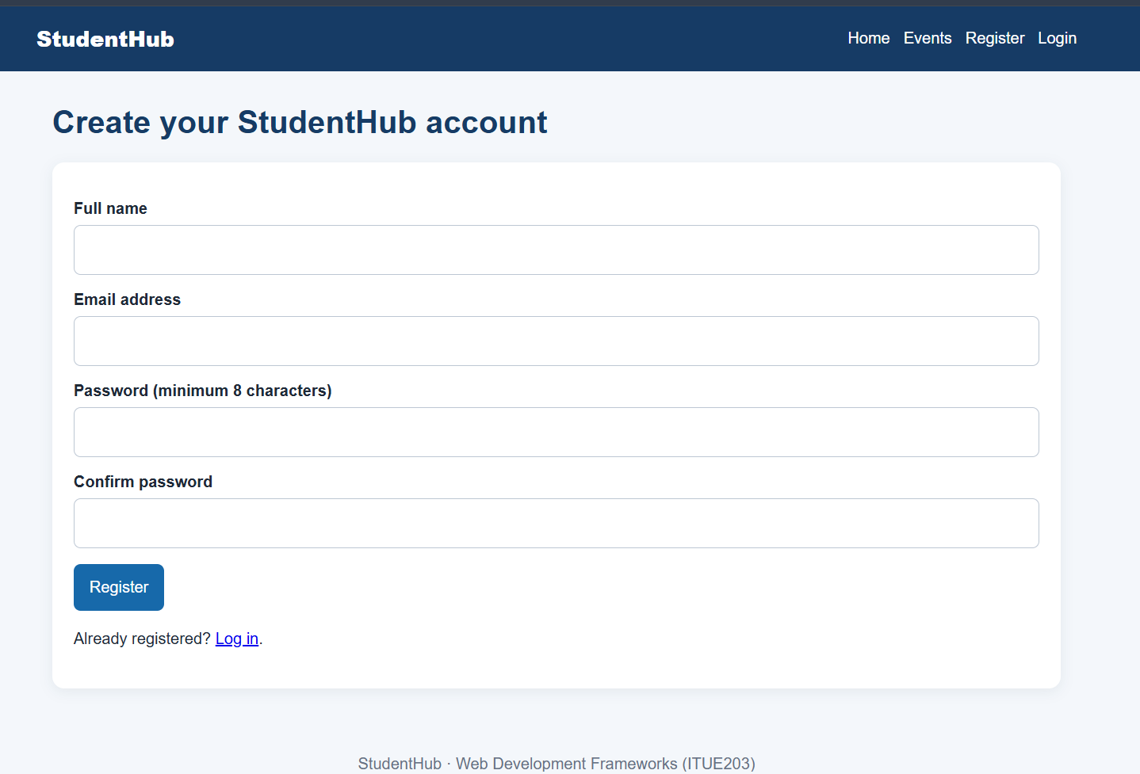
Description: Figure 10.1 login page

GitHub Repository Link:

https://github.com/PritTejani7/student-hub

Challenges Faced:
Handling session hijacking, fixation vulnerabilities, and cookie parameter tampering across browsers.

Learning Outcome:
I learned how to implement login/logout with secure session management.

Faculty Remarks: (Keep this blank for faculty)

