Practical - 12
Practical Title: Event Management CRUD with Poster Upload and File Validation

Problem Definition: Develop event management functionality for admin users. Admin can add, view, update, delete, and upload event posters with file type and file size validation.

Theory

Are add, update, and delete functionalities implemented correctly?
Answer: Yes, all event mutation actions are executed via MySQLi queries with database persistence.

Is the UI linked with the database correctly?
Answer: Yes, form controls and tables render and submit directly to MySQL database records.

3. Are poster uploads validated for type and size?
Answer: Yes, file extensions check restricts to JPG/PNG and limits size to 2MB.

4. Are success and failure messages displayed?
Answer: Yes, dynamic success and error notice bars display after every operation.

Implementation/ Output/Result

Feature | Implementation
Event CRUD | Full add, edit, list, and delete operations via MySQLi
Type check | Restricts uploads to JPEG and PNG extensions.
Size check | Rejects image files larger than 2MB.
Storage | Saves files to uploads/ with unique filenames.
Feedback | Displays success and error message alerts.

Evidence of Work (Screenshots)

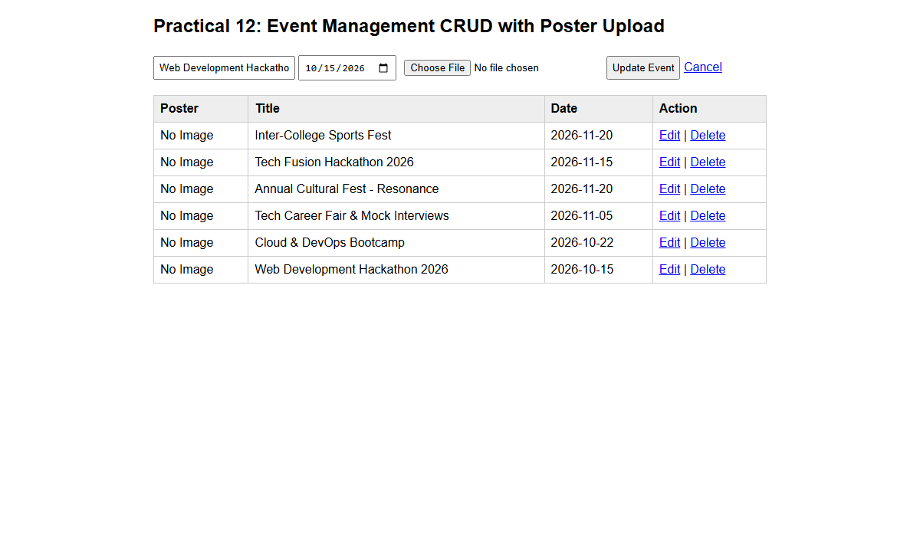
Description: Figure 12.1 events list, edit and upload

GitHub Repository Link:

https://github.com/PritTejani7/student-hub

Challenges Faced:
Validating actual file MIME types securely while removing orphaned images on update/delete.

Learning Outcome:
I learned how to implement a secure CRUD module with validated file upload.

Faculty Remarks: (Keep this blank for faculty)

