Practical - 13
Practical Title: PHP JSON API and AJAX/Fetch-Based CRUD without Page Reload

Problem Definition: Create simple PHP JSON API endpoints for events or students and consume them using Fetch API. Perform list, add, update, and delete operations asynchronously without full page reload.

Theory

Do PHP endpoints return valid JSON responses?
Answer: Yes, backend sets Content-Type: application/json and returns responses via json_encode().

Are GET and POST requests handled properly?
Answer: Yes, $_SERVER[‘REQUEST_METHOD’] routes GET, POST, PUT, and DELETE requests.

3. Are loading, success, and error states shown on the frontend?
Answer: Yes, the frontend dynamically reflects data loading, success messages, error alerts.

4. Is input validation performed before database operations?
Answer: Yes, empty and invalid payload values are rejected before executing queries.

Implementation/ Output/Result

Feature | Implementation
JSON API | Returns json_encode() based on HTTP method
GET (List) | Fetches records via fetch() and updates
POST (Add) | Sends JSON payload asynchronously to api.php
PUT (Edit) | Updates record via HTTP PUT without reload
DELETE | Removes record asynchronously using HTTP DELETE.

Evidence of Work (Screenshots)

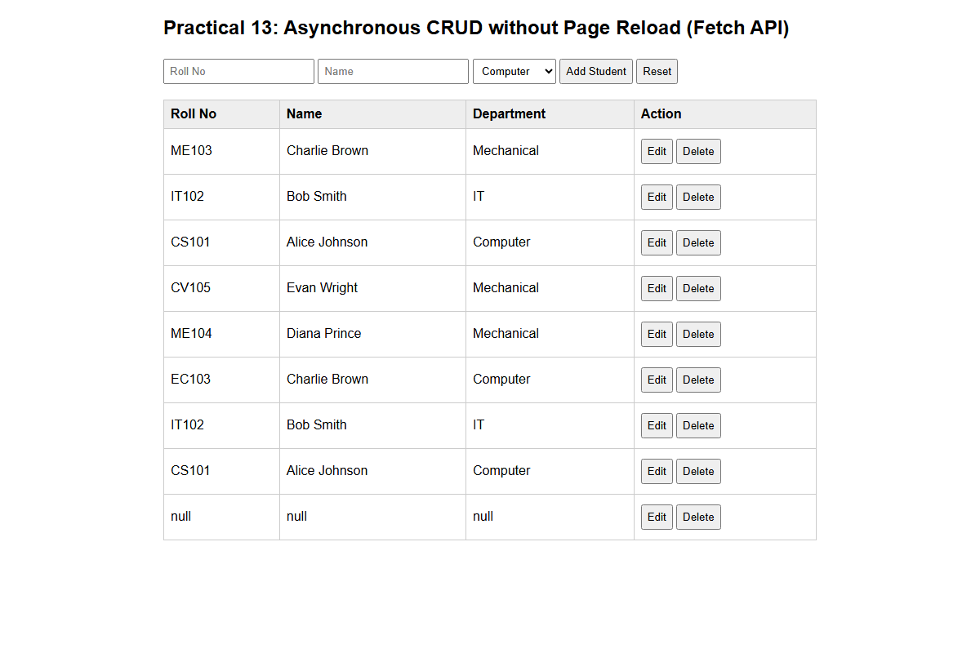
Description: Figure 13.1 asynchronous records

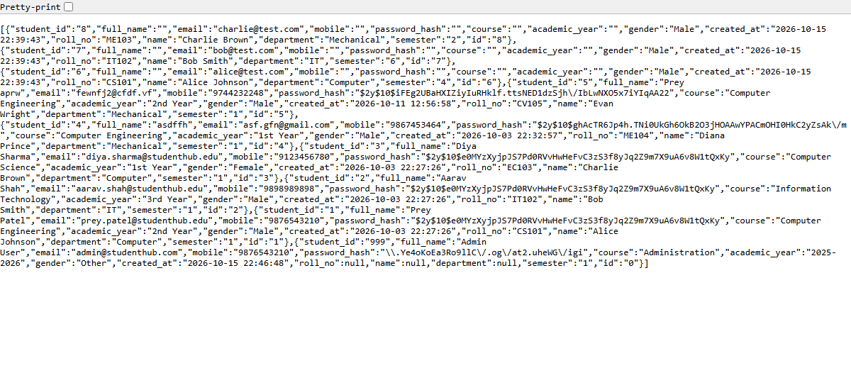
Description: Figure 13.2 json api response

GitHub Repository Link:\

https://github.com/PritTejani7/student-hub

Challenges Faced:
Managing asynchronous race conditions, parsing JSON payloads, and syncing frontend DOM state.

Learning Outcome:
I learned how to integrate frontend JavaScript with PHP backend using JSON APIs.

Faculty Remarks: (Keep this blank for faculty)

