Practical - 14
Practical Title: Admin Dashboard with Role-Based Access Control, Dynamic Menu, and Audit Log

Problem Definition: Develop an admin dashboard that displays user statistics, student count, event count and latest registrations. Restrict access to admin users only and show dynamic menu options based on role.

Theory

Are dashboard values loaded dynamically from the database?
Answer: Yes, counts for students, events, and users are calculated via dynamic COUNT(*) SQL queries.

Is access restricted to admin users?
Answer: Yes, administrative panels and sensitive views are protected behind role checks.

3. Are role-based menus working?
Answer: Yes, navigation elements render conditionally based on the active role (admin, faculty, student).

4. Are important admin actions recorded in audit_logs?
Answer: Yes, user actions, IP addresses, and event details are written into the audit_logs table.

Implementation/ Output/Result

Feature | Implementation
KPI metrics | Counts users, students, and events using COUNT(*).
Recent data | Displays latest 5 registrations using LIMIT 5.
Access control | Restricts sensitive views to the admin role.
Dynamic Menu | Renders links conditionally by session role.
Audit log | Inserts actions and IP addresses into audit_logs.

Evidence of Work (Screenshots)
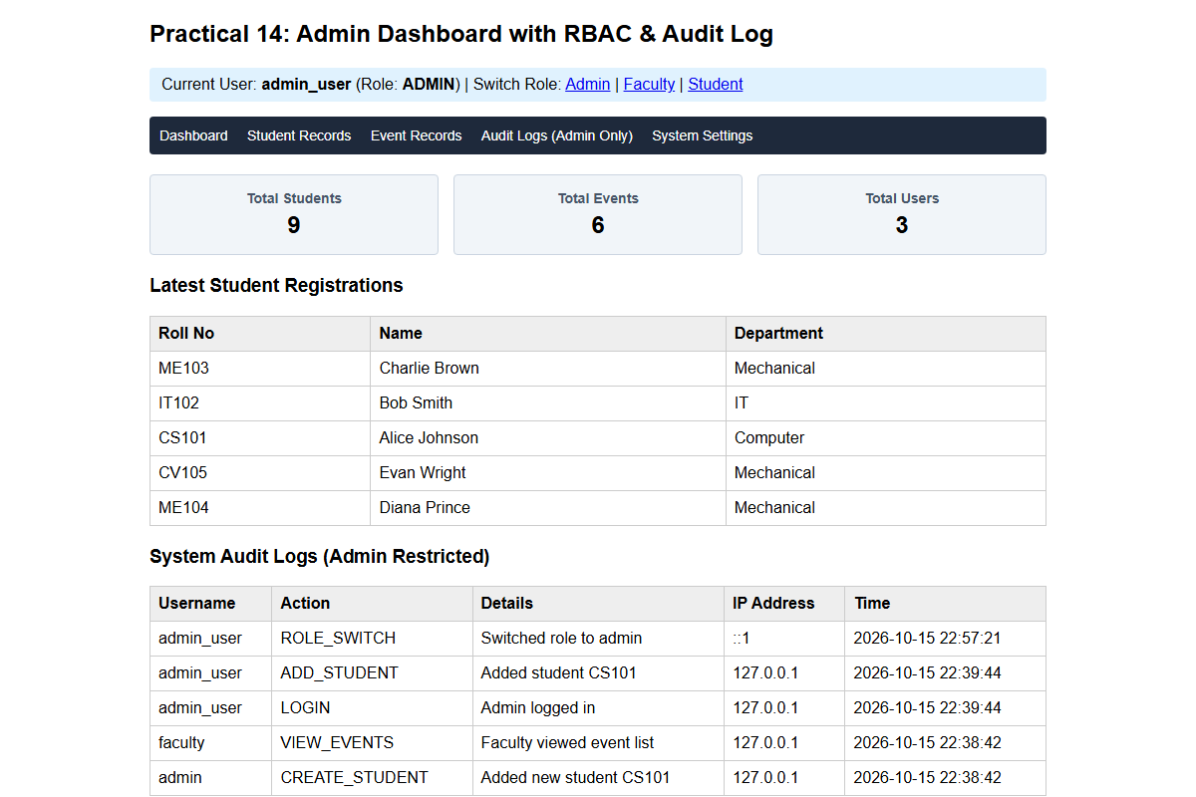
Description: Figure 14.1 admin dashboard with audit log
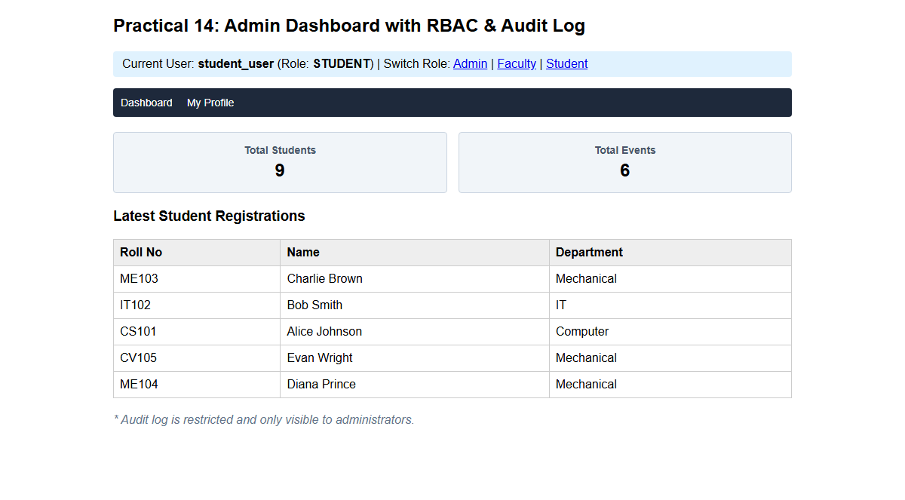
Description: Figure 14.2 student role (restricted)

GitHub Repository Link:

https://github.com/PritTejani7/student-hub

Challenges Faced:
Designing fine-grained privilege matrices without leaving endpoints exposed to URL parameter manipulation.

Learning Outcome:
I learned how to build a role-based admin dashboard with basic monitoring and traceability.

Faculty Remarks: (Keep this blank for faculty)

