Practical-2
Practical Title: Semantic HTML5 Pages with Accessibility-Ready Structure1
Problem Definition: Develop static HTML5 skeletons for at least 10 Student Hub pages such as Home, About, Register, Login, Dashboard, Events, Profile, Contact, Admin, FAQ,and Feedback. Use semantic tags and accessibility-friendly structure.
A. Theory
1. Are semantic tags such as header, nav, main, section, article, aside, and footer used properly?
Answer: Yes, semantic tags like header, nav, main, section and footer are used to arrange the page properly.
References :
https://web.dev/learn/html/semantic-html
2. Are form labels, headings, image alt text, and navigation links accessible?
Answer: Yes, headings, form labels and navigation links are used properly so the pages are easy to use.
References:
https://www.w3schools.com/html/html_accessibility.asp
3. Is the page structure consistent across all pages?
Answer: Yes, all pages have a similar structure with a header, navigation, main content and footer.
References:
https://web.dev/learn/accessibility/navigation

B. Implementation/ Output/Result :
1.Home page html code :
<!DOCTYPE html>
<html lang="en">
<head>
<meta charset="UTF-8">
<meta name="viewport" content="width=device-width, initial-scale=1.0">
<title>Student Hub Portal - Home</title>

<body>

<table border="1" width="100%" cellpadding="30">
<tr>
<td width="80%" align="center">
<h1><b>STUDENT HUB PORTAL</b></h1>
</td>
<td width="20%" align="center">LOGO </td>
</tr>
<tr>
<td colspan="2" >
<h2>Welcome to Student Hub Portal</h2>
<p>Learn • Connect • Achieve</p>
<a href="login.html"><button>Login</button></a>
&nbsp;&nbsp;&nbsp;
<a href="explore.html"><button>Explore</button></a>
</div>
</td>
</tr>
<tr>
<td colspan="2">
<h3>Quick Access</h3>
<table width="100%" border="1" cellpadding="15">
<tr align="center">
<td>Profile</td>
<td>Courses</td>
<td>Timetable</td>
<td>Assignments</td>
</tr>
<tr align="center">
<td>Results</td>
<td>Attendance</td>
<td>Events</td>
<td>News</td>
</tr>
</table>
</td>
</tr>

<tr>
<td width="60%" valign="top">
<h3>Latest News</h3>
<hr>
<ul>
<li>Admission Notice</li>
<li>Exam Time Table Released</li>
<li>Scholarship Information</li>
<li>Placement Updates</li>

</ul>

</td>

<td width="40%" valign="top">

<h3>Upcoming Events</h3>
<hr>
<ul>

<li>Tech Fest</li>
<li>Workshop</li>
<li>Seminar</li>
<li>Sports Day</li>

</ul>
</td>
</tr>
<tr>

<td colspan="2">
<h3>About Student Hub</h3>
<p>

Student Hub Portal is a central place where students can
access attendance, notes, assignments, results,
timetable, notices, events and news.

</p>
</td
</tr>
<tr align="center">

<td colspan="2">
About &nbsp;&nbsp;&nbsp;
Contact &nbsp;&nbsp;&nbsp;
Help &nbsp;&nbsp;&nbsp;
Privacy Policy &nbsp;&nbsp;&nbsp;
Follow Us
</td>

</tr>
</table>
</body>
</html>

2.Login page html code :
<!DOCTYPE html>
<html>
<head>
<meta charset="UTF-8">
<meta name="viewport" content="width=device-width, initial-scale=1.0">
<title>Student Hub - Login</title>

</head>

<body>

<center>
<h1>STUDENT HUB PORTAL</h1>
<h2>Login</h2>
<h3>Sign in to your account</h3>
</center>
<hr>
<br>

<center>
<table border="1" cellpadding="15" width="500">

<tr>
<td>
<!-- Email Input Field -->
<p><label for="email"><b>Email</b></label></p>
<input type="email" id="email" name="email" placeholder="Enter your email" required style="width: 90%; padding: 8px;">
<br><br>

<!-- Password Input Field -->
<p><label for="password"><b>Password</b></label></p>
<input type="password" id="password" name="password" placeholder="Enter your password" required style="width: 90%; padding: 8px;">
<br><br>

<!-- Submit Button styled to submit the form data -->
<!-- Clickable button that links directly to the dashboard -->
<a href="dashboard.html">
<button type="button">Sign In</button>
</a>
<br><br>

<!-- Forgot Password Link -->
<a href="forgot_password.html">Forgot Password?</a>
</td>
</tr>
</table>
</center>
<br>
<hr>
</body>
</html>

B. Evidence of Work (Screenshots) :
Description: figure 2.1 home page :
The Home Page is the main page of the Student Hub Portal.
It provides quick access to important pages like Profile, Courses, Timetable, Assignments, Results, and Attendance.
It also shows latest news and upcoming events for students.
The page gives a simple overview of the Student Hub and helps students easily find important information.

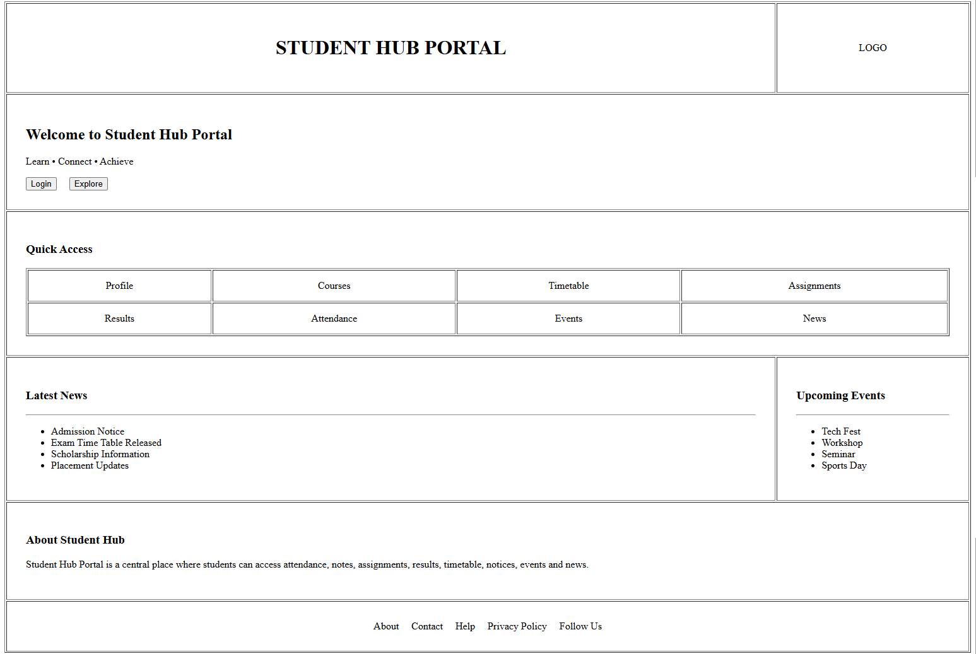

Description: figure 2.2 Login page
The Login Page allows students to access their Student Hub account.
Students enter their email and password to sign in.
It also provides a Forgot Password option for users who cannot remember their password.
After successful login, students can access the portal pages.
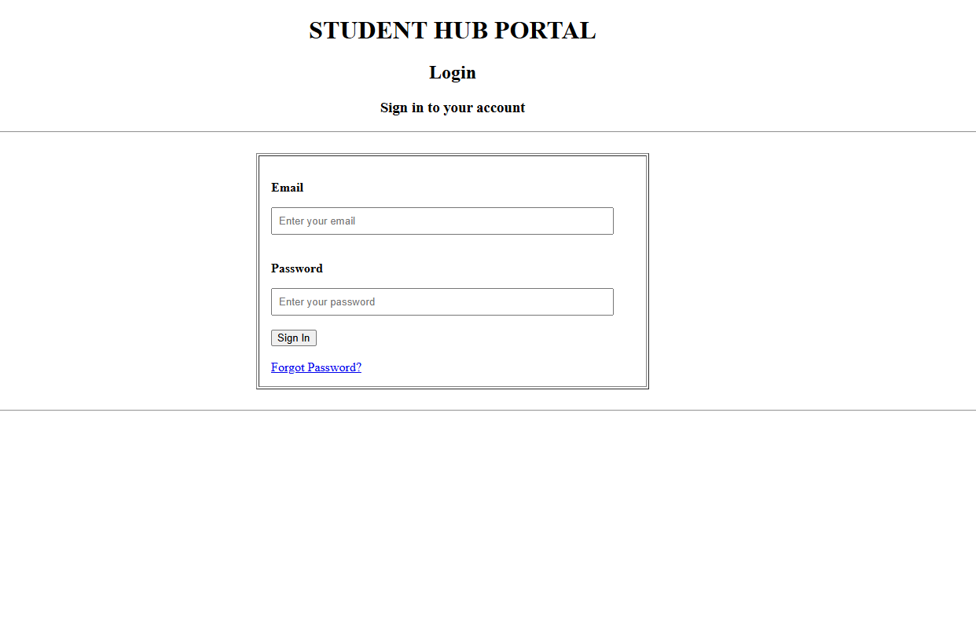

Description: figure 2.3 Dashboard page
The Dashboard Page gives students a quick overview of their important information.
It provides quick access to Courses, Attendance, Assignments, and Results.
It also shows important notifications such as assignment due dates and new grades.
The Quick Links section provides easy access to the library, course materials, fee payment, and academic calendar.
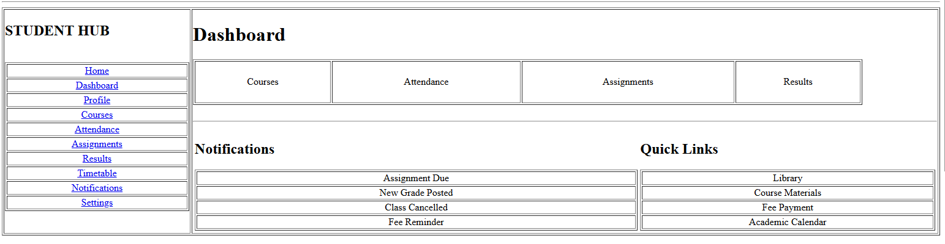

Description: figure 2.4 profile page
The Profile Page displays the student's personal and academic information.
It contains details such as name, email, phone, student ID, address, branch, year, and semester.
A photo section is also provided for the student's profile picture.
The Edit option allows the student to update their information.
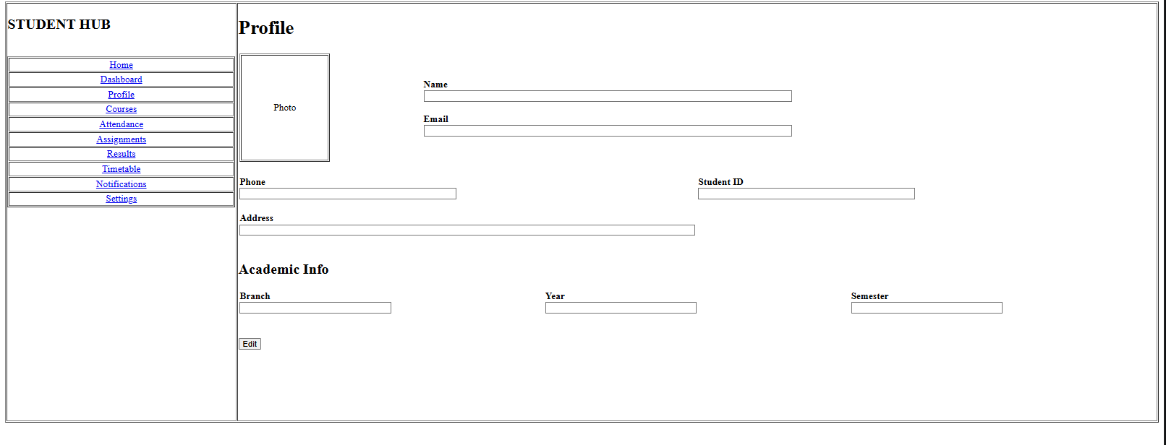

Description: figure 2.5 Courses page
The Courses Page displays all the courses studied by the student.
Each course shows information such as the course code, faculty name, and credits.
Students can easily view their subjects in separate course sections.
This page helps students know their current courses.
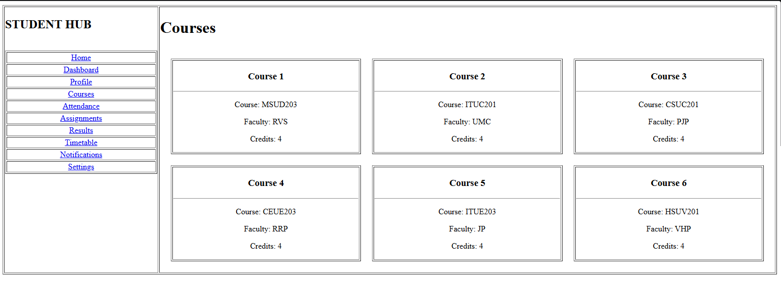

Description: figure 2.6 attendance page
The Attendance Page shows the student's attendance information.
It displays the overall attendance percentage and attendance for each course.
Students can see how many classes they attended and their percentage.
This helps students keep track of their attendance.
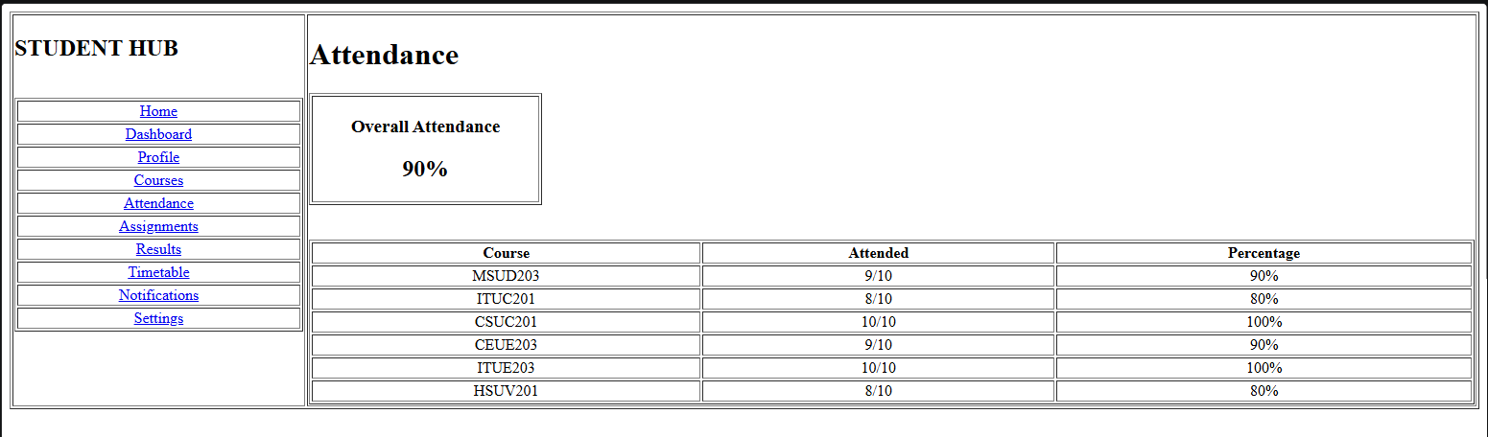

Description: figure 2.7 assignments page
The Assignments Page shows the assignments given to the student.
It includes the assignment title, due date, and current status.
Students can check whether an assignment is pending, submitted, or in progress.
This helps students manage their assignments and deadlines.
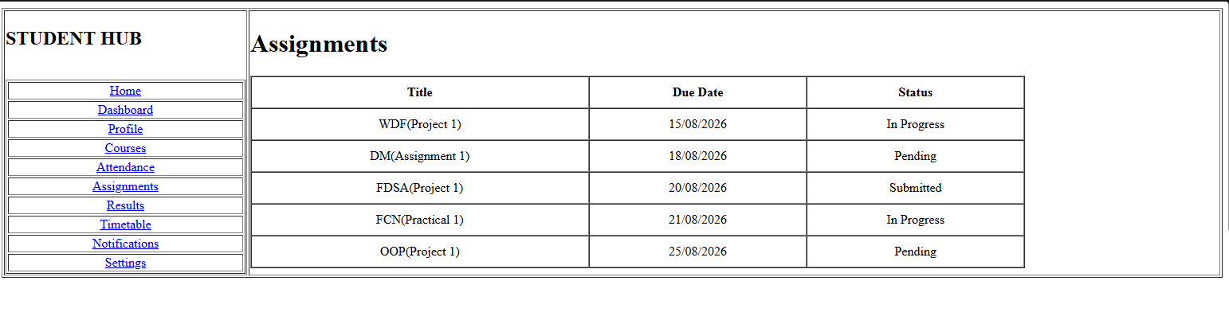

Description: figure 2.8 result page
The Results Page displays the student's academic results.
It shows the course name, credits, and grade for each subject.
It also displays the student's SGPA and CGPA.
Students can select a semester to view the corresponding results.
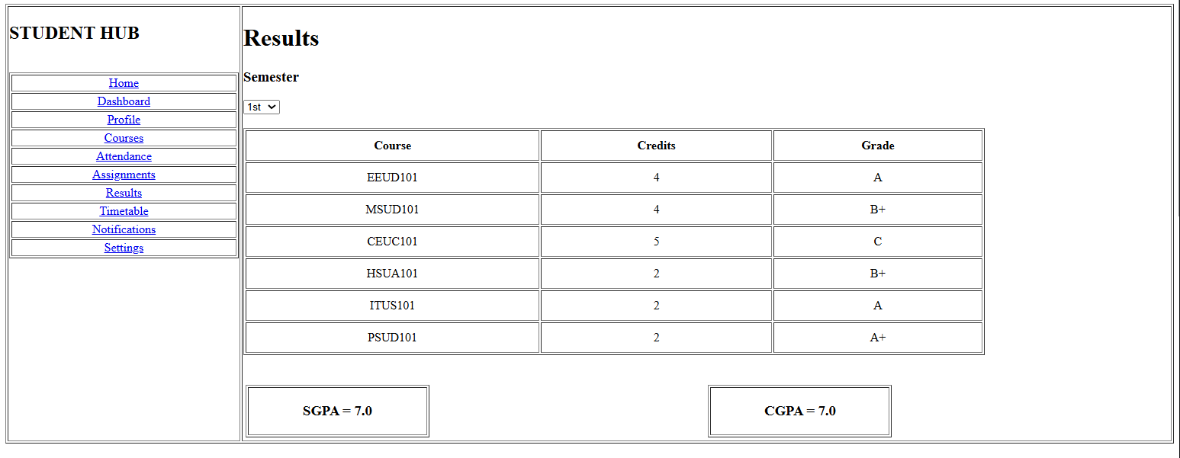

Description: figure 2.9 Time table page
The Timetable Page shows the student's weekly class schedule.
It contains the time, days, course codes, and classroom numbers.
Students can use it to know which class they have and where it is held.
It also shows breaks, counselling sessions, and mentoring sessions.
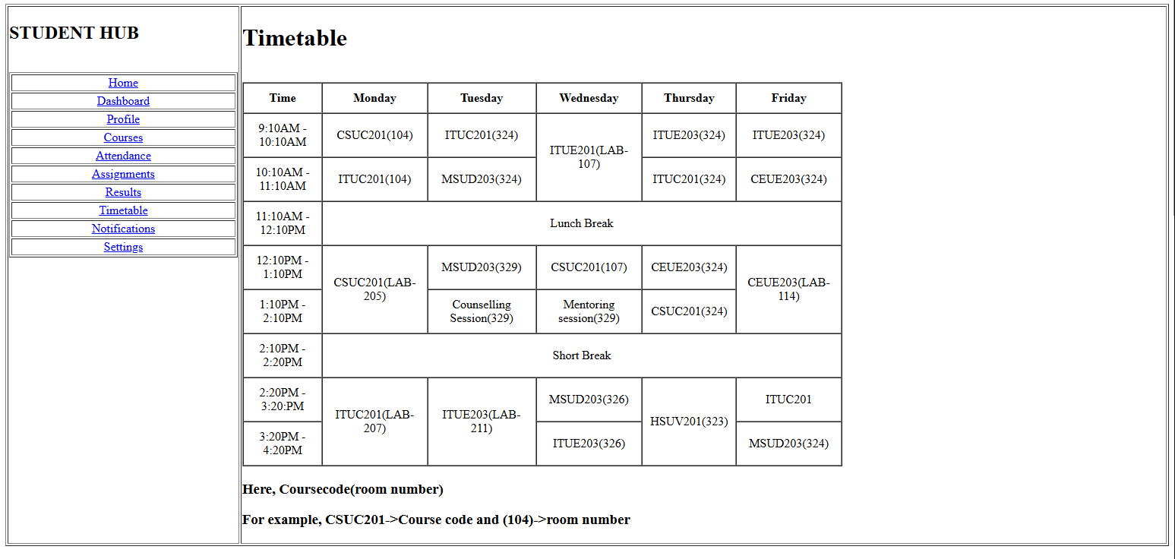

Description: figure 2.10 Notification page
The Notifications Page displays important updates for students.
It can show information about assignment deadlines, new grades, and cancelled classes.
Each notification also shows the time of the update.
This helps students stay informed about important changes.
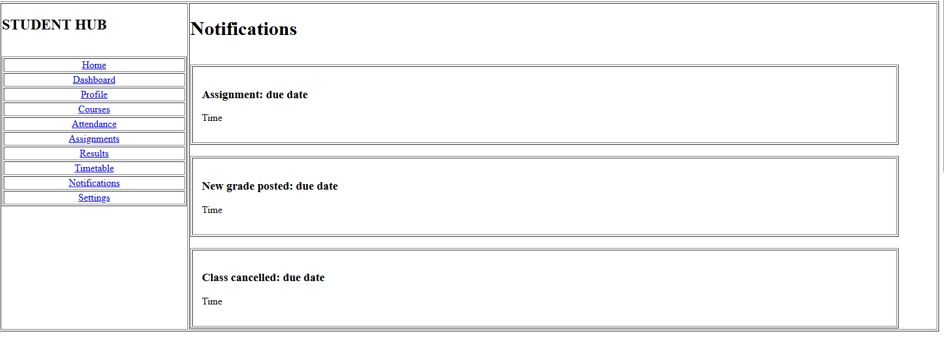

Description: figure 2.11 Settings page
The Settings Page allows students to manage their portal preferences.
Students can control email notifications, push notifications, dark mode, and language.
They can also change their password and log out of the portal.
This page helps students customize and manage their account.
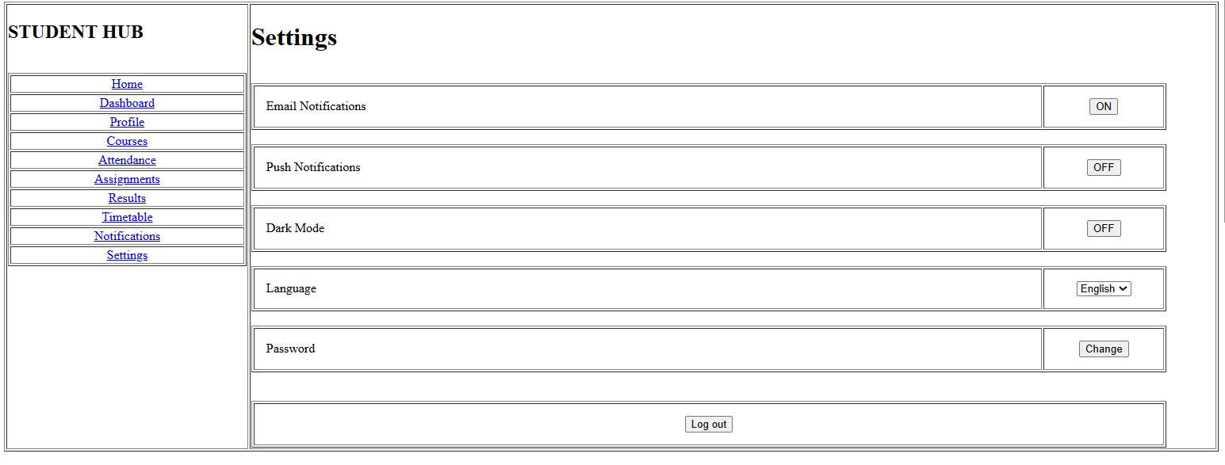

D. GitHub Repository Link:
Link: https://github.com/PritTejani7/student-hub
E. Challenges Faced:
Answer: The main challenge was understanding and using HTML5 tags for me. And I learn how add all 10 pages with each other by navigation of href.
F. Learning Outcomes:
Answer: I learned how to use HTML5 tags properly and where it is use for what purpose. This practical helped me to understand how to create a simple website page.
G. Faculty Remarks:

