Practical – 3

Practical Title: Responsive UI Design using CSS Grid, Flexbox, and Bootstrap/Tailwind

Problem Definition: Design responsive layouts for Home, About, Registration, Dashboard, and Events pages using CSS Grid and Flexbox. Optional to use CSS framework such as Bootstrap or Tailwind. Ensure mobile-first responsiveness.

Theory
- How does the layout adapt for mobile, tablet, and desktop screens?
Answer: The layout uses responsive design so the content adjusts properly to different screen sizes.
References:
https://developer.mozilla.org/en- US/docs/Learn_web_development/Core/CSS_layout/Responsive_Design?

- Which layout technique is used and why?
Answer: CSS Flexbox and Grid are used to arrange content properly and create flexible.
References:

https://developer.mozilla.org/en-US/docs/Learn_web_development/Core/CSS_layout?

- Are the typography, spacing, colors, and contrast readable?
Answer: Yes, readable fonts, proper spacing, and suitable colors and contrast are used for better readability.
References:

https://developer.mozilla.org/en-US/docs/Learn_web_development/Core/Text_styling?

- Is the framework used consistently without unnecessary inline CSS?
Answer: Yes, the framework and CSS styles are used consistently, with minimal unnecessary inline CSS.
References:

https://developer.mozilla.org/en- US/docs/Learn_web_development/Core/Styling_basics?utm_source=chatgpt.com

Implementation/ Output/Result
First, I am making a folder for save all files in one place and add all files into the folder and then I created code of HTML5 only and then I add CSS in the code and run all files into the VS CODE and get a student hub portal as output.

Evidence of Work (Screenshots)

Description: Figure 3.1 Home Page
The Home page provides a simple and user-friendly interface.
It is designed to be responsive on different screen sizes.
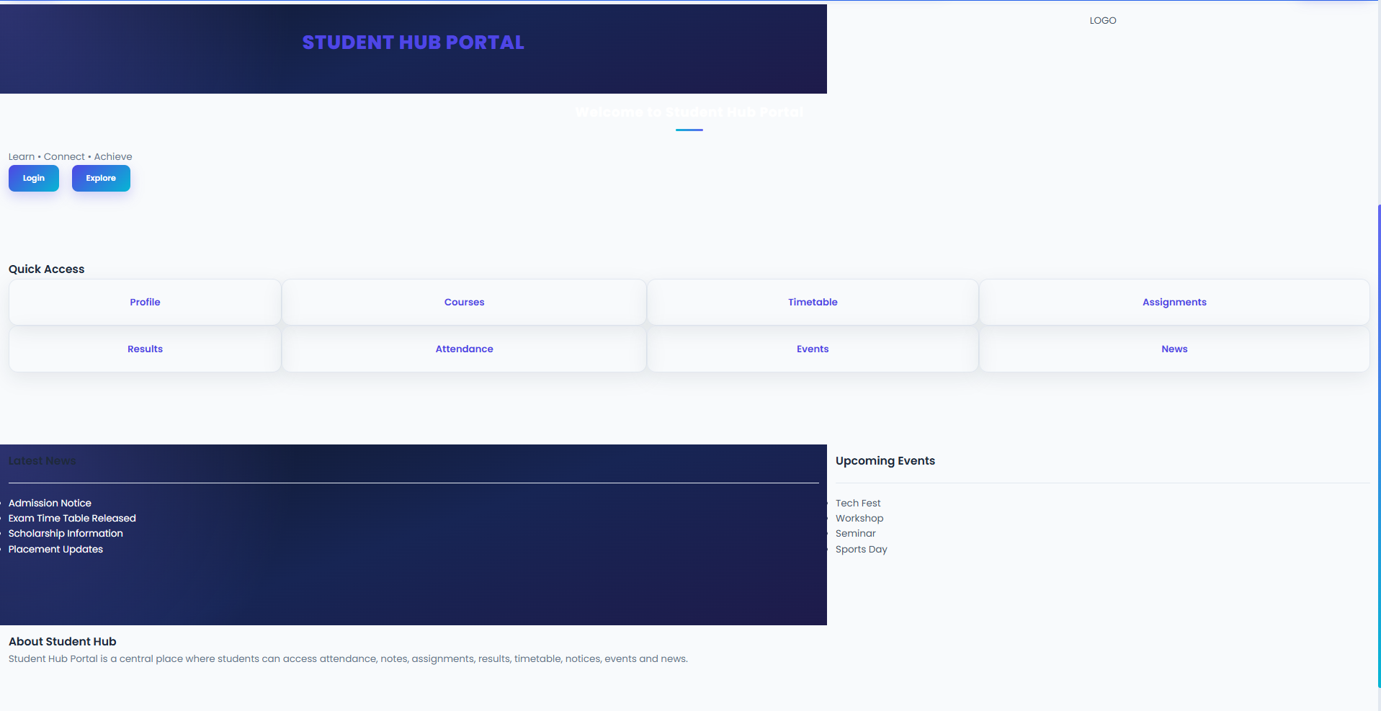

Description: Figure 3.2 Login Page
The Login page allows students to securely enter their login details.
It has a simple and responsive layout for different screen sizes.
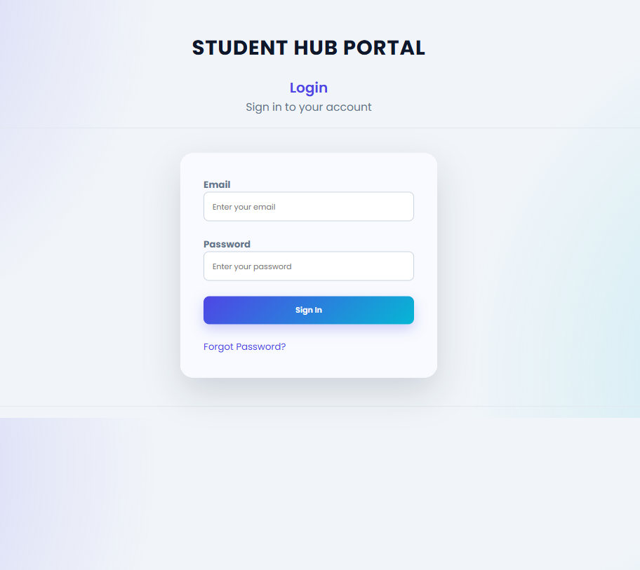

Description: Figure 3.3 Profile Page
The Profile page displays the student's basic information.
It has a simple and responsive layout.
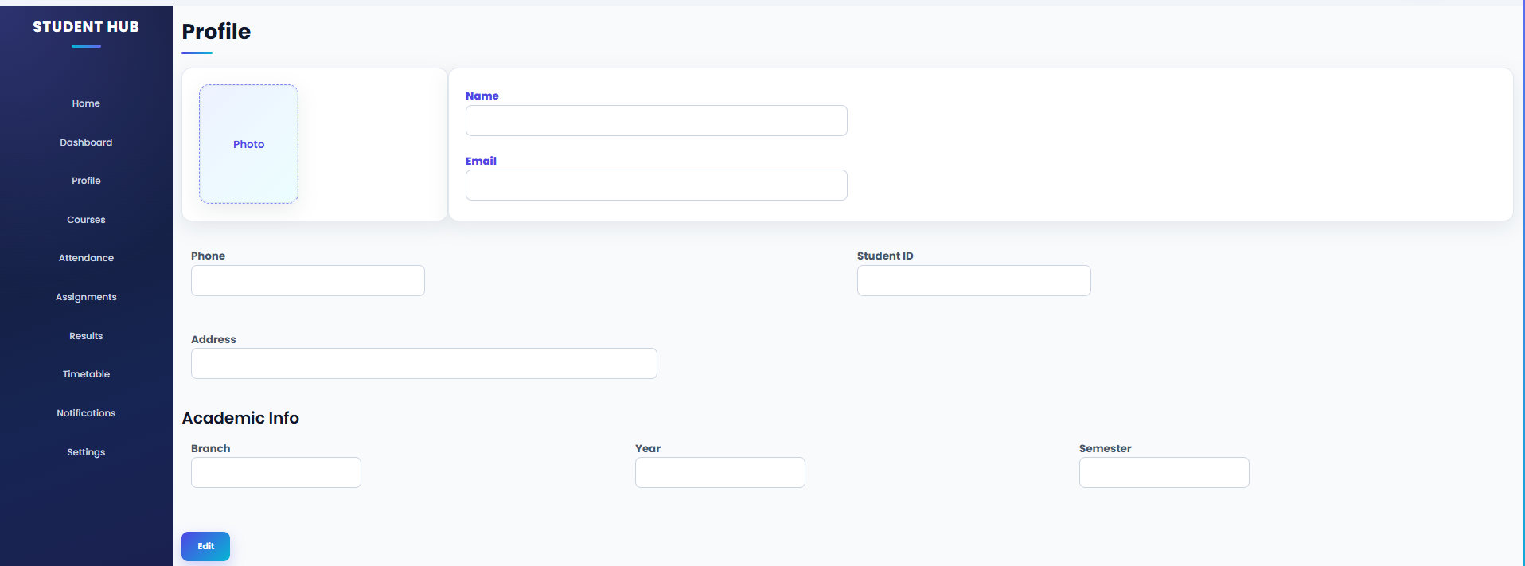

Description: Figure 2.4 Dashboard Page
The Dashboard page shows important student information in one place.
It uses a simple and responsive layout for easy access.
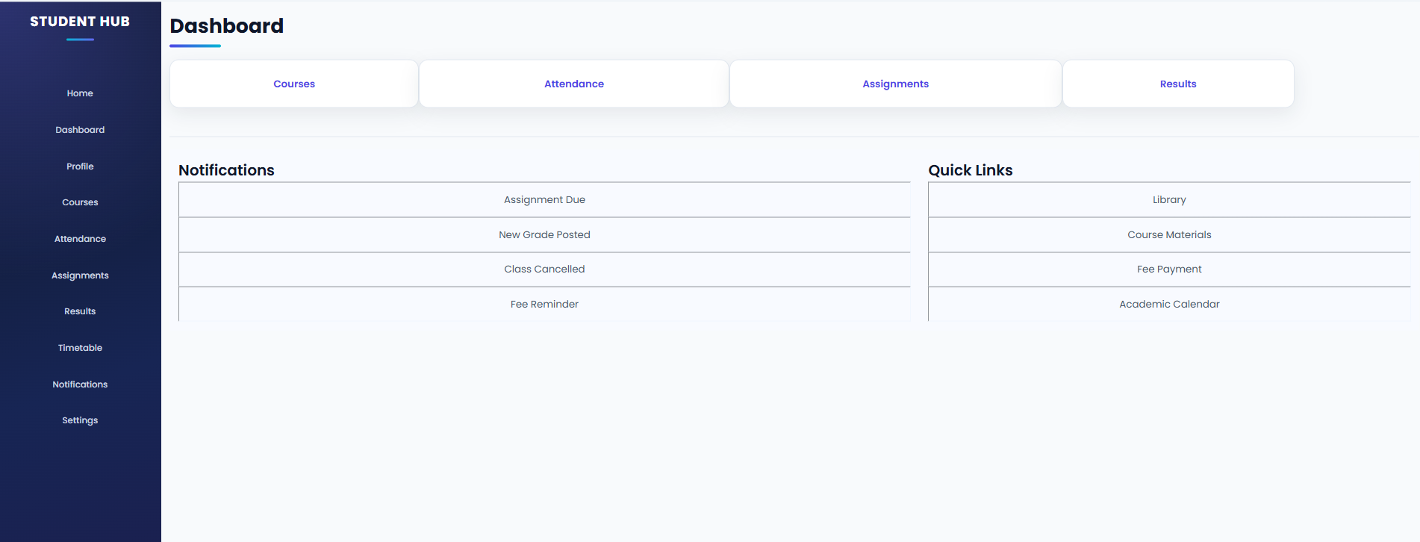

Description: Figure 2.5 Courses Page
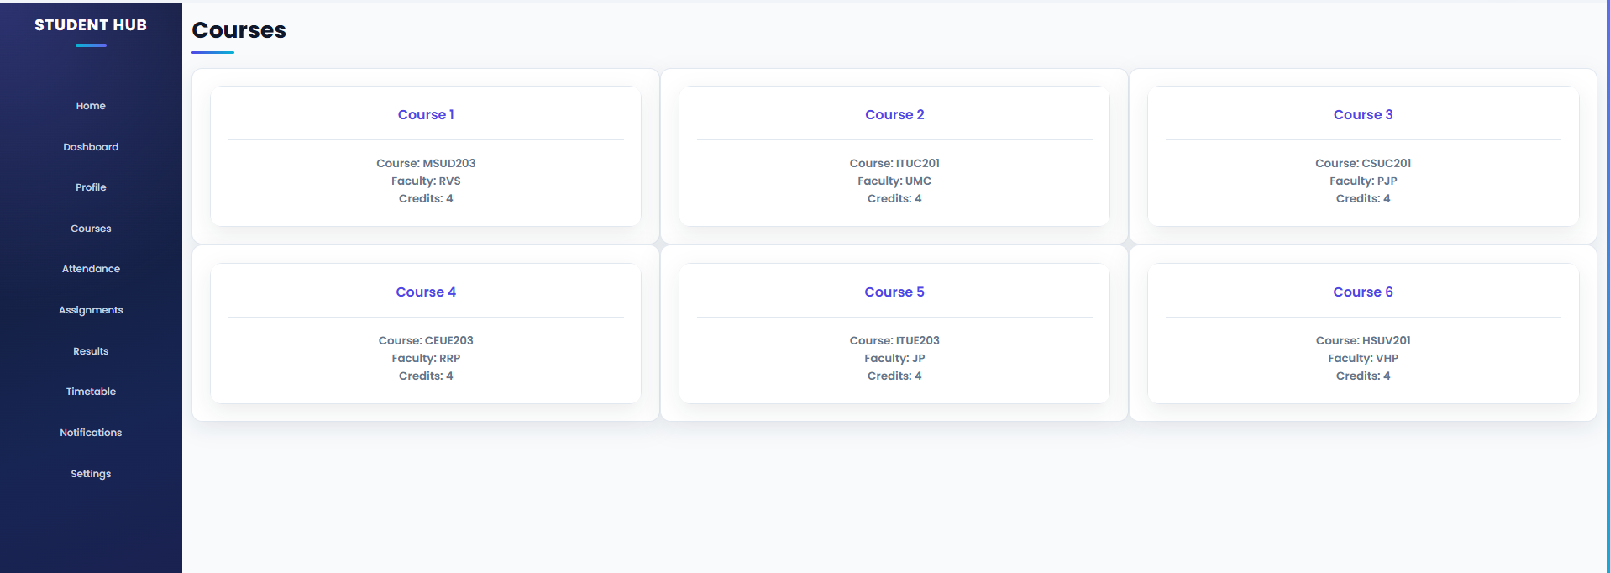
Description: Figure 2.6 Attendance Page
The Attendance page shows the student's attendance details.
It presents the information in a clear and simple format.
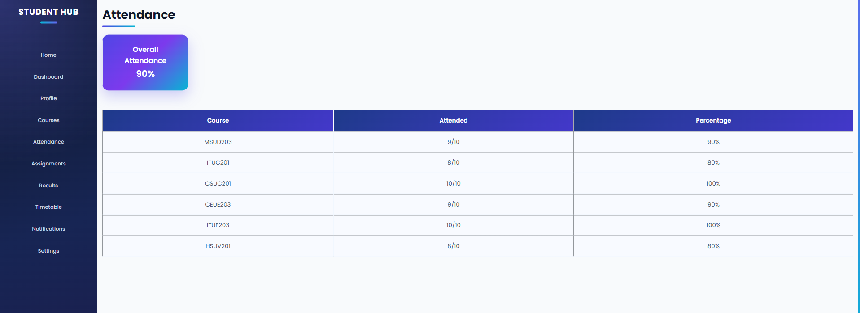

Description: Figure 2.7 Assignments Page
The Assignments page shows the tasks given to students.
It helps students view their assignments easily.

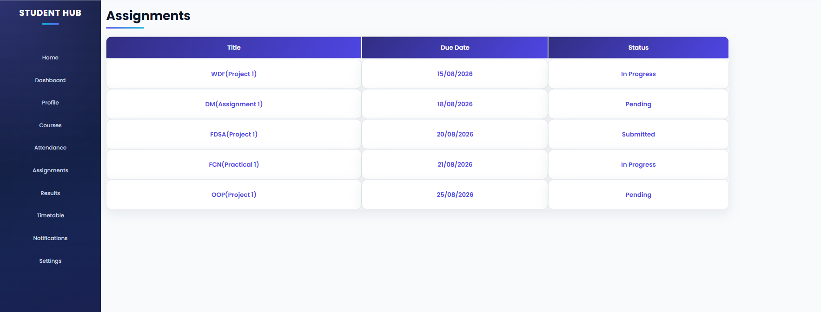

Description: Figure 2.8 Results Page
The Results page displays the student's academic results clearly.
It has a simple and responsive layout.
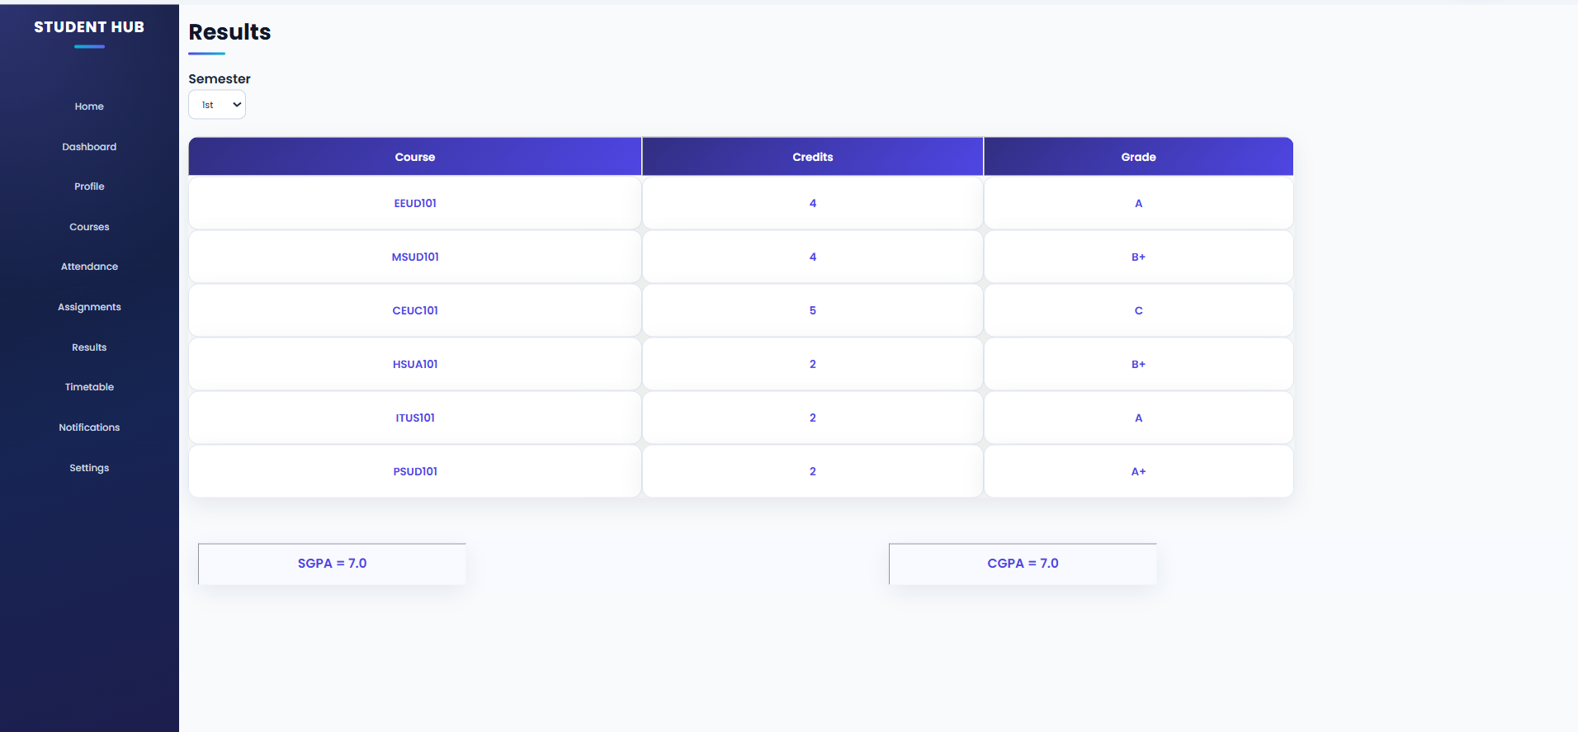

Description: Figure 2.9 time table Page
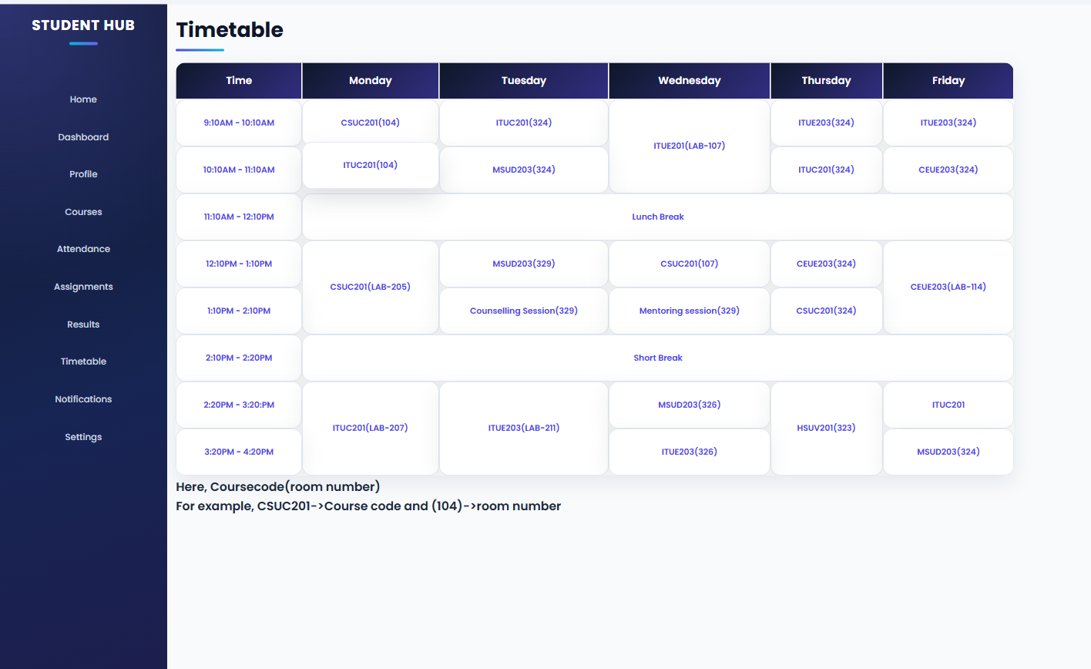
Description: Figure 2.10 notification Page
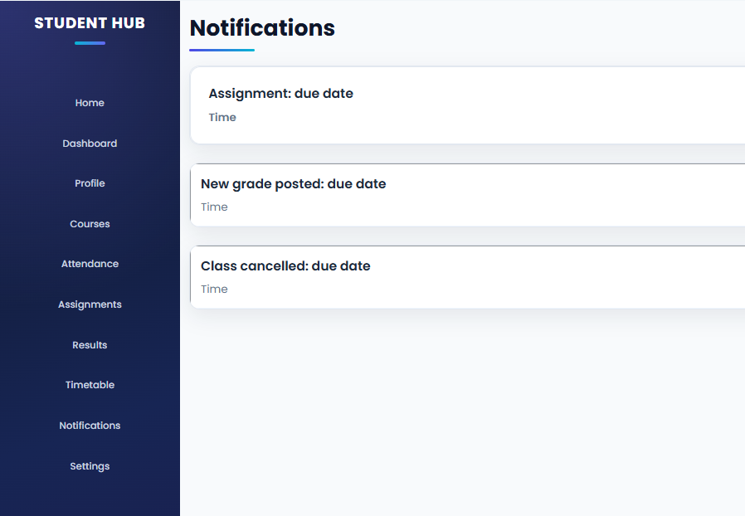

Description: Figure 2.11 settings Page
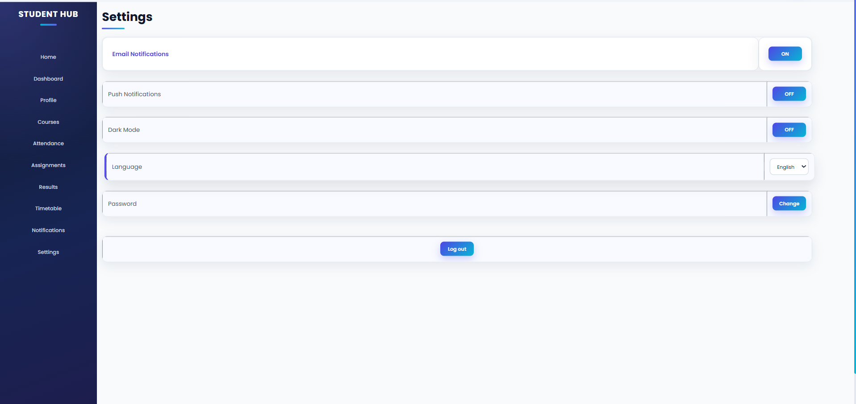

D. GitHub Repository Link:
Link: https://github.com/PritTejani7/student-hub

Challenges Faced:

Answer: The main challenge was understanding and using HTML5 tags for me. And I learn how add all 10 pages with each other by navigation of h ref. I learned how to add CSS in html and add PNG or JPEG file in the background in the web pages.

Learning Outcomes:

Answer: The main challenge was understanding and using HTML5 tags for me. And I learn how add all 10 pages with each other by navigation of h ref. I learned how to add CSS in html and add PNG or JPEG file in the background in the web pages.

G. Faculty Remarks:

