Practical - 4
Practical Title: JavaScript DOM Manipulation, Event Handling, and UI Interactivity
Problem Definition: Add dynamic UI components such as collapsible FAQ, modal popup,
image/content slider, notification banner, hamburger menu, and light/dark
theme switcher using JavaScript
A. Theory
1. How are DOM elements selected and modified?
Answer: Elements are selected using document.getElementById() for single elements with a unique id (like nav-toggle, theme-toggle, fee-banner) and document.querySelectorAll() for a group of elements that share a class (like all .faq-question buttons). Once selected, elements are modified not by changing their style directly, but by adding or removing CSS classes with classList.add(), classList.remove(), and classList.contains() — for example, adding the dark-theme class to <html> switches the whole site's colors, since the CSS is already written to respond to that class.
2. Are event listeners attached correctly?
Answer: Yes. Every interactive element uses addEventListener('click', function() {...}) rather than inline onclick attributes in the HTML, which keeps the JavaScript separate from the markup. Each listener is wrapped in an if (element) check first, since one shared script.js file runs on all 10 pages, but elements like the FAQ buttons or the payment modal only exist on specific pages — without the check, the browser console would throw a "cannot read property of null" error on pages that don't have that element.
3. Is localStorage used for remembering theme choice?
Answer: Yes. When the theme toggle is clicked, localStorage.setItem('studenthub-theme', 'dark') (or 'light') saves the choice in the browser. On every page load, localStorage.getItem('studenthub-theme') checks for a saved value and applies it immediately, so the theme stays consistent even after a refresh or when navigating to a different page — something a normal JavaScript variable couldn't do, since variables reset on every page load.
4. Does interactivity improve usability without breaking accessibility?
Answer: Yes. The hamburger button and FAQ buttons update their aria-expanded attribute ("true"/"false") every time they're toggled, so screen readers announce whether the menu or an FAQ answer is currently open, not just sighted users relying on the visual animation. The payment modal uses role="dialog" and aria-modal="true" so assistive technology treats it as a focused overlay rather than part of the regular page flow.

B. Implementation / Output / Result
Five interactive components were added using vanilla JavaScript and one shared js/script.js file linked from all 10 pages:
Hamburger menu — on every page, toggles a nav-open class on the navigation list so it collapses into a compact menu on small screens
Light/dark theme switcher — toggles a dark-theme class on the <html> element and persists the choice using localStorage, so it's remembered across the whole site
Dismissible notification banner — on the Dashboard page, a fee-reminder banner can be closed with a button; once dismissed, localStorage keeps it hidden even after a refresh
Collapsible FAQ — on the About page, three question/answer pairs expand and collapse individually when clicked, using classList.toggle()
Payment confirmation modal — on the Fees page, clicking "Pay now" opens a popup dialog with Cancel/Confirm buttons instead of navigating away

C. Evidence of Work (Screenshots)

Home page :
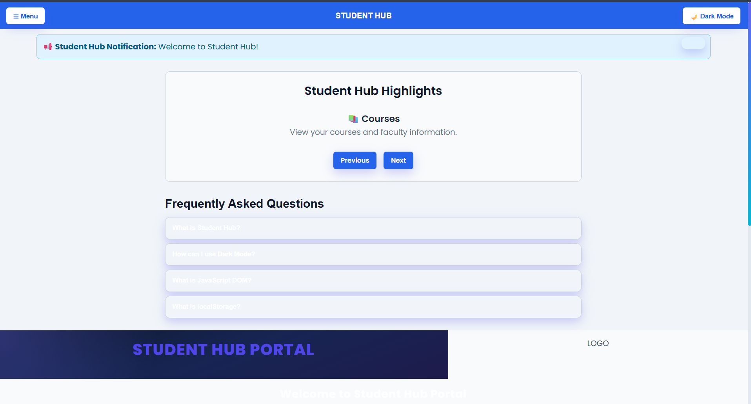
Login page :
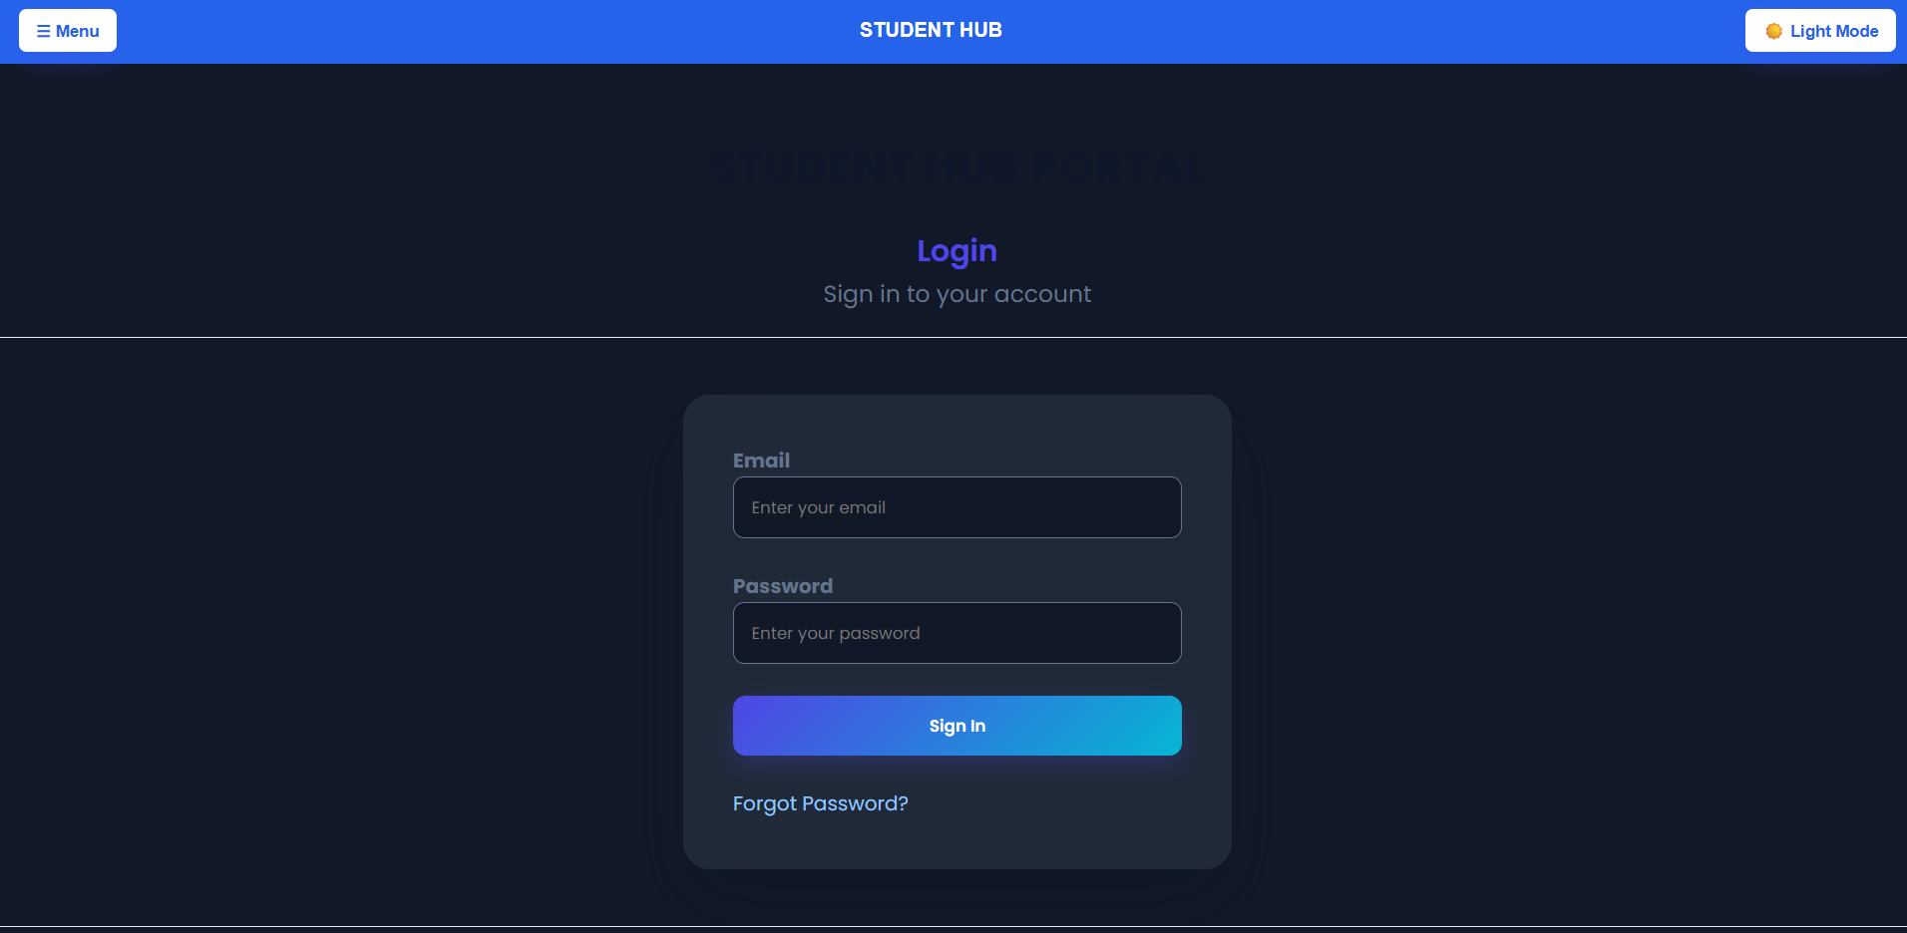

Dashboard :
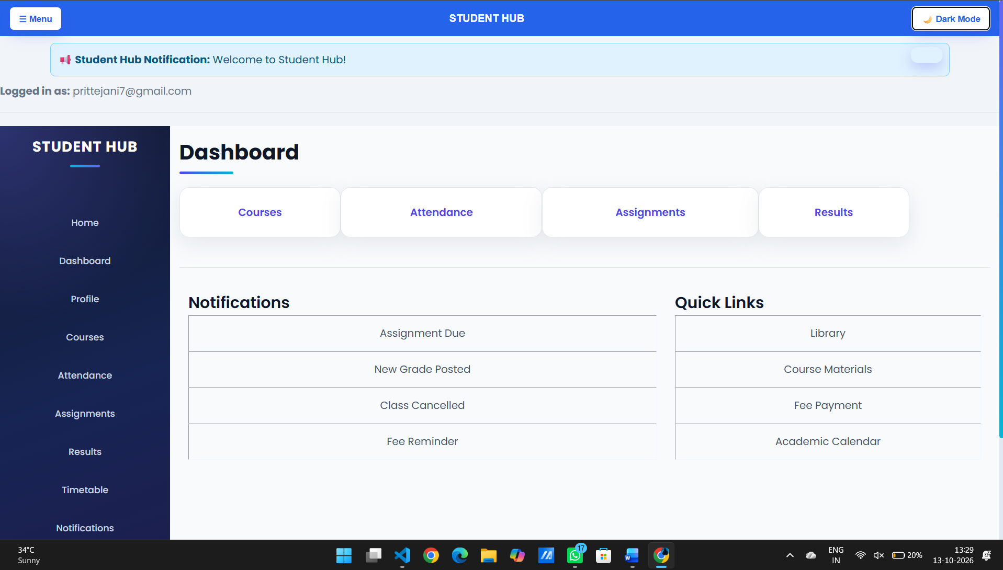
Profile page :
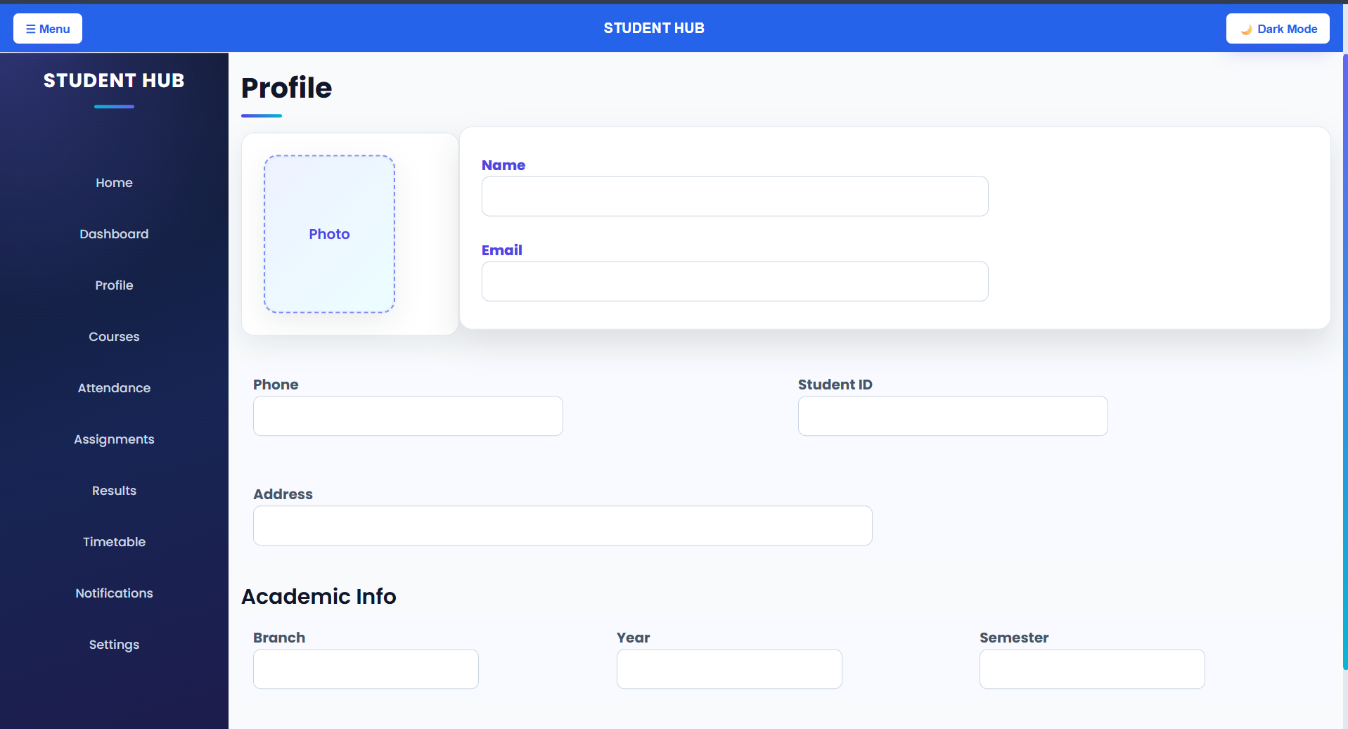
Courses :
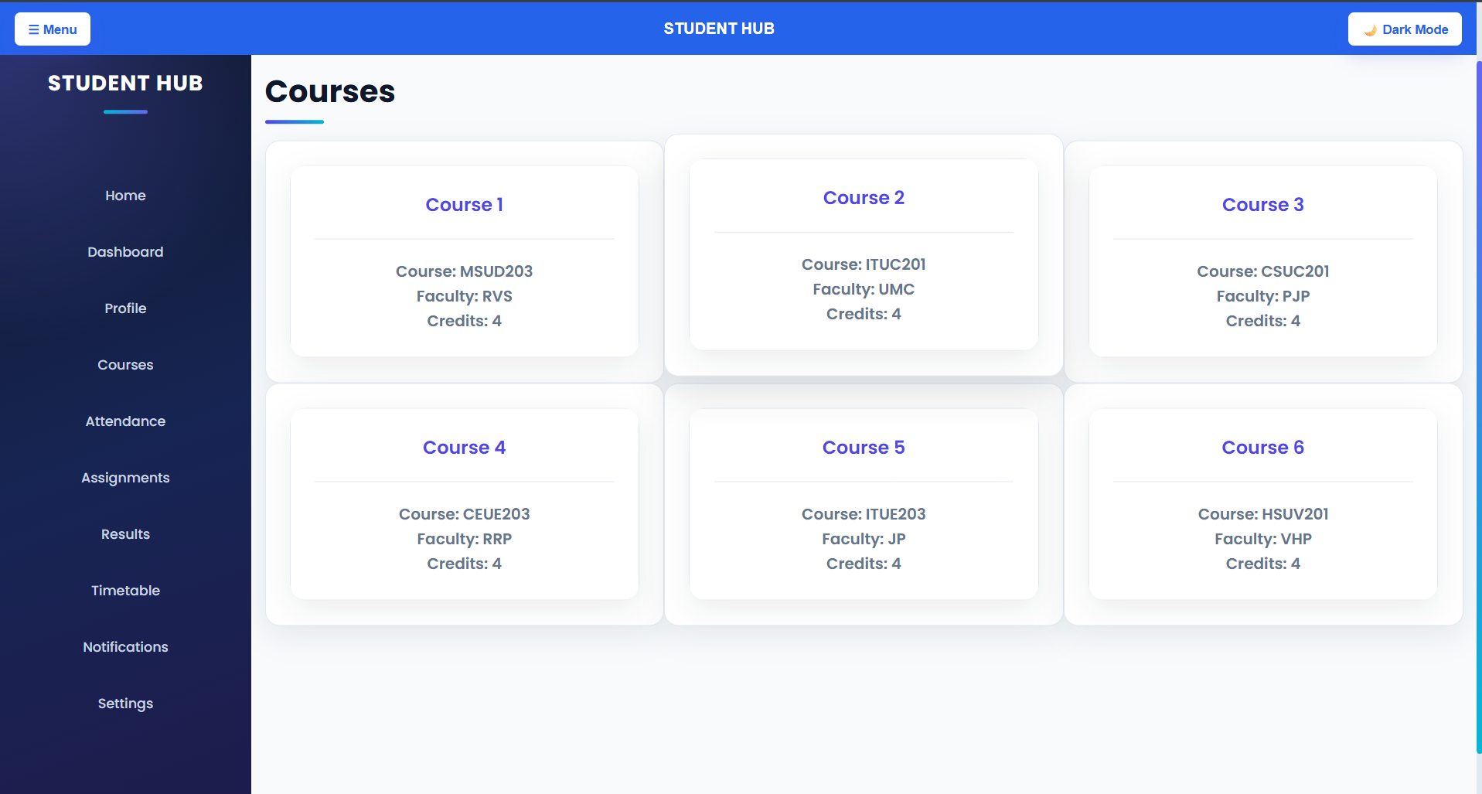
Attendance:
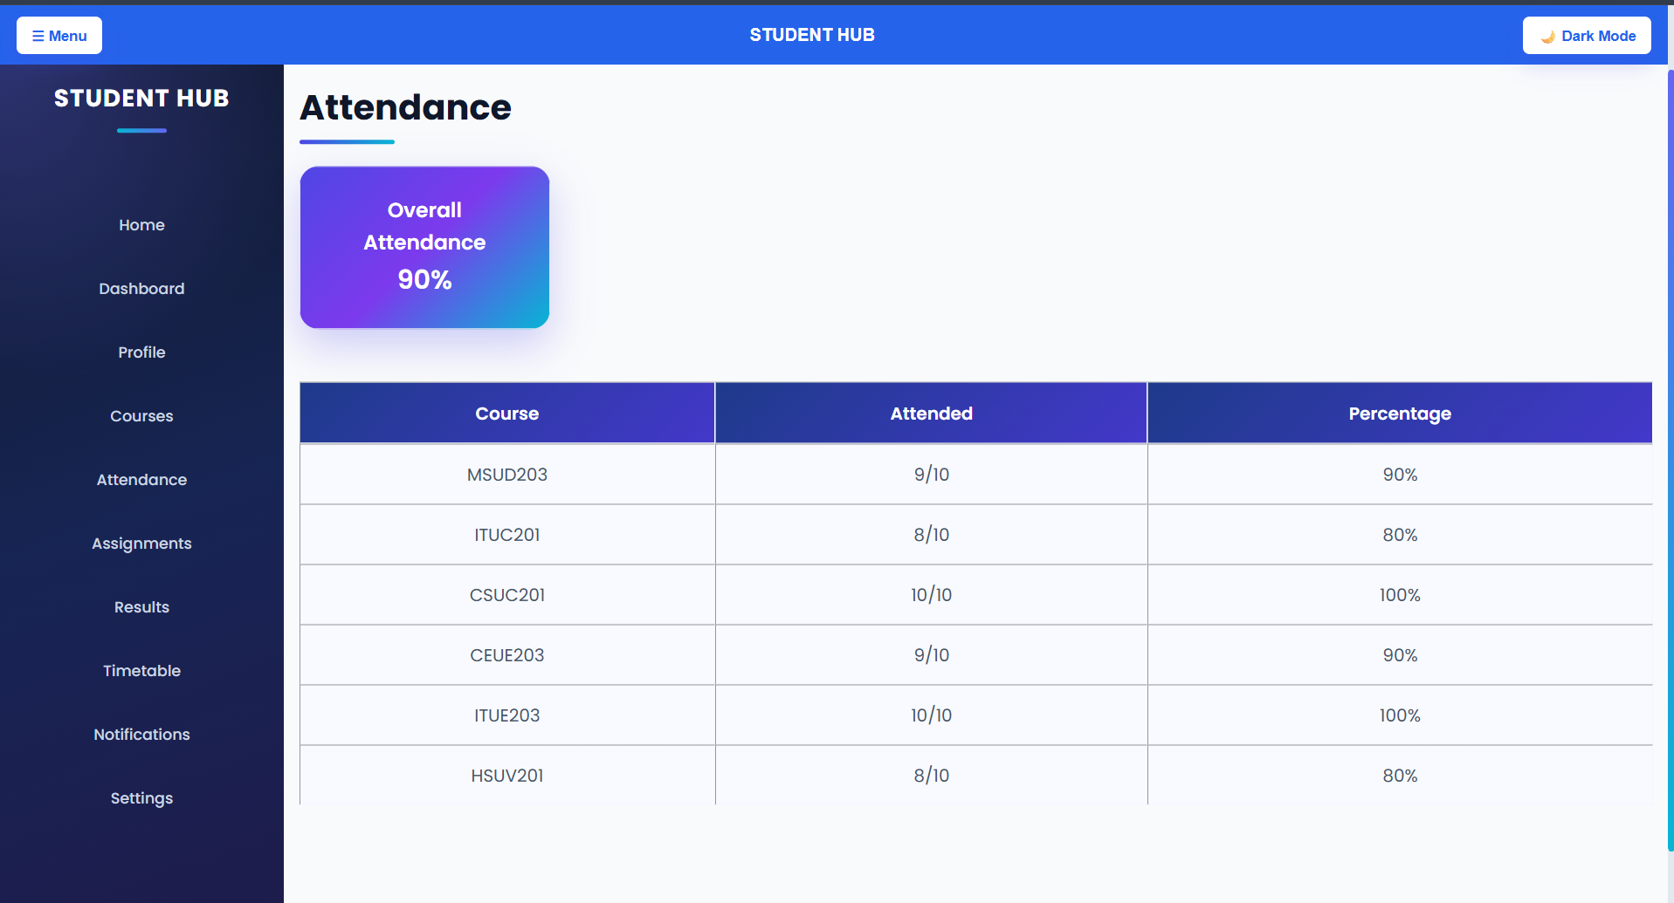
Assignments :
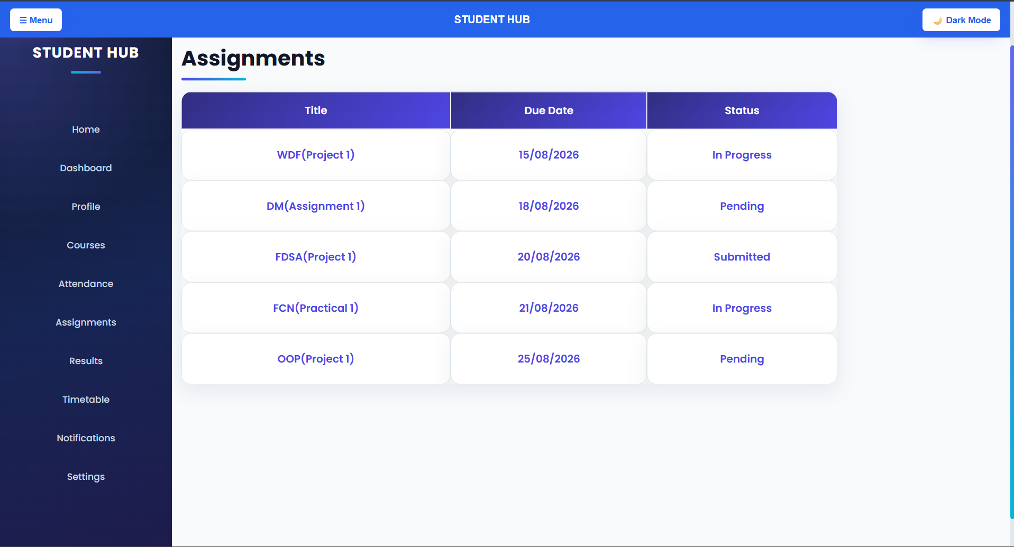
Results :
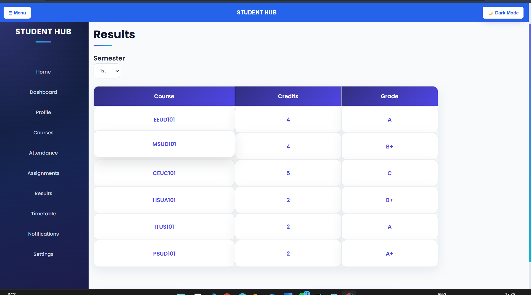
Timetable :
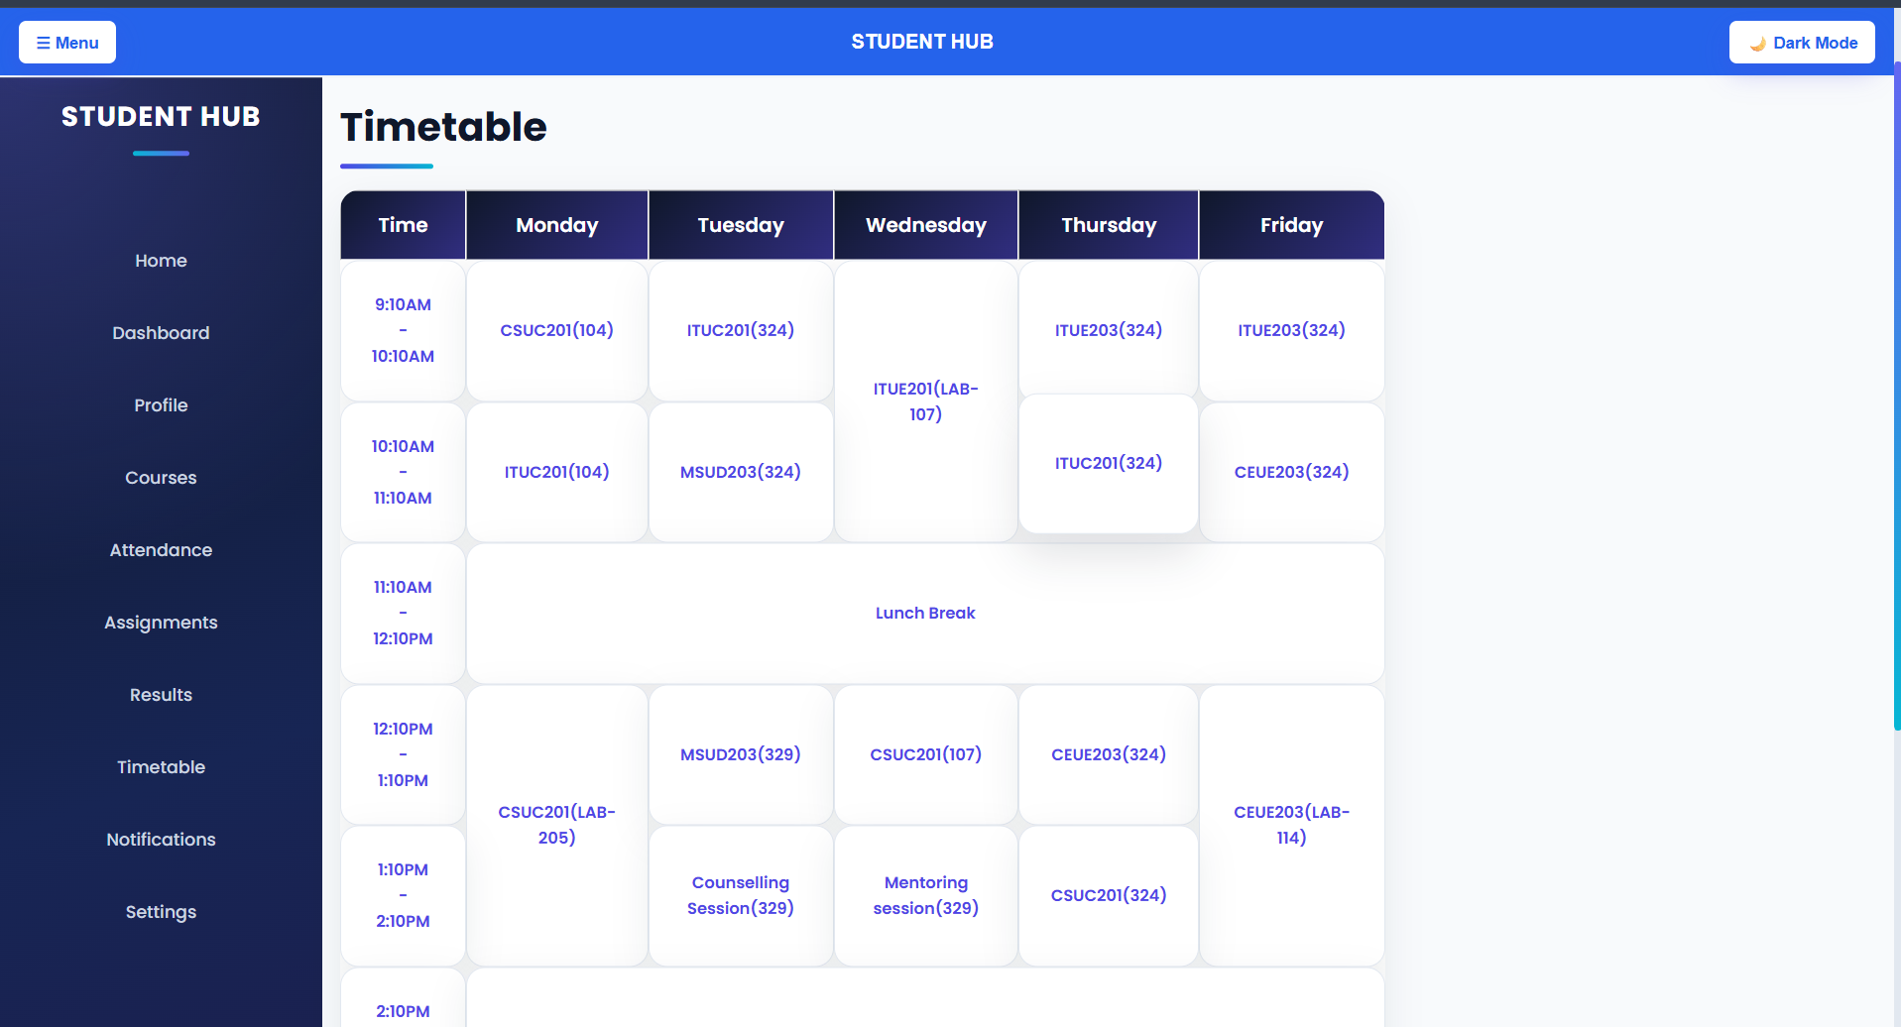
Notification :
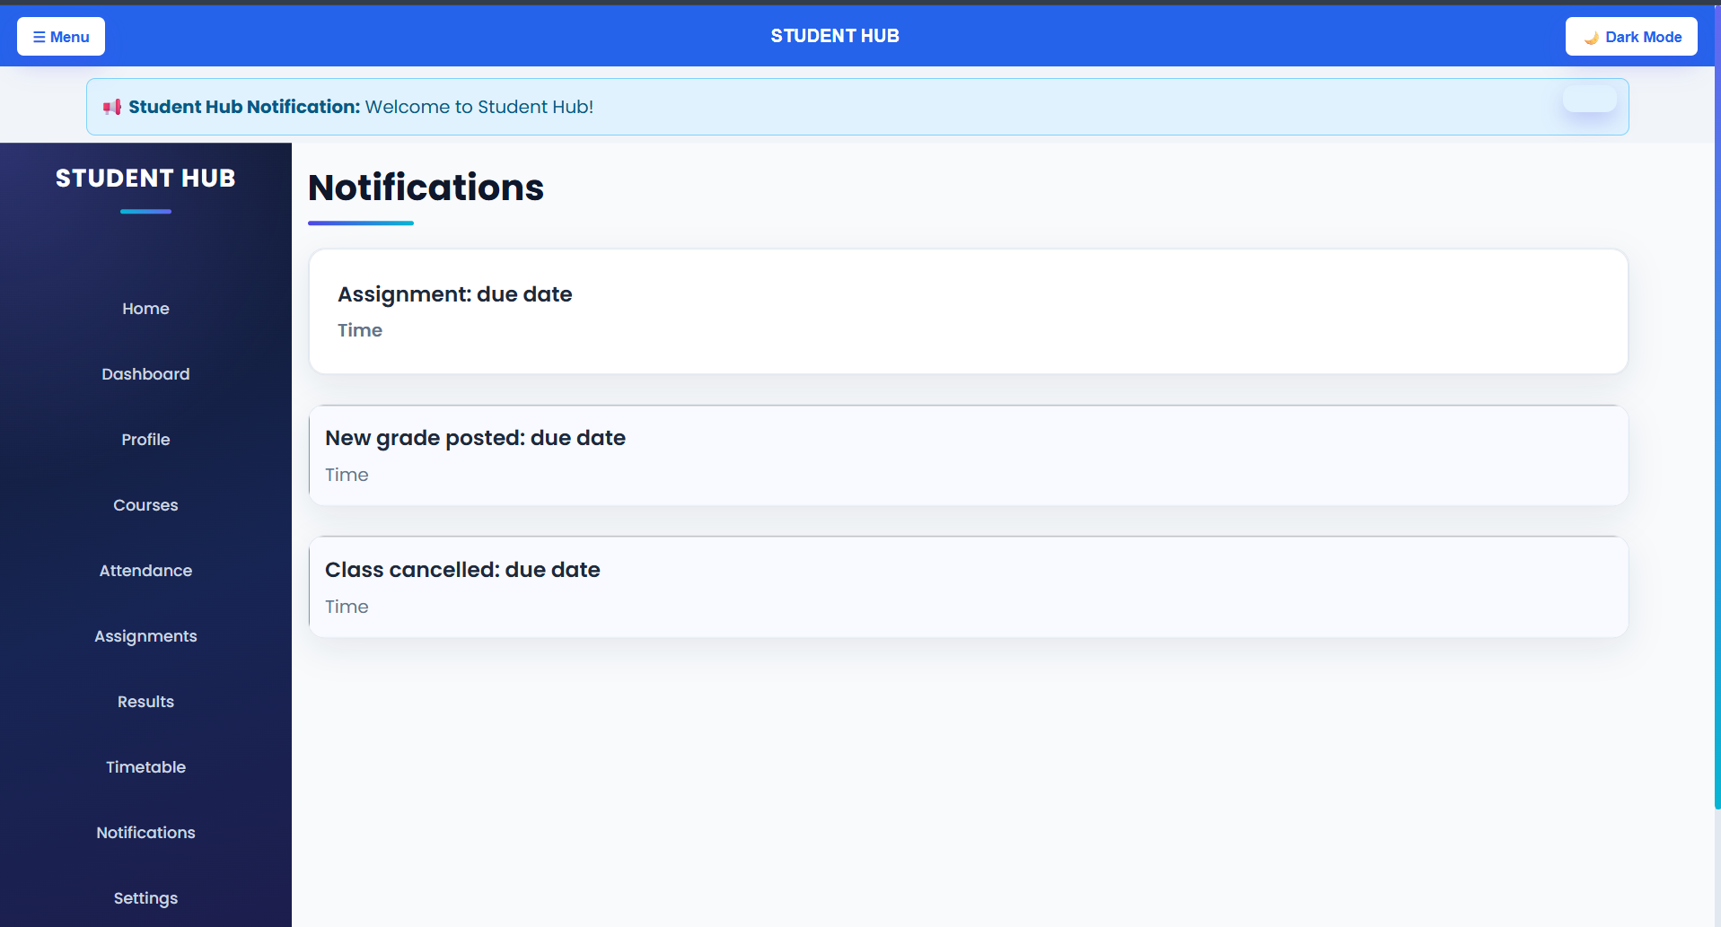
Settings :
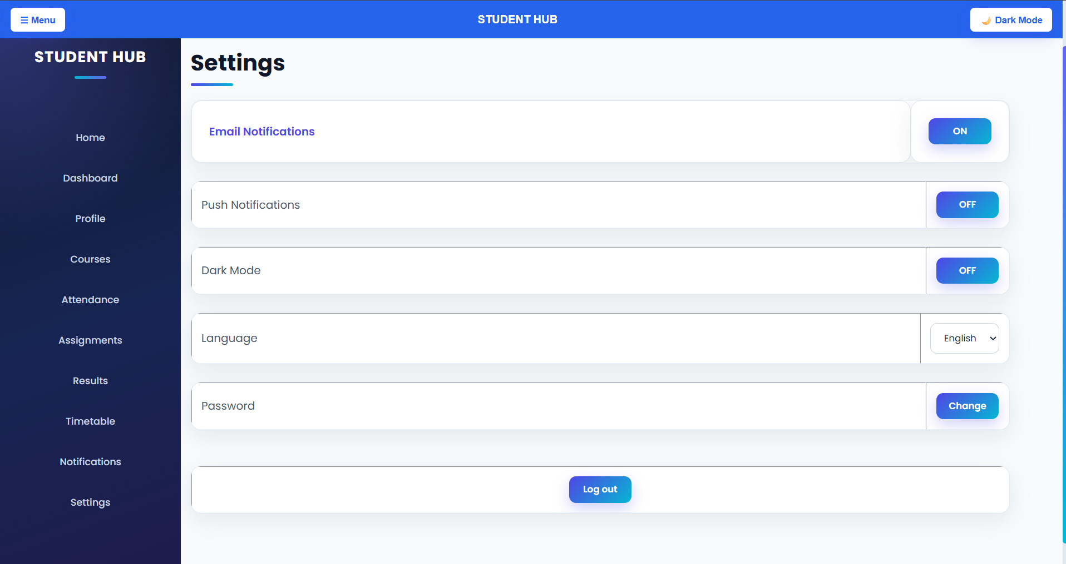

D. GitHub Repository Link :
https://github.com/PritTejani7/student-hub

E. Challenges Faced:
The trickiest part was keeping element ids consistent between the HTML and the JavaScript across all 10 pages — a single typo in an id (like nav-toggle vs navtoggle) means getElementById() silently returns null and nothing happens, with no error message to point you to the mistake. I also had to think through the difference between a normal JavaScript variable and localStorage: a variable resets the moment the page reloads, but the dark mode preference needed to survive both a refresh and moving to a different page, which is exactly what localStorage.setItem() and getItem() are for. Wrapping every feature in an if (element) check was also new — since one shared script.js file runs on every page, but not every page has a FAQ or a payment modal, and without those checks the console throws errors on pages missing that content.
F. Learning Outcomes:
I learned how classList.add(), remove(), and toggle() are used to change an element's appearance by switching CSS classes on and off, rather than writing styles directly in JavaScript. I understood how addEventListener('click', ...) connects a user action to a function, and how aria-expanded needs to be updated by JavaScript (not just CSS) so screen readers announce whether a menu or FAQ item is open. I also practiced using localStorage to remember a user's theme choice across page reloads, and saw firsthand how much simpler and more reliable the code becomes when every DOM-selecting line is checked for null before it's used.
G. Faculty Remarks:

