Practical - 8
Practical Title: MySQL Schema Design, ER Model, PDO Connectivity, and Prepared Statements

Problem Definition: Design the database for StudentHub with students, events and registrations. Create PHP database connection using MYSQL statements.

Theory

Is the schema normalized properly?
Answer: Yes, the schema is normalized properly with no redundancy.

Are primary keys and foreign keys correctly defined?
Answer: Yes, all primary and foreign key constraints are correctly linked.

3. Is the database connection handled securely?
Answer: Yes, the database connection is handled securely using PDO exceptions and prepared statements.

Implementation/ Output/Result
Purpose | What it does
Database Design | Created 3 tables: students, events and registrations with foreign keys.
Connection | Connects PHP to MySQL using PDO.
Queries | Inserts and reads data using prepared statements to prevent SQL injection.

Evidence of Work (Screenshots)
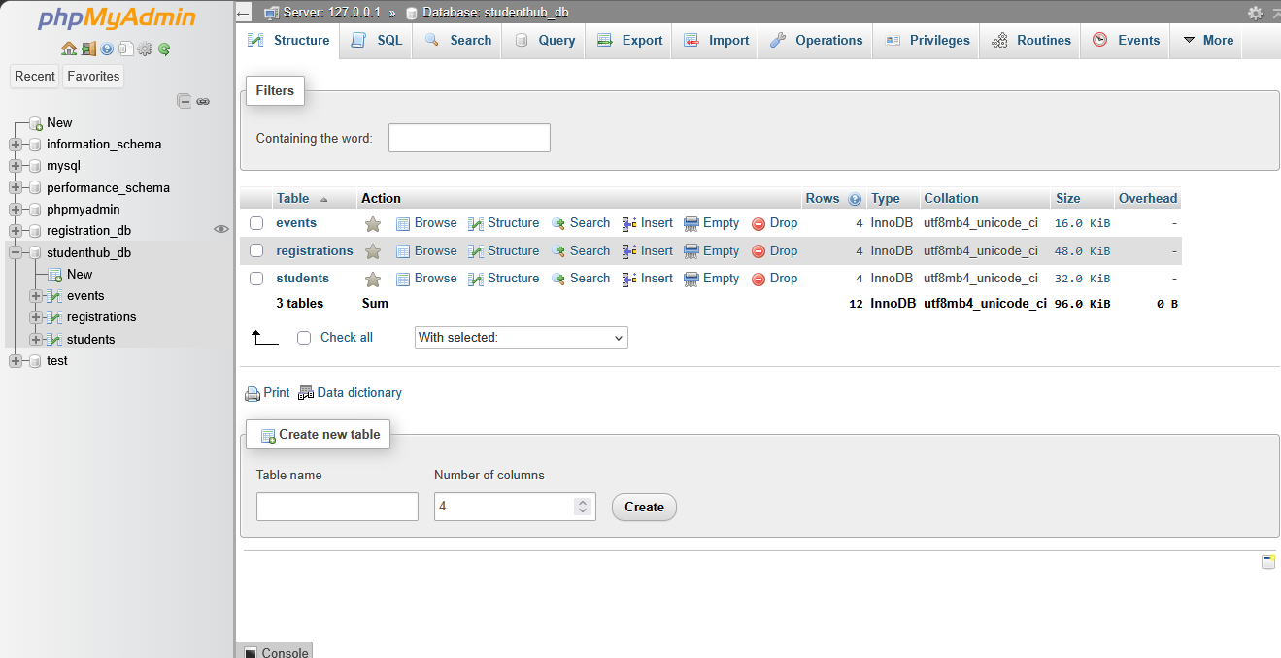
Description: Figure 8.1 database and its tables

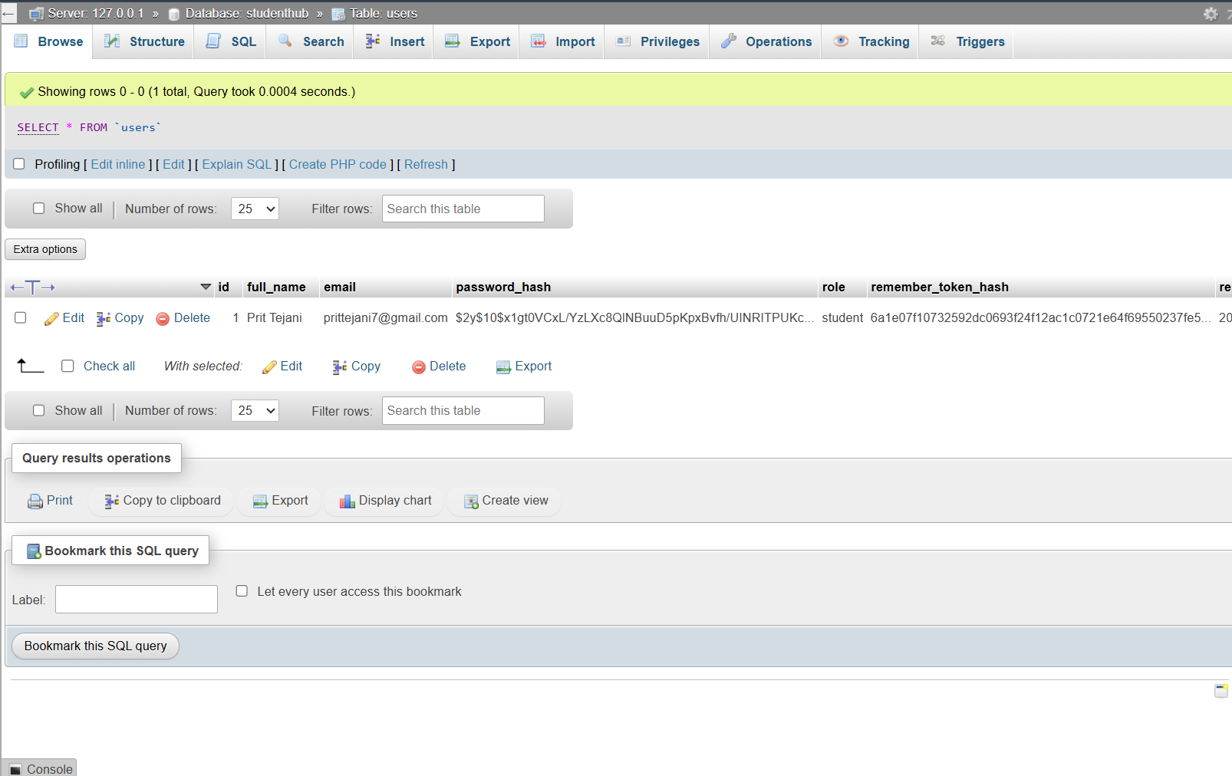
Description: Figure 8.2 Students table

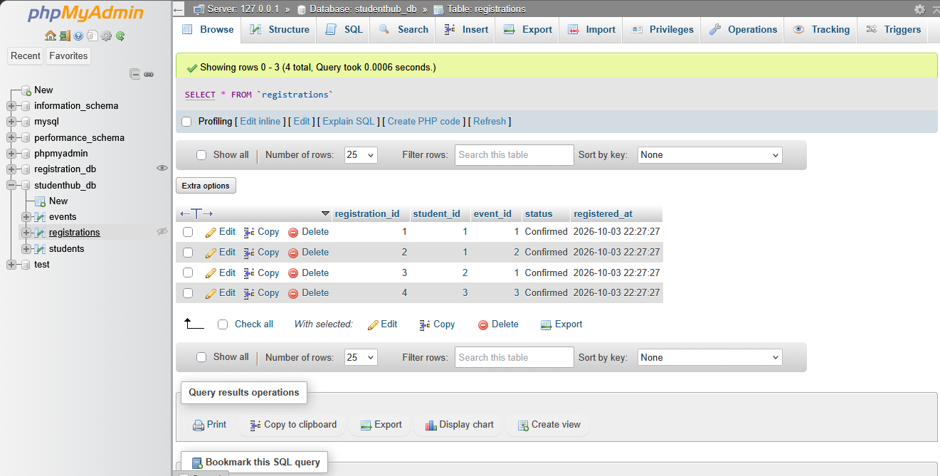
Description: Figure 8.3 Registrations table
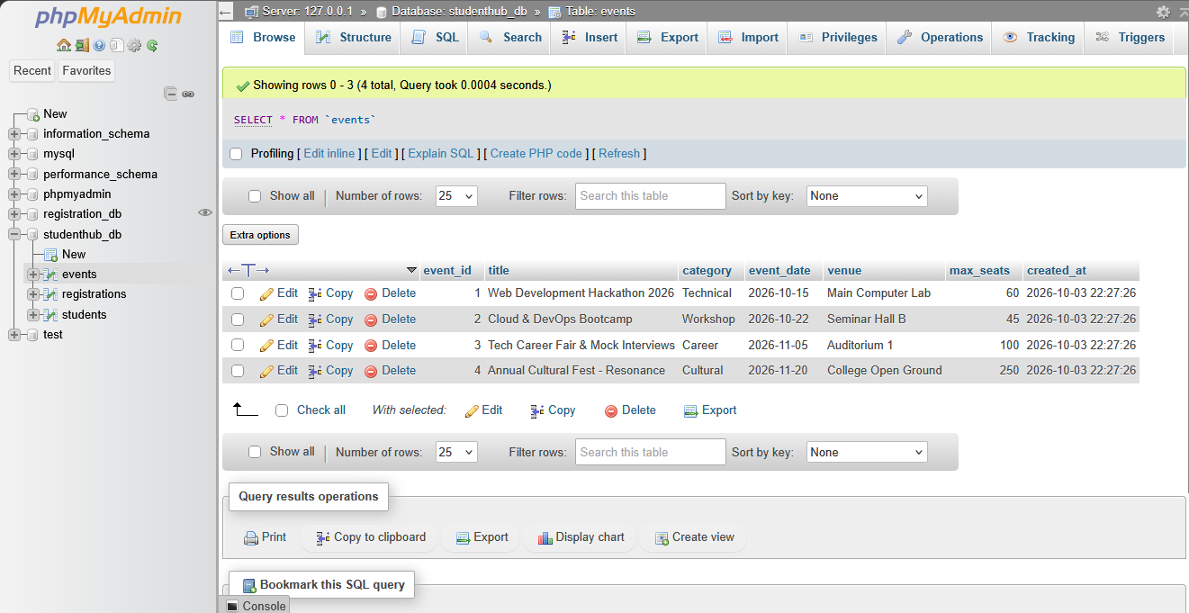
Description: Figure 8.4 Events table

GitHub Repository Link:

https://github.com/PritTejani7/student-hub

Challenges Faced:
Understanding foreign key constraints and debugging PDO connection errors.

Learning Outcome:
I learned how to design and connect a normalized database securely using PHP.

Faculty Remarks: (Keep this blank for faculty)

