**FLIPFLOP USING BEHAVIOUR MODELLING STYLE**

1. D FLIPFLOP (CODE)

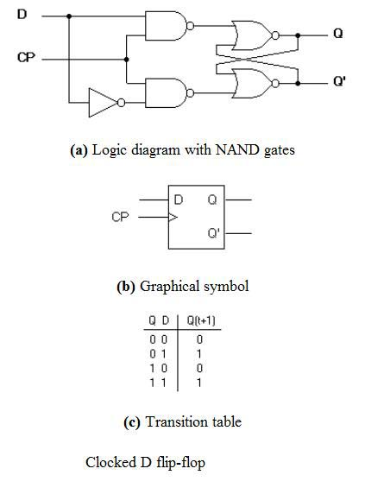

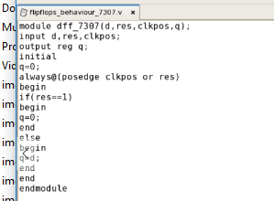

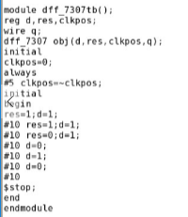

D FLIPFLOP (WAVEFORM)

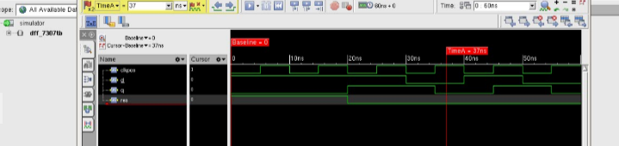

2)J-K FLIPFLOP (CODE)

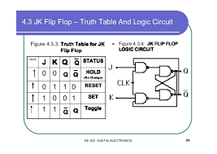

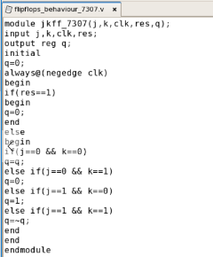

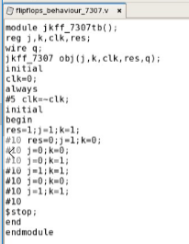

J-K FLIPFLOP (WAVEFORM)

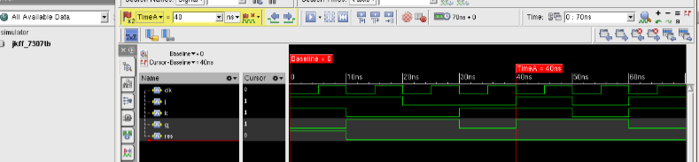3) S-R FLIPFLOP(CODE)

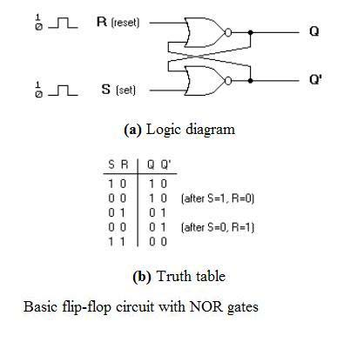

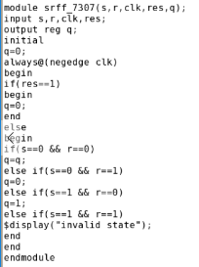

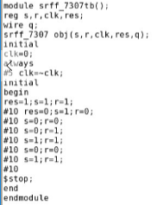

S-R FLIPFLOP (WAVEFORM)

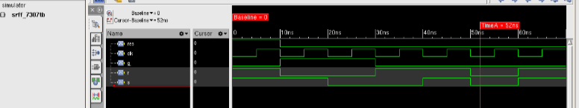

4) T FLIPFLOP (CODE)

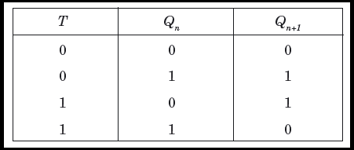

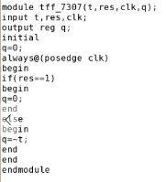

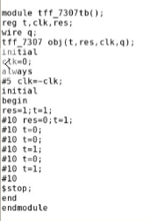

T FLIPFLOP (WAVEFORM)

