HealthFirst Care
Data Analysis Report
Appointment, Feedback & Resource Utilization Analysis
Google Data Analytics Capstone — Task Module 04

Executive Summary
This report summarizes the cleaning, combination, and trend analysis of three HealthFirst Care datasets — appointments, patient feedback, and resource logs — covering 201 appointment records, 199 feedback entries, and 200 resource utilization records. The analysis identifies peak appointment periods, satisfaction patterns by department, and departments with resource strain, to support operational planning.

Key Findings
- Monday is the busiest day of the week (34 appointments); 6 PM is the busiest hour of the day (27 appointments).
- Cardiology has the highest average patient satisfaction score (7.03/10); General Medicine has the lowest (5.38/10).
- Dissatisfaction correlates with peak load: the 6 PM slot has both the highest appointment volume and the highest share of "Low" satisfaction feedback (25%), suggesting late-day congestion affects patient experience.
- Pediatric resources are overburdened (4.85 avg usage hours vs. a 3.85 department-wide average); General Medicine and Orthopedics are underutilized (3.41 and 3.37 respectively).

Methodology
The three source datasets (appointment_data.csv, feedback_data.csv, resource_data.csv) were cleaned and standardized in Excel: duplicate rows were removed, dates were formatted as MM/DD/YYYY, times as HH:MM AM/PM, missing feedback scores were replaced with the column average, and missing non-numeric fields were flagged with an "N/A" placeholder. Feedback records were then linked to appointment records by Patient ID using VLOOKUP to build a Combined_Dataset, and each feedback entry was classified as "High" (score ≥ 4) or "Low" (score < 4) satisfaction using an IF formula. Pivot-style summary tables (department × hour, department × satisfaction, department average resource usage) were built with SUMIFS/COUNTIFS/AVERAGEIFS formulas so they recalculate automatically as source data changes.
The full cleaned and analyzed workbook — including the Cleaned_Appointment, Cleaned_Feedback, Cleaned_Resource, Combined_Dataset, Pivot_Appointments, Pivot_Satisfaction, Pivot_Resource, and Trends_Analysis sheets, plus native Excel charts — accompanies this report as a separate Excel file (appointment_data_task2.xlsx).

1. Appointment Trends
Appointment volume was analyzed by day of week and hour of day using the cleaned appointment records.
Day of Week | Appointments
Monday | 34
Saturday | 31
Sunday | 30
Tuesday | 27
Wednesday | 27
Friday | 26
Thursday | 23
N/A (missing date) | 3

Hour of Day | Appointments
6:00 PM | 27
5:00 PM | 20
3:00 PM | 19
8:00 AM | 18
12:00 PM | 18
4:00 PM | 18
11:00 AM | 17
9:00 AM | 15
2:00 PM | 13
10:00 AM | 14
1:00 PM | 12
N/A (missing time) | 10
Monday and weekends (Saturday/Sunday) see the highest appointment volume, and demand climbs steadily through the afternoon, peaking at 6 PM. This suggests staffing should be weighted toward Monday and weekend shifts, with extra front-desk and clinical coverage in the late afternoon/early evening window.
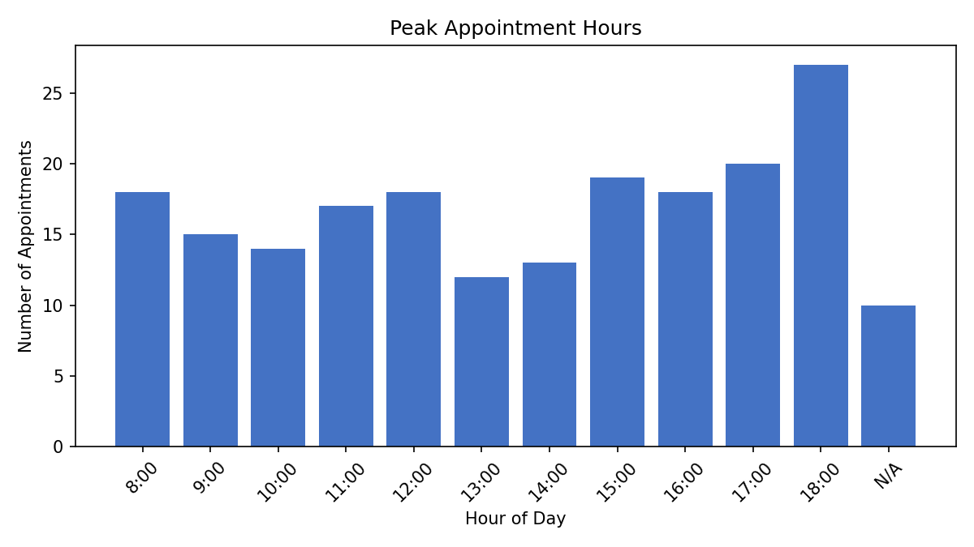
Figure 1. Appointment volume by hour of day.

2. Patient Satisfaction Analysis
Average feedback scores and High/Low satisfaction counts were calculated per department from the Combined_Dataset.
Department | Avg Feedback Score | High Count | Low Count
Cardiology | 7.03 | 31 | 2
Oncology | 6.50 | 26 | 6
Pediatric | 6.32 | 32 | 5
Neurology | 6.26 | 33 | 1
Orthopedics | 5.93 | 21 | 8
General Medicine | 5.38 | 21 | 5
Cardiology delivers the strongest patient experience, while General Medicine and Orthopedics show the most room for improvement — both the lowest average scores and among the highest Low-satisfaction counts.

Correlation with Peak Appointment Times
Cross-referencing satisfaction level against appointment hour shows dissatisfaction is not evenly spread through the day — it concentrates at the busiest hour:
Hour | Total Feedback | Low Count | Low %
6:00 PM | 28 | 7 | 25.0%
4:00 PM | 19 | 4 | 21.1%
11:00 AM | 16 | 3 | 18.8%
8:00 AM | 18 | 3 | 16.7%
2:00 PM | 15 | 2 | 13.3%
3:00 PM | 20 | 2 | 10.0%
5:00 PM | 21 | 2 | 9.5%
1:00 PM | 9 | 1 | 11.1%
9:00 AM | 19 | 1 | 5.3%
10:00 AM | 14 | 1 | 7.1%
12:00 PM | 19 | 1 | 5.3%
The 6 PM slot — already identified as the busiest hour — also has the highest proportion of Low-satisfaction feedback (25%), roughly 2–5x the rate seen in mid-morning slots. This is consistent with congestion (longer waits, rushed visits) driving down satisfaction during peak load.
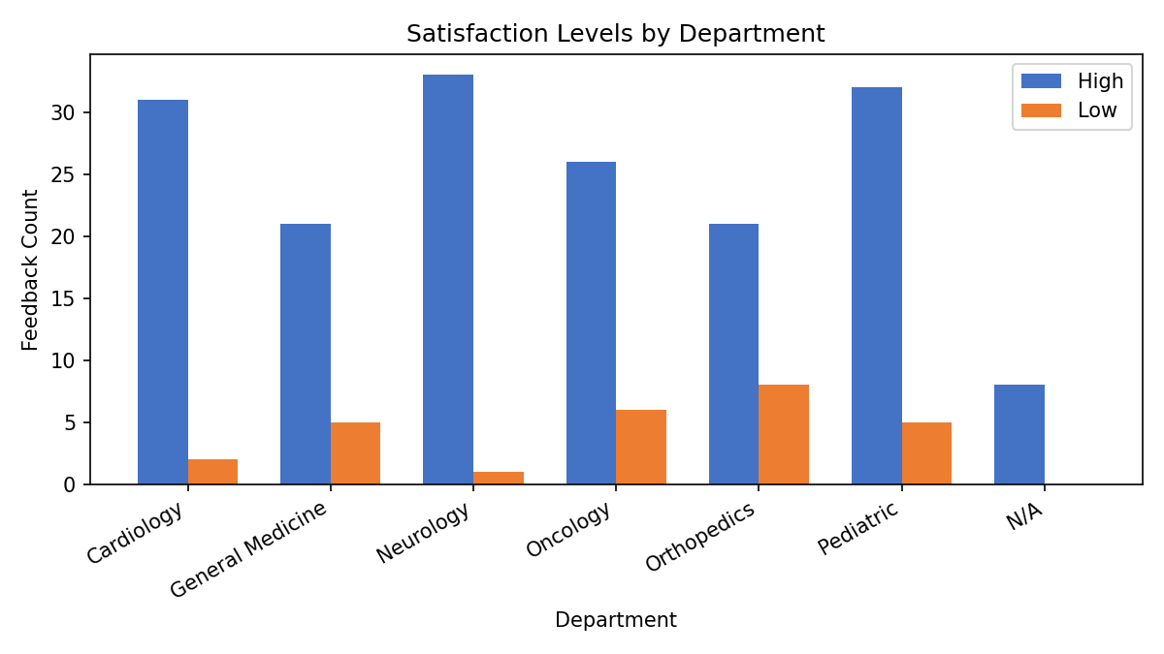
Figure 2. High vs. Low satisfaction counts by department.

3. Resource Utilization
Average usage hours per resource were calculated by department and compared against the overall department-wide average (3.85 hours) to flag overburdened (>10% above average) and underutilized (>10% below average) departments.
Department | Avg Usage Hours | Resource Count | Status
Pediatric | 4.85 | 40 | Overburdened
Cardiology | 4.18 | 22 | Normal
Neurology | 3.79 | 34 | Normal
Oncology | 3.56 | 36 | Normal
General Medicine | 3.41 | 39 | Underutilized
Orthopedics | 3.37 | 27 | Underutilized
Pediatric resources (staff, rooms, and equipment combined) are running noticeably above the department-wide average, indicating a potential bottleneck. General Medicine and Orthopedics, by contrast, have comparatively idle capacity — this pairing suggests an opportunity to rebalance shared resources (e.g., flexible/cross-trained staff or shared equipment) from the underutilized departments toward Pediatric during peak periods.
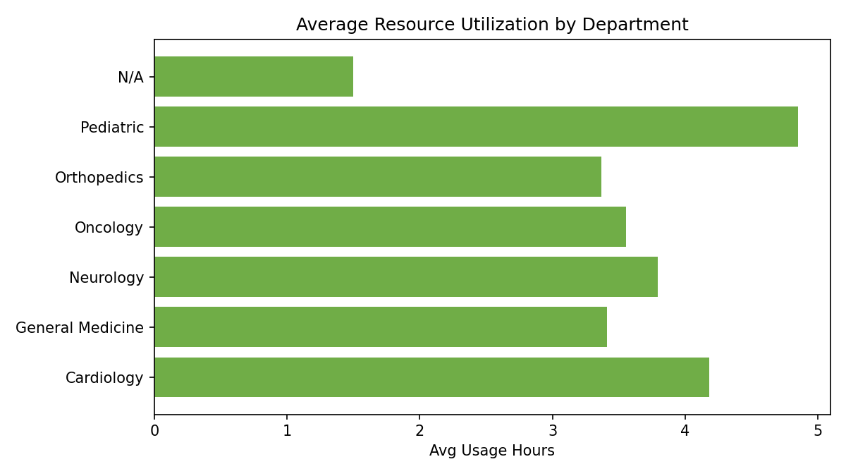
Figure 3. Average resource usage hours by department.

Recommendations
- Add staffing coverage on Mondays and weekends, and specifically in the 4–6 PM window, where both appointment volume and dissatisfaction peak together.
- Investigate service delivery in General Medicine and Orthopedics — the lowest satisfaction scores — to identify root causes (e.g., wait times, communication gaps).
- Rebalance resources toward Pediatric, which is running above the department-wide utilization average, potentially by reallocating idle capacity from General Medicine or Orthopedics.
- Continue tracking the missing/"N/A" records (3 appointments with no date, 10 with no time, and similar gaps in other sheets) at the source system level to improve data completeness for future analysis.

Appendix: Cleaned Dataset Sample
The tables below show a sample of the standardized data from each cleaned sheet. The complete cleaned dataset for all three sources is provided in the accompanying Excel workbook.

Cleaned_Appointment (sample)
AppointmentID | PatientID | DoctorID | Department | Date | Time | Status
A7515 | P16262 | D1 | Orthopedics | 09/10/2024 | 01:00 PM | No Show
A7537 | P99601 | D30 | Cardiology | 12/17/2024 | 03:00 PM | Completed
A8866 | P55235 | D30 | Neurology | 07/09/2024 | 03:30 PM | Rescheduled

Cleaned_Feedback (sample)
FeedbackID | PatientID | Department | Score | WaitTime (min)
F1000 | P99601 | Cardiology | 4 | 45
F1001 | P36565 | Orthopedics | 3 | 45
F1003 | P67499 | Neurology | 9 | 30

Cleaned_Resource (sample)
ResourceID | Department | ResourceType | UsageHours | Date | Availability
R5487 | Cardiology | Nurse | 2 | 07/28/2024 | Available
R8097 | Orthopedics | Doctor | 0 | 09/10/2024 | Unavailable
R2557 | General Medicine | Room | 0 | 12/17/2024 | Under Maintenance

