HealthFirst Care
Detailed Process Maps Using Swimlane Diagrams
Advanced BPMN Workflow Analysis & Role-Based Process Mapping
Capstone Project — Module 03, Lesson 02
Prepared by: Pritam Kar

1. Introduction
This report presents a detailed process mapping exercise conducted for HealthFirst Care as part of the ongoing operations improvement initiative. Building on the previously completed Business Requirements Document (BRD), Requirements Traceability Matrix (RTM), Stakeholder Analysis and Engagement Plan, and As-Is/To-Be Process Models, this exercise applies advanced Business Process Model and Notation (BPMN) techniques to map three cross-functional workflows using swimlane diagrams.
Swimlane diagrams were selected because they make role ownership explicit: each lane represents a distinct stakeholder group, and every handoff between lanes is a visible point where delay, miscommunication, or rework can occur. The three workflows analyzed are:
- Patient Appointment Scheduling and Confirmation — involving the patient, admin staff, and the IT/automated scheduling system.
- Patient Check-In and Resource Allocation — involving the patient, front desk staff, nurses, and doctors.
- Discharge Planning Process — involving doctors, nurses, admin/billing staff, and the patient.
For each workflow, this report documents the stakeholders and touchpoints involved, the BPMN elements used to model decision logic and events, the resulting swimlane diagram, and the current challenges, proposed improvements, and expected impact on operational efficiency.

2. Task 1: Analysis of Complex Workflows
Each workflow was analyzed using scheduling, feedback, and resource utilization data to identify critical touchpoints, unclear role ownership, and process bottlenecks. A summary of stakeholders and dependencies for each workflow is presented below.

2.1 Appointment Scheduling and Confirmation
Stakeholders: Patient, Admin Staff, IT/Automated System.
- Critical touchpoint: the handoff from Admin Staff checking slot availability to the IT system scheduling the appointment and sending the notification.
- Inefficiency: when a preferred slot is unavailable, the patient is routed back to reselect a slot, creating a manual retry loop instead of an automated suggestion of the next best available slot.
- Bottleneck: appointment data indicates delays concentrate at the slot-availability check, since it depends on Admin Staff manually querying the system rather than the patient viewing live availability.

2.2 Patient Check-In and Resource Allocation
Stakeholders: Patient, Front Desk, Nurse, Doctor.
- Critical touchpoint: verification of patient details and insurance at the Front Desk, which gates entry into triage.
- Inefficiency: when details are invalid, the patient is looped back through the Front Desk for correction, adding wait time before triage can even begin.
- Bottleneck: feedback data points to the Front Desk verification step as the primary source of patient dissatisfaction, since incomplete records force rework before Nurse triage and room assignment can proceed.

2.3 Discharge Planning Process
Stakeholders: Doctor, Nurse, Admin/Billing, Patient.
- Critical touchpoint: the handoff from Nurse (care instructions) to Admin/Billing (final bill and coverage check), which the patient cannot move past until billing is cleared.
- Inefficiency: unclear ownership of billing exceptions — when billing is not cleared, resolution loops back through Admin/Billing with no defined turnaround time.
- Bottleneck: resource data shows discharge delays cluster at the billing clearance gateway, extending patient bed occupancy and downstream resource availability.

3. Task 2: Advanced BPMN Elements Applied
Each workflow was modeled using standard BPMN elements to make decision logic, repeatable sub-processes, and start/end events explicit:
- Tasks — individual workflow steps such as “Verify Patient Details & Insurance” or “Calculate Final Bill & Check Coverage.”
- Decision gateways — diamond-shaped branch points such as “Is Slot Available?”, “Details Valid?”, and “Billing Cleared?” that route the process along different paths.
- Sub-processes — grouped, repeatable steps such as “Generate & Sign Discharge Summary” and “Resolve Billing Issues,” which can be expanded into their own detailed flow.
- Event triggers — start and end events such as “Request Appointment,” “Discharge Request Initiated,” and “Patient Discharged,” marking where each workflow begins and ends.
The table below maps the three workflows to their key BPMN elements.
Workflow | Key Gateway(s) | Key Sub-process | Start / End Events
Appointment Scheduling | Is Slot Available? | Schedule Appointment & Send Notification | Request Appointment / Appointment Confirmed
Patient Check-In & Resource Allocation | Details Valid? | Triage & Check Vital Signs | Arrive & Request Check-in / Check-in & Visit Completed
Discharge Planning | Billing Cleared? | Generate & Sign Discharge Summary; Resolve Billing Issues | Discharge Request Initiated / Patient Discharged

4. Task 3: Swimlane Diagrams
The swimlane diagrams below segregate each workflow into role-based lanes. Every lane represents one stakeholder group's responsibilities, and arrows crossing lane boundaries mark a handoff — the points most likely to introduce delay.

4.1 Patient Appointment Scheduling and Confirmation
Lanes: Patient, Admin Staff, IT/Automated System. The patient requests an appointment; Admin Staff checks slot availability; if unavailable, the patient selects a new slot and the loop repeats; if available, the IT system schedules the appointment and sends a notification, which the patient receives as confirmation.
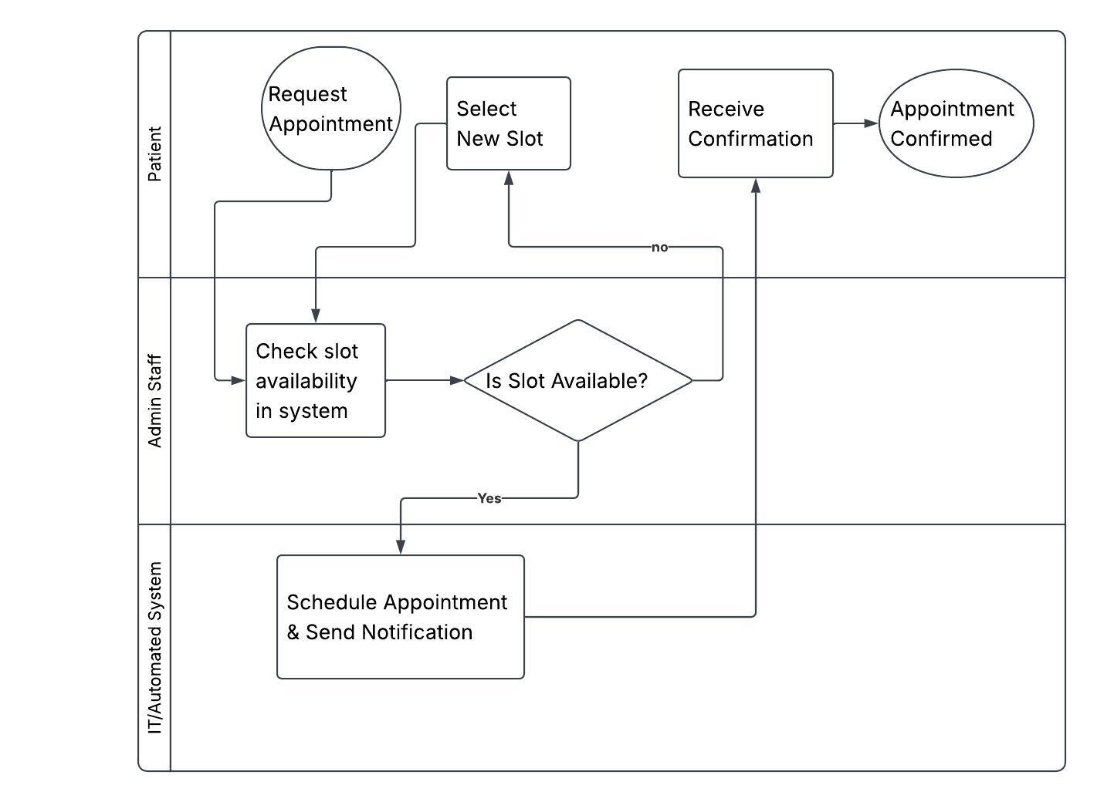
Figure: Swimlane diagram — 4.1 Patient Appointment Scheduling and Confirmation

4.2 Patient Check-In and Resource Allocation
Lanes: Patient, Front Desk, Nurse, Doctor. The patient arrives and requests check-in; Front Desk verifies details and insurance; invalid details are corrected and re-verified; once valid, the Nurse triages the patient, checks vital signs, and assigns a consultation room; the Doctor then conducts the consultation and updates the EHR to complete the visit.
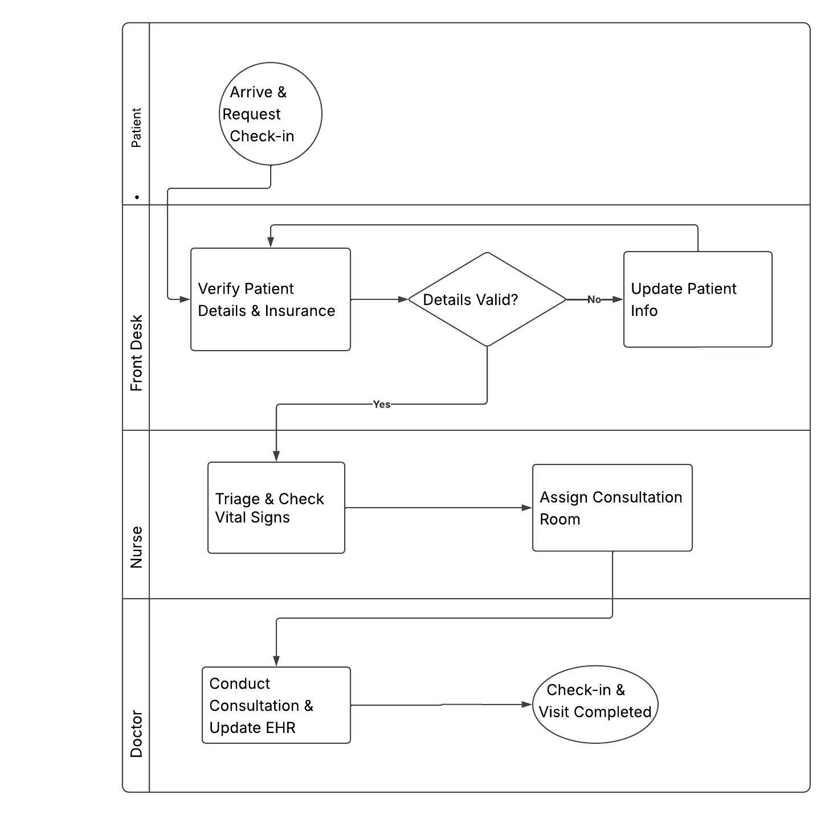
Figure: Swimlane diagram — 4.2 Patient Check-In and Resource Allocation

4.3 Discharge Planning Process
Lanes: Doctor, Nurse, Admin/Billing, Patient. A discharge request initiates the process; the Doctor generates and signs the discharge summary; the Nurse delivers care instructions; Admin/Billing calculates the final bill and checks coverage — unresolved billing issues are looped back for resolution before clearance is issued; once billing is cleared, the discharge clearance pass is issued and the patient receives clearance and leaves.
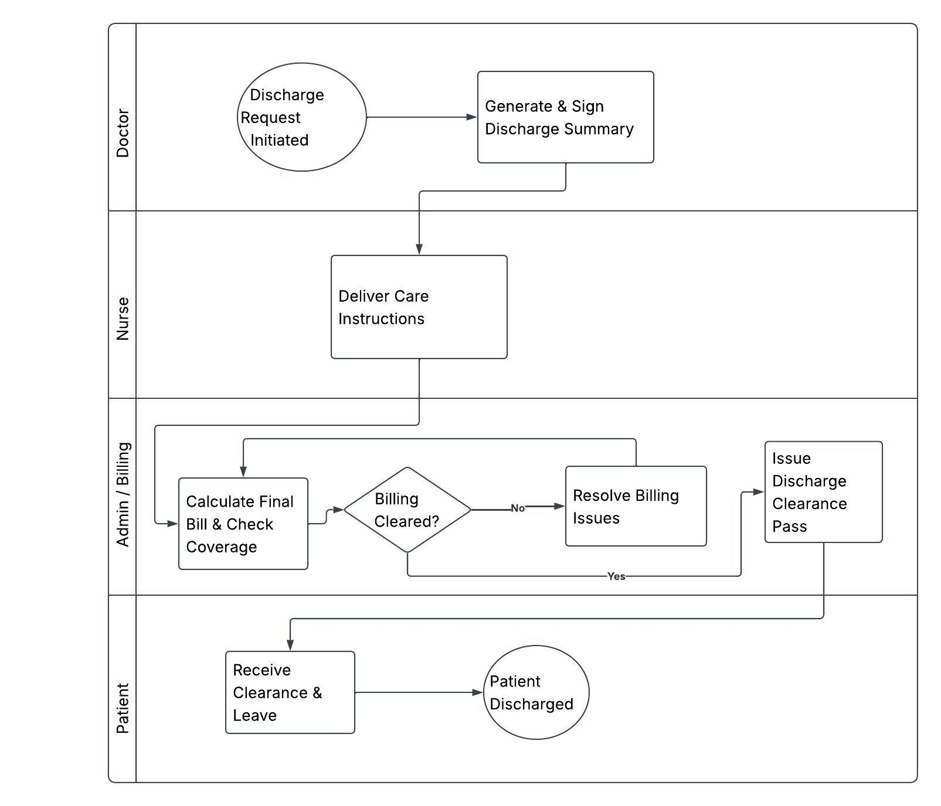
Figure: Swimlane diagram — 4.3 Discharge Planning Process

5. Task 4: Findings and Proposed Improvements

5.1 Appointment Scheduling and Confirmation

Current challenges
- Slot-availability checks are performed manually by Admin Staff rather than surfaced to the patient in real time, adding an avoidable round trip.
- An unavailable slot returns the patient to slot selection with no visibility into the next best available time.

Proposed improvements
- Expose live slot availability directly to the patient-facing booking interface to remove the manual Admin Staff availability check as a default step.
- Add an automated “suggest next available slot” sub-process when the preferred slot is unavailable.

Impact on efficiency
Removing the manual availability check is expected to reduce scheduling turnaround time and administrative workload, while automated slot suggestions should reduce the number of reschedule loops.

5.2 Patient Check-In and Resource Allocation

Current challenges
- Invalid patient details loop the patient back through Front Desk verification, delaying entry into triage.
- Resource allocation (room assignment) only begins after triage is fully complete, creating a serial rather than parallel flow.

Proposed improvements
- Enable pre-visit verification of patient details and insurance (e.g., online or via a check-in kiosk) to shrink the Front Desk correction loop.
- Allow consultation room assignment to run in parallel with triage rather than strictly after it.

Impact on efficiency
Shifting verification earlier and parallelizing room assignment is expected to reduce patient wait times at check-in and improve patient satisfaction scores, which feedback data identifies as most sensitive to delays at this stage.

5.3 Discharge Planning Process

Current challenges
- Billing clearance has no defined turnaround time, so unresolved billing issues can stall discharge indefinitely.
- Care instructions (Nurse) and billing calculation (Admin/Billing) run sequentially even though they do not depend on each other.

Proposed improvements
- Introduce a service-level target for billing issue resolution and escalate unresolved cases automatically.
- Run “Deliver Care Instructions” and “Calculate Final Bill & Check Coverage” in parallel once the discharge summary is signed, rather than in sequence.

Impact on efficiency
Parallelizing the Nurse and Admin/Billing steps and adding a billing SLA is expected to shorten overall discharge time, freeing beds sooner and improving downstream resource availability, consistent with the bottleneck identified in the resource utilization data.

6. Conclusion
Mapping the appointment scheduling, patient check-in, and discharge planning workflows as swimlane diagrams made role ownership and cross-functional handoffs explicit in a way that the earlier As-Is process models did not. In each of the three workflows, the primary source of delay was the same pattern: a manual verification or approval step that could either be automated, moved earlier, or run in parallel with an independent task. Implementing the proposed improvements — real-time slot visibility, pre-visit verification, parallelized discharge tasks, and defined billing SLAs — is expected to reduce patient wait times, lower administrative overhead, and improve resource utilization across HealthFirst Care's operations.

