BUSINESS REQUIREMENTS DOCUMENT (BRD)
HealthFirst Care Initiative: Patient Experience & Operational Efficiency Overhaul

Capstone_Project_M01L01_BRD.doc
Document Title: Project Name: Author / Analyst:
Date & Version:
HealthFirst Care Initiative
Pritam Kar (Junior Data Analyst)
August 17, 2026 | Version 1.0 Final

Executive Summary & Project Context
The HealthFirst Care Initiative was established to address severe operational bottlenecks that degrade patient experience and strain medical staff. Prior to this analysis, operational workflows suffered from fragmented scheduling systems, high appointment drop-off rates, and misaligned resource allocation.
This Business Requirements Document (BRD) synthesizes quantitative data analysis across 216
appointment records, 217 patient feedback submissions, and 213 resource logs to establish formal, actionable requirements for modernizing HealthFirst Care's healthcare delivery infrastructure.

Problem Statement & Operational Baseline
Rigorous empirical analysis of HealthFirst Care operational data revealed three critical challenges currently impeding performance:
- Excessive Patient Wait Times: Patients experience an average wait time of 41.4 minutes across all
medical departments (peaking in General Medicine at 43.9 minutes and Orthopedics at 42.0 minutes). This delay directly depresses patient satisfaction ratings to an average of 6.3 / 10.
- Severe Scheduling Conflicts: The legacy booking system produced 32 confirmed double-bookings (exact same doctor, date, and time slot). Consequently, only 26.8% of scheduled appointments reach successful completion, while 24.1% end in No Shows, 23.1% in Rescheduling, and 21.8% in Cancellations.
- Resource Availability Deficit: 42.7% of all hospital resources (doctors, rooms, equipment, nurses, technicians) are currently unavailable (30.5%) or under maintenance (12.2%). Severe workload
imbalances exist, with Orthopedics doctors averaging 7.86 usage hours per day while Cardiology doctors record unmapped usage.

Key Data Analysis Findings & Visual Evidence
The following visualizations provide empirical support for the requirements set forth in this BRD. They summarize key patterns identified during MS Excel data analysis across appointment schedules, feedback surveys, and resource logs.

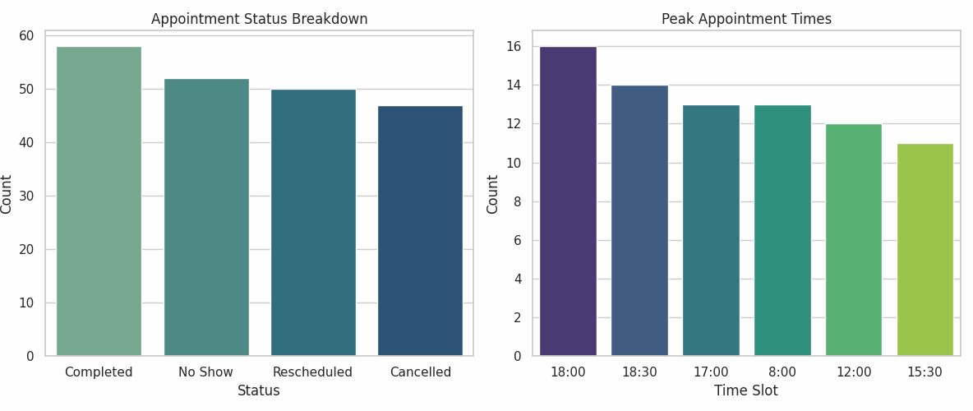
Figure 1: Appointment Status Breakdown and Identification of Peak Demand Time Slots (17:00–18:30).
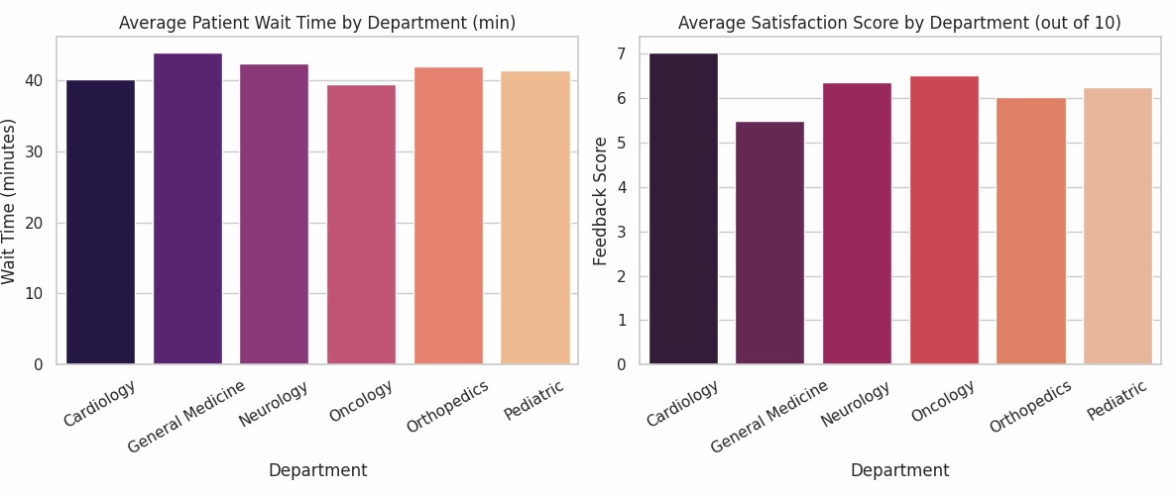
Figure 2: Departmental Average Wait Times (min) and Corresponding Patient Satisfaction Scores (out of 10).
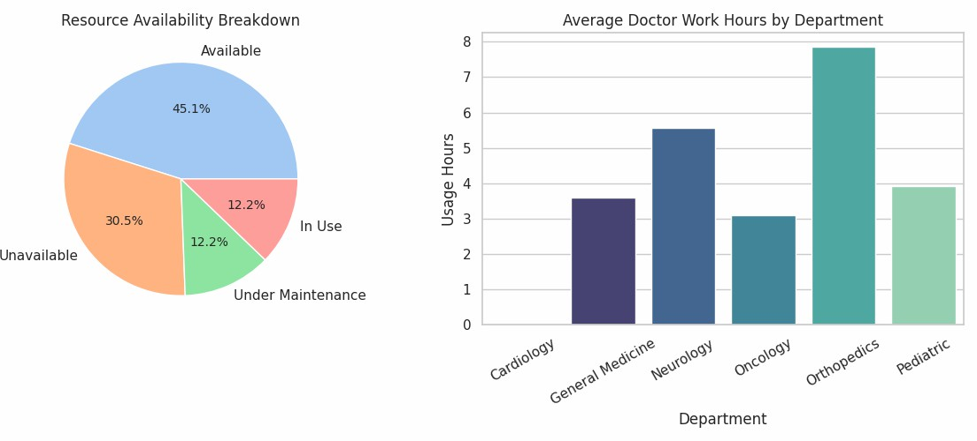
Figure 3: Resource Availability Deficit Breakdown and Average Doctor Work Hours by Department.

Stakeholder Profile & Actionable Requirements Matrix

Stakeholder needs were extracted from profile analyses and mapped directly to technical and operational requirements:
Stakeholder Group Key Operational Challenges Actionable System Requirements

Patients Long wait times (41.4 min avg), lack of delay notifications, high cancellation
friction.
Automated SMS/Email booking
confirmations, live queue wait-time updates, and 24/7 self-service
rescheduling.

Doctors & Nurses Severe workload imbalance (7.86 hrs in Orthopedics), double bookings,
room conflicts.
Automated conflict prevention
engine, synchronized daily schedules, and live room allocation boards.

Administrative Staff Manual booking entry errors, 32 double-booking incidents, high patient complaint volume.
Centralized administrative dashboard with automated calendar lockouts for occupied slots.

IT & Operations Data silos, lack of real-time EHR integration, legacy hardware
constraints.
Cloud-enabled Centralized Electronic Health Records (EHR) integration with role-based security access.

Project Scope

In-Scope Components
    - Development of an automated appointment scheduling engine with real-time double-booking prevention.
    - Deployment of a centralized resource allocation and room tracking system across all 6 departments.
    - Implementation of an automated patient notification system (SMS and Email reminders/updates).
    - Creation of real-time operational dashboards for administrative and clinical management.

Out-of-Scope Components
    - Hardware replacement of diagnostic medical machinery (e.g., MRI/CT scanners).
    - Full overhaul of core hospital financial, billing, and accounting systems (deferred to Phase 2).

Key Requirements, Constraints & Assumptions

System Functional Requirements (FR)
    - FR-01 (Automated Conflict Prevention): The system must validate doctor, room, and patient availability before confirming any appointment, achieving 0 double bookings.
    - FR-02 (Live Resource Tracking): The platform must maintain real-time availability status (Available, In Use, Under Maintenance) for doctors, rooms, and equipment.

    - FR-03 (Patient Notification Service): Automated notifications must be dispatched 24 hours prior to scheduled appointments and immediately upon schedule changes.

Constraints & Assumptions
    - Budget Limitations: System development and deployment must remain strictly within approved cap-ex financial allocations for system upgrades.
    - Legacy Database Interoperability: The new solution must interface securely with legacy patient data storage architectures without requiring total data migration.
    - Staff Adoption Assumption: Administrative staff and medical personnel will complete mandatory system training prior to enterprise rollout.

Formal Acceptance Criteria
Project success will be formally evaluated against explicit target thresholds derived from baseline data:

ID | Objective | Baseline Metric | Target Acceptance Criteria
AC-01 | Reduction in Patient Wait | 41.4 minutes average wait | Reduction of average wait
 | Time | time | time by at least 20% (<=
 |  |  | 33.1 minutes).
AC-02 | Elimination of Double | 32 double-booking | 0 double bookings (100%
 | Bookings | incidents identified | automated conflict
 |  |  | prevention).
AC-03 | Patient Satisfaction | 6.3 / 10 average score | Achieve average patient
 | Improvement |  | satisfaction score of >= 8.0 /
 |  |  | 10.
AC-04 | Resource Utilization & | 45.1% resource availability | Achieve >= 70% available
 | Availability | rate | resource utilization rate
 |  |  | during peak hours.

