Failure Modes and Effects Analysis (FMEA) of Wind Turbine

**Subject:** Reliability Engineering (EEL 447)

**System:** Wind Turbine (Off Shore)

**Function:**  A wind turbine is a device that harness wind energy to generate mechanical power which [converts](https://en.wikipedia.org/wiki/Wind_power" \o "Wind power) the wind's [kinetic energy](https://en.wikipedia.org/wiki/Kinetic_energy" \o "Kinetic energy) into [electrical energy](https://en.wikipedia.org/wiki/Electrical_energy" \o "Electrical energy).It is a Renewable-form of energy production .

**Performed by:** Stanzin Lundup

**Submitted to:** Dr. Vivek Shrivastava

**Abstract:**

In todays world , there is an increasing demand and requirement of electricity so much that only foosil fuel based generating system will not able to keep pace with current energy requirements of the world .In addition ,the process of foosil fuel generated enegy causes serious environmental issues like defforestation,air and water pollution ans so on. In order to meet the increasing demand of electricity we can switch to sustainable and renewable form of energy such as wind energy and there has been a rapidgrowth of wind power industry, therefore reliability of wind turbines has become an important aspect for sustainable energy development.The failure modes ,failure causes and detection methods and the reliability of main components of the wind turbine are the key factors which are analyzed properly to enhance wind generated energy. Also, the frequently used methods of reliability analysis and research status of wind turbine reliability are analyzed. The focus on the methods and measures to improve wind turbine reliability are also mentioned and it is of great significance to reduce the cost of operation and maintenance and to improve the safety of wind turbines.

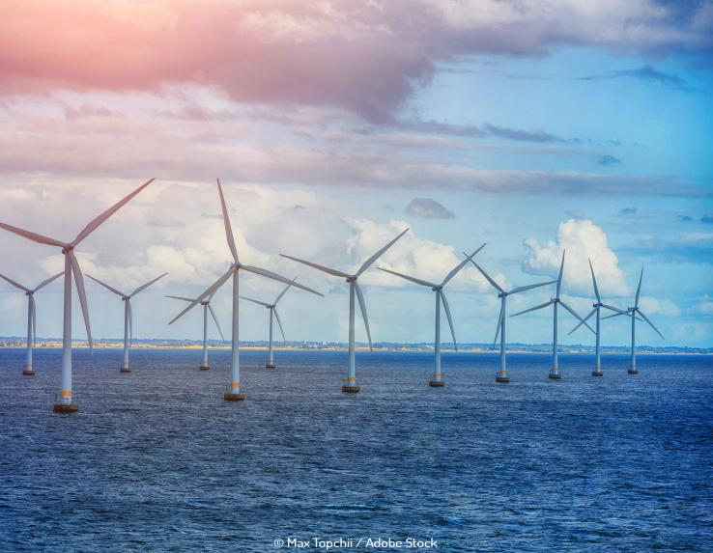**Introduction:**

In the past decades, global warming, energy shortage and environmental pollution have become more serious all over the world, and India is no exception. The development and

utilization of renewable energy provides an important means to deal with the problems. Wind energy is one of the most promising renewable energy sources due to its extensive availability and low cost, and also due to the advances in technology and the increase in efficiency . It is clear that wind power has played a critical role in the sustainable development of the world.

The concept of harnessing wind energy to generate mechanical power goes back for[millennia](https://www.energy.gov/eere/wind/history-wind-energy). As early as 5000 B.C., Egyptians used wind energy to propel boats along the Nile River. American colonists relied on windmills to grind grain, pump water and cut wood at sawmills. Today’s wind turbines are the windmill’s modern equivalent :- converting the kinetic energy in wind into clean, renewable electricity.

The majority of wind turbines consist of three blades mounted to a tower made from tubular steel. There are less common varieties with two blades, or with concrete or steel lattice towers. At 100 feet or more above the ground, the tower allows the turbine to take advantage of faster wind speeds found at higher altitudes.Turbines catch the wind's energy with their propeller-like blades, which act much like an airplane wing. When the wind blows, a pocket of low-pressure air forms on one side of the blade. The low-pressure air pocket then pulls the blade toward it, causing the rotor to turn. This is called lift. The force of the lift is much stronger than the wind's force against the front side of the blade, which is called drag. The combination of lift and drag causes the rotor to spin like a propeller.

A series of gears increase the rotation of the rotor from about 18 revolutions a minute to roughly 1,800 revolutions per minute , a speed that allows the turbine’s generator to produce AC electricity.A streamlined enclosure called a nacelle houses key turbine components usually including the gears, rotor and generator are found within a housing called the nacelle. Sitting atop the turbine tower, some nacelles are large enough for a helicopter to land on. Another key component is the turbine’s controller, that keeps the rotor speeds from exceeding 55 mph to avoid damage by high winds. An anemometer continuously measures wind speed and transmits the data to the controller. A brake, also housed in the nacelle, stops the rotor mechanically, electrically or hydraulically in emergency conditions like thunder-storm, cyclones or even during earthquakes.Overall , the proper functioning of the wind turbine subsystem yields a greater result in generating clean and eco-friendly supply of energy.

**FMEA:**

The Failure Modes and Effects Analysis (FMEA), also known as Failure Modes, Effects, and Criticality Analysis (FMECA), has its origin in the US military in the late 1940s.

The failure mode that describes the way in which a design fails to perform as intended; the effect or the impact on the customer resulting from the failure mode; and the causes or means by which an element of the design resulted in a failure mode.

FMEA is a methodology developed to identify potential failure modes in a product or process, to determine the effect of each failure on system operation and to identify and carry out corrective actions. It may also incorporate some method to rank each failure to its severity and probability of occurrence. A successful FMEA activity helps to identify potential failure modes based on past experience with similar products or processes or based on common failure mechanism logic.

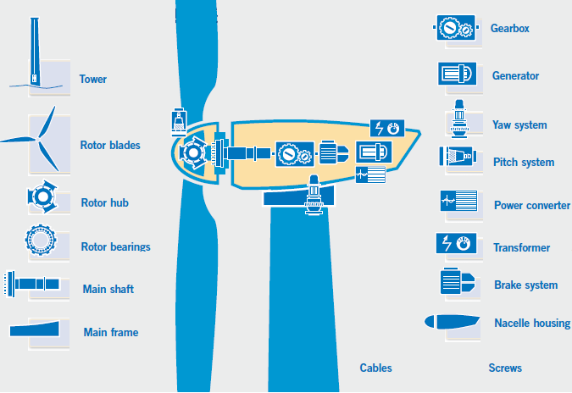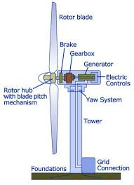

Fig 1: Sub-system or components of Wind Turbine

**\* Subsystem:**

1 )Brake system: Brake disk, Spring, Motor

2 )Cables

3) Gearbox : Toothed gear wheels, Pump, Oil heater/cooler, Hoses

4) Generator : Shaft, Bearings, Rotor, Stator, Coil

5) Main frame:

6)Main shaft : Shaft, Bearings, Couplings

7) Nacelle housing: Nacelle

8) Pitch system: Pitch motor, Gears

9) Power converter : Power electronic switch, cable, DC bus

10) Rotor bearings

11) Rotor blades : Blades

12) Rotor hub : Hub, Air brake

13) Screws

14) Tower : Tower, Foundation

15) Transformer : Controllers

16) Yaw system : Yaw drive, Yaw motor

Table: For description of wind turbine units and their failure analysis.

|  |  |  |  |  |
| --- | --- | --- | --- | --- |
| **Description Of Unit** | | **Description Of Failure** | | |
| **Object** | **Function** | **Failure Mode** | **Failure Cause** | **Detection**  **Method** |
| Brake System | To stop the wind turbines in case of malfunction of a critical component | Overheat , fatigue | Lightning | Overheating detection sensors and regular maintainance |
| Cables | The cables connect the individual turbines together and allows electricity to be transferred to a local or national distribution network. | Fatigue, line breakage | extreme load on the line | Periodic inspection of the cables |
| Gearbox | Transmit torque with speed increase | Internal gear tooth failure | Fatigue loads underestimated; exceeding design load; improper material; loss of lubricating oil | Vibration sensor |
| Generator | Generate electric  power | Overheat; fault; jammed bearing; bearing seizure; overspeed; | Overload;  No-excitation; environmental effects; misalignment; fatigue; mechanical-failure; loss-of-drivetrain control | Protective relays; overspeed detection; testing |
| Main Frame | The gearbox, rotor bearing and the bearing for the connection to the tower are flange-mounted on the mainframe. | Fatigue ,excessive deformation | External forces or environmental condition | Regular Maintainance |
| Main Shaft | Transmit large torque | Fracture | Fatigue-loads underestimated; operation of WTG at off-design conditions; material properties below specs | Low-speed sensor; bearing vibration sensor |
| Nacelle Housing | A cover [housing](https://en.wikipedia.org/wiki/Enclosure_(electrical)" \o "Enclosure (electrical)) that houses all of the generating components in a [wind turbine](https://en.wikipedia.org/wiki/Wind_turbine" \o "Wind turbine), including the [generator](https://en.wikipedia.org/wiki/Electric_generator" \o "Electric generator), [gearbox](https://en.wikipedia.org/wiki/Gearbox" \o "Gearbox), [drive train](https://en.wikipedia.org/wiki/Drive_train" \o "Drive train), and brake assembly | Structure failure,Crack | Environmental Conditions | Regular Maintainance |
| Pitch System | It is used to operate and control the angle of the blades in a wind turbine | fatigue | Bearing Malfunction,electrical overload | Bearing vibration sensor |
| Power Converter | It is capable of adjusting the generator frequency and voltage to the grid | creep and fatigue, bond wire lift-off | Extreme load on electric line | Regular maintainance and diagnostic tests |
| Rotor Bearings | It supports turbine rotor and protect the shaft from any tear and wear during the running condition | rolling contact fatigue, white etching crack, skidding | Fatigue_loads underestimated, material properties below specs | Regular Maintainance |
| Rotor blades | Capture wind | Fracture, edge crack, stuck, motor failure, pitch bearing failure | Fatigue loads higher than anticipated,extreme loads, environment influences, imbalance | Excessive vibration sensed by rotor bearing accelerometer in hub; high stresses recorded by operating instrumentation |
| Rotor Hub | Transmit torque from blades | Structure failure; bolt failure | Excessing design loads; excessive preload; stress corrosion | Rotor-bearing accelerometer; periodic inspection for loose or missing bolts |
| Screws | Use to fasten the components of Wind Turbine together | It can get loose | Continuous Vibration of the wind turbine | Periodic inspection for loose or missing bolts |
| Tower | The tower of the wind turbine carries the nacelle and the rotor and is usually 250 feet high | excessive deformation, fatigue, yielding,  and plastic collapse | Wind storm, typhoon  Or other environmental effects | Regular inspection of tower for any wear and tear and its foundation |
| Transformer | A transformer is a passive electrical device that transfers electrical energy from one electrical circuit to another, or multiple circuits | tap changer failures, bushing failures, tank failures, moisture ingress | Line surges, Voltage spikes, switching surges and line faults | Regular maintainance and diagnostic tests |
| Yaw system | Enable the nacelle to rotate on the tower | Increased bearing friction | Cracked roller; galled surface; lack of lubrication | Yaw error signal |

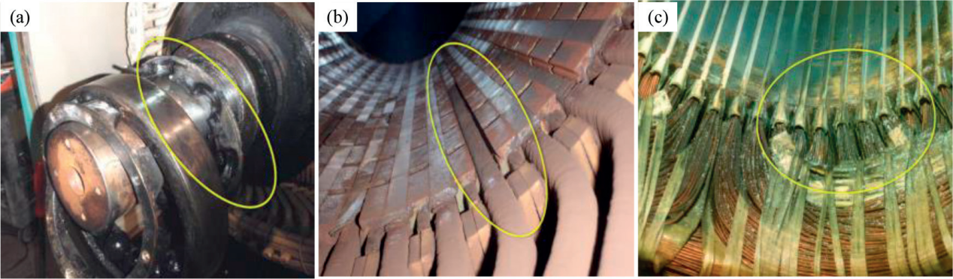

Fig 2: Generator failure: (a) bearing, (b) magnetic wedge loss and (c) contamination.

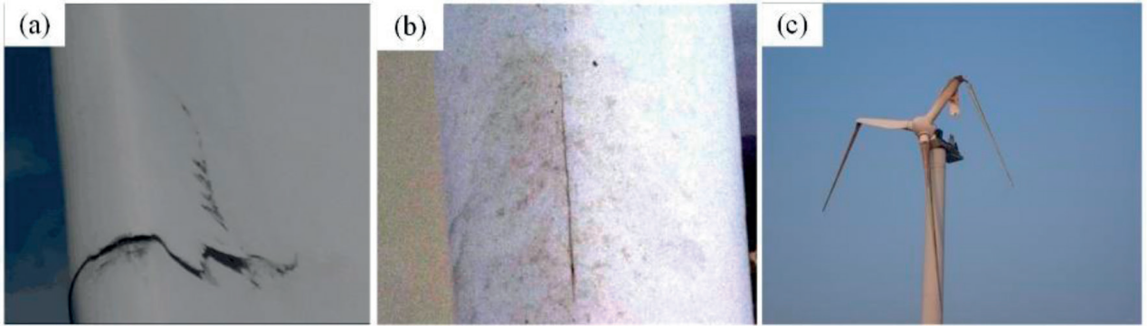

Fig 3: Failure modes of the blades. (a) Trailing edge crack; (b) leading edge failure and (c) blade fracture

Fig: Fault Tree Diagram for the three major components of wind turbine:

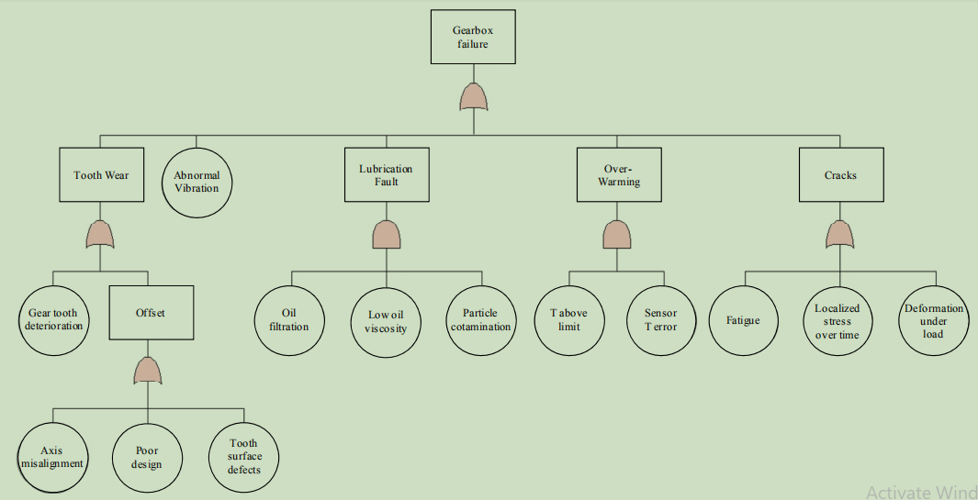

1. Gearbox Fault Diagram

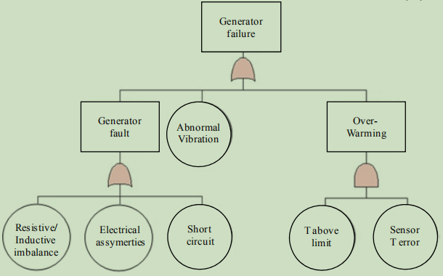

1. Generator Fault Diagram

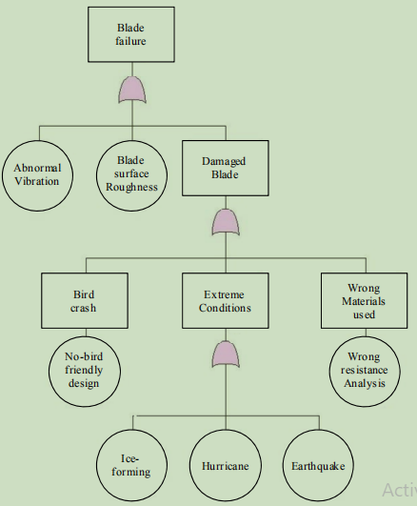

1. Rotor Blade Fault Diagram

Table – Severity rating scale for wind turbine FMEA.

|  |  |  |
| --- | --- | --- |
| **Scale** | **Description** | **Criteria** |
| 1 | Category IV  (minor) | Electricity can be generated but urgent  repair is required. |
| 2 | Category III (marginal) | Reduction in ability to generate electricity. |
| 3 | Category II (critical) | Loss of ability to generate electricity. |
| 4 | Category I  (catastrophic) | Major damage to the Turbine as a  capital installation. |

Table – Occurrence rating scale for wind turbine FMEA.

|  |  |  |
| --- | --- | --- |
| **Scale** | **Description** | **Criteria** |
| 1 | Level E  (extremely unlikely) | A single failure mode probability of occurrence is less than 0.001. |
| 2 | Level D (remote) | A single failure mode probability of occurrence is more than 0.001 but  less than 0.01. |
| 3-4 | Level C (occasional) | A single failure mode probability of occurrence is more than 0.01 but  less than 0.10. |
| 5 | Level A  (frequent) | A single failure mode probability of  occurrence is greater than 0.10. |

Table – Detection rating scale for wind turbine FMEA.

|  |  |  |
| --- | --- | --- |
| **Scale** | **Description** | **Criteria** |
| 1-3 | Almost  certain | Current monitoring methods almost  always will defect the failure. |
| 4-6 | High | Good likelihood current monitoring  methods will detect the failure. |
| 7-9 | Low | Low likelihood current monitoring methods will defect the failure. |
| 10 | Almost impossible | No known monitoring methods available to detect the failure. |

Table: For determing the effects of failue on the system and sub-system

|  |  |  |  |  |
| --- | --- | --- | --- | --- |
| **Sub-system** | **Effect of failure** | **Failure**  **Rate** | **Severity**  **Scale** | **Risk Reducing**  **Measures** |
| Brake System | Noise and system overload | 0.013 | 2 | Monitoring temperature signature to anticipate possible failures |
| Cables | Overspeed | 0.008 | 3 | Periodic inspection of cable for any wear and tear |
| Gearbox | Reduced power | 0.179 | 3 | Remote visual inspection(RVI) to ensure the quality of gearbox |
| Generator | Causing follow-up damage | 0.15 | 2 | A comprehensive maintenance and repair program |
| Main Frame | Overspeed | 0.011 | 4 | Monitoring structural integrity of components |
| Main Shaft | Reduced Power | 0.043 | 2 | Regular repair and service |
| Nacelle Housing | Overspeed | 0.012 | 3 | Regular inspection and maintainance |
| Pitch System | Power Outage | 0.013 | 4 | Timely status and temperature monitoring of the pitch system to anticipate or prevent possible failures |
| Power Converter | Degradation of generator  Function followed by power outage | 0.068 | 4 | Use of well designed line filters and step-up transformer to improve reliability |
| Rotor Bearings | Vibration | 0.01 | 3 | Magnetic Particle Testing to anticipate possible failures like fatigue cracks |
| Rotor blades | Overload | 0.174 | 3 | Regular ultrasonic testing and replacement of damage or corroded blades to prevent unnecessary blade related incident |
| Rotor Hub | Rotor-imbalance resulting in tower strike with a blade | 0.139 | 2 | [Phased Array Inspection](https://www.intertek.com/testing/non-destructive-testing/phased-array/" \o "Phased Array Inspections) testing are conducted to detect cracks, material inclusions and disbanding of composite materials |
| Screws | Vibration | 0.005 | 1 | Monitoring vibration signatures to detect any loose or missing bolt to prevent any structural failure |
| Tower | Overspeed | 0.144 | 4 | From drone inspection to locate any crack or deformation to conducting periodic repair and service |
| Transformer | Power outage, black-out or even explosion | 0.140 | 3 | Transformer must incorporate loading, harmonics, low voltage (LV) fault ride , as well as fire behavior and switching surges to ensure reliability |
| Yaw system | Plant Stoppage | 0.013 | 2 | Regualar oiling and servicing is a must to ensure the safety of the mechanical parts. |

**\* Risk Priority Number (RPN)**  is a measure used when assessing risk to help  
identify critical failure modes associated with your design or process. The RPN  
values range from 1 (absolute best) to 1000 (absolute worst). Failure mode with high RPN are more critical and thus given higher priority.

Risk Priority Number = Severity * Occurence * Detection

RPN =S*O*D

Table – Rank scale of wind turbine sub-system for the FMEA or RPN

|  |  |  |
| --- | --- | --- |
| **Scale** | **Category** | **Description** |
| 1-3 | Very High | Most Critical Component and requires the most caring and servicing as well as timely replacement |
| 4-7 | High | Critical Component requires proper maintainance,service and timely component replacement |
| 8-12 | Moderate | Components require proper inspection and repairing at regular intervals |
| 13-15 | Low | These components does not require much concern |
| 16-(>16) | Very Low | Least Critical Component |

Table: The RPN values for wind turbine sub-assemblies

|  |  |  |  |  |  |  |
| --- | --- | --- | --- | --- | --- | --- |
| S.No. | Sub-system | S | O | D | RPN | Rank |
| 1. | Brake System | 2 | 2 | 7 | 28 | 11 |
| 2. | Cables | 3 | 2 | 1 | 6 | 14 |
| 3. | Gearbox | 3 | 5 | 7 | 105 | 2 |
| 4. | Generator | 2 | 5 | 7 | 70 | 5 |
| 5. | Main Frame | 4 | 2 | 4 | 32 | 10 |
| 6. | Main Shaft | 2 | 3 | 7 | 42 | 8 |
| 7. | Nacelle Housing | 3 | 2 | 1 | 6 | 14 |
| 8. | Pitch System | 4 | 2 | 7 | 56 | 7 |
| 9. | Power Converter | 4 | 3 | 7 | 84 | 4 |
| 10. | Rotor Bearings | 3 | 2 | 4 | 24 | 12 |
| 11. | Rotor blades | 3 | 5 | 7 | 105 | 2 |
| 12. | Rotor Hub | 2 | 5 | 4 | 40 | 9 |
| 13. | Screws | 1 | 2 | 1 | 2 | 16 |
| 14. | Tower | 4 | 5 | 7 | 140 | 1 |
| 15. | Transformer | 3 | 5 | 4 | 60 | 6 |
| 16. | Yaw system | 2 | 2 | 4 | 16 | 13 |

**Conclusion:**

In order to solve reliability problems in wind power industry, scholars all over the world proposed many methods. But the Failure Mode and Effect Analysis (FMEA) analysis method shines out from other methods as it mainly focus on the failure analysis of subsystems and there impact and effect on other subsystems as well as the whole system . The Impact of the failure analysis are limited if the system is simplified but it provides us with enough knowledge and experience to develop better tools, techniques and equipments to improve the reliability of a particular system like wind turbine . In the above FMEA analysis we found that the tower is having the RPN value of 140 which makes it the most critical component of wind turbine where as the screws are having the least RPN value of 2 ,thus making it the least concerned component of the wind turbine system .As a result, we need to focus more on the improving the reliability and performence of critical components rather than wasting too much time on less critical components.

**Reference:**

1. A Fuzzy-FMEA Risk Assessment Approach for Offshore Wind Turbines

F. Din mohammadi1, M. Shafiee

1. Reliability Analysis of Wind Turbines Caichao Zhu and Yao Li
2. Failure Modes, Effects and Criticality Analysis for Wind Turbines Considering Climatic Regions and Comparing Geared and Direct Drive Wind Turbines

Samet Ozturk 1 , Vasilis Fthenakis 1,* and Stefan Faulstich

1. <https://www.google.com/>
2. <https://en.wikipedia.org/wiki/Wind_turbine>