**What Is Random Forest?**

A random forest algorithm with supervised sections and a regression algorithm. As the name suggests, this random algorithm creates a forest with several trees.

Usually, as the trees grow in the forest, the forest becomes stronger. Similarly, in random forest planning, as the number of trees in a forest grows, the results are more accurate.

In simple terms, a random forest forms multiple decision-making trees (called forests) and combines them to produce more accurate and stable predictions. The constructive forest is a collection of Decision Trees, trained in the form of bagging.

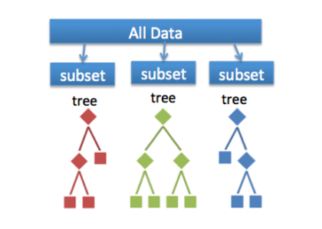

The random forest ensures that the performance of each tree is not significantly related to the behavior of any other tree in the model by using the following two methods:

* Bagging or Bootstrap Aggregation
* Random feature selection
* Bagging or Bootstrap Aggregation:

**Decision trees are more sensitive to the data they have been trained on, a small change in the training data set can lead to a very different tree construction.**

**The random forest takes advantage of this by allowing each tree to randomly sample in the database by inserting another, which results in a variety of trees. This process is called Bagging.**

* **Random feature selection:**

**each tree in a random forest can only select from a random subset of features. This forces a very large difference between the trees in the model and ultimately leads to lower connections in the trees and more division.**

**So in a random forest, we end up with trees trained in different sets of data and use a variety of factors to make decisions.**