**Minor Project Report**

**Submitted in partial fulfilment of the degree of**

**B.Tech**

**By**

**GROUP ALPHA**

**Himanshu Mishra (11900121089)**

**Aryan harsh (11900121099)**

**Rajesh Kumar (11900121072) (C)**

**Abhishek Roy (11900121081)**

**Sanjoy Dey (11900121092)**

**Pritam Chakraborty (11900121103)**

**Second year student of**

**Siliguri Institute Of Technology**

**Under the supervision of**

Mr. Biprosom Majumder

**SikharthyInfotechPvt. Ltd.**

**Department of Computer Science and Engineering**

Date: 28/02/2023

I hereby forward the documentation prepared by GROUP ALPHAunder the supervision of Mr.Biprosom Majumder Sir entitled **Uber Data Analysis Using Tensorflow** accepted as fulfilment of the requirement for the Degree of Bachelor of Technology in **Computer Science and Engineering** from **Siliguri Institute Of Technology** affiliated to **Maulana Abul Kalam Azad University of Technology** (**MAKAUT**) .

|  |  |
| --- | --- |
| ______________________________    **Mr.Biprosom Majumder**  **(Senior Software Engineer & Project Manager)**    **Project Guide**  **SikharthyInfotechPvt. Ltd.** | ____________________________________    **Team Alpha**  **Computer Science and Engineering**  **Siliguri Institute of Technology** |

**Uber Data Analysis Using Tensorflow**

By

**GROUP ALPHA**

UNDER THE GUIDANCE OF

**Mr. Biprosom Majumder**

**Project Guide**

**SikharthyInfotechPvt. Ltd.**

THIS IS SUBMITTED IN FULFILLMENT OF THE REQUIREMENTS FOR THE DEGREE OF

**B.Tech**

IN

COMPUTER Science and Engineering

**SILIGURI INSTITUTE OF TECHNOLOGY**

**AFFILIATED TO**

**MaulanaAbulKalam Azad University of Technology**

[**Address**](https://www.google.co.in/search?rlz=1C1GTPM_enIN734IN734&biw=1366&bih=613&q=future+institute+of+technology+address&stick=H4sIAAAAAAAAAOPgE-LVT9c3NEyrMC-JTzbO0JLNTrbSz8lPTizJzM-DM6wSU1KKUouLAYQ6jCEwAAAA&sa=X&ved=0ahUKEwi3htjS0_rbAhVLQY8KHTJnC-kQ6BMI1wEwEQ)**:**Salbari SUkna SIliguri Dist:-Darjeeling, West Bengal

[**Phone**](https://www.google.co.in/search?rlz=1C1GTPM_enIN734IN734&biw=1366&bih=613&q=future+institute+of+technology+phone&sa=X&ved=0ahUKEwi3htjS0_rbAhVLQY8KHTJnC-kQ6BMI6gEwEw)**:9382421410**

**Email: Devlopersplace@gmail.com**

**Website**:Sit.ac.in

**Certificate of Approval**

The foregoing project is hereby approved as a creditable study for the B.TECH in Computer Science and Engineering and presented in a manner of satisfactory to warrant its acceptance as a prerequisite to the degree for which it has been submitted. It is understood that by this approval the undersigned do not necessarily endorsed or approved any statement made, opinion express or conclusion therein but approve this project only for the purpose for which it is submitted.

Final Examination for

Evaluation of the Project ----------------------------------------

-----------------------------------------

------------------------------------------

Signatures of Examiners

------------------------------------------------------------------------------------------------

**ABSTRACT**

The purpose of the project entitled as “**Uber Data Analysis Using Tensorflow**

” is to develop a webpagewhich is user friendly simple, fast, and cost effective. It deals with the Uber data details and their results etc.The main function of the system is to store student details. The “Uber Data Analysis Using Tensorflow ” has a database section, from where users can check or download results.Admin can add, update or remove any from admin panel.

**ACKNOWLEDGEMENT**

It is a great pleasure for me to acknowledge the assistance and participation of a large number of individuals to this attempt. Our project report has been structured under the valued suggestion, support and guidance of **Mr. Biprosom Majumder**. Under his guidance we have accomplished the challenging task in a very short time.

Finally, we express our sincere thankfulness to our family members for inspiring me all throughout and always encouraging us.

**Group Alpha**

**Computer Application**

**TABLE OF CONTENTS**

Chapter 1: Introduction

1: Introduction

Chapter 2: What We Used

2.1: Pandas

2.2: Python

2.3: numpy

2.4:DataBase

2.5: tensorflow

Chapter 3:

3.1: machine learning

3.2: tensorflow

3.3: matplotlib

Chapter 4:FEATURES

4.1.easy access to dataset

Chapter 5: System Analysis

5.1: Identification of the need

5.2: Preliminary Investigation

5.3: Feasibility Study

Chapter 6:Project Planning and Scheduling

Chapter 7: Functional Requirement of the System

7.1: Software Requirement

Chapter 8: Database Design

8.1: Data Dictionary

Chapter 9: Conclusion

Chapter 10: References

**INTRODUCTION:**

**Uber data analysis using tensorflow**  created specifically for accessingResult of data of uber. This method will help individual to publish all uber result and uber can easily access their result.The technology also enables for the quick and easy management of an online result that user can see and download from with just a few mouse clicks.

**2.1 Machine Learning**

We used python3, in this project we learned python datatypes, methods, class, sorting , OOPs concept, loops and many elements in our python program.

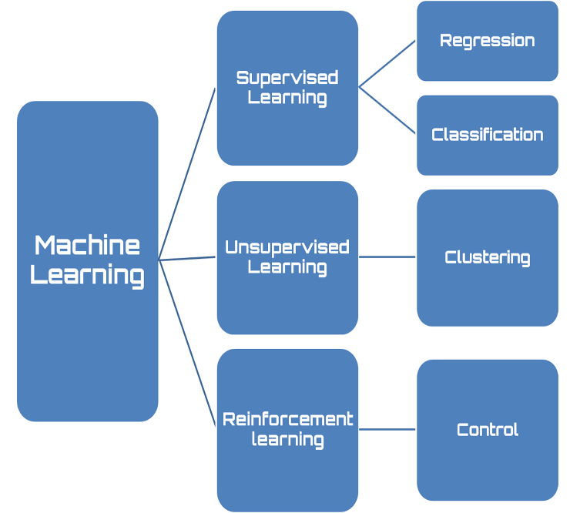

**2.2Tensorflow**

We used tensorflow for graphs



**2.3IDE**

We used Microsoft Visual Studio Code(VS Code), eclipse in our project as IDE.

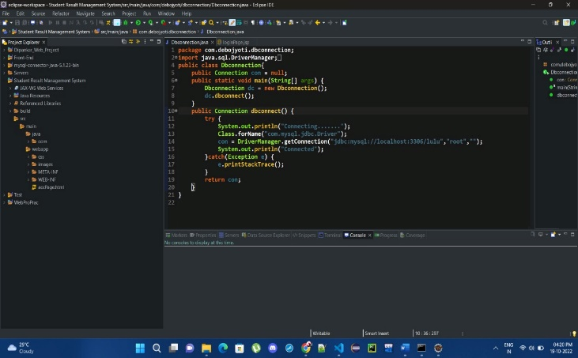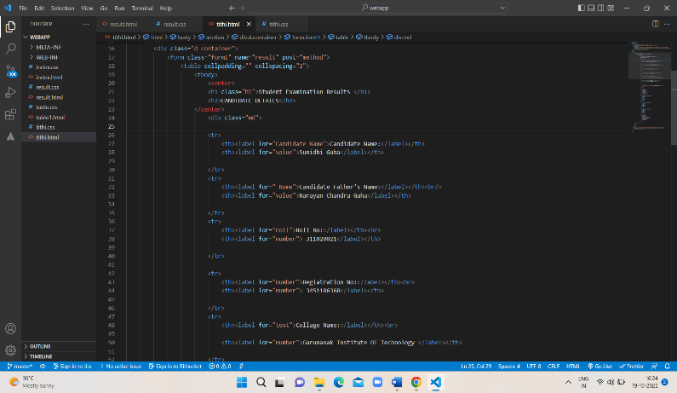

**3. FUNCTIONALITY OF THE UBER DATA**

**3.1: Dataset using Tensorflow**

Tensorflow is used for dataset

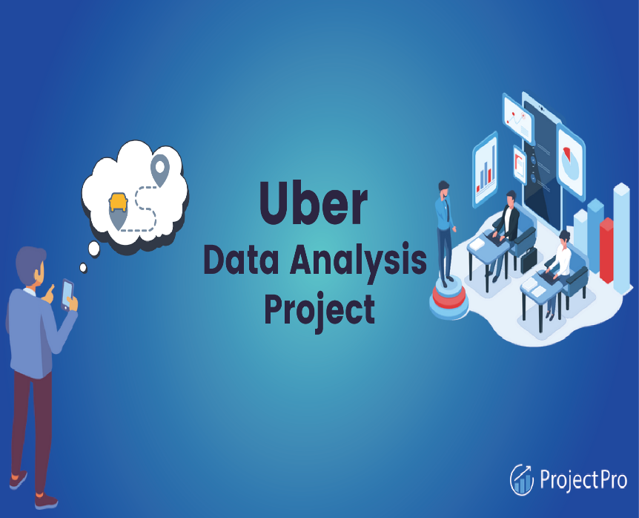

**3.2Uber dataset**

This is the data se t for Uber data Analysis Using Tensorflow

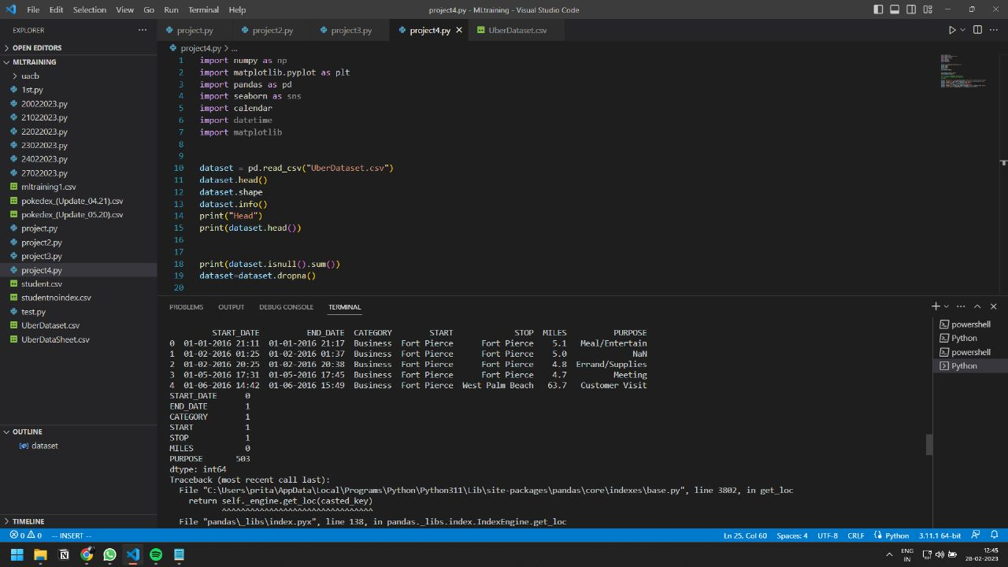

**3.4 Uber Data Reading**

Here we used data to read of Uber.



**3.5 Data Processing.**

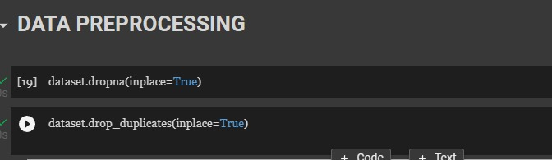

**3.6 Data time Operation.**

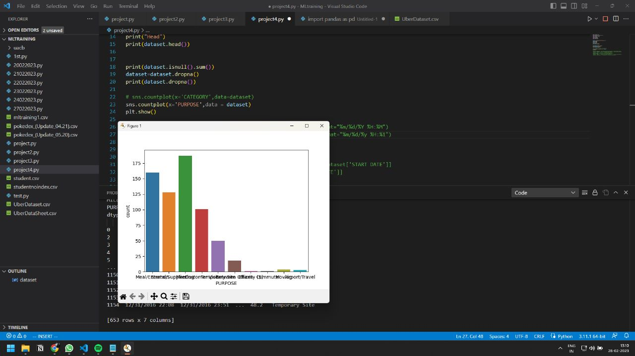

**4. FEATURES**

**Matplotlib is used to graph.**

**5. SYSTEM ANALYSIS**

**5.1 IDENTIFICATION OF NEED**

At the behind of any project, there are mainly two important parts i.e. Proper Plans and Right execution of those plans. This is the key of success. That will always help to execute the ideas.

Here that same process we followed during that development. We made the plan of making this **Uber data analysis**  to make it easy for the users to access their result and manage/download them.

**5.2 PRELIMINARY INVESTIGATION**

Preliminary investigations involve collecting information that helps to evaluate the merits of a project and make an informed judgement about the feasibility of the proposed project.

While we planned about **“Uber data analysis”,** on the Internet a lot of consideration was given to all these issues. Extensive thought was given to the various minimum-offering levels that can be provided against the possible returns from such offerings.

**5.3 FEASIBILITY STUDY**

The feasibility of the project is analysed in this phase and business proposal is put forth with a very general plan for the project and some cost estimates. During system analysis the feasibility study of the proposed system is to be carried out. This is to ensure that the proposed system is not a burden to both the public and the company. For feasibility analysis, some understanding of the major requirements for the system is essential. Three key considerations involved in the feasibility analysis are:

**5.3.1 Economic Feasibility**

This study is carried out to check the economic impact on the system of the organization. The amount of fund that the company can pour into the research and development of the system is limited. The expenditures must be justified. Thus the developed system as well within the budget and this was achieved because most of the technologies used are freely available.

**5.3.2 Technical Feasibility**

This study is carried out to check the technical feasibility i.e. the technical requirements of the system. Any system developed must not have a high demand on the available technical resources. This will lead to high demands being placed on the client. The developed system must have a modest requirement, as only minimal or null changes for implementing this system.

**5.3.3 Operational Feasibility**

The aspect of study is to check the level of acceptance of the system by the user. This includes the process of training the user to use the system efficiently. The user must not feel threatened by the system, instead must accept it as a necessity. The level of acceptance by the users solely depends on the methods that are employed to educate the user about the system and to make him familiar with it.

**6.Project Planning and Scheduling**

Scheduling is an important activity of any project management. Scheduling a software project involves first breaking down an entire problem into a logical set of tasks which would be assigned to developers.

In order to Schedule the “**Uber data analysis”** we have to do the following:

▪ Identify the tasks needed to complete the project.

▪ Determine the dependency among different tasks.

▪ Establish the most likely estimates for the duration of the identified tasks.

▪ Plan the starting and ending dates for various tasks.

▪ Determine the critical path i.e. the chain of tasks that determine the duration of the project.

**7. Functional Requirement of the System**

Being a web-based solution the first and foremost thing that starts acquiring importance in this project is the way the complete package needs to be configured. Web-based solutions by virtue of their designs are mostly thin client solutions. To run this kind of a solution properly it is necessary that the Server configurations are properly worked out. It is the server that will have to ultimately scale up as and when the numbers of users start increasing.

**7.1 HARDWARE REQUIREMENTS**

The minimum Hardware requirements for the application to run smoothly should have the following configuration:

|  |  |
| --- | --- |
| **Processor** | Intel Core i3 |
| **RAM** | 4GB or more |
| **HDD** | 3GB or more |

**7.2 SOFTWARE SPECIFICATIONS**

The minimum software requirements are as follows:

|  |  |
| --- | --- |
| **Operating System** | Windows 7,8 and upwards |
|  |  |
| **User Interface Design** | tensorflow |
| **Language Used** | Python language |
| **Web Browser** | Mozilla, Google Chrome, OPERA |
| **Working IDE** | Visual Studio Code, Pycharm |

**8. DATABASE DESIGN**

**8.1 DATA DICTIONARY**

The logical characteristics of current system data stores including start date, end date, purpose ,stop miles identifies process where the data are used and where immediate access to information required, Serves as the basis for identifying database requirements during system design.

**Uses of Data Dictionary:**

* To manage the details in large systems.
* To communicate a common meaning for all system elements.
* To document the features of the system.
* To facilitate analysis of the details in order to evaluate characteristics and determine where system changes should be made.
* To locate errors and omissions in the system.

**9. CONCLUSION**

We looked at two different types of Uber ride datasets – a personal ride history for a single person and a two-month record of all the Uber rides in Boston, MA. We compared similar graphs in the EDA process of both these datasets to generate real-world insights into the behavior of the Uber riders and trips in the city of Boston. Furthermore, we used different ML models to perform a price prediction of the Uber ride based on a fixed number of features from the second dataset. We also perform feature selection to reduce the number of features and find the optimal amount to improve model performance to a certain degree.

**Finally, we noted some crucial issues faced by scientists during EDA and data analysis and listed the challenges of working with the Uber datasets.**

**10.REFERENCES**

1. https://www.w3schools.com/
2. <https://www.codewithharry.com/>
3. <https://www.javatpoint.com/>